Exercise XCT #3 – Signal and Noise, Undersampling and Motion Artefacts

Shuo Li; Yitong Li

Task 3.1

Calculate the number of photons incident to the object during an X-ray burst.

– tube voltage

– relative X-ray yield

– number of electrons incident to the object during an X-ray burst

– anode current

– X-ray burst duration

According to the Beer Lamberts law, the number of photons that are transmitted through the object can be expressed as:

In this task, the photon energy has been set as 50 KeV or 100 KeV. So we don’t need to do the integration of .

The detected signal follows a Poisson distribution. The mean value, which is also the variance, is determined by the value of the actual signal. In here, we use poissrnd() to add a Poisson noise to the projection.

Experimental results:

Without noise:

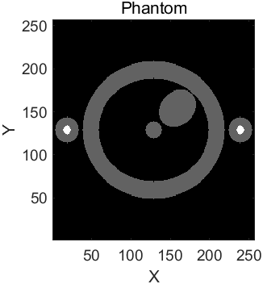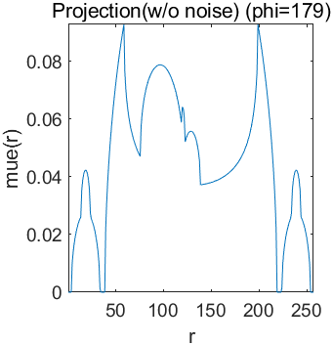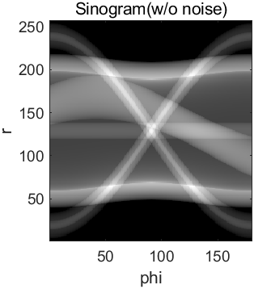 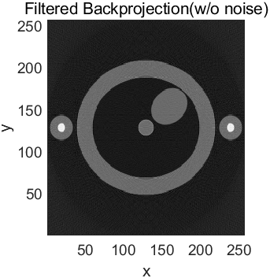

After adding noise:

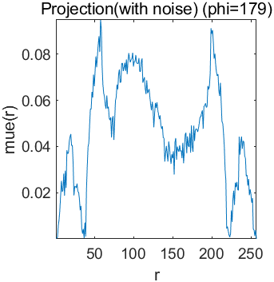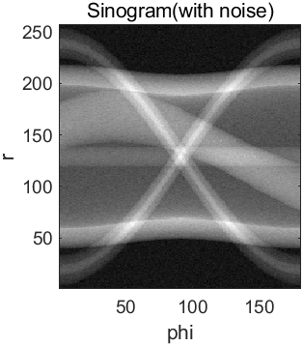

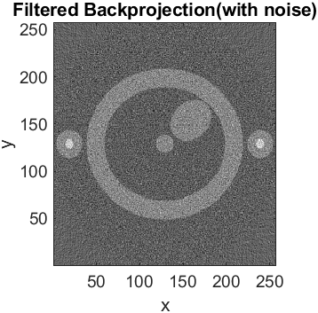

Task 3.2

2-dimensional Gaussian distribution:

In this task, we have and .

Full width at half maximum:

Standard deviation:

Define the resolution reduction factor as the ratio of matrix size and FWHM. In this way, less higher frequency components can pass through the filter when the resolution reduction factor increases.

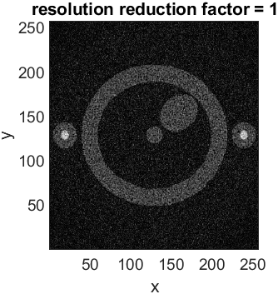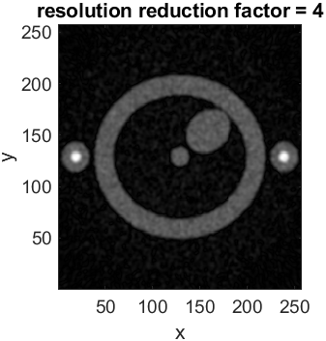

From the results of different FWHM, we can conclude that higher FHWM can increase resolution while also preserving more noise. In other words, applying low-pass filters to reduce noise will also lead to the decrease of resolution.

Task 3.3

According to the definition of SNR (signal to ratio), we can get:

Change tube current:



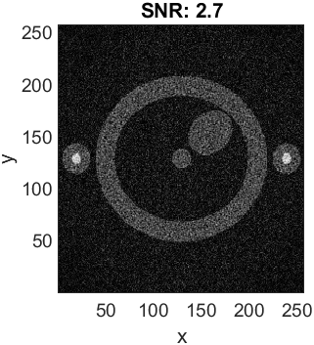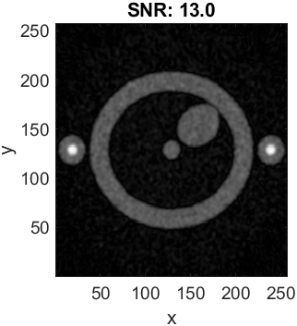

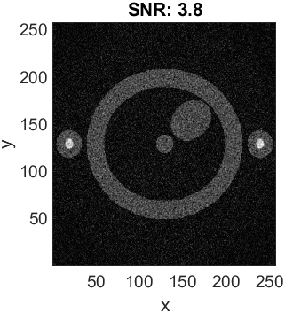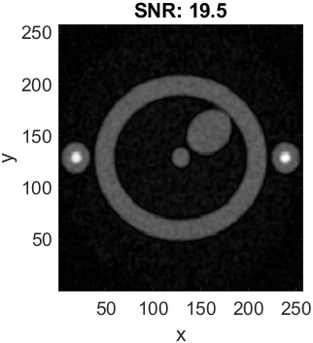

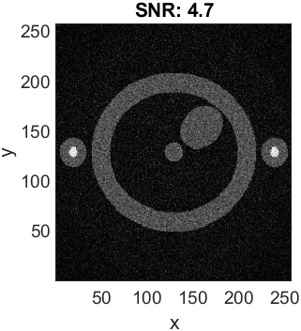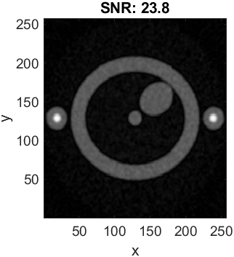

Change burst duration:

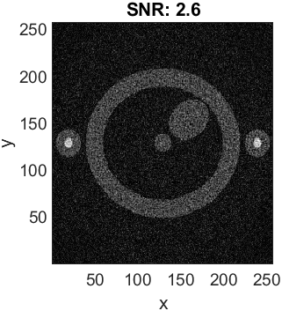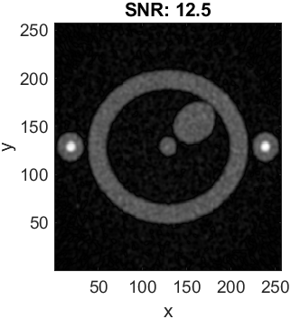

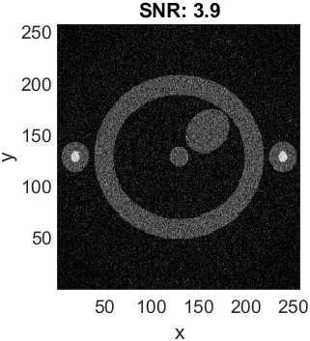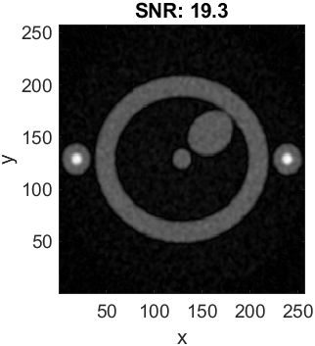

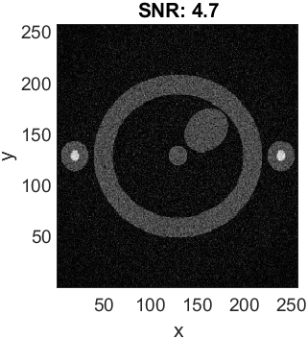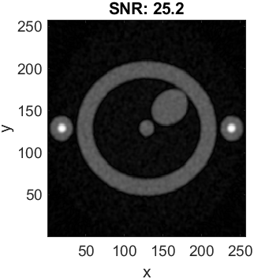

According to the definition of SNR and the expression of pixel noise, we can get the mathematical relationship between SNR, tube current and burst duration :

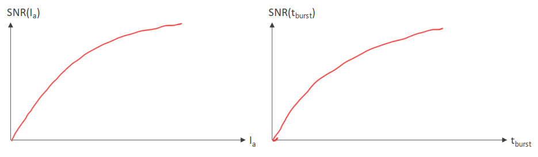

Task 3.4

To simulate the beating heart, we can simply change the half axis of heart in each projection.

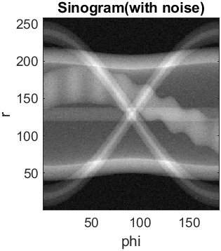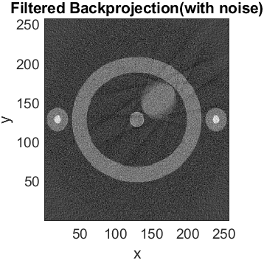

From the sinogram, we can see the main difference with the results of stationary heart is that the sinogram of heart has some periodic “shakes”. And the result in the FBP image also shows that the image of heart is blurred. This is because in the imaging process, the heart keeps beating periodically. So the size keeps changing. We can simply calculate the number of cycles using the following equation:

The calculation result is identical corresponds to the sinogram result.

1. R=2

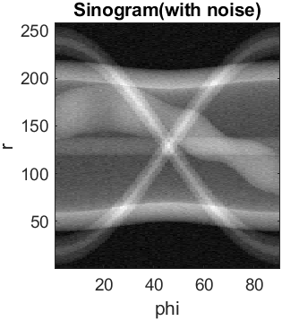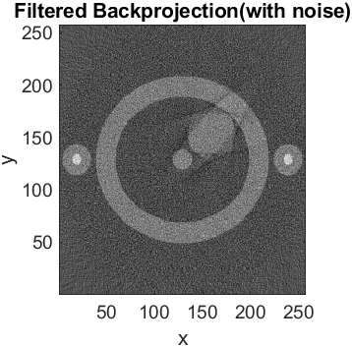

1. R=4

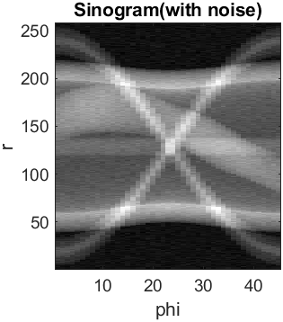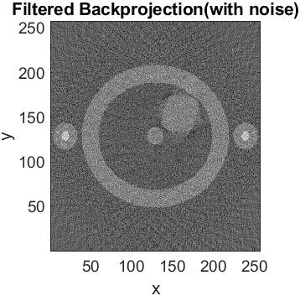

1. R=8

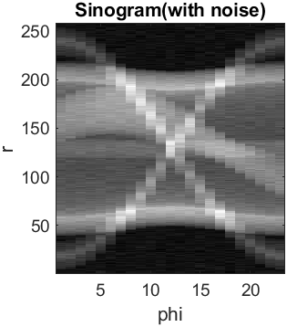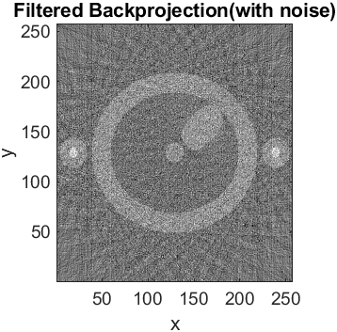

The imaging speed, motion artifacts and image SNR are restricted by each other. If we decrease the sampling times to increase the imaging speed, motion artifacts can be improved. But the SNR will decrease because we decrease our sampling rate. If we increase the imaging speed using a lower burst duration, we can also improve motion artifacts because the beating heart is averaged in a shorter time period. But the SNR will decrease. To increase the SNR, we can do repeated scanning and then average them to offset the influence of Poisson noises.

To deal with the motion problem, we can control the scanning time. In other words, the projections can be gated on for short time durations and then gated off to coordinate with the periodic beating of hearts. For instance, we can do the projections every time when the heart is in the lowest point of contraction. In this way, we will get a contracted and stationary heart instead of a beating one.