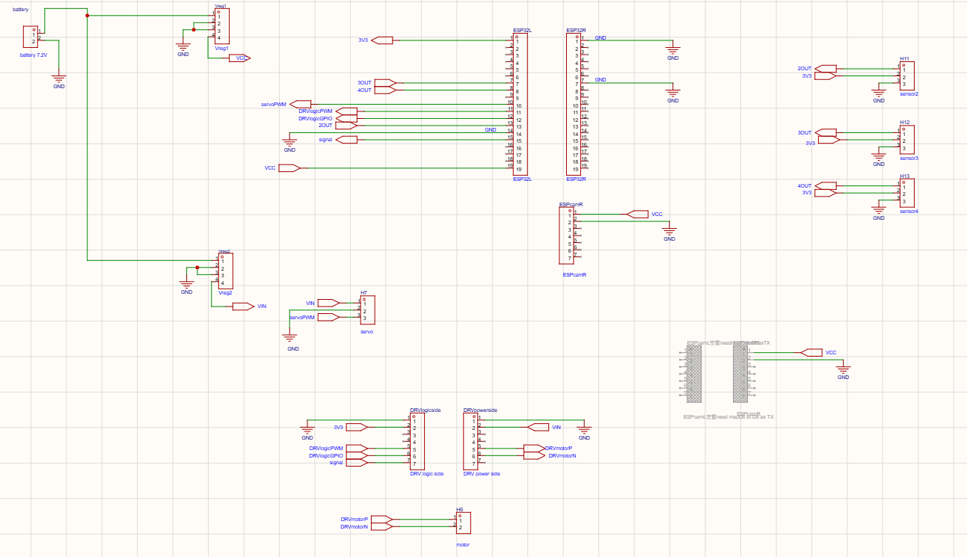
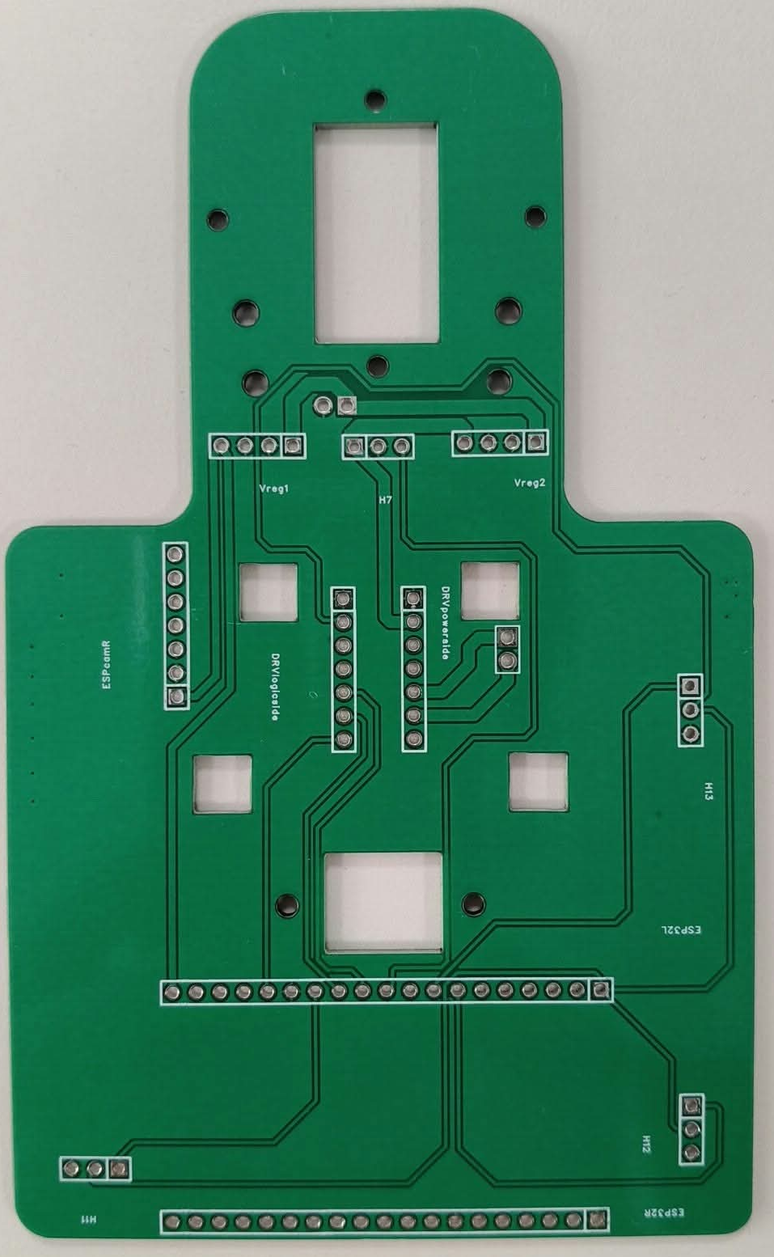
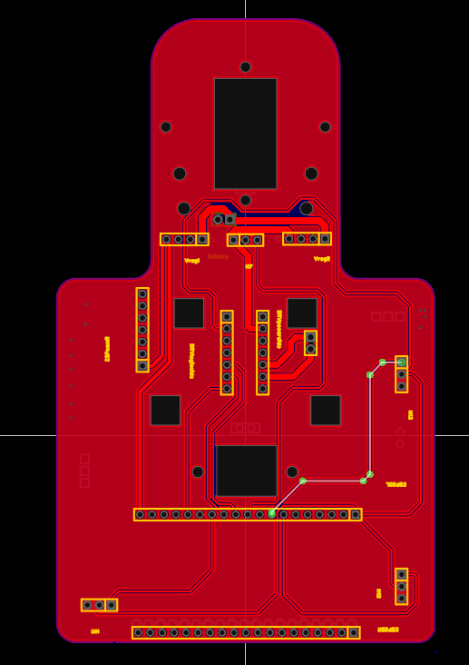

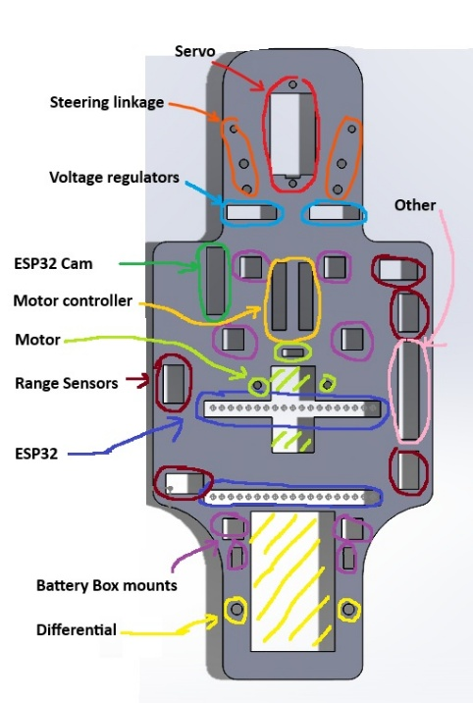
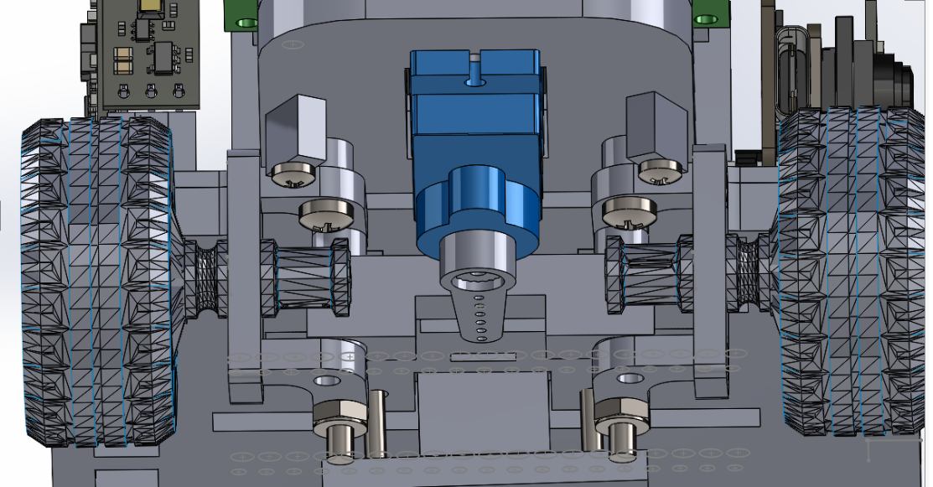
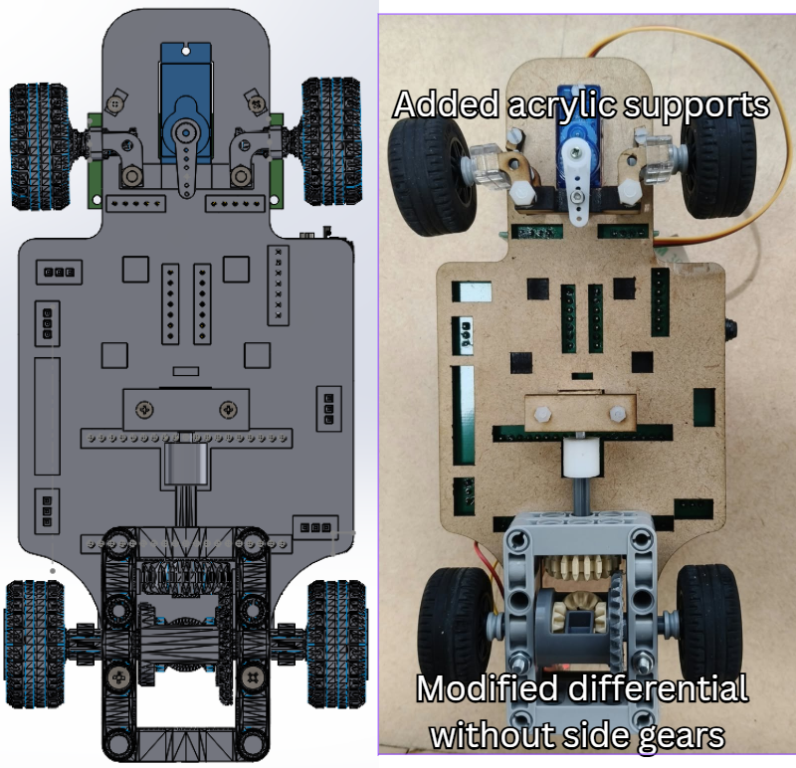
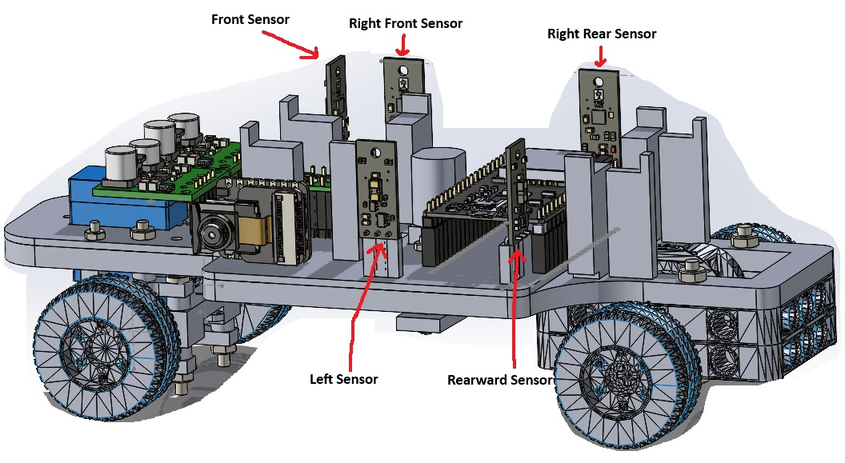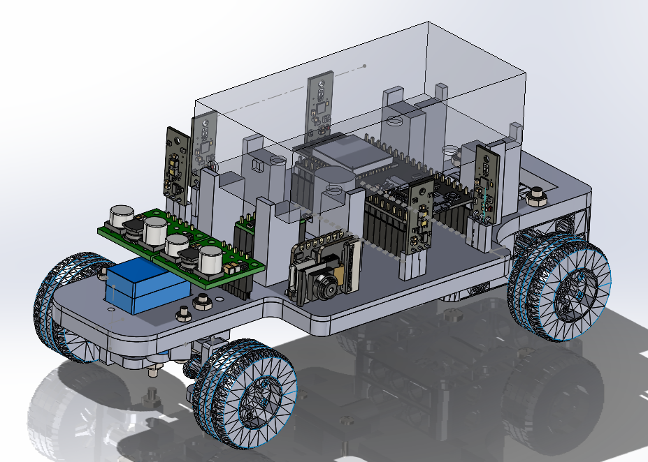
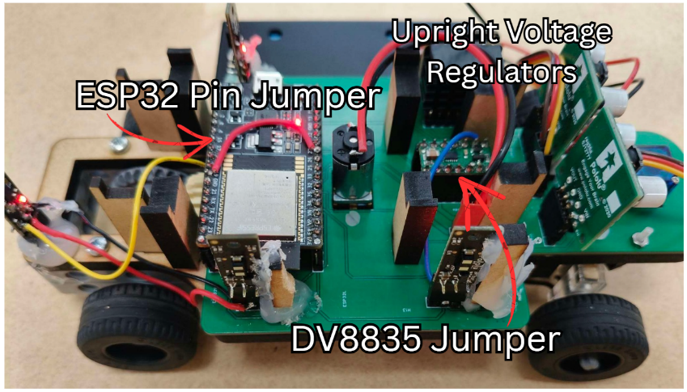
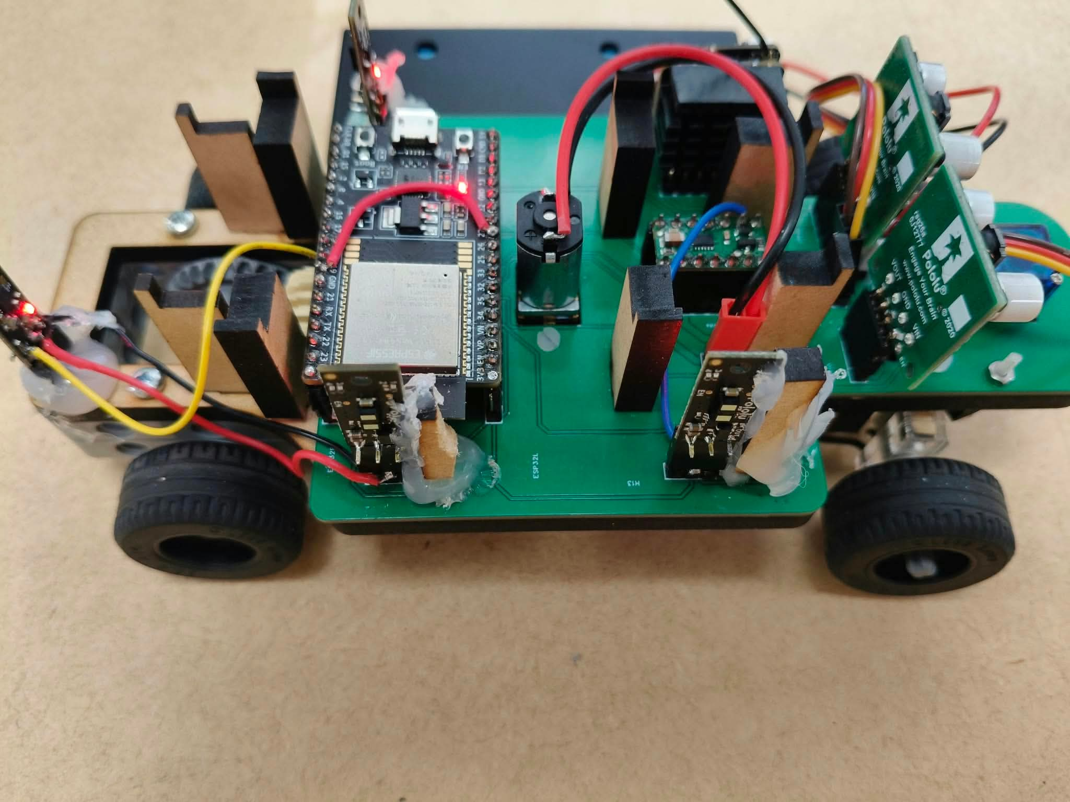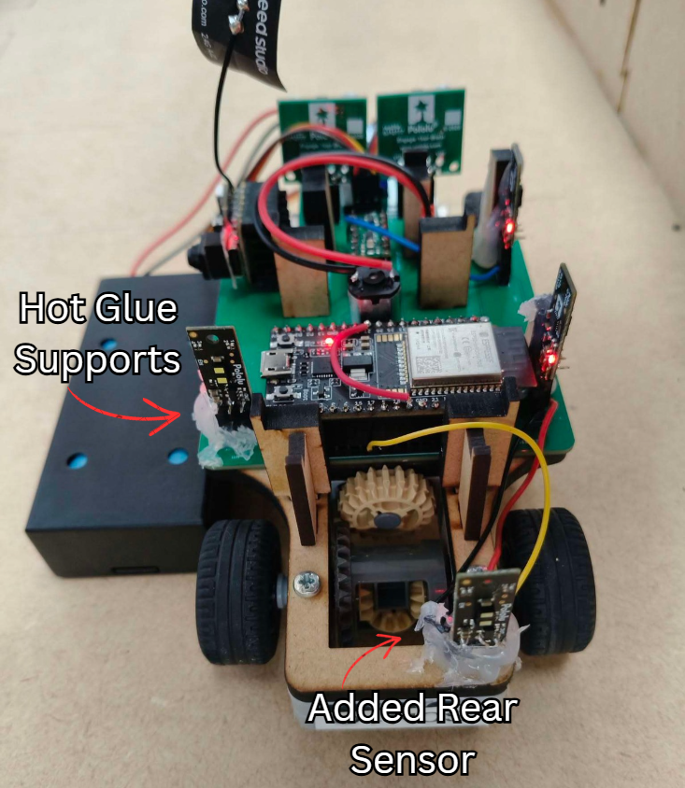

START
Initialise camera, laptop program, ESP32, sensors and motors
Send configuration settings to ESP32
Wait for ESP32 to acknowledge the settings
Wait for the user to press Enter

Identify and store up to two target colours
Lock colours once none are visible for 0.5 s

WHILE the parking task is not complete:

Read camera frames
Detect target colours inside the ROI
Read sensor values from the ESP32

IF camera data or sensor data is unavailable,
or a state timeout is reached:
Send STOP command
Stop the vehicle
Handle the fault

ELSE IF an unparked target colour is detected:
Start the forward timer once
Drive forward while ESP32 wall-following operates

IF the 10 s forward timer finishes:
Send PARK command

ESP32:
Set steering to full lock
Reverse along the arc
Ignore rear sensors during minimum arc time
Compare rear sensors B and B2
Align the vehicle with the wall
Straighten the steering
Reverse straight towards the final position
Stop at the rear-sensor stop distance
Report PARK_DONE

Laptop:
Wait 2 s after PARK_DONE
Record the parked colour

IF another target remains
AND fewer than two bays are parked:
Send UNPARK command

ESP32:
Drive forward
Turn out
Reverse-align
Drive forward again
Report each phase
Report UNPARK_DONE

Wait for UNPARK_DONE
Wait for the old marker to leave the camera view
Resume searching
ELSE:
Send STOP command
Keep the vehicle stopped
Finish the task

ELSE:
Continue driving
Use right-hand sensors to maintain
approximately 105 mm from the wall

END WHILE

STOP
