RecyclerView的使用学习--------------------------------------------------------------------------------------------------

张云浩

本文主要讲解RecyclerView的相关使用详解：本文可以看到：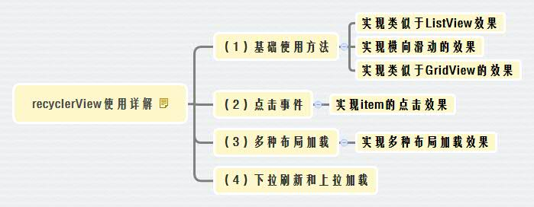
- 基本使用方法
  - 基础配置的实现：
1-1-1：创建新的项目：
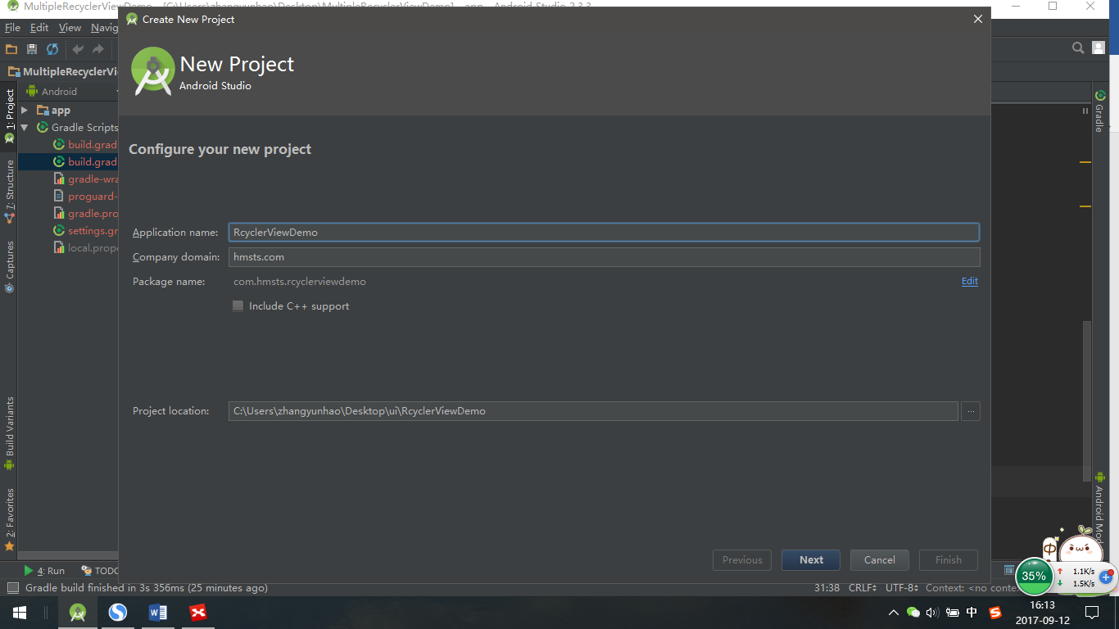
1-1-2在AndroidStudio Module：app中进行配置：添加：
compile 'com.android.support:recyclerview-v7:25.3.1'

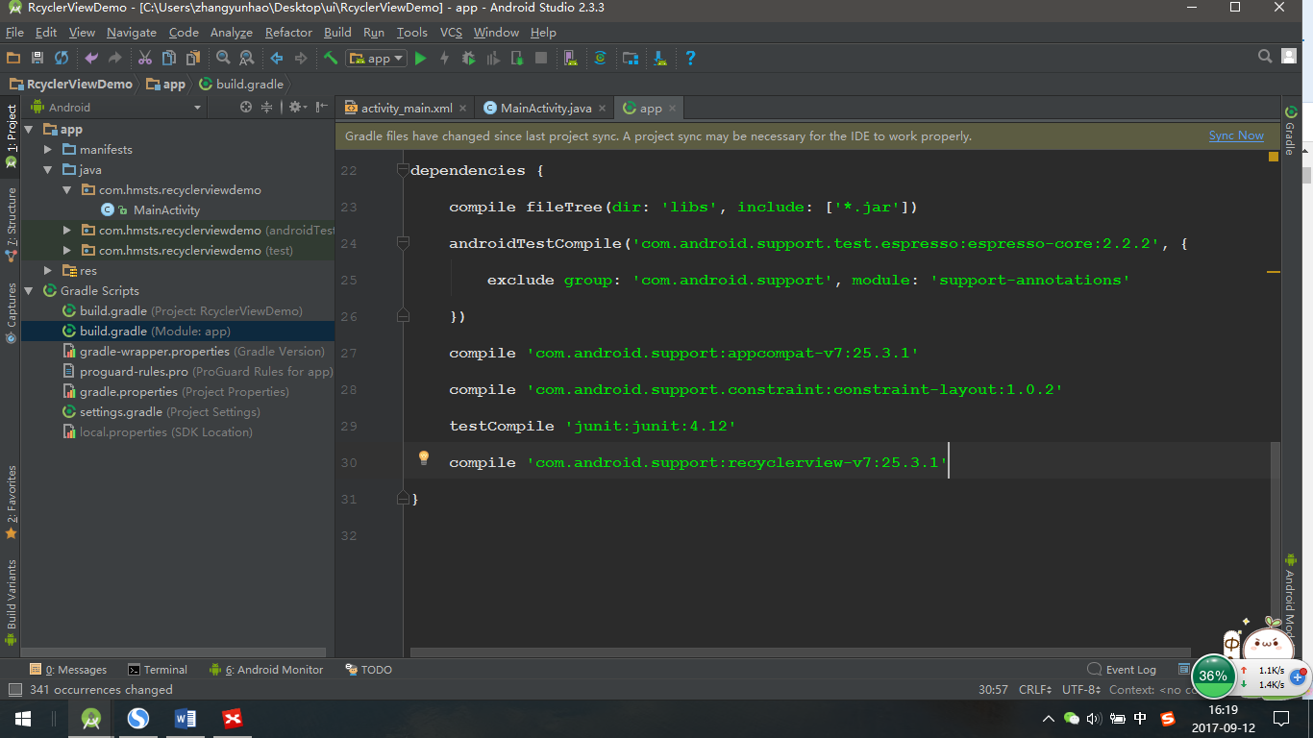
然后点击右上角，在有网络的情况下同步下载：
1-1-3 MainActivity的Xml布局文件中添加recyclerView控件：
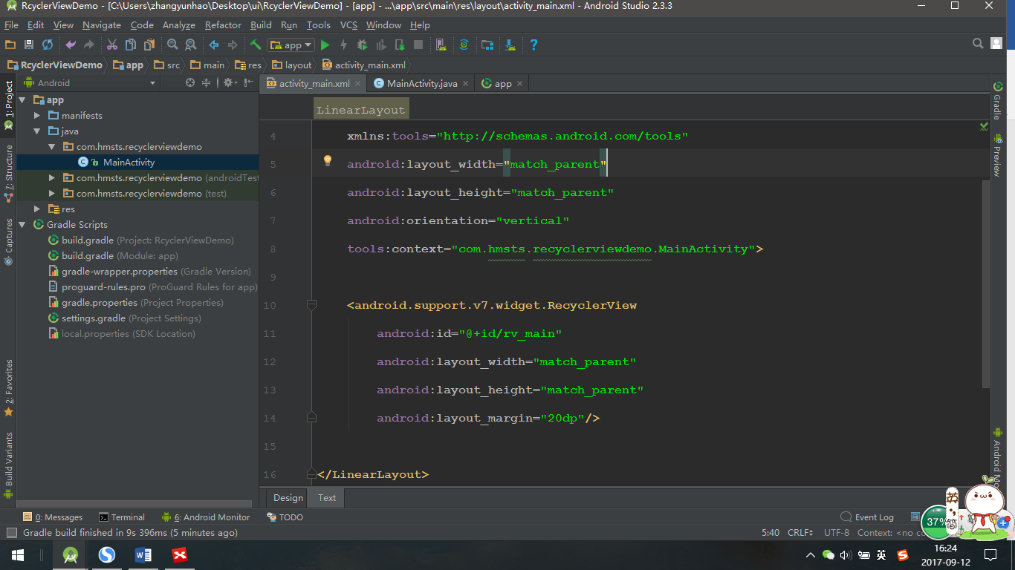
1-1-4 代码中实现类似于ListView：
（1）MainActivity中的代码的实现：
//找到相关的RecyclerView
mRecyclerView = (RecyclerView) findViewById(R.id.rv_main);
//初始化显示数据：
List<String> strings = new ArrayList<>();
for (int i = 1; i <= 50; i++) {
strings.add("第" + i + "个");
}
Log.e("-------", strings.toString());
//初始化布局管理器
LinearLayoutManager linearLayoutManager = new LinearLayoutManager(this);
//设置布局管理器的方向（竖直/水平）
linearLayoutManager.setOrientation(LinearLayoutManager.VERTICAL);
mRecyclerView.setLayoutManager(linearLayoutManager);
//将上下文和要显示的list集合通过构造函数传递给adapter
mRecyclerView.setAdapter(new recyclerViewAdapter(this, strings));
（2）创建每个条目的布局文件item：
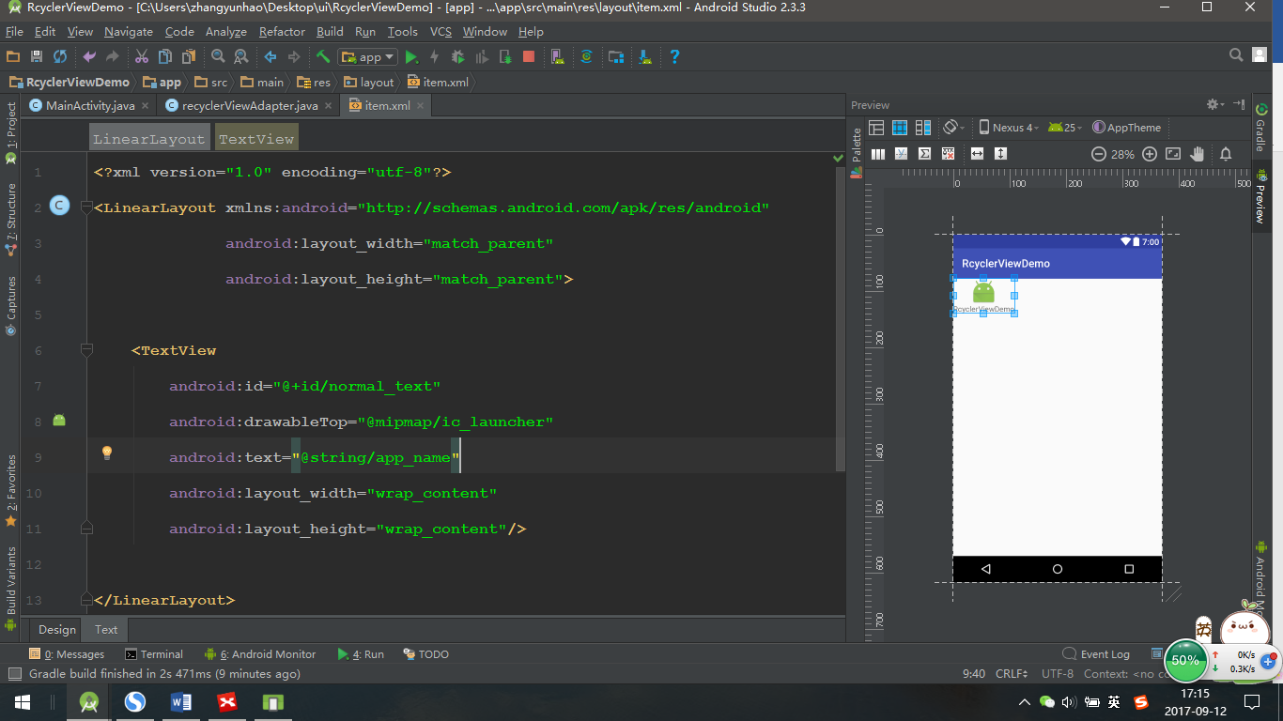
注意：每个条目的布局文件指的是每个item加载一些数据的布局，可以相同也可以根据实际情况新建不同的布局；
（3）设置RecyclerView的adapter的代码：
public class recyclerViewAdapter extends RecyclerView.Adapter<RecyclerView.ViewHolder> {
private List<String> mString;
private Context mContext;
//构造函数，获取传递的数据并本地化
public recyclerViewAdapter(Context context, List<String> string) {
this.mString = string;
this.mContext = context;
}
//创建Viewhoder
@Override
public RecyclerView.ViewHolder onCreateViewHolder(ViewGroup parent, int viewType) {
View view = View.inflate(mContext, R.layout.item, null);
return new NormalHolder(view);
}
//将创建的ViewHoder绑定到特定的位置position上
@Override
public void onBindViewHolder(RecyclerView.ViewHolder holder, int position) {
NormalHolder normalHolder = (NormalHolder) holder;
normalHolder.textView.setText(mString.get(position));
}
//控制要显示的行数
@Override
public int getItemCount() {
return mString.size();
}
//自定义的viewholder 并获得holder的控件，便于对空间进行操作
public static class NormalHolder extends RecyclerView.ViewHolder {
TextView textView;
public NormalHolder(View itemView) {
super(itemView);
textView = (TextView) itemView.findViewById(R.id.normal_text);
}
}
}
（4）运行结果：
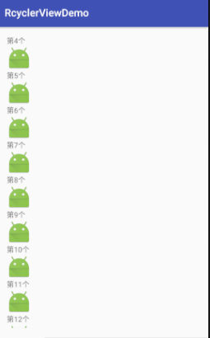
1-1-5 实现横向滚动的运行结果：
横向滚动和竖向的只是在配置LinearLayoutManager时不同，默认的是竖向滑动。
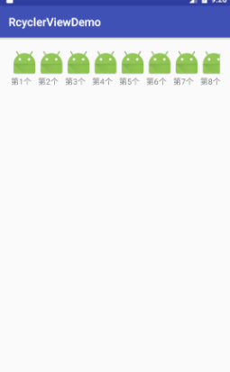
1-1-6 实现GridView效果
这个只需要在布局管理器进行更改：
//初始化布局管理器
GridLayoutManager gridLayoutManager = new GridLayoutManager(this,4);//this是上下文 4 指的是每行显示的个数的控制；
mRecyclerView.setLayoutManager(gridLayoutManager);
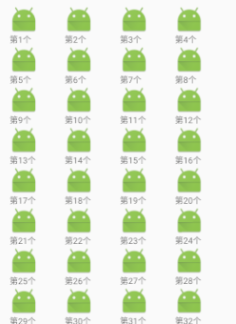

- 简单的点击事件的处理
2-1-1对于控件的点击事件的处理：
normalHolder.textView.setOnClickListener(new View.OnClickListener() {
@Override
public void onClick(View v) {
Toast.makeText(mContext, "第"+position+"条目被点击", Toast.LENGTH_SHORT).show();
}
});
- 加载多种布局
3-1-1多种布局：
RecyclerView加载多种布局，一般指的是在前几个item中放置不同的布局，后边的是统一布局，一般不多于5种布局类型；
3-1-2 多种布局的实现：
多种布局的实现是在adapter中 进行设置的；
- 重写getItemViewType（）方法用来标记不同的布局类型；先声明几个int类型的静态变量用来区分不同的类型：
private final int BANNER_VIEW_TYPE = 0;
private final int CHANNEL_VIEW_TYPE = 1;
private final int GIRL_VIEW_TYPE = 2;
private final int NORMAL_VIEW_TYPE = 3;
- getItemViewType的代码：
@Override
public int getItemViewType(int position) {
if (position == 0) {
return BANNER_VIEW_TYPE;
} else if (position == 1) {
return CHANNEL_VIEW_TYPE ;
} else if (position == 2) {
return GIRL_VIEW_TYPE;
} else {
return NORMAL_VIEW_TYPE;
}
}
- 更改onCreateViewHolder中的代码，根据同的类型创建不同的viewholder
@Override
public RecyclerView.ViewHolder onCreateViewHolder(ViewGroup parent, int viewType) {
if (viewType == BANNER_VIEW_TYPE) {
View view = View.inflate(mContext, R.layout.firsrtitem, null);
return new FirstHolder(view);
} else if (viewType == CHANNEL_VIEW_TYPE) {
View view = View.inflate(mContext, R.layout.secondtitem, null);
return new SecondHolder(view);
} else if (viewType == GIRL_VIEW_TYPE) {
View view = View.inflate(mContext, R.layout.thirditem, null);
return new ThirdHolder(view);
} else {
View view = View.inflate(mContext, R.layout.forthitem, null);
return new ForthHolder(view);
}

}
- 创建不同的布局项目了文件
【1】第一个
<?xml version="1.0" encoding="utf-8"?>
<LinearLayout xmlns:android="http://schemas.android.com/apk/res/android"
android:layout_width="match_parent"
android:layout_height="match_parent"
android:orientation="vertical">

<TextView
android:id="@+id/tv_item_one"
android:layout_width="wrap_content"
android:layout_height="wrap_content"
android:drawableTop="@mipmap/ic_launcher_round"
android:text="@string/app_name"
android:textSize="28sp"/>
</LinearLayout>
【2】第二个
<?xml version="1.0" encoding="utf-8"?>
<LinearLayout xmlns:android="http://schemas.android.com/apk/res/android"
android:layout_width="match_parent"
android:layout_height="match_parent"
android:orientation="vertical">

<ImageView
android:id="@+id/iv_show"
android:layout_width="wrap_content"
android:layout_height="wrap_content"
android:contentDescription="@string/app_name"/>
</LinearLayout>
【3】第三个
<?xml version="1.0" encoding="utf-8"?>
<LinearLayout xmlns:android="http://schemas.android.com/apk/res/android"
android:layout_width="match_parent"
android:layout_height="match_parent"
>

<TextView
android:id="@+id/tv_item"
android:layout_width="wrap_content"
android:layout_height="wrap_content"
android:drawableTop="@mipmap/ic_launcher_round"
android:text="@string/app_name"
android:textSize="28sp"/>

<ImageView
android:id="@+id/third_imageView"
android:layout_width="wrap_content"
android:layout_height="wrap_content"
android:contentDescription="@string/app_name"/>
</LinearLayout>
【4】第四个
<?xml version="1.0" encoding="utf-8"?>
<LinearLayout xmlns:android="http://schemas.android.com/apk/res/android"
android:layout_width="match_parent"
android:layout_height="match_parent"
android:orientation="vertical">

<TextView
android:id="@+id/tv_item"
android:layout_width="wrap_content"
android:layout_height="wrap_content"
android:drawableTop="@mipmap/ic_launcher_round"
android:text="@string/app_name"
android:textSize="28sp"/>
</LinearLayout>
- 创建相对应的viewHolder
//自定义的viewholder 并获得holder的控件，便于对空间进行操作
public static class ThirdHolder extends RecyclerView.ViewHolder {
TextView textView;
ImageView mImageView;

public ThirdHolder(View itemView) {
super(itemView);
textView = (TextView) itemView.findViewById(R.id.tv_item);
mImageView = (ImageView) itemView.findViewById(R.id.third_imageView);
}
}

//自定义的viewholder 并获得holder的控件，便于对空间进行操作
public static class FirstHolder extends RecyclerView.ViewHolder {
TextView textView;

public FirstHolder(View itemView) {
super(itemView);
textView = (TextView) itemView.findViewById(R.id.tv_item_one);
}
}

//自定义的viewholder 并获得holder的控件，便于对空间进行操作
public static class SecondHolder extends RecyclerView.ViewHolder {
ImageView mImageView;

public SecondHolder(View itemView) {
super(itemView);
mImageView = (ImageView) itemView.findViewById(R.id.iv_show);
}
}

//自定义的viewholder 并获得holder的控件，便于对空间进行操作
public static class ForthHolder extends RecyclerView.ViewHolder {
TextView textView;

public ForthHolder(View itemView) {
super(itemView);
textView = (TextView) itemView.findViewById(R.id.tv_item);
}
}
（6）根据Position的不同绑定不同的viewholder
@Override
public void onBindViewHolder(RecyclerView.ViewHolder holder, final int position) {
if (position == 0) {
FirstHolder firstHolder = (FirstHolder) holder;
firstHolder.textView.setText("这是第0个要展示的item内容！");
} else if (position == 1) {
SecondHolder secondHolder = (SecondHolder) holder;
secondHolder.mImageView.setImageResource(R.mipmap.river);
} else if (position == 2) {
ThirdHolder thirdHolder = (ThirdHolder) holder;
thirdHolder.textView.setText(mString.get(position));
thirdHolder.mImageView.setImageResource(R.mipmap.river);
} else {
ForthHolder forthHolder = (ForthHolder) holder;
forthHolder.textView.setText(mString.get(position - 3));
}
}
- 条目多少的控制：
@Override
public int getItemCount() {
return mString.size() + 3;
}
3-2-2 添加分割线：
mVisitorList.addItemDecoration(new DividerItemDecoration(CommonVisitorActivity.this,
DividerItemDecoration.VERTICAL_LIST));
分割线类代码：
public class DividerItemDecoration extends RecyclerView.ItemDecoration {

private static final int[] ATTRS = new int[]{
android.R.attr.listDivider
};

public static final int HORIZONTAL_LIST = LinearLayoutManager.HORIZONTAL;

public static final int VERTICAL_LIST = LinearLayoutManager.VERTICAL;

private Drawable mDivider;

private int mOrientation;

public DividerItemDecoration(Context context, int orientation) {
final TypedArray a = context.obtainStyledAttributes(ATTRS);
mDivider = a.getDrawable(0);
a.recycle();
setOrientation(orientation);
}

public void setOrientation(int orientation) {
if (orientation != HORIZONTAL_LIST && orientation != VERTICAL_LIST) {
throw new IllegalArgumentException("invalid orientation");
}
mOrientation = orientation;
}

@Override
public void onDraw(Canvas c, RecyclerView parent) {

if (mOrientation == VERTICAL_LIST) {
drawVertical(c, parent);
} else {
drawHorizontal(c, parent);
}

}

public void drawVertical(Canvas c, RecyclerView parent) {
final int left = parent.getPaddingLeft();
final int right = parent.getWidth() - parent.getPaddingRight();

final int childCount = parent.getChildCount();
for (int i = 0; i < childCount; i++) {
final View child = parent.getChildAt(i);
android.support.v7.widget.RecyclerView v = new android.support.v7.widget.RecyclerView(parent.getContext());
final RecyclerView.LayoutParams params = (RecyclerView.LayoutParams) child
.getLayoutParams();
final int top = child.getBottom() + params.bottomMargin;
final int bottom = top + mDivider.getIntrinsicHeight();
mDivider.setBounds(left, top, right, bottom);
mDivider.draw(c);
}
}

public void drawHorizontal(Canvas c, RecyclerView parent) {
final int top = parent.getPaddingTop();
final int bottom = parent.getHeight() - parent.getPaddingBottom();

final int childCount = parent.getChildCount();
for (int i = 0; i < childCount; i++) {
final View child = parent.getChildAt(i);
final RecyclerView.LayoutParams params = (RecyclerView.LayoutParams) child
.getLayoutParams();
final int left = child.getRight() + params.rightMargin;
final int right = left + mDivider.getIntrinsicHeight();
mDivider.setBounds(left, top, right, bottom);
mDivider.draw(c);
}
}

@Override
public void getItemOffsets(Rect outRect, int itemPosition, RecyclerView parent) {
if (mOrientation == VERTICAL_LIST) {
outRect.set(0, 0, 0, mDivider.getIntrinsicHeight());
} else {
outRect.set(0, 0, mDivider.getIntrinsicWidth(), 0);
}
}
}

