CESM–SCRAM: A Configurable Size–Composition-Resolved Aerosol Framework for Prognostic Mixing State in CESM2
Target journal: Journal of Advances in Modeling Earth Systems (JAMES)

Key Points
- CESM–SCRAM independently configures size and particle-property dimensions across multiple aerosol families.
- Matched MAM4/Internal/External cases separate modal-to-sectional and mixing-state effects.
- Tropospheric SCRAM adds ISORROPIA NH4–NO3–Cl chemistry while MAM4 retains stratospheric aerosol.

Abstract
Atmospheric aerosol climate effects depend on particle mixing state as well as on mass and size, yet most Earth system models compress particle diversity into a small number of internally mixed modes. We present CESM–SCRAM, a configurable size–composition-resolved aerosol framework implemented in CESM2 through the CESM/CARMA interface. Users can define size-bin boundaries, particle-property/composition classes, species-group mappings, and selected microphysical and optical options without redesigning the CESM coupling architecture. Unlike BC-centered or fixed-population schemes, the same state space can be configured to distinguish BC, dust, sea salt, sulfate, organic aerosol, and other particle families without imposing a prescribed lognormal size-distribution shape. The current implementation focuses SCRAM on the troposphere, where fresh aerosol and precursor emissions generate the strongest particle-to-particle compositional contrasts and subsequent condensation, coagulation, secondary formation, cloud processing, and chemical aging reshape mixing state. MAM4 is retained for stratospheric aerosol, which also reduces the cost of carrying the high-dimensional SCRAM state aloft. Relative to the original SCRAM formulation, CESM–SCRAM extends inorganic chemistry through ISORROPIA to explicitly represent ammonium, nitrate, and chloride partitioning. As an initial demonstration and validation, we use seven dry-diameter bins spanning 0.003–10 µm with 14 particle-phase species and compare matched 7 × 1 internally mixed and 7 × 11 externally mixed cases. These settings are experimental choices rather than model limits. Together with a MAM4 control, the hierarchy separates modal-to-sectional/SCRAM changes from the incremental effects of prognostic composition diversity, providing a flexible platform for testing how particle-level complexity propagates through aerosol–radiation–cloud interactions.

Plain Language Summary
Particles in the atmosphere can have the same size but very different chemical compositions. One particle may be dominated by black carbon, another by sulfate or sea salt, and another may contain several components that have mixed together during atmospheric transport. These differences affect how much sunlight particles absorb or scatter, how readily they form cloud droplets, and how quickly they are removed. Climate models normally simplify this diversity because tracking it is computationally expensive. We developed CESM–SCRAM to retain selected particle-composition information in a global Earth system model. The model divides particles by both size and composition, while allowing the number and definition of these categories to be changed for different scientific questions. For the demonstration in this study, we compare a standard CESM aerosol model with two deliberately chosen SCRAM configurations that use the same seven size bins but either one or eleven composition classes. These values are not fixed by the framework; users can redesign the size and particle-property coordinates for a different process or observational question. The matched demonstration separates the effects of changing aerosol size representation from the additional effects of resolving particle mixing state. The framework is intended to connect detailed single-particle observations and process studies with the reduced aerosol representations needed for multi-year global climate simulations.

1. Introduction
Aerosol mixing state describes how chemical and physical properties are distributed among individual particles within an aerosol population. It matters because particles of similar size can differ substantially in light absorption, hygroscopicity, cloud-condensation-nuclei (CCN) activity, chemical reactivity, and removal. These effects have been documented most extensively for black carbon (BC), for which coating and aging can alter absorption, lifetime, and cloud activation even at unchanged BC mass (Jacobson, 2001; Bond et al., 2013; Ching et al., 2017; Riemer et al., 2019). The resulting modeling problem is therefore not simply whether mixing state matters, but how to retain the relevant particle diversity in a global model without making the aerosol state prohibitively expensive.
Most previous global mixing-state parameterizations have approached this problem from the perspective of BC or other strongly absorbing primary particles. At the simplest level, freshly emitted hydrophobic BC is converted to a hydrophilic or internally mixed state using a prescribed or process-dependent aging rate. Modal schemes embed a similar concept by assigning fresh and aged particles to different modes; in CESM, for example, MAM4 places primary BC and organic aerosol in a primary-carbon mode and transfers material toward the accumulation mode through condensation and coagulation (Liu et al., 2012, 2016). More explicit approaches have introduced a dedicated BC mixing coordinate. Oshima et al. (2009), Oshima and Koike (2013), and the ATRAS/ATRAS2 developments of Matsui and colleagues resolved particle size together with BC mass fraction or coating state, eventually enabling global CAM simulations of BC mixing-state evolution and its radiative effects (Matsui, 2017; Matsui and Mahowald, 2017; Matsui et al., 2018; Matsui, 2020). A related strategy retains the compact modal aerosol state but parameterizes unresolved BC properties more carefully; recent CAM6 work has used observation-constrained or particle-resolved information to improve BC coating, optical properties, and CCN-related mixing-state effects without replacing MAM4 (Chen et al., 2023, 2024; Shen et al., 2024). These studies established both the climatic importance of mixing state and practical ways to represent selected aspects of it in Earth system models.
Broader aerosol schemes have also represented multiple mixing populations. MATRIX and MADE-in, for example, distinguish several internally and externally mixed populations involving sulfate, nitrate, ammonium, carbonaceous aerosol, dust, and sea salt and allow atmospheric processing to transfer particles among predefined states (Bauer et al., 2008; Aquila et al., 2011). Together with modal BC-aging approaches, these models form an important middle ground between bulk aerosol and particle-resolved descriptions. Their common limitation, however, is that the degrees of freedom are largely prescribed by the model architecture. Modal schemes constrain the size distribution to a fixed set of lognormal modes, generally with prescribed distribution widths, and mixing-state information is tied to the identities and transfer rules of those modes. Multi-population schemes increase the number of states but still define in advance which particle types and mixing pathways can exist. Dedicated two-dimensional BC models relax the size constraint and resolve coating more explicitly, but their second coordinate is designed primarily around BC. Consequently, changing the scientific target from BC aging to, for example, dust–sulfate, sea-salt–nitrate, organic–inorganic, or multi-component particle mixing generally requires a new population design, new assumptions, or substantial model restructuring. It remains difficult to vary particle size resolution and particle-property resolution independently within one global-model framework.
Sectional and particle-resolved models clarify the two ends of this trade-off. Sectional schemes remove the prescribed lognormal shape by prognosing aerosol in explicit size intervals; within CESM, CARMA has established a mature pathway for global size-resolved aerosol microphysics (Yu et al., 2015; Tilmes et al., 2023). Size resolution alone, however, does not guarantee mixing-state resolution: a size section can still be represented by one average composition. At the opposite limit, particle-resolved models such as PartMC–MOSAIC retain the composition of individual computational particles and therefore provide a powerful benchmark for aerosol diversity, aging, optical properties, and CCN activity (Riemer et al., 2009; Zaveri et al., 2010; Riemer and West, 2013). Their computational cost is not currently compatible with routine multi-year global Earth system simulations. What is missing is a configurable intermediate representation in which size and particle properties can be resolved independently, without either imposing a fixed lognormal size distribution or tracking every particle individually.
SCRAM was developed to provide such an intermediate representation by discretizing aerosol populations simultaneously in size and composition space (Zhu et al., 2015). Multiple composition classes can coexist within the same size interval, and particles move through the size–composition state as condensation, evaporation, coagulation, nucleation, thermodynamic partitioning, and removal alter their mass and composition. Previous box-model and regional applications demonstrated the ability of this approach to represent externally mixed particle populations and compare modeled particle diversity with single-particle observations (Zhu et al., 2015, 2016a, 2016b). The key feature for Earth system modeling is not one particular set of SCRAM bins or classes, but the freedom of the state space. The number and boundaries of size sections can be defined by the user rather than by a prescribed modal size distribution, while the particle-property dimension can be constructed from user-defined composition groups and class boundaries. The same framework can therefore distinguish, within a common prognostic state, particles characterized by different contributions from BC, mineral dust, sea salt, sulfate, organic aerosol, and other configured components, rather than being tied to a single BC-centered mixing coordinate. Size resolution and particle-property resolution can also be varied separately, making model structural complexity itself an experimental variable.
CESM–SCRAM brings this configurable size–particle-property representation into CESM2 and couples it to global transport, emissions, aerosol microphysics, gas–particle exchange, cloud activation, optical properties, radiation, and removal. The current implementation also incorporates ISORROPIA-based ammonium, nitrate, and chloride thermodynamics as a supporting chemical extension, but this is not the central novelty of the framework. SCRAM is intentionally applied to the troposphere, where fresh aerosol and precursor emissions generate the strongest particle-to-particle compositional contrasts and where subsequent condensation, coagulation, secondary formation, cloud processing, and removal drive mixing-state evolution; MAM4 is retained for stratospheric aerosol. This focus also avoids transporting the high-dimensional SCRAM state through regions that are not the primary target of the present mixing-state application.
Here we provide the first multi-year CESM demonstration of this framework using one controlled configuration rather than proposing a universal discretization. The demonstration uses seven user-defined dry-size bins and 14 particle species and compares (1) standard MAM4, (2) an internally mixed SCRAM case with seven size bins and one composition class, and (3) an externally mixed SCRAM case with the same size and species coordinates but 11 composition classes. The 7-bin and 11-class choices are therefore validation settings, not intrinsic limits of CESM–SCRAM. The MAM4-to-Internal contrast diagnoses the combined transition from a modal representation to the SCRAM sectional framework, whereas the External-to-Internal contrast isolates the incremental influence of resolving composition diversity within the same SCRAM host framework. We ask three questions: (1) Can a configurable size–particle-property aerosol state be integrated stably in CESM2 over multi-year global simulations? (2) Which aerosol and climate responses arise from replacing the modal size representation, and which arise specifically from added mixing-state resolution? (3) Can a freely configurable size–composition state provide a practical bridge between single-particle observations and particle-resolved process models on one hand and global aerosol–cloud–radiation simulations on the other?

2. CESM–SCRAM Model Description

2.1 Host model and coupling strategy
CESM–SCRAM is implemented in the CESM2/CAM framework using the existing CARMA physics interface as the entry point for binned aerosol microphysics. CESM2 provides the large-scale atmospheric state, transport, gas-phase chemistry, cloud macrophysics and microphysics, radiation, surface exchange, and component coupling (Danabasoglu et al., 2020; Emmons et al., 2020). The CARMA interface in carma_intr.F90 provides constituent registration, initialization, timestep tendency calculations, emissions, wet deposition, and diagnostic output. CESM–SCRAM extends this interface so that the transported aerosol state is defined by SCRAM size–composition sections while CAM continues to advect the registered tracers and supply the meteorological and chemical environment.
The coupling is intentionally modular. The CAM/CARMA interface handles constituent registration and CAM physics-buffer exchange; SCRAM performs the sectional/composition-resolved aerosol calculations; dedicated ownership and exchange modules determine whether SCRAM or MAM4 controls aerosol in a model layer; and the CESM aerosol-radiation pathway receives SCRAM optical properties in SCRAM-owned layers. This architecture minimizes changes to the host dynamical core and permits the SCRAM aerosol representation to be changed through runtime configuration rather than by rewriting the CESM physics driver.
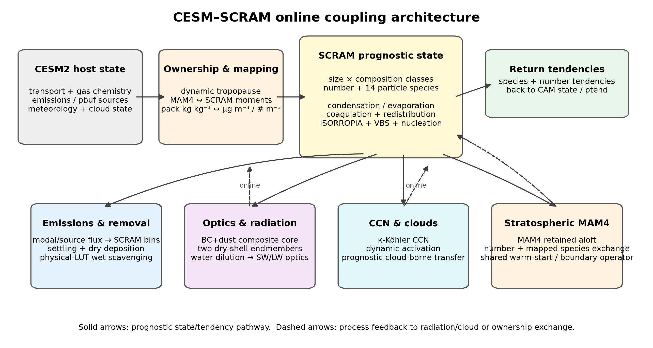
Figure 1. CESM–SCRAM coupling architecture.
Figure 1. CESM–SCRAM online coupling architecture. The landscape schematic separates the host CESM2 state, ownership/moment mapping, prognostic SCRAM size–composition state, and the online branches for emissions/removal, reduced-shell optics and radiation, CCN/cloud activation, and stratospheric MAM4 exchange. Solid arrows denote prognostic state/tendency transfer; dashed arrows denote online process feedback or ownership exchange.

2.2 Prognostic size–composition state
The size coordinate is a runtime-configurable dimension of CESM–SCRAM rather than a fixed model grid. Users can change the number of size bins and their explicit diameter boundaries to allocate resolution to the particle sizes most relevant to a target process. For the initial demonstration evaluated in this paper, we use seven dry-diameter intervals: 0.003–0.01, 0.01–0.0398, 0.0398–0.1585, 0.1585–0.631, 0.631–2.5, 2.5–5.0, and 5.0–10.0 µm. The 5 µm boundary in this demonstration separates the lower- and upper-coarse sections rather than merging the full 2.5–10 µm range. The Internal and External validation cases use this identical size grid so that composition resolution can be changed without simultaneously changing size resolution.
The particle-species inventory and its mapping into reduced particle-property groups are likewise configuration inputs. In the demonstration realization used here, 14 particle-phase species are carried: mineral dust (PMD), black carbon (PBC), sodium/sea-salt cation (PNA), sulfate (PSO4), ammonium (PNH4), nitrate (PNO3), chloride (PHCL), five VBS secondary-organic particle species (PSOA1P–PSOA5P), one nonvolatile primary-organic particle species (PPOAlP), and particle water (PH2O). The dry composition used for class assignment is constructed from the non-water particle components, while water is diagnosed/coupled separately for thermodynamics and hygroscopic/optical calculations.
For $N_{b}$ size bins, $N_{c}$ composition classes, and $N_{s}$ particle species, the SCRAM aerosol state contains one number carrier and $N_{s}$ species-mass carriers for each size–composition cell,
$$N_{SCRAM}=N_{b}N_{c}(1+N_{s}).$$
For the present demonstration, $N_{b}=7$ and $N_{s}=14$. The Internal validation case ($N_{c}=1$) therefore contains 105 SCRAM aerosol carriers and the External validation case ($N_{c}=11$) contains 1,155. These counts describe only this selected realization of the SCRAM aerosol state; changing the user-defined size, species, or particle-property dimensions changes the state dimension accordingly. The full CAM constituent count also includes host-model transported tracers.

2.3 Internal and external mixing configurations
CESM–SCRAM does not prescribe one universal composition taxonomy. The particle-property coordinate is defined at runtime through a mapping from individual aerosol species to reduced composition groups and through user-selected group-fraction boundaries. For the controlled demonstration in this study, Internal and External SCRAM are deliberately matched in size grid, species set, thermodynamics, microphysical switches, emissions mapping, optical configuration, and host CESM physics. Internal collapses every size interval to one composition class. External uses the same seven size bins and 14 particle species, but resolves 11 feasible composition classes generated from six reduced dry-composition groups (Table 1).
Table 1. Production mapping of the 14 SCRAM aerosol species to the six dry-composition groups used by the External classifier. PH2O is carried thermodynamically but excluded from dry composition classification.
SCRAM species | Physical meaning | Composition group | Role in the mixing-state classifier
PMD | Mineral dust | DU | Source-distinguishing group; direct mineral-dust emissions define dust-rich particles
PBC | Black carbon | BC | Source-distinguishing group; direct combustion/fire/aircraft BC defines BC-rich particles
PNA | Sodium / sea-salt cation | SLT | Source-distinguishing sea-salt group
PSO4 | Sulfate | SUF | Sulfur-rich group; retained separately because sulfate has explicit source pathways and is a major aging/coating component
PNH4 | Ammonium | SED | Secondary/background residual; no independent fresh-source class
PNO3 | Nitrate | SED | Secondary/background residual; no independent fresh-source class
PHCL | Particle chloride / HCl-equivalent chloride | SLT | Kept with the sea-salt/chloride chemical family so sea-salt identity is preserved during chloride processing
PSOA1P | SOA volatility bin 1 | SED | Secondary/background residual
PSOA2P | SOA volatility bin 2 | SED | Secondary/background residual
PSOA3P | SOA volatility bin 3 | SED | Secondary/background residual
PSOA4P | SOA volatility bin 4 | SED | Secondary/background residual
PSOA5P | SOA volatility bin 5 | SED | Secondary/background residual
PPOAlP | Nonvolatile primary organic aerosol | POA | Source-distinguishing group; direct primary-organic emissions define POA-rich particles
PH2O | Particle water | — | Excluded from dry-composition classification; retained for thermodynamics and aerosol-water diagnostics
The grouping follows a source-oriented reduction principle. Components with a recognizable direct aerosol source or source-characteristic lineage in the CESM emission mapping are allowed to define source-dominant particle classes: BC, dust, sea salt/chloride, sulfate, and POA. Species produced predominantly by gas–particle conversion and not used to define an independent fresh-source population—ammonium, nitrate, and the five SOA volatility bins—are collected in the SED background/residual group. This prevents every secondary chemical product from multiplying the number of composition classes while still allowing secondary material to modify the composition of every prognostic particle class. Sulfate is intentionally retained as a separate SUF coordinate because the production system contains explicit sulfate source pathways in addition to secondary sulfate production and because sulfate is a major coating/aging constituent. Chloride remains within SLT to preserve sea-salt chemical identity during chloride processing.
The External demonstration uses group-mass-fraction boundaries of 0, 0.5, 0.9, and 1.0. The resulting geometry is deliberately simple: one Well Mixed class has no single source-character group contributing 50% or more of dry particle mass, while each of the five source-character groups has a moderately enriched state (0.5–0.9) and a strongly source-dominated state (0.9–1.0). This gives $1+5\times2=11$ feasible classes. Table 2 lists the class convention used in this paper. The representative fractions of 0.70 and 0.95 are illustrative interval midpoints for interpretation; the model stores the full species masses and class membership is determined by the fraction ranges, not by fixed centroid compositions. For manuscript reporting, NC1–NC11 follow the production Fortran mixed-radix enumeration, in which the secondary source-character coordinates vary in the order DU → SLT → SUF → POA before the primary BC coordinate. The physical definitions are the fraction ranges themselves, and the runtime model does not attach the interpretive labels “fresh”, “aged”, or “well mixed”.
Table 2. Physical interpretation and group-mass-fraction ranges of the 11 External composition classes in the demonstration configuration. Fractions are dry group mass fractions. SED is the residual fraction, $f_{SED}=1−f_{BC}−f_{DU}−f_{SLT}−f_{SUF}−f_{POA}$. “Fresh” and “aged” are interpretive labels for source dominance and dilution/coating, not explicit particle-age tracers. The illustrative mixtures assign the non-dominant remainder to SED only to provide an intuitive representative composition; the prognostic class itself permits any physically feasible composition within the listed ranges.
NC | BC | DU | SLT | SUF | POA | SED | Illustrative mixture | Physical interpretation
NC1 | <0.50 | <0.50 | <0.50 | <0.50 | <0.50 | residual | not unique | Well Mixed: no single source-character group dominates
NC2 | <0.50 | 0.50–<0.90 | <0.50 | <0.50 | <0.50 | residual | DU≈0.70, SED≈0.30 | Dust-rich / partially mixed dust
NC3 | <0.50 | 0.90–1.00 | <0.50 | <0.50 | <0.50 | residual | DU≈0.95, SED≈0.05 | Dust-dominated particle
NC4 | <0.50 | <0.50 | 0.50–<0.90 | <0.50 | <0.50 | residual | SLT≈0.70, SED≈0.30 | Sea-salt-rich / processed sea salt
NC5 | <0.50 | <0.50 | 0.90–1.00 | <0.50 | <0.50 | residual | SLT≈0.95, SED≈0.05 | Sea-salt-dominated particle
NC6 | <0.50 | <0.50 | <0.50 | 0.50–<0.90 | <0.50 | residual | SUF≈0.70, SED≈0.30 | Sulfate-rich mixed particle
NC7 | <0.50 | <0.50 | <0.50 | 0.90–1.00 | <0.50 | residual | SUF≈0.95, SED≈0.05 | Sulfate-dominated particle
NC8 | <0.50 | <0.50 | <0.50 | <0.50 | 0.50–<0.90 | residual | POA≈0.70, SED≈0.30 | POA-rich / partially mixed POA
NC9 | <0.50 | <0.50 | <0.50 | <0.50 | 0.90–1.00 | residual | POA≈0.95, SED≈0.05 | POA-dominated particle
NC10 | 0.50–<0.90 | <0.50 | <0.50 | <0.50 | <0.50 | residual | BC≈0.70, SED≈0.30 | Aged / coated BC
NC11 | 0.90–1.00 | <0.50 | <0.50 | <0.50 | <0.50 | residual | BC≈0.95, SED≈0.05 | Fresh-like BC / BC-dominated
This construction makes atmospheric aging a movement through composition space rather than a prescribed first-order conversion between two hard-coded particle types. For example, direct BC can enter a BC-dominated class, while condensation of sulfate, nitrate, ammonium, and SOA, together with coagulation with other particles, progressively lowers the BC mass fraction and transfers the particle first into an aged-BC class and eventually into the Well Mixed class. The same logic applies to dust, sea salt, and POA. Secondary material therefore affects all classes through prognostic mass transfer but does not create a separate set of “fresh secondary” classes. This source-oriented reduction is specific to the present demonstration; users can redefine the composition groups and fraction boundaries for other questions without changing the CESM coupling architecture.
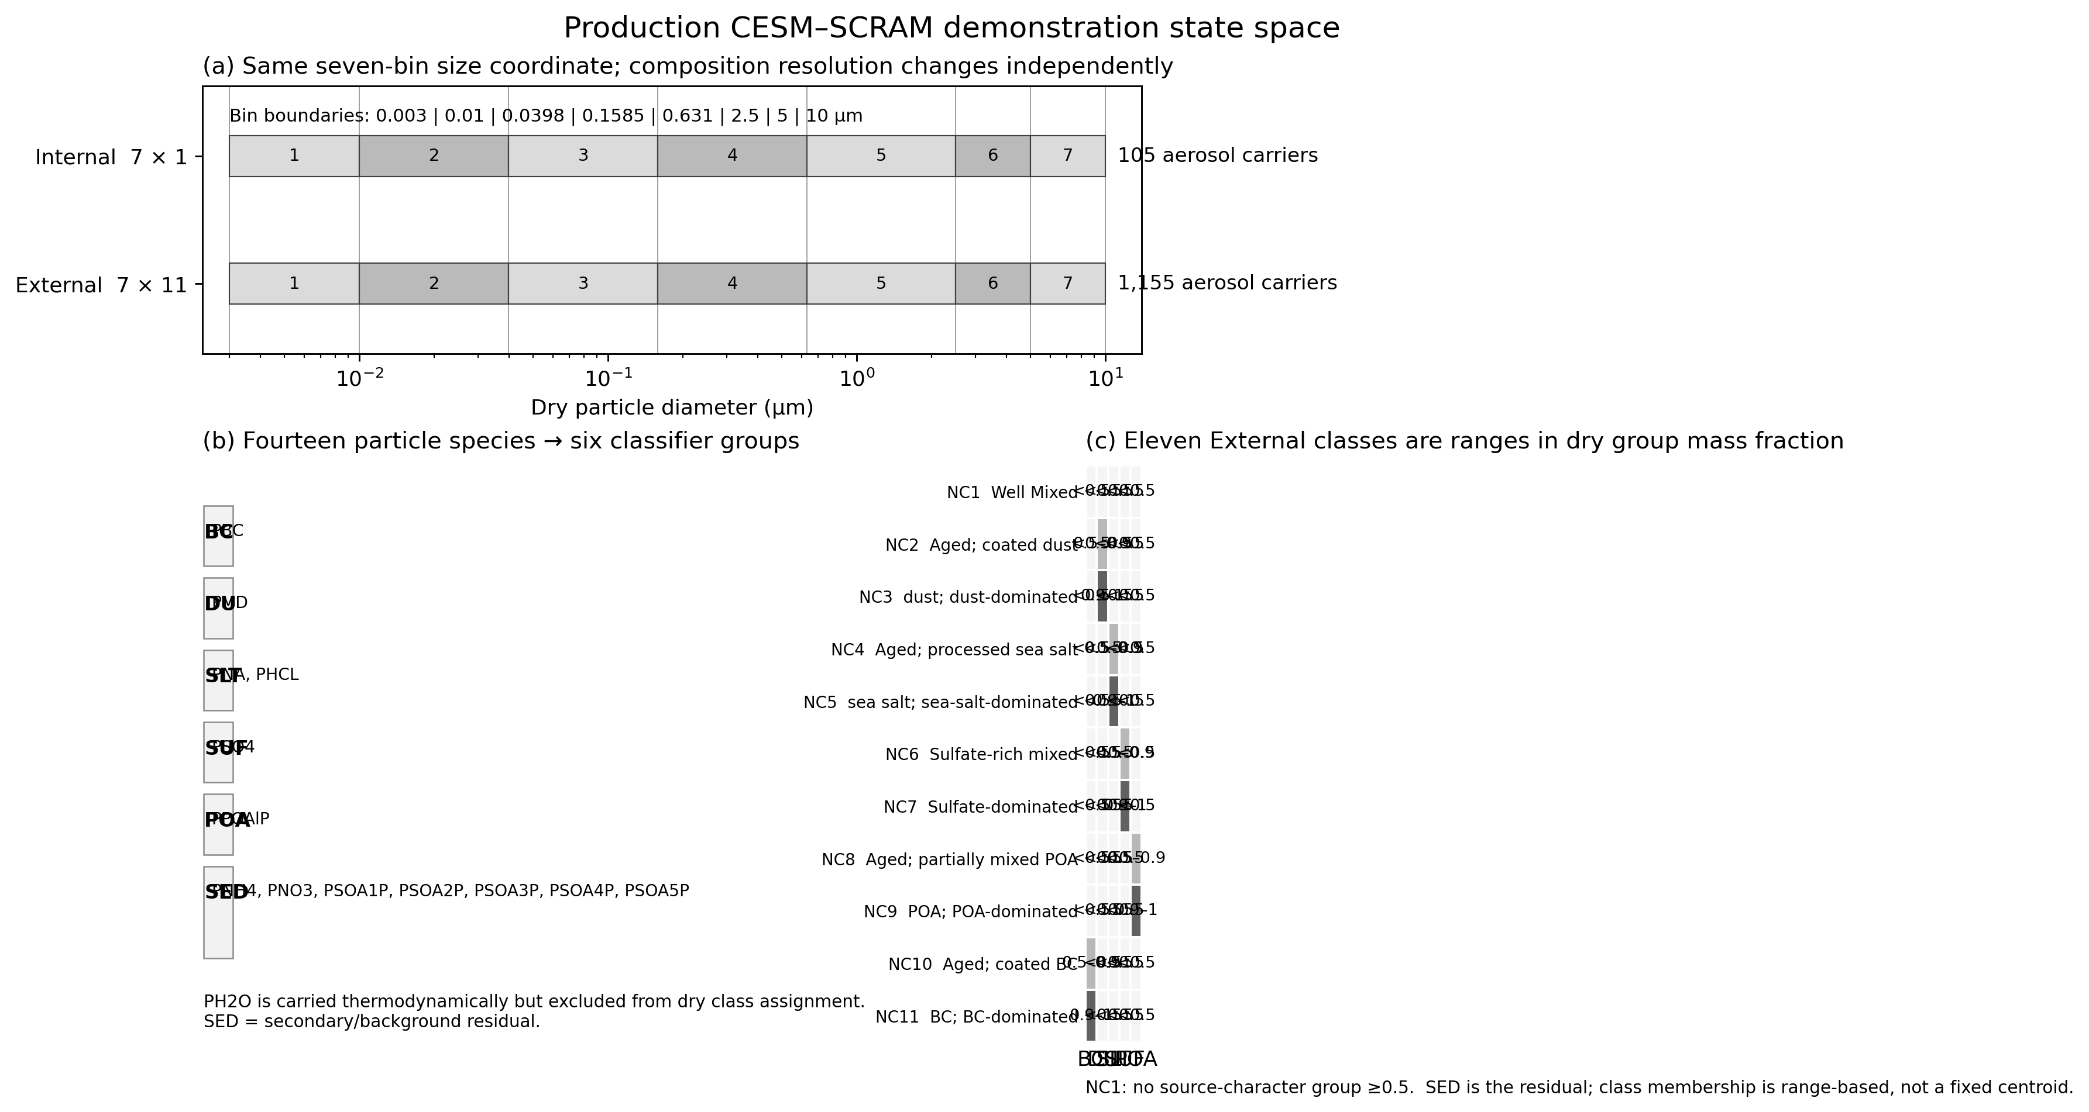
Figure 2. Production CESM–SCRAM size–composition state space.
Figure 2. Production state space used for the initial CESM–SCRAM demonstration. Panel (a) shows the common seven-bin dry-size coordinate and the increase from 105 Internal to 1,155 External SCRAM aerosol carriers. Panel (b) shows how the 14 particle species are reduced to six dry classifier groups. Panel (c) shows the actual 11 External composition classes as group-mass-fraction ranges rather than fixed centroid compositions. Size and composition resolution are independently configurable and the 7 × 1 and 7 × 11 states are controlled evaluation choices, not framework limits.

2.4 Aerosol microphysics, conservative redistribution, and gas–particle thermodynamics
The production configuration activates condensation/evaporation, coagulation, and H$​_{2}$SO$​_{4}$–H$​_{2}$O binary nucleation using the Vehkamäki et al. (2002) parameterization, but two numerical operators are particularly important for retaining the meaning of the size–composition state during particle growth and collision. First, coagulation is evaluated directly from the prognostic number and species masses. For a collision between states $i$ and $j$, the event rate is
$$R_{ij}=K_{ij}N_{i}N_{j},$$
with the usual factor of $1/2$ for $i=j$. The composition of one product particle is formed species by species,
mp,s=Mi,sNi+Mj,sNj, Vp=s​mp,sρs, Dp=6Vpπ1/3.
The resulting dry diameter and group mass fractions are then located in the configured size and composition intervals; the production algorithm therefore does not require a precomputed coagulation-coefficient file or a nearest-centroid approximation. Source number and every species-mass flux are budget limited before the tendency is applied, so a single collision removes one particle net while conserving each chemical component. The complete band-ownership rules and conservation checks are given in Text S4 and Figure S3.
Second, condensation/evaporation can move the mean particle size of a prognostic cell away from its fixed size-section pivot. CESM–SCRAM therefore uses a moving-center/dual-pivot redistribution operator. For a populated section,
$$v_{k}=\frac{V_{k}}{N_{k}}, D_{k}={\left(\frac{6V_{k}}{πN_{k}}\right)}^{1/3},$$
is allowed to move freely while $D_{k}$ remains inside the section. Only after the moving center exits its section is the population split between the two fixed pivot volumes $v_{l}^{*}$ and $v_{h}^{*}$ that bracket $v_{k}$. Number is split with
$$w_{N,h}=\frac{v_{k}−v_{l}^{*}}{v_{h}^{*}−v_{l}^{*}}, w_{N,l}=1−w_{N,h},$$
whereas species mass uses the volume-consistent weights $w_{M,l}∝w_{N,l}v_{l}^{*}/v_{k}$ and $w_{M,h}∝w_{N,h}v_{h}^{*}/v_{k}$, normalized to unity. This dual-moment construction follows the general principle of moment-preserving pivot methods (Kumar & Ramkrishna, 1996a, 1996b) but is implemented here as a true moving-center operator on the configured SCRAM bins. It independently conserves total particle number and every species mass while preventing artificial redistribution when the prognostic mean remains within its original bin (Text S5; Figure S4).
Inorganic gas–particle partitioning is coupled to ISORROPIA equilibrium thermodynamics (Fountoukis & Nenes, 2007), including the CESM–SCRAM ammonium, nitrate, and chloride extensions. Organic gas–particle partitioning uses five volatility bins with $C_{298}^{*}=0.01,0.1,1,10,100 μg m^{−3}$, following absorptive partitioning concepts (Pankow, 1994a, 1994b) and the volatility-basis-set framework (Donahue et al., 2006). For volatility bin $i$, the equilibrium particle fraction is
$$ξ_{i}=\frac{K_{p,i}(T)C_{OA}}{1+K_{p,i}(T)C_{OA}},$$
where $C_{OA}$ contains the five semivolatile particle bins; the nonvolatile PPOAlP pool is excluded from this absorbing phase. The temperature dependence of $K_{p}$, exact five-bin parameters, and the CAM–SCRAM gas-tracer mapping are documented in Texts S6–S7 and Tables S3–S4. CAM gas mixing ratios are converted to SCRAM concentration by $C=qρ_{air}{10}^{9}$, and the gas changes returned by SCRAM are converted back to CAM tendencies, so CAM transport remains authoritative.

2.5 Emissions, sedimentation, and deposition
Emission routing uses the same moment-aware philosophy as the prognostic aerosol state. For a lognormal source with number-median diameter $D_{g}$ and geometric standard deviation $σ_{g}$, sectional number and volume/mass fractions are calculated from the zeroth and third moments, respectively. When both physical number flux $F_{N}$ and dry-volume flux $F_{V}$ are available, the emitted median diameter is diagnosed rather than prescribed,
$$D_{g}={\left[\frac{F_{V}}{F_{N}(π/6)exp\left(4.5\ln^{2}σ_{g}\right)}\right]}^{1/3}.$$
Number and mass weights are separately normalized on their common represented support. Constituents belonging to the same physical source population share one number flux, avoiding number duplication when, for example, sea-salt mass is split between sodium and chloride or fire aerosol between BC and primary organic matter. Direct sectional dust and sea-salt producers retain their native number/size information, while mapped modal, aircraft, biomass-burning, and volcanic sources use the production source table described in Text S8 and Table S5.
Removal is size dependent and is evaluated from the instantaneous particle geometry. Gravitational settling uses the CARMA terminal-velocity calculation, beginning with the Stokes–Cunningham limit and applying Reynolds-number corrections when needed (Pruppacher & Klett, 1978). Dry deposition combines aerodynamic transfer with Brownian diffusion, impaction, interception, and gravitational settling in the size-resolved resistance framework used by CARMA/CAM (Zhang et al., 2001). The formal production cases use the physical_lut wet-deposition option: below-cloud scavenging coefficients are tabulated from rain-drop–particle collision efficiencies as functions of particle radius and density and are then passed to CAM wet deposition together with local precipitation and cloud fields. The exact production switches and equations are given in Text S10 and Figure S8.

2.6 Warm-start initialization and tropopause exchange
Warm-start initialization and the moving SCRAM–MAM4 ownership boundary use the same conservative modal-to-sectional mapping rather than two independent conversion schemes. For each MAM mode, the number geometric diameter is diagnosed from its prognostic number $N_{m}$, dry volume $V_{m}$, and $σ_{g}$,
$$D_{g}={\left[\frac{V_{m}}{N_{m}(π/6)exp(4.5\ln^{2}σ_{g})}\right]}^{1/3}.$$
The fraction of lognormal moment $k$ within a SCRAM diameter interval $[D_{l},D_{u}]$ is
$$w_{k}=Φ​\left(\frac{lnD_{u}−μ_{k}}{lnσ_{g}}\right)−Φ​\left(\frac{lnD_{l}−μ_{k}}{lnσ_{g}}\right), μ_{k}=lnD_{g}+k\ln^{2}σ_{g}.$$
CESM–SCRAM uses $k=0$ to map particle number and $k=3$ to map dry volume/species mass. The two moments are normalized independently on common size support, allowing exact closure of mode number and each mapped species mass. At startup, MAM4 aerosol is first converted with this operator and each resulting SCRAM size bin is assigned to one composition class from its mapped group fractions; only after the warm state has been constructed is MAM4 aerosol cleared from SCRAM-owned layers.
During integration, scram_ownership_mod diagnoses the dynamic tropopause and the production configuration additionally imposes a 100-hPa ceiling. If the boundary rises, newly SCRAM-owned layers are populated by the same $w_{0}/w_{3}$ MAM4→SCRAM mapping used for warm start. If it descends, SCRAM number and species mass are aggregated across composition classes and mapped back to MAM modes using the inverse normalized moment weights before the SCRAM state is cleared. Sulfate, BC, POA, the five SOA bins, sea salt, dust, and particle number are exchanged; ammonium, nitrate, and particle water have no matched MAM4 exchange tracer in the present implementation. This transaction-based design and the exact species mapping are described in Text S9, Table S6, and Figure S5.

2.7 Reduced-shell aerosol optics and radiation coupling
The production optics are evaluated separately for every size–composition class (Optics_perclass = 1) using a new reduced-shell coated-sphere closure. The optical closure should not be interpreted as a prognostic statement that particles are literally spherical core–shell objects; rather, it maps the resolved composition onto a tractable morphology for radiation. For species mass $M_{s}$ and density $ρ_{s}$, $V_{s}=M_{s}/ρ_{s}$. BC and mineral dust form a two-component refractory core,
$$V_{core}=V_{BC}+V_{dust}, f_{BC,core}=\frac{V_{BC}}{V_{core}},$$
with a volume-weighted complex core refractive index
$$m_{core}(λ)=f_{BC,core}m_{BC}(λ)+(1−f_{BC,core})m_{dust}(λ).$$
All other dry material forms the dry shell. The wet outer radius is obtained from host-model relative humidity and the class-resolved, volume-weighted hygroscopicity $κ$ using a sub-saturated $κ$-Köhler equilibrium calculation (Petters & Kreidenweis, 2007), rather than by directly interpreting prognostic PH2O as an optical radius. The corresponding core-radius ratio is $η=r_{core}/r_{wet}$, and the water dilution of the shell is summarized by
$$χ_{w}=\frac{V_{shell,wet}−V_{shell,dry}}{V_{shell,wet}}.$$
A second new feature is a low-dimensional binary dry-shell representation. If the organic fraction of the dry shell, $ϕ_{org,dry}$, exceeds 0.5, the BrC/organic-like shell end member is selected; otherwise a sulfate-like end member is used. Water then continuously dilutes that end member,
$$m_{shell}=(1−χ_{w})m_{dry}+χ_{w}m_{water}.$$
The production lookup table therefore spans wavelength, wet radius, $η$, BC fraction within the composite core, $χ_{w}$, and two dry-shell end members. Coated-sphere Mie efficiencies $Q_{ext}$, $Q_{sca}$, and $g$ are interpolated online and converted to layer optical moments before the classes are summed. The formal production LUT contains 30 RRTMG wavelengths × 22 wet-radius nodes × 10 $η$ nodes × 6 BC-core-fraction nodes × 11 water-fraction nodes × 2 shell end members. Optical constants follow established BC, mineral-dust, and aerosol-optics sources (Bond & Bergstrom, 2006; Sokolik & Toon, 1999; Hess et al., 1998), while coated-sphere calculations follow Bohren and Huffman (1983). The full equations, production LUT checksum/quality-control contract, and algorithm schematic are provided in Text S11, Table S7, and Figure S6.
SCRAM optical moments replace, rather than augment, the MAM4 aerosol contribution in SCRAM-owned layers. This ownership rule is also why standard CAM AOD variables cannot automatically be assumed to have identical aerosol content in MAM4-only and SCRAM cases; formal comparisons use the variable contract defined in Text S13.

2.8 Sectional CCN activation and cloud-borne aerosol coupling
CCN activation is calculated for each size–composition cell from the same prognostic population used by aerosol optics. The effective hygroscopicity is volume weighted,
κeff=s​ϵsκs, ϵs=Ms/ρsj​Mj/ρj,
excluding particle water. The $κ$-Köhler critical supersaturation for the cell is then evaluated from its dry radius and local temperature (Petters & Kreidenweis, 2007). Composition classes therefore retain distinct activation thresholds; a BC-dominated class with low $κ$ is not forced to activate like a sulfate-rich class of the same size.
For cloud activation, CESM–SCRAM uses the same-timestep CAM subgrid updraft velocity and an Abdul-Razzak–Ghan maximum-supersaturation calculation adapted to the sectional bin×class population (Abdul-Razzak & Ghan, 2000). A critical dry diameter is diagnosed from $S_{max}$, and partial-bin activation is integrated from the prognostic number and dry-volume moments rather than imposing an internally reconstructed lognormal distribution. A fixed 0.1% supersaturation diagnostic (SCRAM_CCN3) is calculated from the same population for comparison with MAM CCN diagnostics.
The activated concentration is subsequently filtered by CAM liquid-cloud-base/new-cloud geometry before contributing to NPCCN. In the formal production configuration, activation also performs a prognostic cloud-borne transaction: particle number and the complete species vector are removed from the interstitial size–composition cell and transferred together to the cloud-borne reservoir using the same activation fraction, with a separate mass-moment fraction used where needed for sulfate. This prevents cloud processing from creating number without composition or vice versa. The activation equations, cloud turnover operator, and diagnostics are given in Text S12 and Figure S7.

3. Experimental Design and Evaluation

3.1 Three-model attribution hierarchy
Three global CESM simulations form the initial demonstration and validation experiment. The MAM4 case is the standard modal aerosol reference. Internal SCRAM instantiates CESM–SCRAM with seven size bins and one composition class. External SCRAM uses the same demonstration size grid and 14-species inventory but resolves 11 composition classes. The matched 7 × 1 and 7 × 11 settings were chosen to create a clean attribution experiment; they should not be interpreted as the only configurations supported by CESM–SCRAM. MAM4 and Internal SCRAM have completed their five-year production integrations; External SCRAM is being advanced through the same nominal five-year period.
The experiment is interpreted through two primary contrasts:
$$Δ_{sectional}=X_{Internal}−X_{MAM4},$$
which combines the effects of modal-to-sectional size representation and the SCRAM aerosol process framework, and
$$Δ_{mixing}=X_{External}−X_{Internal},$$
which is the principal mixing-state contrast because both SCRAM cases use the same size grid, species set, and host coupling. The total External–MAM4 difference is useful for overall model comparison but is not interpreted as a pure mixing-state effect.

3.2 Common-time-window design
Because External SCRAM is still advancing, all formal three-way statistics use an exact common-time-window manifest constructed from the actual CAM history timestamps of the three production cases. The workflow does not infer simulation duration from case names. Initialization records are excluded, the same spin-up rule is applied to all cases, and only dates present in all three simulations are retained. The manifest is regenerated whenever new External history files become available, and every derived statistic carries the retained-date hash in its provenance record.
This design prevents differences in integration length or missing history files from being misinterpreted as aerosol-model effects. Five-year MAM4–Internal comparisons can additionally be used to assess longer-term robustness, but any figure or table containing all three configurations is restricted to their exact overlap.

3.3 Diagnostic-variable contract
Variables are included in a three-way comparison only when their physical definitions are equivalent across configurations. This requirement is particularly important for aerosol optics because MAM4 optical contributions are intentionally masked in SCRAM-owned layers. The CAM field AODVIS, for example, cannot be interpreted as the same tropospheric total-AOD quantity in MAM4 and SCRAM simulations. For three-way visible-AOD evaluation we instead use AEROD_v, which is written from the host radiation optical-depth array only after the CARMA/SCRAM contribution has been added. In the MAM4 control, AEROD_v closes numerically with AODVIS, while in SCRAM runs it carries the combined SCRAM plus remaining host-aerosol contribution. Standard climate diagnostics such as precipitation, cloud liquid water path, and top-of-atmosphere radiation can be compared directly when metadata and definitions match. SCRAM-specific optical, mixing-state, size-bin, and composition-class diagnostics are used for Internal–External process attribution.
The variable contract and the exact file inventory are stored as machine-readable provenance alongside each analysis product. This separation of same-name from same-meaning variables is treated as part of the model-validation methodology rather than a post-processing detail.

3.4 Evaluation hierarchy
Evaluation is organized by process rather than by one aggregate skill score. Aerosol amount and composition are evaluated using surface and column constraints where the model and observation definitions can be harmonized. Aerosol optical depth and, where possible, absorption are evaluated against observation products with matched wavelengths and sampling. CCN and cloud activation are assessed using fixed-supersaturation CCN, cloud-sampled CCN, activated number, subgrid vertical velocity, cloud droplet number, and liquid-water diagnostics. Large-scale climate-state integrity is assessed using precipitation, cloud fields, and top-of-atmosphere shortwave and longwave radiation. Mixing-state evaluation uses class fractions, BC-containing particle fractions, size-dependent composition, and diversity metrics that can be compared with particle-resolved model benchmarks and single-particle observations when representativeness permits.

3.5 Statistical treatment and reproducibility
Global and regional averages use CESM grid-cell area weights. Seasonal statistics are calculated from the exact retained daily samples rather than from unequal monthly sample counts. Interannual and seasonal variability are reported separately from the multi-year mean, and uncertainty estimates use year/block resampling where appropriate instead of treating every daily grid cell as an independent climate realization.
All manuscript figures are generated with Python from production NetCDF output, production configuration files, source-code metadata, or formal observational products. The paper-specific analysis directory records the model case paths, code revision, configuration hashes, common-window manifest, variable definitions, and figure provenance. No numerical field is inserted into a manuscript figure as an illustrative substitute for missing production data.

4. Results

4.1 Production architecture and dimensionality
The selected production demonstration shows one use of the framework’s configurable state space: composition resolution is varied while the seven-bin size grid and 14-species inventory are intentionally held fixed. In this particular realization, collapsing the composition dimension gives 105 SCRAM aerosol carriers in the Internal case, whereas resolving 11 classes increases this to 1,155 carriers in External SCRAM. The host-model integration therefore exposes a controlled order-of-magnitude change in aerosol state dimension while leaving the rest of the experimental framework largely unchanged. Figure 1 summarizes the CESM–SCRAM coupling architecture, and Figure 2 shows the production size–composition state space directly from the runtime configuration.
The same runtime configuration confirms that the difference between Internal and External SCRAM is not limited to a diagnostic mixing-state label: the composition classes are prognostic states that participate in coagulation, condensation/evaporation, size/composition redistribution, optical calculations, and removal. This makes the External–Internal experiment a test of whether preserving particle composition diversity changes the subsequent process chain rather than merely adding an offline mixing-state diagnostic.

4.2 Multi-year integration and numerical integrity
Both MAM4 and Internal SCRAM have completed five-year production integrations, demonstrating that the sectional SCRAM coupling can be sustained over multi-year CESM integrations. External SCRAM has completed more than three model years and continues toward the same five-year endpoint. The final numerical-integrity assessment will report restart continuity, missing-file coverage, negative/NaN tracer screening, mass and elemental budget residuals, tropopause-exchange conservation, wall-clock throughput, restart volume, and history I/O.
The common-window workflow is regenerated as External advances, so the scientific statistics below are not tied to an obsolete shorter experiment. Operational run status itself is kept in provenance rather than treated as a scientific result.

4.3 Modal-to-sectional changes in the bulk aerosol–climate state
The MAM4-to-Internal contrast provides the first test of whether replacing the modal aerosol population with the SCRAM sectional framework produces a physically stable global climate state before explicit composition diversity is introduced. The analysis focuses first on variables with identical host-model definitions—precipitation, liquid cloud water, top-of-atmosphere shortwave and longwave radiation—and then on aerosol quantities whose definitions can be harmonized. Spatial distributions and seasonal cycles are emphasized over a single global score because aerosol structural differences are expected to be regime dependent.
The first production common-window screening shows that the Internal simulation remains in a broadly comparable global climate regime to MAM4 while producing non-negligible changes in cloud water and the top-of-atmosphere energy budget (Figure 3). These differences are not interpreted as mixing-state effects because they are already present when SCRAM is internally mixed. They instead establish the magnitude of the combined sectional-size and SCRAM-process perturbation against which External–Internal changes must be judged.
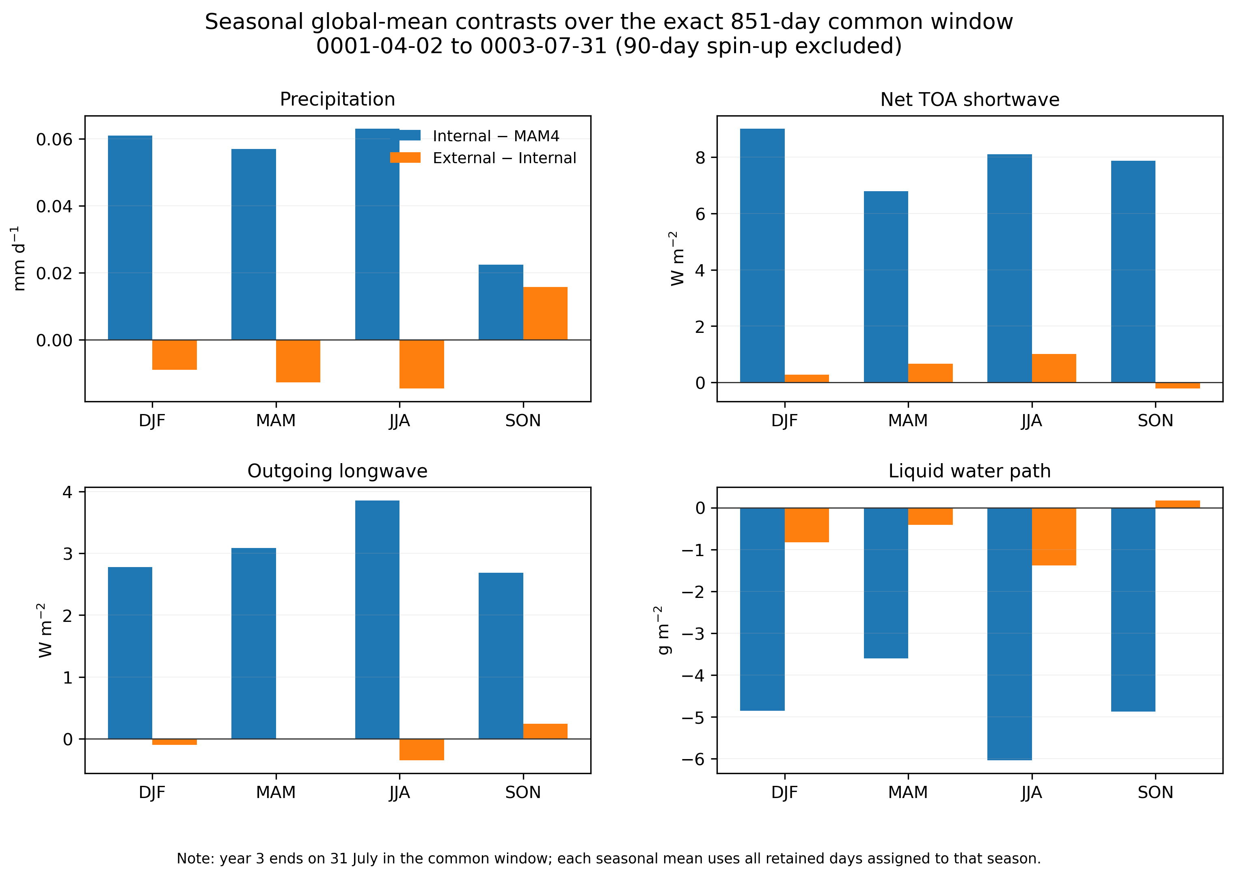
Figure 3. Seasonal global-mean host-climate contrasts over the exact common window.
Figure 3. Seasonal global-mean host-climate contrasts over the exact 851-day MAM4–Internal–External common window (model dates 0001-04-02 through 0003-07-31 after a common 90-day spin-up). The panels compare the combined modal-to-sectional/SCRAM response (Internal − MAM4) with the incremental composition-diversity response (External − Internal) for precipitation, top-of-atmosphere shortwave and longwave radiation, and liquid cloud water path.
To avoid conflating modal and sectional representations, Figure 4 first shows MAM4 in its native reconstructed lognormal form and Internal/External SCRAM on their native sectional support, and only then maps all three onto the same seven intervals for integrated comparison. The common-support particle-number comparison shows a pronounced redistribution of the simulated size spectrum (Figure 4). Over the 851-day common window, total surface number is 714, 676, and 639 cm−3 in MAM4, Internal, and External, respectively, while the 0.0398–0.1585 µm section contains 53.6% of MAM4 number but 72.8% and 71.3% in Internal and External. A first independent size-distribution evaluation uses 2010 EBAS Level-2 SMPS/DMPS observations at five quality-controlled European and Arctic sites and restricts the comparison to three diameter intervals fully covered by both observations and the model (Figure 5). MAM4 underestimates the integrated number over these intervals by 78% across the retained site–bin sample; the bias is reduced to 61% in Internal and 66% in External. The largest structural improvement occurs at 39.8–158.5 nm, where the median model/observation ratio increases from 0.33 in MAM4 to 0.67 in Internal and 0.59 in External. All three configurations remain strongly low at 10–39.8 nm, with median ratios of only 0.09–0.11, indicating that resolving a sectional size coordinate and prognostic mixing state does not by itself remove the model’s ultrafine-number deficiency.
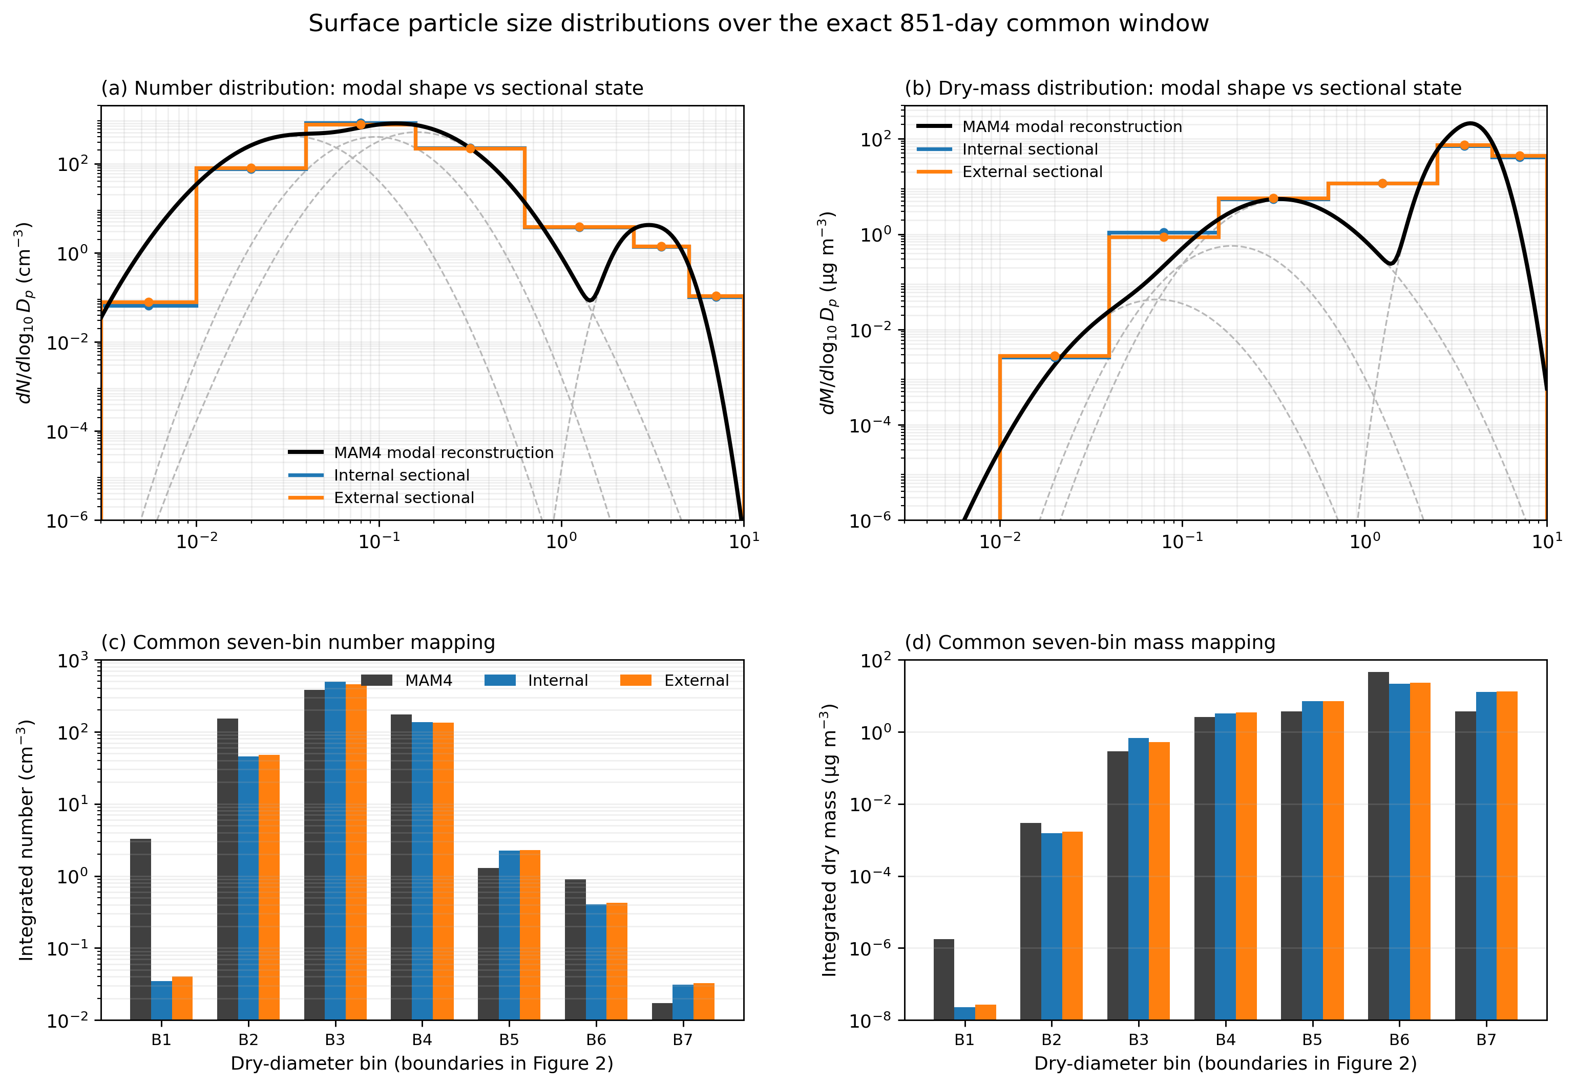
Figure 4. Three-way surface particle size distributions on common support.
Figure 4. Surface particle size distributions over the exact 851-day common window. The upper panels preserve each model’s native representation: MAM4 is reconstructed as the area/time-weighted mixture of its four formal lognormal modes using grid-cell-diagnosed geometric diameters and formal mode widths, whereas Internal and External SCRAM are shown as piecewise-constant sectional distributions on the seven configured bins. Faint dashed curves show the four MAM4 component modes. The lower panels retain the moment-conserving MAM4-to-seven-bin mapping so that integrated number and dry mass can still be compared on exactly the same support.
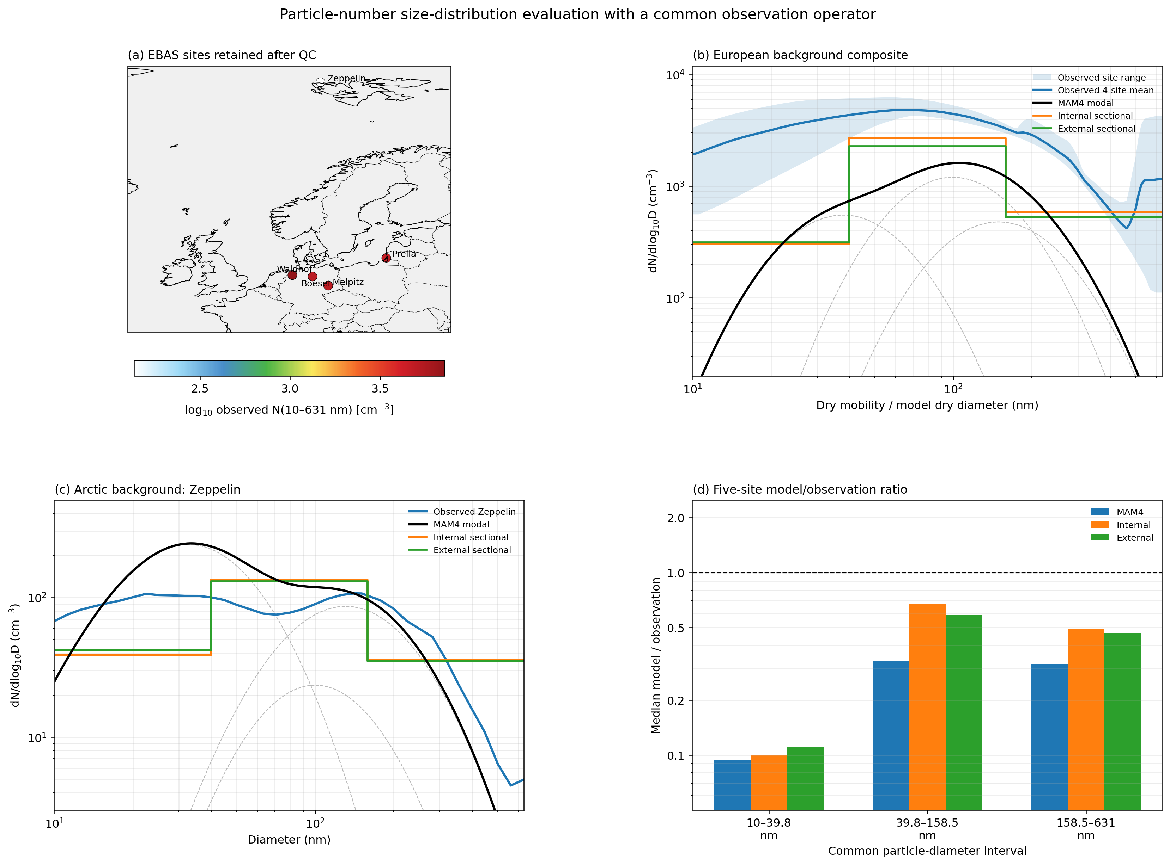
Figure 5. EBAS particle-number size-distribution validation.
Figure 5. Particle-number size-distribution evaluation against 2010 EBAS Level-2 SMPS/DMPS observations at five quality-controlled European and Arctic sites. In the spectral panels, MAM4 is shown in its native continuous four-mode lognormal form reconstructed from daily grid-cell modal number, diagnosed geometric diameter, and formal mode width, whereas Internal and External SCRAM retain their sectional representation. The quantitative model/observation ratio panel uses the three diameter intervals fully shared by the observations and all model configurations (10–39.8, 39.8–158.5, and 158.5–631 nm).

4.4 Incremental influence of prognostic mixing state
The External–Internal contrast isolates the added effect of resolving 11 composition classes on the same seven-bin size grid. The central result is evaluated as a connected set of changes rather than as independent variables: changes in class occupancy and size distribution alter hygroscopic and optical particle properties; those changes modify CCN and absorption/scattering; cloud sampling and activation then determine how much of the aerosol perturbation reaches cloud droplet number, liquid water, precipitation, and radiation.
Current production diagnostics show that the External–Internal perturbation is modest in several global-mean climate variables but more structured by season and aerosol process. The manuscript will therefore emphasize maps, regional regimes, vertical structure, and seasonal attribution rather than using global means alone to judge the importance of mixing state.
The formal NC11 diagnostics demonstrate why this regional view is necessary (Figures 6, 7, and 8). Class identities diagnosed from the actual 13-dry-species restart composition show distinct dust-, sea-salt-, sulfate/inorganic-, POA-, and BC-rich branches rather than the historical labels used during early model development. In the 27-month surface-number record, the POA-dominant NC9 class contributes 33.6% of global number, whereas the sea-salt-dominant NC5 class dominates locally over the largest geographic area. Regional populations differ sharply: NC9 contributes 38.7% and 44.2% of surface number over East and South Asia, while NC5 contributes 77.1% over the Southern Ocean.
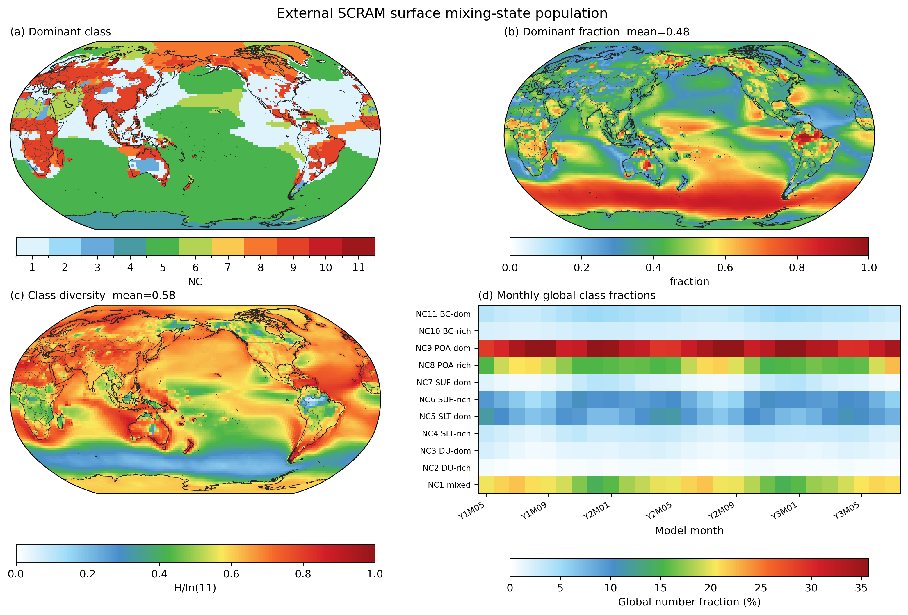
Figure 6. External SCRAM NC11 mixing-state population.
Figure 6. Surface mixing-state population in the External SCRAM demonstration over 27 complete monthly history files (Y1M05–Y3M07). Panels show the dominant class, its local number fraction, normalized class-population entropy, and a month × NC heat map of global number fractions. Compact NC labels are used in the figure; the full physical class definitions are given in Table 2 and are verified against the actual 13-dry-species restart composition.
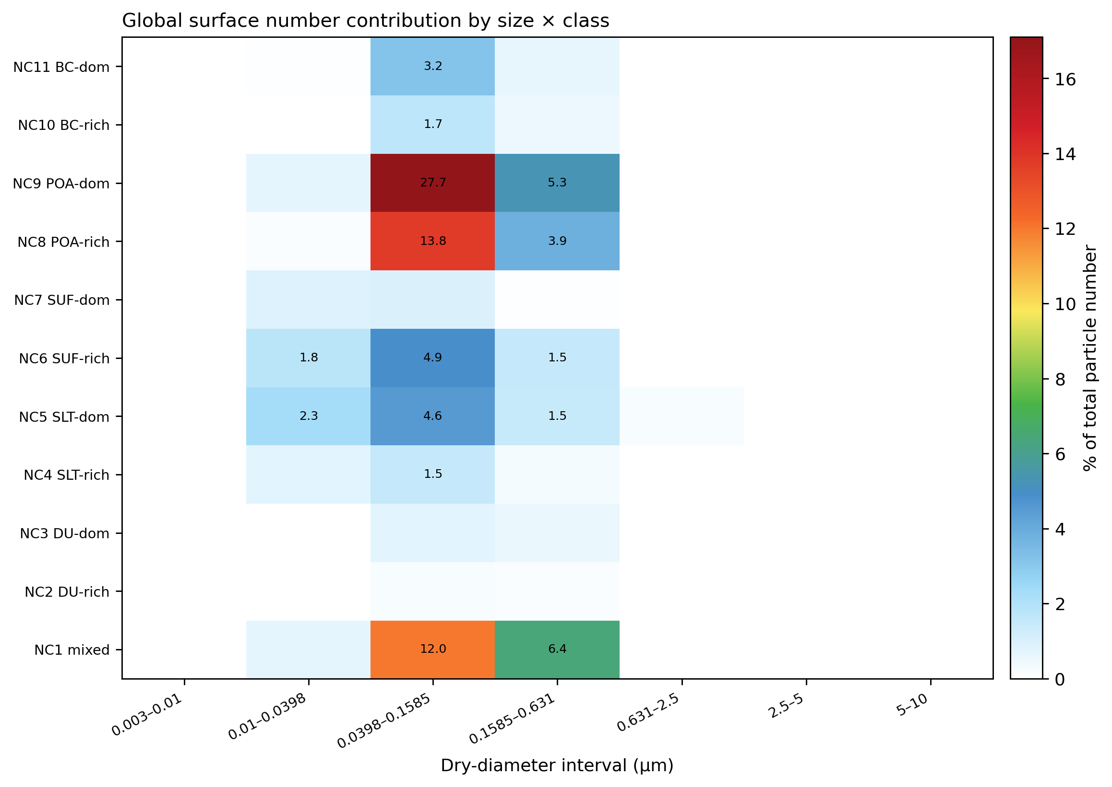
Figure 7. External size-by-composition particle-number distribution.
Figure 7. Global surface particle-number contribution across the seven dry-diameter bins and 11 prognostic External composition classes. The size × class matrix shows directly how particle number is distributed across the two resolved coordinates rather than reducing the population to a single modal or bulk composition description.
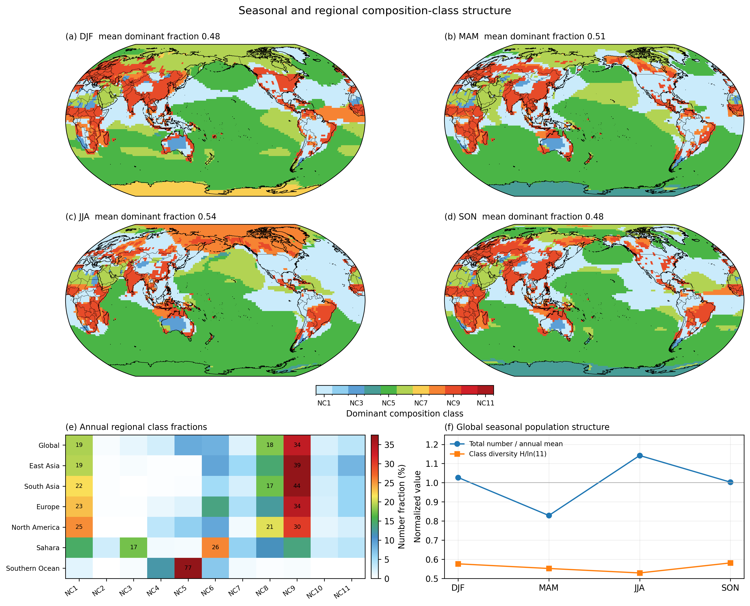
Figure 8. Seasonal and regional External NC11 composition-class structure.
Figure 8. Seasonal and regional composition-class structure in External SCRAM. DJF, MAM, JJA, and SON maps show the dominant surface-number class. A region × NC heat map replaces the former 11-category stacked legend and summarizes annual composition-class fractions across major aerosol regimes, while the final panel compares normalized seasonal total particle number with NC-population diversity. Full class names are defined in Table 2.
For the primary scalar mixing-state diagnostic, the 13 dry prognostic species are first aggregated into the same six physically interpretable groups used by the production composition classifier—DU, BC, SLT, SUF, POA, and SED—and the entropy-based Riemer–West index is then calculated across the 77 size–composition particle types (Figure 9; Riemer and West, 2013). We denote this physical-group metric as $χ_{g}$. It therefore asks whether source- and process-characteristic aerosol material is co-located within the same particle types, rather than treating ions belonging to the same material family (for example Na and chloride in sea salt) as independent mixing dimensions. Over the 28 monthly restart snapshots used for the formal analysis, the global surface mean $χ_{g}$ is 40.5%, increasing from 37.5% in DJF to 42.6% in JJA. The regional contrast is strong: annual-mean $χ_{g}$ is 22.8% over the Sahara, 25.4% over the Middle East, 36.0% over East Asia, and 39.6% over Europe. These low desert values occur despite dust accounting for 95.4% and 85.2% of dry aerosol mass over the Sahara and Middle East, respectively, because the remaining physical groups are concentrated in particle types that are compositionally distinct from the dominant dust population.
The interpretation of $χ_{g}$ requires the companion bulk diversity $D_{γ,g}$. The Riemer–West index becomes undefined in the exact single-component limit $D_{γ}=1$ and numerically ill-conditioned as that limit is approached (Riemer and West, 2013; Riemer et al., 2019). This is relevant over remote marine regions: the Southern Ocean is 92.6% SLT by grouped dry mass and has $D_{γ,g}=1.13$, so its raw $χ_{g}$ is not interpreted as an intermediate degree of atmospheric mixing. Figure 9 therefore shows $D_{γ,g}$ explicitly and uses gray shading to flag $D_{γ,g}<1.2$ as a low-diversity conditioning regime; the threshold is a visualization flag only, and all unmasked values are retained in the provenance. The original 13-species chemical mixing index $χ_{s}$ is retained in Figure S13 to document sensitivity to component definition, but is not used as the primary mixing-state result.
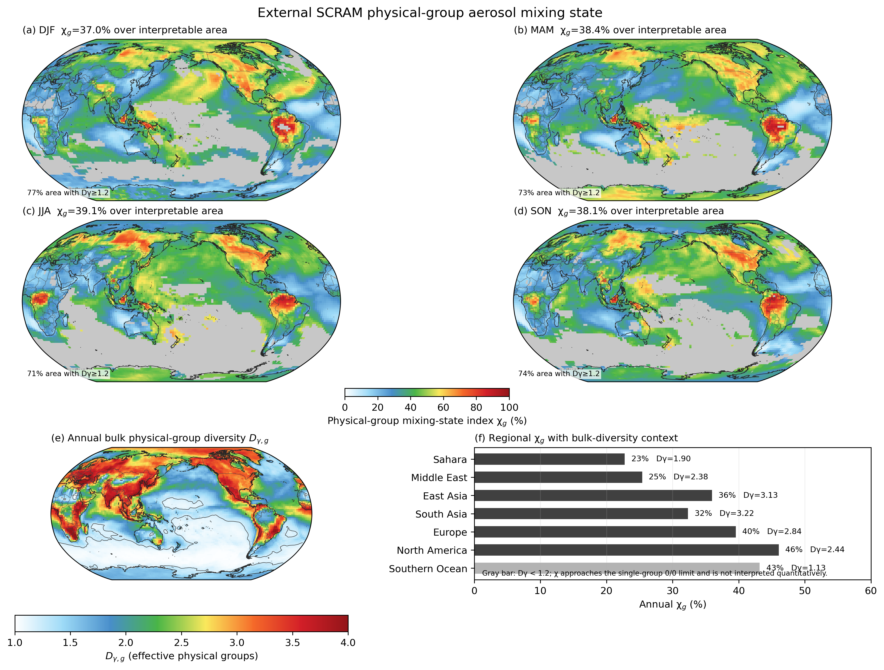
Figure 9. Physical-group aerosol mixing-state index χg.
Figure 9. Physical-group aerosol mixing state in External SCRAM. The 13 dry prognostic species are aggregated into the six production classifier groups (DU, BC, SLT, SUF, POA, and SED) before calculating the Riemer–West mixing-state index $χ_{g}$ across 77 size–composition particle types. Seasonal maps show $χ_{g}$ only where bulk group diversity $D_{γ,g}≥1.2$; lower-diversity regions are gray because $χ$ approaches the single-component $0/0$ limit as $D_{γ}→1$. Panel (e) shows annual $D_{γ,g}$ and panel (f) summarizes regional annual $χ_{g}$ together with $D_{γ,g}$. The $D_{γ,g}=1.2$ threshold is used only to flag poorly conditioned interpretation and does not modify the archived raw metric.

4.5 Mixing state, cloud activation, and liquid-cloud response
The cloud analysis follows the sequence
$$\begin{aligned}\text{size–composition state}&→\text{fixed-S CCN}→\text{cloud-sampled CCN/updraft} \\ &→\text{activated number}→N_{d}→\text{LWP/precipitation/radiation}.\end{aligned}$$
This framework explicitly tests whether a larger CCN reservoir at prescribed supersaturation translates into increased activated aerosol and cloud droplet number under the model’s actual cloud and updraft conditions. The JJA mechanism-chain analysis first follows the horizontal response from CCN through cloud droplet number and liquid water to shortwave cloud-radiative effects (Figure 10), while regional and vertical diagnostics identify where External–Internal differences are filtered or amplified between these stages (Figure 11). In model year 2, global-mean surface CCN at S = 0.1% is 114, 107, and 83 cm−3 in MAM4, Internal, and External, respectively. Over East Asia the corresponding values are 313, 564, and 372 cm−3, showing that the modal-to-sectional response is strongly region dependent and that explicit composition diversity subsequently reduces the large Internal CCN enhancement. The SCRAM-only cloud pathway further traces SCRAM_CCN_CLOUD into positive droplet-number activation (SCRAM_NPCCN) and transfer into the prognostic cloud-borne sectional reservoir (SCRAM_CWNUM_ACT), avoiding a false one-to-one interpretation of fixed-supersaturation CCN.
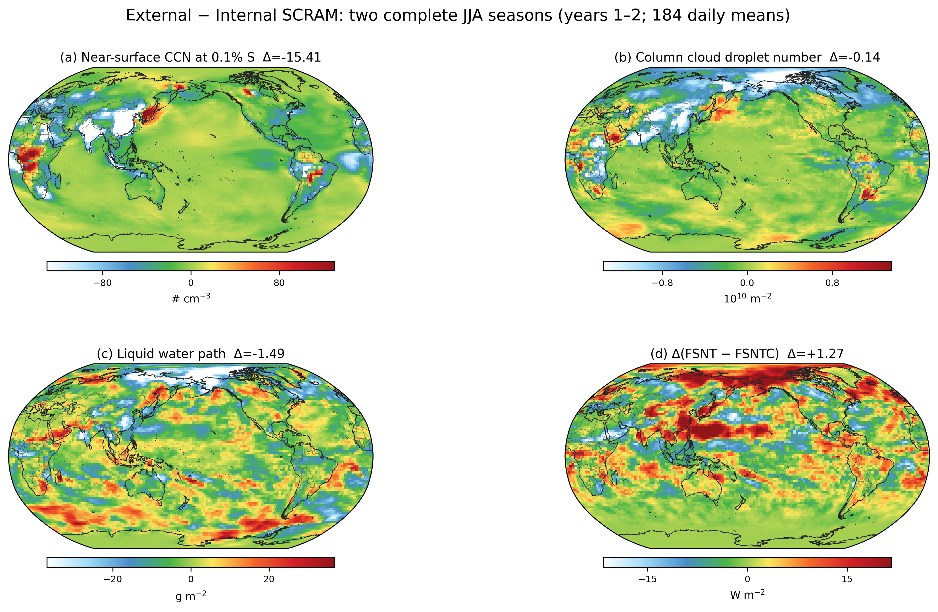
Figure 10. JJA aerosol–cloud–radiation mechanism chain.
Figure 10. External − Internal SCRAM aerosol–cloud–radiation mechanism chain for the two complete JJA seasons in model years 1–2 (184 daily means). Spatial contrasts track the response from fixed-supersaturation SCRAM CCN through cloud droplet number and liquid cloud water to the shortwave cloud-radiative component, providing a process-oriented view of where explicit composition diversity propagates into clouds and radiation.
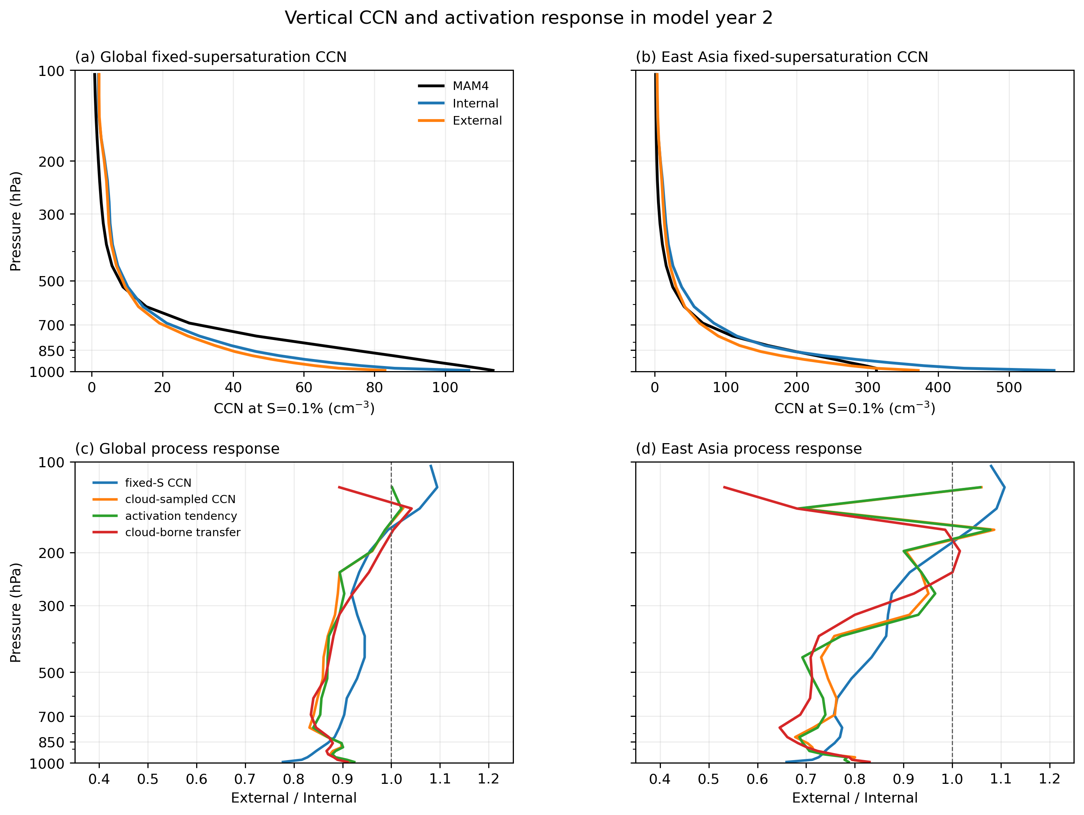
Figure 11. Vertical CCN and SCRAM cloud-activation diagnostics.
Figure 11. Model-year-2 tropospheric CCN and cloud-activation profiles (1000–100 hPa). The upper panels compare MAM4 CCN3 and SCRAM SCRAM_CCN3 at the same supersaturation, S = 0.1%, for the global domain and East Asia. The lower panels express External/Internal ratios for fixed-S CCN, cloud-sampled CCN, positive droplet-number activation, and transfer into the prognostic cloud-borne sectional reservoir, allowing process attenuation or amplification to be compared without mixing incompatible units.
The cloud-state evaluation is consistent with this need for process-separated interpretation. Against a 24-month MODIS Collection 6.1 2013–2014 climatology, liquid cloud water is compared using a grid-box proxy constructed as liquid-cloud CWP multiplied by the liquid retrieval fraction rather than comparing the in-cloud MODIS retrieval directly with CESM TGCLDLWP (Figure 12). The global LWP bias decreases from +14.7 g m−2 in MAM4 to +10.0 g m−2 in Internal and +9.3 g m−2 in External, and the RMSE decreases from 29.8 to 25.9 and 25.7 g m−2, although Internal retains a slightly higher spatial correlation than External. Similarly, the year-2 CERES comparison (Figure 13) shows that net cloud radiative effect improves from a −5.71 W m−2 bias and 12.20 W m−2 RMSE in MAM4 to −1.27/10.18 in Internal and −0.57/9.92 W m−2 in External. The individual shortwave and longwave cloud-radiative components do not improve monotonically, however, so the smaller net bias partly reflects compensation rather than uniform improvement of every cloud-radiation process.
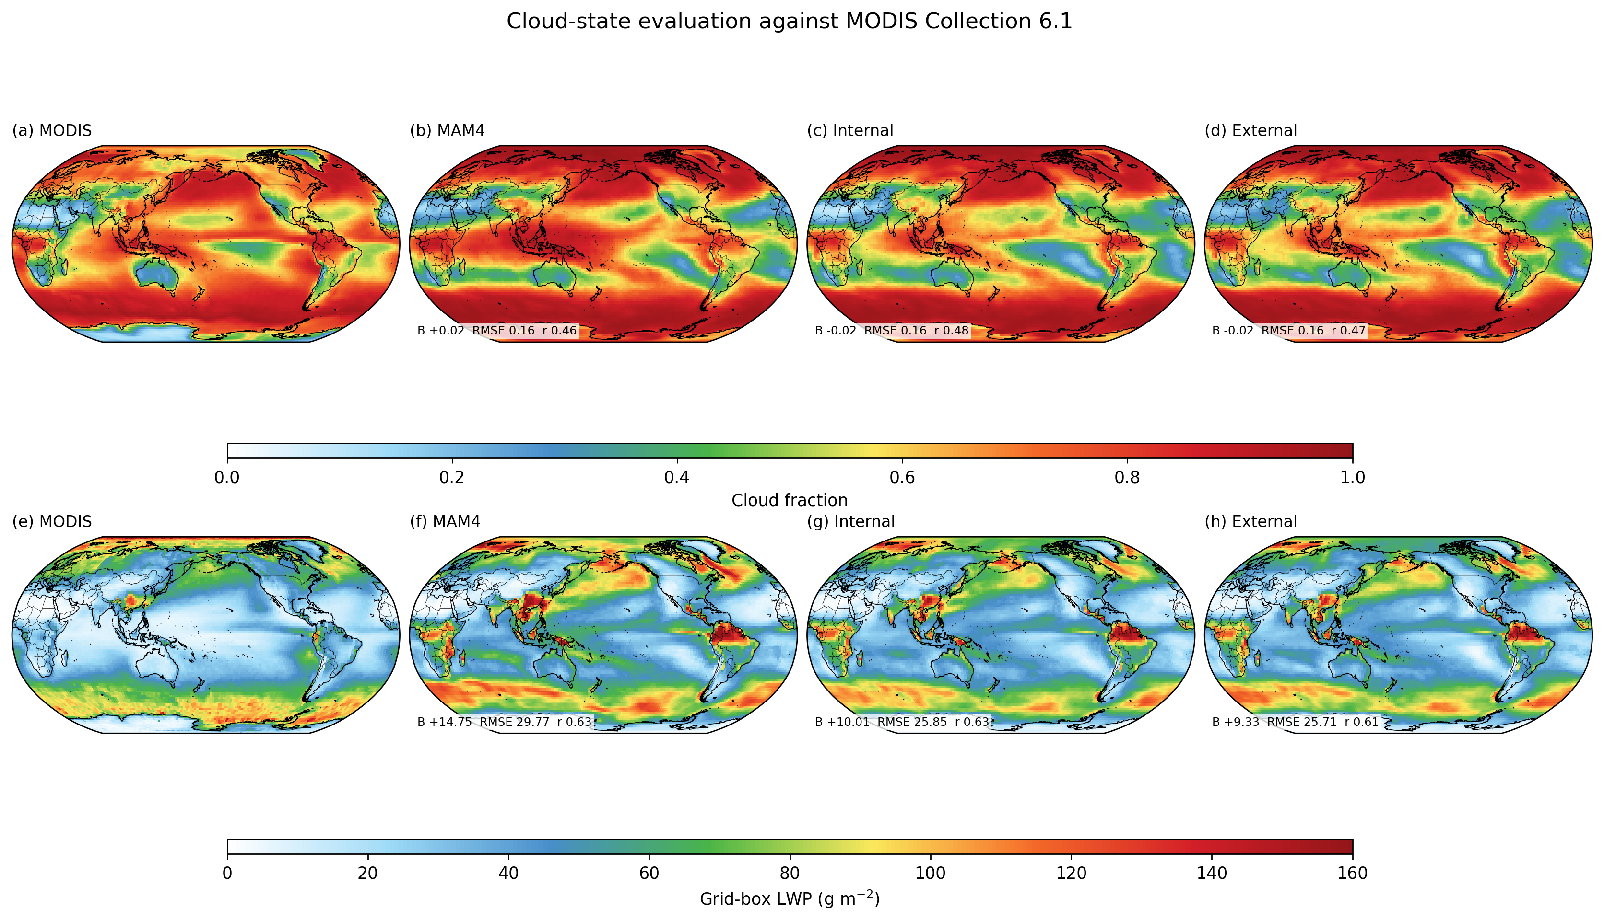
Figure 12. MODIS cloud fraction and liquid-water-path validation.
Figure 12. CESM–SCRAM cloud-state evaluation against MODIS Collection 6.1. Cloud fraction and liquid water are shown on common absolute-value color scales for MODIS, MAM4, Internal, and External, with bias/RMSE/spatial correlation placed as compact in-panel annotations. The primary liquid-water comparator is a grid-box proxy formed from liquid-cloud water path multiplied by the liquid retrieval fraction, avoiding a direct mismatch between in-cloud MODIS retrievals and grid-box CESM TGCLDLWP.
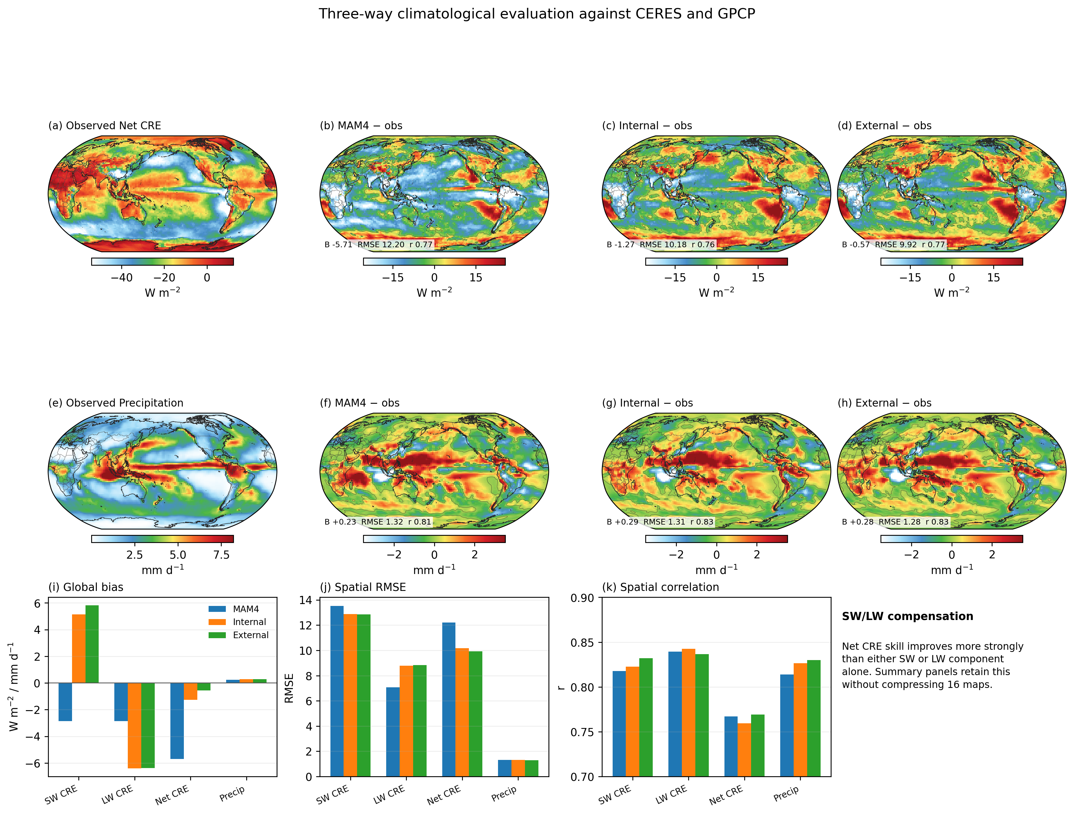
Figure 13. CERES and GPCP three-way climate-state validation.
Figure 13. Three-way climatological validation of model year 2 against calendar-year 2010 observations on the CESM grid. The map rows focus on net cloud radiative effect (CERES EBAF) and precipitation (GPCP), while the lower summary panels retain bias, RMSE, and spatial correlation for SW, LW, and net cloud radiative effects together with precipitation. This layout preserves the SW/LW compensation diagnostic without compressing 16 maps into one figure. Because F2010 climatological forcing is repeated, the comparison is interpreted as a spatial/climatological structural test rather than event-by-event meteorological verification.

4.6 Optical response of composition diversity
Optical attribution uses the identical SCRAM online optical diagnostics in the Internal and External simulations. The analysis separates total shortwave AOD, absorption AOD, single-scattering albedo, BC-related optical depth, and dust-related optical depth and links them to the composition-class distribution and size spectrum (Figure 14). Particular attention is given to cases where BC-containing particle abundance or BC-related optical depth changes without a same-sign response in total absorption, because such behavior can arise from changes in size, coating environment, scattering material, or the relative contribution of non-BC aerosol.
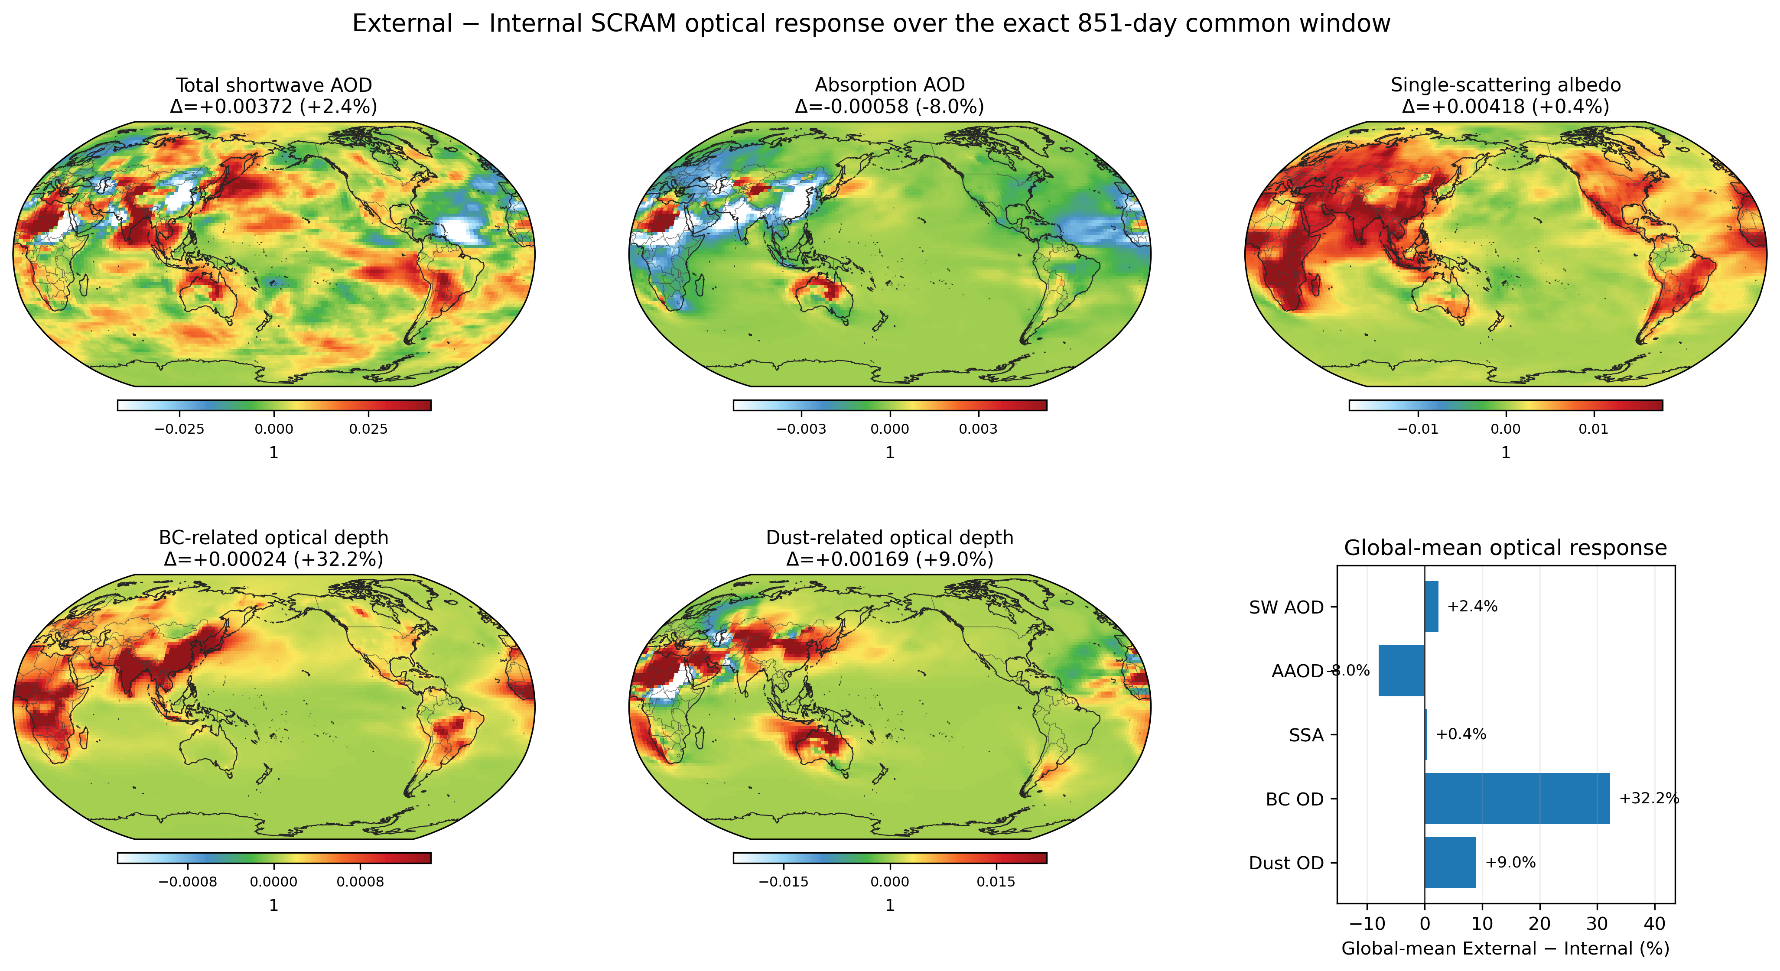
Figure 14. Mixing-state optical response.
Figure 14. Optical response to prognostic composition diversity over the exact 851-day common window, evaluated only with diagnostics having identical SCRAM optical semantics in Internal and External. The figure summarizes External − Internal changes in total shortwave aerosol optical depth, absorption aerosol optical depth, single-scattering albedo, BC-related optical depth, and dust-related optical depth.
The three-way visible-AOD comparison therefore uses the ownership-consistent host-radiation field AEROD_v rather than AODVIS. Source-code tracing confirms that the SCRAM/CARMA optical-depth contribution is added to the host shortwave optical-depth array before AEROD_v is written; in the MAM4 control, AEROD_v and AODVIS agree to numerical precision. This diagnostic contract enables a direct 550-nm evaluation against 2010 AERONET V3 Level-1.5 observations at 266 sites with at least 30 daily measurements (Figure 15). MAM4 underestimates the station-mean AOD with a normalized mean bias of −41.4%, RMSE of 0.151, and spatial correlation of 0.613. Internal reduces the normalized bias to −1.84% (RMSE 0.107, r = 0.751), while External gives −0.43% (RMSE 0.105, r = 0.759); the fraction of stations within a factor of two increases from 47% in MAM4 to 84% and 85% in Internal and External. Because the simulations use repeating F2010 forcing rather than observed year-specific meteorology, these scores are interpreted as climatological spatial-structure tests rather than event-by-event forecast verification. AODVIS remains excluded from direct three-way optical evaluation and is retained only as an ownership/debug diagnostic.
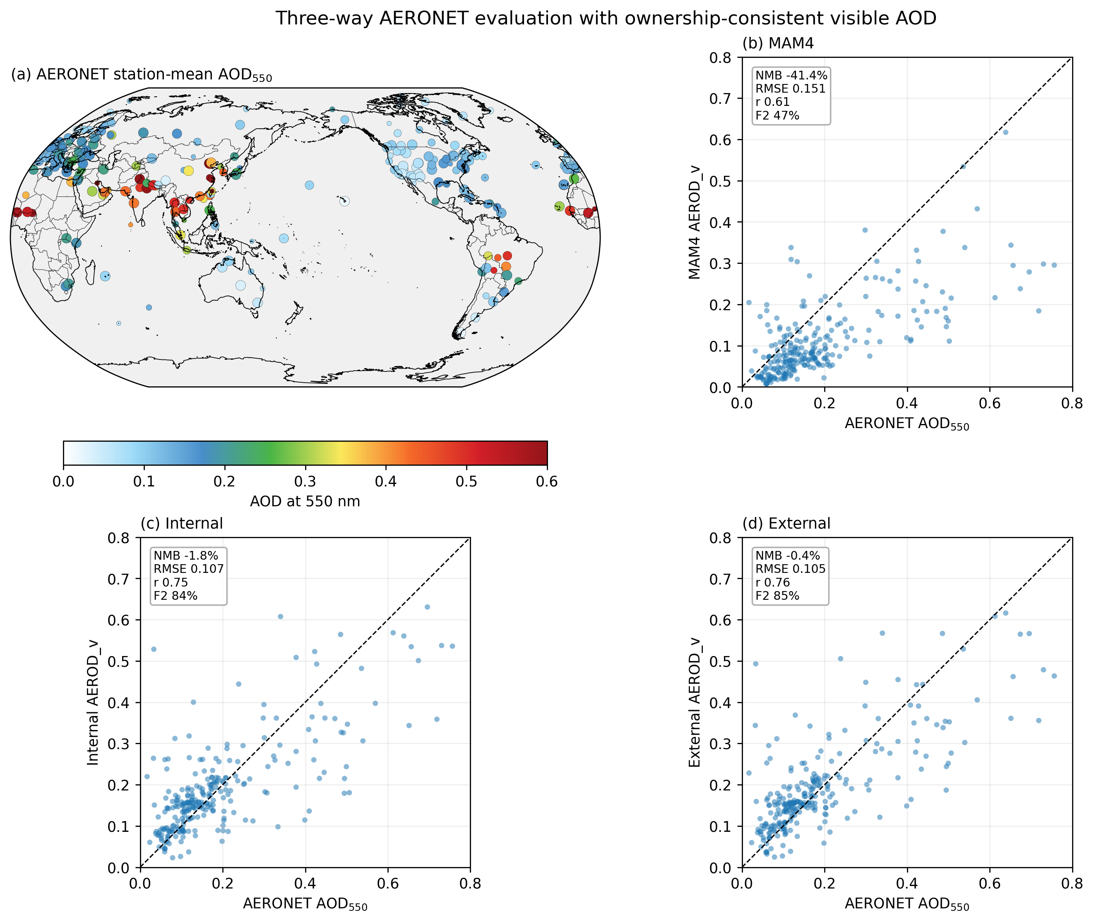
Figure 15. AERONET visible-AOD validation using AEROD_v.
Figure 15. AERONET evaluation using the ownership-consistent total visible aerosol optical depth diagnostic AEROD_v. Station-mean 550-nm AOD from 266 AERONET V3 Level-1.5 sites with at least 30 daily observations in 2010 is compared with MAM4, Internal, and External. Panel titles are kept short and NMB/RMSE/r/factor-of-two statistics are shown in compact annotation boxes. AODVIS is not used as a three-way comparator because its meaning changes under SCRAM aerosol ownership.

4.7 Computational cost versus information gained
Explicit composition resolution increases the aerosol state dimension substantially, so computational cost is part of the scientific evaluation. We quantify throughput, memory, restart size, and history volume for MAM4, Internal SCRAM, and External SCRAM using production job records. These costs are compared with the additional information gained: explicit mixing-state geography, class-resolved source and aging pathways, composition-dependent optical properties, and the ability to evaluate particle-diversity metrics directly.
The objective is not to argue that the highest available composition resolution should always be used. Instead, CESM–SCRAM enables future complexity-convergence experiments in which composition classes or size bins are progressively merged until a target climate diagnostic changes beyond an acceptable tolerance.

5. Discussion

5.1 What CESM–SCRAM adds beyond sectional aerosol microphysics
CESM–CARMA studies have already established the value and feasibility of replacing modal aerosol with explicit sectional size resolution in CESM (Yu et al., 2015; Tilmes et al., 2023). CESM–SCRAM builds on this pathway but addresses a different structural limitation: particles of the same size need not have the same composition. The added prognostic composition coordinate permits aerosol diversity to survive within a size section and allows atmospheric processing to move particles through that composition space. This shifts the model from size-resolved aerosol toward a reduced representation of the multidimensional particle population.
The distinction is important scientifically. If Internal and External SCRAM respond similarly relative to MAM4, the dominant difference is likely related to sectional sizing, SCRAM microphysics, or other shared coupling changes. If External departs from Internal while these shared components remain fixed, composition diversity becomes the leading structural explanation. The three-model hierarchy therefore addresses a common ambiguity in aerosol-model intercomparisons, where size representation, thermodynamics, optics, and mixing-state assumptions often change simultaneously.

5.2 Bridging observations and Earth system model state space
Single-particle observations increasingly describe quantities that a fully internally mixed aerosol model cannot predict directly: the fraction of BC-containing particles, coating distributions, source-dependent composition classes, particle-to-particle hygroscopic diversity, or entropy-based mixing-state indices. In CESM–SCRAM these types of information can be mapped onto prognostic composition groups or class fractions. A disagreement with observation can therefore be diagnosed as an error in population structure rather than being visible only indirectly through AOD or total PM.
This bridge is necessarily approximate. Eleven composition classes do not reconstruct the complete particle-resolved distribution. Their value is that they preserve selected dimensions of particle history at a computational cost compatible with global simulation. The same framework can be reconfigured to retain different properties when a different observational or process question is targeted.

5.3 Configurable particle complexity as a model-development strategy
The 7 × 11 External state used here is deliberately a demonstration case, not a model definition and not a claim of universal optimality. CESM–SCRAM exposes the size and particle-property coordinates to the user so that alternative discretizations can be created without redesigning the CESM coupling layer. The architecture supports a broader set of questions: How many composition classes are needed before CCN or absorption converges? Is additional size resolution more valuable than additional composition resolution for a given forcing metric? Which BC classes are required to reproduce observed coating distributions? Can dust or source tags be transported without participating in all thermodynamic calculations? Does the optimal state-space complexity differ between polluted continental, biomass-burning, marine, dust, and remote environments?
These questions convert aerosol structural complexity from an implicit modeling choice into an explicit experimental dimension. Such a strategy is particularly useful for Earth system modeling because model development must balance physical completeness against throughput, memory, and data volume.

5.4 Current limitations
CESM–SCRAM remains a reduced representation of the aerosol population. Particles within one size–composition cell still share the properties assigned to that cell, and the current composition coordinate does not explicitly resolve arbitrary particle morphology. The optical lookup treatment reduces complex particle structure to a tractable parameterization and therefore should not be interpreted as a full morphology-resolving calculation. Cloud responses depend on the host activation and cloud-microphysics formulations as well as on aerosol state. The current model intentionally does not use SCRAM as a stratospheric aerosol model. Its principal target is the tropospheric evolution of mixing state, where fresh emissions create strong particle-to-particle compositional contrasts and atmospheric aging progressively redistributes material among particles. MAM4 is retained above the tropopause, which also controls computational cost and avoids applying the present ISORROPIA-centered inorganic chemistry outside the regime for which this CESM–SCRAM configuration was designed. The resulting tropospheric SCRAM/stratospheric MAM4 ownership boundary introduces an additional mapping problem that must be monitored for conservation. Finally, the External demonstration transports more than one thousand SCRAM aerosol carriers, making computational efficiency and I/O important practical constraints.
These limitations define the next development steps rather than invalidating the framework. Particle-resolved models remain essential benchmarks, while CESM–SCRAM provides a tractable global layer between those benchmarks, single-particle observations, and conventional climate aerosol schemes.

6. Conclusions
We developed CESM–SCRAM as a configurable size–composition-resolved aerosol framework in CESM2, in which aerosol structural complexity is an explicit user choice rather than a fixed model definition. The framework permits users to redesign the size grid, particle-property/composition coordinate, class boundaries, species/group mapping, and selected optical and process options while retaining the same CESM coupling infrastructure. The 7-bin, 14-species, 7 × 1 Internal and 7 × 11 External states evaluated here are an initial demonstration and validation realization of that broader capability. Relative to the original SCRAM formulation, the CESM implementation expands inorganic aerosol chemistry with ISORROPIA-coupled ammonium, nitrate, and chloride partitioning. Because the strongest mixing-state contrasts arise from fresh emissions and subsequent aging in the troposphere, the detailed size–composition treatment is intentionally focused there, with MAM4 retained for stratospheric aerosol; this choice also reduces computational cost and keeps the ISORROPIA-centered chemistry within its targeted atmospheric regime. Within that domain, the implementation couples the high-dimensional aerosol state online to aerosol microphysics and thermodynamics, emissions and removal, optical properties and radiation, and cloud activation.
The three-model MAM4–Internal–External hierarchy provides the central experimental advantage. It separates the consequences of moving from a modal to a sectional/SCRAM framework from the incremental consequences of resolving particle composition diversity. This distinction allows aerosol mixing state to be evaluated as a model-structural degree of freedom rather than as an inseparable difference between unrelated aerosol schemes.
More broadly, CESM–SCRAM is intended as a bridge between particle-resolved aerosol science and Earth system modeling. Its configurable size and composition coordinates can be redesigned around BC coating, hygroscopicity, dust, source tags, or other particle properties, enabling systematic tests of how much particle-level complexity is needed to reproduce climate-relevant aerosol behavior. The multi-year evaluation developed here provides the first step toward using that capability to quantify how mixing state propagates through aerosol optics, cloud activation, clouds, and radiation at the global scale.

Open Research
The final submission will archive the exact CESM–SCRAM source revision, runtime configuration files, paper-specific Python analysis code, variable-contract metadata, common-window manifests, and figure/table provenance required to reproduce the reported results. Large production history files will be documented by immutable manifests and checksums, with derived data products archived where redistribution of the complete model output is impractical.

Acknowledgments
[To be completed before submission.]

References
Abdul-Razzak, H., & Ghan, S. J. (2000). A parameterization of aerosol activation: 2. Multiple aerosol types. Journal of Geophysical Research: Atmospheres, 105, 6837–6844. https://doi.org/10.1029/1999JD901161
Aquila, V., Hendricks, J., Lauer, A., et al. (2011). MADE-in: a new aerosol microphysics submodel for global simulation of insoluble particles and their mixing state. Geoscientific Model Development, 4, 325–355. https://doi.org/10.5194/gmd-4-325-2011
Bauer, S. E., Wright, D. L., Koch, D., Lewis, E. R., McGraw, R., Chang, L.-S., Schwartz, S. E., & Ruedy, R. (2008). MATRIX (Multiconfiguration Aerosol TRacker of mIXing state): an aerosol microphysical module for global atmospheric models. Atmospheric Chemistry and Physics, 8, 6003–6035. https://doi.org/10.5194/acp-8-6003-2008
Bohren, C. F., & Huffman, D. R. (1983). Absorption and Scattering of Light by Small Particles. Wiley.
Bond, T. C., & Bergstrom, R. W. (2006). Light absorption by carbonaceous particles: An investigative review. Aerosol Science and Technology, 40, 27–67. https://doi.org/10.1080/02786820500421521
Bond, T. C., Doherty, S. J., Fahey, D. W., et al. (2013). Bounding the role of black carbon in the climate system: A scientific assessment. Journal of Geophysical Research: Atmospheres, 118, 5380–5552. https://doi.org/10.1002/jgrd.50171
Chen, G., Liu, C., Wang, J., Yin, Y., & Wang, Y. (2024). Accounting for black carbon mixing state, nonsphericity, and heterogeneity effects in its optical property parameterization in a climate model. Journal of Geophysical Research: Atmospheres, 129, e2024JD041135. https://doi.org/10.1029/2024JD041135
Chen, G., Wang, J., Wang, Y., et al. (2023). An aerosol optical module with observation-constrained black carbon properties for global climate models. Journal of Advances in Modeling Earth Systems, 15, e2022MS003501. https://doi.org/10.1029/2022MS003501
Ching, J., Fast, J., West, M., & Riemer, N. (2017). Metrics to quantify the importance of mixing state for CCN activity. Atmospheric Chemistry and Physics, 17, 7445–7458. https://doi.org/10.5194/acp-17-7445-2017
Danabasoglu, G., Lamarque, J.-F., Bacmeister, J., et al. (2020). The Community Earth System Model Version 2 (CESM2). Journal of Advances in Modeling Earth Systems, 12, e2019MS001916. https://doi.org/10.1029/2019MS001916
Donahue, N. M., Robinson, A. L., Stanier, C. O., & Pandis, S. N. (2006). Coupled partitioning, dilution, and chemical aging of semivolatile organics. Environmental Science & Technology, 40, 2635–2643. https://doi.org/10.1021/es052297c
Emmons, L. K., Schwantes, R. H., Orlando, J. J., et al. (2020). The chemistry mechanism in the Community Earth System Model Version 2 (CESM2). Journal of Advances in Modeling Earth Systems, 12, e2019MS001882. https://doi.org/10.1029/2019MS001882
Fountoukis, C., & Nenes, A. (2007). ISORROPIA II: A computationally efficient thermodynamic equilibrium model for K$​^{+}$–Ca$​^{2+}$–Mg$​^{2+}$–NH$​_{4}^{+}$–Na$​^{+}$–SO$​_{4}^{2−}$–NO$​_{3}^{−}$–Cl$​^{−}$–H$​_{2}$O aerosols. Atmospheric Chemistry and Physics, 7, 4639–4659. https://doi.org/10.5194/acp-7-4639-2007
Hess, M., Koepke, P., & Schult, I. (1998). Optical properties of aerosols and clouds: The software package OPAC. Bulletin of the American Meteorological Society, 79, 831–844. https://doi.org/10.1175/1520-0477(1998)079<0831:OPOAAC>2.0.CO;2
Jacobson, M. Z. (2001). Strong radiative heating due to the mixing state of black carbon in atmospheric aerosols. Nature, 409, 695–697. https://doi.org/10.1038/35055518
Kumar, S., & Ramkrishna, D. (1996a). On the solution of population balance equations by discretization—I. A fixed pivot technique. Chemical Engineering Science, 51, 1311–1332. https://doi.org/10.1016/0009-2509(96)88489-2
Kumar, S., & Ramkrishna, D. (1996b). On the solution of population balance equations by discretization—II. A moving pivot technique. Chemical Engineering Science, 51, 1333–1342. https://doi.org/10.1016/0009-2509(95)00355-X
Liu, X., Easter, R. C., Ghan, S. J., et al. (2012). Toward a minimal representation of aerosols in climate models: Description and evaluation in the Community Atmosphere Model CAM5. Geoscientific Model Development, 5, 709–739. https://doi.org/10.5194/gmd-5-709-2012
Liu, X., Ma, P.-L., Wang, H., Tilmes, S., Singh, B., Easter, R. C., Ghan, S. J., & Rasch, P. J. (2016). Description and evaluation of a new four-mode version of the Modal Aerosol Module (MAM4) within version 5.3 of the Community Atmosphere Model. Geoscientific Model Development, 9, 505–522. https://doi.org/10.5194/gmd-9-505-2016
Matsui, H. (2017). Development of a global aerosol model using a two-dimensional sectional method: 1. Model design. Journal of Advances in Modeling Earth Systems, 9, 1921–1947. https://doi.org/10.1002/2017MS000936
Matsui, H. (2020). Black carbon absorption efficiency under preindustrial and present-day conditions simulated by a size- and mixing-state-resolved global aerosol model. Journal of Geophysical Research: Atmospheres, 125, e2019JD032316. https://doi.org/10.1029/2019JD032316
Matsui, H., & Mahowald, N. (2017). Development of a global aerosol model using a two-dimensional sectional method: 2. Evaluation and sensitivity simulations. Journal of Advances in Modeling Earth Systems, 9, 1887–1920. https://doi.org/10.1002/2017MS000937
Matsui, H., Hamilton, D. S., & Mahowald, N. M. (2018). Black carbon radiative effects highly sensitive to emitted particle size when resolving mixing-state diversity. Nature Communications, 9, 3446. https://doi.org/10.1038/s41467-018-05635-1
Matsui, H., Koike, M., Kondo, Y., Moteki, N., Fast, J. D., & Zaveri, R. A. (2013). Development and validation of a black carbon mixing state resolved three-dimensional model: Aging processes and radiative impact. Journal of Geophysical Research: Atmospheres, 118, 2304–2326. https://doi.org/10.1029/2012JD018446
Oshima, N., & Koike, M. (2013). Development of a parameterization of black carbon aging for use in general circulation models. Geoscientific Model Development, 6, 263–282. https://doi.org/10.5194/gmd-6-263-2013
Oshima, N., Koike, M., Zhang, Y., Kondo, Y., Moteki, N., Takegawa, N., & Miyazaki, Y. (2009). Aging of black carbon in outflow from anthropogenic sources using a mixing state resolved model: Model development and evaluation. Journal of Geophysical Research: Atmospheres, 114, D06210. https://doi.org/10.1029/2008JD010680
Pankow, J. F. (1994a). An absorption model of gas/particle partitioning of organic compounds in the atmosphere. Atmospheric Environment, 28, 185–188. https://doi.org/10.1016/1352-2310(94)90093-0
Pankow, J. F. (1994b). An absorption model of the gas/aerosol partitioning involved in the formation of secondary organic aerosol. Atmospheric Environment, 28, 189–193. https://doi.org/10.1016/1352-2310(94)90094-9
Petters, M. D., & Kreidenweis, S. M. (2007). A single parameter representation of hygroscopic growth and cloud condensation nucleus activity. Atmospheric Chemistry and Physics, 7, 1961–1971. https://doi.org/10.5194/acp-7-1961-2007
Pruppacher, H. R., & Klett, J. D. (1978). Microphysics of Clouds and Precipitation. Reidel. https://doi.org/10.1007/978-94-009-9905-3
Riemer, N., & West, M. (2013). Quantifying aerosol mixing state with entropy and diversity measures. Atmospheric Chemistry and Physics, 13, 11423–11439. https://doi.org/10.5194/acp-13-11423-2013
Riemer, N., Ault, A. P., West, M., Craig, R. L., & Curtis, J. H. (2019). Aerosol mixing state: Measurements, modeling, and impacts. Reviews of Geophysics, 57, 187–249. https://doi.org/10.1029/2018RG000615
Riemer, N., West, M., Zaveri, R. A., & Easter, R. C. (2009). Simulating the evolution of soot mixing state with a particle-resolved aerosol model. Journal of Geophysical Research: Atmospheres, 114, D09202. https://doi.org/10.1029/2008JD011073
Shen, W., Wang, M., Riemer, N., Zheng, Z., Liu, Y., & Dong, X. (2024). Improving BC mixing state and CCN activity representation with machine learning in the Community Atmosphere Model Version 6 (CAM6). Journal of Advances in Modeling Earth Systems, 16, e2023MS003889. https://doi.org/10.1029/2023MS003889
Sokolik, I. N., & Toon, O. B. (1999). Incorporation of mineralogical composition into models of the radiative properties of mineral aerosol from UV to IR wavelengths. Journal of Geophysical Research: Atmospheres, 104, 9423–9444. https://doi.org/10.1029/1998JD200048
Takemura, T., Nozawa, T., Emori, S., Nakajima, T. Y., & Nakajima, T. (2005). Simulation of climate response to aerosol direct and indirect effects with aerosol transport-radiation model. Journal of Geophysical Research: Atmospheres, 110, D02202. https://doi.org/10.1029/2004JD005029
Tilmes, S., Mills, M. J., Zhu, Y., Bardeen, C. G., Vitt, F., Yu, P., Fillmore, D., Liu, X., Toon, B., & Deshler, T. (2023). Description and performance of a sectional aerosol microphysical model in the Community Earth System Model (CESM2). Geoscientific Model Development, 16, 6087–6125. https://doi.org/10.5194/gmd-16-6087-2023
Vehkamäki, H., Kulmala, M., Napari, I., Lehtinen, K. E. J., Timmreck, C., Noppel, M., & Laaksonen, A. (2002). An improved parameterization for sulfuric acid–water nucleation rates for tropospheric and stratospheric conditions. Journal of Geophysical Research: Atmospheres, 107(D22), 4622. https://doi.org/10.1029/2002JD002184
Yu, P., Toon, O. B., Bardeen, C. G., Mills, M. J., Fan, T., English, J. M., & Neely, R. R. (2015). Evaluations of tropospheric aerosol properties simulated by the Community Earth System Model with a sectional aerosol microphysics scheme. Journal of Advances in Modeling Earth Systems, 7, 865–914. https://doi.org/10.1002/2014MS000421
Zaveri, R. A., Barnard, J. C., Easter, R. C., Riemer, N., & West, M. (2010). Particle-resolved simulation of aerosol size, composition, mixing state, and the associated optical and cloud condensation nuclei activation properties in an evolving urban plume. Journal of Geophysical Research: Atmospheres, 115, D17210. https://doi.org/10.1029/2009JD013616
Zhang, L., Gong, S., Padro, J., & Barrie, L. (2001). A size-segregated particle dry deposition scheme for an atmospheric aerosol module. Atmospheric Environment, 35, 549–560. https://doi.org/10.1016/S1352-2310(00)00326-5
Zheng, Z., West, M., Zhao, L., Ma, P.-L., Liu, X., & Riemer, N. (2021). Quantifying the structural uncertainty of the aerosol mixing state representation in a modal model. Atmospheric Chemistry and Physics, 21, 17727–17741. https://doi.org/10.5194/acp-21-17727-2021
Zhu, S., Sartelet, K. N., & Seigneur, C. (2015). A size-composition resolved aerosol model for simulating the dynamics of externally mixed particles: SCRAM (v1.0). Geoscientific Model Development, 8, 1595–1612. https://doi.org/10.5194/gmd-8-1595-2015
Zhu, S., Sartelet, K. N., Healy, R. M., & Wenger, J. C. (2016b). Simulation of particle diversity and mixing state over Greater Paris: A model–measurement inter-comparison. Faraday Discussions, 189, 547–566. https://doi.org/10.1039/C5FD00175G
Zhu, S., Sartelet, K. N., Zhang, Y., & Nenes, A. (2016a). Three-dimensional modeling of the mixing state of particles over Greater Paris. Journal of Geophysical Research: Atmospheres, 121, 5930–5947. https://doi.org/10.1002/2015JD024241

