Supporting Information for

CESM–SCRAM: A Configurable Size–Composition-Resolved Aerosol Framework for Prognostic Mixing State in CESM2

Contents
Text S1. Production code and configuration provenance Text S2. Prognostic aerosol state and species definitions Text S3. Size discretization and composition classification Text S4. Analytical coagulation product placement Text S5. Moving-center/dual-pivot size redistribution and composition reclassification Text S6. Gas–particle thermodynamics and five-bin VBS organic aerosol Text S7. CAM–SCRAM gas mapping and tendency exchange Text S8. Emission routing and moment-conserving source allocation Text S9. Unified warm-start and tropopause exchange Text S10. Gravitational settling, dry deposition, and wet scavenging Text S11. Reduced-shell optical closure Text S12. Sectional CCN activation and prognostic cloud-borne aerosol lifecycle Text S13. Common-window construction and diagnostic-variable contract Text S14. Numerical integrity, restart, and conservation tests Text S15. Observation processing and statistical methods Text S16. Physical-group and chemical-species mixing-state metrics Text S17. Additional meteorological, vertical, cloud, and climate-state diagnostics Text S18. Performance and computational cost Tables S1–S7 and machine-readable production tables Figures S1–S13 plus result/validation figures

Text S1. Production code and configuration provenance
CESM–SCRAM is configuration driven; the runtime profiles used for this paper define one demonstration realization rather than the intrinsic dimensionality of the framework. All numerical model-description values reported for the demonstration are derived from the production CESM–SCRAM repository and the exact runtime profiles used to construct the formal Internal and External simulations. Historical development reports are not treated as model-definition sources. The manuscript analysis records the Git revision, runtime-file hashes, formal case paths, CAM history-file inventories, and common retained-date hash in machine-readable provenance files under paper/james_2026/provenance/.
The paper-specific production runtime profiles are:
- Internal SCRAM: scram/install_package/runtime/scram_cesm_nc1_internal.cfg
- External SCRAM: scram/install_package/runtime/scram_cesm_7bin_nc11_external.cfg
- particle species table: scram/install_package/runtime/scram_species.dat
- CAM–SCRAM gas mapping: scram/install_package/runtime/scram_gas_map.txt
- aerosol emission mapping: scram/install_package/runtime/scram_emis_map.txt
The current source/runtime SHA256 values used to audit these method descriptions are reported in Table S1. They will be regenerated from the frozen submission revision before final archival.

Text S2. Prognostic aerosol state and species definitions
The particle-species inventory is user configurable. The production demonstration evaluated in this paper uses 14 particle-phase species:
- PMD — mineral dust
- PBC — black carbon
- PNA — sodium / sea-salt cation representation
- PSO4 — sulfate
- PNH4 — ammonium
- PNO3 — nitrate
- PHCL — chloride/HCl-equivalent particle component
- PSOA1P — VBS SOA particle bin 1
- PSOA2P — VBS SOA particle bin 2
- PSOA3P — VBS SOA particle bin 3
- PSOA4P — VBS SOA particle bin 4
- PSOA5P — VBS SOA particle bin 5
- PPOAlP — nonvolatile primary organic aerosol
- PH2O — particle water
Each size–composition cell carries particle number plus the 14 species masses. Thus the SCRAM aerosol carrier count is
$$N_{SCRAM}=N_{b}N_{c}(1+N_{s}).$$
For the seven-bin demonstration grid used here, this gives 105 SCRAM carriers for Internal ($N_{c}=1$) and 1,155 for External ($N_{c}=11$). These numbers characterize the present validation cases only: user-defined changes in size bins, particle species, or composition/property classes change the SCRAM state dimension accordingly. The full CAM constituent count additionally contains host-model tracers and should not be confused with the SCRAM-only state dimension.

Text S3. Size discretization and composition classification
Size-bin number and boundaries are runtime configuration inputs. For the demonstration and validation presented here, the dry-diameter boundaries are 0.003, 0.01, 0.0398, 0.1585, 0.631, 2.5, 5.0, and 10.0 µm, defining seven bins. Internal and External SCRAM intentionally use identical boundaries to isolate the effect of the composition/property dimension.
The particle-property/composition coordinate and class boundaries are also user configurable. In the demonstration External runtime profile, three primary-fraction and three secondary-fraction intervals with boundaries 0, 0.5, 0.9, and 1.0 are used; physically feasible combinations yield 11 active composition classes for this experiment. The matched Internal profile disables external mixing and collapses the same composition dimension to one class.
The classifier operates on six reduced dry-composition groups: BC, DU, SLT, SUF, POA, and SED. The exact production mapping is PBC→BC, PMD→DU, PNA/PHCL→SLT, PSO4→SUF, PPOAlP→POA, and PNH4/PNO3/PSOA1P–PSOA5P→SED; PH2O is excluded from dry class assignment. The first five groups preserve source-character information, whereas SED serves as the secondary/background residual. With fraction bounds 0, 0.5, 0.9, and 1.0, the production classifier yields one class in which none of the five source-character groups exceeds 0.5 plus two enrichment states (0.5–0.9 and 0.9–1.0) for each source-character group, giving 11 feasible classes. The “fresh-like”, “aged/partially mixed”, and “well mixed” labels used in the manuscript are physical interpretations of these group-fraction ranges rather than explicit age diagnostics.
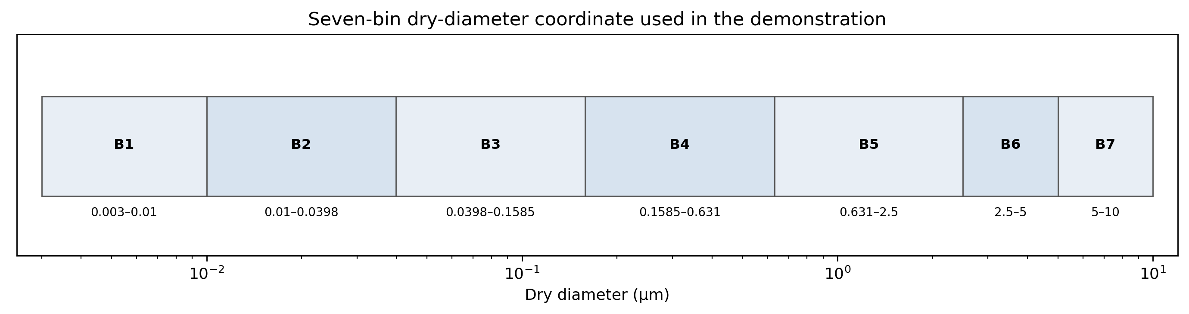
Figure S1. Production seven-bin dry-diameter grid.
Figure S1. Seven-bin dry-diameter grid used for the initial demonstration. Bin number and boundaries are runtime configuration inputs rather than fixed framework limits.
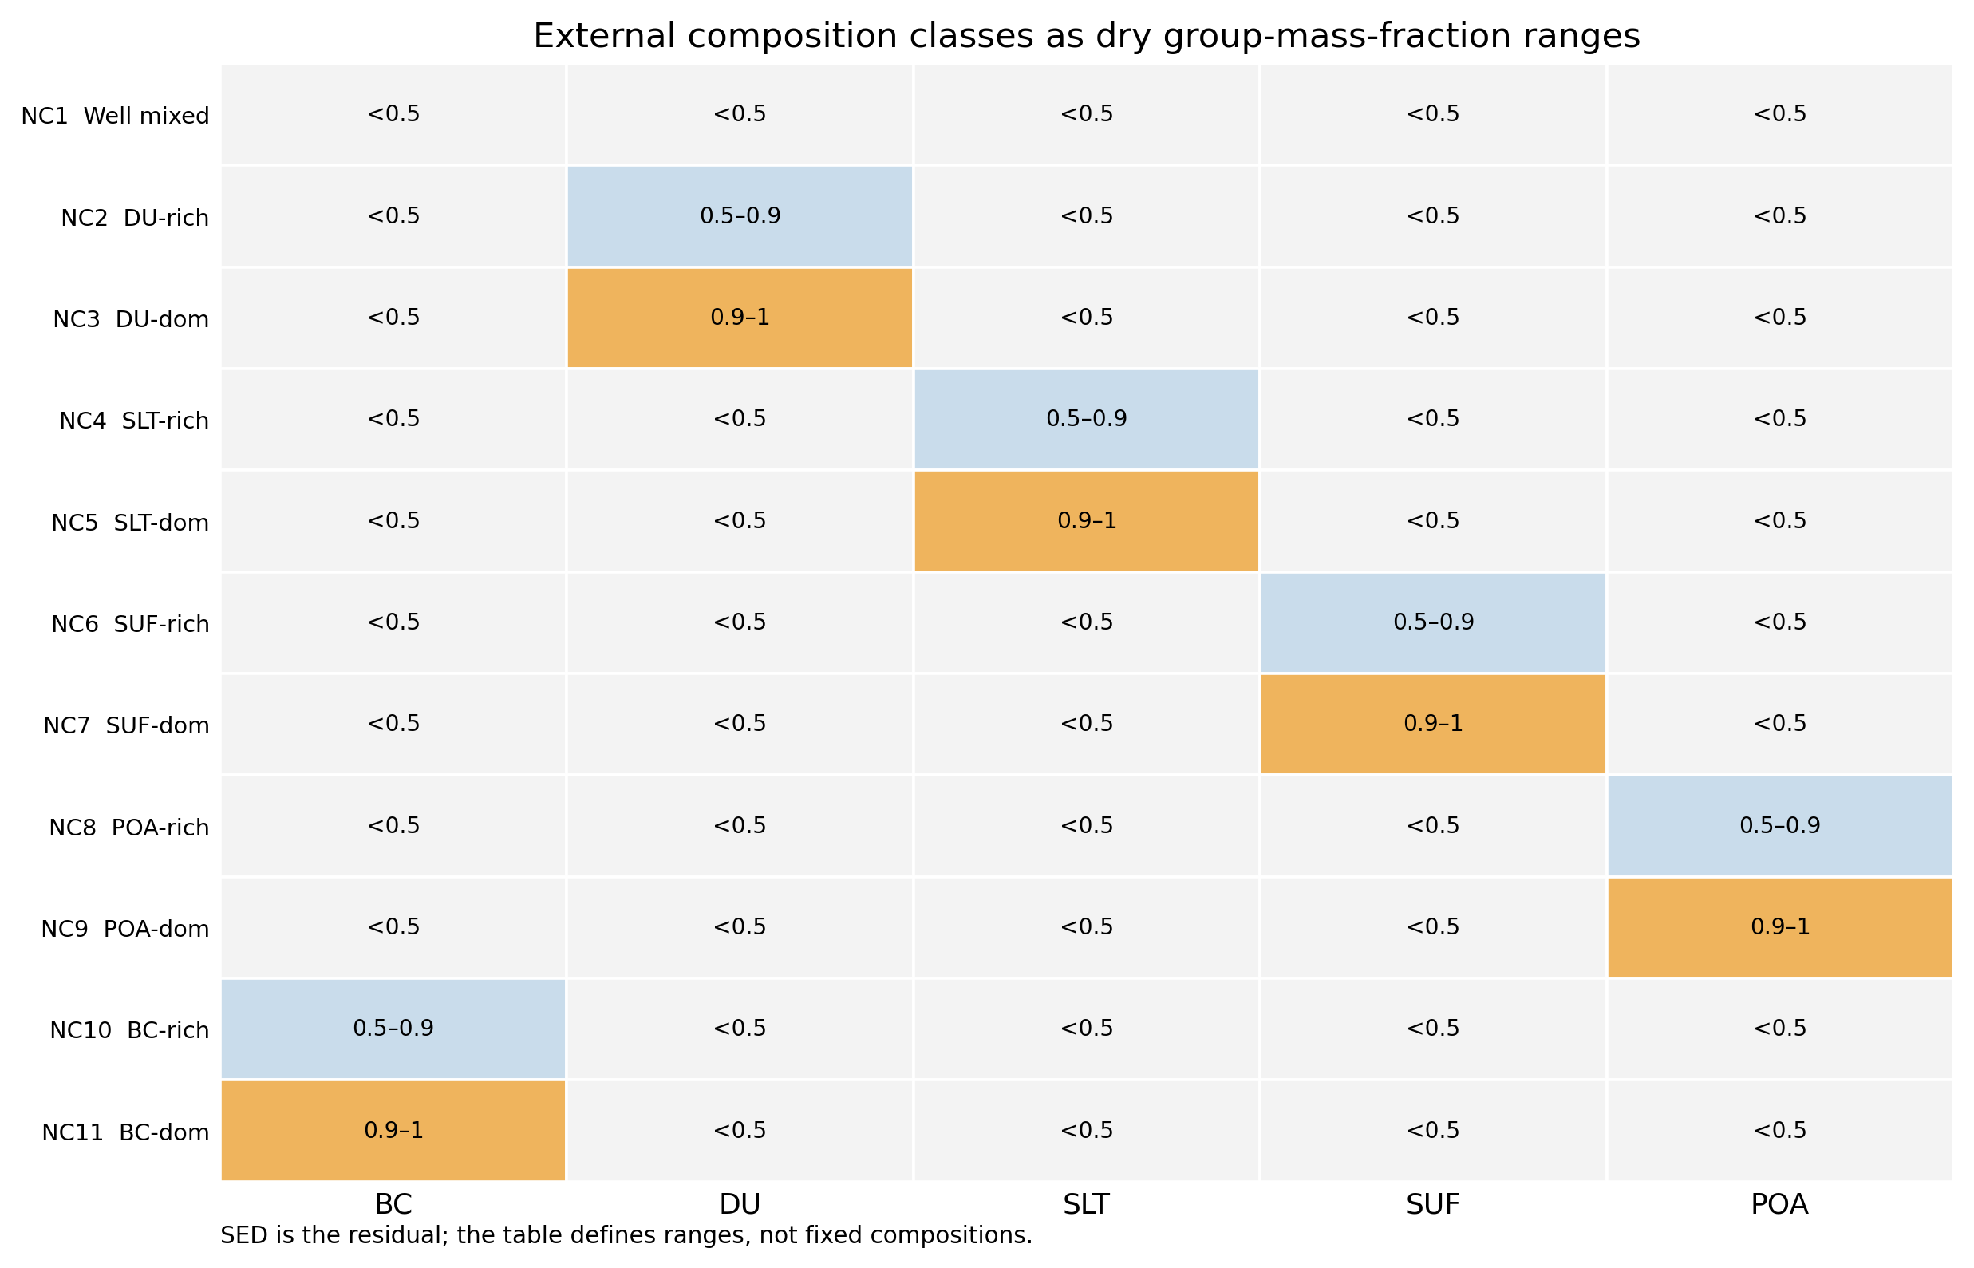
Figure S2. Production External composition classes.
Figure S2. Eleven External composition classes used in the demonstration. The labels summarize dry group-mass-fraction intervals; the prognostic state retains the individual species masses within each class.

Text S4. Analytical coagulation product placement
The formal production cases use Coagulation_repartition_mode = 1, implemented by ModuleCoeffRepartitionNearest.F90. Despite the historical option name “nearest,” the current production implementation does not place a product at the nearest state-space centroid. Instead, it constructs the physical product particle analytically and assigns it to the configured diameter and composition bands.
For two parent states $i$ and $j$, the coagulation event rate is
$$R_{ij}=\left\{\begin{matrix}K_{ij}N_{i}N_{j}, & i≠j, \\ \frac{1}{2}K_{ii}N_{i}^{2}, & i=j,\end{matrix}\right.$$
where $K_{ij}$ is the instantaneous coagulation kernel and $N_{i}$ and $N_{j}$ are particle number concentrations. For species $s$, the mass carried by one particle from each parent is $M_{i,s}/N_{i}$ and $M_{j,s}/N_{j}$; therefore the product-particle composition is
$$m_{p,s}=\frac{M_{i,s}}{N_{i}}+\frac{M_{j,s}}{N_{j}}.$$
The total dry product mass, volume, and equivalent-volume dry diameter are
mp=s​mp,s, Vp=s​mp,sρs, Dp=6Vpπ1/3.
The same product species masses are summed into the configured dry-composition groups to obtain
fp,g=s∈g​mp,smp.
The target cell is then selected using $D_{p}$ and $\{f_{p,g}\}$. Size-bin ownership is deterministic: the first size interval owns its lower boundary, subsequent bins use left-open/right-closed intervals, and products larger than the configured top diameter are saturated into the largest represented size bin. Composition-band ownership uses the same boundary convention as the composition-redistribution operator. Invalid or non-normalized product states are rejected rather than silently routed to a default bin.
The unbounded event rate is additionally constrained by the available parent inventories during the physics step. For parent $a$, an upper bound on removable number is approximately
$$F_{N,a}^{max}=(1−{10}^{−12})\frac{N_{a}}{Δt},$$
and an analogous limit is calculated for every species mass that is required by a collision. The accepted event flux is the minimum of the physical kernel rate and all source-number/species-mass budgets. This prevents negative concentrations while retaining the collision stoichiometry. Each accepted collision removes two parent particles and creates one product particle, so net particle number changes by one per event while the mass of every chemical species is conserved.
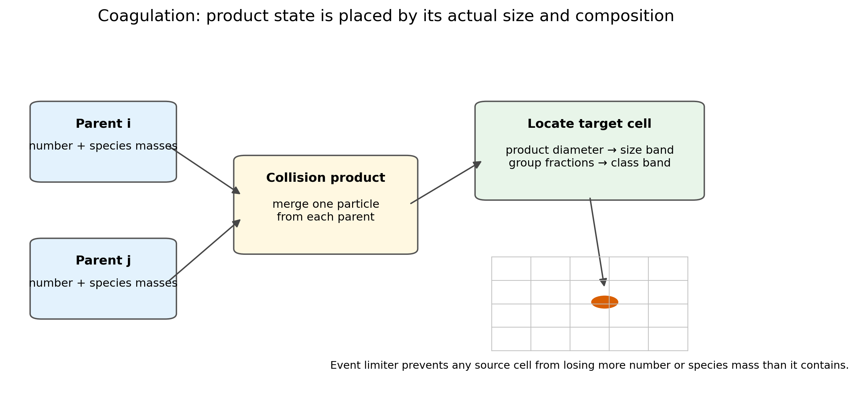
Figure S3. Analytical coagulation product placement.
Figure S3. Analytical coagulation product placement. The product dry diameter and reduced composition fractions are calculated from the two parent particles and are then located in the configured size–composition bands. The diagram shows the logical operator, not the geometric spacing of the production composition classes.

Text S5. Moving-center/dual-pivot size redistribution and composition reclassification
Condensation, evaporation, aqueous processing, and chemical partitioning change particle mass without directly changing the number of particles in a size–composition cell. A fixed-center sectional method would therefore require frequent remapping even when the updated mean particle remains physically inside its existing size interval. CESM–SCRAM instead uses a true moving-center representation within each size section and applies a conservative dual-pivot remap only when the prognostic center exits the section.
For section $k$, the total dry particle volume and mean particle volume are
Vk=s​Mk,sρs, vk=VkNk,
and the corresponding moving dry diameter is
$$D_{k}={\left(\frac{6v_{k}}{π}\right)}^{1/3}.$$
The fixed pivot diameter associated with an explicit size interval $[D_{k,l},D_{k,u}]$ is the logarithmic midpoint,
$$D_{k}^{*}=\sqrt{D_{k,l}D_{k,u}}, v_{k}^{*}=\frac{π}{6}(D_{k}^{*})^{3}.$$
When $D_{k}$ remains within its current section, no size redistribution is performed. If the moving center exits, the two pivot volumes $v_{l}^{*}$ and $v_{h}^{*}$ bracketing $v_{k}$ are selected. Number is split with
$$w_{N,h}=\frac{v_{k}−v_{l}^{*}}{v_{h}^{*}−v_{l}^{*}}, w_{N,l}=1−w_{N,h}.$$
Species mass must use different weights because each target population must possess the target pivot volume per particle. The unnormalized mass weights are
$${\tilde{w}}_{M,l}=w_{N,l}\frac{v_{l}^{*}}{v_{k}}, {\tilde{w}}_{M,h}=w_{N,h}\frac{v_{h}^{*}}{v_{k}},$$
followed by normalization $w_{M,q}={\tilde{w}}_{M,q}/({\tilde{w}}_{M,l}+{\tilde{w}}_{M,h})$. The transfer is
$$N_{l}+=w_{N,l}N_{k}, N_{h}+=w_{N,h}N_{k},$$
$$M_{l,s}+=w_{M,l}M_{k,s}, M_{h,s}+=w_{M,h}M_{k,s}.$$
This construction preserves total number and every species mass while recovering legal moving centers in the target sections. It is related to fixed- and moving-pivot moment-preserving methods (Kumar & Ramkrishna, 1996a, 1996b), but the implementation here is a CESM–SCRAM-specific moving-center/dual-moment operator rather than a direct reproduction of either published algorithm.
Size redistribution and composition redistribution are deliberately separated. After chemistry or microphysics changes the species vector, redistribution_fraction() recomputes dry group masses and group fractions in each occupied cell. The entire number and species-mass state is then moved to the composition class whose configured fraction intervals contain the new group fractions. Thus composition-space movement does not interpolate chemical mass between artificial class centroids; the class boundary is used only as a reduced-state label for the fully prognostic species vector.
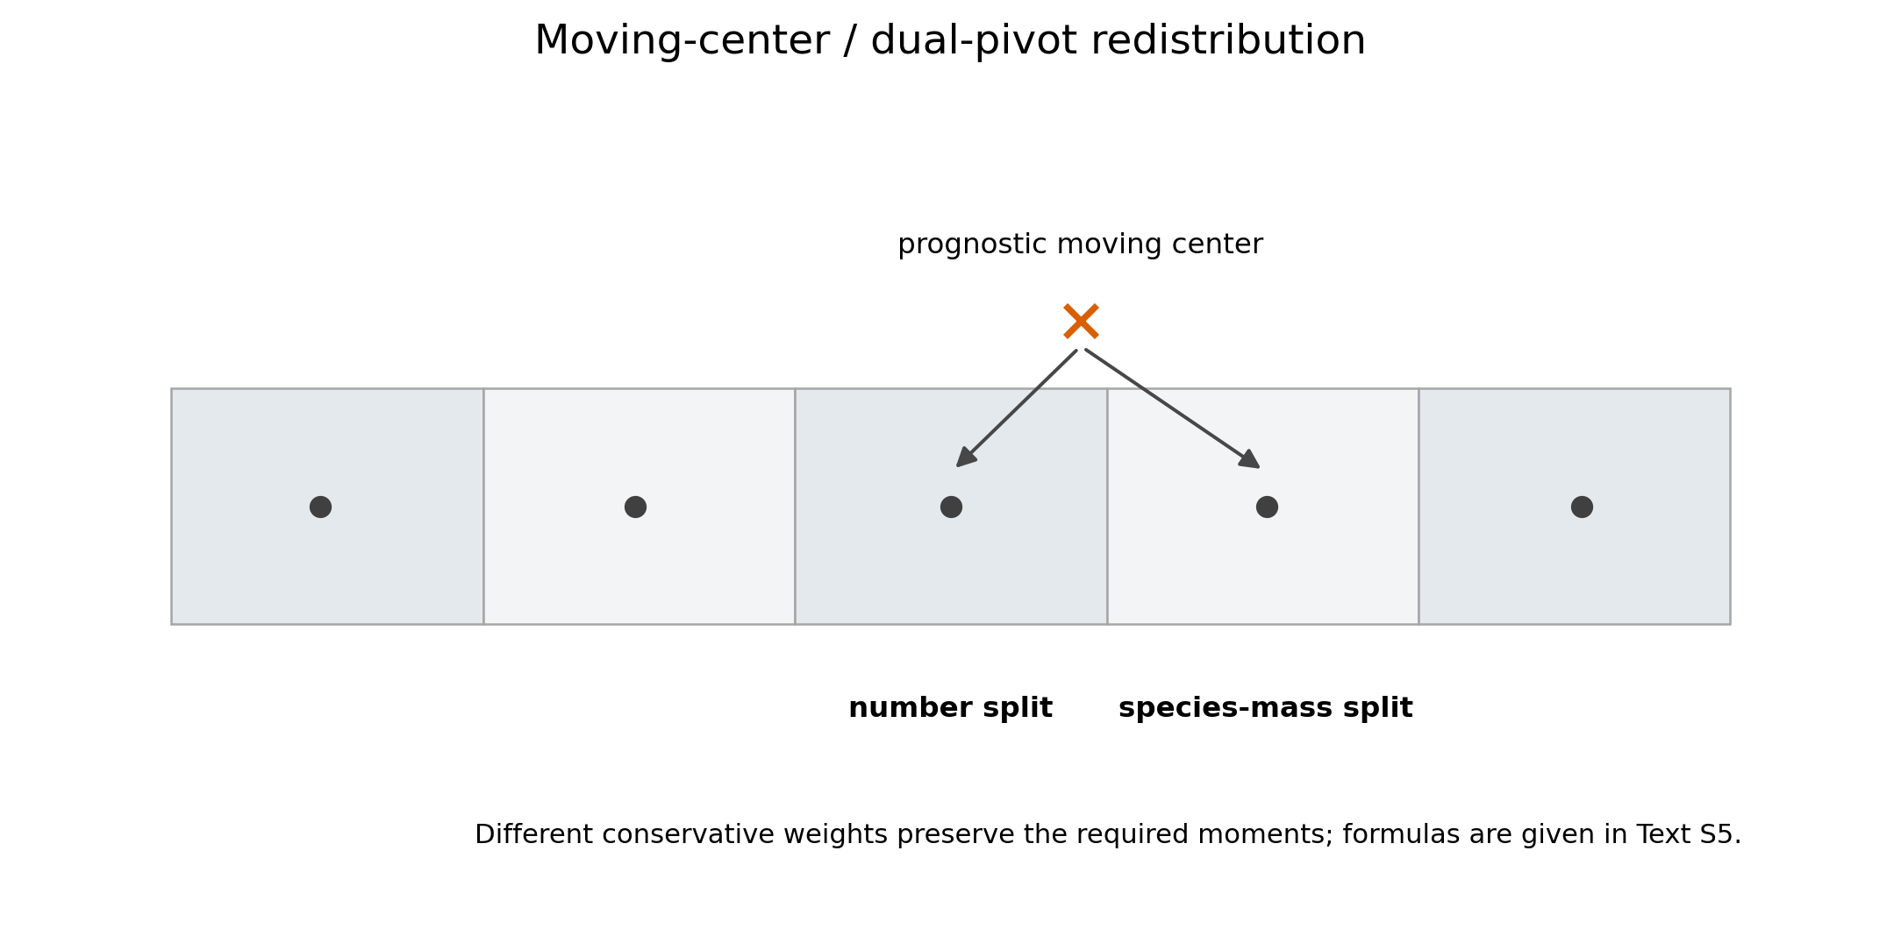
Figure S4. Moving-center/dual-pivot redistribution.
Figure S4. Moving-center/dual-pivot size redistribution. The population retains its prognostic moving center until it leaves its current size section; only then are number and mass split between bracketing legal pivots with different conservative moment weights.

Text S6. Gas–particle thermodynamics and five-bin VBS organic aerosol
Inorganic equilibrium uses ISORROPIA (Fountoukis & Nenes, 2007). The current CESM–SCRAM chemistry includes sulfate, ammonium, nitrate, sodium/chloride, and aerosol water in the coupled inorganic calculation. The present implementation additionally uses a five-bin volatility basis set for semivolatile organic aerosol. Gas bins SOAG0–SOAG4 exchange with particle species PSOA1P–PSOA5P with $C_{298}^{*}$ of 0.01, 0.1, 1, 10, and 100 $μg m^{−3}$, respectively. The partitioning follows absorptive-partitioning theory (Pankow, 1994a, 1994b) in the VBS representation (Donahue et al., 2006).
For volatility bin $i$, the production configuration stores $K_{p,i}(298)=1/C_{i}^{*}(298)$. Its temperature dependence is
$$K_{p,i}(T)=\frac{T}{298}K_{p,i}(298)exp\left[\frac{ΔH_{v,i}}{R}\left(\frac{1}{T}−\frac{1}{298}\right)\right].$$
For total organic concentration $C_{tot,i}=C_{g,i}+C_{p,i}$, the equilibrium condensed fraction is
$$ξ_{i}=\frac{K_{p,i}(T)C_{OA}}{1+K_{p,i}(T)C_{OA}},$$
where
$$C_{OA}=\sum_{j=1}^{5}{C_{p,j}}.$$
The nonvolatile primary organic pool PPOAlP is intentionally excluded from $C_{OA}$, so it does not create an artificial absorbing medium for the semivolatile VBS. The five coupled equations are solved by fixed-point iteration. The production process flags also include particle-phase SOA photolysis with $k_{SOA}=0.0004J_{NO_{2}}$; photochemical loss is applied before repartitioning so that the remaining gas+particle pool is re-equilibrated.
The formal demonstration configuration sets With_nucleation: 1 0, selecting the H$​_{2}$SO$​_{4}$–H$​_{2}$O binary pathway. SCRAM first evaluates the Vehkamäki et al. (2002) sulfuric-acid threshold for the local temperature and relative humidity, then evaluates the parameterized binary nucleation rate and critical-cluster composition when gas-phase H$​_{2}$SO$​_{4}$ exceeds that threshold. The number tendency is placed in the smallest represented section and the associated sulfuric-acid mass is added consistently. A gas-availability limiter prevents a dynamic substep from nucleating more H$​_{2}$SO$​_{4}$ mass than is available.
Table S3. Production five-bin VBS parameters.
CAM gas | SCRAM particle | C* at 298 K (µg m⁻³) | Kp at 298 K (m³ µg⁻¹) | ΔHvap (kJ mol⁻¹)
SOAG0 | PSOA1P | 0.01 | 100 | 153
SOAG1 | PSOA2P | 0.1 | 10 | 142
SOAG2 | PSOA3P | 1 | 1 | 131
SOAG3 | PSOA4P | 10 | 0.1 | 120
SOAG4 | PSOA5P | 100 | 0.01 | 109

Text S7. CAM–SCRAM gas mapping and tendency exchange
CAM remains authoritative for resolved gas transport and provides the host chemical tracer basis (Emmons et al., 2020), while SCRAM supplies the reduced aerosol/gas microphysical representation (Zhu et al., 2015). At the beginning of a SCRAM microphysics call, a CAM gas mass mixing ratio $q_{g}$ is converted to a concentration used by SCRAM,
$$C_{g}=q_{g}ρ_{air}×{10}^{9} [μg m^{−3}],$$
where $ρ_{air}$ is in kg m$​^{−3}$. After SCRAM chemistry and gas–particle exchange, the concentration change is converted back to a CAM mixing-ratio tendency,
$${\left.\frac{dq_{g}}{dt}\right|}_{SCRAM}=\frac{ΔC_{g} {10}^{−9}}{ρ_{air}Δt}.$$
When multiple CAM tracers contribute to one reduced SCRAM gas, the returned change is apportioned according to the pre-SCRAM contributions; a coefficient-weighted fallback is used only when the pre-step pool is effectively zero. This preserves the host-model tracer basis while allowing SCRAM to use a reduced chemistry nomenclature. The exact formal mapping is configuration data rather than hard-coded manuscript text.
Table S4. Complete production CAM-gas to SCRAM-gas mapping. The mapping is generated directly from scram_gas_map.txt; all current coefficients are 1.0.
CAM tracer | SCRAM gas | mapping coefficient
CH2O | FORM | 1.0
CH3CHO | ALD2 | 1.0
CH3COCHO | MGLY | 1.0
HCOOH | FACD | 1.0
CH3COOH | AACD | 1.0
CH3COOOH | PACD | 1.0
CH3OOH | MEPX | 1.0
CRESOL | CRES | 1.0
C2H5OH | ETOH | 1.0
C2H6 | ETHA | 1.0
C2H4 | ETH | 1.0
TOLUENE | TOL | 1.0
XYLENES | XYL | 1.0
MTERP | TERP | 1.0
HO2NO2 | HNO4 | 1.0
H2SO4 | SULF | 1.0
O3 | O3 | 1.0
NO | NO | 1.0
NO2 | NO2 | 1.0
NO3 | NO3 | 1.0
N2O5 | N2O5 | 1.0
HNO3 | HNO3 | 1.0
CO | CO | 1.0
CH4 | CH4 | 1.0
SO2 | SO2 | 1.0
NH3 | NH3 | 1.0
H2O2 | H2O2 | 1.0
O | O | 1.0
HCL | HCL | 1.0
ISOP | ISOP | 1.0
MACR | CRES | 1.0
MVK | ISPD | 1.0
PAN | PAN | 1.0
MPAN | MPAN | 1.0
SOAG0 | SOA1P | 1.0
SOAG1 | SOA2P | 1.0
SOAG2 | SOA3P | 1.0
SOAG3 | SOA4P | 1.0
SOAG4 | SOA5P | 1.0

Text S8. Emission routing and moment-conserving source allocation
Mapped CESM aerosol sources, including MAM4-style modal source fields (Liu et al., 2016), are converted from modal source descriptions to the explicit SCRAM size grid using lognormal moments. For a number lognormal distribution with median diameter $D_{g}$, geometric standard deviation $σ_{g}$, and moment order $k$, define
$$μ_{k}=lnD_{g}+k\ln^{2}σ_{g},$$
and the fraction of moment $k$ within section $[D_{l},D_{u}]$ as
$$w_{k}=Φ\left(\frac{lnD_{u}−μ_{k}}{lnσ_{g}}\right)−Φ\left(\frac{lnD_{l}−μ_{k}}{lnσ_{g}}\right).$$
Number uses $w_{0}$; dry volume and species mass use $w_{3}$. The represented support is harmonized and the two sets of weights are normalized separately, which avoids the common error of forcing one weighting function to conserve both number and volume.
Where a physical number flux $F_{N}$ and dry-volume flux $F_{V}$ are both available, the model diagnoses the source median diameter:
$$D_{g}={\left[\frac{F_{V}}{F_{N}(π/6)exp(4.5\ln^{2}σ_{g})}\right]}^{1/3}.$$
Species that belong to one physical emitted population share that population’s number flux. For example, sea-salt mass is split between PNA and PHCL, but number is not duplicated; likewise the fire BC and POM maps are treated as members of the same emitted population for number allocation. Direct sectional dust and sea-salt producers bypass the corresponding legacy modal source when their native sectional number/mass source is active. Aircraft, biomass-burning, and volcanic pathways are routed through their production physics-buffer fields.
Table S5. Production aerosol-emission mapping. dg_um and sigma_g are source-distribution parameters when modal/lognormal mapping is used; allocation_fraction partitions source mass, whereas physical particle number is shared within source groups.
CESM source | SCRAM species | Dg (µm) | σg | mass fraction | source type | auxiliary field
so4_a1 | PSO4 | 0.15 | 1.6 | 1.0 | surface_flux
bc_a1 | PBC | 0.11 | 1.6 | 1.0 | surface_flux
soa1_a1 | PSOA1P | 0.11 | 1.6 | 1.0 | surface_flux
soa2_a1 | PSOA2P | 0.11 | 1.6 | 1.0 | surface_flux
soa3_a1 | PSOA3P | 0.11 | 1.6 | 1.0 | surface_flux
soa4_a1 | PSOA4P | 0.11 | 1.6 | 1.0 | surface_flux
soa5_a1 | PSOA5P | 0.11 | 1.6 | 1.0 | surface_flux
pom_a1 | PPOAlP | 0.11 | 1.6 | 1.00 | surface_flux
so4_a2 | PSO4 | 0.05 | 1.6 | 1.0 | surface_flux
soa1_a2 | PSOA1P | 0.026 | 1.6 | 1.0 | surface_flux
soa2_a2 | PSOA2P | 0.026 | 1.6 | 1.0 | surface_flux
soa3_a2 | PSOA3P | 0.026 | 1.6 | 1.0 | surface_flux
soa4_a2 | PSOA4P | 0.026 | 1.6 | 1.0 | surface_flux
soa5_a2 | PSOA5P | 0.026 | 1.6 | 1.0 | surface_flux
so4_a3 | PSO4 | 0.90 | 1.6 | 1.0 | surface_flux
dst_a3 | PMD | 0.90 | 1.87 | 1.0 | surface_flux
bc_a4 | PBC | 0.10 | 1.6 | 1.0 | surface_flux
pom_a4 | PPOAlP | 0.10 | 1.6 | 1.00 | surface_flux
dst_a1 | PMD | 0.11 | 1.6 | 1.0 | surface_flux
dst_a2 | PMD | 0.026 | 1.6 | 1.0 | surface_flux
ncl_a1 | PNA | 0.11 | 1.6 | 0.3866 | surface_flux
ncl_a1 | PHCL | 0.11 | 1.6 | 0.6134 | surface_flux
ncl_a2 | PNA | 0.026 | 1.6 | 0.3866 | surface_flux
ncl_a2 | PHCL | 0.026 | 1.6 | 0.6134 | surface_flux
ncl_a3 | PNA | 0.90 | 1.7 | 0.3866 | surface_flux
ncl_a3 | PHCL | 0.90 | 1.7 | 0.6134 | surface_flux
ac_PMNV | PBC | 0.05 | 1.8 | 1.00 | pbuf_tend
ac_PMSO | PSO4 | 0.03 | 1.6 | 1.00 | pbuf_tend
ac_PMFO | PPOAlP | 0.05 | 1.8 | 1.00 | pbuf_tend
SCRAM_BC_FIRE_FRC | PBC | 0.10 | 1.6 | 1.00 | pbuf_tend
SCRAM_POM_FIRE_FRC | PPOAlP | 0.10 | 1.6 | 1.00 | pbuf_tend
VOLC_MMR1 | PSO4 | 0.026 | 1.6 | 1.00 | pbuf_mmr | VOLC_RAD_GEOM1
VOLC_MMR2 | PSO4 | 0.11 | 1.6 | 1.00 | pbuf_mmr | VOLC_RAD_GEOM2
VOLC_MMR3 | PSO4 | 0.90 | 1.6 | 1.00 | pbuf_mmr | VOLC_RAD_GEOM3

Text S9. Unified warm-start and tropopause exchange
Warm-start initialization and online MAM4↔SCRAM tropopause exchange use the same modal-to-sectional moment operator. This is a key design choice: a particle population does not change mathematical meaning simply because the conversion occurs at initialization rather than when the diagnosed ownership boundary moves.
For each MAM mode, its dry volume per unit air mass $V_{m}$, prognostic number $N_{m}$, and geometric width $σ_{g}$ imply a number-median diameter
$$D_{g}={\left[\frac{V_{m}}{N_{m}(π/6)exp(4.5\ln^{2}σ_{g})}\right]}^{1/3}.$$
The lognormal moment fraction $w_{k}$ is identical to the emission formula above. CESM–SCRAM uses $w_{0}$ for number and $w_{3}$ for every mapped dry species mass. Number and mass moments are normalized independently on common support. After forward mapping, the species vector in each size interval is evaluated by the production composition classifier so that all mapped number and chemical mass enter one physically compatible SCRAM composition class.
At warm start, the MAM aerosol state is first converted to SCRAM; only after the new state is complete are MAM aerosol tracers removed from SCRAM-owned levels. During online exchange, an upward-moving ownership boundary invokes the same MAM→SCRAM operator. A downward-moving boundary first aggregates SCRAM number and species masses across composition classes and then maps them back to the matched MAM modes with the corresponding inverse normalized moment weights; the SCRAM source state is cleared only after the destination has been updated. The exchange is therefore a transactional ownership transfer rather than a diagnostic copy.
Not every SCRAM species has a matched MAM4 carrier. The present exchange transfers sulfate, BC, POA, the five SOA volatility bins, sea salt, dust, and particle number. PNH4, PNO3, and PH2O are not independently exchanged because the corresponding matched MAM4 transported tracers are absent in this configuration. Sea-salt reverse exchange reconstructs NaCl-equivalent mass from sodium/chloride consistently with the production allocation.
Table S6. Species-family mapping shared by warm start and tropopause exchange.
family | MAM4 representation | SCRAM representation | direction | implementation note
sulfate | so4_a1, so4_a2 | PSO4 | both | moment-3 mass; mode moment-0 number
black carbon | bc_a1, bc_a4 | PBC | both | moment-3 mass; mode moment-0 number
primary organic aerosol | pom_a1, pom_a4 | PPOAlP | both | 100% to nonvolatile POA
SOA volatility bins | soa1_a1..soa5_a2 / legacy soa_a1,a2 fallback | PSOA1P..PSOA5P | both | matched VBS bins; legacy bulk fallback only for startup
sea salt | ncl_a1, ncl_a2, ncl_a3 | PNA + PHCL | both | Na/Cl mass split; reconstructed NaCl on reverse exchange
mineral dust | dst_a1, dst_a2, dst_a3 | PMD | both | moment-3 mass; mode moment-0 number
particle number | num_a1, num_a2, num_a3, num_a4 | number carrier per bin/class | both | moment-0; independent of species mass
NH4 / NO3 / aerosol H2O | no matched MAM4 transferred tracer | PNH4 / PNO3 / PH2O | not exchanged | tropospheric SCRAM-only chemistry/water diagnostics
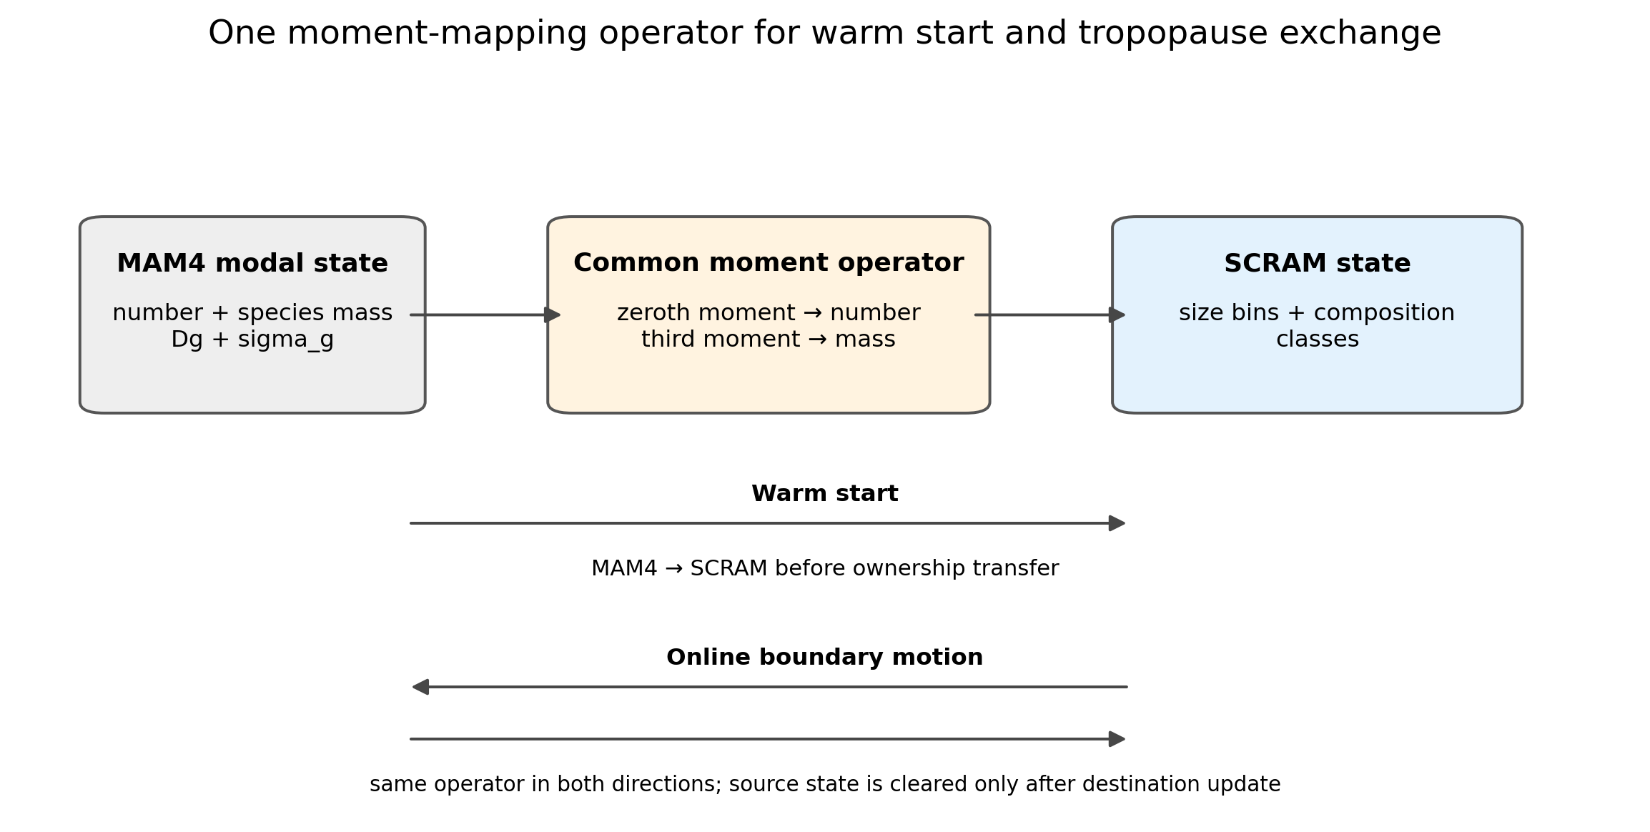
Figure S5. Common warm-start and tropopause mapping operator.
Figure S5. Common lognormal moment mapping used for warm initialization and online tropopause ownership exchange. Zeroth and third moments are treated independently so that particle number and each species mass close simultaneously.

Text S10. Gravitational settling, dry deposition, and wet scavenging
The formal External production case uses scram_settling_geometry='moving_center', unit settling and dry-deposition scale factors, and scram_wetdep_scheme='physical_lut'. Removal calculations therefore use the instantaneous moving-center particle geometry rather than only nominal section midpoints.
For gravitational settling, CARMA first evaluates the gas mean free path $λ$, Knudsen number $Kn=λ/r$, and Cunningham slip correction
$$C_{c}=1+1.246Kn+0.42Knexp(−0.87/Kn).$$
The Stokes-limit terminal speed is
$$v_{St}=\frac{2ρ_{p}r^{2}gC_{c}}{9μ},$$
with iterative Reynolds-number correction when Stokes flow is not valid; the high-Reynolds branch uses a drag-coefficient asymptote. This is the standard CARMA settling framework based on cloud/aerosol fall-speed physics (Pruppacher & Klett, 1978).
For dry deposition, the quasi-laminar surface resistance includes Brownian diffusion, impaction, interception, and settling. The particle Brownian diffusivity is
$$D_{B}=\frac{k_{B}TC_{c}}{6πμr}, Sc=\frac{ν}{D_{B}}.$$
The Brownian collection efficiency scales as $E_{B}=Sc^{−γ}$, with the surface-dependent exponent supplied by the CARMA/CAM land-surface resistance data. For surfaces without an explicit collector radius, the impaction Stokes number is
$$St=\frac{v_{f}u_{*}^{2}}{gν}, E_{IM}={\left(\frac{St}{α+St}\right)}^{2},$$
where $α$ is surface dependent; vegetated surfaces can instead use a collector-radius form of $St$. Interception $E_{INT}$ is calculated from particle-to-collector geometry. The surface resistance is
$$r_{s}={\left[3u_{*}(E_{B}+E_{IM}+E_{INT})\right]}^{−1}.$$
With aerodynamic resistance $r_{a}$, the turbulent-plus-surface resistance and total deposition velocity are
$$r_{t}=r_{a}+r_{s}+r_{a}r_{s}v_{f}, v_{d}=v_{f}+\frac{1}{r_{t}}.$$
This is the size-resolved resistance framework used by CARMA/CAM and is consistent with the particle-deposition formulation summarized by Zhang et al. (2001).
Below-cloud wet removal uses a production lookup table generated from explicit rain-drop/aerosol collision calculations rather than the legacy constant Dana–Hales scavenging coefficient. For one rain-drop class $j$ and particle class $a$, the total collection efficiency is
$$E_{ja}=min(1,E_{B}+E_{INT}+E_{IMP}),$$
and its sweep contribution is
$$Λ_{ja}=4πr_{r,j}^{2}v_{r,j}n_{r,j}E_{ja}.$$
The rain distribution is normalized to 1 mm h$​^{−1}$ during LUT construction. The resulting number/volume scavenging rates are tabulated versus particle radius and density; runtime interpolation supplies the coefficient to CAM wet deposition, where it is scaled by local precipitation and cloud conditions. In-cloud removal and resuspension remain under the host CAM wet-deposition/cloud lifecycle. Dana and Hales (1976) provide the historical washout framework, while the production physical_lut explicitly resolves Brownian, interception, and impaction collection.
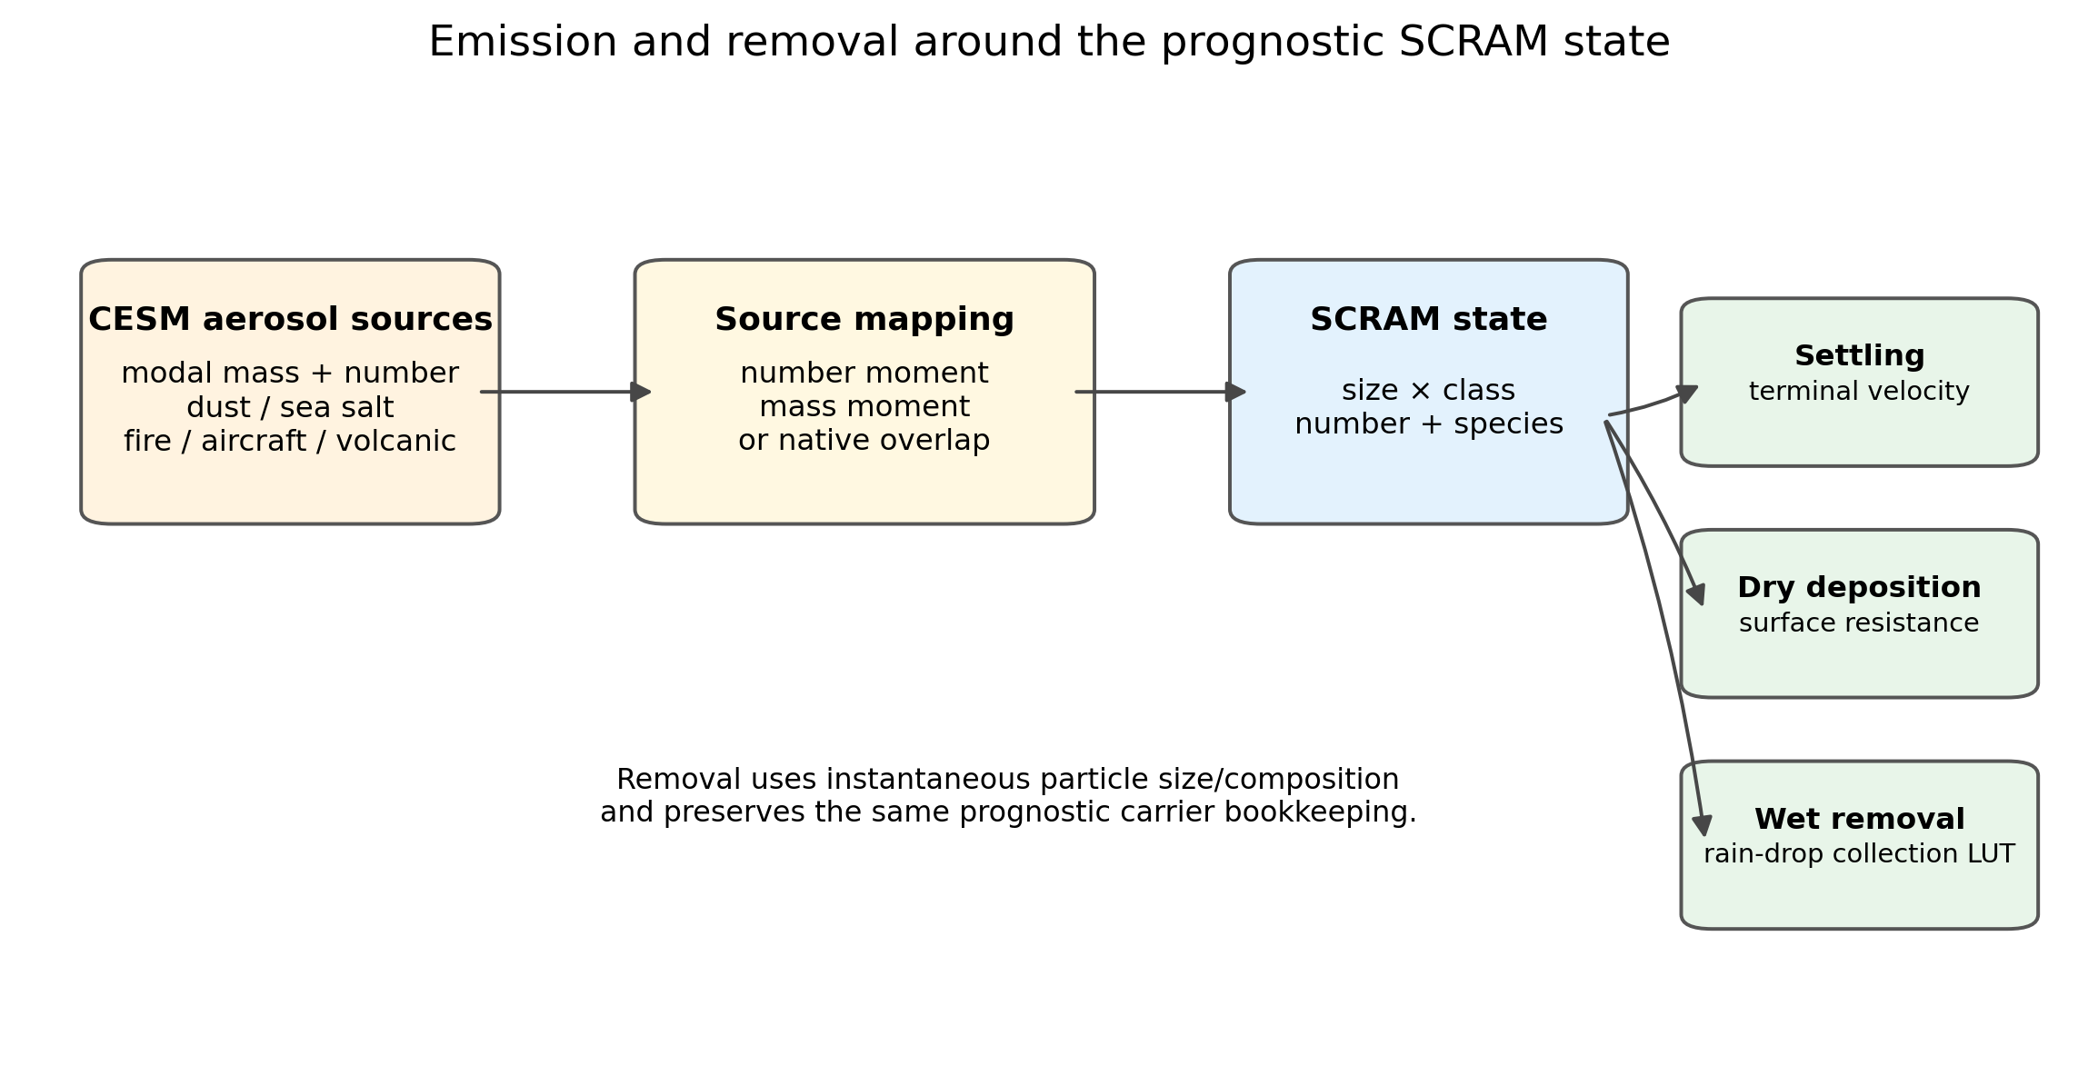
Figure S6. Emission and removal algorithms.
Figure S6. Emission and removal operators around the prognostic SCRAM state. Source number and mass enter through distinct moment mappings; settling and deposition use the instantaneous particle geometry; production below-cloud scavenging uses the physical collision LUT.

Text S11. Reduced-shell optical closure
The formal production optics use Optics_mixing=2, Optics_perclass=1, and Optics_dryshell_selector=2. Optical calculations are performed independently for each size–composition class before their layer optical moments are summed. The closure is a radiative mapping of the prognostic composition and should not be interpreted as an explicit prediction of particle morphology.
For each class, dry species volumes are $V_{s}=M_{s}/ρ_{s}$. The composite refractory core is
$$V_{c}=V_{BC}+V_{dust}, f_{BC,c}=\frac{V_{BC}}{V_{c}},$$
and the core refractive index is linearly volume mixed,
$$m_{c}(λ)=f_{BC,c}m_{BC}(λ)+(1−f_{BC,c})m_{dust}(λ).$$
All remaining dry material is assigned to the dry shell. Hygroscopic growth is calculated from host-model relative humidity using the same species $κ$ table as CCN activation. For the class,
κeff=s​Vsκss​Vs,
with PH2O excluded. The optical RH is limited to 0.95. A Kelvin-free $κ$-Köhler growth factor provides an upper bound, after which the code solves
$$RH=a_{w}(r_{w})exp\left(\frac{A}{r_{w}}\right),$$
where
$$a_{w}=\frac{r_{w}^{3}−r_{d}^{3}}{r_{w}^{3}−r_{d}^{3}(1−κ_{eff})}, A=\frac{2σ_{w}M_{w}}{RTρ_{w}},$$
by bounded bisection. This use of host RH is deliberate: prognostic PH2O remains available to thermodynamics and diagnostics but is not allowed to define the optical wet radius directly.
The optical geometry is described by
$$η=\frac{r_{c}}{r_{w}}={\left(\frac{V_{c}}{V_{tot,wet}}\right)}^{1/3}, χ_{w}=\frac{V_{shell,wet}−V_{shell,dry}}{V_{shell,wet}}.$$
The dry shell has two end members in the same LUT. Define
$$ϕ_{org,dry}=\frac{V_{org}}{V_{shell,dry}}.$$
The production selector uses a sulfate-like dry shell for $ϕ_{org,dry}≤0.5$ and a BrC/organic-like dry shell for $ϕ_{org,dry}>0.5$. The wet-shell complex refractive index is
$$m_{shell}(λ,χ_{w})=(1−χ_{w})m_{dry}(λ)+χ_{w}m_{water}(λ).$$
This packed binary-endmember design adds one physically interpretable organic-dominance decision while keeping water uptake continuous. The offline coated-sphere calculations use the Bohren–Huffman Mie solution; the runtime interpolates $Q_{ext}$, $Q_{sca}$, and asymmetry parameter $g$ in $logr_{w}$, $η$, $f_{BC,c}$, and $χ_{w}$, with dry-shell mode as a discrete selector. Optical constants are based on established BC, dust, and aerosol-optics compilations (Bond & Bergstrom, 2006; Sokolik & Toon, 1999; Hess et al., 1998).
The formal External run uses a 871,200-node LUT. Its production SHA256 is 0e9054cca9e22c196bbf92e7e81473514033794b52ce69dd9b232a0c5b797c6e. The frozen production LUT reports failed_nodes=0; 1,254 primary coated-sphere solver failures were recovered by the independent multilayer scattnlay fallback, leaving no unresolved nodes. This runtime file, rather than an older install-package copy, defines the paper optics.
Table S7. Production reduced-shell LUT dimensions.
LUT coordinate | nodes | definition
wavelength | 30 | RRTMG LW+SW band centers
r_wet | 22 | wet outer radius; interpolation in log(r_wet)
eta | 10 | r_core/r_wet
f_BC,core | 6 | BC volume fraction within BC+dust composite core
chi_w | 11 | wet-shell water volume fraction = 1-1/Gamma_shell
dry-shell mode | 2 | sulfate-like or BrC/organic-like end member
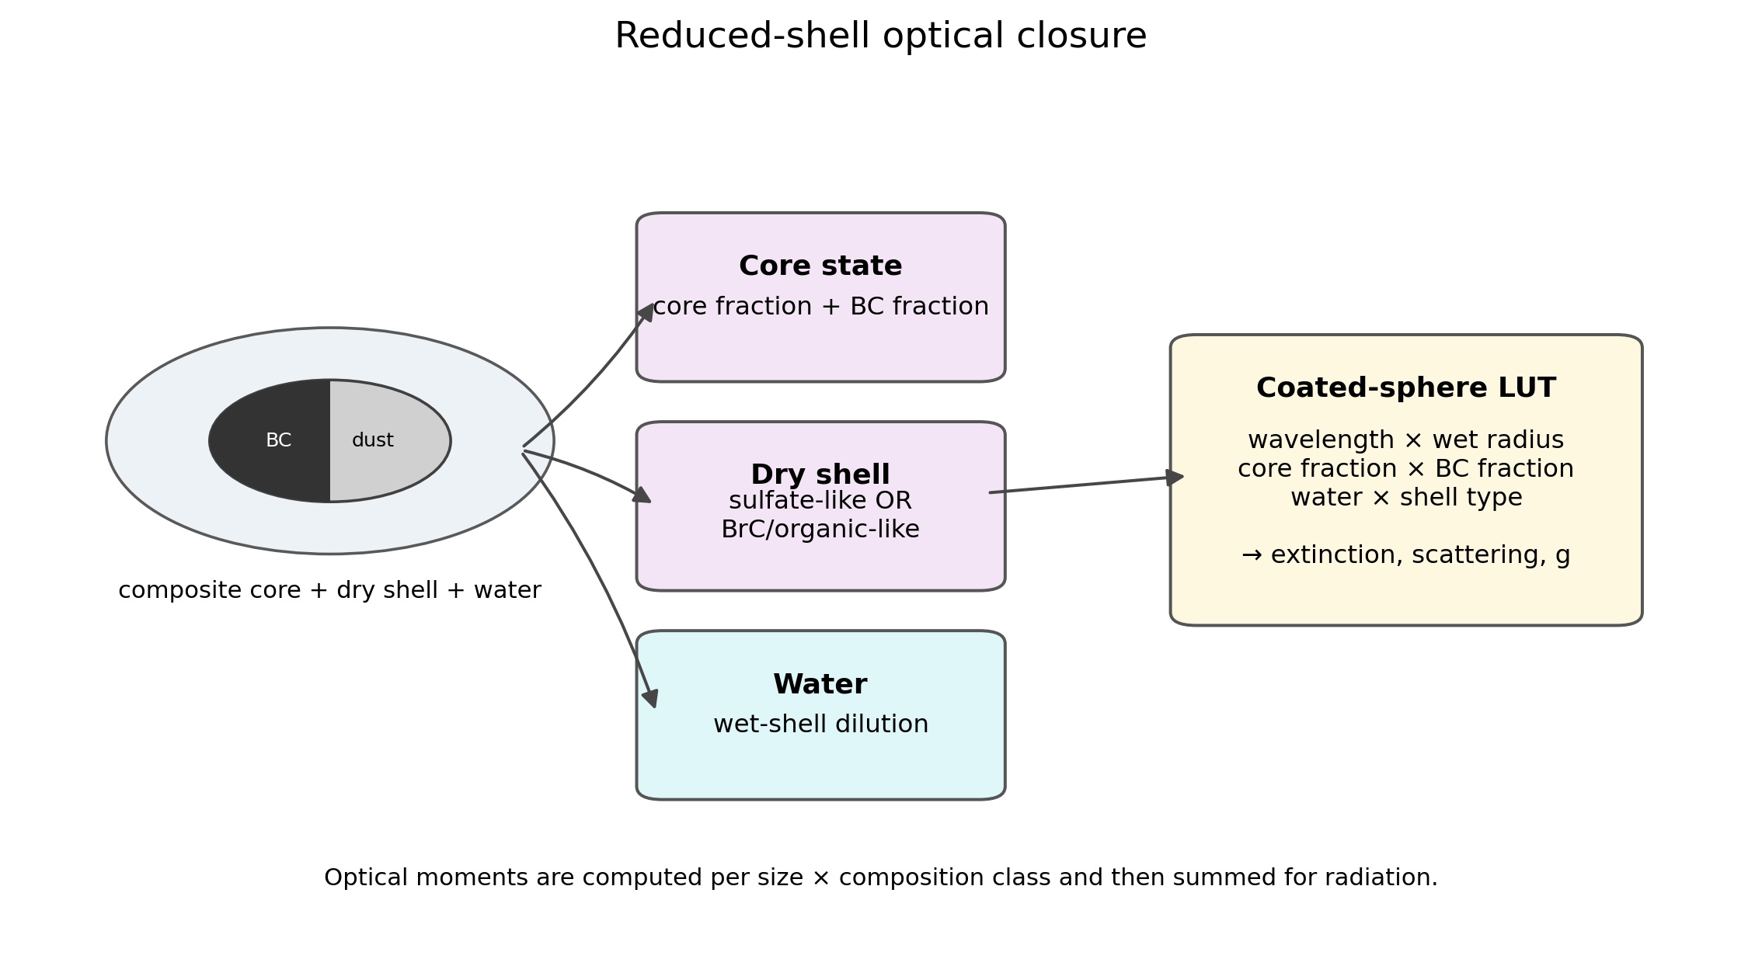
Figure S7. Production reduced-shell optical algorithm.
Figure S7. Production reduced-shell optical closure. BC and mineral dust form a two-component composite core; the dry shell switches between sulfate-like and BrC/organic-like end members, and water continuously dilutes the selected shell through $χ_{w}$. This is a radiative closure, not a claim of explicit core–shell particle morphology.

Text S12. Sectional CCN activation and prognostic cloud-borne aerosol lifecycle
CCN activation is calculated for every populated size×composition cell. The effective hygroscopicity is volume weighted (Petters & Kreidenweis, 2007),
ϵs=Ms/ρsj​Mj/ρj, κeff=s​ϵsκs,
again excluding particle water. With local temperature-dependent Kelvin parameter $A$, the production code evaluates the $κ$-Köhler critical supersaturation of the dry bin center as
$$S_{c}=2A\sqrt{\frac{A}{27κ_{eff}r_{d}^{3}}}.$$
A purely hydrophobic resolved class with $κ_{eff}=0$ remains physically present but does not contribute to liquid-water activation.
Dynamic activation uses same-timestep CAM subgrid updraft (WSUB_CURR, with the production lower floor of 0.20 m s$​^{−1}$) and the Abdul-Razzak and Ghan (2000) maximum-supersaturation framework. Each SCRAM bin×composition class is one competing sectional mode. For the monodisperse-bin limit used in the maximum-supersaturation calculation, $F_{1}=0.5$ and $F_{2}=1.0$, and
Smax2=i​F1g1,i+F2g2,iSc,i2−1,
with the thermodynamic growth/competition variables $g_{1}=(ζ/η_{i})^{3/2}$ and $g_{2}=[S_{c,i}/(η_{i}+3ζ)^{1/2}]^{3/2}$ evaluated using the same diffusion, thermal-conduction, latent-heat, and air-density terms as the CAM activation calculation. At the first step, when same-step subgrid updraft is unavailable, a 0.2% supersaturation fallback is used.
The model does not simply activate an entire size section from its midpoint. Once a target supersaturation $S_{t}$ is available, the critical dry diameter is
$$D_{crit}=D_{mid}{\left(\frac{S_{c}}{S_{t}}\right)}^{2/3}.$$
Within each explicit section, a linear dry-mass density in $lnD$ is fitted so that its number and dry-volume moments equal the two prognostic moments. The corresponding number density is proportional to the reconstructed mass density divided by $D^{3}$. Integrating above $D_{crit}$ gives the activated-number fraction; integrating the mass density gives the mass activation fraction. The fixed-supersaturation SCRAM_CCN3 diagnostic uses the same resolved population and sub-bin integration with $S_{t}=0.1\%$, whereas cloud activation uses dynamic $S_{max}$.
The dynamically activated layer-local number is then coupled to CAM cloud geometry. Cloud-base activation samples the layer below cloud base, newly formed liquid cloud samples the current layer, and persistent-cloud activation can be controlled by a production parameter. The target activated number is converted to an equilibrium grid-mean number and only a positive droplet-number deficit contributes to NPCCN.
For the formal production cases, scram_cloudborne_scheme='prognostic'. Activation is also a conservative aerosol transaction. A cloud turnover fraction
$$C_{turn}=L_{new}\left[1−exp\left(−\frac{Δt}{10800 s}\right)\right]$$
multiplies the sectional activation fraction. Particle number and every species mass are transferred together:
$$A_{N}=C_{turn}f_{act}N, A_{s}=C_{turn}f_{act}M_{s}.$$
The transfer is rejected if the source state lacks either resolvable number or dry composition, preventing creation of compositionless droplets or mass without particles. A separate dry-mass moment fraction is used for sulfate where the number-activation fraction would not conserve PSO4 mass. Number, sulfate, and total dry-mass closure are exported as explicit diagnostics.
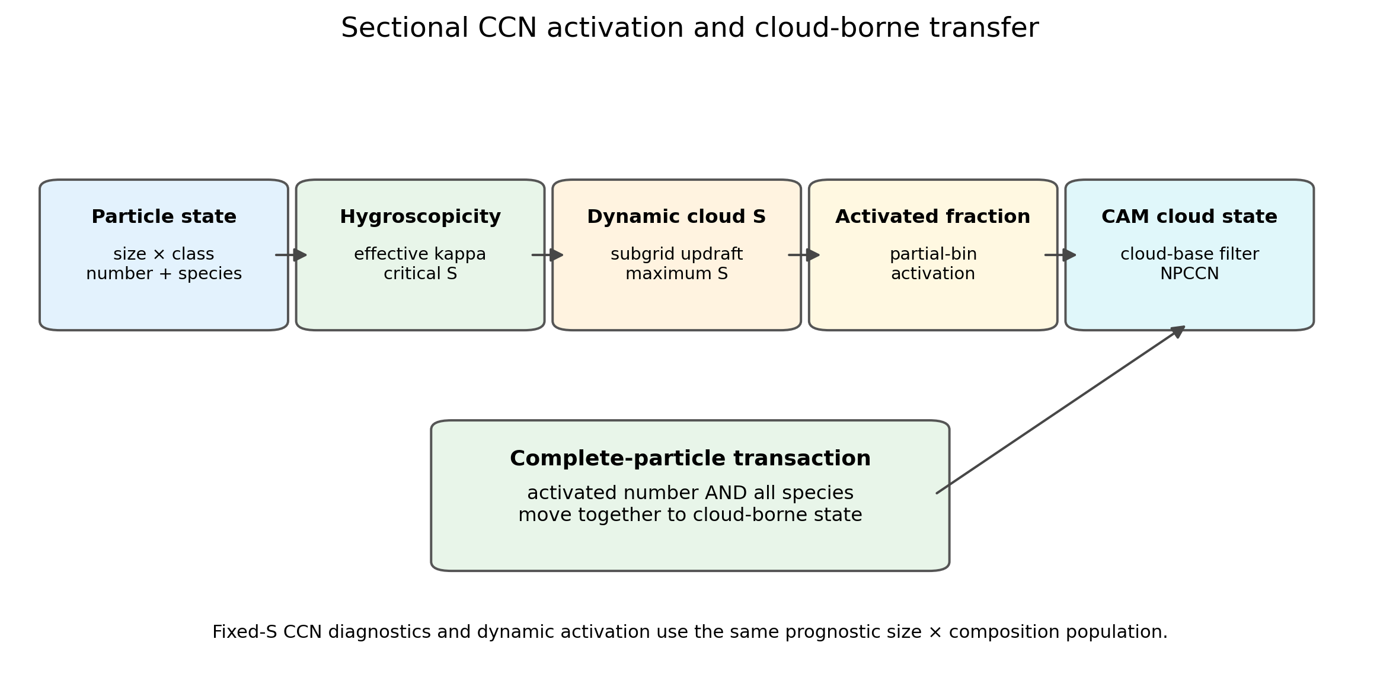
Figure S8. Sectional activation and CAM cloud coupling.
Figure S8. SCRAM sectional activation and CAM cloud coupling. The same size×composition state determines $κ$, critical supersaturation, dynamic activation, and the complete-particle cloud-borne transaction.

Text S13. Common-window construction and diagnostic-variable contract
The formal MAM4, Internal SCRAM, and External SCRAM cases have unequal current integration lengths because External SCRAM is still progressing toward the common five-year endpoint. A paper-specific Python workflow inventories every CAM history timestamp, removes initialization records, applies the same spin-up exclusion, and retains the exact date intersection. The retained dates and their hash are stored in provenance/common_window_*.json.
The common window is regenerated whenever new External files are completed. Any table or figure containing all three cases is regenerated from the updated date set. This prevents different sample lengths from contaminating the External–Internal mixing-state contrast.
The variable-contract audit separately verifies units, dimensions, long names, averaging convention, spectral definition, and aerosol ownership for every candidate comparison field. Fields with identical names but different physical content are excluded from three-way comparisons. This is particularly important for optics because SCRAM replaces the tropospheric MAM4 optical contribution rather than adding to it.

Text S14. Numerical integrity, restart, and conservation tests
The model-validation package uses process-level invariants in addition to atmospheric evaluation. The core checks include finite/nonnegative tracer screening; coagulation species-mass closure; moving-center number and species-mass closure; composition-remapping closure; CAM↔SCRAM gas conversion closure; source number/mass normalization; warm-start/tropopause number and mapped-species closure; cloud activation number/species closure; restart reproducibility; and history continuity.
These checks are intentionally attached to individual numerical operators. A climate-model field can look plausible even when a redistribution operator violates a conserved moment, so passing a multi-year simulation is not treated as a substitute for source-level conservation tests. In the current method audit, the standalone moving-center/dual-pivot conservation test, cloud-activation transaction test, physical wet-deposition LUT test, and sulfate-removal-control test all pass. Two older system-test wrappers are explicitly excluded from this statement because they still assert a historical 16-species cloud-activation contract or a removed debug token, whereas the frozen production aerosol inventory now contains 14 particle species. Their stale-contract status is recorded rather than being hidden by modifying the production algorithm. The machine-readable audit is provenance/methods_validation_20260812.json.

Text S15. Observation processing and statistical methods
Observation products are included only when their physical definitions can be reconciled with model diagnostics. Surface particulate matter comparisons use consistent size cuts and dry/ambient conventions. Optical comparisons harmonize wavelength and aerosol ownership. Satellite products are sampled with explicit treatment of missing values and geolocation; station observations are compared with collocated model values rather than global means.
Global model averages use CESM Gaussian latitude weights. Seasonal means are calculated from the retained daily samples. Spatial correlations, RMSE, mean bias, and mean fractional bias are reported with their exact definitions. Interannual or block resampling will be used for uncertainty estimates where the retained simulation length permits.

Text S16. Physical-group and chemical-species mixing-state metrics
The entropy-based mixing-state framework follows Riemer and West (2013). For particle type $i$ and component $a$, let $p_{i}^{a}$ be the mass fraction of component $a$ within particle type $i$. The particle mixing entropy and effective component diversity are
Hi=−a​pialnpia, Di=exp(Hi).
Let $p_{i}$ be the fraction of total aerosol dry mass contained in particle type $i$. The mass-weighted average particle entropy is
Hα=i​piHi, Dα=exp(Hα),
while $D_{γ}=exp(H_{γ})$ is obtained from the component mass fractions of the bulk aerosol population. The mixing-state index is then
$$χ=100 \frac{D_{α}−1}{D_{γ}−1}.$$
Two component definitions are retained. The manuscript-primary physical-group index, $χ_{g}$, first aggregates the 13 prognostic dry species into the six groups that define the production SCRAM composition classifier: DU = Dust; BC = BC; SLT = Na + chloride; SUF = sulfate; POA = primary organic aerosol; and SED = ammonium + nitrate + SOA1–SOA5. This aggregation aligns the metric with the scientific question posed by the External experiment: whether distinct aerosol material families and source/process characteristics occupy common particle types. It also avoids counting the Na and chloride constituents of one sea-salt material family as two independent mixing dimensions.
The original chemical-species index, $χ_{s}$, is calculated from all 13 dry species without aggregation and is retained as a sensitivity analysis. Water is excluded from both definitions. Both metrics use the actual species masses stored in monthly CAM restart files for all 77 External particle types (7 size bins × 11 composition classes). The formal comparison uses 28 monthly restart snapshots from 0001-05-01 through 0003-08-01, matching the analysis interval used for the manuscript mixing-state diagnostics.
The component definition materially changes the interpretation in source-dominated regimes. Using the six physical groups, the annual regional values of $χ_{g}$ are approximately 22.8% over the Sahara, 25.4% over the Middle East, 36.0% over East Asia, and 39.6% over Europe. The corresponding grouped dry-mass fractions show that DU contributes 95.4% over the Sahara and 85.2% over the Middle East. Low $χ_{g}$ in these regions therefore does not imply weak dust dominance; it indicates that the smaller non-dust material fractions remain concentrated in particle types whose group composition differs from the dominant dust population.
A second interpretive issue occurs when bulk component diversity approaches one. Riemer and West (2013) identify the exactly single-component population as a special case for which $χ$ is undefined because both numerator and denominator approach zero. Accordingly, the main-text Figure 9 retains the raw $χ_{g}$ calculation but visually flags locations with $D_{γ,g}<1.2$ as a low-diversity conditioning regime. The threshold does not redefine $χ$ or remove values from the archived diagnostics; it simply prevents a nearly single-group population from being described as a quantitatively meaningful intermediate internal/external mixture. The Southern Ocean illustrates this case: SLT contributes about 92.6% of grouped dry mass and annual $D_{γ,g}$ is only about 1.13.
For comparison, the 13-species definition produces a global annual $χ_{s}$ of about 66.0%, with much higher values over marine regions because Na and chloride contribute separately to within-particle chemical diversity. This behavior is physically meaningful for a chemical-species diversity metric but is less aligned with the manuscript’s primary question about mixing among distinct aerosol material families. We therefore retain $χ_{s}$ in Figure S13 rather than using it as the main-text mixing-state metric.
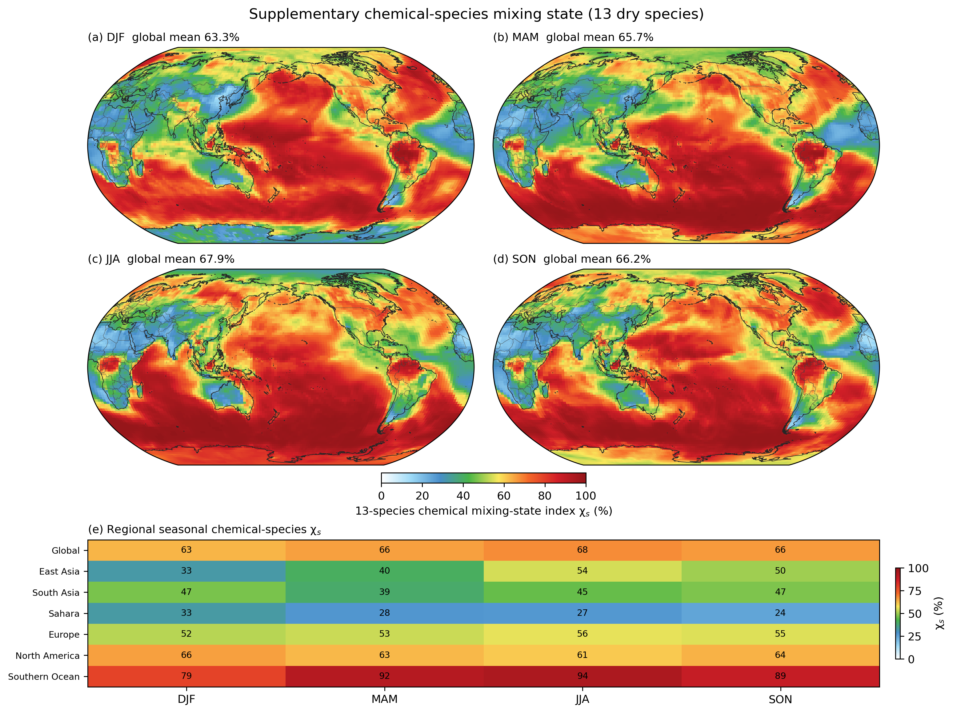
Figure S13. Chemical-species aerosol mixing-state index.
Figure S13. Chemical-species mixing-state index $χ_{s}$ calculated from the actual 13 dry prognostic species masses in the 77 External SCRAM particle types. Four seasonal maps and a regional seasonal heat map retain the original species-resolved entropy calculation as a sensitivity analysis. Unlike main-text Figure 9, Na and chloride are treated as separate chemical species, and ammonium, nitrate, and the five SOA bins also remain separate components; this increases the effective within-particle diversity of compositionally simple material families such as sea salt. Particle water is excluded.

Text S17. Additional meteorological, vertical, cloud, and climate-state diagnostics
The principal manuscript figures focus on aerosol representation, mixing state, CCN, clouds, optics, and observation-based evaluation. Additional model-state diagnostics are retained in the Supporting Information to establish that the three production cases occupy comparable meteorological regimes and to expose vertically or seasonally structured responses that are too detailed for the main text. These diagnostics use complete model year 2 because it is available for all three cases and is also the period used for several observation-based structural evaluations.
Near-surface meteorology is summarized as zonal annual means of 2-m air temperature, surface pressure, 10-m wind speed, and 2-m relative humidity (Figure S9). RHREFHT is written directly by the SCRAM cases. The MAM4 h0 stream does not contain RHREFHT, so its near-surface relative humidity is reconstructed from QREFHT, TREFHT, and PS using vapor pressure and saturation vapor pressure. This diagnostic is used only as a consistency check and does not enter aerosol process calculations.
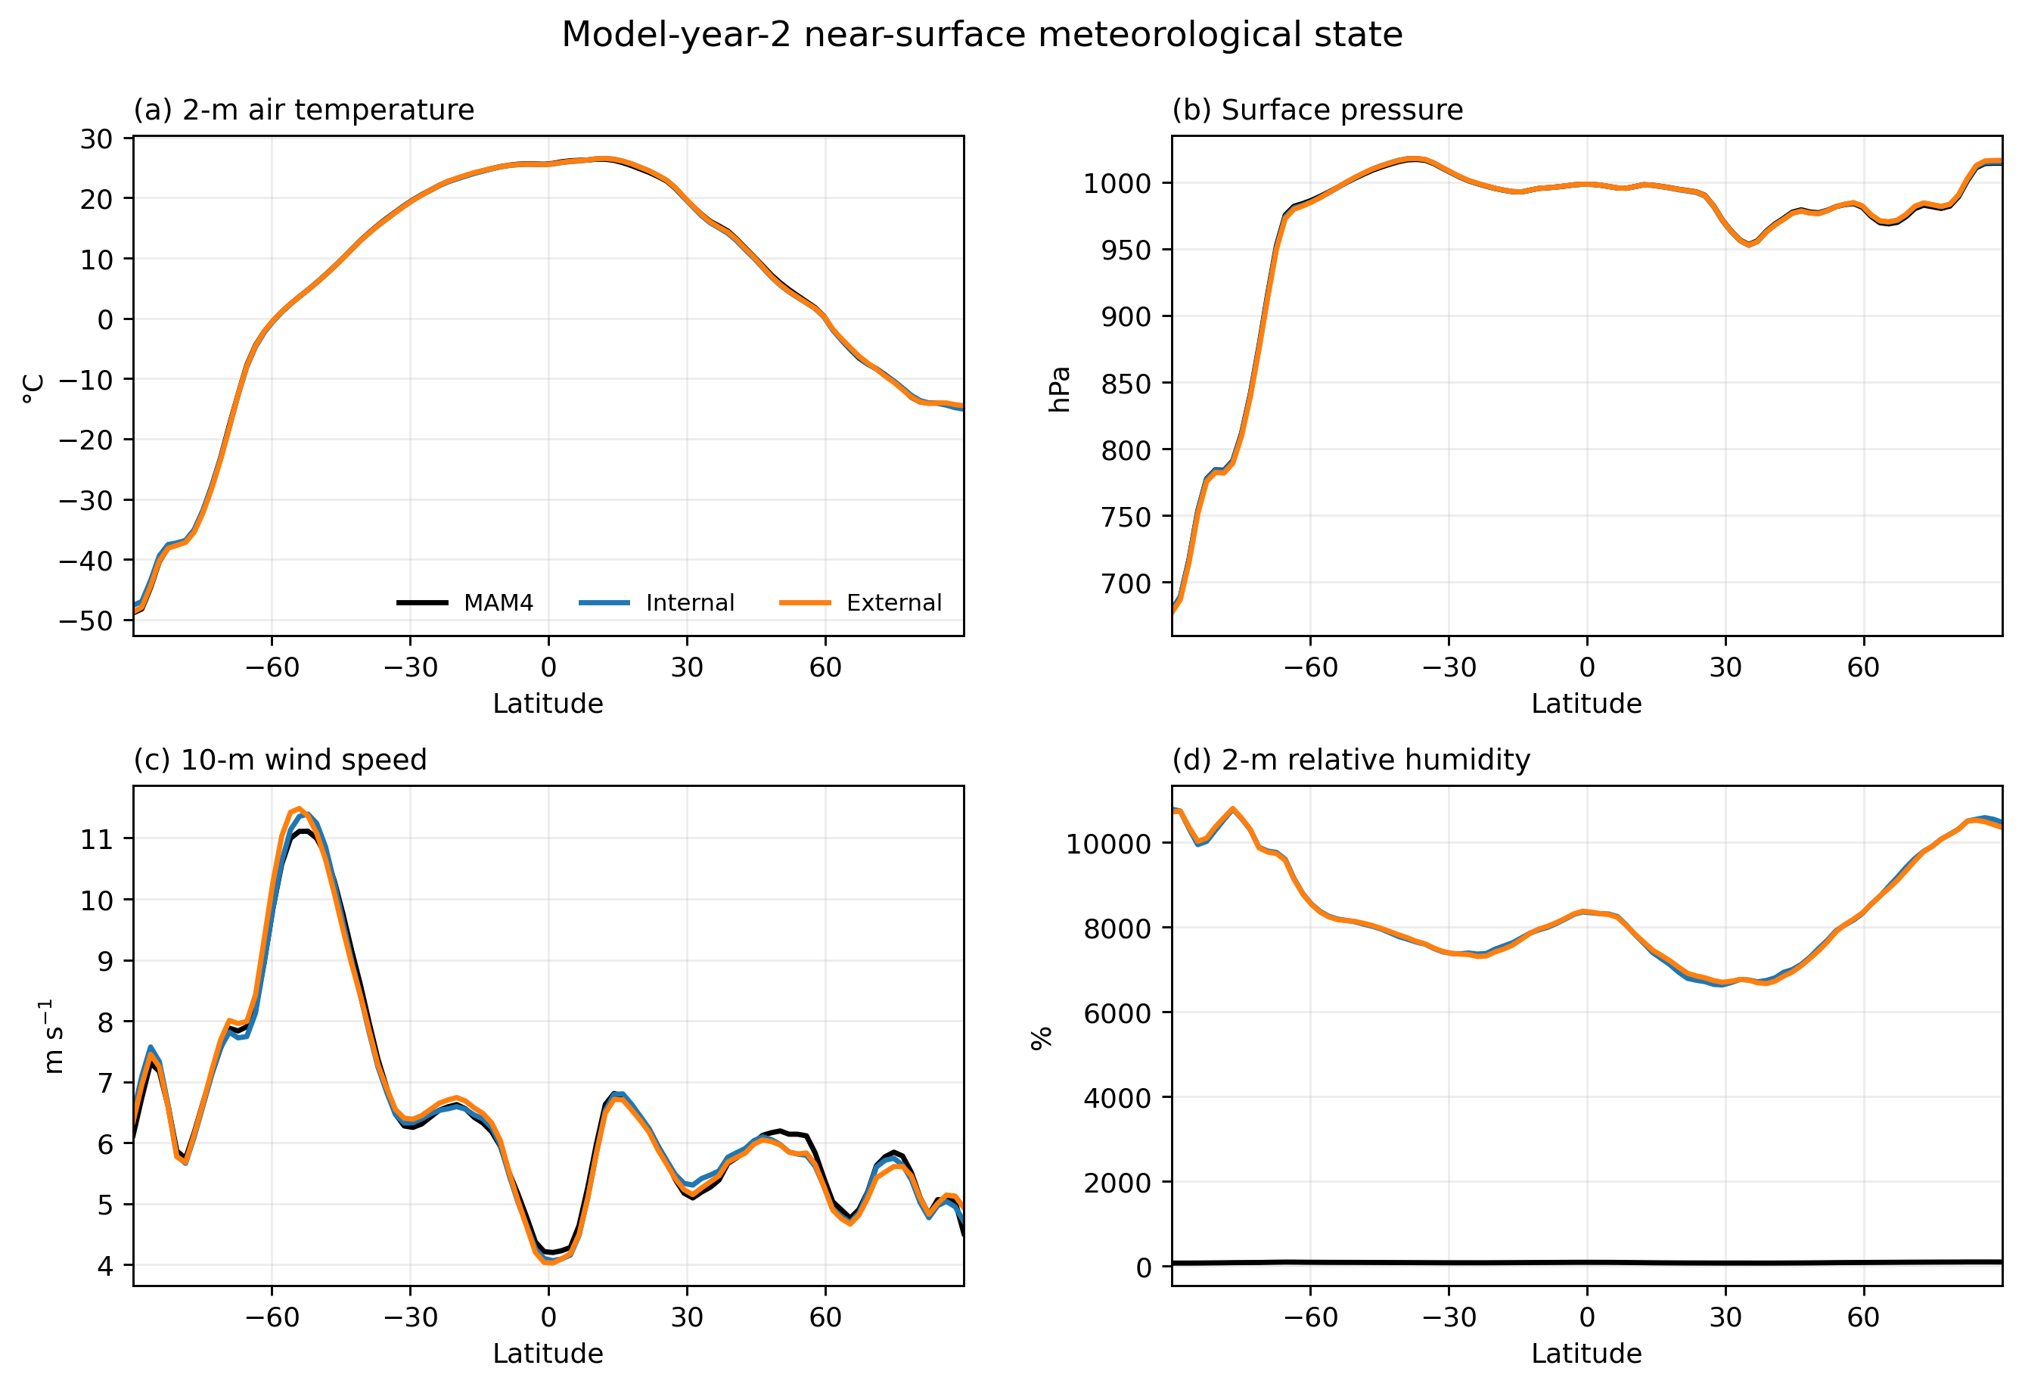
Figure S9. Model-year-2 near-surface meteorological state.
Figure S9. Model-year-2 annual zonal means of near-surface air temperature, surface pressure, 10-m wind speed, and relative humidity for MAM4, Internal SCRAM, and External SCRAM. The purpose is to test whether the aerosol-representation experiments remain embedded in comparable large-scale meteorological states rather than to tune any individual meteorological field.
Three-dimensional atmospheric structure is evaluated with latitude–pressure sections of temperature, relative humidity, zonal wind, and cloud fraction (Figure S10). Internal and External store these three-dimensional fields in monthly h1 output, which is averaged using calendar-day weights. The corresponding formal MAM4 experiment stores the same fields in daily h0 output; its year-2 zonal sections are therefore formed from daily samples. The two rows deliberately separate Internal − MAM4 from External − Internal so that modal-to-sectional changes are not confused with incremental composition-diversity effects.
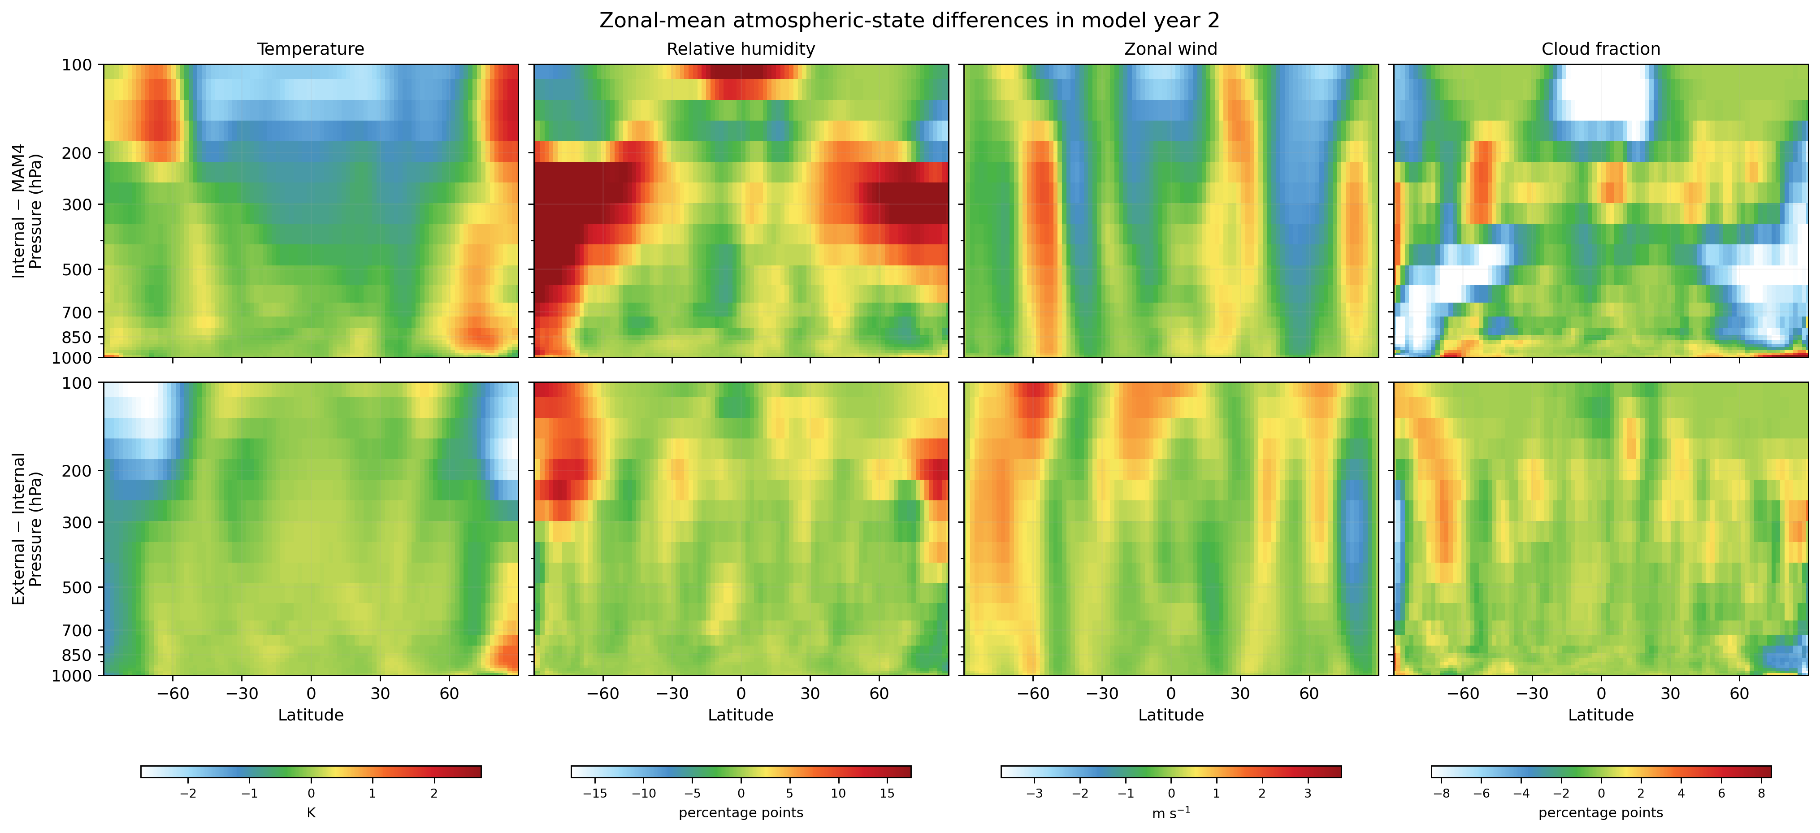
Figure S10. Model-year-2 zonal-mean atmospheric-state differences.
Figure S10. Latitude–pressure differences in annual-mean temperature, relative humidity, zonal wind, and cloud fraction during model year 2. The upper row shows Internal − MAM4 and the lower row External − Internal. Signed fields use the NCAR/NCL WhiteBlueGreenYellowRed colormap and common symmetric limits within each variable.
Additional cloud and radiative response maps are shown in Figure S11. Total cloud fraction, liquid water path, ice water path, and shortwave cloud forcing are displayed for the same two attribution contrasts. These fields complement the main-text MODIS/CERES comparisons by showing where the internally mixed SCRAM transition already alters the host cloud state and where explicit composition diversity adds a further response.
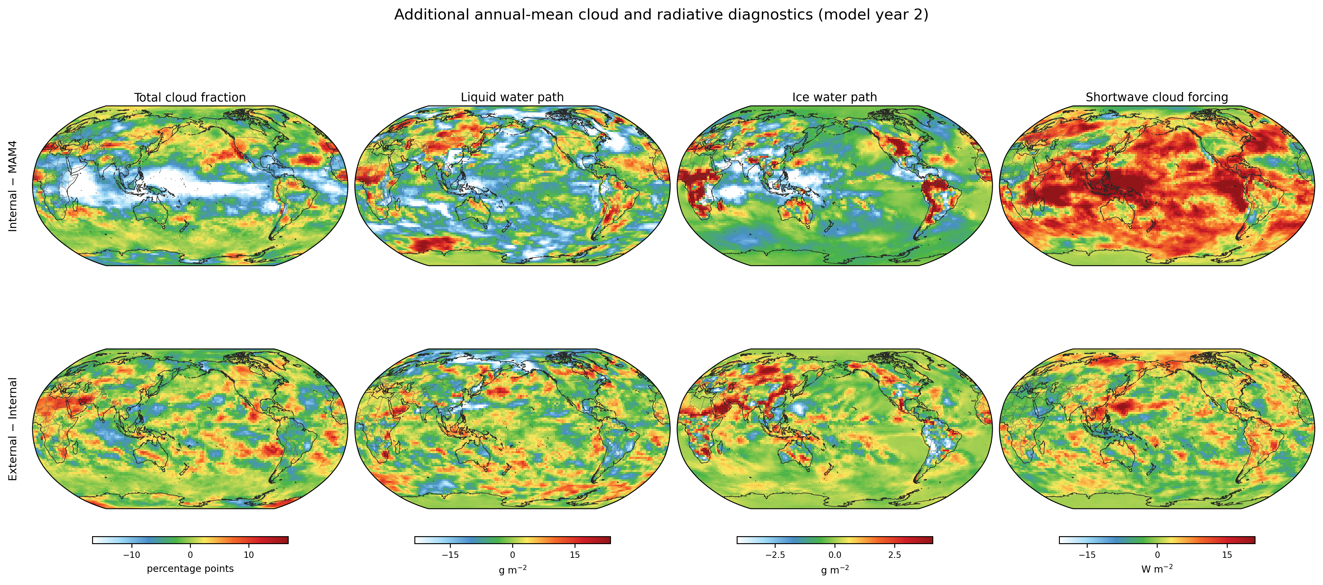
Figure S11. Additional model-year-2 cloud and radiative diagnostics.
Figure S11. Annual-mean cloud and radiative contrasts for model year 2. The upper row shows Internal − MAM4 and the lower row External − Internal for total cloud fraction, liquid water path, ice water path, and shortwave cloud forcing. All global maps include 50-m Natural Earth coastlines and country borders.
Finally, Figure S12 summarizes global monthly cycles for near-surface temperature, precipitation, total cloud fraction, liquid and ice water paths, column droplet number, and shortwave and longwave cloud forcing. These curves provide a compact check that conclusions drawn from annual or selected-season maps are not caused by a single month and identify variables whose response is strongly seasonal.
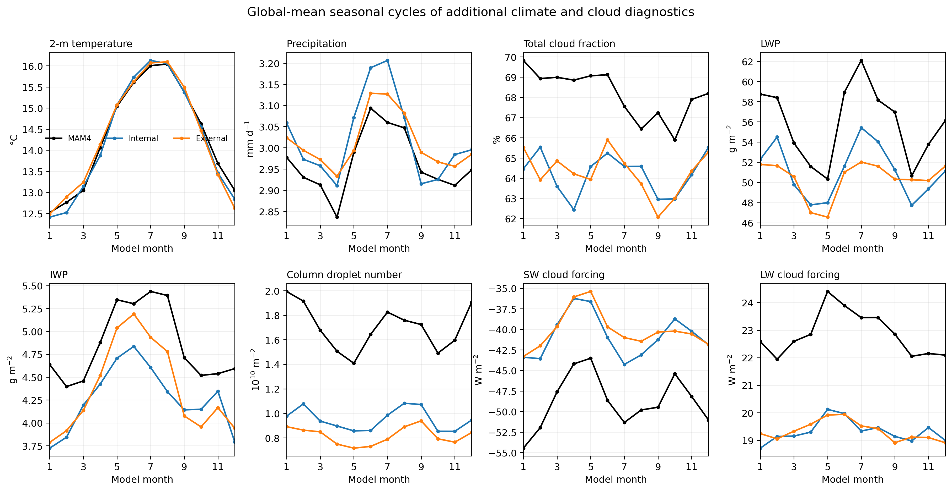
Figure S12. Seasonal cycles of additional climate and cloud diagnostics.
Figure S12. Global-mean model-year-2 seasonal cycles of eight additional meteorological, cloud, precipitation, and cloud-radiative diagnostics for MAM4, Internal SCRAM, and External SCRAM. The full extraction and weighting contract is recorded in provenance/y2_supplement_diagnostics_provenance.json.

Text S18. Performance and computational cost
The demonstrated External state contains eleven times as many SCRAM size–composition cells as the matched Internal case, but this is not an intrinsic cost multiplier of CESM–SCRAM. Runtime cost depends on the user-selected state dimensions and on which process/diagnostic options are active. Formal production job records are therefore used to report simulated years per wall day, memory, restart volume, history volume, and the cost of major physics components for the actual paper cases rather than historical development benchmarks.

Supporting Tables
Table S1. Source/configuration provenance for the algorithms documented in this SI. SHA256 values are generated from the current source tree and paper runtime profiles.
component | source/runtime file | SHA256
coagulation_nearest | ModuleCoeffRepartitionNearest.F90 | ae3817004936ed158ad3e8a3d1e838731b46ba0706dba40bb75f0bafac886554
moving_center_dualpivot | moving_diam.f90 | a2f855796d2b80bffd429f80ed77d202e10dfd4e2e3ad51a2a45dfb1bd882620
scram_coupling | carma_model_mod.F90 | dfb55600038eae222bba532cc4aa37ca7d96f3ab3d2dd517e2faee662daa4170
tropopause_exchange | scram_trop_exchange_mod.F90 | cedec9465d94cf624c650eff2b0276faa6e784114ac18413faf7c2c3b2e42e32
reducedshell_optics | scram_reducedshell_optics_mod.F90 | 260434a782985c107dba2b12b3bcd8bc7d41a6a3069a5ddfd854bcd7a7ca5e1c
reducedshell_generator | reducedshell_lut_generator.py | 87e49c9b93104e9896d7ff0563a64431f95fb4366e944bf2e0a249576071879a
cloud_activation_math | scram_cloud_activation_math_mod.F90 | 58f95abc5511af744a8aed70bb507215988aa019ef46c81a6e9417e86cb03a73
cloud_props | carma_cloud_props_mod.F90 | 6332fc91722c21dd95e27fe6af300c6d0139e944d7c5d81441fc74e18e511e29
microp_aero | microp_aero.F90 | bfd9c5b8ec9ddca99b7b985cc5f13b3c0ae8305810a3fdbbc6fb687492f7ab86
settling | setupvf_std.F90 | 32312b4e1838e9cb4336461bc6b0b2f35f8c474d79a760a55caf6d01eeea32f4
dry_deposition | calcrs.F90 | d855029dca904e1c30d32b57c3598e96cadf6bc500b57721522c47f206d0160b
wet_deposition_interface | carma_intr.F90 | 6b0fb046f7218102b9554cf9cc38ac96870b62b0a375cb55583b934c34a684bb
gas_map | scram_gas_map.txt | 942199d45cae21115332d9b13bf0ecf01c43a9b564bb2edcd810f5fa05d42df2
emission_map | scram_emis_map.txt | cd6c480e9023990f74869378fd02585bb28a6b413ff40541d93db800b6db3e71
species | scram_species.dat | f2de7f93fe4d65fe6c8ceda63bfbd55898bb8adffa20487d3266858b46eea734
external_config | scram_cesm_7bin_nc11_external.cfg | 9e1884cd731ec793bbae4819594d27ad53bd131743d95009d72ab9a301f7a401
Table S2. The complete 14-species→6-group mapping and NC1–NC11 composition-class definitions are given as main-text Tables 1–2 and are reproduced machine-readably in tables/production_species_to_group.csv, tables/production_nc11_classes.csv, and provenance/production_composition_class_definition.json.
Tables S3–S7 are embedded in Texts S6–S11 above. Paper-validation tables for process conservation, diagnostic-variable contracts, observation products, and computational performance will be generated from their production analysis scripts once the final common integration window is frozen.

Supporting Figures
Figures S1–S8 document the core numerical algorithms in Texts S3–S12. Figure S13 documents the chemical-species mixing-state sensitivity analysis in Text S16. Figures S9–S12 provide additional model-year-2 meteorological, zonal-vertical, cloud, radiation, and seasonal-cycle diagnostics in Text S17. Each supporting figure is embedded at its first point of discussion with a full caption immediately below the image.

References cited in the Supporting Information
Abdul-Razzak, H., & Ghan, S. J. (2000). A parameterization of aerosol activation: 2. Multiple aerosol types. Journal of Geophysical Research: Atmospheres, 105, 6837–6844. https://doi.org/10.1029/1999JD901161
Bohren, C. F., & Huffman, D. R. (1983). Absorption and Scattering of Light by Small Particles. Wiley.
Bond, T. C., & Bergstrom, R. W. (2006). Light absorption by carbonaceous particles: An investigative review. Aerosol Science and Technology, 40, 27–67. https://doi.org/10.1080/02786820500421521
Dana, M. T., & Hales, J. M. (1976). Statistical aspects of the washout of polydisperse aerosols. Atmospheric Environment, 10, 45–50. https://doi.org/10.1016/0004-6981(76)90258-4
Donahue, N. M., Robinson, A. L., Stanier, C. O., & Pandis, S. N. (2006). Coupled partitioning, dilution, and chemical aging of semivolatile organics. Environmental Science & Technology, 40, 2635–2643. https://doi.org/10.1021/es052297c
Emmons, L. K., Schwantes, R. H., Orlando, J. J., et al. (2020). The chemistry mechanism in the Community Earth System Model Version 2 (CESM2). Journal of Advances in Modeling Earth Systems, 12, e2019MS001882. https://doi.org/10.1029/2019MS001882
Fountoukis, C., & Nenes, A. (2007). ISORROPIA II: A computationally efficient thermodynamic equilibrium model for K+–Ca2+–Mg2+–NH4+–Na+–SO4²−–NO3−–Cl−–H2O aerosols. Atmospheric Chemistry and Physics, 7, 4639–4659. https://doi.org/10.5194/acp-7-4639-2007
Hess, M., Koepke, P., & Schult, I. (1998). Optical properties of aerosols and clouds: The software package OPAC. Bulletin of the American Meteorological Society, 79, 831–844. https://doi.org/10.1175/1520-0477(1998)079<0831:OPOAAC>2.0.CO;2
Kumar, S., & Ramkrishna, D. (1996a). On the solution of population balance equations by discretization—I. A fixed pivot technique. Chemical Engineering Science, 51, 1311–1332. https://doi.org/10.1016/0009-2509(96)88489-2
Kumar, S., & Ramkrishna, D. (1996b). On the solution of population balance equations by discretization—II. A moving pivot technique. Chemical Engineering Science, 51, 1333–1342. https://doi.org/10.1016/0009-2509(95)00355-X
Liu, X., Ma, P.-L., Wang, H., Tilmes, S., Singh, B., Easter, R. C., Ghan, S. J., & Rasch, P. J. (2016). Description and evaluation of a new four-mode version of the Modal Aerosol Module (MAM4) within version 5.3 of the Community Atmosphere Model. Geoscientific Model Development, 9, 505–522. https://doi.org/10.5194/gmd-9-505-2016
Pankow, J. F. (1994a). An absorption model of gas/particle partitioning of organic compounds in the atmosphere. Atmospheric Environment, 28, 185–188. https://doi.org/10.1016/1352-2310(94)90093-0
Pankow, J. F. (1994b). An absorption model of the gas/aerosol partitioning involved in the formation of secondary organic aerosol. Atmospheric Environment, 28, 189–193. https://doi.org/10.1016/1352-2310(94)90094-9
Petters, M. D., & Kreidenweis, S. M. (2007). A single parameter representation of hygroscopic growth and cloud condensation nucleus activity. Atmospheric Chemistry and Physics, 7, 1961–1971. https://doi.org/10.5194/acp-7-1961-2007
Pruppacher, H. R., & Klett, J. D. (1978). Microphysics of Clouds and Precipitation. Reidel. https://doi.org/10.1007/978-94-009-9905-3
Riemer, N., & West, M. (2013). Quantifying aerosol mixing state with entropy and diversity measures. Atmospheric Chemistry and Physics, 13, 11423–11439. https://doi.org/10.5194/acp-13-11423-2013
Riemer, N., Ault, A. P., West, M., Craig, R. L., & Curtis, J. H. (2019). Aerosol mixing state: Measurements, modeling, and impacts. Reviews of Geophysics, 57, 187–249. https://doi.org/10.1029/2018RG000615
Sokolik, I. N., & Toon, O. B. (1999). Incorporation of mineralogical composition into models of the radiative properties of mineral aerosol from UV to IR wavelengths. Journal of Geophysical Research: Atmospheres, 104, 9423–9444. https://doi.org/10.1029/1998JD200048
Vehkamäki, H., Kulmala, M., Napari, I., Lehtinen, K. E. J., Timmreck, C., Noppel, M., & Laaksonen, A. (2002). An improved parameterization for sulfuric acid–water nucleation rates for tropospheric and stratospheric conditions. Journal of Geophysical Research: Atmospheres, 107(D22), 4622. https://doi.org/10.1029/2002JD002184
Zhang, L., Gong, S., Padro, J., & Barrie, L. (2001). A size-segregated particle dry deposition scheme for an atmospheric aerosol module. Atmospheric Environment, 35, 549–560. https://doi.org/10.1016/S1352-2310(00)00326-5
Zhu, S., Sartelet, K. N., & Seigneur, C. (2015). A size-composition resolved aerosol model for simulating the dynamics of externally mixed particles: SCRAM (v1.0). Geoscientific Model Development, 8, 1595–1612. https://doi.org/10.5194/gmd-8-1595-2015

