**实验二 HTML编程基础**

学生姓名： 张淑平 学 号： 6103115049 专业班级： 计科152

实验类型：□ 验证□ 综合 □ 设计 □ 创新 实验日期： 4/12 实验成绩：

1. **实验项目名称**

HTML编程基础

1. **实验目的**

1． 掌握静态网页制作的一般方法

2． 掌握HTML中的常见标签

3． 学习利用常用的文字布局及字体标签、列表标签、表格标签、框架标签进行网页布局设计

4． 掌握链接标签、表单标签进行前台交互页面设计

1. **实验要求**

1． 实验内容中各习题源代码文件名规范，尽量见名知意，并有适当的注释

2． 创建一个WEB项目，将实验内容中习题1~习题5所实现的HTML文件，放入此项目内

3． 部署并运行已创建的WEB项目

4． 在至少一种以上的浏览器上运行并测试项目

1. **主要仪器设备及耗材**

PC机系统软件配置Window 7系统以上，至少安装一种以上的浏览器用于页面测试

1. **实验内容**

习题1. 用HTML开发一个用户留言板界面，要求将HTML文件设定为黑色底、文件标题为“用户留言本”，界面中至少应含有输入用户名和留言文字的两个部分。

习题2. 输入一篇文章“HTML简介”，如下：

*HTML（HyperText Mark-up Language，超文本标记语言），是构成网页文档的主要语言。一般情况下，网页上看到的文字、图形、动画、声音、表格、链接等元素大部分都是由 HTML语言描述的。*

*HTML语言的基本组成部分是各种标签，一张生动的网页往往含有大量的标签。使用标签，实际上就是采用一系列指令符号来控制输出的效果，如：<BR>，是最常使用的控制格式的标签，它表示在网页上换行*

*HTML 有两种类型的标签：*

*一类是单标签，<BR>就是一种单标签，它只需要单独一组符号就可以表示完整的功能。*

*另一类是双标签，形如<B>内容</B>，表示将"内容"显示为粗体，这种标签所围绕的内容就是标签作用的作用域*

利用下列标记（标记可以自由组合）给这篇文章建立多样化的文字编排效果。

<Hn>、<FONT>、<B>、<I>、<U>、<UL>、<OL>、<BR>、<P>、<SUP>、<SUB>、<HR>、<DIV>、<SPAN>

在该文章中插入两幅图片，插入位置为文章的右上角和左下角。

习题3.建立一个课本目录的超链接架构，页面上的超链接文字为书的章节，链接的内容为各章节的简介，简介结尾处单击“返回”可回到书的章节处

习题4. 使用表格标签建立一个班级课程表，要求表格的边框颜色为黑色，宽度为3，每天划分为（7：50~9：25，9：25~12：10，13：50~15：25，15：45~18：10分）5个时间段，不同时间段的表格单元用不同背景色突现，不同的课程名用不同的颜色标示，此外还需要显示制作表格的时间。

习题5. 利用框架标签建立一个页面，要求先上下分割成两个窗口，其中下面的窗口再分割成左右两个窗口，各个窗口都显示一个HTML文件，如课本图2-19所示，在页面的A部分显示“Login”和“Register”链接，单击Login链接，C部分显示如图2-20所示，单击Register链接，C部分显示如图2-21所示。在页面的B部分显示三个链接分别是HTML简介、课本目录、班级课程表，点击超链接，在C部分分别显示习题2、习题3、习题4的页面内容。

习题6. 设计并建立一个自选主题的网站主页。

自选主题（如个人网站、班级网站、学院网站、小型花店网站、体育比赛宣传网站等），设计并建立一个网站主页。应包含：网站图标、导航条、主题栏目、友情链接，网站备案等，网站的素材自行准备。

1. **实验数据及处理结果**

请在此处将实验内容中各习题页面源代码附在此处，代码中应有适当的注释，实现效果请用截图形式呈现。

习题1：代码

<!DOCTYPE html>

<html lang="en">

<head>

    <meta charset="UTF-8">

    <meta name="viewport" content="width=device-width, initial-scale=1, maximum-scale=1, user-scalable=no">

    <!-- 最新版本的 Bootstrap 核心 CSS 文件 -->

    <link rel="stylesheet" href="https://cdn.bootcss.com/bootstrap/3.3.7/css/bootstrap.min.css" >

    <style>

        /*初始化css*/

        *{

            padding: 0;

            margin: 0;

        }

        body{

            background-image: url(../images/bg.jpg);

            background-repeat: no-repeat;

            background-position: 0 0;

            background-size: auto;

            width: 100%;

            height: 100%;

        }

        .main{

            padding-top: 10vh;

            height: 100vh;

            opacity:0.5;

            background-color:#000;

            overflow: auto;

        }

        .title{

            width:15%;

            margin-left: auto;

            margin-right: auto;

            color: #000;

            font-weight: 800;

            color: #fff;

        }

        .form-group{

            width: 80%;

            margin-left: auto;

            margin-right: auto;

        }

        button{

            margin-top: 30px;

        }

    </style>

    <title>用户留言板</title>

</head>

<body>

    <div class="container-fluid">

      <div class="row">

            <div class="col-md-3"></div>

            <div class="col-md-6 main">

                <div class="title"><h1>留言板</h1></div>

                <div class="form-group">

                 <input type="text" class="form-control" id="name" placeholder="请输入你的姓名">

                </div>

                <div class="form-group">

                 <textarea class="form-control" placeholder="请输入留言内容" id="content" rows="10"></textarea>

                </div>

                <div class="form-group">

                    <button type="button" class="btn btn-lg btn-primary" id="tj" >提交</button>

                </div>

            </div>

            <div class="col-md-3"></div>

      </div>

    </div>

    <!-- 引入jquery -->

    <script src="https://cdn.bootcss.com/jquery/3.3.1/jquery.min.js"></script>

    <script>

        $("#tj").click(function() {

            var name=$("#name").val();

            var content=$("#content").val();

            if(name==""){

                alert("请输入姓名！")

            }else if(content==""){

                alert("请输入留言内容！")

            }else{

                alert("你的姓名为:"+name+"你的留言内容为："+content);

            }

        })

    </script>

</body>

</html>

习题1：截图

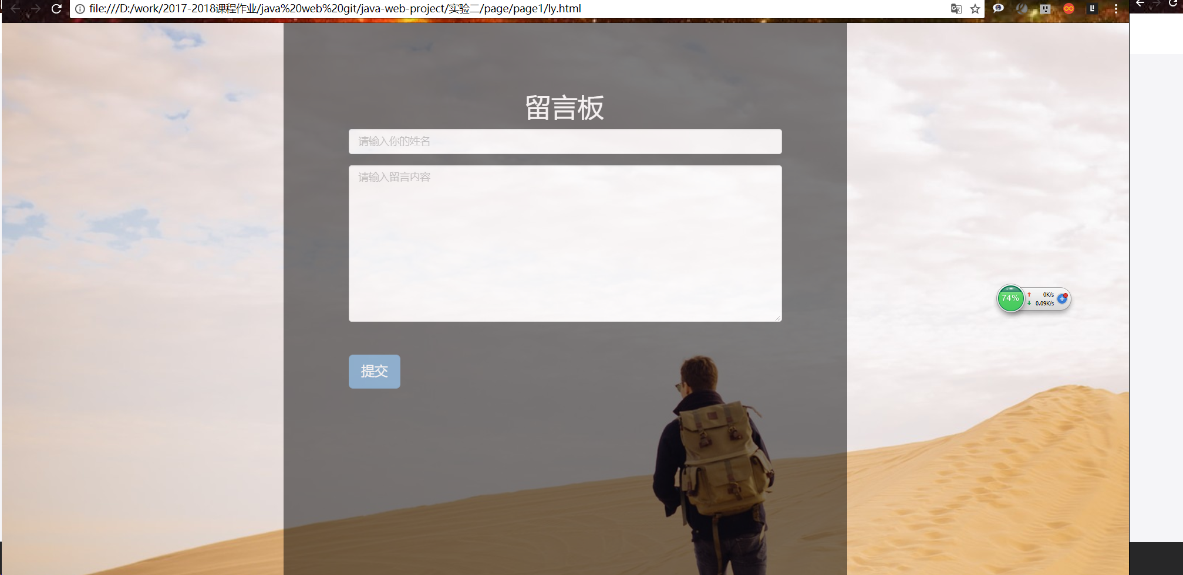

习题2：代码

<!DOCTYPE html>

<html lang="en">

<head>

    <meta charset="UTF-8">

    <style>

        *{

            padding: 0;

            margin: 0;

        }

        body{

            background-image: url(../images/bg.jpg);

            background-repeat: no-repeat;

            background-position: 0 0;

            background-size: auto;

            width: 100%;

            height: 100%;

        }

        .content{

            height: 90vh;

            width: 80%;

            background-color: rgba(255,255,255,.6);

            margin-left: auto;

            margin-right: auto;

            color:#000;

            padding:5vh 10px;

        }

    </style>

    <title>html简介</title>

</head>

<body>

    <div class="content">

        <div align="right"> <img src="../images/ncu.png" width="260px" height="260px"> </div>

        <p style="font-family:'Times New Roman','SimSun';text-indent: 2em">

            &nbsp;&nbsp;HTML（HyperText Mark-up Language，超文本标记语言），是构成网页文档的主要语言。一般情况下，网页上看到的文字、图形、动画、声音、表格、链接等元素大部分都是由 HTML语言描述的。

        </p>

        <hr>

        <p style="font-family:'Times New Roman','SimSun';text-indent: 2em">

            &nbsp;&nbsp;HTML语言的基本组成部分是各种标签，一张生动的网页往往含有<b>大量的标签</b>。使用标签，实际上就是<i>采用一系列指令符号来控制输出的效果</i>，如：<font color="red" size="20px">br</font>，是最常使用的控制格式的标签，它表示在网页上换行

        </p>

    <hr>

        <p style="font-family:'Times New Roman','SimSun';text-indent: 2em">

            &nbsp;&nbsp;HTML 有两种类型的标签：一类是<u>单标签</u>，&ltbr&gt就是一种单标签，它只需要单独一组符号就可以表示完整的功能。

            另一类是<u>双标签</u>，形如&ltB&gt内容&lt/B&gt，表示将"<b>内容</b>"显示为粗体，这种标签所围绕的内容就是标签作用的作用域。

        </p>

    <div align="left"><img src="../images/ncu.png" width="260px" height="260px"> </div>

    </div>

</body>

</html>

习题2：截图

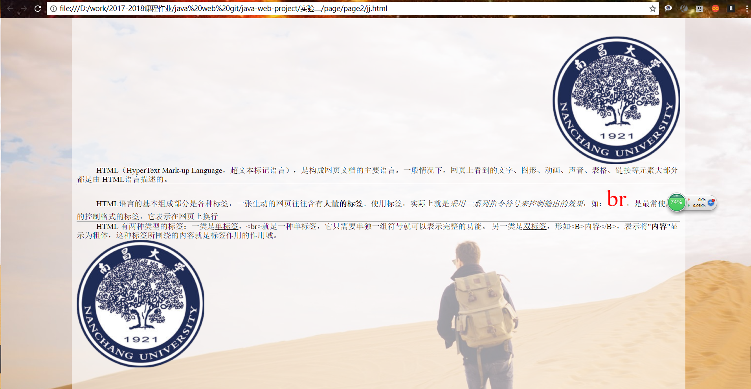

习题3：代码

<!DOCTYPE html>

<html lang="en">

<head>

    <meta charset="UTF-8">

    <title>课表</title>

    <link rel="stylesheet" href="https://cdn.bootcss.com/bootstrap/3.3.7/css/bootstrap.min.css" >

    <style>

        *{padding: 0;margin: 0;}

        .title{text-align: center;}

        table{border: #000 solid 3px;text-align: center;}

        table tr th,td{text-align: center;width: 10%;height: 15vh;border: #000 solid 3px;}

        .time1{background-color: #d8d885;}

        .time2{background-color: #ddd;}

        .time3{background-color: #aaa;}

        .time4{background-color: #f00;}

        .pro1{color:red;}

        .pro2{color:blue;}

        .pro3{color:yellow;}

        .pro4{color:#d8d8d8;}

        .pro5{color:#aaa;}

        .pro6{  color: #d8d885;}

        .pro7{color:#f00;}

    </style>

</head>

<body>

    <div class="container-fluid">

      <div class="row">

          <div class="col-md-3"></div>

          <div class="col-md-6">

              <div class="title"><h1>计科152班课表</h1></div>

                <div class="table">

                    <table>

                        <tr>

                            <th></th><th>周一</th><th>周二</th><th>周三</th><th>周四</th><th>周五</th><th>周六</th><th>周日</th>

                        </tr>

                        <tr>

                            <td class="time1">7:50-9:25</td><td class="time1"> </td><td class="time1"></td><td class="time1"></td><td class=" time1 pro1">linux程序设计</td><td class="time1"></td><td class="time1"></td><td class="time1"></td>

                        </tr>

                        <tr><td class="time2">9:25-12:10</td><td class=" time2 pro2">web程序设计</td><td class=" time2 pro2">web程序设计实验</td><td class="time2 pro3">编译原理</td><td class="time2 pro1">linux程序设计实验</td><td class="time2 pro7">网络安全技术</td><td class="time2"></td><td class="time2"></td>

                        </tr>

                        <tr><td class="time3">13:50-15:25</td><td class="pro4 time3">计算机图形学实验</td><td class="time3"></td><td class="pro3 time3">编译原理实验</td><td class="time3"></td><td class="pro6 time3">微机接口实验</td><td class="time3"></td><td class="time3"></td>

                        </tr>

                        <tr><td class="time4">15：45~18：10</td><td class=" time4 pro4">计算机图形学</td><td class="time4 pro5">软件工程</td><td class="time4"></td><td class="time4"></td><td class=" time4 pro6">微机接口</td><td class="time4"></td><td class="time4"></td>

                        </tr>

                    </table>

                </div>

                <div class="time">2018/04/18 12:25</div>

            </div>

          <div class="col-md-3"></div>

      </div>

  </div>

</body>

</html>

习题3：截图

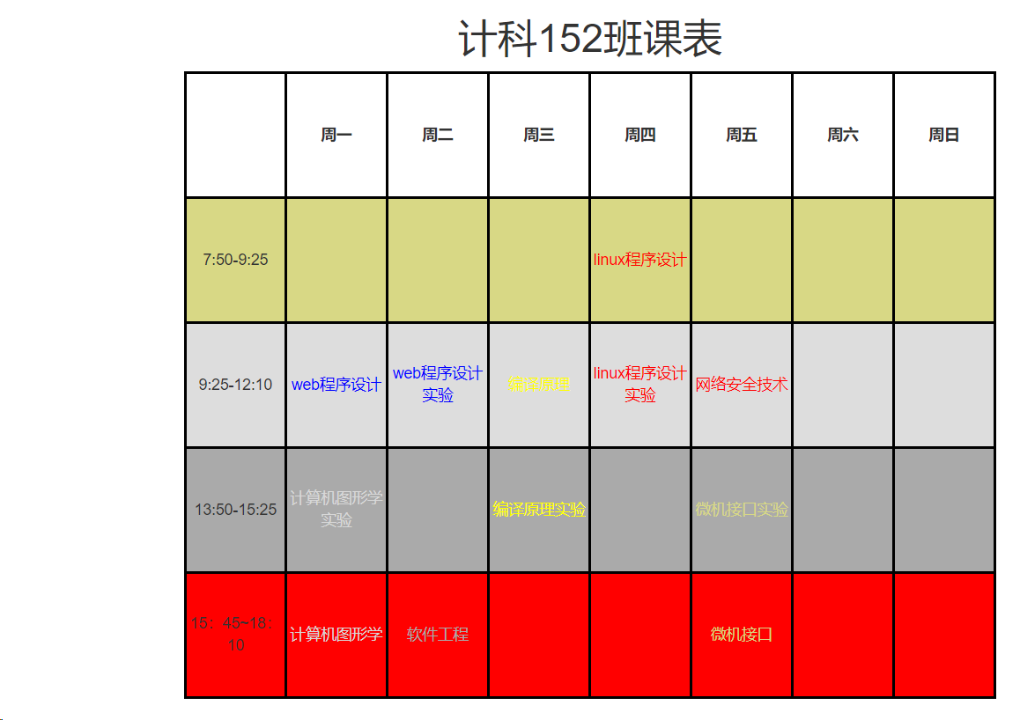

习题4：代码

<!DOCTYPE html>

<html lang="en">

<head>

    <meta charset="UTF-8">

    <style>

        *{

            padding: 0;

            margin: 0;

        }

        body{

            width: 100%;

            height: 100%;

        }

        .m1,.page1,.page2,.page3,.page4,.page5,.page6,.page7,.page8{

            width: 100%;

            height:100vh;

        }

        .m1{

            background-image: url(../images/bg.jpg);

            background-repeat: no-repeat;

            background-position: 0 0;

            background-size: auto;

            width: 100%;

            height: 100%;

        }

        .m1 .content{

            width: 60%;

            height: 100vh;

            background-color: #000;

            opacity:0.6;

            margin-left: auto;

            margin-right: auto;

            color: #fff;

            font-size: 25px;

            padding: 50px;

            text-align: center;

        }

        a{

            text-decoration: none;

        }

    </style>

    <title>课本目录</title>

</head>

<body>

    <!-- 目录页面 -->

    <div class="m1" id="m1">

        <div class="content">

            <h1>目录</h1>

            <ul>

                <li><a href="#page1">第一章：java web 开发环境配置</a></li>

                <li><a href="#page2">第二章：html基础</a></li>

                <li><a href="#page3">第三章：javascript基础</a></li>

                <li><a href="#page4">第四章：jsp基本语法</a></li>

                <li><a href="#page5">第五章：表单开发</a></li>

                <li><a href="#page6">第六章：jsp访问数据库</a></li>

                <li><a href="#page7">第七章：jsp内置对象一</a></li>

                <li><a href="#page8">第八章：jsp内置对象二</a></li>

            </ul>

        </div>

    </div>

    <div class="page1" id="page1" >

        第一章：java web 开发环境配置<br>

        <a href="#m1">返回目录</a>

    </div>

    <div class="page2" id="page2">

        第二章：html基础<br>

        <a href="#m1">返回目录</a>

    </div>

    <div class="page3" id="page3">

        第三章：javascript基础<br>

        <a href="#m1">返回目录</a>

    </div>

    <div class="page4" id="page4">

        第四章：jsp基本语法<br>

        <a href="#m1">返回目录</a>

    </div>

    <div class="page5" id="page5" >

        第五章：表单开发<br>

        <a href="#m1">返回目录</a>

    </div>

    <div class="page6" id="page6">

        第六章：jsp访问数据库<br>

        <a href="#m1">返回目录</a>

    </div>

    <div class="page7" id="page7">

        第七章：jsp内置对象一<br>

        <a href="#m1">返回目录</a>

    </div>

    <div class="page8" id="page8">

        第七章：jsp内置对象二<br>

        <a href="#m1">返回目录</a>

    </div>

</body>

</html>

习题4：截图

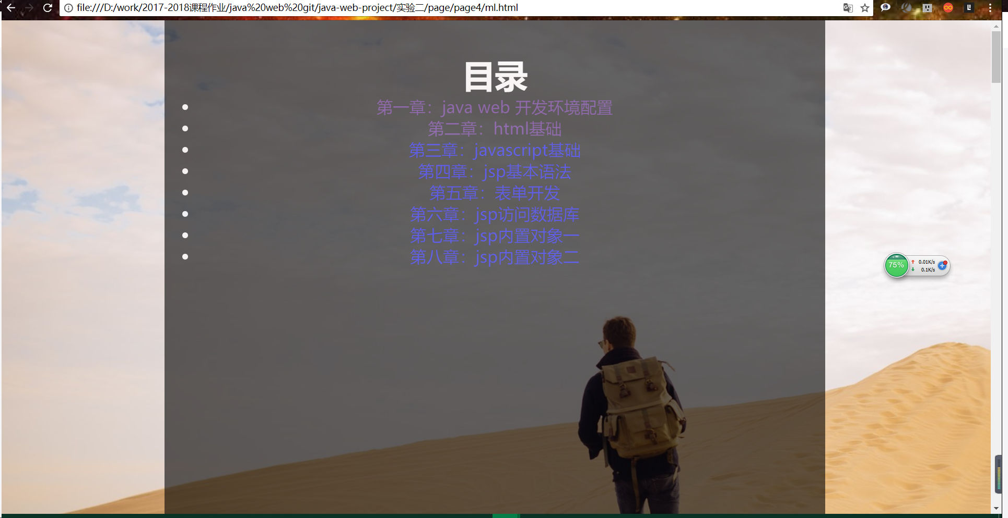

习题5：代码

frame.html

<html>

    <frameset rows="20%,80%" border="2">

        <frame src="top.html" noresize scrolling="no" name="top"></frame>

     <frameset cols="30%,70%">

         <frame src="treemenu.html" noresize scrolling="no" name="treemenu"></frame>

         <frame src="main.html" noresize scrolling="no" name="main"></frame>

     </frameset>

    </frameset>

    </frame>

</html>

login.html

<!DOCTYPE html>

<html>

<head>

<meta charset="UTF-8">

<title>Insert title here</title>

</head>

<style>

    .whole{

        width:60%; height:100%;

        background-color: #f6f5ec;

        margin-left: 20%;

        font-size:20px;

        margin-top: 8%;

        line-height: 45px;

    }

</style>

<body>

<div class="whole">

    <div style="margin-left: 40%">

        <b>Please Log In</b>

    </div>

    <div>

        <form name="login" method="post" action="aa.jsp" ">

            <table style=" width:100% ;table-layout:fixed">

                <tr>

                    <td align="right">Login:</td>

                    <td colspan="2"><input type="text" size="40"

                     value="please input your name" onfocus="if (value=='please input your name'){value=''}"

                     onblur="if(value==''){value='please input your name'}" ></td>

                </tr>

                <tr>

                    <td align="right" >Password:</td>

                    <td colspan="2"><input type="password" size="41"></td>

                </tr>

                <tr>

                    <td>&nbsp</td>

                    <td align="left">

                        <input type="button" value="OK" >

                        <input type="button" value="Forget Password">

                    </td>

                    <td>&nbsp</td>

                </tr>

            </table>

        </form>

    </div>

</div>

</body>

</html>

main.html

<html>

<body>

<h3 style="text-align:center">main.html (Section C)</h3>

</body>

</html>

register.html

<!DOCTYPE html>

<html>

<head>

<meta charset="UTF-8">

<title>Insert title here</title>

<style>

    .contents{

        background-color: #f6f5ec;

        width:100%;

        height: 100%;

    }

    .forms{

        margin-left:3%;

        margin-top:3%;

        width:100%;

        height:80%;

    }

    .tables{

        width:100%;

        height:100%;

        border:"2";

    }

    .name{

        width:13%;

    }

</style>

</head>

<body>

<div class="contents">

    <div style="height:15px"></div>

    <form class="forms">

        <table class="tables" >

            <caption><b>New Member</b></caption>

            <tr><td>&nbsp</td></tr>

            <tr>

                <td class="name">ID</td>

                <td><input type="text" size="45"></td>

            </tr>

            <tr>

                <td>Password</td>

                <td><input type="password" size="46"></td>

            </tr>

            <tr>

                <td>Re-Password</td>

                <td><input type="password" size="46"></td>

            </tr>

            <tr><td>&nbsp</td></tr>

            <tr>

                <td>First Nme</td>

                <td><input type="text" size="45"></td>

            </tr>

            <tr>

                <td>Last Name</td>

                <td><input type="text" size="45"></td>

            </tr>

            <tr>

                <td>Address</td>

                <td><input type="text" size="45"></td>

            </tr>

            <tr>

                <td>City</td>

                <td><input type="text" size="45"></td>

            </tr>

            <tr>

                <td>State</td>

                <td>

                    <select>

                        <option selected>[Select State]</option>

                        <option> State1</option>

                        <option> State2</option>

                        <option> State3</option>

                    </select>

                </td>

            </tr>

            <tr>

                <td>Country</td>

                <td><input type="text" size="20"></td>

            </tr>

            <tr>

                <td>Email Address</td>

                <td><input type="text" size="45"></td>

            </tr>

            <tr><td>&nbsp</td></tr>

            <tr>

                <td>Select Interest</td>

                <td>

                    <input type="checkbox"> Technology

                    <input type="checkbox"> Enterprise

                    <input type="checkbox"> Research

                    <input type="checkbox"> Government

                    <input type="checkbox"> People

                    <input type="checkbox"> Life Style

                    <input type="checkbox"> Option

                </td>

            </tr>

            <tr><td>&nbsp</td></tr>

            <tr>

                <td>Question</td>

                <td>

                    <select>

                        <option selected>[Select Question]</option>

                        <option>Question1</option>

                        <option>Question2</option>

                        <option>Question3</option>

                        <option>Question4</option>

                    </select>

                </td>

            </tr>

            <tr>

                <td>Answer</td>

                <td><input type="text" size="45"></td>

            </tr>

            <tr><td>&nbsp</td></tr>

            <tr>

                <td>&nbsp</td>

                <td>

                    <input type="button" value="Submit Information">

                    <input type="button" value="ResetForm">

                </td>

            </tr>

        </table>

    </form>

</div>

</body>

</html>

top.html

<html>

<body>

<h3 style="text-align:center">top.html (Section A)</h3>

<p style="text-align:center"><a href="login.html"target="main">Login</a></p>

<p style="text-align:center"><a href="register.html"target="main">Register</a></p>

</body>

</html>

treemenu.html

<html>

<body>

<h3 style="text-align:center">treemenu.html (Section B)</h3>

<p style="text-align:center">

<a href="../page2/jj.html"target="main">HTML简介</a>

<a href="../page4/ml.html"target="main">课本目录</a>

<a href="../page3/kb.html"target="main">班级课程表</a>

</p>

</body>

</html>

习题5：截图

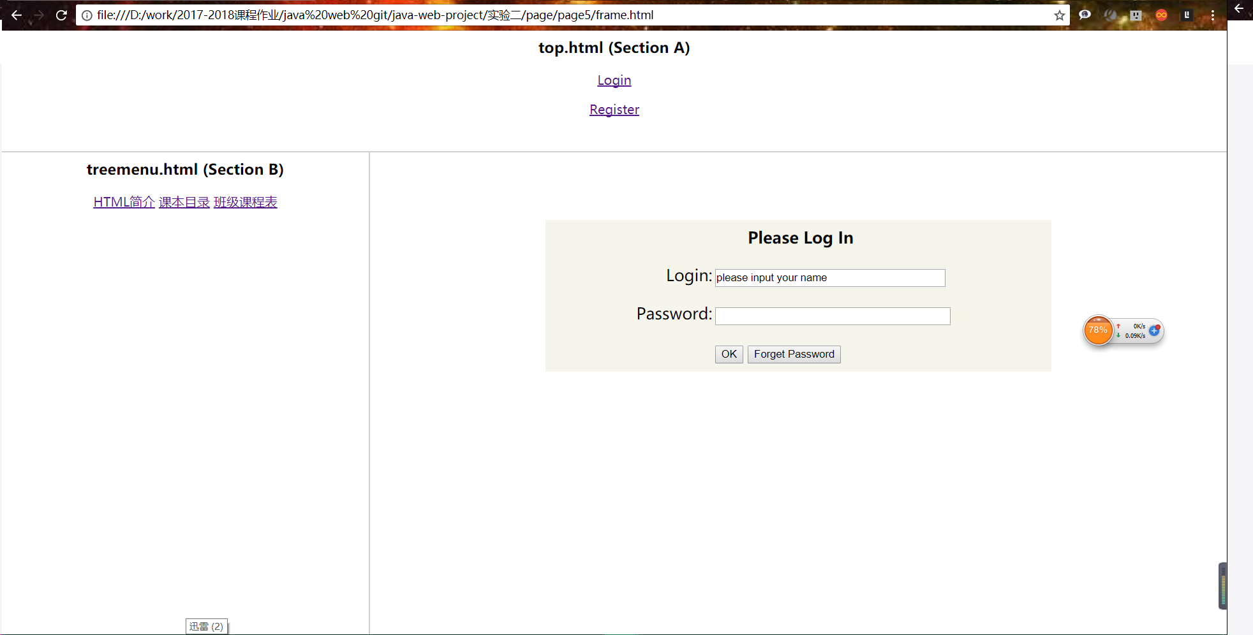

习题6：代码

<!DOCTYPE html>

<html lang="en">

<head>

    <meta charset="UTF-8">

    <meta name="viewport" content="width=device-width, initial-scale=1, maximum-scale=1, user-scalable=no">

    <link rel="stylesheet" href="../css/bootstrap.min.css">

    <link rel="stylesheet" href="../css/common.css">

    <link rel="stylesheet" href="../css/index.css">

    <title>博客首页</title>

</head>

<body>

    <div class="container-fluid">

        <!-- 导航栏 -->

      <div class="row ">

          <div class="nav">

                <div class="col-md-2 col-sm-1 col-xs-1">

                </div>

                <div class="col-md-1 col-sm-1 col-xs-1">

                    <div class="logo">

                        <img src="../images/logo.png" alt="">

                    </div>

                </div>

                <div class="col-md-4 col-sm-5 col-xs-5">

                    <div class="nav_list">

                        <div class="item item1"><a href="#">首页</a></div>

                        <div class="item item2"><a href="#">归档</a></div>

                        <div class="item item3"><a href="#">关于</a></div>

                        <div class="item item4 "><a href="#">链接</a></div>

                        <div class="clear"></div>

                    </div>

                </div>

                <div class="col-md-3 col-sm-1 col-xs-1">

                    <div class="search">

                        <div class="input-group">

                         <input type="text" class="form-control" placeholder="Search for...">

                         <span class="input-group-btn">

                         <button class="btn btn-default" type="button">搜索</button>

                         </span>

                     </div>

                    </div>

                </div>

                <div class="col-md-2 col-sm-1 col-xs-1">

                </div>

          </div>

      </div>

        <!--下面主体内容 -->

      <div class="row">

            <div class="contents">

                <div class="col-md-2">

                </div>

                <div class="col-md-6 ">

                    <div class="pro_list">

                        <div class="item">

                            <div class="lib">

                                <span class="dfl">前端</span>

                                    /

                                <span class="xfl">css</span>

                            </div>

                            <div class="title prj_title">

                                面试题：你能写一个Vue的双向数据绑定吗？

                            </div>

                            <div class="info">

                                <span class="read">

                                    <img src="images/read.png" alt="">

                                    <span class="read_num">1000</span>

                                </span>

                                <span class="time">1小时前</span>

                                <!-- <span class="start"></span>

                                <span class="speak"></span> -->

                            </div>

                        </div>

                        <div class="item">

                            <div class="lib">

                                <span class="dfl">前端</span>

                                    /

                                <span class="xfl">css</span>

                            </div>

                            <div class="title prj_title">

                                面试题：你能写一个Vue的双向数据绑定吗？

                            </div>

                            <div class="info">

                                <span class="read">

                                    <img src="images/read.png" alt="">

                                    <span class="read_num">1000</span>

                                </span>

                                <span class="time">1小时前</span>

                                <!-- <span class="start"></span>

                                <span class="speak"></span> -->

                            </div>

                        </div>

                        <div class="item">

                            <div class="lib">

                                <span class="dfl">前端</span>

                                    /

                                <span class="xfl">css</span>

                            </div>

                            <div class="title prj_title">

                                面试题：你能写一个Vue的双向数据绑定吗？

                            </div>

                            <div class="info">

                                <span class="read">

                                    <img src="images/read.png" alt="">

                                    <span class="read_num">1000</span>

                                </span>

                                <span class="time">1小时前</span>

                                <!-- <span class="start"></span>

                                <span class="speak"></span> -->

                            </div>

                        </div>

                        <div class="item">

                            <div class="lib">

                                <span class="dfl">前端</span>

                                    /

                                <span class="xfl">css</span>

                            </div>

                            <div class="title prj_title">

                                面试题：你能写一个Vue的双向数据绑定吗？

                            </div>

                            <div class="info">

                                <span class="read">

                                    <img src="images/read.png" alt="">

                                    <span class="read_num">1000</span>

                                </span>

                                <span class="time">1小时前</span>

                                <!-- <span class="start"></span>

                                <span class="speak"></span> -->

                            </div>

                        </div>

                        <div class="item">

                            <div class="lib">

                                <span class="dfl">前端</span>

                                    /

                                <span class="xfl">css</span>

                            </div>

                            <div class="title prj_title">

                                面试题：你能写一个Vue的双向数据绑定吗？

                            </div>

                            <div class="info">

                                <span class="read">

                                    <img src="images/read.png" alt="">

                                    <span class="read_num">1000</span>

                                </span>

                                <span class="time">1小时前</span>

                                <!-- <span class="start"></span>

                                <span class="speak"></span> -->

                            </div>

                        </div>

                        <div class="item">

                            <div class="lib">

                                <span class="dfl">前端</span>

                                    /

                                <span class="xfl">css</span>

                            </div>

                            <div class="title prj_title">

                                面试题：你能写一个Vue的双向数据绑定吗？

                            </div>

                            <div class="info">

                                <span class="read">

                                    <img src="images/read.png" alt="">

                                    <span class="read_num">1000</span>

                                </span>

                                <span class="time">1小时前</span>

                                <!-- <span class="start"></span>

                                <span class="speak"></span> -->

                            </div>

                        </div>

                        <div class="item">

                            <div class="lib">

                                <span class="dfl">前端</span>

                                    /

                                <span class="xfl">css</span>

                            </div>

                            <div class="title prj_title">

                                面试题：你能写一个Vue的双向数据绑定吗？

                            </div>

                            <div class="info">

                                <span class="read">

                                    <img src="images/read.png" alt="">

                                    <span class="read_num">1000</span>

                                </span>

                                <span class="time">1小时前</span>

                                <!-- <span class="start"></span>

                                <span class="speak"></span> -->

                            </div>

                        </div>

                        <div class="item">

                            <div class="lib">

                                <span class="dfl">前端</span>

                                    /

                                <span class="xfl">css</span>

                            </div>

                            <div class="title prj_title">

                                面试题：你能写一个Vue的双向数据绑定吗？

                            </div>

                            <div class="info">

                                <span class="read">

                                    <img src="images/read.png" alt="">

                                    <span class="read_num">1000</span>

                                </span>

                                <span class="time">1小时前</span>

                                <!-- <span class="start"></span>

                                <span class="speak"></span> -->

                            </div>

                        </div>

                        <div class="item">

                            <div class="lib">

                                <span class="dfl">前端</span>

                                    /

                                <span class="xfl">css</span>

                            </div>

                            <div class="title prj_title">

                                面试题：你能写一个Vue的双向数据绑定吗？

                            </div>

                            <div class="info">

                                <span class="read">

                                    <img src="images/read.png" alt="">

                                    <span class="read_num">1000</span>

                                </span>

                                <span class="time">1小时前</span>

                                <!-- <span class="start"></span>

                                <span class="speak"></span> -->

                            </div>

                        </div>

                    </div>

                </div>

                <div class="col-md-2 ">

                    <div class="right_list">

                        <!-- <div class="item about_me">

                            <div class="img">

                                <img src="images/my.jpg" alt="">

                            </div>

                        </div> -->

                        <div class="item">

                            <div class="time_list">

                                <div class="title">

                                    往期回顾

                                </div>

                                <div class="list">

                                    <span class="time">2018年4月</span>

                                    <span class="num">16篇</span>

                                </div>

                                <div class="list">

                                    <span class="time">2018年4月</span>

                                    <span class="num">16篇</span>

                                </div>

                                <div class="list">

                                    <span class="time">2018年4月</span>

                                    <span class="num">16篇</span>

                                </div>

                                <div class="list">

                                    <span class="time">2018年4月</span>

                                    <span class="num">16篇</span>

                                </div>

                                <div class="list">

                                    <span class="time">2018年4月</span>

                                    <span class="num">16篇</span>

                                </div>

                            </div>

                        </div>

                        <div class="item">

                            <div class="lib_list">

                                <div class="title">

                                    标签分类

                                </div>

                                <div class="list">

                                    <span class="time">2018年4月</span>

                                    <span class="num">16篇</span>

                                </div>

                                <div class="list">

                                    <span class="time">2018年4月</span>

                                    <span class="num">16篇</span>

                                </div>

                                <div class="list">

                                    <span class="time">2018年4月</span>

                                    <span class="num">16篇</span>

                                </div>

                                <div class="list">

                                    <span class="time">2018年4月</span>

                                    <span class="num">16篇</span>

                                </div>

                                <div class="list">

                                    <span class="time">2018年4月</span>

                                    <span class="num">16篇</span>

                                </div>

                        </div>

                        <div class="item">

                            <div class="link_list">

                                <div class="title">

                                    友情链接

                                </div>

                                <div class="list">

                                    <a href="http://www.ncu.edu.cn">南大官网</a>

                                </div>

                                <div class="list">

                                    <a href="https://juejin.im/">稀土掘金</a>

                                </div>

                                <div class="list">

                                    <a href="http://i.mooc.chaoxing.com/space/index.shtml/">网教平台</a>

                                </div>

                                <div class="list">

                                    <a href="https://shupingzhang1.github.io/zsp.github.io/">我的博客</a>

                                </div>

                            </div>

                        </div>

                        <div class="footer">

                            <div class="cop">Copyright @ zsp.All Rights Reserved.</div>

                             赣ICP备 17003717-1号

                        </div>

                    </div>

                </div>

                <div class="col-md-2 ">

                </div>

            </div>

      </div>

    </div>

    <script src="../js/jquery.min.js"></script>

    <script src="../js/index.js"></script>

</body>

</html>

习题6：截图

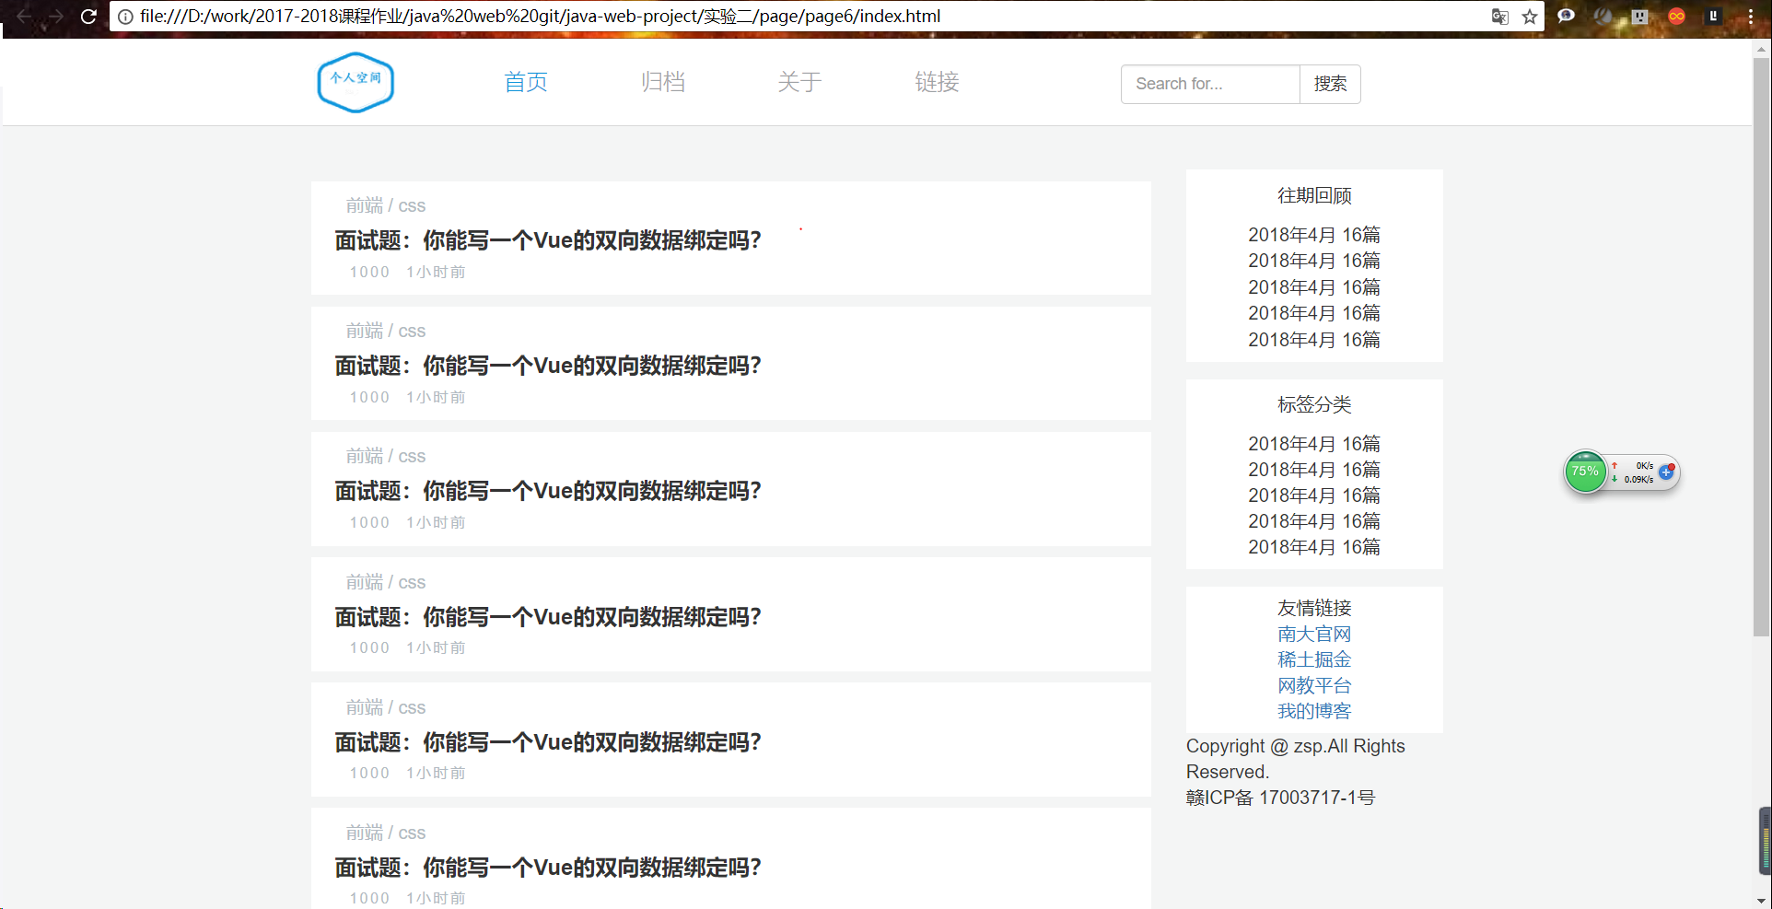

代码：https://zhangsp.cn:2021/

1. **简答题**

1、比较表单中普通按钮组件、提交按钮组件、重置按钮组件的不同。  
 普通按钮按下后无反应，提交按钮按下后，表单中的参数会按设置的action方式以不同的形态出现在处理页面的网址后。重置按钮按下后会清空表单内容。

2、多重框架与表格在设计网页布局有哪些不同之处？DIV+CSS布局呢？  
 表格是用于划分页面区域的，而框架是用于分割浏览器窗口的，即使用框架结构的页面可以将一个浏览器窗口划分为多个相互独立又相互联系的小窗口，每个区域都可以显示不同的HTML文档，从而实现将多个HTML文件组织到一个浏览器窗口中显示。  
  div+css布局定位简单，提升了网页访问速度，有利于优化。