1. **執行結果:**

必做1：

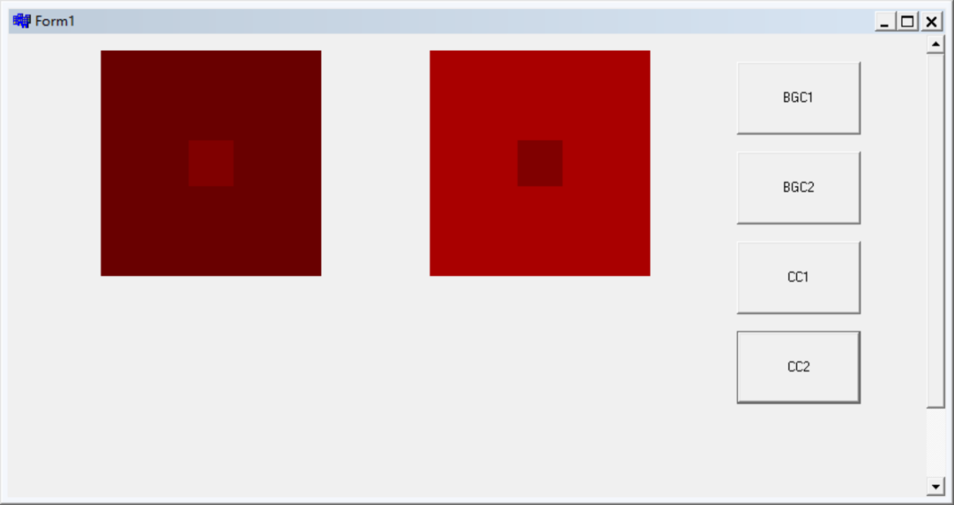

//-------------------------------------------------------------------

必做2：

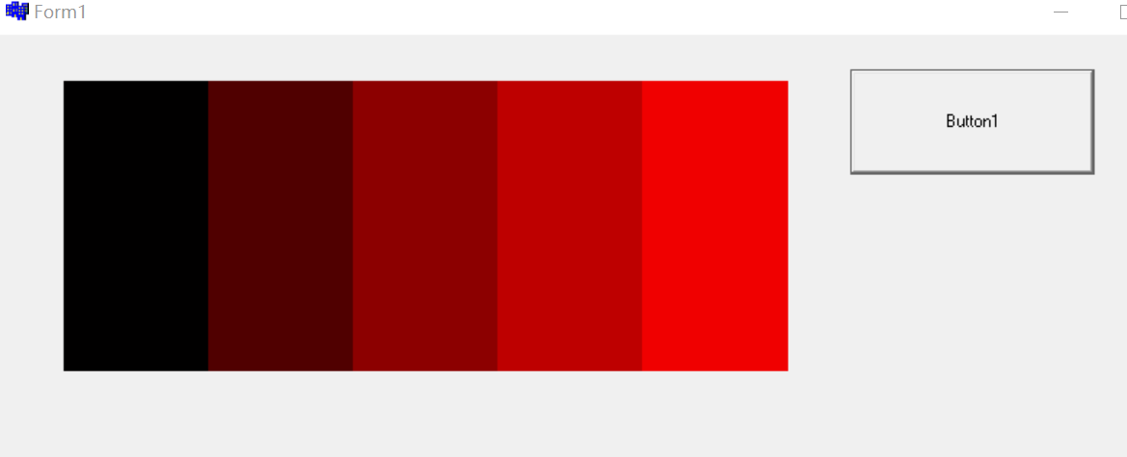

//-------------------------------------------------------------------

選做1：

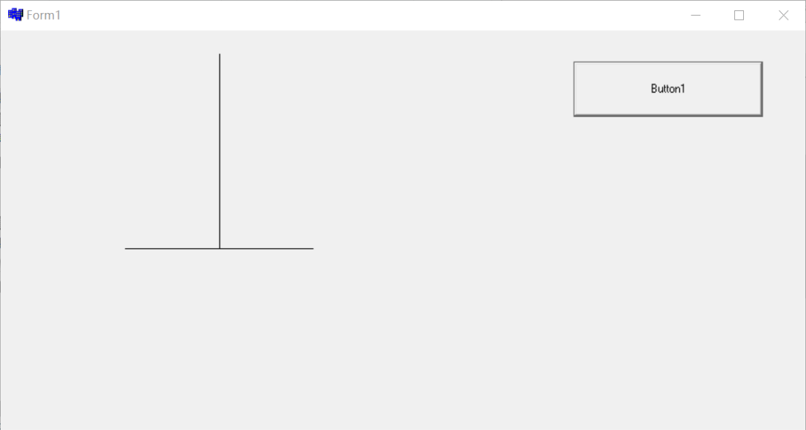

//----------------------------------------------------------------

選做2：

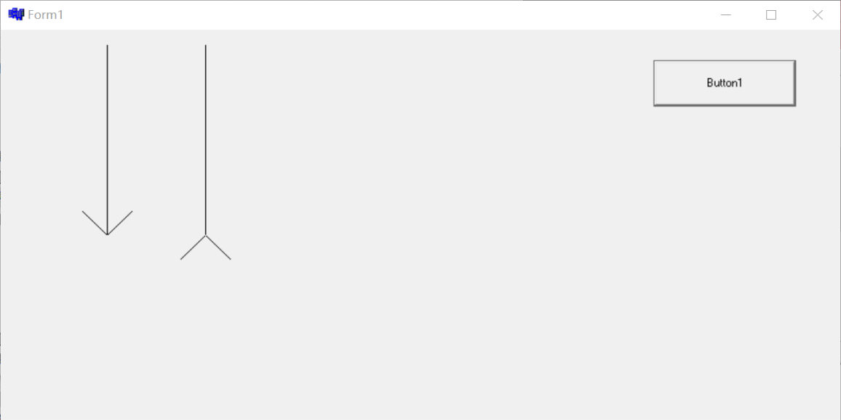

//-----------------------------------------------------------------

選做3：

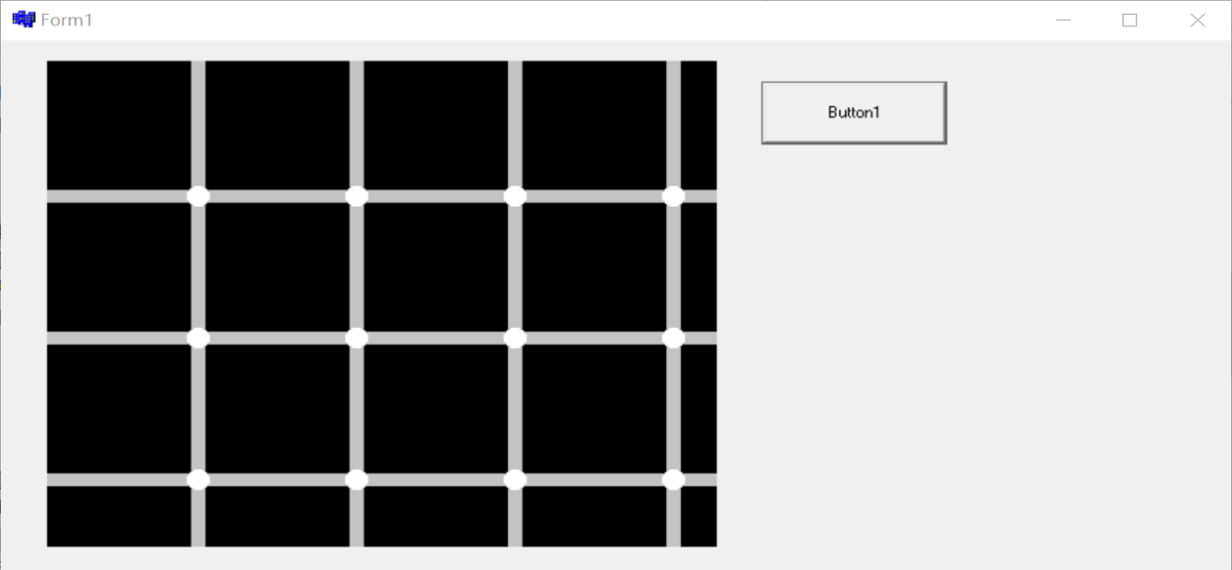

//---------------------------------------------------------------

選做4：

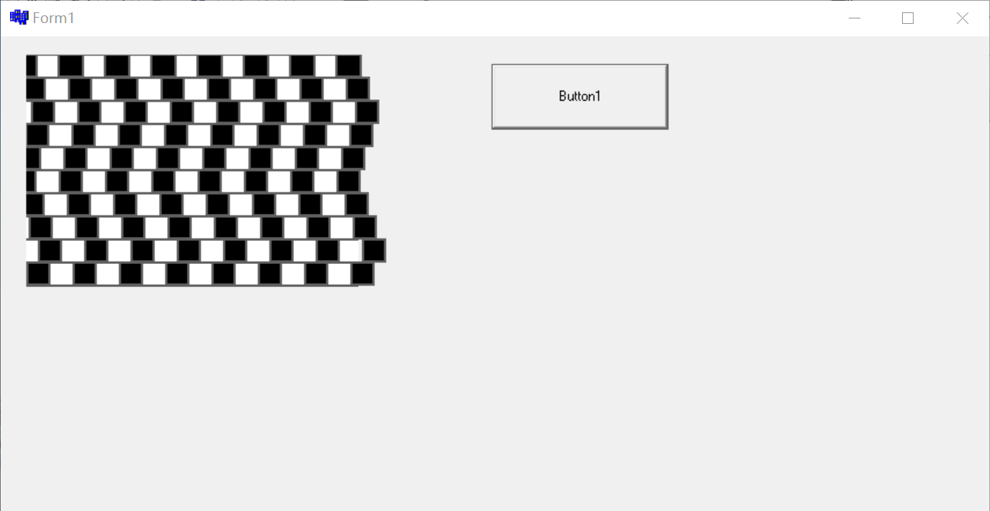

//---------------------------------------------------------------

選做5：

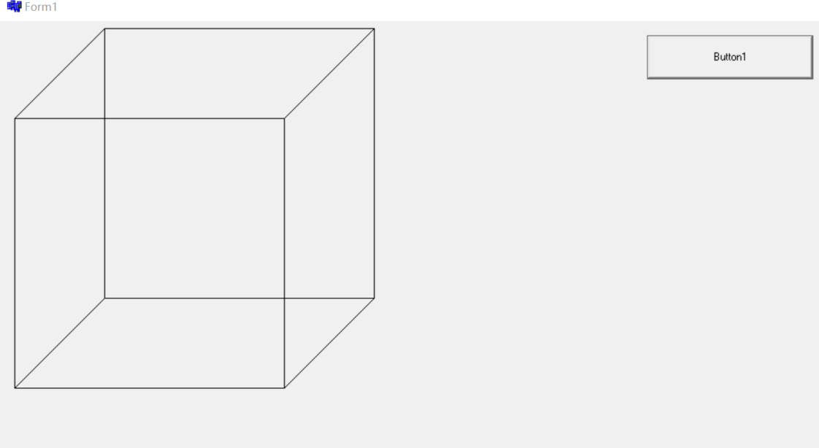

//---------------------------------------------------------------

選做6：

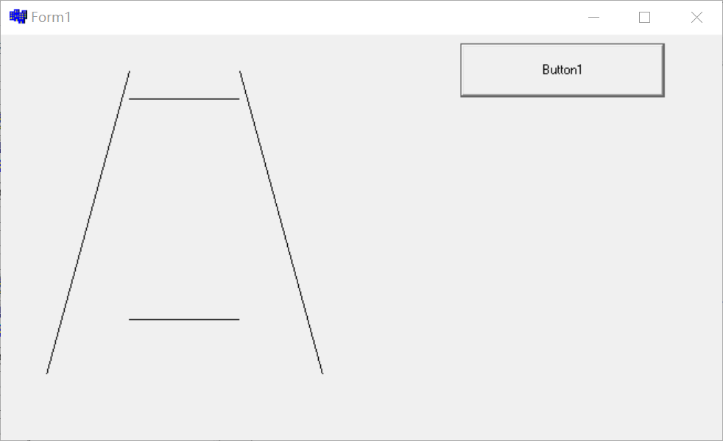

**二、程式碼**

必做1：

//-------------------------------------------------------------------

__fastcall TForm1::TForm1(TComponent* Owner)

: TForm(Owner)

{

}

//-------------------------------------------------------------------

void __fastcall TForm1::BGC1Click(TObject *Sender)

{

for(int i=0;i<=200;i++)

{

for (int j=0;j<=200;j++)

{

PaintBox1->Canvas->Pixels[i][j]=105;

}

}

}

//-------------------------------------------------------------------

void __fastcall TForm1::BGC2Click(TObject *Sender)

{

for(int i=300;i<=500;i++)

{

for (int j=0;j<=200;j++)

{

PaintBox1->Canvas->Pixels[i][j]=169;

}

}

}

//-------------------------------------------------------------------

void __fastcall TForm1::CC1Click(TObject *Sender)

{

for(int i=80;i<=120;i++)

{

for (int j=80;j<=120;j++)

{

PaintBox1->Canvas->Pixels[i][j]=128;

}

}

}

//-------------------------------------------------------------------

void __fastcall TForm1::CC2Click(TObject *Sender)

{

for(int i=380;i<=420;i++)

{

for (int j=80;j<=120;j++)

{

PaintBox1->Canvas->Pixels[i][j]=128;

}

}

}

//-------------------------------------------------------------------

必做2：

//-------------------------------------------------------------------

__fastcall TForm1::TForm1(TComponent* Owner)

: TForm(Owner)

{

}

//-------------------------------------------------------------------

void __fastcall TForm1::Button1Click(TObject *Sender)

{

for(int i=0;i<=100;i++)

{

for (int j=0;j<=200;j++)

{

PaintBox1->Canvas->Pixels[i][j]=1;

}

}

for(int i=100;i<=200;i++)

{

for (int j=0;j<=200;j++)

{

PaintBox1->Canvas->Pixels[i][j]=80;

}

}

for(int i=200;i<=300;i++)

{

for (int j=0;j<=200;j++)

{

PaintBox1->Canvas->Pixels[i][j]=140;

}

}

for(int i=300;i<=400;i++)

{

for (int j=0;j<=200;j++)

{

PaintBox1->Canvas->Pixels[i][j]=190;

}

}

for(int i=400;i<=500;i++)

{

for (int j=0;j<=200;j++)

{

PaintBox1->Canvas->Pixels[i][j]=240;

}

}

}

//-------------------------------------------------------------------

選做1：

//-------------------------------------------------------------------

__fastcall TForm1::TForm1(TComponent* Owner)

: TForm(Owner)

{

}

//-------------------------------------------------------------------

void __fastcall TForm1::Button1Click(TObject *Sender)

{

PaintBox1->Canvas->Pen->Color=0;

PaintBox1->Canvas->MoveTo(200,0);

PaintBox1->Canvas->LineTo(200,200);

PaintBox1->Canvas->MoveTo(100,200);

PaintBox1->Canvas->LineTo(300,200);

}

//-------------------------------------------------------------------

選做2：

//-------------------------------------------------------------------

__fastcall TForm1::TForm1(TComponent* Owner)

: TForm(Owner)

{

}

//-------------------------------------------------------------------

void __fastcall TForm1::Button1Click(TObject *Sender)

{

PaintBox1->Canvas->Pen->Color=0;

PaintBox1->Canvas->MoveTo(100,0);

PaintBox1->Canvas->LineTo(100,200);

PaintBox1->Canvas->MoveTo(75,175);

PaintBox1->Canvas->LineTo(100,200);

PaintBox1->Canvas->MoveTo(125,175);

PaintBox1->Canvas->LineTo(100,200);

PaintBox1->Canvas->MoveTo(200,0);

PaintBox1->Canvas->LineTo(200,200);

PaintBox1->Canvas->MoveTo(175,225);

PaintBox1->Canvas->LineTo(200,200);

PaintBox1->Canvas->MoveTo(225,225);

PaintBox1->Canvas->LineTo(200,200);

}

//-------------------------------------------------------------------

選做3：

//-------------------------------------------------------------------

__fastcall TForm1::TForm1(TComponent* Owner)

: TForm(Owner)

{

}

//-------------------------------------------------------------------

void __fastcall TForm1::Button1Click(TObject *Sender)

{

for(int i=0;i<=700;i++)

{

for (int j=0;j<=700;j++)

{

PaintBox1->Canvas->Pixels[i][j]=RGB(195,195,195);

}

PaintBox1->Canvas->Brush->Color=RGB(0,0,0);

}

for(int i=0;i<=5;i++)

{

PaintBox1->Canvas->Rectangle(0+i*110,0,100+i*110,100);

}

for(int i=0;i<=5;i++)

{

PaintBox1->Canvas->Rectangle(0+i*110,110,100+i*110,210);

}

for(int i=0;i<=5;i++)

{

PaintBox1->Canvas->Rectangle(0+i*110,220,100+i*110,320);

}

for(int i=0;i<=5;i++)

{

PaintBox1->Canvas->Rectangle(0+i*110,330,100+i*110,430);

}

PaintBox1->Canvas->Pen->Color=RGB(255,255,255);

PaintBox1->Canvas->Brush->Color=RGB(255,255,255);

for(int i=0;i<=4;i++)

{

PaintBox1->Canvas->Ellipse(97+i*110,97,113+i*110,113);

}

for(int i=0;i<=4;i++)

{

PaintBox1->Canvas->Ellipse(97+i*110,207,113+i*110,223);

}

for(int i=0;i<=4;i++)

{

PaintBox1->Canvas->Ellipse(97+i*110,317,113+i*110,333);

}

for(int i=0;i<=4;i++)

{

PaintBox1->Canvas->Ellipse(97+i*110,427,113+i*110,443);

}

}

//-------------------------------------------------------------------

選做4：

//-------------------------------------------------------------------

__fastcall TForm1::TForm1(TComponent* Owner)

: TForm(Owner)

{

}

//-------------------------------------------------------------------

void __fastcall TForm1::Button1Click(TObject *Sender)

{

for(int i=0;i<=300;i++)

{

for (int j=0;j<=200;j++)

{

PaintBox1->Canvas->Pixels[i][j]=RGB(255,255,255);

}

}

PaintBox1->Canvas->Pen->Color=RGB(95,95,95);

PaintBox1->Canvas->Brush->Color=0;

PaintBox1->Canvas->Pen->Width = 2;

for(int i=0;i<8;i++)

{

PaintBox1->Canvas->Rectangle(2+i*40,0,24+i*40,20);

}

for(int i=0;i<8;i++)

{

PaintBox1->Canvas->Rectangle(11+i*40,20,31+i*40,40);

}

for(int i=0;i<8;i++)

{

PaintBox1->Canvas->Rectangle(19+i*40,40,39+i*40,60);

}

for(int i=0;i<8;i++)

{

PaintBox1->Canvas->Rectangle(14+i*40,60,34+i*40,80);

}

for(int i=0;i<8;i++)

{

PaintBox1->Canvas->Rectangle(7+i*40,80,27+i*40,100);

}

for(int i=0;i<8;i++)

{

PaintBox1->Canvas->Rectangle(3+i*40,100,23+i*40,120);

}

for(int i=0;i<8;i++)

{

PaintBox1->Canvas->Rectangle(10+i*40,120,30+i*40,140);

}

for(int i=0;i<8;i++)

{

PaintBox1->Canvas->Rectangle(17+i*40,140,37+i*40,160);

}

for(int i=0;i<8;i++)

{

PaintBox1->Canvas->Rectangle(25+i*40,160,45+i*40,180);

}

for(int i=0;i<8;i++)

{

PaintBox1->Canvas->Rectangle(15+i*40,180,35+i*40,200);

}

PaintBox1->Canvas->Pen->Color=RGB(95,95,95);

PaintBox1->Canvas->Pen->Width = 2;

PaintBox1->Canvas->MoveTo(0,0);

PaintBox1->Canvas->LineTo(300,0);

PaintBox1->Canvas->MoveTo(0,20);

PaintBox1->Canvas->LineTo(300,20);

PaintBox1->Canvas->MoveTo(0,40);

PaintBox1->Canvas->LineTo(300,40);

PaintBox1->Canvas->MoveTo(0,60);

PaintBox1->Canvas->LineTo(300,60);

PaintBox1->Canvas->MoveTo(0,80);

PaintBox1->Canvas->LineTo(300,80);

PaintBox1->Canvas->MoveTo(0,100);

PaintBox1->Canvas->LineTo(300,100);

PaintBox1->Canvas->MoveTo(0,120);

PaintBox1->Canvas->LineTo(300,120);

PaintBox1->Canvas->MoveTo(0,140);

PaintBox1->Canvas->LineTo(300,140);

PaintBox1->Canvas->MoveTo(0,160);

PaintBox1->Canvas->LineTo(300,160);

PaintBox1->Canvas->MoveTo(0,180);

PaintBox1->Canvas->LineTo(300,180);

PaintBox1->Canvas->MoveTo(0,200);

PaintBox1->Canvas->LineTo(300,200);

}

//------------------------------------------------------------------

選做3：

//-------------------------------------------------------------------

__fastcall TForm1::TForm1(TComponent* Owner)

: TForm(Owner)

{

}

//-------------------------------------------------------------------

void __fastcall TForm1::Button1Click(TObject *Sender)

{

PaintBox1->Canvas->MoveTo(100,0);

PaintBox1->Canvas->LineTo(0,100);

PaintBox1->Canvas->LineTo(0,100);

PaintBox1->Canvas->LineTo(0,400);

PaintBox1->Canvas->LineTo(300,400);

PaintBox1->Canvas->LineTo(400,300);

PaintBox1->Canvas->LineTo(400,0);

PaintBox1->Canvas->LineTo(300,100);

PaintBox1->Canvas->LineTo(0,100);

PaintBox1->Canvas->MoveTo(0,400);

PaintBox1->Canvas->LineTo(100,300);

PaintBox1->Canvas->LineTo(100,0);

PaintBox1->Canvas->MoveTo(100,0);

PaintBox1->Canvas->LineTo(400,0);

PaintBox1->Canvas->MoveTo(100,300);

PaintBox1->Canvas->LineTo(400,300);

PaintBox1->Canvas->MoveTo(300,100);

PaintBox1->Canvas->LineTo(300,400);

}

//-------------------------------------------------------------------

選做5：

//-------------------------------------------------------------------

__fastcall TForm1::TForm1(TComponent* Owner)

: TForm(Owner)

{

}

//-------------------------------------------------------------------

void __fastcall TForm1::Button1Click(TObject *Sender)

{

PaintBox1->Canvas->MoveTo(100,50);

PaintBox1->Canvas->LineTo(200,50);//長度100

PaintBox1->Canvas->MoveTo(100,250);

PaintBox1->Canvas->LineTo(200,250);//長度100

PaintBox1->Canvas->MoveTo(100,25);

PaintBox1->Canvas->LineTo(25,300);

PaintBox1->Canvas->MoveTo(200,25);

PaintBox1->Canvas->LineTo(275,300);

}

//-------------------------------------------------------------------