1. **執行結果:**
2. 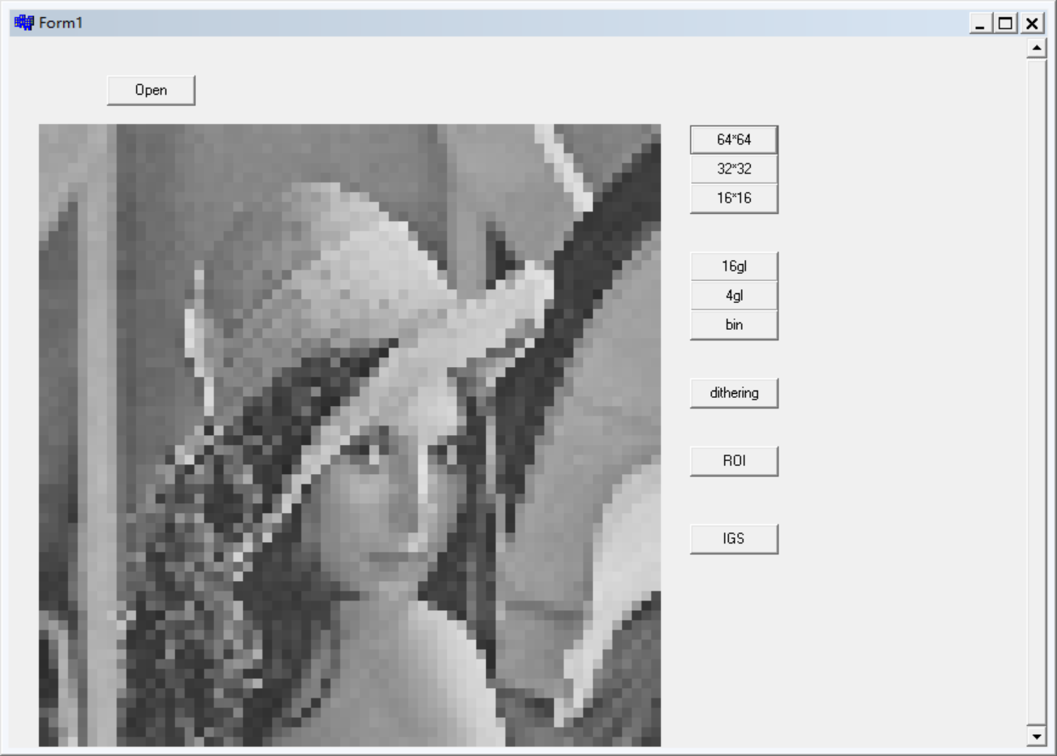Quantization for spatial resolution with 3 levels 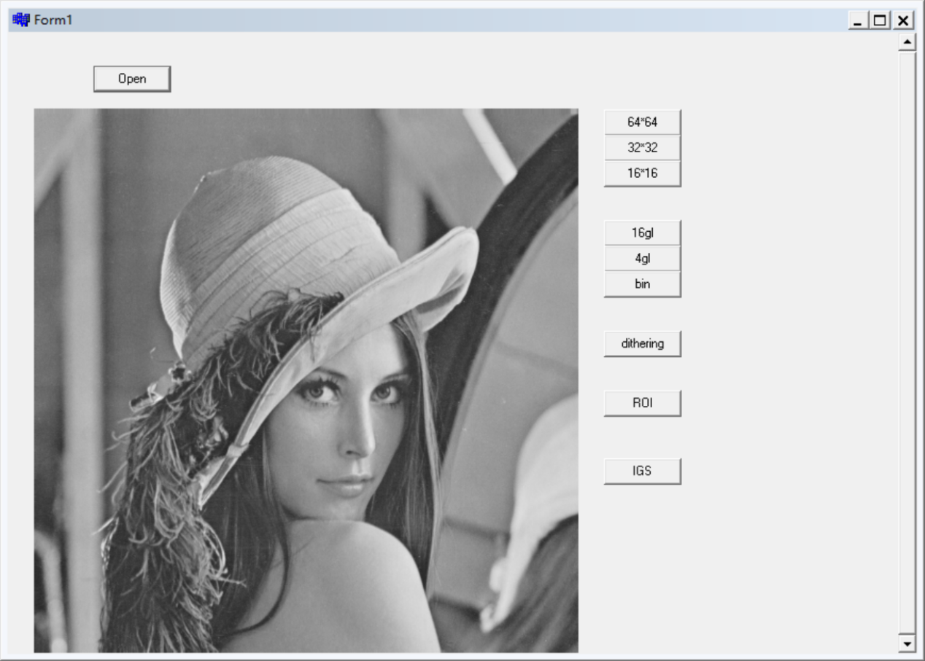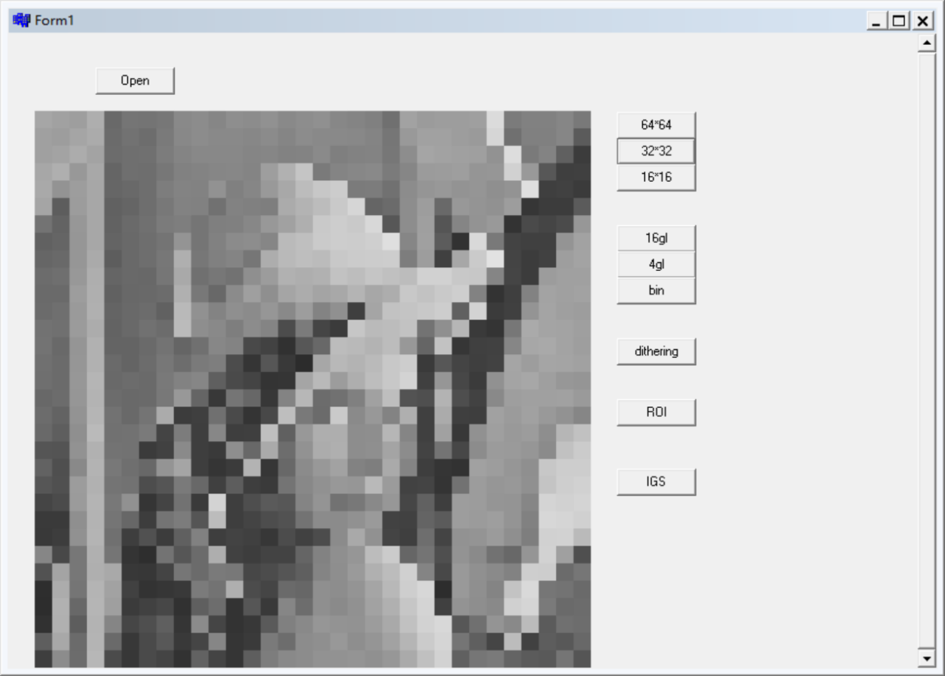

2. Quantization for the gray-level resolution with 3 levels 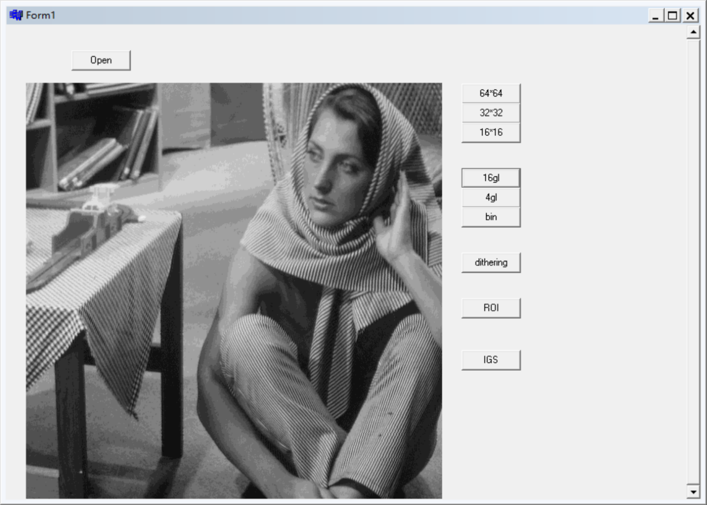

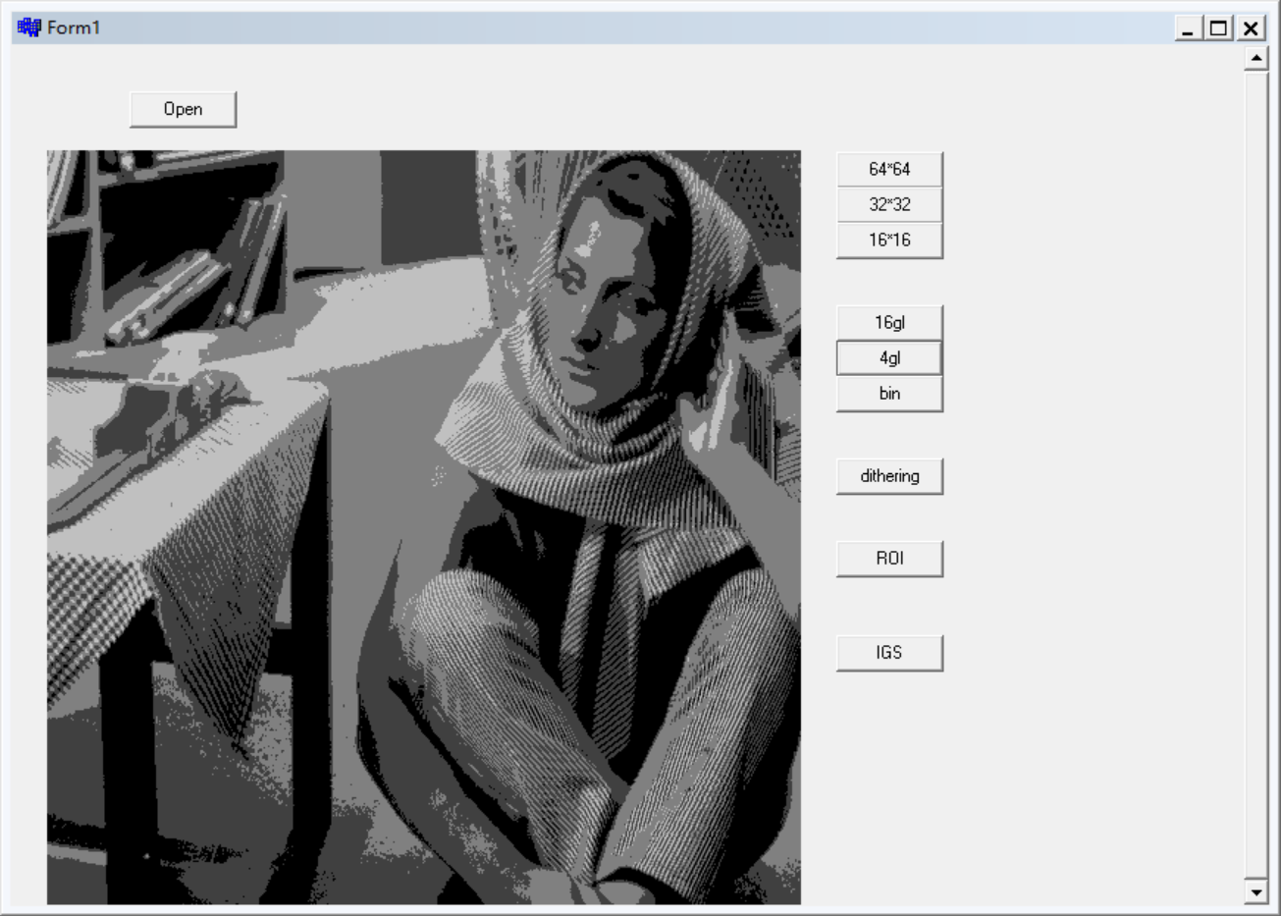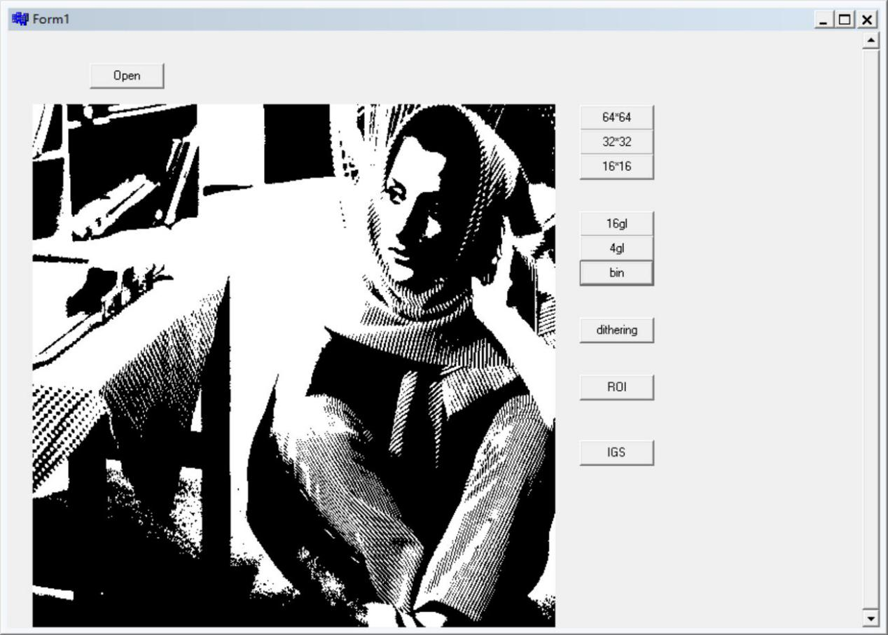

3.Dithering :halftoning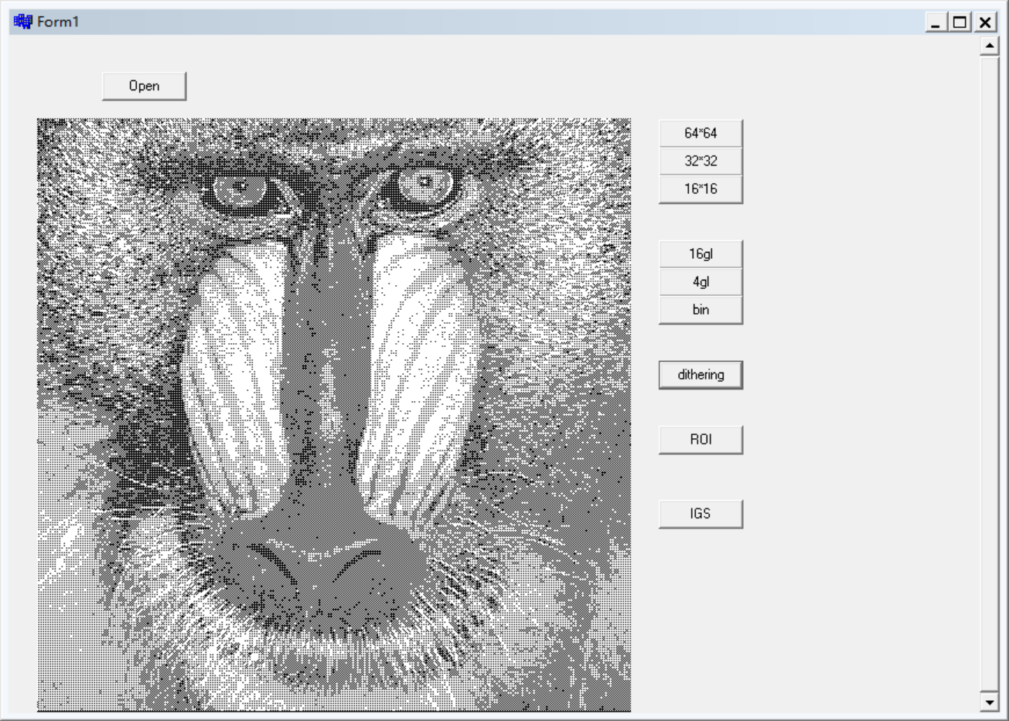

4. ROI (Region-of-Interest) functionality

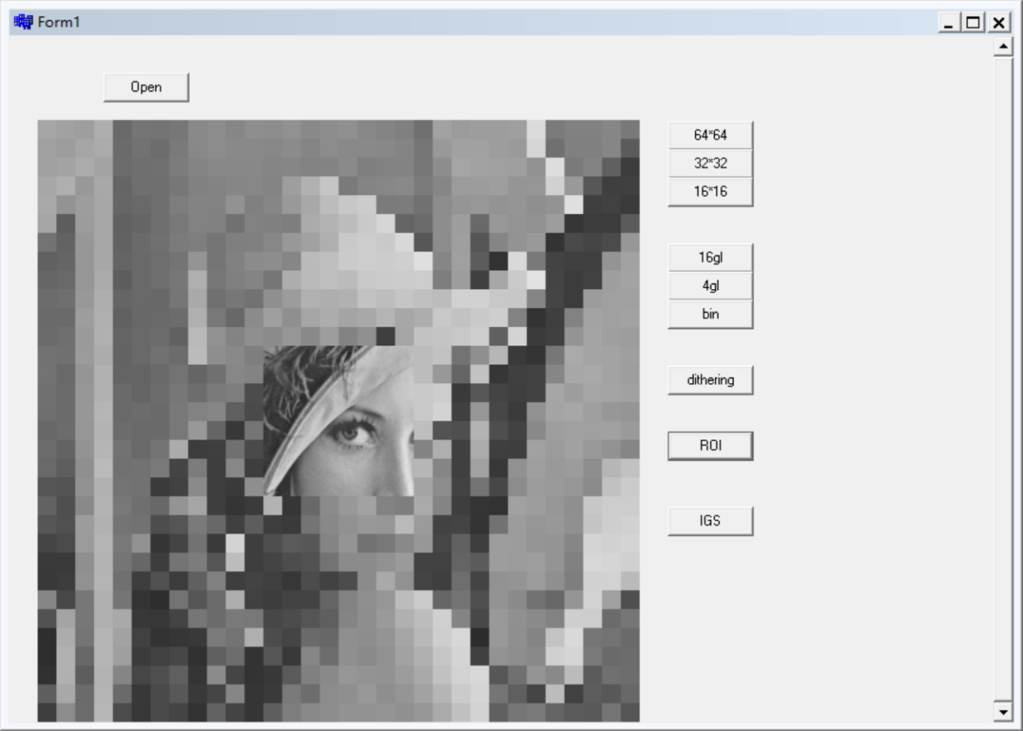

5. IGS(with quantization)

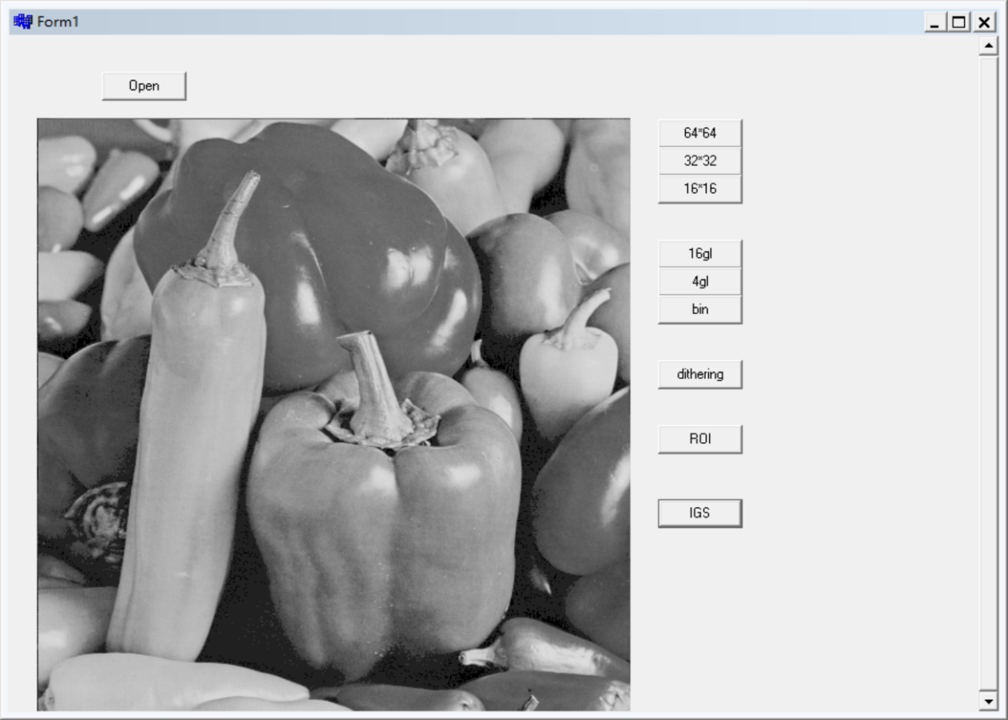

**二、程式碼**

//---------------------------------------------------------------

#include <vcl.h>

#include <stdio.h>

#include <math.h>

#pragma hdrstop

#include "Unit1.h"

//---------------------------------------------------------------

#pragma package(smart_init)

#pragma resource "*.dfm"

TForm1 *Form1;

unsigned char image_array[512][512];

int height;

int width;

int sizeofimage;

//---------------------------------------------------------------

__fastcall TForm1::TForm1(TComponent* Owner)

: TForm(Owner)

{

}

//---------------------------------------------------------------

void __fastcall TForm1::Button1Click(TObject *Sender) **//open**

{

height = 512;

width = 512;

sizeofimage = height*width;

FILE *file_open;

String image_name;

if(OpenDialog1->Execute())

{

image_name = ExtractFilePath(OpenDialog1->FileName);

image_name = image_name + ExtractFileName(OpenDialog1->FileName);

file_open = fopen(image_name.c_str(),"rb");

fread(image_array,sizeof(unsigned char)*512*512,1,file_open);

for(int x=0;x<512;x++)

{

for(int y = 0;y < 512;y++)

{

int pic = image_array[y][x];

PaintBox1->Canvas->Pixels[x][y]=RGB(pic,pic,pic);

}

}

fclose(file_open);

}

}

//---------------------------------------------------------------

void __fastcall TForm1::Button2Click(TObject *Sender)**//Quantization for spatial resolution with 3 levels 64*64**

{

height = 512;

width = 512;

sizeofimage = height*width;

FILE *file_open;

String image_name;

int pic;

if(OpenDialog1->Execute())

{

image_name = ExtractFilePath(OpenDialog1->FileName);

image_name = image_name + ExtractFileName(OpenDialog1->FileName);

file_open = fopen(image_name.c_str(),"rb");

fread(image_array,sizeof(unsigned char)*512*512,1,file_open);

for(int x=0;x<512;x=x+8)

{

for(int y=0;y<512;y=y+8)

{

pic = image_array[x][y];

PaintBox1->Canvas->Pen->Color=RGB(pic,pic,pic);

PaintBox1->Canvas->Brush->Color=RGB(pic,pic,pic);

PaintBox1->Canvas->Rectangle(y,x,y+8,x+8);

}

}

fclose(file_open);

}

}

//---------------------------------------------------------------

void __fastcall TForm1::Button3Click(TObject *Sender)**//Quantization for spatial resolution with 3 levels 32*32**

{

height = 512;

width = 512;

sizeofimage = height*width;

FILE *file_open;

String image_name;

int pic;

if(OpenDialog1->Execute())

{

image_name = ExtractFilePath(OpenDialog1->FileName);

image_name = image_name + ExtractFileName(OpenDialog1->FileName);

file_open = fopen(image_name.c_str(),"rb");

fread(image_array,sizeof(unsigned char)*512*512,1,file_open);

for(int x=0;x<512;x=x+16)

{

for(int y=0;y<512;y=y+16)

{

pic = image_array[x][y];

PaintBox1->Canvas->Pen->Color=RGB(pic,pic,pic);

PaintBox1->Canvas->Brush->Color=RGB(pic,pic,pic);

PaintBox1->Canvas->Rectangle(y,x,y+16,x+16);

}

}

fclose(file_open);

}

}

//---------------------------------------------------------------

void __fastcall TForm1::Button4Click(TObject *Sender)

**//Quantization for spatial resolution with 3 levels 16*16**

{

height = 512;

width = 512;

sizeofimage = height*width;

FILE *file_open;

String image_name;

int pic;

if(OpenDialog1->Execute())

{

image_name = ExtractFilePath(OpenDialog1->FileName);

image_name = image_name + ExtractFileName(OpenDialog1->FileName);

file_open = fopen(image_name.c_str(),"rb");

fread(image_array,sizeof(unsigned char)*512*512,1,file_open);

for(int x=0;x<512;x=x+32)

{

for(int y=0;y<512;y=y+32)

{

pic = image_array[x][y];

PaintBox1->Canvas->Pen->Color=RGB(pic,pic,pic);

PaintBox1->Canvas->Brush->Color=RGB(pic,pic,pic);

PaintBox1->Canvas->Rectangle(y,x,y+32,x+32);

}

}

fclose(file_open);

}

}

//---------------------------------------------------------------

void __fastcall TForm1::Button5Click(TObject *Sender) **//Quantization for the gray-level resolution with 3 levels 16gl**

{

height = 512;

width = 512;

sizeofimage = height*width;

FILE *file_open;

String image_name;

int pic;

if(OpenDialog1->Execute())

{

image_name = ExtractFilePath(OpenDialog1->FileName);

image_name = image_name + ExtractFileName(OpenDialog1->FileName);

file_open = fopen(image_name.c_str(),"rb");

fread(image_array,sizeof(unsigned char)*512*512,1,file_open);

for(int x=0;x<512;x++)

{

for(int y = 0;y < 512;y++)

{

int pic = image_array[y][x];

pic = (pic/16)*16;

PaintBox1->Canvas->Pixels[x][y]=RGB(pic,pic,pic);

}

}

}

}

//---------------------------------------------------------------

void __fastcall TForm1::Button6Click(TObject *Sender)

//**Quantization for the gray-level resolution with 3 levels 4gl**

{

height = 512;

width = 512;

sizeofimage = height*width;

FILE *file_open;

String image_name;

int pic;

if(OpenDialog1->Execute())

{

image_name = ExtractFilePath(OpenDialog1->FileName);

image_name = image_name + ExtractFileName(OpenDialog1->FileName);

file_open = fopen(image_name.c_str(),"rb");

fread(image_array,sizeof(unsigned char)*512*512,1,file_open);

for(int x=0;x<512;x++)

{

for(int y = 0;y < 512;y++)

{

int pic = image_array[y][x];

pic = (pic/64)*64;

PaintBox1->Canvas->Pixels[x][y]=RGB(pic,pic,pic);

}

}

}

}

//---------------------------------------------------------------

void __fastcall TForm1::Button7Click(TObject *Sender)

**//Quantization for the gray-level resolution with 3 levels bin**

{

height = 512;

width = 512;

sizeofimage = height*width;

FILE *file_open;

String image_name;

int pic;

if(OpenDialog1->Execute())

{

image_name = ExtractFilePath(OpenDialog1->FileName);

image_name = image_name + ExtractFileName(OpenDialog1->FileName);

file_open = fopen(image_name.c_str(),"rb");

fread(image_array,sizeof(unsigned char)*512*512,1,file_open);

for(int x=0;x<512;x++)

{

for(int y = 0;y < 512;y++)

{

int pic = image_array[y][x];

pic = (pic/128)*255;

PaintBox1->Canvas->Pixels[x][y]=RGB(pic,pic,pic);

}

}

}

}

//---------------------------------------------------------------

void __fastcall TForm1::Button8Click(TObject *Sender)**//dithering**

{

height = 512;

width = 512;

sizeofimage = height*width;

FILE *file_open;

String image_name;

int pic;

int q;

if(OpenDialog1->Execute())

{

image_name = ExtractFilePath(OpenDialog1->FileName);

image_name = image_name + ExtractFileName(OpenDialog1->FileName);

file_open = fopen(image_name.c_str(),"rb");

fread(image_array,sizeof(unsigned char)*512*512,1,file_open);

for(int x=0;x<512;x=x+2)

{

for(int y = 0;y < 512;y=y+2)

{

double pic = image_array[y][x];

if(pic > 0)

{

pic = 255;

}

else

{

pic = 0;

}

PaintBox1->Canvas->Pixels[x][y]=RGB(pic,pic,pic);

}

}

for(int x=1;x<512;x=x+2)

{

for(int y = 0;y < 512;y=y+2)

{

double pic = image_array[y][x];

if(pic > 192)

{

pic = 255;

}

else

{

pic = 0;

}

PaintBox1->Canvas->Pixels[x][y]=RGB(pic,pic,pic);

}

}

for(int x=0;x<512;x=x+2)

{

for(int y = 1;y < 512;y=y+2)

{

double pic = image_array[y][x];

if(pic > 128)

{

pic = 255;

}

else

{

pic = 0;

}

PaintBox1->Canvas->Pixels[x][y]=RGB(pic,pic,pic);

}

}

for(int x=1;x<512;x=x+2)

{

for(int y = 1;y < 512;y=y+2)

{

pic = image_array[y][x];

if(pic > 64)

{

pic = 255;

}

else

{

pic = 0;

}

PaintBox1->Canvas->Pixels[x][y]=RGB(pic,pic,pic);

}

}

}

}

//---------------------------------------------------------------

void __fastcall TForm1::Button10Click(TObject *Sender)**//IGS**

{

height = 512;

width = 512;

sizeofimage = height*width;

FILE *file_open;

String image_name;

int pic;

if(OpenDialog1->Execute())

{

image_name = ExtractFilePath(OpenDialog1->FileName);

image_name = image_name + ExtractFileName(OpenDialog1->FileName);

file_open = fopen(image_name.c_str(),"rb");

fread(image_array,sizeof(unsigned char)*512*512,1,file_open);

for(int x=0;x<512;x++)

{

for(int y=0;y<512;y++)

{

int pic1 = image_array[y][x];

if (pic1 > 55 )

PaintBox1->Canvas->Pixels[x][y]=RGB(pic1,pic1,pic1);

else

{

int pic2 = image_array[y-1][x];

pic = pic1 + pic2 % 16;

pic = pic/32*32;

PaintBox1->Canvas->Pixels[x][y]=RGB(pic,pic,pic);

}

}

}

fclose(file_open);

}

}

//---------------------------------------------------------------

void __fastcall TForm1::Button9Click(TObject *Sender)**//ROI**

{

height = 512;

width = 512;

sizeofimage = height*width;

int pic;

FILE *file_open;

String image_name;

if(OpenDialog1->Execute())

{

image_name = ExtractFilePath(OpenDialog1->FileName);

image_name = image_name + ExtractFileName(OpenDialog1->FileName);

file_open = fopen(image_name.c_str(),"rb");

fread(image_array,sizeof(unsigned char)*512*512,1,file_open);

for(int y = 0;y <192;y++)

{

for(int x=0;x<512;x++)

{

pic = image_array[y/16*16][x/16*16];

PaintBox1->Canvas->Pixels[x][y]=RGB(pic,pic,pic);

}

}

for(int y = 320;y <512;y++)

{

for(int x=0;x<512;x++)

{

pic = image_array[y/16*16][x/16*16];

PaintBox1->Canvas->Pixels[x][y]=RGB(pic,pic,pic);

}

}

for(int y = 192;y <320;y++)

{

for(int x=0;x<192;x++)

{

pic = image_array[y/16*16][x/16*16];

PaintBox1->Canvas->Pixels[x][y]=RGB(pic,pic,pic);

}

}

for(int y = 192;y<320;y++)

{

for(int x=320;x<512;x++)

{

pic = image_array[y/16*16][x/16*16];

PaintBox1->Canvas->Pixels[x][y]=RGB(pic,pic,pic);

}

}

for(int x=192;x<320;x++)

{

for(int y = 192;y <320;y++)

{

int pic = image_array[y][x];

PaintBox1->Canvas->Pixels[x][y]=RGB(pic,pic,pic);

}

}

fclose(file_open);

}

}

//---------------------------------------------------------------