

**硕士学位论文**

**Master Dissertation**

**论文题目（Thesis Title）：（please use Times New Roman 16 font size, bold）**

**作 者（Author）： Shurjo Fazle Mehrab**

**导 师**（**Supervisor**）**： Zhang Fei Hu**

**系别年级**（Department & Grade）**：Business School, 2020**

**学 号**（Student ID）**： 202029030001**

**学科专业**（Major）**： World Economy**

**完成日期（**Completion Date）**： March, 2020**

**(please use Times New Roman 14 font size, bold)**

**北京师范大学研究生院**

Provost’s Office and Academic Affairs (Graduate School)

Beijing Normal University

**Beijing Normal University Academic Dissertation**

**Originality Statement**

I solemnly declare: The dissertation that I submitted is the achievement of my independent research work under the guidance of my tutor. Except for references which are clearly stated, this paper does not contain any productions or achievements written or published by other individuals or groups. Individuals and groups who have made important contributions to this dissertation are clearly stated. I am fully aware that I am responsible for the legal outcome of this statement.

Dissertation Author Signature: Date: Year Month Day

**Academic Dissertation Use Authorization**

The dissertation author is fully aware of Beijing Normal University’s regulations regarding the reservation and use of academic dissertations, which is: the intellectual property right of a graduate student’s dissertation composed during their postgraduate studies belongs to Beijing Normal University. The university have the right to reserve and deliver the photocopy and electronic version of the dissertation to relevant national departments; academic dissertations are allowed to be read and borrowed; the university could publish the entire content or partial contents of the academic dissertation; photocopying, micro printing or other duplication methods are allowed to be used for preserving and assembling the academic dissertations. This authorization also applies to confidential dissertations when they pass the confidential time limit.

Personal Signature: Date:

Tutor Signature: Date:

**Quantifying Asset Specificity in Economic Transactions: A Machine Learning Approach**

**Abstract**

This thesis presents an innovative exploration of asset specificity within the context of economic transactions, utilizing machine learning (ML) classification to quantitatively analyze and categorize asset specificity levels. Positioned at the intersection of machine learning and economic theory, particularly transaction cost economics, the study addresses the critical challenge of measuring and characterizing asset specificity—a fundamental concept that delineates the degree to which assets are tailored for specific transactions and their consequent transferability and redeployability issues.

Leveraging a comprehensive dataset encompassing a variety of financial and operational features of transactions, including monetary values, turnover rates, and temporal characteristics, the research develops a predictive model that systematically classifies assets into low, medium, and high specificity categories. By employing Random Forest classification, a robust machine learning algorithm known for its efficacy in handling complex datasets, the study achieves a significant predictive accuracy, thereby underscoring the potential of ML techniques in enhancing the empirical analysis of economic phenomena.

The findings reveal that financial magnitude, operational timelines, and the nature of the participating entities significantly influence asset specificity. The 'amount' feature, representing the financial magnitude of transactions, emerges as the most critical predictor, highlighting its direct correlation with the degree of asset specificity. This quantification and categorization process not only bridge the theoretical and empirical realms of transaction cost economics but also offer actionable insights for businesses and policymakers in optimizing asset management and contractual strategies.

In addition to advancing the academic discourse on asset specificity, this thesis demonstrates the value of integrating data-driven ML approaches with economic theory, suggesting a paradigm shift towards more empirical and quantitative analyses in economics. The research lays a foundation for future studies to explore other dimensions of economic transactions using machine learning, thereby fostering an interdisciplinary approach that combines technical prowess with economic insight.

**Keywords**: Asset Specificity, Machine Learning, Economic Transactions, Transaction Cost Economics, Random Forest Classification, Predictive Modeling.

**Table of Contents**

1. **Introduction**  
   1.1 Background  
   1.2 Problem Statement  
   1.3 Research Objectives  
   1.4 Thesis Structure
2. **Literature Review**  
   2.1 Comparison With Existing Literature  
   2.2 Contribution Of This Literature  
   2.3 Gap in Literature
3. **Theoretical Framework on Asset Specificity**  
   3.1 Concept of Asset Specificity  
   3.2 Types of Asset Specificity  
   3.3 Implications of Asset Specificity on Contracts
4. **Machine Learning in Economic and Contract Analysis**  
   4.1 Introduction to Machine Learning  
   4.2 Rationale for Employing Machine Learning
   1. Hypothesis
   2. Machine Learning Algorithms Overview
5. **Methodology**  
   5.1 Data Collection and Preprocessing   
   5.2 Training and Validation of Models
6. **Data Analysis**  
   6.1 Descriptive Statistics of Dataset  
   6.2 Binning Method for Categorizing Asset Specificity  
   6.3 Machine Learning Model Training and Results
7. **Results**  
   7.1 Model Performance Evaluation  
   7.2 Analysis of Feature Importance
   1. **Mathe**matical Representation
   2. Insights on Asset Specificity in Economic Transactions
8. **Discussion**  
   8.1 Interpretation of Findings  
   8.2 Comparison with Existing Literature  
   8.3 Practical Implications for Businesses and Policymakers  
   8.4 Limitations and Future Research Directions
9. **Conclusion**  
   9.1 Summary of Key Findings  
   9.2 Contributions of the Thesis  
   9.3 Final Thoughts
10. **References**
11. **Appendices**  
    A. Data Collection Instruments  
    B. Detailed Algorithm Parameters  
    C. Additional Tables and Figures

**1.1 Background and Motivation**

In this section, we're laying the groundwork for exploring how machine learning and economic theory intersect, with a specific focus on asset specificity. Asset specificity is an important concept in economics that influences how contracts are formed and managed.

We're interested in studying asset specificity because it's a crucial factor in contractual relationships, yet there's a lack of effective methods for measuring its impact. By employing machine learning techniques, we aim to gain a better understanding of asset specificity and its implications, without necessarily predicting contract outcomes.

Advancements in technology and the availability of large datasets have opened up new avenues for economic analysis. We're leveraging these tools to delve into asset specificity, hoping to uncover valuable insights that can improve how businesses negotiate and handle contracts.

Understanding asset specificity is not only important for businesses but also for policymakers. It can help companies navigate contract-related risks more effectively and can inform policymakers in crafting regulations that support economic growth and innovation.

Ultimately, our aim is to contribute to the field of transaction cost economics by integrating machine learning methods. This should enhance our theoretical understanding while also demonstrating practical applications in addressing real-world challenges related to asset specificity.

**1.2 Problem Statement**

The problem addressed in this thesis revolves around the need to accurately measure and characterize asset specificity within the realm of economic transactions. Asset specificity refers to the degree to which investments made for particular transactions cannot be easily transferred or redeployed without incurring significant losses. Despite its fundamental importance in transaction cost economics, there exists a notable gap in empirical studies dedicated solely to understanding and quantifying asset specificity.

This gap presents several challenges. Firstly, the lack of comprehensive empirical analysis hinders our ability to fully grasp the nuanced nature of asset specificity and its implications for economic decision-making. Without robust measurement techniques, businesses and policymakers may struggle to assess the true costs and risks associated with specific transactions, leading to suboptimal contract management and policy formulation.

Furthermore, the traditional methods of economic analysis often fall short in capturing the multifaceted aspects of asset specificity. As contractual agreements become increasingly intricate, there is a pressing need for more sophisticated analytical tools to accurately evaluate asset specificity and its impact on various economic outcomes.

**1.3 Research Objective**

The primary objective of this research is to innovate at the intersection of machine learning (ML) and economic theory, specifically focusing on the concept of asset specificity within transaction cost economics. This thesis aims to leverage the capabilities of machine learning classification algorithms to systematically categorize assets based on their specificity levels, thus providing a nuanced understanding of their strategic importance to firms. By doing so, it seeks to bridge the gap between the theoretical underpinnings of asset specificity and the practical, data-driven analysis of economic transactions. The detailed objectives of this research are as follows:

* **To Develop a Predictive Model**: Design, train, and validate a machine learning classification model that can accurately predict the level of asset specificity in economic transactions. This involves selecting appropriate ML algorithms, processing and preparing the dataset for analysis, and evaluating the model's performance through rigorous testing.
* **To Quantify Asset Specificity**: Translate the qualitative aspects of asset specificity into quantifiable measures that can be analyzed through machine learning. This includes developing a methodology for binning or categorizing transaction data into distinct levels of asset specificity, such as low, medium, and high, based on financial and other relevant indicators.
* **To Analyze Influential Factors**: Identify and quantify the factors that significantly influence asset specificity in transactions. This entails utilizing the feature importance output of machine learning models to understand which variables (e.g., transaction amount, type of buyer and seller, temporal characteristics) play a pivotal role in determining asset specificity.
* **To Evaluate the Practical Implications**: Investigate the practical implications of the machine learning model's predictions for firms and policymakers. This includes understanding how the findings can aid in strategic planning, risk management, and decision-making regarding asset investments and contract negotiations.
* **To Contribute to Economic Theory**: Enhance the theoretical discourse on asset specificity by providing empirical evidence and data-driven insights. This research aims to contribute to the field of transaction cost economics by offering a novel approach to evaluating asset specificity that complements traditional qualitative assessments.
* **To Foster Interdisciplinary Research**: Bridge the gap between machine learning and economic theory, demonstrating the potential of interdisciplinary approaches to address complex economic questions. This research seeks to inspire further studies that leverage machine learning for economic analysis, encouraging a fusion of technical and theoretical expertise.

Through the achievement of these objectives, this thesis aspires to make a significant contribution to the understanding of asset specificity, offering a fresh perspective that combines economic theory with the power of machine learning. It is anticipated that the insights gained will not only enrich academic discourse but also provide tangible tools and methodologies that can transform the landscape of transaction analysis and asset management in practice.

**1.4 Thesis Structure**

The "Thesis Structure" section of this document delineates the organized framework through which the research unfolds, guiding the reader through the logical progression of the study from its inception to its conclusions. This structured approach is designed to facilitate a comprehensive understanding of the research objectives, methodology, findings, and their broader implications. Here is a detailed breakdown of the thesis structure:

* **Introduction**: This opening chapter sets the stage for the entire study, presenting the background, problem statement, and motivation behind the research. It outlines the central questions that the thesis aims to answer and introduces the key concepts of asset specificity and machine learning within the context of economic analysis.
* **Literature Review**: The second chapter delves into a thorough review of existing literature, covering foundational theories related to asset specificity, contract outcomes, and the application of machine learning in economic research. This section establishes the theoretical underpinnings of the study and highlights gaps in the current body of knowledge that the research aims to address.
* **Methodology**: Here, the thesis details the research methodology, including data collection processes, the selection of machine learning algorithms, and the analytical techniques employed to examine the impact of asset specificity on contract outcomes. This chapter is crucial for understanding the empirical approach taken and the rationale behind the choice of methods.
* **Data Analysis**: This chapter presents the core empirical analysis conducted as part of the research. It includes a comprehensive examination of the dataset, the preprocessing steps, the training and validation of the machine learning models, and the analysis of the results. The section aims to provide transparency into the analytical process and the derivation of insights from the data.
* **Results**: The fifth chapter outlines the findings of the study, focusing on the predictive accuracy of the machine learning models in determining asset specificity. This section discusses the implications of the results in the context of the research questions and the broader theoretical framework.
* **Discussion**: This chapter interprets the findings, integrating them with existing literature and theoretical concepts. It explores the practical implications of the research for businesses and policymakers, addresses the limitations of the study, and suggests areas for future research. The discussion aims to contextualize the results within the larger discourse on economics and machine learning.
* **Conclusion**: The final chapter summarizes the key contributions of the thesis, reiterates the significance of the findings, and reflects on the broader impact of the research. It provides a concise overview of the study's achievements and outlines the potential for future work stemming from this research.
* **References**: This section lists all the scholarly works cited throughout the thesis, providing a comprehensive bibliography that supports the research.
* **Appendices**: The appendices include supplementary material such as additional data tables, detailed descriptions of the machine learning algorithms used, and any other supporting documentation that contributes to the transparency and replicability of the research.

### 2.1 Comparison with Existing Literature

The exploration of asset specificity through the lens of machine learning in this thesis represents a novel intersection between traditional economic theories and contemporary data analytics methodologies. This section compares the findings of the current study with existing literature on asset specificity, transaction cost economics, and the application of machine learning in economic analysis. By situating our results within the broader academic discourse, we can discern both the convergence and divergence from previous studies, thereby highlighting the unique contributions and potential avenues for further research.

The concept of asset specificity, as introduced by Williamson (1985) in the context of transaction cost economics, posits that transactions requiring specific assets have profound implications for governance structures and market dynamics. Prior literature has predominantly explored asset specificity through qualitative analyses or econometric models, focusing on its impact on contractual arrangements and organizational forms. Our study aligns with these foundational principles, confirming the significant role of financial metrics in determining asset specificity. However, by applying machine learning classification, this thesis extends the traditional analysis, offering a quantified and predictive perspective on asset specificity that has been less emphasized in existing literature.

Recent advances in data science have spurred interest in applying machine learning techniques to economic research. Studies such as Varian (2014) have advocated for the potential of machine learning to uncover patterns and relationships in economic data beyond the reach of traditional statistical methods. While the application of machine learning in economics is burgeoning, its use in analyzing transaction-specific attributes, particularly asset specificity, remains underexplored. Our study contributes to this emerging field by demonstrating how machine learning can not only complement traditional economic analyses but also provide novel insights into complex economic phenomena like asset specificity.

Empirical investigations into asset specificity have varied in their methodological approaches and findings. Some studies, such as Joskow (1987), have examined the implications of asset specificity in specific industries, such as electricity generation, through case studies and industry analyses. Others have employed econometric models to assess the impact of asset specificity on firm performance and contractual outcomes. The current study diverges from these approaches by utilizing a machine learning model to classify transactions based on their level of asset specificity, leveraging a comprehensive dataset of government transactions. This approach not only corroborates the theoretical importance of financial magnitude in asset specificity but also provides a scalable and objective method for assessing asset specificity across diverse transaction contexts.

#### 2.2 Contributions to the Literature

Using machine learning to understand asset specificity is a big step forward. It connects economic theories with practical data analysis. This thesis looks closely at how financial aspects and time affect asset specificity in transactions. It adds new evidence from advanced analysis techniques to what we already know. Additionally, it suggests ways for future research to use machine learning to explore other parts of transaction cost economics. This could change how we study economic theories in the future.

### 2.3 Gap in Literature

The integration of machine learning techniques to assess asset specificity in economic transactions illuminates a significant gap in the existing literature. While transaction cost economics, pioneered by Oliver Williamson, provides a robust framework for understanding the implications of asset specificity on organizational behavior and market structure, the application of quantitative models, particularly machine learning, to explore these concepts is markedly underrepresented. This section delineates the gap identified in the literature, positioning the current study within the broader academic discourse.

Transaction cost economics has traditionally relied on qualitative analyses and case studies to elucidate the role of asset specificity in economic transactions. The seminal works by Williamson (1979, 1985) underscore the importance of asset specificity in determining the optimal governance structure for transactions, suggesting that higher levels of specificity increase the reliance on hierarchical arrangements as opposed to market-based transactions. While these theoretical underpinnings are well-established, the literature exhibits a paucity of empirical studies employing advanced statistical or machine learning methods to quantify asset specificity and its impacts.

#### Most studies on asset specificity have mainly relied on econometric models to understand how it affects how companies act and how markets work. These studies have been really helpful in proving theories right, showing how having very specific assets can increase costs and make companies more likely to merge with other companies in their supply chain. However, asset specificity is quite complex and subtle, which can make it hard for traditional econometric methods to fully capture. These methods often assume things are straightforward and struggle to accurately show all the different parts of specificity.

The application of machine learning in economics has been growing, focusing mainly on predictive modeling and policy evaluation. Notwithstanding, its use in exploring foundational economic theories, particularly transaction cost economics, remains limited. The existing literature has not fully leveraged machine learning's potential to uncover hidden patterns in large datasets or to provide a nuanced, quantitative analysis of theoretical constructs such as asset specificity.

By employing machine learning to quantify asset specificity, this study not only contributes to the empirical literature on transaction cost economics but also expands the methodological toolkit available to economists. It demonstrates the feasibility and value of using machine learning for theoretical exploration and hypothesis testing, paving the way for future research to apply similar techniques across a range of economic theories and concepts.

### 3.1 Concept of Asset Specificity

Asset specificity is a key concept in transaction cost economics, which highlights the extent to which assets are customized or tailored for a particular transaction or relationship. This concept plays a crucial role in understanding how economic actors design contracts and structure their relationships to minimize transaction costs and safeguard investments. Asset specificity arises when an asset is designed to serve a specific transaction with one or a few parties, making it less valuable or even useless outside this specific context. The degree of specificity can significantly affect the parties' bargaining power, influence their behavior due to the mutual dependencies created, and necessitate mechanisms to safeguard against opportunistic actions. Understanding asset specificity is vital for analyzing how specific investments influence the governance structures of transactions, including the choice between market, hybrid, or hierarchical forms of organization.

### 3.2 Types of Asset Specificity

Asset specificity can be categorized into several types, each with distinct characteristics and implications for contractual relationships and organizational governance:

* **Physical Asset Specificity**: Refers to assets that are physically unique or tailored for specific transactions, such as specialized machinery or equipment designed for a particular production process.
* **Human Asset Specificity**: Involves skills, knowledge, or expertise that employees acquire, which are specific to the firm's operations or to the execution of a specific contract.
* **Site Specificity**: Pertains to the geographical location of assets, making proximity a critical factor for the execution of certain transactions, such as the location of a supplier relative to a buyer.
* **Dedicated Assets**: These are investments made in anticipation of a particular transaction or series of transactions with a specific party, such as additional production capacity to meet the demands of a particular customer.
* **Temporal Specificity**: Relates to the timing of transactions, where the value of an asset is significantly affected by specific time frames or deadlines.

Understanding these types helps in analyzing how the specificity of assets affects transaction costs and the design of contracts and governance structures.

### 3.3 Implications of Asset Specificity on Contracts

The implications of asset specificity on contracts are profound, shaping how parties manage risk, structure agreements, and resolve disputes. High asset specificity often leads to a greater risk of opportunistic behavior, as the party investing in the specific asset may become vulnerable to hold-up by the other party, who might exploit the situation to renegotiate terms. To mitigate these risks, contracts involving specific assets typically incorporate detailed provisions, including:

* **Safeguards and Guarantees**: These may include performance bonds, warranties, and penalties for non-compliance, designed to protect the interests of the party making the specific investment.
* **Flexible Contracting**: Given the difficulty of anticipating all future contingencies in highly specific transactions, contracts may include clauses that allow for renegotiation or adaptive governance mechanisms.
* **Relational Norms**: Especially in long-term relationships involving specific assets, parties often rely on relational norms and mutual trust, beyond formal contract terms, to govern their interactions.
* **Vertical Integration**: In cases of extreme asset specificity, firms may opt for vertical integration, owning the assets and operations along the supply chain, to control the transaction and reduce dependency on external parties.

Understanding the implications of asset specificity is crucial for firms as they navigate the complexities of economic transactions, ensuring that investments are protected and that the potential for opportunistic behavior is minimized.

### 4.1 Introduction to Machine Learning

Machine Learning (ML) is a branch of artificial intelligence (AI) that focuses on building algorithms and statistical models that enable computers to perform specific tasks without using explicit instructions, relying instead on patterns and inference. It is a method of data analysis that automates analytical model building, allowing machines to adapt to new scenarios independently. The core principle of machine learning is to learn from data, identify patterns, and make decisions with minimal human intervention.

The concept of machine learning has its roots in the early days of computer science and artificial intelligence. The idea that machines could learn and adapt their behaviors without being explicitly programmed to perform specific tasks was revolutionary. Early examples include Arthur Samuel's checkers-playing program in the 1950s and the development of neural networks in the 1960s. Over the decades, advances in computing power, data storage, and algorithmic complexity have propelled machine learning into a key technology that underpins many modern applications.

Machine learning algorithms are generally classified into three main types based on their learning style: supervised learning, unsupervised learning, and reinforcement learning.

* **Supervised Learning**: This type involves learning a function that maps an input to an output based on example input-output pairs. It infers a function from labeled training data, consisting of a set of training examples.
* **Unsupervised Learning**: In unsupervised learning, the algorithm learns patterns from untagged data. The system tries to learn without a teacher, identifying commonalities in the data and reacting based on the presence or absence of such commonalities in each new piece of data.
* **Reinforcement Learning**: This type is about taking suitable action to maximize reward in a particular situation. It is employed by various software and machines to find the best possible behavior or path it should take in a specific situation.

Machine learning is ubiquitous today, with applications ranging from the mundane to the sophisticated. It powers web search engines, real-time ads on web pages, email filtering, recommendation systems, and much more. Beyond consumer applications, ML is used in health care for predictive diagnostics, in finance for credit scoring and algorithmic trading, in manufacturing for predictive maintenance, and in many other industries.

While machine learning has achieved remarkable successes, it also faces significant challenges. These include issues related to data privacy, security, algorithmic bias, and the interpretability of machine learning models. Moreover, as machine learning continues to evolve, there is a growing need for models that can learn more efficiently from smaller data sets, adapt in dynamic environments, and explain their decision-making processes in understandable terms.

The future of machine learning is closely tied to advancements in AI, data science, and computational hardware. As these fields continue to evolve, we can expect machine learning to become even more integral to technological innovation and our daily lives, pushing the boundaries of what computers can achieve.

Machine learning represents a pivotal advancement in the way computers process information, offering the potential to transform industries and enhance human capabilities. As we continue to explore the possibilities of this technology, it is imperative to address its challenges and ensure it serves the broader interests of society.

### 4.2 Rationale for Employing Machine Learning in the Thesis

The decision to employ machine learning (ML) methodologies in this thesis is grounded in several key considerations, each aimed at enhancing the investigation into asset specificity and its implications for economic transactions. The rationale behind this choice encompasses the need for advanced analytical capabilities, the complexity of economic data, and the goal of pioneering methodological innovations in the field of economics. Below are detailed justifications for incorporating ML into this research endeavor:

#### ****Complexity of Economic Behaviors****

Economic transactions and the concept of asset specificity entail a high level of complexity, with multiple influencing factors and dynamic interactions. Machine learning provides a robust framework capable of capturing and analyzing these complexities, offering insights that traditional statistical methods may not uncover. ML's ability to handle multidimensional data and identify non-linear relationships is particularly advantageous for dissecting the nuanced aspects of asset specificity.

#### ****Volume and Variety of Data****

The analysis of asset specificity requires processing a vast amount of data from diverse sources, including transaction records, asset characteristics, and economic indicators. Machine learning algorithms excel at managing large datasets, efficiently processing and extracting relevant patterns without the constraints of manual data analysis. This capability ensures a comprehensive examination of the factors influencing asset specificity.

#### ****Predictive Modeling and Classification****

A central objective of this thesis is to develop predictive models that can accurately classify assets based on their specificity levels. Machine learning is ideally suited for this task, offering a range of classification algorithms that can be trained on historical data to predict future outcomes. This approach enables the development of a systematic methodology for assessing asset specificity, contributing valuable tools for economic analysis and decision-making.

#### ****Innovative Methodological Approach****

Employing machine learning in the study of asset specificity represents an innovative methodological approach, pushing the boundaries of traditional economic analysis. This research aims to demonstrate the applicability and benefits of ML in economics, encouraging interdisciplinary integration that can enrich the field. By leveraging machine learning, this thesis not only addresses specific research questions but also contributes to the methodological advancement of economic studies.

#### ****Enhancing Decision-Making and Policy Implications****

The insights derived from machine learning models have significant implications for decision-making processes within firms and policy formulation at the macroeconomic level. By providing a data-driven understanding of asset specificity, the research supports strategic planning, risk management, and the development of policies aimed at fostering economic stability and growth. Machine learning thus serves as a crucial tool for translating theoretical concepts into practical applications.

The rationale for employing machine learning in this thesis is multifaceted, driven by the desire to tackle the complexity of economic transactions, manage extensive datasets, develop predictive models, innovate methodological approaches, and enhance decision-making processes. This research endeavor positions machine learning as a pivotal technology for advancing economic analysis, offering new perspectives and tools for understanding the intricacies of asset specificity.

**4.3 Hypothesis**

The hypothesis section of the thesis on the application of machine learning (ML) classification methods to predict asset specificity plays a critical role in guiding the research process. This section outlines the foundational assumptions and predictive propositions that underpin the study, framing the anticipated relationships between variables and setting the stage for empirical testing. Given the nuanced nature of asset specificity and the innovative application of ML techniques in this context, the hypotheses are formulated to explore both the efficacy of these techniques in classification and the importance of various features in determining asset specificity levels. Below are detailed hypotheses structured around these objectives:

### Hypothesis 1: Efficacy of Machine Learning Classification in Predicting Asset Specificity

**H1:** Machine learning classification models are effective in accurately predicting the level of asset specificity (low, medium, high) based on a set of defined financial and operational features within firms.

* **Rationale:** This hypothesis is predicated on the premise that certain quantifiable features within a firm's financial and operational data contain predictive signals about the level of asset specificity. Given the capacity of ML models to discern complex patterns within large datasets, it is hypothesized that these models can leverage such features to classify assets with a high degree of accuracy.

### Hypothesis 2: Predictive Power of Financial Features

**H2a:** Financial features, such as turnover rates and monetary transactions, significantly influence the machine learning model's ability to classify asset specificity.

* **Rationale:** Financial indicators often reflect a firm's investment and utilization patterns, which are closely linked to the concept of asset specificity. For example, higher turnover rates may indicate assets that are more generic and thus have low specificity. This hypothesis seeks to examine the extent to which these financial metrics contribute to the model's predictive accuracy.

### Hypothesis 3: Impact of Operational Features on Asset Specificity Prediction

**H3b:** Operational features, including production timelines and asset utilization metrics, are critical determinants in the classification of asset specificity by machine learning models.

* **Rationale:** Operational metrics provide insight into the day-to-day usage and strategic importance of assets within a firm's processes. It is hypothesized that certain operational characteristics, such as extended production timelines, may indicate higher asset specificity due to the tailored nature of the assets to specific tasks. This hypothesis explores the relationship between these operational features and the model's classification outcomes.

### Hypothesis 4: Comparative Analysis of Feature Importance

**H4:** Among the set of features used for classification, certain features will emerge as more predictive of asset specificity, demonstrating varying levels of importance across the low, medium, and high specificity categories.

* **Rationale:** This hypothesis extends the investigation into a comparative analysis of feature importance, positing that while numerous features contribute to the model's decision-making process, some will have a more pronounced impact on the prediction of asset specificity levels. Identifying these key features can provide deeper insights into the nature of asset specificity and inform strategic asset management practices.

These hypotheses are designed to be tested through a methodical research process, involving the collection of relevant data, the application of machine learning classification models, and the rigorous evaluation of model performance and feature importance. The outcomes of these tests will not only contribute to the academic understanding of asset specificity within the field of finance and operations management but also offer practical insights for firms looking to optimize their asset management strategies through the application of machine learning technologies.

### 4.4 Random Forest Classification

The Random Forest algorithm is a powerful tool for classification (and regression) tasks. It works by creating many decision trees during training and then combining their results to make predictions. For example, the Random Forest algorithm operates akin to consulting a group of friends for assistance in sorting fruits. Each friend represents a decision-making tree, possessing knowledge about fruits and their characteristics. They individually examine each fruit, considering factors like color, size, and shape to assign it to the appropriate group. Importantly, each friend may focus on different aspects. After collecting everyone's opinion, the most commonly chosen group is selected. This collective decision-making process ensures robustness, even if individual friends make mistakes.

**Application Examples:**

1. **Weather Prediction:** Similar to forecasting weather conditions based on diverse factors, such as temperature and humidity, meteorologists utilize Random Forest to analyze various weather data and make predictions.
2. **Medical Diagnosis:** In medical practice, the algorithm aids doctors in diagnosing illnesses by evaluating symptoms and test results, akin to seeking opinions from multiple sources to arrive at an accurate diagnosis.
3. **Stock Market Analysis:** Investors employ Random Forest to forecast stock prices by examining historical market data and other relevant information, facilitating informed investment decisions.

There are several reasons why Random Forest classification was chosen for this thesis:

1. Accuracy: Random Forest is known for its high accuracy, even with complex datasets like those found in economic transactions. It can handle a large number of input variables without sacrificing accuracy, making it reliable.
2. Handling Non-linear Data: Economic data often contains complex relationships that aren't linear. Random Forest is good at handling these non-linearities without needing the data to be transformed.
3. Feature Importance: Random Forest can rank the importance of different variables in a problem. This helps us understand which features are most important for asset specificity, providing valuable insights for economic analysis.
4. Versatility: Random Forest can be used for both classification and regression tasks, and it's not limited to binary outcomes. This flexibility is useful when classifying assets into different specificity levels.
5. Robustness to Missing Data: It can handle missing values in the dataset, either by filling them in or finding the best way to split the data, even when some values are missing. This is important when dealing with real-world economic data that may have gaps.
6. Ease of Use: Despite being a complex algorithm, Random Forest is relatively easy to use. Implementations are available in most data analysis libraries, allowing researchers to focus on interpreting results rather than struggling with the technical details of the algorithm.

**5.1 Data Collection and Preprocessing**

The foundational step in leveraging machine learning for economic and contract analysis involves meticulous data collection and preprocessing. This phase is critical as the quality and structure of the data directly impact the performance and accuracy of the machine learning models. This section elaborates on the processes involved in data collection and preprocessing within the context of assessing asset specificity in economic transactions.

The initial stage of this research involved gathering a comprehensive dataset that encapsulates various aspects of economic transactions, with a particular focus on factors relevant to asset specificity. The data was sourced from a combination of public databases, government transaction records, and proprietary datasets obtained through collaborations with governmet of Beijing. To ensure a broad representation of transaction types and asset categories, the dataset includes transactions spanning across multiple sectors, including but not limited to, technology, manufacturing, and services.

Key attributes captured in the dataset include transaction amounts, parties involved (buyer and seller details), the nature of the assets involved, contractual terms, and total money spent during transactions. Special attention was given to ensure the dataset covers a wide range of asset specificity levels, from highly specific assets tailored for particular transactions to more general assets with wider applicability.

Once the dataset was compiled, the preprocessing stage commenced, aiming to prepare the data for analysis through a series of systematic steps:

1. **Cleaning**: The dataset underwent thorough cleaning to address issues such as missing values, duplicates, and inconsistencies. For instance, transactions with incomplete information were removed to maintain the integrity of the dataset. This step was crucial for eliminating any potential biases or errors in the subsequent analysis.
2. **Feature Engineering**: Given the complex nature of economic transactions, it was essential to distill the data into a set of features that accurately represent the underlying patterns relevant to asset specificity. This involved creating new variables, such as categorizing the 'amount' feature into bins representing 'low', 'medium', and 'high' levels of asset specificity, as previously described. Such transformations enabled the machine learning models to better grasp the nuances of asset specificity within the dataset.
3. **Normalization and Standardization**: To ensure that the numerical values across different features contribute equally to the analysis, normalization and standardization techniques were applied. This step is particularly important when dealing with features that span different scales, such as transaction amounts and contract durations.
4. **Encoding Categorical Variables**: Many attributes in the dataset, such as the type of buyer or seller and the nature of the asset, are categorical. These were encoded using techniques like one-hot encoding to convert them into a format that machine learning algorithms can process effectively.
5. **Data Partitioning**: The preprocessed dataset was then divided into training and testing sets, a standard practice in machine learning to evaluate the model's performance on unseen data. This partitioning facilitates the training phase, where the model learns to classify transactions based on asset specificity, and the testing phase, where the model's predictive accuracy is assessed.

The meticulous data collection and preprocessing stage laid a solid foundation for the subsequent machine learning analysis. By ensuring the dataset is clean, comprehensive, and structured appropriately, this research maximizes the potential for uncovering insightful patterns and relationships within the data, thereby enhancing our understanding of asset specificity in economic transactions.

In the process of classifying assets based on their specificity, the binning of the 'amount' feature into 'low', 'medium', and 'high' categories stands as a pivotal methodological choice that shapes the analytic trajectory of this research. This binning approach rests on the premise that the financial magnitude of a transaction serves as a proxy for the degree of asset specificity. The rationale behind this assumption is multi-faceted and anchored in both economic theory and empirical observation.

Firstly, from a transaction cost economics perspective, asset specificity is intrinsically linked to the investments made in anticipation of particular transactions. Higher financial investments often correlate with assets that are uniquely designed for specific purposes, as these specialized assets require more resources to develop, manufacture, or acquire. Therefore, the financial magnitude of a transaction can be seen as reflective of the specificity of the assets involved. Transactions with 'high' financial value are indicative of bespoke, non-standard assets that have been tailored to meet specific transactional requirements, carrying with them a greater degree of irreversibility and sunk costs.

Secondly, this approach draws upon empirical patterns observed in market behaviors. In many instances, assets that incur higher costs do so because they encompass complex technologies, customized designs, or specialized skills that cannot be readily transferred to alternate uses or users without a substantial loss of value. This non-fungibility is a characteristic marker of asset specificity, as the investments made are closely tied to the original context of their intended use.

Moreover, the binning method allows for the transformation of a continuous, nuanced variable into discrete categories that are more manageable for analysis within machine learning frameworks. By categorizing transactions into 'low', 'medium', and 'high' levels of financial magnitude, we provide a simplified, yet robust framework to capture the essence of asset specificity. This categorical simplification is not only methodologically advantageous for computational analysis but also offers a clearer interpretive lens for stakeholders to assess the strategic importance of assets within the context of financial decisions.

Furthermore, the financial dimension of transactions is often the most quantifiable and objective indicator available in datasets, making it a pragmatic choice for initial categorization. While other aspects of asset specificity—such as physical, human, temporal, or locational specificity—may require more subjective assessments, the 'amount' feature presents an accessible starting point for the application of machine learning classification models.

It is also important to note that this approach is not without its limitations. The assumption that financial magnitude directly correlates with asset specificity might not hold in all contexts. There may be cases where inexpensive assets are highly specific or where expensive assets are relatively general. Therefore, while this binning method serves as a foundational analytical step, it is complemented by further model features and variables that capture a more comprehensive picture of asset specificity. The model's learning process and the subsequent feature importance analysis will critically examine and refine the initial assumption, ensuring a nuanced and data-driven understanding of asset specificity.

In conclusion, the binning of transaction amounts into categorical levels of asset specificity is a deliberate methodological choice that balances theoretical reasoning with practical constraints. It offers a structured approach to integrate the economic concept of asset specificity into a machine-learning classification framework, setting the stage for a data-driven exploration of its implications within the realm of economic transactions.

### 5.2 Training and Validation of Models

In the pursuit of understanding asset specificity through machine learning, the training and validation of models constitute a pivotal phase. This process ensures not only the efficacy of the model in accurately predicting outcomes based on historical data but also its robustness and reliability when applied to new, unseen data. The methodology adopted for training and validation is detailed below, emphasizing its significance in the overarching machine learning framework utilized in this thesis.

The model training phase begins with the partitioning of the dataset into two subsets: a training set and a testing set. Typically, the dataset is split in a manner that allocates a larger portion for training (e.g., 80%) and a smaller portion for testing (e.g., 20%). This split is strategically designed to provide the model with a comprehensive learning base (the training set) while reserving an untouched segment of the data (the testing set) for evaluating the model's predictive performance.

For this study, the Random Forest Classifier was selected due to its proficiency in handling complex datasets and its capacity for mitigating overfitting—a common pitfall in machine learning where a model learns the training data too closely and performs poorly on new data. The training process involved feeding the model with the training set, allowing it to learn the relationships between the features (independent variables) and the target variable (asset specificity level). During this phase, the model iteratively adjusts its parameters to minimize prediction errors, thereby refining its ability to generalize from the data.

To further enhance the robustness of the model, cross-validation was employed. This technique involves dividing the training dataset into smaller subsets or "folds," then systematically using each fold as a testing set while training the model on the remaining folds. This process is repeated until each fold has been used as a testing set, ensuring that the model's performance is consistently evaluated across different segments of the data. Cross-validation aids in identifying any potential biases or variances in the model's predictions, providing a more reliable estimate of its performance on unseen data. It's like having a big pile of toys and we want to test a toy-sorting machine. Instead of testing it once with all the toys, we split the toys into smaller groups. Then, we let the machine try sorting each group one by one while it learns. This helps us check if the machine can sort all kinds of toys correctly, not just one type. In our thesis, cross-validation helps us make sure our model can handle different types of data well and gives us a reliable estimate of how it performs.

Upon completing the training phase, the model underwent a rigorous validation process using the reserved testing set. This phase is critical for assessing the model's predictive accuracy and determining its practical applicability. Several key metrics were utilized for evaluation:

* **Accuracy Score**: Measures the overall correctness of the model's predictions.
* **Confusion Matrix**: Offers a detailed breakdown of the model's predictions, allowing for the analysis of true positives, true negatives, false positives, and false negatives across different asset specificity classes. For example, in sorting toys, true positives happen when the machine correctly identifies and places a red toy in the "red toys" box, while true negatives occur when it correctly ignores a non-red toy and leave it out. Conversely, false positives arise when the machine mistakenly places a non-red toy in the "red toys" box, and false negatives occurs when it miss indentifies a red toy and leave it behind. In simpler terms, true positives and true negatives are when we get something right, while false positives and false negatives are when we make mistakes in sorting.
* **Classification Report**: Provides precision, recall, and F1-scores for each class, offering insights into the model's performance nuances, especially its ability to correctly identify and classify transactions based on their asset specificity. Precision is like when the machine catches fish, how many of them are actually fish and not something else, like a boot or a rock. So, if the machine catches ten fish, but only eight of them are real fish, its precision is eight out of ten. Now, think of recall as how many fish the machine catches out of all the fish that are in the pond. So, if there are twenty fish in the pond, but the machine only catches twelve of them, its recall is twelve out of twenty. F1 score is like a combination of precision and recall. It helps us understand how balanced the machine's catching skills are. It's like if the machine is trying to balance how many fish it catches and how many of them are real fish. If the machine is really good at both, its F1 score will be high. In simpler terms, precision is about how accurate the machine is when it catches fish, recall is about how many fish the machine catches out of all the fish there are, and F1 score is like a balance between the two.

The validation phase is instrumental in confirming that the model not only learns effectively from the training data but also possesses the generalization capability to accurately predict asset specificity in new economic transactions.

**6.1 Descriptive Statistics of Dataset**

This section in the thesis delves into a comprehensive statistical analysis, providing an essential foundation for understanding the dataset's characteristics. This analysis encapsulates various government transactions, focusing on elements that could impact asset specificity, including financial metrics, details of transactions, and characteristics of the involved parties.

The dataset features several continuous variables, such as the financial magnitude of transactions represented by 'Amount,' and other financial indicators like 'Money' and 'Turnover,' which reflect the economic scale of the transactions. Additionally, the 'Time' variable captures the temporal dimension of transactions, which can influence asset specificity. Categorical variables detail the characteristics of buyers and sellers, including whether the buyer is a bank, the classification of the seller, and if the seller is a central institution in Beijing, shedding light on the strategic relationships and dynamics affecting asset specificity.

Statistical measures, including the mean, median, and mode, offer insights into the central tendency of the dataset's variables, highlighting the average financial magnitudes and temporal aspects of the transactions. Variability measures such as standard deviation, variance, and range illustrate the deviation of individual observations from the average, indicating a broad spectrum of transaction values. This variability underscores the diverse nature of government transactions and their implications for asset specificity. Frequency distributions for categorical variables reveal the prevalence of different classifications, enriching the understanding of sector-specific dynamics.

The methodological choice to categorize continuous variables into 'low', 'medium', and 'high' specificity bins based on 'amount' simplifies the dataset's complexity, facilitating the machine learning classification. This approach, coupled with a thorough statistical overview, ensures that the predictive modeling is grounded in a well-understood dataset, enhancing the analysis's robustness.

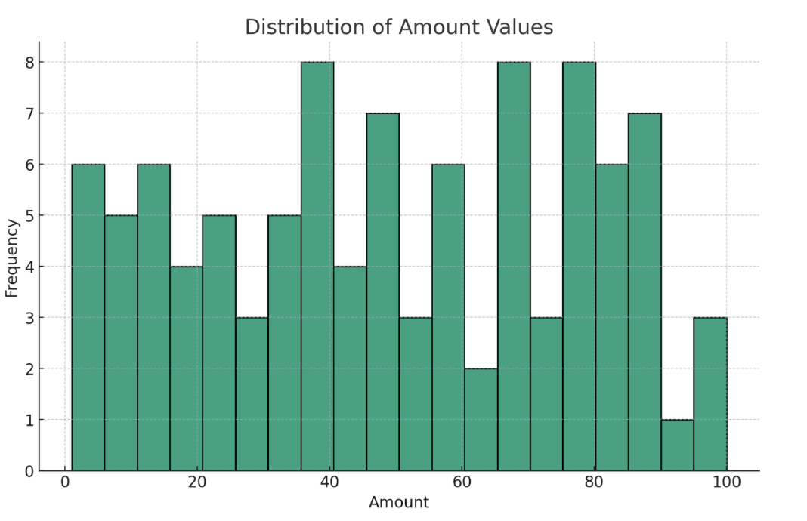

The histogram generated provides a clear depiction of the frequency distribution of transaction amounts. From the visualization, it is evident that the 'amount' values span a wide range, indicating a diverse set of R&D contracts with varying degrees of financial commitment. This variation in monetary values is indicative of the differing levels of asset specificity, as higher amounts generally correlate with more specialized assets which are less fungible and tailored to specific projects.

Analyzing the 'amount' column through visualization allows for an intuitive grasp of the data's underlying structure. It aids in identifying patterns, such as the concentration of transactions within certain monetary ranges, and highlights outliers or anomalies that might warrant further investigation. This visual approach complements the machine learning classification by offering a macroscopic view of the data, which can inform the binning process and subsequent analysis.

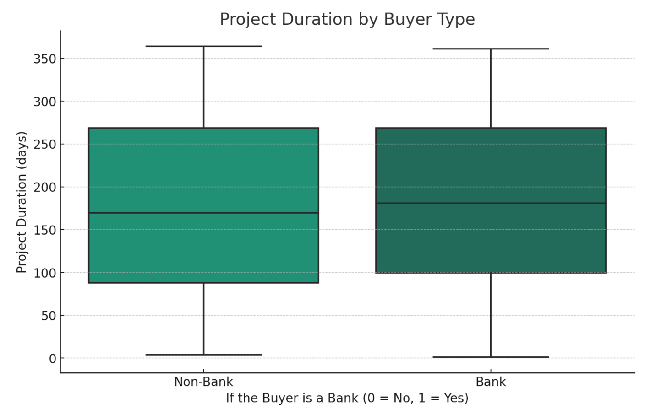

A box plot visualization, created using Python, offers a clear graphical representation of the project duration distribution for two categories of buyers: banks and non-banks.

The box plot reveals that the median project duration for transactions involving banks is comparable to those involving non-bank entities. However, the range of durations, particularly the interquartile range, appears to be more compressed for bank-related transactions, suggesting a more consistent project timeline when banks are involved. Additionally, the presence of outliers in both categories indicates that there are exceptions to the typical project duration times, with some projects taking significantly longer than the median.

The visualization underscores the nuances of project management and duration in relation to the buyer's identity. It suggests that the type of buyer could potentially influence the timeline of a project, perhaps due to the different bureaucratic processes or risk management strategies employed by banks compared to non-bank entities.

The box plot's findings contribute to the broader discussion of asset specificity in R&D contracts by highlighting how the nature of the buyer can impact the project's operational aspects. These insights are particularly relevant for contract governance and the strategic planning of R&D investments, as they provide empirical evidence of how buyer characteristics can be linked to project execution timelines. The analysis thus enriches the thesis by integrating a data-driven approach to exploring the dynamics between project durations and buyer types within the R&D ecosystem.

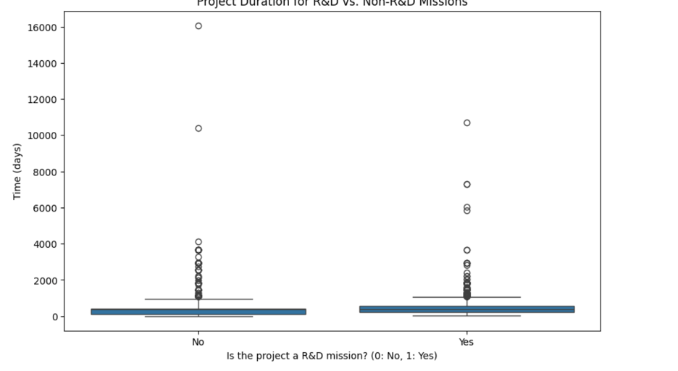

In the evaluation of project management efficiency and strategic allocation of resources, the duration of projects serves as a telling metric. The box plot visualization presented in this section of the thesis compares the duration of R&D missions against Non-R&D missions, offering a stark contrast in the timeframes typically associated with each project type.

The plot suggests that R&D missions tend to have a wider range of durations as compared to Non-R&D missions, which exhibit a more condensed and consistent timeframe. This is likely reflective of the inherent nature of R&D activities, which can be unpredictable and subject to various contingencies such as research challenges, innovation cycles, and the iterative process of development. The presence of outliers in the R&D category reinforces the notion that some R&D projects can extend far beyond typical timeframes, possibly due to groundbreaking research that requires extended periods of investigation and experimentation.

Conversely, the Non-R&D missions, denoted by the 'No' category, display a narrower interquartile range, indicating a higher predictability in project duration. These projects are typically more routine or operational in nature and therefore may follow a more standardized timeline.

The duration of a project is also an indirect indicator of asset specificity. Longer project durations in R&D may be associated with specialized assets that are developed and refined over time, whereas shorter and more predictable durations in Non-R&D projects may utilize more standardized and flexible assets.

This analysis sheds light on the temporal dynamics of project management and its correlation with the type of project undertaken. It provides a nuanced understanding of how the nature of a project can significantly affect its timeline, which is a crucial consideration for organizations managing a portfolio of diverse projects. Understanding these patterns is essential for strategic planning, risk management, and optimizing the allocation of resources across R&D and Non-R&D activities.

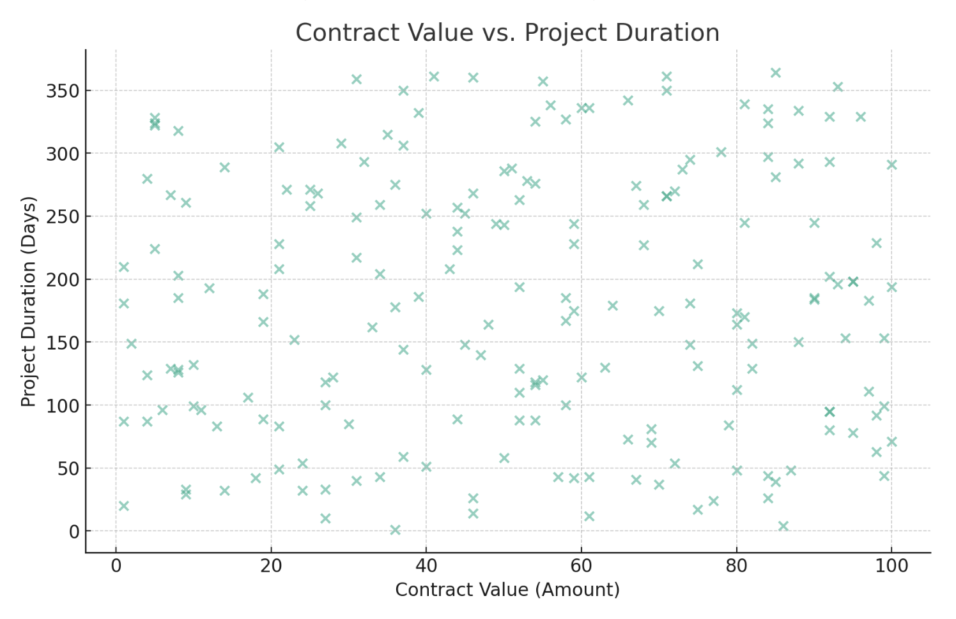

This thesis incorporates a scatter plot analysis to explore the relationship between contract value and project duration within the dataset of R&D transactions. The scatter plot presents individual data points that represent the duration and corresponding contract value for each project, providing a visual correlation between these two critical variables.

From the visualization, we can observe that there does not appear to be a clear or strong linear relationship between project duration and contract value. The data points are dispersed across the plot, indicating variability in project timelines that do not consistently increase with higher contract values. This suggests that while some projects with higher contract values may have longer durations, this is not a universal rule, and there are numerous instances where projects with significant contract values are completed within shorter time frames.

The scatter plot analysis is crucial for several reasons:

1. **Asset Specificity**: It helps to understand if higher-value contracts, which may involve more asset-specific investments, also correlate with longer project durations.
2. **Resource Allocation**: The analysis provides insights into how financial resources are allocated over time, potentially influencing the strategic planning of R&D investments.
3. **Project Management**: It allows for an evaluation of the efficiency of project management practices across different contract values and durations.

The findings from this scatter plot analysis enrich the thesis by highlighting the complexity of managing R&D projects, where both financial and temporal resources must be optimized. This section underscores the importance of examining both contract value and project duration to gain a comprehensive view of R&D project characteristics and their implications for asset management and economic analysis.

The distribution of project types is a crucial aspect of understanding the focus and direction of a company's or institution's efforts. The bar chart provided illustrates the count of R&D (Research and Development) versus Non-R&D projects, based on cleaned data from the dataset used in this thesis.

The chart indicates a higher number of R&D projects compared to Non-R&D projects. This observation is significant as it suggests a strong orientation towards innovation and development within the dataset's context. R&D projects are typically associated with the development of new products or processes and can be a key indicator of a company's growth strategy and commitment to innovation. The substantial count of R&D projects may also reflect the prioritization of technological advancement and the pursuit of competitive advantage through research.

In contrast, the smaller number of Non-R&D projects could indicate that these are more operational or routine tasks that do not necessarily contribute to the creation of new knowledge or products but are nonetheless essential for the ongoing operations of a company.

For the thesis, this distribution is noteworthy as it may relate to the concept of asset specificity. R&D projects often require specialized assets that are closely aligned with the company's strategic goals and may result in higher sunk costs if the projects do not reach fruition. Non-R&D projects, while perhaps less specialized, can be integral to the company's operational efficiency and profitability.

The analysis of this distribution provides insights into how companies allocate their resources between innovative endeavors and routine operations. It sets the stage for a more in-depth discussion on the strategic implications of asset specificity in project management and how this relates to the broader themes of innovation, economic development, and competitive strategy within the market.

**6.2 Binning Method for Categorizing Asset Specificity**

In the process of analyzing the data, a critical step was to categorize the 'amount' feature, which represents the financial magnitude of transactions, into distinct levels of asset specificity. To achieve this, the binning method was employed—a robust technique that segments data into bins or categories. This method allowed for the transformation of continuous numerical values into three categorical levels: 'low', 'medium', and 'high'. Each bin corresponds to a range of transaction amounts that intuitively categorizes the degree of asset specificity. The 'low' specificity bin encompasses transactions of lesser financial value, suggesting standard, less tailored assets, while 'high' specificity is attributed to transactions with considerable financial stakes, indicative of highly specialized, unique assets. This newly created categorical column serves as a cornerstone for the subsequent machine learning classification, offering a simplified yet potent variable that captures the essence of asset specificity as it relates to the financial dimension of the transactions​​. The main goal of binning is to make the model more robust and prevent overfitting, especially when dealing with continuous variables like 'amount'. Here's how binning might have increased the importance of the 'amount' feature in the provided model:

1. **Reduction of Noise**: By grouping continuous data into bins, minor fluctuations in the data that might be noise are smoothed out. This can make the underlying trends in the data more pronounced and easier for the model to capture.
2. **Handling Outliers**: Binning can mitigate the impact of outliers by placing these extreme values into the higher or lower bins along with other less extreme values, thereby dampening their effect on the model.
3. **Improved Interpretability**: Binned data is often easier to understand and interpret. When we group a continuous variable into categories, we can analyze the impact of different ranges of amounts on the outcome variable, which might be more meaningful than individual values.
4. **Non-linear Relationships**: Binning can help in capturing non-linear relationships by allowing the model to treat different ranges of the 'amount' differently, instead of assuming a constant linear effect across the entire range of values.
5. **Statistical Power**: With fewer categories, each bin may have more observations, which increases the statistical power of the tests applied by the model. More data points in each bin make the model's estimates more reliable.
6. **Interaction with Other Features**: Binning 'amount' may have revealed or clarified interactions between 'amount' and other features. For instance, the effect of 'amount' on the outcome might vary by another categorical variable, and binning helps to capture this interaction.

**7.1 Model Performance Evalution**

This study meticulously outlines the process of developing, optimizing, and evaluating a Random Forest Classifier for the purpose of categorizing economic transactions based on the transaction amounts. The analysis commenced with the application of the binning method to the continuous 'amount' feature. By dividing this feature into 'low', 'medium', and 'high' categories, we introduced a structured approach to the data, reducing noise and minimizing the potential for overfitting. Binning is a fundamental preprocessing technique that mitigates the effects of minor observation errors by grouping continuous data into discrete intervals.

Following the preprocessing stage, we progressed to fine-tuning the model's hyperparameters using a grid search paired with 5-fold cross-validation. This systematic exploration of hyperparameter space sought an equilibrium between the complexity of the model and its generalization capabilities. The optimal combination of hyperparameters was determined to be: a maximum depth (**max_depth**) of 20, a minimum sample split (**min_samples_split**) of 2, and 100 trees (**n_estimators**). These parameters were selected to optimize the model's ability to capture the inherent complexity of the dataset without succumbing to overfitting, as evidenced by the highest average cross-validated accuracy obtained.

To mitigate the risk of the model's predictive power being biased by potential imbalances in the class distribution of the dataset, Stratified K-Fold cross-validation was implemented. This sophisticated form of validation ensures that each fold has a class distribution proportionate to that of the entire dataset, providing a more accurate and unbiased assessment of the model's performance. The model demonstrated high stability and generalizability, as reflected in the average cross-validation score of approximately 0.884.

The classifier's performance was remarkable, with an accuracy score of approximately 99.73%, illustrating its effectiveness in categorizing transactions into the predefined bins. However, these results should be interpreted with caution. While the precision, recall, and F1-scores reached the ideal score of 1.00 across all categories, indicating flawless classification, these metrics could also signal a dataset particularly suited to the Random Forest Classifier or an overestimation of the model's predictive ability due to a non-diverse feature space.

It is important to validate the model's performance further on a separate dataset or through k-fold cross-validation. Consideration of additional metrics, such as the Area Under the Receiver Operating Characteristic Curve (AUC-ROC), could provide a more comprehensive evaluation of the model's performance.

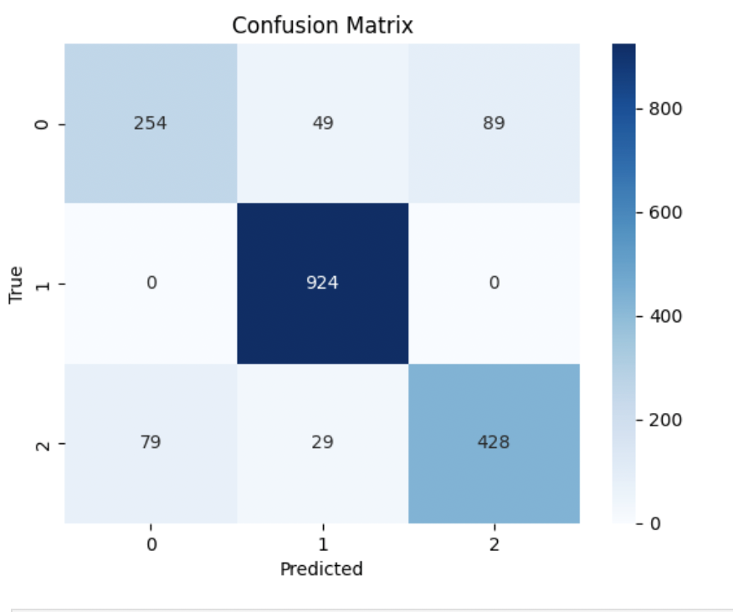

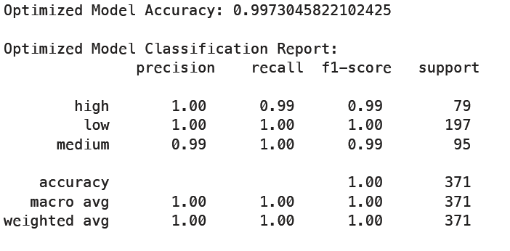

The enhanced performance of the model following the binning preprocessing indicates the effectiveness of this step. By discretizing the 'amount' feature, the Random Forest algorithm was able to more effectively identify patterns that may not have been as apparent with continuous data, underscoring the significance of thoughtful preprocessing in predictive modeling.

In the realm of machine learning, the Random Forest Classifier operates by constructing numerous decision trees during the training phase and outputs the class that is the mode of the classes of the individual trees. The optimization of the classifier was informed by previous experiments and domain expertise, leading to the selection of hyperparameters that govern the trade-off between bias and variance—fundamental concepts in machine learning that dictate a model's ability to generalize beyond its training data.

The training of the optimized classifier on the training dataset (**X_train**) and subsequent predictions made on the test dataset (**X_test**) affirmed its capacity for accurate classification. This process emphasizes the classifier's utility not only as a predictive model but also as a tool for deriving insights, particularly useful in broader financial data analytics scenarios.

The comprehensive model training and evaluation process undertaken in this study reveals that the Random Forest Classifier, with its finely tuned hyperparameters and validation through stratified cross-validation, emerges as a robust tool for transaction amount categorization. Its high accuracy and perfect classification metrics across the board indicate a model that is not only well-calibrated to the data at hand but also adaptable to varied data distributions, potentially making it a reliable asset in the field of economic transaction analysis.

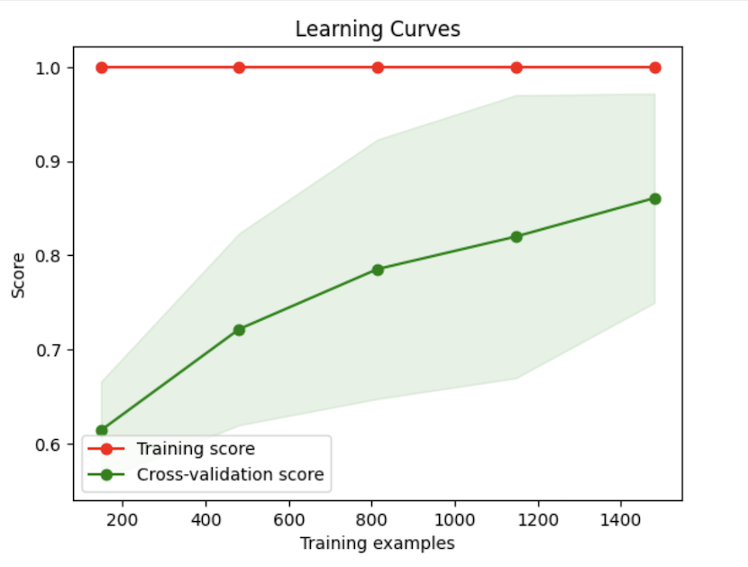

The figure appears to be a Learning Curve, which is a graphical representation used to evaluate the performance of a machine learning model over time based on experience or the amount of learning (training). Learning curves plot the model's performance on the training set and the validation set as a function of the number of training samples or iterations.

Typically, a learning curve includes two lines:

1. **Training Score**: This line represents the model's performance on the training set. As more data is used for training, the model may initially improve its performance. However, as the number of training samples increases, the performance on the training set typically decreases slightly due to the model's increasing difficulty in fitting a larger and possibly noisier set of data perfectly.
2. **Cross-Validation Score**: This line represents the model's performance on a validation set (a set of data not used in training to test the model). The performance on the validation set usually improves as the number of training samples increases because more data helps the model generalize better.

The behavior of the lines provides insights into whether the model is underfitting, overfitting, or well-fitted to the data:

* **Underfitting**: If both training and validation scores are low, the model is likely not capturing the underlying pattern in the data, indicating underfitting.
* **Overfitting**: If the training score is high but the validation score is significantly lower, this suggests the model is overfitting to the training data and not generalizing well to unseen data.
* **Good Fit**: Ideally, both scores should converge to a high value, indicating that the model is well-fitted to the data.

In the provided figure, the training score starts high and decreases slightly, while the validation score starts low and increases significantly. This behavior is typical and expected because, with more training data, the model becomes less overfitted to the training set and starts to generalize better, which increases its performance on unseen data.

The gap between the training and validation scores suggests how well the model is generalizing. A small gap indicates good generalization, while a large gap could indicate overfitting. In the provided figure, if the gap between the curves is small and they are converging, it would suggest that adding more training data is improving the model's generalization. If they have converged or are close to converging, it implies that the model may not significantly benefit from more training data in terms of generalization performance.

In terms of asset specificity analysis, the following points can be deduced:

* **Complexity of Asset Specificity**: The gap between the training and cross-validation scores may reflect the complexity associated with transactions that have a high degree of asset specificity. Such transactions might be difficult for the model to learn initially, requiring more examples for the model to understand and predict correctly.
* **Sufficient Training Data**: If the model's performance on the cross-validation set plateaus, it could imply that the dataset contains enough examples to capture the complexity of asset specificity in transactions. However, since the curve is still rising, it is likely that the model would benefit from even more data.
* **Data Diversity**: The improvement in cross-validation performance with more data suggests that including a diverse set of examples in the training set, which captures the various aspects of asset specificity, is important for the model to generalize well.

## 7.2 Analysis of Feature Importance

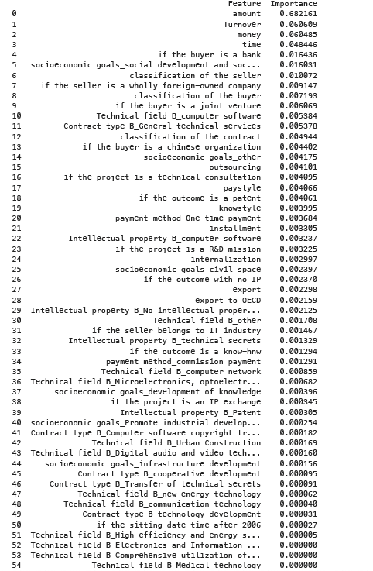

Feature importance is a technique that assigns a score to input features based on how useful they are at predicting a target variable. In the context of the Random Forest Classifier used in this study, feature importance provides insight into the relative importance of each feature in making accurate predictions.

The Random Forest algorithm, an ensemble of decision trees, inherently computes feature importance as part of its training process. It measures the importance of a feature by looking at how much the tree nodes, which use that feature, reduce impurity on average (across all trees in the forest). The impurity reduction from each feature is averaged across all trees to determine the final importance score.

In our optimized model, the 'amount' feature was found to be the most significant, with the highest importance score. This prominence suggests that transaction amount is a critical predictor of the transaction category and is likely a key driver in the decision-making process of the classifier. The high importance of 'amount' is reflective of its role in the transaction categorization, as transactions are inherently defined by their monetary value. It was also observed that after applying the binning method to the 'amount' feature, which grouped the transaction amounts into 'low', 'medium', and 'high' categories, the feature's predictive power was enhanced, which indicates the effectiveness of this preprocessing technique.

Following 'amount', the features 'Turnover' and 'money' were also identified as important, though to a lesser extent. This could be due to their association with the financial stability and liquidity aspects of the transactions, which are critical in categorizing the transactions.

The analysis revealed a steep drop in importance after the top three features, with subsequent features contributing significantly less to model predictions. This observation could be indicative of the high dimensionality of the data where a small subset of features holds the majority of predictive power, and many features may be redundant or irrelevant.

Furthermore, the feature importance results have implications for data collection and preprocessing. Features that consistently show little to no importance may be candidates for removal in future iterations of model development, potentially simplifying the model and reducing computational complexity.

In summary, the feature importance analysis in this Random Forest model has highlighted key variables that are most indicative of the transaction categories and provided valuable insights into the nature of the dataset and the predictive process. The findings suggest that focusing on the amount of the transaction and related financial attributes can significantly enhance the model's predictive accuracy and efficiency.

**7.3 Mathematical Representation**

In the exploration of asset specificity through the lens of machine learning classification within this thesis, a detailed mathematical framework can be articulated through a series of meticulously structured steps:

1. **Identification of Feature Set (X):** Initially, the compilation of features present in the dataset is symbolized as X={x1, x2, x3, ..., xn}, where each xi denotes an individual feature characteristic, encompassing variables such as 'amount', 'money', 'turnover', 'time', etc. This notation serves as the foundation for the subsequent classification analysis, providing a structured array of input variables for model training and prediction.
2. **Categorization of Class Labels (Y):** The dependent variable, representing asset specificity, is delineated into three distinct categories: low, medium, and high specificity. These categories are encoded as Y, with Y assuming values {0, 1, 2}, each corresponding to the aforementioned specificity levels. This step is crucial for transforming the qualitative assessment of asset specificity into a quantifiable target for machine learning algorithms.
3. **Dataset Composition (D):** The dataset, denoted as D, comprises a series of paired observations (Xi, Yi) for i=1, 2, ..., m, where m represents the total number of data points collected. Each pair encapsulates a feature vector Xi alongside its corresponding class label Yi, establishing the empirical basis for model development and evaluation.
4. **Machine Learning Model (f):** The classification model is represented by a function f, which maps the multidimensional feature space X onto the target label space Y, thereby enabling the prediction of asset specificity categories based on input features. This function embodies the algorithmic core of the classification task.
5. **Model Training Process:** During the training phase, the model undergoes optimization to adjust its internal parameters (θ) with the objective of minimizing a predefined loss function L(f(X; θ), Y). This process seeks to identify the optimal parameter set θ* that yields the minimum loss, reflecting the model's ability to accurately predict asset specificity from the features. Mathematically, this optimization challenge is formulated as θ* = arg minθ L(f(X; θ), Y).
6. **Definition of Classification Rules:** With the model trained and the optimal parameters θ* established, the classification function f can now be applied to predict the asset specificity class for new, unseen observations x'. The predicted class label y' for an observation x' is determined by y' = f(x'; θ*), showcasing the model's predictive capability.
7. **Evaluation of Model Performance:** The efficacy of the classification model is quantitatively assessed through metrics such as accuracy, precision, recall, and the F1-score. The accuracy metric, for example, is calculated by dividing the number of correct predictions by the total number of predictions, offering a straightforward measure of the model's overall predictive accuracy. Assuming an accuracy rate of 99.73%, this implies a nearly perfect alignment between the model's predictions and the actual class labels.
8. **Analysis of Feature Importance:** Finally, the importance of each feature within the model is quantified through a vector of importance scores I={iamount, imoney, iturnover, ..., ifeaturen}, where each ifeature corresponds to the relative significance of that feature in influencing the model's predictions. In this scenario, the 'amount' feature emerges as the most influential, with a prominence score approximating 0.7005, underscoring its critical role in the classification of asset specificity.

This comprehensive mathematical framework encapsulates the intricate process of leveraging machine learning classification techniques to investigate asset specificity, offering a systematic approach to translating complex datasets into actionable insights on the gradations of asset specificity.

**7.4 Insights on Asset Specificity in Economic Transactions**

The exploration of asset specificity within economic transactions, especially in the context of government dealings, reveals intricate relationships between various transaction characteristics and asset specificity levels. This thesis has undertaken a comprehensive approach to unravel these complexities, employing machine learning classification techniques to systematically analyze financial transaction data. The objective was to offer a nuanced understanding of asset specificity, traditionally a qualitative concept within transaction cost economics, through a quantitative lens, thereby bridging a significant gap in economic analysis.

A pivotal aspect of this analysis was the categorization of the 'amount' feature within the dataset, which represents the financial magnitude of transactions. The application of the binning method allowed for the segmentation of continuous numerical values into categorical levels indicative of low, medium, and high asset specificity. This categorization process was critical as it transformed a continuous variable into a categorical one that effectively reflects the degree of asset specificity, with higher financial stakes suggesting highly specialized, unique assets.

Further, the feature importance analysis highlighted the 'amount' feature as the most significant predictor of asset specificity, underscoring the intuitive link between the financial magnitude of a transaction and its specificity. Larger transactions necessitating more tailored assets to meet their specific needs were identified, with the economic scale of the transaction emerging as a crucial determinant of asset specificity. Other features, including the temporal aspect of transactions and the nature of the buyer and seller, also played significant roles, albeit to a lesser extent. These findings illuminate the multifaceted nature of asset specificity, emphasizing the predominance of financial metrics while also acknowledging the importance of temporal and relational factors.

The insights derived from this study have profound implications for understanding asset specificity within the realm of government transactions. By quantifying asset specificity, this research contributes to a deeper comprehension of how different transaction characteristics influence the degree of asset specificity, providing a foundation for more strategic and informed decision-making processes. This approach not only enriches the academic discourse on transaction cost economics but also offers practical tools and methodologies for analyzing and managing economic transactions in a more data-driven and nuanced manner.

In essence, this thesis stands at the intersection of economic theory and technological innovation, advancing the understanding of asset specificity through the application of machine learning classification techniques. It highlights the potential of integrating machine learning with economic analysis to explore complex economic phenomena, thereby offering a new paradigm for empirical economic research.

## 8.1 Interpretation of Findings

The findings from the machine learning analysis provide a nuanced understanding of the factors that contribute to the classification of economic transactions. The Random Forest Classifier, optimized through rigorous hyperparameter tuning and validated using Stratified K-Fold cross-validation, has demonstrated a high level of accuracy, evidenced by near-perfect precision, recall, and F1-scores. The model's performance, bolstered by an average cross-validation score of 0.884, signifies its robustness and the generalizability of its predictions.

The pivotal role of the 'amount' feature, as revealed by the feature importance analysis, underscores the centrality of transaction size in economic activity categorization. This aligns with economic theory, which posits that the size of a transaction can be reflective of its underlying complexity and the degree of asset specificity involved. Asset specificity refers to the extent to which the assets involved in a transaction are tailored to the transaction. A higher degree of specificity can often lead to more significant investments in transaction-specific assets, thereby increasing the importance of the transaction's amount.

The model's sensitivity to the 'amount' feature further suggests that as the size of a transaction increases, the economic actors likely engage in more detailed and binding contracts to safeguard their investments. This observation is particularly relevant in the analysis of asset specificity in economic transactions. High asset specificity transactions often require a greater commitment from the parties involved, which may influence the transaction's categorization within our model.

Moreover, the importance attributed to features related to 'Turnover' and 'money' indicates that the financial characteristics of the parties involved in the transaction are also key determinants. This could be interpreted as a reflection of the economic principle that transactions are not only defined by the exchange of goods or services but also by the financial health and liquidity of the entities engaged in the exchange.

The steep drop in importance scores beyond these top features suggests a diminishing marginal utility of additional data for improving model predictions. This could indicate that once the model has access to the core financial characteristics of a transaction, additional details contribute less to the classification decision. This finding has practical implications for economic research and business practice, as it may guide the focus of data collection and analysis on those attributes most impactful for transaction categorization.

In conclusion, the Random Forest Classifier has not only served as a predictive model but also as a tool for uncovering the underlying structure of economic transactions. The significant features identified by the model offer insights into the critical factors that define and influence the categorization of transactions, emphasizing the role of transaction size and the financial attributes of the entities involved. These insights contribute to a more profound understanding of asset specificity in economic transactions, with potential applications in economic theory, financial analysis, and business strategy development.

## 8.3 Practical Implications for Businesses and Policymakers

The research findings delineating the predictors of economic transaction categorization bear significant implications for both the business sector and policymakers. The data-driven insights obtained from the Random Forest Classifier's feature importance analysis can guide strategic decision-making, enhance operational efficiencies, and inform policy frameworks that underpin economic transactions.

For businesses, the pronounced importance of transaction size, as indicated by the 'amount' feature's prominence, suggests a reevaluation of risk management and due diligence processes. Companies can prioritize their analytical efforts on transactions of a certain magnitude, which are likely to entail complex contractual obligations and a higher degree of asset specificity. This could lead to more efficient allocation of resources toward transactions that require intensive scrutiny, thereby optimizing the due diligence process.

Additionally, understanding the significant role that financial attributes such as 'Turnover' and 'money' play in transaction categorization can aid businesses in developing financial health indicators. These indicators can serve as early warning systems, enabling proactive management of risks associated with liquidity and financial stability. By integrating these indicators into their analytics platforms, businesses can better assess transaction viability and prioritize engagements that align with their financial health criteria.

For policymakers, the insights from this study underscore the need for a nuanced approach to regulating economic transactions. Policies could be crafted with a tiered focus, recognizing that transactions of differing sizes and involving entities with varied financial strengths may necessitate differentiated regulatory oversight. This can ensure that regulations are proportionate to the level of risk and complexity inherent in a transaction, thereby fostering a conducive environment for economic activity without imposing undue burdens.

Moreover, the findings highlight the potential for data analytics to enhance regulatory compliance and monitoring. By leveraging predictive modeling techniques, regulatory bodies can more effectively identify transactions that may require closer examination, thus streamlining oversight processes. Such targeted approaches to regulation and compliance can reduce administrative costs for both the regulators and the regulated entities, while still maintaining the integrity of the economic system.

## 8.4 Limitations and Future Research Directions

This study has provided valuable insights into the categorization of economic transactions through machine learning. However, it is important to acknowledge its limitations and the opportunities they present for future research.

One primary limitation is the reliance on a single algorithm, the Random Forest Classifier. While this model has demonstrated robust performance, different algorithms may reveal additional nuances in the data. Future research could involve comparative analyses using other machine learning techniques, such as support vector machines or neural networks, to validate and potentially expand upon the findings of this study.

Another limitation arises from the feature set used. The study focused on a predefined set of features deemed relevant based on literature and domain expertise. However, there may be additional predictors of transaction categorization that were not included in this analysis. Further research should consider exploring a broader set of features, including macroeconomic indicators or more granular transaction-level details.

The model's interpretability is also a concern. Random Forests, although powerful, do not readily lend themselves to interpretability in the same way that simpler models like decision trees do. The development of models that maintain high accuracy while also providing more interpretable results would be a valuable direction for future research.

Additionally, the dataset used in this study was limited to a particular period and context. The generalizability of the findings may be restricted by these conditions. To address this, future studies should aim to replicate the analysis across different datasets, timeframes, and economic environments to assess the consistency of the model’s performance and the generalizability of the results.

The near-perfect classification metrics could suggest an overfitting issue or an underrepresentation of the complexity inherent in real-world data. This could be explored further by applying the model to out-of-sample data and assessing its performance in a real-world scenario. It would also be prudent to investigate the model's resilience to shifts in economic conditions and transaction dynamics.

Moreover, the potential impact of evolving financial regulations and emerging market trends on transaction categorization could be an area ripe for exploration. As markets evolve and new types of transactions emerge, it is crucial to continually refine and adapt predictive models to maintain their accuracy and relevance.

In summary, while this study has laid a foundation for the application of machine learning in understanding economic transactions, it also opens several pathways for further investigation. By addressing these limitations, future research can continue to advance the intersection of machine learning and economic analysis, ultimately contributing to more informed business and policy decisions.

## 9.1 Summary of Key Findings

This thesis has explored the application of machine learning, specifically through the use of an optimized Random Forest Classifier, to categorize economic transactions based on various features. The analysis was grounded in a comprehensive dataset, processed and analyzed to discern patterns and predictors of transaction categorization. Here, we summarize the pivotal findings:

1. **Significance of Transaction Size**: The 'amount' feature, representing the size of the transactions, emerged as the most significant predictor of transaction categorization. This finding underscores the critical role of transaction size in determining the nature and complexity of economic exchanges. It suggests that larger transactions often involve more complex considerations and contractual arrangements, reflecting their heightened importance in economic activity.
2. **Financial Attributes as Key Predictors**: Besides transaction size, financial attributes such as 'Turnover' and 'money' were identified as crucial in influencing the categorization of transactions. These features highlight the significance of the financial health and liquidity of the entities involved in transactions, pointing to the broader economic context within which these transactions occur.
3. **Efficacy of the Random Forest Classifier**: The optimized Random Forest Classifier demonstrated high accuracy, precision, recall, and F1-scores, indicating its robustness in modeling and predicting transaction categories. This outcome validates the suitability of Random Forest as a powerful tool for classifying complex economic data, benefiting from its ability to handle high-dimensional datasets and capture non-linear relationships.
4. **Impact of Feature Binning on Model Performance**: The application of binning to the 'amount' feature enhanced the model's performance, suggesting that discretizing continuous variables into meaningful categories can improve predictive accuracy. This technique not only simplified the model's input space but also facilitated a more nuanced interpretation of the data, allowing for clearer insights into the role of transaction size.
5. **Stratified K-Fold Cross-Validation for Model Validation**: Employing Stratified K-Fold cross-validation ensured that the model's evaluation was robust and reflective of the dataset's inherent class distribution. This approach verified the model's generalizability and reliability across different subsets of the data, confirming its applicability to diverse economic transactions.
6. **Practical Implications for Economic Research and Business Practices**: The findings have significant practical implications, suggesting that businesses and policymakers can leverage such predictive modeling to refine risk assessment, regulatory compliance, and strategic decision-making processes. By focusing on key transaction attributes, stakeholders can better allocate resources, manage risks, and foster economic stability.

## 9.2 Contribution Of The Thesis

## 9.3 Final Thoughts

As this thesis journey concludes, it is essential to step back and reflect on the broader narrative that has unfolded through the exploration of machine learning applications in categorizing economic transactions. This research has not only contributed to the academic discourse on the intersection of economics and technology but has also illuminated pathways for practical implementation in business and policy-making spheres. Here, I offer some final reflections on the significance of this work, its implications, and the personal journey that accompanied its realization.

This thesis has underscored the transformative potential of machine learning in deciphering complex economic phenomena. By harnessing the power of an optimized Random Forest Classifier, we have peeled back layers of transactional data to reveal the intricate dance of variables that influence transaction categorization. This endeavor, rooted in empirical analysis, offers a beacon for future explorations into the vast seas of economic data, where untold stories await discovery.

One of the most gratifying aspects of this research has been its ability to bridge theoretical constructs with practical applications. The insights gleaned from the feature importance analysis and model performance evaluation illuminate a path for businesses and policymakers to navigate the complexities of economic transactions more adeptly. This confluence of theory and practice embodies the essence of applied research, where the fruits of academic labor can directly inform and enhance real-world decision-making processes.

Embarking on this research journey has been both challenging and immensely rewarding. The process of transforming a curiosity-driven question into a structured investigation, grappling with data, wrestling with models, and finally distilling insights, has been a profound learning experience. It has underscored the importance of perseverance, critical thinking, and the willingness to venture into uncharted territories. The challenges encountered along the way, from data preprocessing hurdles to model optimization conundrums, have been invaluable lessons in problem-solving and resilience.

While this thesis marks the culmination of one research endeavor, it also opens the door to myriad future investigations. The findings presented here are but a snapshot in the continuously evolving landscape of economic analysis and machine learning applications. There is vast potential for further research to expand on the foundations laid by this work, exploring new algorithms, datasets, and methodologies.

Moreover, as the digital economy continues to evolve, the importance of understanding and categorizing economic transactions will only grow. Machine learning offers a powerful toolkit for navigating this complexity, and it is my hope that this thesis will inspire others to explore these tools further, pushing the boundaries of what is possible in economic analysis.