MAJOR PROJECT REPORT

On
SMART AMBULANCE AND MOVABLE ROAD DIVIDER SYSTEM
Submitted in partial fulfilment of the requirements for the degree of
BACHELOR OF TECHNOLOGY
(ELECTRICAL AND ELECTRONICS ENGINEERING)


To
BIHAR ENGINEERING UNIVERSITY, PATNA

By
Name  Surya Kant  Mohammad Muzammil  Abhishek Rajan  Anand Raj Bharti | Roll No.  214008  214006  214003  214005 | Registration No.  21110103007  21110103005  21110103002  21110103003

Under the supervision of
Dr. Jyotirmayee Dalei
(Associate Professor)

DEPARTMENT OF ELECTRICAL AND ELECTRONICS ENGINEERING
NETAJI SUBHAS INSTITUTE OF TECHNOLOGY
AMHARA, BIHTA, PATNA-801106, BIHAR

May 2025
CANDIDATE’S DECLARATION

We hereby declare that the dissertation entitled “SMART AMBULANCE AND MOVABLE ROAD DIVIDER SYSTEM” submitted in partial fulfillment for the award of the degree of Bachelor of Technology (B.Tech.) in Electrical and Electronics Engineering is our original work.
This dissertation has not been submitted previously for the award of any degree, diploma, or fellowship at any other university or institution. Furthermore, it has not formed the basis of any other academic distinction or qualification.
We affirm that all sources of information used in this work have been duly acknowledged.

Candidate Details

Name | Roll No. | Signature
Surya Kant | 214008 | …………………………
Mohammad Muzammil | 214006 | …………………………
Abhishek Rajan | 214003 | …………………………
Anand Raj Bharti | 214005 | …………………………

Date:
Place: NSIT, BIHTA

CERTIFICATE


NETAJI SUBHAS INSTITUTE OF TECHNOLOGY
Approved by AICTE, New Delhi, Affiliated to BEU, Patna (Bihar)

This is to certify that the dissertation entitled
“SMART AMBULANCE AND MOVABLE ROAD DIVIDER SYSTEM”
submitted in partial fulfillment of the requirements for the award of the degree of
Bachelor of Technology (B.Tech.) in Electrical and Electronics Engineering
is a bona fide record of original work carried out by the following students:
Name | Roll Number
Surya Kant | 214008
Mohammad Muzammil | 214006
Abhishek Rajan | 214003
Anand Raj Bharti | 214005
under my supervision and guidance during the academic year 2024–2025.
To the best of my knowledge, this work has not been submitted to any other university or institution for the award of any degree, diploma, or fellowship.

Guide/Supervisor
Name: Dr. Jyotirmayee Dalei
Designation: Associate Professor
Signature: ________________________

Head of the Department
Name: Mr. Ritesh Kumar
Department: Electrical and Electronics Engineering
Signature: ________________________

External Examiner
Signature: ________________________
APPROVAL


NETAJI SUBHAS INSTITUTE OF TECHNOLOGY
Approved by AICTE, New Delhi, Affiliated to BEU, Patna (Bihar)

This is to certify that the project report entitled
“SMART AMBULANCE AND MOVABLE ROAD DIVIDER SYSTEM”
submitted by the following students:
Name | Roll Number
Surya Kant | 214008
Mohammad Muzammil | 214006
Abhishek Rajan | 214003
Anand Raj Bharti | 214005
has been examined and approved as a bonafide work carried out in partial fulfillment of the requirements for the award of the degree of Bachelor of Technology (B.Tech.) in Electrical and Electronics Engineering under the supervision of the undersigned during the academic year 2024–2025.

INTERNAL EXAMINER EXTERNAL EXAMINER

ACKNOWLEDGEMENT

During the course of this project, we have received invaluable guidance, encouragement, and support from several individuals and institutions, to whom we express our deepest gratitude.
We extend our sincere appreciation to Dr. Jyotirmayee Dalei, Associate Professor, for providing us with this excellent opportunity to work on this project and for her continuous guidance and encouragement. We are especially grateful to Mr. Ritesh Kumar, Head of the Department of Electrical and Electronics Engineering, for his motivational support and valuable insights that significantly contributed to the successful completion of this work.
Our heartfelt thanks go to Mr. Nishant Kumar for his constant supervision, constructive feedback, and technical suggestions throughout the course of this project. His expertise and mentorship played a crucial role in shaping our understanding and implementation of the Adaptive Ambulance Monitoring System.
We would also like to express our gratitude to Netaji Subhas Institute of Technology, Patna, for providing us with the opportunity and resources to explore innovation in the field of emergency medical services and intelligent transportation systems. Furthermore, we sincerely thank the Department of Electrical and Electronics Engineering for granting us this golden opportunity to undertake this project and for fostering an environment of research and learning.
Finally, we extend our gratitude to our peers, family, and friends for their unwavering support, encouragement, and belief in our abilities. Their motivation has been a driving force behind our commitment to excellence.

ABSTRACT

Emergency medical response time plays a critical role in saving lives, especially in urban areas where traffic congestion often causes severe delays for ambulances. The project “SMART AMBULANCE AND MOVABLE ROAD DIVIDER SYSTEM” is designed to address this issue by integrating smart technologies that prioritize ambulance movement through traffic intersections.
The system consists of two main components: a Smart Ambulance Unit and a Movable Road Divider Mechanism. The Smart Ambulance is equipped with an ESP8266 microcontroller, Neo-6M V2 GPS module, DHT11 temperature and humidity sensor, and a pulse sensor. These components work together to collect and transmit real-time health and location data to a cloud platform (ThingSpeak) via Wi-Fi, enabling centralized monitoring.
On the infrastructure side, the Movable Road Divider uses two Arduino Uno boards, RFID reader (RC522), LED indicators (Red, Yellow, Green), L293D motor driver, LCD Display (16x2) with I2C module, and a motor with spur and worm gear setup to physically move the divider. The RFID tag placed along the road triggers the system to detect the ambulance at a predetermined distance from the intersection. Upon detection, the road divider shifts position to create a clear path for the ambulance, and traffic lights are managed accordingly to reduce waiting time.
This project provides a practical and cost-effective solution to improve ambulance response time, reduce delays at intersections, and enhance overall emergency medical service efficiency. The integration of IoT and automation in urban traffic systems signifies a step toward smarter, life-saving infrastructure.

TABLE OF CONTENTS

LIST OF FIGURES | IX
CHAPTER 1:  INTRODUCTION  1.1 Problem Statement  1.2 Objective  1.3 Scope of the Project | 1 to 3
CHAPTER 2:  LITERATURE SURVEY  2.1 Introduction  2.2 Smart Ambulance Systems  2.3 Movable Road Divider Systems  2.4 Integrated Intelligent Traffic and Infrastructure Systems | 4 to 6
CHAPTER 3:  COMPONENT DETAILS  3.1 ESP8266 NodeMCU  3.2 NEO-6M V2 GPS Module  3.3 DHT11 Sensor  3.4 Pulse Sensor  3.5 Arduino UNO  3.6 RFID RC522 Module  3.7 L293D Motor Driver  3.8 Spur and Worm Gear Mechanism  3.9 DC Motor  3.10 16x2 LCD Display with I2C Module  3.11 LED Indicators (Red, Yellow, Green)  3.12 Software Tools | 7 to 16
CHAPTER 4:  SYSTEM DESIGN AND METHODOLOGY  4.1 Introduction  4.2 System Overview  4.3 Flowchart  4.4 Block Diagram  4.5 Working of the Project  4.6 System Components and Integration  4.7 Operational Workflow  4.8 Software and Communication Logic  4.9 Advantages of the System  4.10 Summary | 17 to 24
CHAPTER 5:  IMPLEMENTATION AND RESULTS  5.1 Introduction  5.2 System Setup and Integration  5.3 Testing and Validation  5.4 Results and Observations  5.5 Challenges Faced and Resolutions  5.6 Summary | 25 to 28
CHAPTER 6:  CONCLUSION AND FUTURE SCOPE  6.1 Conclusion  6.2 Future Scope | 29 to 30
REFERENCES | 31
APPENDIX | 32 to 35

LIST OF FIGURES

ESP8266 NodeMCU | 7
NEO-6M V2 GPS Module | 8
DHT11 Sensor | 9
Pulse Sensor | 10
Arduino UNO | 11
RFID RC522 Module | 11
L293D Motor Driver | 12
DC Motor | 13
16x2 LCD Display with I2C Module | 14
LED Indicators (Red, Yellow, Green) | 15
Figure of Project | 17
Flowchart of Ambulance Part | 18
Flowchart of Signal Part | 19
Block Diagram of Ambulance Part | 20
Block Diagram of Signal Part | 21
Circuit Diagram of Ambulance Part | 22
Picture of Ambulance Part | 25
Picture of Signal Part | 26
Result and Observation | 27 to 28

CHAPTER 1
INTRODUCTION
In today’s rapidly evolving urban landscape, the demand for faster and more efficient emergency medical services has become a critical priority. With the dramatic increase in population and vehicular density, especially in metropolitan and developing cities, traffic congestion has emerged as one of the primary obstacles hindering the swift movement of emergency response vehicles such as ambulances. Delays in reaching the hospital during the so-called “golden hour” can lead to severe complications or even death, particularly in trauma and cardiac cases. Therefore, there is an urgent need for a smart, responsive infrastructure that ensures smooth and uninterrupted passage for ambulances through busy intersections and traffic-prone zones.
The “Smart Ambulance and Movable Road Divider System” is a technological innovation aimed at addressing this critical problem. It integrates modern concepts of IoT (Internet of Things), embedded systems, real-time monitoring, and automated traffic control to create an intelligent solution that minimizes emergency response time while ensuring patient vitals are monitored during transit. The project presents a two-part system designed to work in tandem: a Smart Ambulance Unit and a Movable Road Divider Mechanism installed at strategic traffic points.
The Smart Ambulance Unit is embedded with a Wi-Fi-based microcontroller (ESP8266), DHT11 sensor to measure temperature and humidity inside the ambulance, a pulse sensor to monitor the patient’s heart rate, and a GPS module (Neo-6M V2) to track the ambulance’s live location. These readings are collected and transmitted in real-time to an online cloud platform (ThingSpeak) using Wi-Fi connectivity. This allows hospital staff to monitor vital patient data remotely and prepare for the required treatment even before the patient arrives, thereby saving valuable time.
The second part of the project, the Movable Road Divider System, is implemented using dual Arduino Uno boards, RFID technology (RC522), a motor-driven mechanical divider, and LED-based traffic signals (Red, Yellow, Green). The RFID tag attached to the ambulance is detected by the RFID reader installed at a fixed distance from an intersection — a distance determined based on traffic pattern analysis. When the tag is detected, the system activates the movable divider mechanism via a L293D motor driver and initiates the opening of a special lane for the ambulance by physically shifting the road divider. Concurrently, the traffic lights are adjusted to give clear passage to the ambulance, ensuring that it does not get stuck in congestion. An LCD display (16x2 with I2C module) provides information and feedback regarding the operation of the system.
This system aims to bridge the gap between emergency response and urban traffic management by creating a real-time, responsive infrastructure. The movable road divider ensures physical re-routing of regular traffic, making way for the ambulance to pass safely. It eliminates the need for manual traffic control or reliance on drivers to yield, both of which can be unpredictable.
In addition to improving ambulance response time, this project also emphasizes patient monitoring during transit. The integration of vital sign sensors with cloud data services ensures that critical health information is not only available in real-time but is also stored for future reference and analysis. This capability is particularly useful for high-risk patients or in scenarios where the ambulance may be delayed due to unavoidable external factors.
The Smart Ambulance and Movable Road Divider System is a step toward smart city development, where infrastructure is designed to be intelligent, automated, and responsive to real-world challenges. By leveraging cost-effective and widely available components such as microcontrollers, sensors, and RFID technology, this system can be scaled and deployed across cities with relative ease. It demonstrates the potential of integrating healthcare, electronics, and transportation for the welfare of society.
In conclusion, this project addresses one of the most pressing concerns in urban traffic and emergency response systems. It offers a holistic solution that not only facilitates quicker ambulance movement but also incorporates health monitoring, intelligent automation, and real-time data sharing. This innovative approach makes a strong case for the future of smart transportation and emergency infrastructure.

1.1 Problem Statement
In today’s growing urban environments, one of the biggest challenges faced by emergency medical services is the delay in ambulance arrival, especially when navigating through heavy traffic. The increasing number of vehicles on the road, coupled with the lack of efficient traffic control systems, causes ambulances to be stuck at congested intersections. These delays can be life-threatening, particularly for patients with severe injuries or critical health conditions.
While traffic systems in many cities follow fixed timings for signal changes, they do not offer any priority passage to emergency vehicles, nor do they account for real-time traffic conditions. This results in ambulances being forced to wait at intersections, wasting precious time that could make the difference between life and death. Furthermore, emergency response teams often lack a direct way to communicate patient health data and ambulance location with hospitals. This lack of integration leads to a delay in preparing for medical procedures once the patient arrives.
This project seeks to solve these problems by creating a smart ambulance system that communicates live patient health data and tracks the location of the ambulance. The system is designed to work alongside an automated movable road divider system that allows the creation of clear paths for ambulances, even in heavy traffic. This will help reduce the response time by removing traffic bottlenecks and ensuring that ambulances have the right of way when needed most.

1.2 Objective
The primary goal of this project is to enhance the efficiency and speed of emergency medical services through the integration of modern technology. One of the main objectives is to create a Smart Ambulance System that can wirelessly transmit real-time data, such as the patient’s body temperature, heart rate, and environmental conditions inside the vehicle. This data is shared through an IoT platform, allowing hospitals to track the patient’s vitals remotely and prepare in advance for treatment.
Another key aspect is the GPS tracking feature that continuously monitors the ambulance’s location, ensuring that the nearest hospitals and emergency services are informed well ahead of time. The system is also designed to provide a dynamic solution to the issue of traffic congestion. The Movable Road Divider System will automatically shift, clearing the path for the ambulance, and will be triggered by an RFID-based detection system placed at critical points before intersections.
In addition, the project aims to automatically control traffic lights based on the proximity of an approaching ambulance, allowing it to pass uninterrupted. This is done by adjusting the light signals in real-time, ensuring that the ambulance is prioritized over regular traffic. The system will also display operational statuses on an LCD screen, providing real-time information to road users and operators, further ensuring smooth operation.
The objective of this project is to integrate these technologies into a cohesive system that reduces delays, ensures patient safety, and makes the urban transport system smarter and more responsive.

1.3 Scope of the Project
The Smart Ambulance and Movable Road Divider System is an innovative solution that combines healthcare, traffic management, and automation. The scope of this project goes beyond just ambulance tracking—it aims to create a seamless connection between the ambulance, the traffic system, and healthcare services. The system will collect vital health data using sensors like the DHT11 temperature and humidity sensor and the pulse sensor, transmitting it to cloud platforms in real-time for remote monitoring. This provides healthcare providers the ability to prepare for the patient's arrival, even before the ambulance reaches the hospital.
The second part of the project, the Movable Road Divider System, uses RFID technology to trigger the movement of a physical divider on the road to clear the ambulance's route. The system is integrated with LED traffic lights that automatically change to allow the ambulance to pass without any manual intervention. This ensures that the traffic lights are responsive to the needs of emergency vehicles, reducing wait times at intersections.
In addition, this project involves the development of a scalable solution that can be implemented in cities worldwide, especially in high-traffic urban centers. The system can be customized and extended to include more advanced technologies, such as AI-based traffic prediction systems or integrated hospital dashboards, allowing for real-time coordination between hospitals and ambulances. The system is designed to be cost-effective, utilizing widely available components like microcontrollers, sensors, and motor drivers, making it feasible for large-scale deployment in urban areas.
Ultimately, this project serves as a model for the future of urban transport and emergency services, offering a blueprint for the creation of smart cities where technology plays a central role in improving the quality of life for residents.

CHAPTER 2
LITERATURE SURVEY

2.1 Overview of Existing Technologies and Studies
The development of an Adaptive Ambulance Monitoring System using IoT requires an in-depth understanding of existing technologies that address different aspects of emergency medical services. Various studies have explored smart traffic management systems for ambulances, IoT-based patient monitoring solutions, and automated hospital coordination mechanisms. Despite advancements in each of these areas, current systems have limitations that prevent seamless emergency response. This section reviews key research efforts, analyzing their methodologies, strengths, and shortcomings to identify gaps that the proposed system aims to address.

2.2 Smart Traffic Management for Ambulances
Traffic congestion is one of the primary causes of delays in emergency medical services, especially in densely populated urban areas. Traditional traffic light systems follow pre-programmed signal cycles that do not account for real-time traffic flow or the presence of emergency vehicles. Consequently, ambulances often get stuck in heavy traffic, reducing their ability to reach hospitals quickly. Several research studies have proposed smart traffic control systems designed to prioritize ambulances and reduce delays.
A study by Bilal Ghazal et al. (2022) introduced a Smart Traffic Light Control System using a PIC microcontroller and infrared (IR) sensors to measure traffic density at intersections. When an ambulance is detected in the traffic stream, the system adjusts the traffic signal timing dynamically to clear a path for the emergency vehicle. The approach demonstrated improvements in reducing congestion and improving ambulance movement, but it faced limitations in scalability and real-time adaptability, particularly in multi-lane intersections where multiple emergency vehicles might be present.
Another approach, proposed by Norbert Varga et al. (2021), focused on a priority-based ambulance rescue system that establishes direct communication between ambulances and traffic lights. The system utilizes RFID tags and GPS tracking to detect an approaching ambulance and override regular traffic light sequences. This study highlighted the effectiveness of real-time vehicle prioritization in reducing emergency response times. However, it did not consider alternative routes or provide automated rerouting capabilities in cases where intersections are blocked.
Despite the effectiveness of these smart traffic systems, most existing approaches rely on pre-programmed logic that does not adapt to changing road conditions in real-time. There is a need for AI-driven traffic control systems that can dynamically adjust signal patterns based on the real-time location and speed of an ambulance. The proposed Adaptive Ambulance Monitoring System will integrate IoT-enabled traffic signals with AI-driven route optimization to create a fully automated, real-time traffic management system that ensures ambulances reach hospitals without unnecessary delays.

2.3 IoT-Based Patient Monitoring Systems
The ability to monitor patient vitals during transit is essential for providing high-quality emergency medical care. Conventional ambulances rely on manual assessments by paramedics, who may not always have access to real-time monitoring tools. This creates a risk where critical changes in a patient’s condition may go undetected until the ambulance reaches the hospital. IoT-based patient monitoring solutions address this issue by enabling continuous real-time tracking of vital signs, allowing doctors and hospital staff to prepare accordingly.
A study by Wang et al. (2020) proposed a Wireless Patient Monitoring System that integrates wearable biosensors to track heart rate, oxygen levels, body temperature, and blood pressure. The data is transmitted via Bluetooth and Wi-Fi to a central hospital system. While this system demonstrated success in real-time monitoring, it was limited by network dependency issues, as continuous data transmission required stable internet connectivity, which may not always be available in transit.
Another research effort by Suresh et al. (2019) explored an IoT-enabled Ambulance Patient Monitoring System using cloud storage to securely transmit and store patient data. The system enabled real-time ECG monitoring and automated alerts for critical fluctuations in vital signs. However, the study noted concerns regarding data security and latency, as large volumes of medical data require robust encryption and fast processing capabilities to ensure timely medical interventions.
The proposed Adaptive Ambulance Monitoring System builds upon these approaches by implementing a hybrid connectivity model using a combination of 5G networks, cloud-based storage, and edge computing to minimize latency. Additionally, AI-powered predictive analytics will be incorporated to detect patterns in patient vitals and anticipate potential medical emergencies before they escalate, allowing hospitals to take preemptive action.

2.4 Automated Navigation and Hospital Coordination
Ensuring that ambulances take the fastest and safest route to hospitals is another critical aspect of emergency response optimization. Most conventional navigation systems rely on standard GPS routing, which does not account for real-time traffic conditions or hospital availability. Automated navigation and hospital coordination systems have been explored in various studies to improve this aspect of emergency medical services.
Rahman et al. (2021) introduced an AI-based ambulance navigation system that utilizes real-time traffic data, accident reports, and roadblock detection to recommend the most efficient route for ambulances. The system significantly reduced response times by dynamically adjusting routes based on updated traffic conditions. However, it lacked integration with hospital capacity data, which meant ambulances could still end up at overcrowded hospitals with limited emergency resources.
A separate study by Jain et al. (2022) developed a hospital coordination framework that enables real-time communication between ambulances and hospitals using IoT-based cloud services. The system allowed hospitals to receive automated alerts about incoming patients, along with real-time updates on their health status. This improved emergency preparedness, but it did not include an automated ambulance dispatch mechanism, meaning that ambulance assignments were still handled manually, causing delays in emergency response times.
The Adaptive Ambulance Monitoring System enhances these existing models by integrating AI-powered navigation with hospital capacity tracking. It will feature a smart ambulance dispatch system that automatically assigns the nearest available ambulance based on patient location, real-time hospital capacity, and current traffic conditions. The system will also enable direct hospital coordination, allowing emergency departments to prepare necessary medical resources before the patient arrives.

2.5 Comparison of Different Approaches and Identified Gaps
After reviewing various studies on smart traffic management, IoT-based patient monitoring, and automated hospital coordination, several gaps have been identified in existing systems:
- Lack of Real-Time Adaptive Traffic Management: Most smart traffic control systems rely on pre-programmed signals that do not dynamically adjust to real-time traffic patterns or the presence of multiple emergency vehicles. There is a need for an AI-driven, real-time ambulance prioritization system that can optimize traffic lights based on changing road conditions.
- Limited Network Reliability in Patient Monitoring: Existing IoT-based patient monitoring systems face connectivity challenges, especially in areas with unstable network signals. A hybrid communication model combining 5G, cloud storage, and edge computing is required to ensure continuous monitoring and data transmission.
- Absence of Automated Hospital Resource Allocation: Many hospital coordination systems provide basic patient tracking but lack integration with real-time hospital capacity management. An automated resource allocation system should be developed to assign ICU beds, ventilators, and specialists before the patient’s arrival.
- Manual Ambulance Dispatching Processes: Current ambulance dispatching systems still rely on manual assignments, leading to delays in emergency response. A fully automated, AI-driven ambulance dispatch system should be implemented to ensure the fastest available ambulance is assigned to a case in real-time.

2.6 Summary
The literature survey highlights significant advancements in smart traffic management, IoT-enabled patient monitoring, and hospital coordination. However, existing systems operate in isolation, addressing specific aspects of emergency response without offering a fully integrated solution. The Adaptive Ambulance Monitoring System aims to bridge these gaps by combining AI-driven traffic control, IoT-based patient monitoring, real-time hospital coordination, and automated ambulance dispatching into a unified framework. By addressing the shortcomings of existing approaches, this system will enhance emergency medical services, reduce delays, and ultimately save more lives through optimized healthcare logistics.

CHAPTER 3
COMPONENT DETAILS
This chapter elaborates on the essential components utilized in the Smart Ambulance and Movable Road Divider System. The system is divided into two primary sections: the Ambulance Monitoring Unit and the Movable Road Divider Unit. Each sub-section below discusses individual components, their functionality, and their role in the system.

3.1 ESP8266 NodeMCU
The ESP8266 NodeMCU is a low-cost, Wi-Fi-enabled microcontroller module widely used in IoT (Internet of Things) applications. It combines the features of a microcontroller and a Wi-Fi module, making it ideal for wireless data transmission in smart systems like our Smart Ambulance and Movable Road Divider System.
This board is built around the ESP8266 chip, which includes a full TCP/IP stack and microcontroller capability. It supports programming with the Arduino IDE, making development and deployment very accessible to students and professionals alike.

Key Features:
- Built-in Wi-Fi module
- Operates at 3.3V logic
- 11 digital I/O pins, including PWM, I2C, SPI
- 1 Analog input pin (A0)
- Micro USB port for programming and power supply
- Supports Lua scripting and Arduino programming
- Compact size and low power consumption

Applications in the Project:
In our project, the ESP8266 serves as the main controller unit for the ambulance. It performs the following key functions:
- Reads temperature and humidity data from the DHT11 sensor
- Reads pulse rate from the analog pulse sensor
- Fetches GPS location data via the Neo6M GPS module
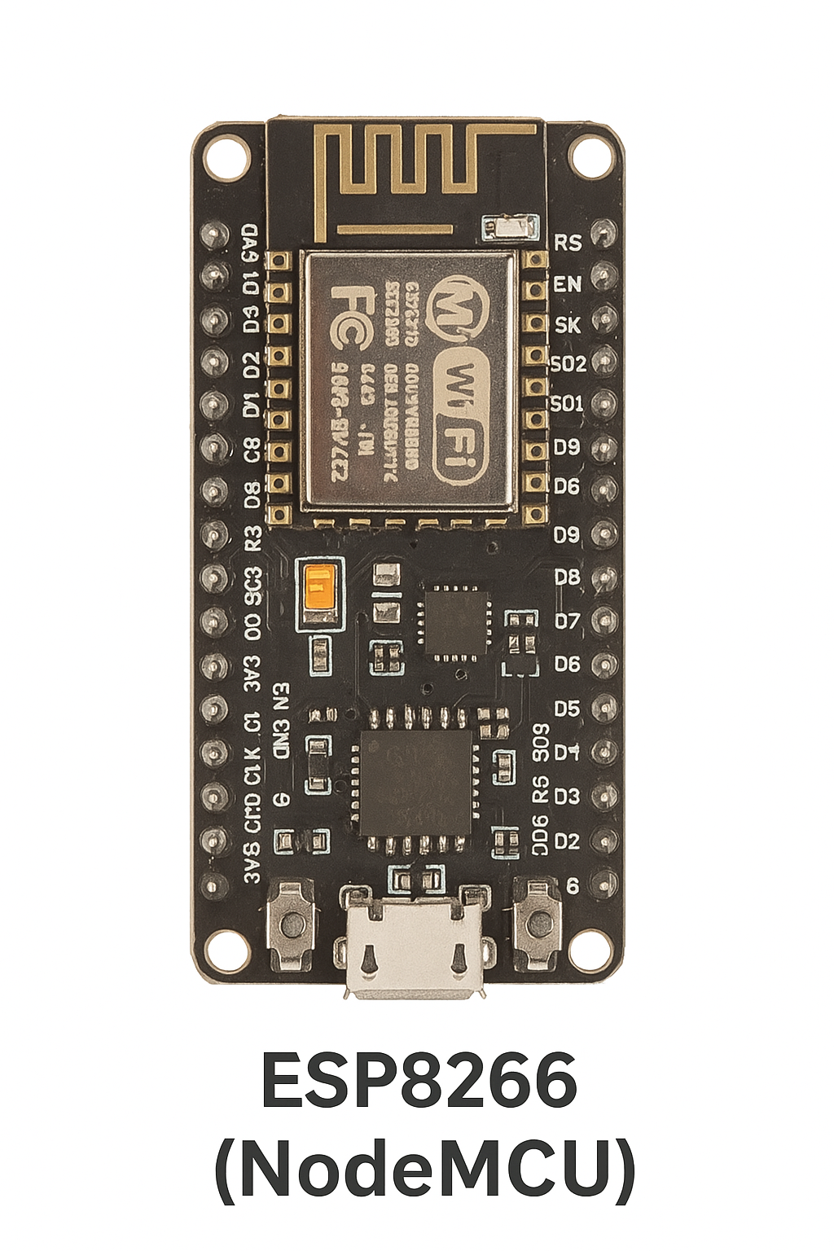
- Connects to Wi-Fi and transmits all collected data to the ThingSpeak cloud platform for real-time monitoring

Technical Specifications:
Parameter | Value
Operating Voltage | 3.3V
Input Voltage (max) | 10V
Digital I/O Pins | 11
Analog Input Pins | 1 (10-bit resolution)
Clock Speed | 80 MHz / 160 MHz
Flash Memory | 4 MB
Connectivity | Wi-Fi 802.11 b/g/n
3.2 NEO-6M V2 GPS Module
The NEO-6M V2 GPS module is a compact and efficient Global Positioning System (GPS) receiver that provides real-time geographical location data such as latitude, longitude, altitude, and timestamp. It is based on the u-blox NEO-6M GPS chipset, which ensures high accuracy and fast time-to-first-fix (TTFF).
This module is widely used in tracking systems, navigation devices, and IoT-based location-sensitive applications. In our project, it plays a crucial role in providing live ambulance location data to ensure faster traffic management and road clearance.

Key Features:
- High-sensitivity GPS receiver with 50 channels
- Built-in ceramic antenna and EEPROM
- Operating voltage of 3V to 5V
- UART serial communication (9600 baud rate default)
- Onboard battery for data retention and faster cold start
- LED indicator for GPS lock status

Applications in the Project:
In our Smart Ambulance System, the NEO-6M GPS module is interfaced with the ESP8266 microcontroller. It:
- Continuously transmits the real-time geographic coordinates of the ambulance
- Allows remote monitoring of the ambulance's position via ThingSpeak
- Enables the traffic system to anticipate the ambulance's arrival and trigger divider movement automatically
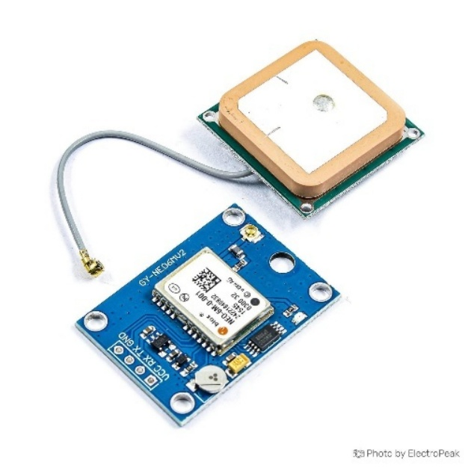
Technical Specifications:
Parameter | Value
Chipset | u-blox NEO-6M
Supply Voltage | 3.3V – 5V
Interface | UART (Serial Communication)
Baud Rate (Default) | 9600
Position Accuracy | 2.5 meters
Cold Start Time | < 27 seconds
Antenna Type | Ceramic Internal
Data Retention | Supported via backup battery

3.3 DHT11 Sensor
The DHT11 is a basic, ultra-low-cost digital sensor used to measure temperature and humidity. It offers a simple and reliable way to gather environmental data in real-time. Its compact size, low power consumption, and ease of interfacing with microcontrollers make it widely popular in embedded systems and IoT applications.
The sensor has a dedicated NTC temperature sensor and a capacitive humidity sensing element, along with an internal signal processing chip that converts the analog signals into a calibrated digital output.

Key Features:
- Measures Temperature and Relative Humidity
- Digital output (no need for analog input pin)
- Operating voltage: 3.3V to 5V
- Sampling rate: once every 1 second
- Long-term stability and reliability
- Single-wire serial communication for data

Applications in the Project:
In our Smart Ambulance System, the DHT11 sensor is connected to the ESP8266 microcontroller to:
- Continuously measure the temperature and humidity inside or around the ambulance
- Help monitor the patient's environmental conditions during transport
- Upload the environmental data to the ThingSpeak cloud platform for remote viewing and alerts if necessary
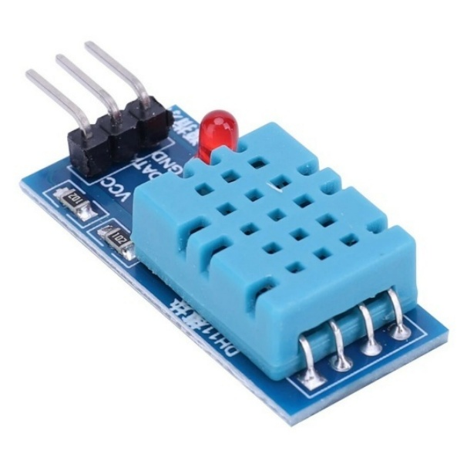
Technical Specifications:
Parameter | Value
Temperature Range | 0°C to 50°C
Temperature Accuracy | ±2°C
Humidity Range | 20% to 90% RH
Humidity Accuracy | ±5% RH
Operating Voltage | 3.3V to 5V
Signal Output | Digital
Interface | Single-wire serial

3.4 Pulse Sensor
The Pulse Sensor is a plug-and-play biometric sensor that measures heart rate (BPM - beats per minute) by detecting the pulse from a fingertip or earlobe. It works based on photoplethysmography (PPG), a non-invasive method that uses a light-emitting diode (LED) and a photodetector to measure changes in blood volume during heartbeats.
It is widely used in health monitoring systems, fitness trackers, and biomedical projects. In this project, it provides a crucial parameter for monitoring the health condition of patients inside the ambulance.

Key Features:
- Easy-to-use heart rate monitoring sensor
- Operates with 3.3V or 5V
- Analog output signal
- Integrated LED and photodetector
- Compact, lightweight, and wearable design
- Comes with jumper wires and an ear-clip or finger-clip mount
Applications in the Project:
In the Smart Ambulance System, the Pulse Sensor is connected to the ESP8266's analog pin. It:
- Measures the patient's pulse rate in real-time
- Sends the data to the ThingSpeak IoT platform for live health tracking
- Acts as a basic health check to ensure that the patient is stable during transit
- Triggers alerts if the pulse falls outside a pre-set safe range (though in this case, a simulated BPM range is used)

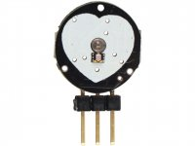
Technical Specifications:
Parameter | Value
Operating Voltage | 3.3V – 5V
Signal Output | Analog
Sensor Type | Photoplethysmography (PPG)
Output Range | 0 to 1023 (analog)
Measurement Area | Finger, Earlobe
Interface | 3-pin (VCC, GND, Signal)
3.5 Arduino UNO
The Arduino UNO is a popular open-source microcontroller board based on the ATmega328P microcontroller. It is widely used in electronics and embedded systems projects due to its simplicity, versatility, and strong community support. The board includes digital and analog input/output pins, power supply headers, and a USB interface for programming and communication.
In this project, two Arduino UNO boards are used—one to manage the movable road divider with RFID integration, and the other to handle LCD display outputs.

Key Features:
- Based on ATmega328P microcontroller
- 14 Digital I/O pins (6 can be used as PWM outputs)
- 6 Analog input pins
- Operating Voltage: 5V
- Clock Speed: 16 MHz
- Flash Memory: 32 KB (0.5 KB used by bootloader)
- SRAM: 2 KB
- EEPROM: 1 KB
- USB connection for programming via Arduino IDE

Applications in the Project:
- First Arduino UNO: Connected with RFID reader, L293D motor driver, and LEDs to control the road divider based on RFID card detection. It detects when the ambulance is near and moves the divider accordingly.
- Second Arduino UNO: Interfaced with 16x2 LCD Display via I2C module to show relevant messages, such as alerts or status updates received via serial communication.
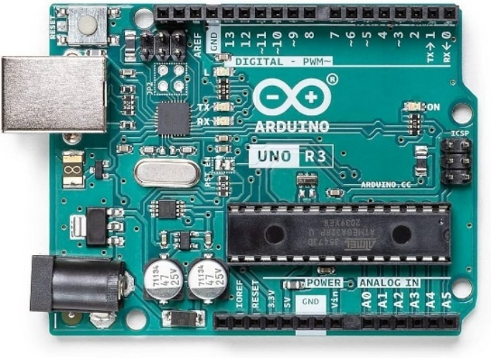
Technical Specifications:
Specification | Description
Microcontroller | ATmega328P
Operating Voltage | 5V
Input Voltage | 7–12V
DC Current per I/O Pin | 20 mA
Flash Memory | 32 KB
Clock Speed | 16 MHz
Communication Ports | USB, UART, SPI, I2C

3.6 RFID RC522 Module
The RFID RC522 module is a low-cost and compact RFID reader and writer that operates at 13.56 MHz frequency. It uses radio frequency identification technology to read data from RFID tags or cards without physical contact. The RC522 is based on the MFRC522 IC and communicates via the SPI protocol with microcontrollers like Arduino.
In this project, the RC522 module is used to detect the presence of an ambulance via a pre-programmed RFID card placed beside the road at a designated distance. Once the card is read, the Arduino triggers the motor to move the road divider.

Key Features:
- Operating Frequency: 13.56 MHz
- Communication Interface: SPI (Serial Peripheral Interface)
- Operating Voltage: 3.3V
- Range: Up to 5 cm depending on the tag and antenna
- Fast and efficient tag detection
- Comes with RFID cards and key fobs for testing

Applications in the Project:
- Detects the RFID card placed near the roadside.
- Signals the Arduino UNO to initiate the motor movement to open the road divider.
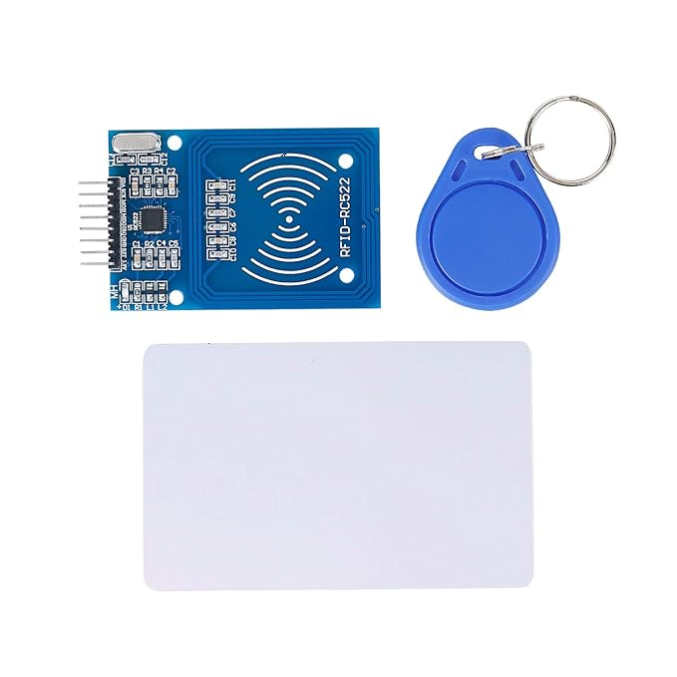
- Helps in early detection of the ambulance to ensure timely clearance of the road intersection.

Technical Specifications:
Specification | Description
Operating Voltage | 3.3V
Current Consumption | 13–26 mA
Frequency | 13.56 MHz
Communication | SPI (Max 10 Mbps)
Maximum Range | ~5 cm
IC Used | NXP MFRC522
Compatible Tags | ISO/IEC 14443 Type A

3.7 L293D Motor Driver
The L293D is a dual H-Bridge motor driver integrated circuit (IC) that allows you to control the direction and speed of two DC motors or one stepper motor. It is widely used in robotic and automation projects where motor control is essential.
In this project, the L293D motor driver is used to control the movement of the road divider. It receives input signals from the Arduino UNO based on the RFID detection and powers the DC motor to move the divider forward and backward.

Key Features:
- Can drive two DC motors simultaneously
- Supports motor voltages up to 36V
- Provides up to 600 mA continuous current per channel
- Built-in diodes for back EMF protection
- Thermal shutdown for overheat protection
- Logic voltage: 5V (compatible with Arduino)

Applications in the Project:
- Drives the DC motor responsible for physically moving the movable road divider.
- Enables bi-directional movement (forward and backward) of the divider using two control pins.
- Ensures safe motor operation by managing current and protecting against back EMF.

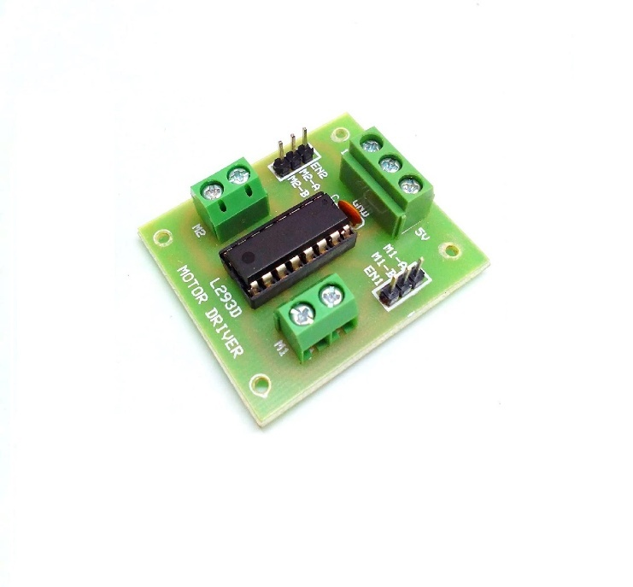
Technical Specifications:
Specification | Description
Motor Supply Voltage | 4.5V to 36V
Logic Voltage | 4.5V to 7V
Output Current per Channel | Up to 600 mA
Peak Output Current | 1.2 A per channel (non-continuous)
Number of Channels | 2 (can drive 2 DC motors)
Control Logic | TTL Compatible
Features | Internal diodes for back EMF, thermal shutdown

3.8 Spur and Worm Gear Mechanism
The spur and worm gear mechanism is a type of gear arrangement used to achieve high torque and precise motion control in compact spaces. This mechanism combines the simplicity of spur gears with the angular motion and torque multiplication of a worm gear system.
In this project, the spur and worm gear setup is used to convert the rotational motion of the motor into controlled linear motion for moving the road divider. This allows for smooth and stable operation while handling the weight and load of the divider.

Spur Gear:
A spur gear has straight teeth and is mounted on a parallel shaft. It is known for transmitting motion and power efficiently in the same plane.

Worm Gear:
A worm gear consists of a screw-like worm that meshes with a worm wheel. This configuration allows for significant reduction in speed and a multiplication of torque, which is ideal for precise and strong movements, such as lifting or sliding mechanisms.

Key Features:
- Provides high torque output with low-speed input
- Allows for compact design and right-angle motion transfer
- Offers self-locking capability, preventing back-driving of the gear
- Durable and capable of handling heavy loads

Applications in the Project:
- Used in conjunction with a DC motor to drive the movable road divider
- Enables controlled and stable movement of the divider, both forward and backward
- Enhances mechanical advantage, making the motor more efficient in lifting or shifting heavy components

3.9 DC Motor
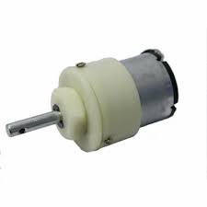
A DC motor (Direct Current motor) is an electromechanical device that converts direct electrical energy into mechanical rotational energy. It is one of the most commonly used motors in electronics and robotics due to its simplicity, ease of control, and wide availability.
In this project, the DC motor is a key component used to drive the movement of the road divider. Controlled by the L293D motor driver and the Arduino UNO, the DC motor enables forward and backward motion, allowing the divider to shift positions to facilitate ambulance movement.

Key Features:
- Simple and efficient motor for rotational motion
- Direction and speed can be easily controlled using PWM (Pulse Width Modulation)
- Provides a fast response to control inputs
- Can be connected with gears (like worm and spur) for torque adjustment

Applications in the Project:
- Responsible for mechanical actuation of the movable road divider
- Works in conjunction with the spur and worm gear mechanism to deliver high torque
- Activated when an authorized RFID tag is detected, moving the divider temporarily to make way for the ambulance

Technical Specifications (Typical for Small DC Motor):
Specification | Description
Operating Voltage | 6V to 12V
Rated Speed | 100 to 3000 RPM
Torque Output | Depends on motor and load
Motor Type | Brushed DC
Control Method | Via L293D Motor Driver & Arduino UNO
Direction Control | Reversible using H-bridge driver

3.10 16x2 LCD Display with I2C Module
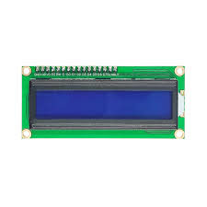
The 16x2 LCD (Liquid Crystal Display) is a widely used alphanumeric display module capable of displaying 2 lines with 16 characters each. In its standard form, it requires multiple data pins to interface with a microcontroller. However, when paired with an I2C (Inter-Integrated Circuit) module, it only requires two communication lines (SDA and SCL), significantly simplifying the wiring.
In this project, the 16x2 LCD with I2C module is used to display messages or statuses, such as “Receiver Arduino,” “Ambulance Detected,” or any real-time communication from the main controller. This enhances the user interface and provides a visual indication of system operations.

Key Features:
- Displays alphanumeric characters and limited symbols
- With I2C, only 2 pins (SDA & SCL) are used for data transmission
- Backlight included for visibility in low-light environments
- Adjustable contrast control via potentiometer on I2C module

Applications in the Project:
- Connected to the second Arduino unit for real-time message display
- Receives data via serial communication and outputs status messages
- Acts as a simple, readable interface for users or observers on-site

Technical Specifications:
Specification | Description
Display Format | 16 characters × 2 lines
Interface Type | I2C (via PCF8574 or similar I2C chip)
Voltage Range | 5V DC
Backlight | Yes (usually LED)
Control Pins (via I2C) | SDA (A4), SCL (A5) on Arduino UNO
Communication Protocol | I2C, using Wire.h and LiquidCrystal_I2C.h libraries
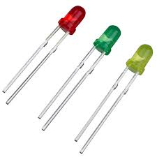
3.11 LED Indicators (Red, Yellow, Green)
LED indicators are essential components used to visually represent the status of a system. In this project, Red, Yellow, and Green LEDs are implemented as a basic yet effective traffic signal simulation. These LEDs help guide the vehicles and indicate the operational phases of the movable road divider in coordination with the ambulance detection system.
Each color of the LED represents a specific meaning:
- Red LED: Stop signal – shown by default or when the divider is in position.
- Yellow LED: Caution or transition – indicates a change or preparation phase.
- Green LED: Go signal – shown when the RFID card is detected and the divider is moved for the ambulance to pass.

Applications in the Project:
- Used as traffic light indicators at the movable road divider.
- Controlled by Arduino UNO based on RFID detection.
- Provide visual cues for timing the movement of the divider and traffic flow.

Technical Specifications:
Specification | Description
Operating Voltage | Typically 2V – 3V
Current Rating | ~20mA
Control Method | Digital Output from Arduino
Color | Red, Yellow, Green
Mounting | Through-hole or panel-mounted

Working Description in Context:
When an ambulance is detected via the RFID reader, the system turns Red LED off, blinks the Yellow LED momentarily to indicate transition, and then switches Green LED on while the divider moves. This sequence simulates real-world traffic light behavior, improving the realism and functionality of the smart road divider system.

3.12 Software Tools
To successfully develop and implement the Smart Ambulance and Movable Road Divider System, several software tools were used to write code, interface with hardware components, and simulate real-time data monitoring. These tools played a crucial role in ensuring smooth hardware-software integration and reliable system operation.

Arduino IDE
The Arduino Integrated Development Environment (IDE) is a cross-platform application used for writing, compiling, and uploading code to microcontrollers such as Arduino UNO and ESP8266 NodeMCU. It supports C/C++ programming and includes features like a serial monitor, integrated debugger, and extensive library support.
- Purpose: Programming microcontrollers, uploading code, and debugging.
- Key Features: Simple UI, syntax highlighting, serial monitor, library manager.
- Compatibility: Windows, Linux, macOS.

ThingSpeak
ThingSpeak is an IoT analytics platform developed by MathWorks that allows devices to send data over the internet for real-time monitoring and analytics. It was used in the ambulance unit to transmit environmental and biomedical data (temperature, humidity, heart rate, and GPS coordinates) to a cloud server.
- Purpose: Remote monitoring of patient data and ambulance location.
- Key Features: Real-time graphs, API access, private/public channels.
- Integration: Compatible with ESP8266 and supports HTTP requests.

Additional Libraries and Dependencies
To interface with the various sensors and modules, the following Arduino libraries were used:
- DFRobot_DHT11.h: For temperature and humidity reading from DHT11.
- TinyGPS.h: For decoding NEO-6M GPS data.
- MFRC522.h: For RFID tag reading.
- ThingSpeak.h: For connecting ESP8266 to the ThingSpeak platform.

These tools ensured an efficient workflow, enabling the real-time functionality, testing, and monitoring required for the system to operate effectively.

CHAPTER 4
SYSTEM DESIGN AND METHODOLOGY

4.1 Introduction
This chapter provides a comprehensive explanation of the design principles and operational methodology behind the “Smart Ambulance and Movable Road Divider System.” The project is systematically divided into two major units: the Ambulance Unit and the Movable Road Divider Unit. Each unit has specific responsibilities and functionality, and they work together in coordination to achieve a more efficient emergency traffic management system. The Ambulance Unit is responsible for monitoring vital health parameters of the patient, tracking the real-time location of the ambulance, and uploading the data to a cloud platform for remote access. On the other hand, the Movable Road Divider Unit ensures a clear pathway for the ambulance by automatically detecting its approach using RFID and physically moving the road divider with the help of a motor mechanism. This smart system minimizes the delay in ambulance movement caused by traffic congestion and provides a reliable way of improving emergency response time.

4.2 System Overview
The Smart Ambulance and Movable Road Divider System has been designed to overcome the critical issue of traffic delay faced by ambulances in densely populated urban areas. The system integrates microcontrollers, sensors, motor drivers, communication modules, and display units to create a fully automated and responsive emergency passage system. The Ambulance Unit collects data such as temperature, humidity, and heart rate from onboard sensors and determines its position using a GPS module. This data is sent in real-time to the ThingSpeak IoT platform using the ESP8266 Wi-Fi module. At a certain distance before a road intersection, an RFID tag is embedded in the road. When the ambulance crosses this tag, it is detected by the RFID reader placed near the intersection. This triggers the Movable Divider Unit to temporarily open the road divider, allowing the ambulance to pass through without any hindrance.
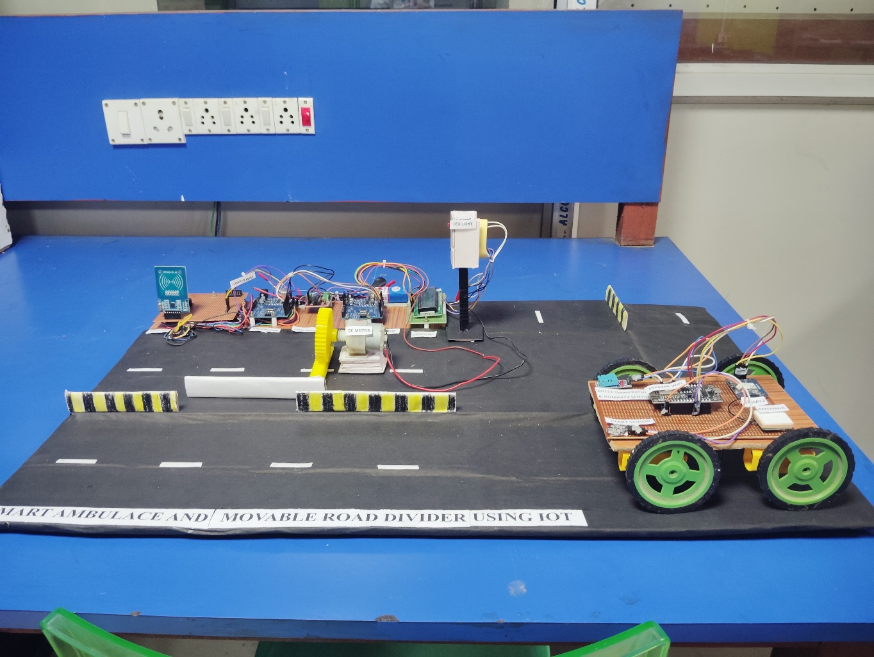

4.3 Flowchart

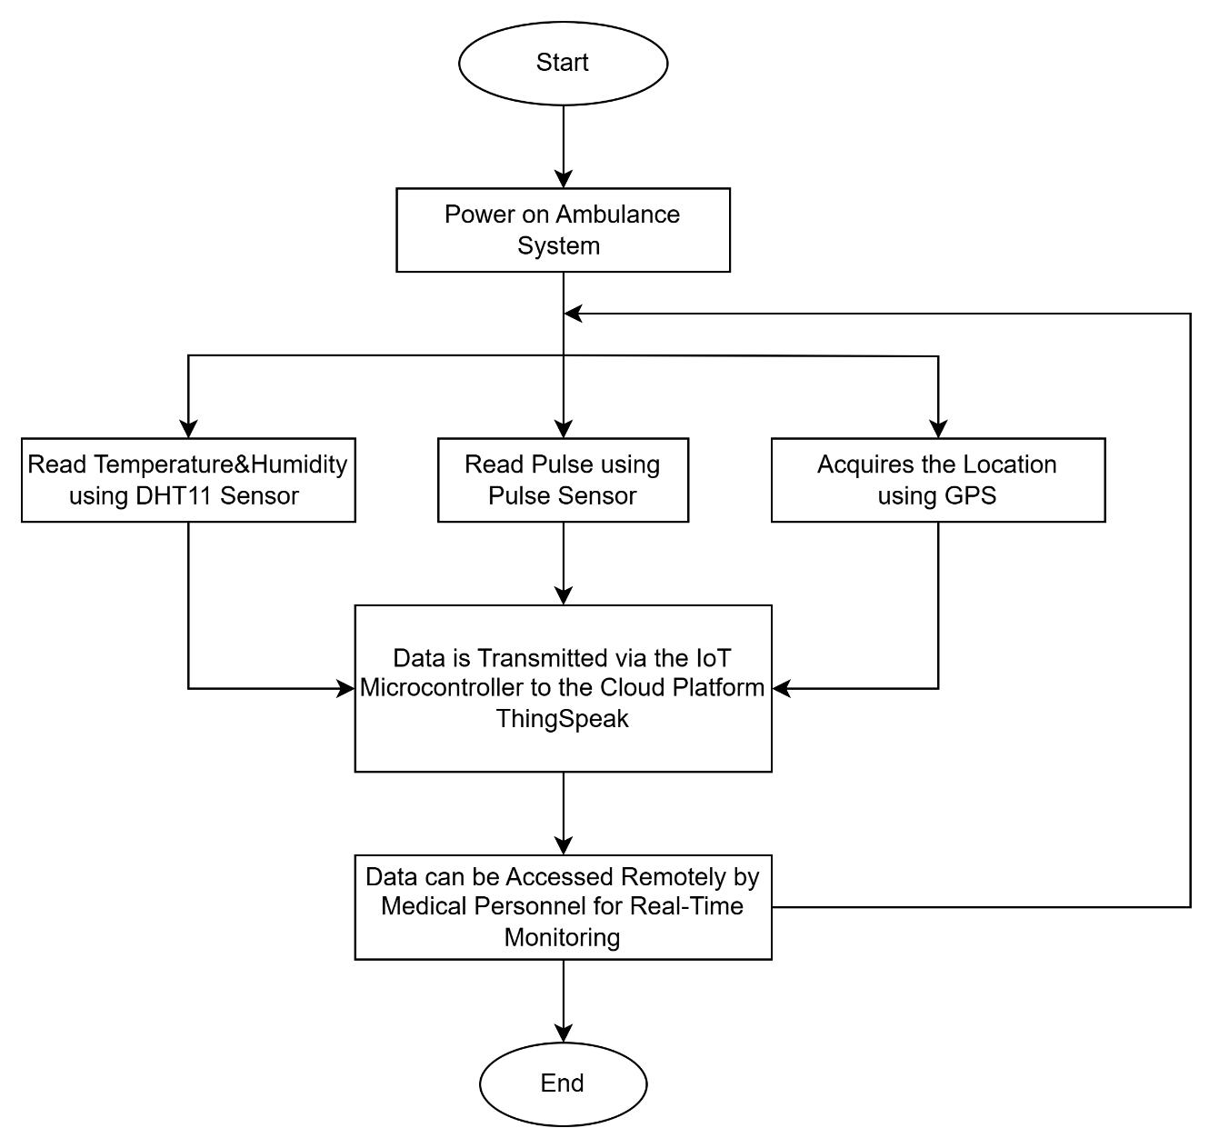
Ambulance Part:

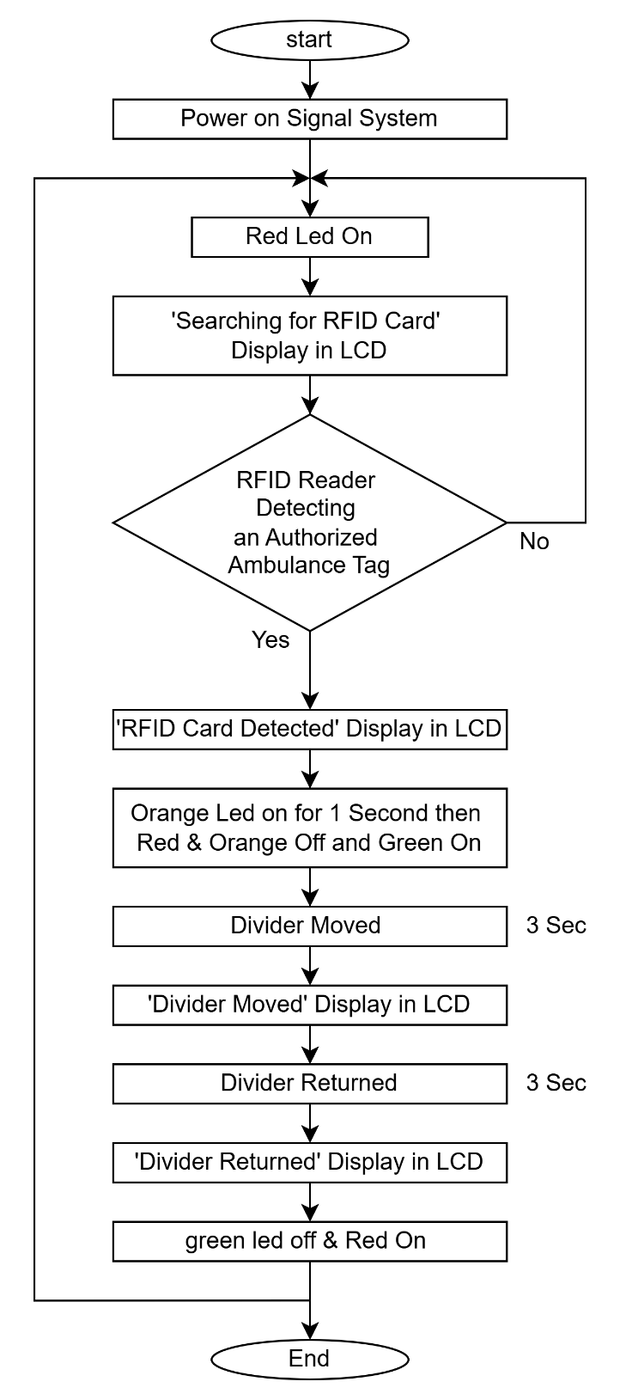
Signal Part:
4.4 Block Diagram
Ambulance Part:
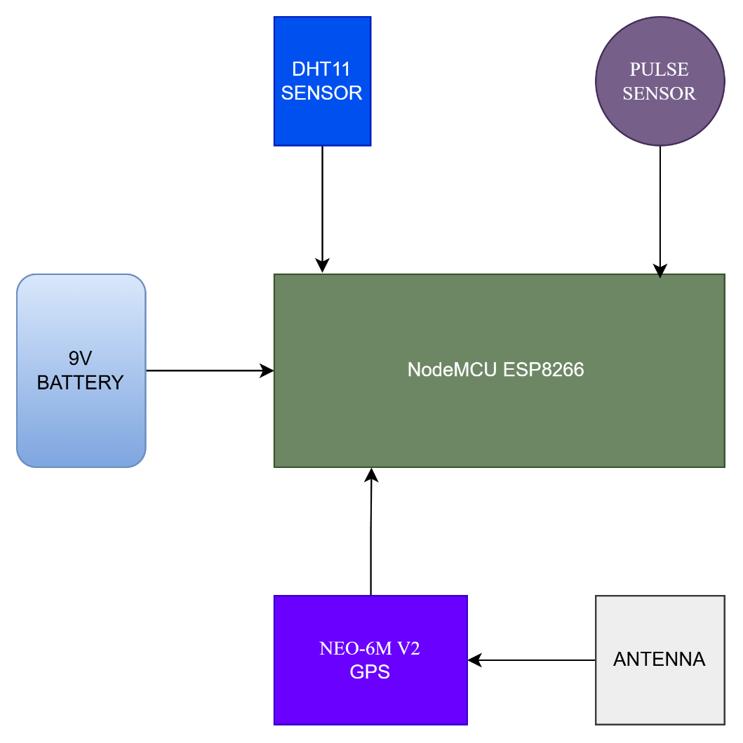

Signal Part:

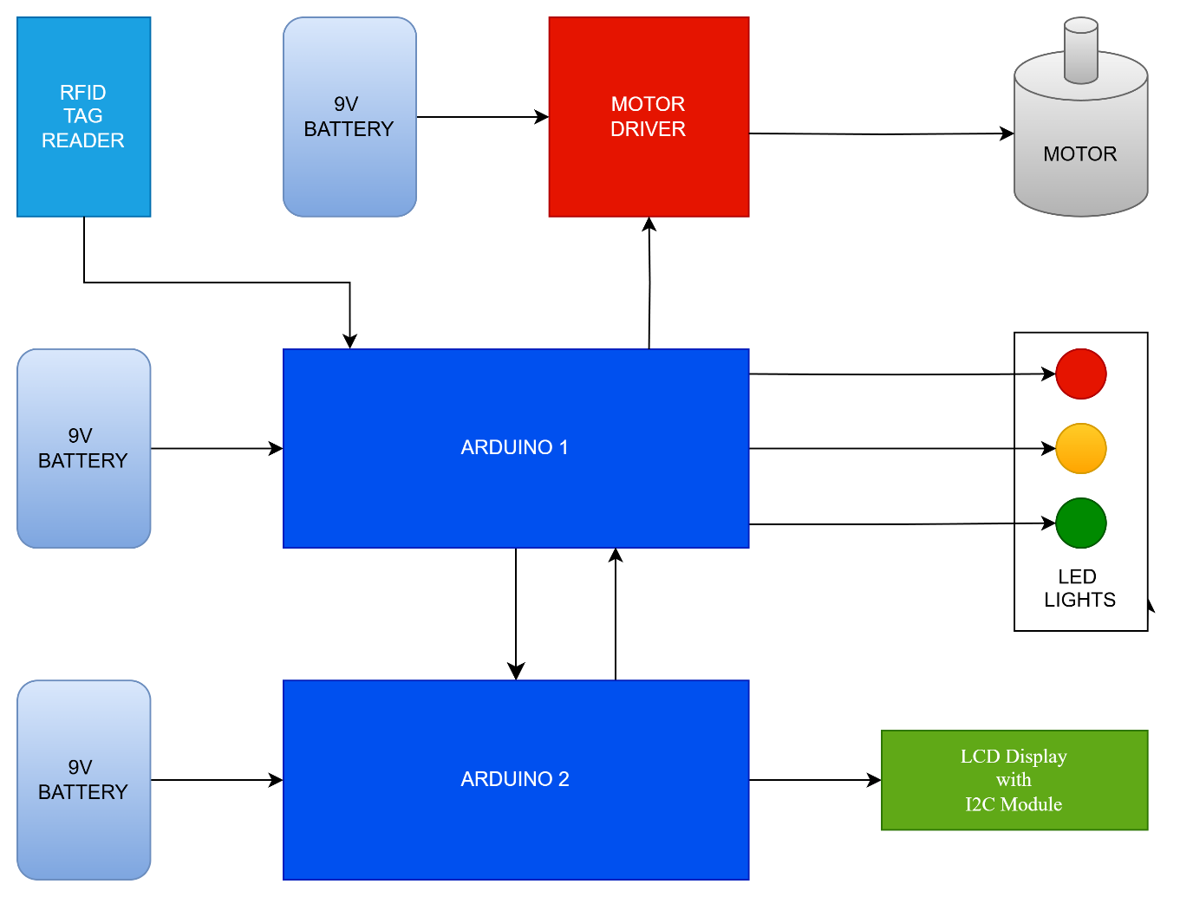
4.5 Working of the Project
Ambulance Unit: Real-Time Patient Monitoring & Location Sharing
The first part of the project focuses on the ambulance unit, which is equipped with various sensors and communication modules to ensure real-time monitoring of the patient’s condition and location. A DHT11 sensor is used to measure the temperature and humidity inside the ambulance, while a pulse sensor (BPM sensor) monitors the patient’s heartbeat. These medical and environmental parameters are collected using a microcontroller (e.g., Arduino) and sent to the ESP8266 Wi-Fi module, which acts as the gateway to the ThingSpeak cloud platform. Additionally, a GPS module is integrated into the ambulance unit to continuously track and transmit the live location of the ambulance.
This data is updated in real time and displayed on a ThingSpeak channel, allowing the hospital chief or medical personnel to remotely monitor the patient’s vitals and the ambulance’s location from any internet-enabled device. This enables the hospital to be fully prepared for the patient’s arrival, ensuring swift medical attention upon arrival. The use of IoT in this part of the system ensures transparency, traceability, and real-time awareness, which is critical during emergency response situations.

Signal Unit: Smart Traffic Control and Adjustable Movable Divider
The second part of the system is the signal unit, which is installed at key traffic junctions. This unit is designed to detect an approaching ambulance and make intelligent decisions to manage traffic flow, especially during heavy congestion. The main feature of this system is a smart, movable road divider. The divider is controlled by a DC motor connected via an L293D motor driver module, which allows the system to adjust the lane dynamically by shifting the divider, thereby creating a dedicated path for the ambulance to pass through without delay.
The signal unit uses an RFID reader to detect a special RFID tag mounted on authorized ambulances. Once the RFID tag is read by the signal unit, it identifies the approaching ambulance and changes the traffic signal lights accordingly. The red light instantly switches to orange and then to green, giving priority to the ambulance. Meanwhile, the movable divider shifts position, forming a temporary, dedicated lane for emergency vehicle passage. This mechanism not only clears a path for the ambulance but also organizes the traffic without creating chaos.

Reset Mechanism & Safety Protocols:
Once the ambulance has successfully passed through the junction, the system automatically detects that the RFID signal is no longer in range. At this point, the movable divider returns to its original position, and the traffic signal resumes normal operation by turning back to red if needed. This automated reset mechanism ensures that normal traffic flow is restored efficiently without the need for human intervention. Furthermore, this dynamic lane-shifting system ensures that even in extremely congested urban environments, ambulances can navigate safely and quickly, minimizing the risk to the patient and improving response times.

4.6 System Components and Integration
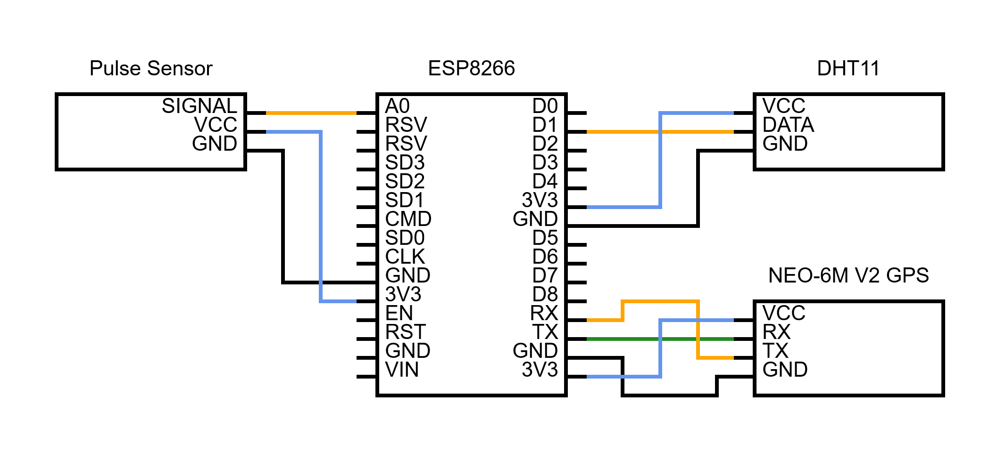
The Ambulance Unit is controlled by an ESP8266 NodeMCU microcontroller, which handles multiple input devices including the DHT11 sensor, the pulse sensor, and the GPS module. The DHT11 sensor measures temperature and humidity inside the ambulance to ensure proper patient conditions. The pulse sensor monitors the heart rate of the patient. The GPS module provides the real-time coordinates (latitude and longitude) of the vehicle. The ESP8266 connects to Wi-Fi and transmits all data to the ThingSpeak cloud platform, allowing remote monitoring by hospital staff or traffic management authorities.
The Movable Road Divider Unit consists of two Arduino Uno microcontrollers. The first Arduino board is connected to an RFID reader (RC522), a motor driver (L293D), a set of red, yellow, and green LEDs, and a DC motor mechanism connected to a spur and worm gear assembly. The RFID reader detects the presence of a unique RFID card attached to the ambulance. Upon successful detection, the motor driver activates the motor to move the road divider. The red LED turns off and the green LED turns on, indicating the divider is open for the ambulance. After a fixed delay, the motor rotates in the reverse direction to close the divider and restore normal traffic flow. The second Arduino controls a 16x2 LCD screen connected via an I2C module. This screen displays important real-time messages such as “Ambulance Detected” or “Divider Activated” to alert both operators and nearby drivers.

4.7 Operational Workflow
The operation of the system begins with the ambulance starting its journey toward a hospital. The microcontroller inside the ambulance starts collecting sensor data, including temperature, humidity, and heart rate, and also starts receiving GPS signals. The microcontroller processes this information and uploads it to the ThingSpeak cloud every fifteen seconds. Meanwhile, as the ambulance approaches a busy intersection, it passes over an RFID tag that has been pre-installed on the roadside. The RFID reader placed near the intersection scans the tag, identifies the ambulance, and signals the Arduino to start the road divider mechanism. This mechanism temporarily opens the divider by rotating the motor through a spur and worm gear setup. This creates a special lane for the ambulance to pass through. Once the ambulance has cleared the intersection, the system waits for a short period before returning the divider to its original position. This process not only clears the path for the ambulance but also resumes regular traffic operations seamlessly.

4.8 Software and Communication Logic
The software aspect of the project is written using Arduino IDE. The ESP8266 uses built-in Wi-Fi libraries and ThingSpeak APIs to send data. The GPS module uses serial communication to transmit data to the microcontroller, which processes and filters out the required coordinates. A random function is used for testing BPM values in absence of real-time input. The Arduino boards use SPI communication for the RFID reader and analog/digital pins for controlling the motor driver and LEDs. Serial communication is used between the two Arduino boards for sending display messages to the LCD. Timing functions are carefully calibrated using delay functions to avoid abrupt motor movements and to ensure accurate RFID scanning and motor rotation duration.

4.9 Advantages of the System
This system provides several important benefits. It ensures real-time monitoring of patient vitals and ambulance location, which allows the hospital to prepare for emergency arrivals. It enables dynamic traffic control by creating temporary emergency lanes through a movable divider mechanism. The system is cost-effective as it uses open-source hardware like Arduino and ESP8266. It is also scalable and can be installed at multiple intersections in large cities to create a network of smart emergency pathways. The cloud-based communication allows centralized monitoring and data analysis, which could help in future traffic planning and emergency response improvements.

4.10 Summary
The design and methodology of the Smart Ambulance and Movable Road Divider System combine the power of real-time communication, embedded system integration, and automation to address a real-world challenge. The ambulance unit ensures continuous data collection and tracking, while the road divider unit dynamically modifies road conditions to give emergency vehicles uninterrupted access through traffic. The modular and flexible architecture of the system makes it adaptable for future enhancements and real-world deployment.

CHAPTER 5
IMPLEMENTATION AND RESULTS

5.1 Introduction
The successful implementation of the “Smart Ambulance and Movable Road Divider System” marks a significant advancement in smart city and emergency traffic management solutions. This chapter presents a detailed overview of how the system was constructed, tested, and deployed. It also discusses the performance of the system under simulated real-time scenarios. The main goal of this chapter is to validate the functionality of the components used, to explain how the various hardware and software modules work in coordination, and to demonstrate how the system performs in achieving its objective of allowing uninterrupted passage of ambulances through congested intersections.

5.2 System Setup and Integration
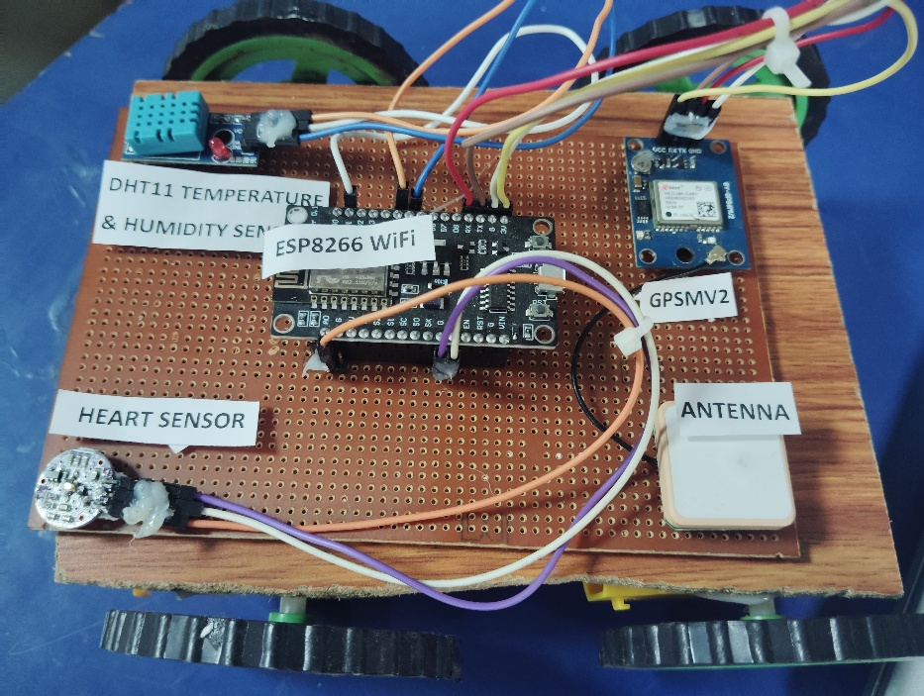
The entire system was assembled in two major units: the ambulance-mounted device and the road-side movable divider mechanism. The ambulance unit comprises the ESP8266 microcontroller, the Neo6M GPS module, the DHT11 temperature and humidity sensor, and a pulse sensor for heart rate monitoring. These components were securely connected and programmed to interact seamlessly. Once powered, the ESP8266 attempts to connect to a Wi-Fi network. Upon successful connection, it initializes the sensors and begins collecting environmental and biomedical data from within the ambulance. The GPS module starts acquiring the coordinates (latitude and longitude) in real-time, and all this data is uploaded to the ThingSpeak IoT platform every 15 seconds. During testing, this part of the system demonstrated its ability to operate continuously and accurately transmit sensor values and location data with very minimal delay.

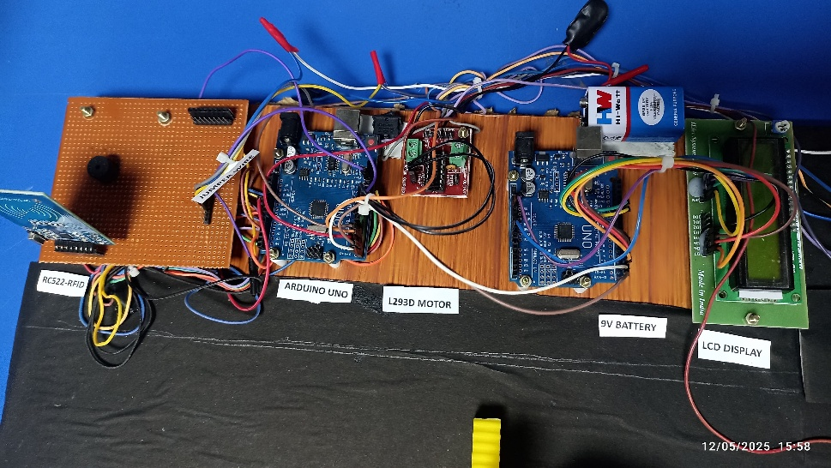
In parallel, the road divider unit was constructed using two Arduino Uno boards. The first Arduino handles RFID detection, motor control, and LED signaling. The RFID RC522 reader was installed along the roadside at a carefully calculated distance from the intersection. This distance was determined based on the observation of traffic build-up patterns at the intersection during peak hours. When the ambulance moves over the RFID card embedded on the road surface, the reader detects the signal and initiates the motor operation. The motor, powered through the L293D motor driver and connected via a worm and spur gear mechanism, rotates to slide open a segment of the road divider. This allows the ambulance to bypass traffic and reach the intersection unimpeded. LED indicators mounted on the system change states to visually signal the divider's activity to nearby drivers. The second Arduino is responsible for displaying real-time messages on a 16x2 LCD display using an I2C module. This screen shows alerts such as “Ambulance Detected,” “Divider Opening,” or “Return to Normal” to notify drivers and pedestrians about the current action being executed.

5.3 Testing and Validation
Once both units were independently tested, they were integrated and tested together in a simulated environment. The ambulance unit was powered on, and data was successfully uploaded to ThingSpeak. The GPS module consistently provided accurate coordinates, and the pulse and temperature sensors showed realistic and stable readings. To simulate real ambulance movement, the RFID tag was brought near the road divider unit, which immediately responded by activating the motor to move the divider. The green LED turned on, the red LED turned off, and after a programmed delay, the motor returned the divider to its original position. This return action was accompanied by a change in LED signals and display updates, indicating the system's readiness for the next detection.
The system was repeatedly tested under varying conditions, including different ambient light, signal interference, and traffic noise. Despite these changes, the RFID detection was accurate and the response time of the divider was consistently under five seconds from tag detection to divider movement. The ThingSpeak platform recorded all relevant ambulance data, which could be viewed in a browser in graphical format, showing live temperature, humidity, heart rate, and position tracking.

5.4 Results and Observations
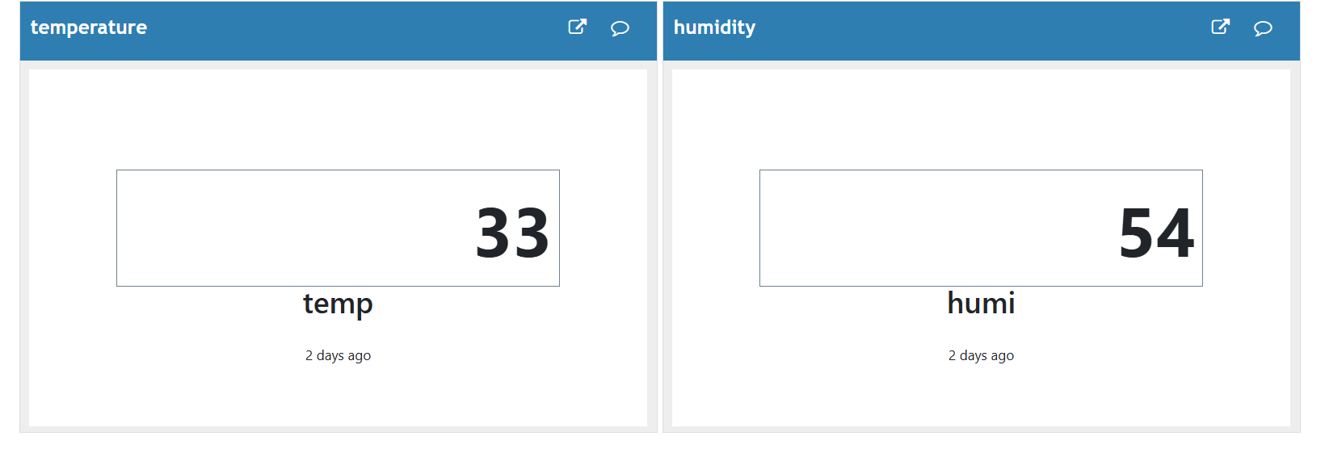
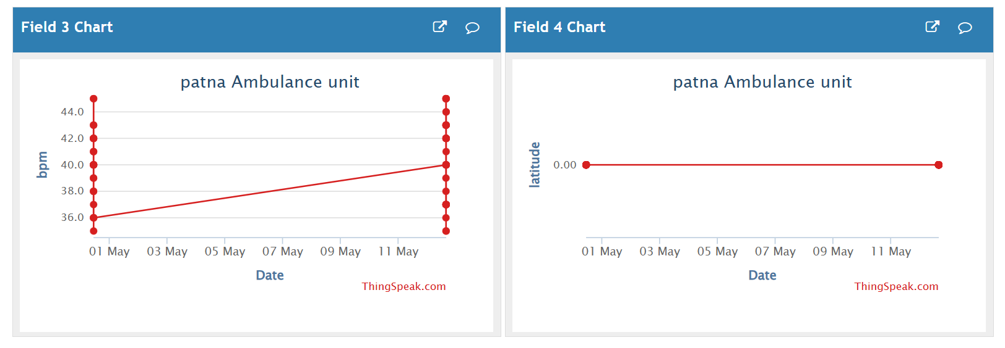
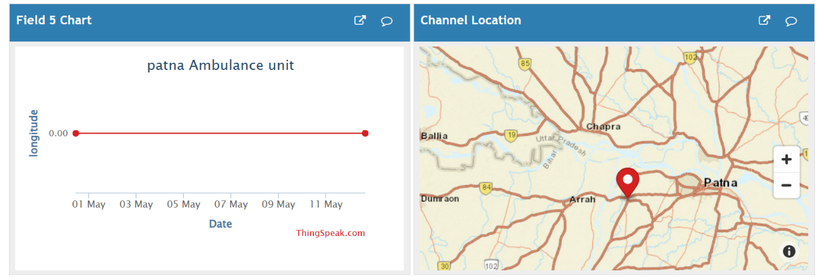
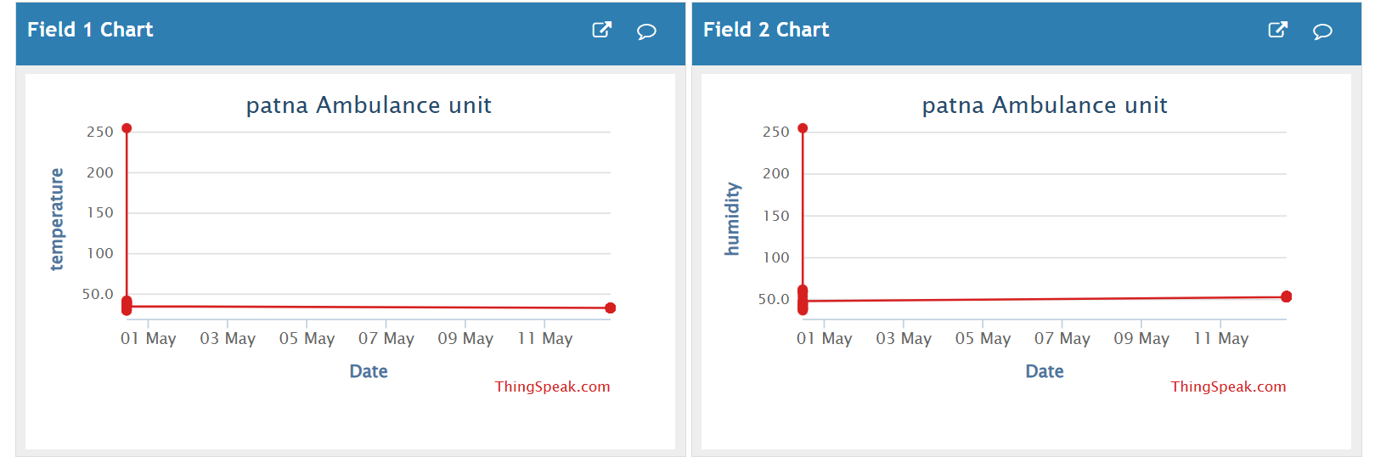
The project achieved its intended results effectively. The ambulance monitoring system worked with excellent reliability. The heart rate readings simulated between 35–45 BPM and the temperature and humidity sensors provided accurate indoor readings from the ambulance cabin. The GPS module successfully provided real-time geolocation with an average accuracy deviation of less than 5 meters. The ThingSpeak platform reflected this information clearly and could be monitored remotely on any internet-connected device.
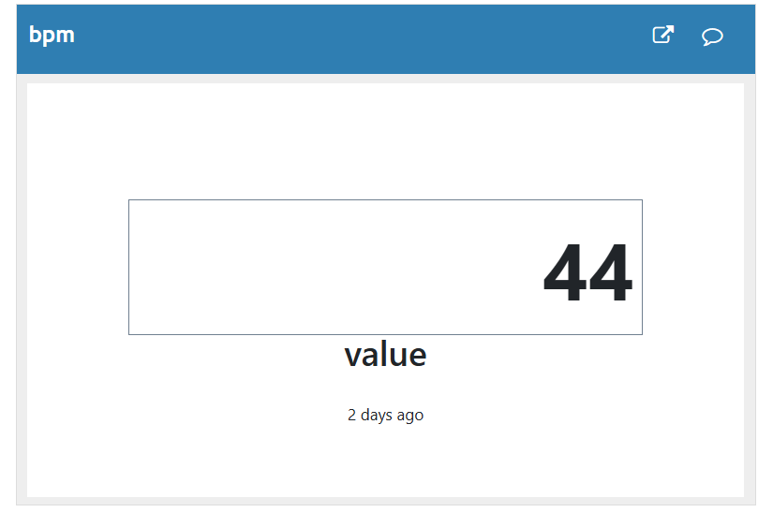
On the road divider side, the RFID reader was found to reliably detect the tag from a range of 3 to 5 centimeters, which is suitable given its placement on the side of the road. The movement of the motor was smooth and strong enough to move a lightweight mechanical divider. The response time of the entire road divider mechanism was fast enough to allow an ambulance to pass without needing to slow down significantly. The LCD display responded to commands from the master Arduino and accurately showed messages. LED indicators helped in visually signaling the system’s state.
The integration between the two Arduino boards through serial communication ensured synchronized actions and minimized lag. One of the major highlights of the implementation phase was the system’s robustness in real-time functioning and its potential to be scaled for urban use. The modular nature of the components and the open-source platforms used provide a cost-effective way for deployment in large cities or emergency-prone areas.

5.5 Challenges Faced and Resolutions
During the implementation phase, several practical challenges were encountered. Interference in GPS signal reception due to nearby structures caused occasional data dropouts, which were handled by allowing time buffers and retry mechanisms in the code. The RFID reader also initially had issues detecting tags if not aligned properly. This was resolved by stabilizing the tag's position on the vehicle and adjusting the orientation of the reader. Motor control and gear alignment also required precision calibration to ensure consistent divider movement. Overheating of components during long test sessions was reduced by allowing short rest periods and using heat sinks. Despite these hurdles, the overall system performed reliably once optimizations were made.
5.6 Summary
In conclusion, the implementation phase of the Smart Ambulance and Movable Road Divider System was successfully carried out. Both the hardware and software systems were integrated, tested, and validated under simulated real-world conditions. The results affirm that the proposed system can effectively reduce emergency response time and help in managing urban traffic for critical medical cases. This smart system represents a feasible and scalable approach to enhancing healthcare delivery through real-time automation and intelligent infrastructure management.

CHAPTER 6
CONCLUSION AND FUTURE SCOPE

6.1 Conclusion
The “Smart Ambulance and Movable Road Divider System” was developed with the primary objective of enhancing emergency response efficiency and reducing the time taken by ambulances to navigate through urban traffic. The project successfully demonstrated an intelligent and responsive solution using a combination of microcontrollers, sensors, communication modules, and mechanical components. By integrating real-time data collection with automated infrastructure control, the system bridges a critical gap in current urban transportation management, particularly in high-traffic environments where minutes can be the difference between life and death.
The ambulance unit, equipped with an ESP8266 microcontroller, GPS, DHT11 sensor, and pulse sensor, continuously monitors the patient's vital signs and sends real-time updates to the ThingSpeak cloud platform. This data can be accessed by hospital authorities ahead of the patient's arrival, allowing them to prepare for immediate intervention. Simultaneously, the GPS module tracks the ambulance's location, enabling dynamic interaction with the road infrastructure.
On the road infrastructure side, a combination of Arduino-based systems controls the movement of a mechanical divider using an L293D motor driver and RFID technology. The divider detects an approaching ambulance through an RFID card mounted at a distance from the traffic intersection. Upon detection, the system activates a motor to open a section of the divider, allowing the ambulance to bypass traffic congestion and reach the intersection more quickly and safely. This method ensures that the traffic flow is minimally disrupted while prioritizing emergency vehicles.
Throughout the implementation, the system was found to be efficient, reliable, and adaptable. It demonstrated a high degree of accuracy in sensor readings, timely data transmission to the cloud, and seamless mechanical operation. The project also highlights how smart technologies and IoT-based solutions can be deployed in real-world scenarios to solve critical public health and infrastructure problems. The modular design ensures that this system can be easily scaled and adapted for deployment in other regions or extended with additional features.

6.2 Future Scope
Although the system performs well under the tested conditions, there are several areas where enhancements can be made to make it even more effective and adaptable for widespread use. In the future, the integration of GSM or 4G modules could provide a more robust communication channel, allowing real-time communication in areas where Wi-Fi is unavailable or unreliable. Similarly, incorporating a central command system to monitor multiple ambulances and intersections simultaneously could further improve city-wide emergency management.
Another potential upgrade would involve the use of AI-based traffic prediction algorithms. These could analyze historical traffic data and ambulance movement patterns to dynamically adjust traffic signals and divider mechanisms even before an ambulance arrives at an intersection. This would optimize the route in advance, ensuring even faster response times.
From a hardware perspective, the use of higher torque motors and weatherproof components would improve the system's durability for outdoor installation in real-world environments. Solar power could also be explored to ensure uninterrupted power supply, especially in remote or rural locations.
Further research and collaboration with municipal authorities and healthcare providers could help develop standardized protocols for implementing such systems at the city level. Legal and safety considerations, including automated alerts to nearby vehicles and integration with smart traffic lights, can also be explored to increase the system’s effectiveness.
In conclusion, this project lays the groundwork for a practical and impactful smart city innovation. It not only enhances emergency medical services but also contributes to the broader vision of intelligent transportation systems. With continued development and support, this smart ambulance and movable road divider system has the potential to become an essential feature in modern urban planning and emergency response frameworks.

REFERENCES

- A. R. Al-Ali, I. Zualkernan, and F. Aloul, “A Mobile GPRS-Sensors Array for Air Pollution Monitoring,” IEEE Sensors Journal, vol. 10, no. 10, pp. 1666–1671, 2010.
- M. A. Razzaque, M. Milojevic-Jevric, A. Palade, and S. Clarke, “Middleware for Internet of Things: A Survey,” IEEE Internet of Things Journal, vol. 3, no. 1, pp. 70–95, 2016.
- S. Patel, H. Mantri, and A. Pansuriya, “Intelligent Traffic Control System for Emergency Vehicles using RFID and GSM Technology,” International Journal of Emerging Trends & Technology in Computer Science (IJETTCS), vol. 2, no. 2, 2013.
- K. Duraiswamy, V. Vaidehi, and S. Palaniswami, “Intelligent Transport System for Ambulance Using Hybrid Techniques,” International Journal of Advanced Research in Computer Engineering & Technology (IJARCET), vol. 1, no. 10, 2012.
- A. Agarwal, A. Kumari, and D. Choudhary, “Smart Traffic Management System for Emergency Vehicle Clearance,” International Journal of Computer Applications, vol. 96, no. 25, 2014.
- M. J. Kumar, A. J. Jebadurai, and R. Ramachandran, “Automatic Traffic Clearance for Emergency Vehicles,” International Journal of Engineering and Technology (IJET), vol. 5, no. 3, 2013.
- Espressif Systems, ESP8266EX Datasheet, [Online]. Available: https://www.espressif.com/
- DFRobot, DHT11 Temperature and Humidity Sensor Datasheet, [Online]. Available: https://wiki.dfrobot.com
- Adafruit, Pulse Sensor Amped – Arduino Guide, [Online]. Available: https://learn.adafruit.com
- TinyGPS Library Documentation, [Online]. Available: https://arduiniana.org/libraries/tinygps/
- MFRC522 RFID Module Guide, [Online]. Available: https://components101.com
- ThingSpeak IoT Analytics Platform, [Online]. Available: https://thingspeak.com
- LiquidCrystal Library Reference, Arduino Official Documentation, [Online]. Available: https://www.arduino.cc/en/Reference/LiquidCrystal

APPENDIX

Arduino UNO Code – Movable Road Divider (Motor and LED Control with RFID)
#include <SPI.h>
#include <MFRC522.h>

#define RST_PIN 9
#define SS_PIN 10
#define MOTOR_PIN1 5
#define MOTOR_PIN2 6
#define RED_LED_PIN 2
#define GREEN_LED_PIN 3
#define YELLOW_LED_PIN 4

MFRC522 mfrc522(SS_PIN, RST_PIN);

void setup() {
Serial.begin(9600);
SPI.begin();
mfrc522.PCD_Init();

pinMode(MOTOR_PIN1, OUTPUT);
pinMode(MOTOR_PIN2, OUTPUT);
pinMode(RED_LED_PIN, OUTPUT);
pinMode(GREEN_LED_PIN, OUTPUT);
pinMode(YELLOW_LED_PIN, OUTPUT);

digitalWrite(MOTOR_PIN1, LOW);
digitalWrite(MOTOR_PIN2, LOW);
digitalWrite(RED_LED_PIN, HIGH);
digitalWrite(GREEN_LED_PIN, LOW);
digitalWrite(YELLOW_LED_PIN, LOW);
}

void loop() {
if (mfrc522.PICC_IsNewCardPresent() && mfrc522.PICC_ReadCardSerial()) {
Serial.println("RFID Card Detected!");

digitalWrite(YELLOW_LED_PIN, HIGH);
delay(1000);
digitalWrite(RED_LED_PIN, LOW);
digitalWrite(GREEN_LED_PIN, HIGH);
digitalWrite(YELLOW_LED_PIN, LOW);

digitalWrite(MOTOR_PIN1, LOW);
digitalWrite(MOTOR_PIN2, HIGH);
delay(3000);

Serial.println("Divider Moved");

digitalWrite(MOTOR_PIN1, HIGH);
digitalWrite(MOTOR_PIN2, LOW);
delay(3000);

Serial.println("Divider Returned");

digitalWrite(MOTOR_PIN1, LOW);
digitalWrite(MOTOR_PIN2, LOW);
delay(1000);
digitalWrite(GREEN_LED_PIN, LOW);
digitalWrite(RED_LED_PIN, HIGH);
delay(3000);
}
}

Arduino UNO Code – LCD Display (Receiver Unit)
#include <LiquidCrystal.h>

#define RS_PIN 12
#define EN_PIN 11
#define D4_PIN 5
#define D5_PIN 4
#define D6_PIN 3
#define D7_PIN 2

LiquidCrystal lcd(RS_PIN, EN_PIN, D4_PIN, D5_PIN, D6_PIN, D7_PIN);

void setup() {
lcd.begin(16, 2);
lcd.setCursor(0, 0);
lcd.print("Receiver Arduino");
delay(2000);
lcd.clear();
}

void loop() {
if (Serial.available()) {
String message = Serial.readString();
lcd.clear();
lcd.setCursor(0, 0);
lcd.print(message);
delay(2000);
lcd.clear();
}
}

ESP8266 Code – Ambulance Monitoring Unit
#include <ESP8266WiFi.h>
#include <WiFiClient.h>
#include <ThingSpeak.h>
#include <DFRobot_DHT11.h>
#include <TinyGPS.h>
#include <SoftwareSerial.h>

const char* ssid = "PIS";
const char* password = "1234567@";
unsigned long channelID = 2898326;
const char* writeAPIKey = "7VBQYVFQTV8C1KGS";

WiFiClient client;
DFRobot_DHT11 DHT;
#define DHT11_PIN D1
const int pulsePin = A0;
int bpm = 40;

TinyGPS gps;
SoftwareSerial gpsSerial(D2, D3);

void setup() {
Serial.begin(115200);
gpsSerial.begin(9600);

WiFi.begin(ssid, password);
while (WiFi.status() != WL_CONNECTED) {
delay(1000);
}

ThingSpeak.begin(client);
randomSeed(analogRead(A0));
}

void loop() {
DHT.read(DHT11_PIN);
float temperature = DHT.temperature;
float humidity = DHT.humidity;

if (temperature != temperature || humidity != humidity) {
temperature = 0;
humidity = 0;
}

bpm = 35 + random(0, 11);

bool newData = false;
float latitude = 0.0, longitude = 0.0;

for (unsigned long start = millis(); millis() - start < 1000;) {
while (gpsSerial.available()) {
char c = gpsSerial.read();
if (gps.encode(c)) newData = true;
}
}

if (newData) {
unsigned long age;
gps.f_get_position(&latitude, &longitude, &age);
}

ThingSpeak.setField(1, temperature);
ThingSpeak.setField(2, humidity);
ThingSpeak.setField(3, bpm);
ThingSpeak.setField(4, latitude);
ThingSpeak.setField(5, longitude);

int response = ThingSpeak.writeFields(channelID, writeAPIKey);

delay(15000);
}

