!

For 2 or 4 players (better with 4)

Around 30~40 minutes (2 players) or 15~25 minutes (4 players)

*Where there are treasures, there are treasure hunters.   
Try to get more treasures, and more valuable ones before others do!*

*(“Ubaware!” means “Snatch it!” in Japanese)*

**Components**

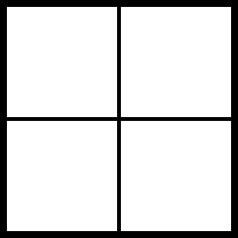 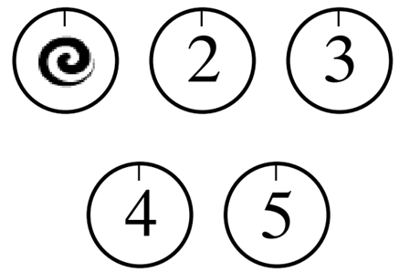  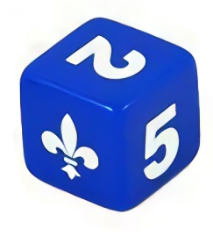

16 x tiles 4 x coins marked with 4 x pawns 1 x dice  
 ace, 2, 3, 4, 5 (20 in total) (2 for 2 players)

**Objective**

Get more points.

**Setup**

1. Put the 16 tiles in a 4x4 square to make an 8x8 chess board.
2. Put all 20 coins (treasures) with the number face down and suite face up. Shuffle all of them.
3. Place the coins with the number face down on the board **randomly** as the figure below shows.

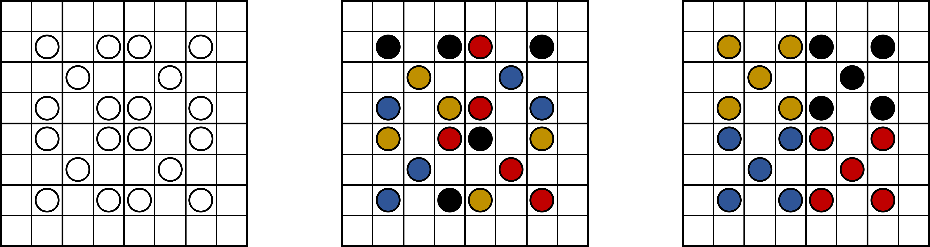

(1) The map (2) Good example of randomness (3) Bad example

1. Place the 4 (or 2) pawns on the 4 (or the 2 diagonal) corners of the board.
2. Decide who goes first and the order however you want.

**Play**

The game is turn-based. In each round, the 4 (or 2) players do the following things:

1. Roll a dice.
2. Move the pawn. The movement follows the rules below:
   1. Move according to the number of the dice:
      1. If the result of rolling the dice is ace (treated as 1), 2, 3, 4, or 5, the steps the player should move is exactly the same, no more, no less.
      2. If the result is blank, then the player can move any steps between 1 and 5.
   2. When moving, the pawn cannot pass through the coin or other pawns. It can, though, stand on the coin at the end of the movement.
   3. Though the number of the steps is decided by the dice, but one can go forward and backward to consume the number. For example, if the result of the dice is 3, one can move only 1 step (the other 2 are consumed by moving forward and backward).
   4. The board is wrapped. That said, if the players want to go right at the right edge of the board, they will appear on the left edge, like a Pac-Man.
3. At the end of the movement:
   1. If the pawn stands on a coin (treasure):
      1. Flip it, if it’s not flipped yet, to show the number on the coin (ace is treated as 1).
      2. Roll the dice once more.
      3. Compare the number of the dice and the coin (the value of the treasure). The ace on the dice is 1, and blank is zero.
         1. If the number of the coin is bigger than the dice, the player failed to get the treasure. In this case, there are two options.
            1. If the number of one of the coins the player holds plus the number of the dice is bigger than or equal to the number of the coin, the coin the player holds can be exchanged with the one the player is trying to get on the board.
            2. After the exchange, or the player doesn’t have such coin, he or she should then undo the last one step to prevent from standing on the coin. For example, if the movement of one player is left, left, down, down, after he or she failed to get the treasure or he or she exchanged the treasure, he or she should go up for 1 step. After that, leave the coin flipped, with the number face up.
         2. If the number of the dice is bigger or equal to the coin, the player succeeded in getting the treasure. He or she should then take the coin.
   2. If the pawn doesn’t stand on a coin, the movement is end.
4. Next player’s turn.
5. The game ends as soon as all coins on the board is taken away, which means that there are no more treasures.

**Winning**

After the game ends, all players calculate the sum of the value of the coins. The player(s) with the highest value wins the game.

(4.5 hours used in designing and play-testing the game. Third iteration.)