2.1 Predicting World Cup 2026 goal difference: from eight ideas to one signal
The question. Football is low-scoring and noisy, so we asked a modest question: how much of a match’s goal difference (team A − team B; mean 0.48, SD 2.02) can be known before kick-off, and which pre-match facts carry it?Choosing the eight variables. We set three rules. (1) Everything must be known before kick-off, so in-match statistics such as shots on target were out. (2) Every variable is expressed as team A minus team B, like the target, so swapping the teams flips the sign of both. (3) One row per real match, giving 104 rows. We then asked what a fan would say decides a game and sorted the answers into four families: strength (FIFA points, 2022 qualification), form (goals scored, goals conceded, points so far), context (host status, knockout stage) and squad (average age). Covering every family let the model tell us which kind of knowledge matters, instead of betting on one idea up front.
Variable | Why we included it (known before kick-off) | What the data said (full 8-variable model)
FIFA points gap | Official, pre-match measure of overall team quality | +0.59 goals per 100 points, p < 0.001: the only survivor
Qualified 2022 gap | Proxy for recent tournament pedigree | r = 0.41 with goal difference alone, but r = 0.66 with FIFA points; adds nothing once FIFA points are in (p = 0.61)
Goals scored gap | Attacking form so far in this tournament | p = 0.42; always zero before a team’s first game
Goals conceded gap | Defensive form so far | Expected sign (−0.19 goals per goal conceded) but p = 0.19
Tournament points gap | Momentum and what is at stake | p = 0.97
Host advantage | Home crowd, less travel, familiarity | +0.54 goals but p = 0.21 (only 15 host matches)
Knockout flag | Knockouts may be cagier and higher stakes | −0.61 goals, p = 0.09: tentative hint of tighter games
Squad age gap | Experience versus fitness | −0.03 goals per year, p = 0.76
Table 1. Why each variable was chosen, and how it fared in the first model.
Act 1: everything in. The full ordinary least squares (OLS) model is significant (F = 10.3, p < 0.001, R² = 0.463, adjusted R² = 0.418) and shows no multicollinearity (all VIF ≤ 2.5). Yet only the FIFA-points gap stands out (Fig. 1, right).
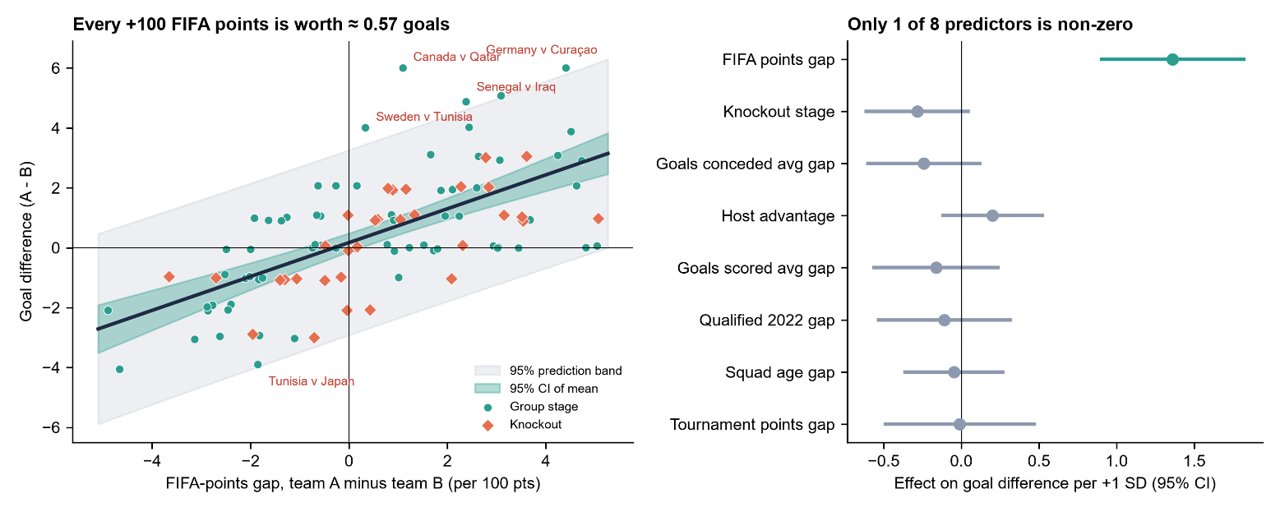
Fig. 1. Left: goal difference rises about 0.57 goals per 100 FIFA points (teal = 95% CI of the mean, grey = 95% prediction band). Right: standardised effects with 95% CIs.
Act 2: the plot twist. Several “different” ideas were echoes of team strength. 2022 qualification tracks FIFA points closely (r = 0.66), and tournament points so far does too (r = 0.51), so once FIFA points are in, the other seven add nothing jointly (partial F = 1.14, p = 0.35). Dropping them gives goal_diff = 0.17 + 0.566 × (FIFA gap / 100). R² falls only from 0.463 to 0.418, adjusted R² is unchanged (0.413 vs 0.418), and AIC and BIC improve (388.4 vs 394.1; 393.7 vs 417.9). The slope’s bootstrap 95% CI is [0.44, 0.70] and survives robust (HC3) errors, which addresses mild heteroscedasticity in the full model (Breusch–Pagan p = 0.041). The intercept is not significant (p = 0.28), so team A has no built-in advantage, and forcing the line through the origin gives almost the same slope (0.58). A squared term, a knockout interaction and Elo-style saturation each added negligible gain (CV RMSE within 0.03 goals).
Act 3: can a cleverer algorithm find what the line missed? We compared 12 models using 5-fold cross-validation repeated 10 times: a mean-only baseline, OLS variants, Ridge, Lasso, Elastic Net, Huber, SVR, k-NN, Random Forest and Gradient Boosting. Every model beats the baseline (RMSE 2.02 goals), but none beats the one-variable OLS (1.56, a 23% reduction), and none differs significantly from the full OLS (Nadeau–Bengio corrected t-test, all p > 0.2). Regularisation could not rescue the full model (≈ 1.62), and the non-linear learners (1.61–1.68) overfit 104 matches.
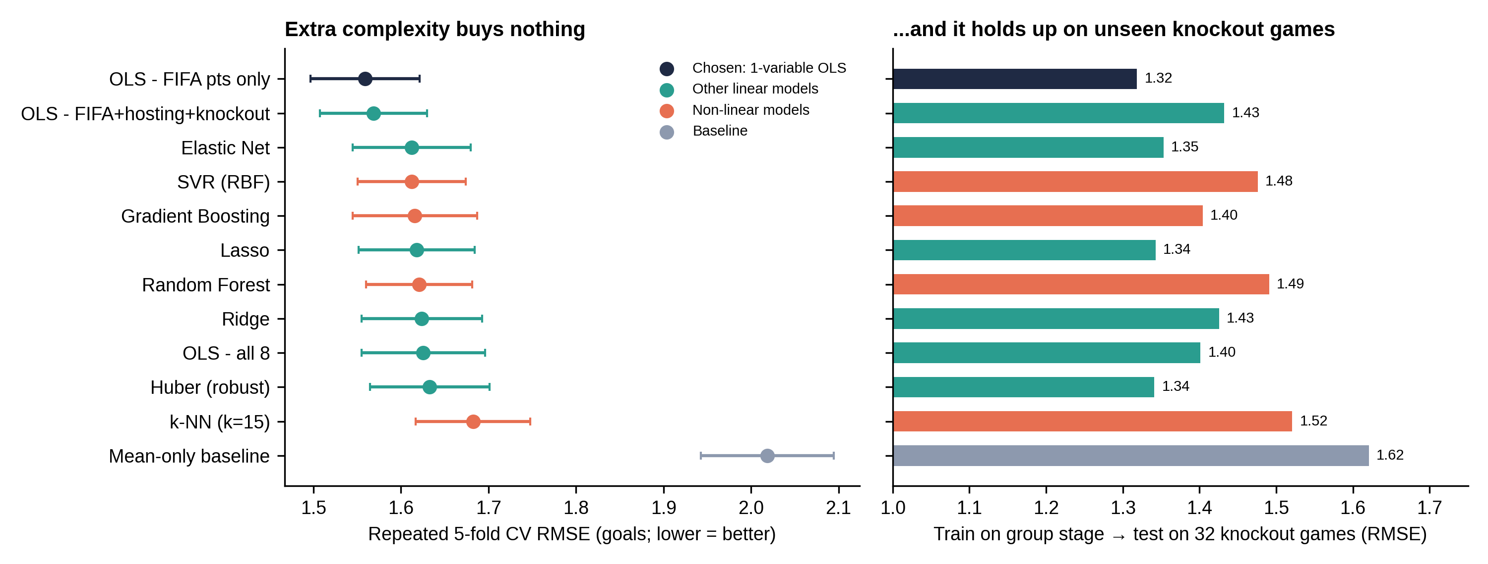
Fig. 2. Left: repeated-CV RMSE (points; bars are approximate 95% intervals). Right: train on group stage, test on knockout games.
Act 4: the stress test. Training on the 72 group games and predicting the 32 knockout games, the one-variable model scored best again (RMSE 1.32 vs 1.40 for all eight and 1.62 for the baseline). Its predicted sign matches the winner in about 84% of the 80 non-drawn matches, against 62.5% for always picking team A. Residuals show no pattern and are close to normal (Shapiro p = 0.20; Fig. 3).
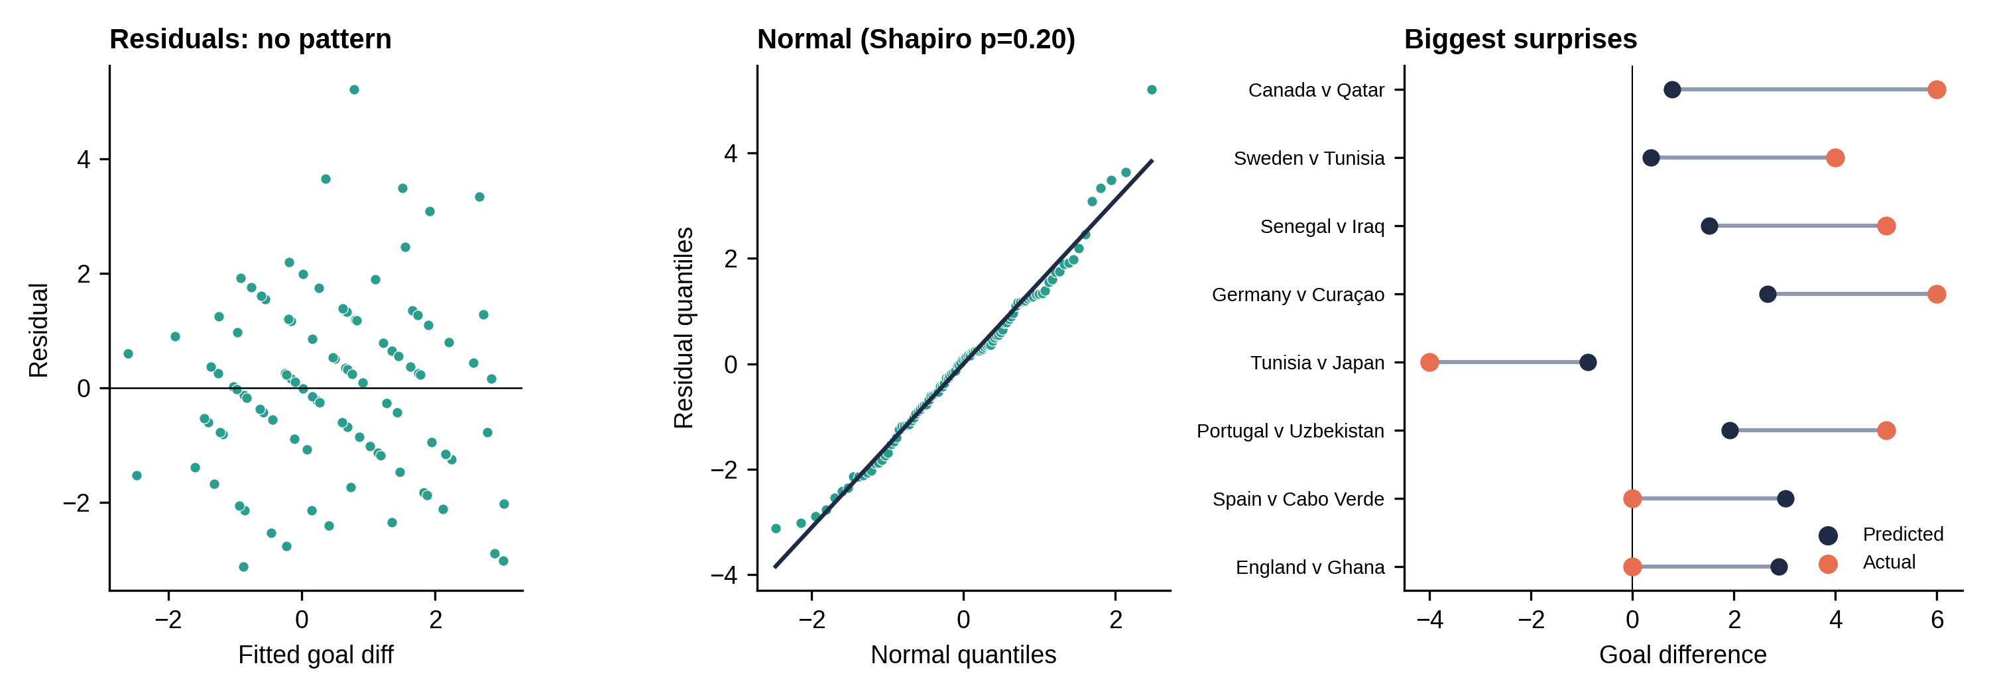
Fig. 3. Residuals vs fitted values, normal Q–Q plot, and the eight biggest gaps between predicted and actual goal difference.
What it means. FIFA points tell us who is likely to win, but football stays noisy: the residual SD is 1.55 goals, so a 250-point gap predicts about 1.6 goals with a 95% prediction interval of roughly ±3. The eight biggest misses all came in the group stage, such as Canada 6–0 Qatar (predicted +0.8) and the goalless draws of Spain v Cabo Verde and England v Ghana (predicted about +3). We therefore recommend the FIFA-points model as final: simplest, best out of sample and easy to explain. If all eight variables must stay, use Elastic Net, which is stable but no better. The knockout flag (−0.61 goals, p = 0.09) deserves more data, and future work should add richer pre-match signals (Elo ratings, squad market value, rest days). With n = 104, conclusions are indicative rather than definitive.

