Database Structure
This reference documents the five related tables used by the sales analysis project: warehouses, customers, products, transaction headers, and transaction line items.

Entity-relationship diagram
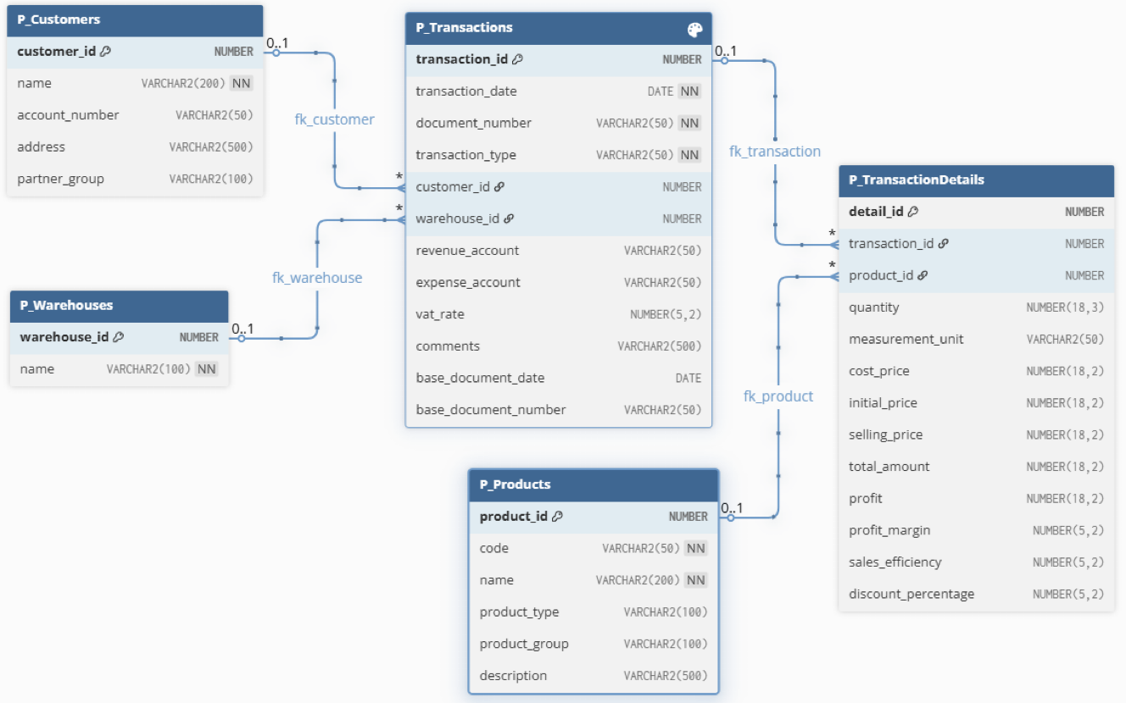

Master tables

P_Warehouses
Stores warehouse identifiers and names.
Column | Oracle data type | Constraint
warehouse_id | NUMBER | PRIMARY KEY
name | VARCHAR2(100) | NOT NULL

P_Customers
Stores customer details and customer-group classifications.
Column | Oracle data type | Constraint
customer_id | NUMBER | PRIMARY KEY
name | VARCHAR2(200) | NOT NULL
account_number | VARCHAR2(50) | Optional
address | VARCHAR2(500) | Optional
partner_group | VARCHAR2(100) | Optional

P_Products
Stores product codes, names, classifications, and descriptions.
Column | Oracle data type | Constraint
product_id | NUMBER | PRIMARY KEY
code | VARCHAR2(50) | NOT NULL
name | VARCHAR2(200) | NOT NULL
product_type | VARCHAR2(100) | Optional
product_group | VARCHAR2(100) | Optional
description | VARCHAR2(500) | Optional

Transaction headers

P_Transactions
Stores transaction-level information, including the date, document number, transaction type, customer, warehouse, and accounting references.
Column | Oracle data type | Constraint
transaction_id | NUMBER | PRIMARY KEY
transaction_date | DATE | NOT NULL
document_number | VARCHAR2(50) | NOT NULL
transaction_type | VARCHAR2(50) | NOT NULL
customer_id | NUMBER | FOREIGN KEY; optional
warehouse_id | NUMBER | FOREIGN KEY; optional
revenue_account | VARCHAR2(50) | Optional
expense_account | VARCHAR2(50) | Optional
vat_rate | NUMBER(5,2) | Optional
comments | VARCHAR2(500) | Optional
base_document_date | DATE | Optional
base_document_number | VARCHAR2(50) | Optional

Foreign-key references
customer_id references P_Customers.customer_id (fk_customer).
warehouse_id references P_Warehouses.warehouse_id (fk_warehouse).

Relationship meaning
One customer can be associated with many transactions, and one warehouse can be associated with many transactions. Each transaction can reference at most one customer and at most one warehouse. The diagram permits either reference to be NULL.

Transaction line items

P_TransactionDetails
Stores product-level transaction lines, including quantities, prices, amounts, and profitability-related values.
Column | Oracle data type | Constraint
detail_id | NUMBER | PRIMARY KEY
transaction_id | NUMBER | FOREIGN KEY; optional
product_id | NUMBER | FOREIGN KEY; optional
quantity | NUMBER(18,3) | Optional
measurement_unit | VARCHAR2(50) | Optional
cost_price | NUMBER(18,2) | Optional
initial_price | NUMBER(18,2) | Optional
selling_price | NUMBER(18,2) | Optional
total_amount | NUMBER(18,2) | Optional
profit | NUMBER(18,2) | Optional
profit_margin | NUMBER(5,2) | Optional
sales_efficiency | NUMBER(5,2) | Optional
discount_percentage | NUMBER(5,2) | Optional

