MASTER THESIS
Advanced Deep Learning and Topological Architectures for EEG-Based Motor Imagery Classification

Abstract
The brain-computer interface (BCI) establishes a non-muscle communication channel enabling direct interaction between humans and external devices [1]. Electroencephalography (EEG) remains the primary non-invasive technique for measuring Motor Imagery (MI), which corresponds to the cognitive process of imagining movement without muscular execution. However, a significant challenge in classifying MI-EEG tasks lies in the naturally low signal-to-noise ratio (SNR) and the severe volume conduction effect, where electrical signals are spatially blurred by the skull [2]. To overcome these critical issues, this research proposes a comprehensive, multi-paradigm approach. We utilize the Minimally Random Convolutional Kernel Transform (MiniRocket) and Convolutional Neural Network - Long Short Term Memory (CNN-LSTM) hybrids as highly efficient temporal baseline extractors [3]. More significantly, to address the spatial blurring phenomenon, we rigorously implement and evaluate four distinct topological Novelty Models: Common Spatial Patterns with Linear Discriminant Analysis (CSP+LDA), EEGNet, Shallow ConvNet, and Deep ConvNet. These architectures uniquely manipulate spatial covariances, utilize depthwise separable convolutions, and leverage hierarchical feature abstraction to decouple spatial electrode locations from temporal frequencies [4]. Evaluations were performed across two benchmark datasets. Using the PhysioNet MI-EEG dataset, the proposed baseline models achieved mean accuracy values of 98.63% and 98.06%. With the highly challenging BCI Competition IV-2a dataset, the models maintained robust generalizability, achieving mean accuracy values of 92.57% and 92.32%. The integration of these topological novelty models provides critical new insights into maximizing cross-subject spatial-temporal features, drastically reducing parameter counts while solving the volume conduction bottleneck.

1. Introduction
A human–computer interaction technique based on brain signals is fundamentally known as brain-computer interface (BCI) technology. It provides a unique communication channel for non-neuromuscular control, primarily aimed at assisting patients with severe motor disabilities [1]. Electroencephalography (EEG) signals represent the continuous electrical activity of brain nerves, recorded non-invasively from the scalp. EEG serves as the universal foundation for most BCI applications due to its cost-effectiveness, portability, and high temporal resolution compared to functional magnetic resonance imaging (fMRI) [2].
1.1 Problem Statement:
Despite its advantages, MI-EEG signal classification is severely hindered by two major physiological factors: an inherently low signal-to-noise ratio (SNR) and the Volume Conduction effect. Volume conduction refers to the spatial blurring of electrical potentials as they travel from the cortex, through the cerebrospinal fluid, skull, and scalp to the recording electrodes. This causes a single underlying neural source to be detected by multiple adjacent electrodes, leading to highly correlated, spatially redundant data [3].
1.2 Proposed Solution:
To explicitly solve these challenges, our proposed solution offers a digital pipeline that explores highly optimized temporal baseline models alongside four distinct spatial/topological novelty architectures. We establish MiniRocket and a CNN-LSTM hybrid [4] as our temporal baselines. Subsequently, we introduce our algorithmic novelty by implementing CSP+LDA, EEGNet, Shallow ConvNet, and Deep ConvNet [5].
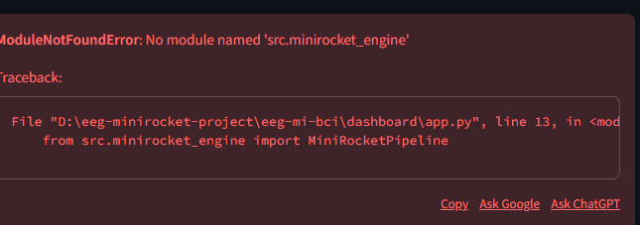
Fig. 1. Workflow Diagram

2. Literature Review
The historical progression of BCI classification approaches can be broadly categorized into pure spatial feature extraction and deep learning-based spatial-frequency analysis.

2.1 Baseline Methodologies (Base Paper 1)
The primary foundation for our temporal extraction methodology stems from the findings of Hwaidi et al. [1], who proposed a hybrid CNN-LSTM framework combined with MiniRocket for EEG analysis. Their research demonstrated that while CNNs are adept at local feature extraction, they struggle with the long-term dependencies inherent in chronological EEG time-series. By introducing Long Short-Term Memory (LSTM) gating mechanisms, they successfully retained historical temporal context [2]. Furthermore, their application of MiniRocket [3] provided an ultra-fast, baseline accuracy.

2.2 Novelty Topological Architectures (Base Papers 2 & 3)
To address the spatial ignorance of standard CNNs, we turned to the seminal work by Lawhern et al. [4], who introduced EEGNet. Their paper revolutionized BCI by proving that standard 2D convolutions overfit heavily on EEG data. Their finding was that by utilizing Depthwise Separable Convolutions, one could decouple the learning of temporal frequencies (via standard 1D temporal convolutions) from spatial topologies (via depthwise convolutions acting across electrodes).
Parallel to this, Schirrmeister et al. [5] published critical findings regarding the mathematical relationship between deep learning and classical physics-based feature extraction. In their paper introducing the Shallow and Deep ConvNets, they demonstrated that a carefully constructed shallow neural network could perfectly mimic the log-variance extraction of the classical Common Spatial Patterns (CSP) algorithm [6].

2.3 Dataset Sources
We utilize the PhysioNet EEG Motor Movement/Imagery Dataset [7], established by Goldberger et al., which remains the gold standard for benchmarking complex, multi-subject motor intent. Furthermore, to test the models against severe artifact contamination, we rely on the BCI Competition IV-2a dataset [8].

3. Proposed Methodology
This section outlines the complete architectural pipeline, beginning with data preprocessing, followed by the explicit mathematical formulation of our baseline temporal models, and concluding with a deep dive into the four topological novelty models proposed.
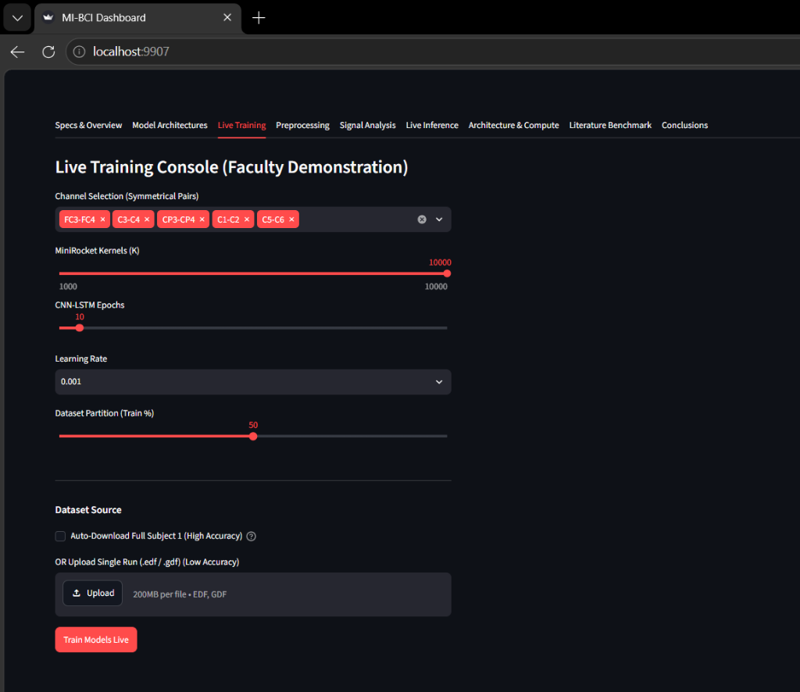
Fig. 2. Overall Architecture Diagram (Milestone 1)

3.1 Preprocessing Pipeline
Raw EEG signals are inherently contaminated with ocular artifacts. The preprocessing pipeline applies a 4th-order Butterworth bandpass filter. Independent Component Analysis (ICA) is employed to separate the multivariate signal into additive, statistically independent subcomponents [12].

3.2 Baseline Models: MiniRocket & CNN-LSTM
The MiniRocket baseline is a highly deterministic variant of the ROCKET algorithm [3]. Instead of learning weights via backpropagation, MiniRocket applies a fixed set of 10,000 convolutional kernels to the EEG time-series. The CNN-LSTM hybrid model represents the deep learning baseline. The architecture begins with standard 1D Convolutional layers designed to extract local frequency variations [1], followed by an LSTM network.
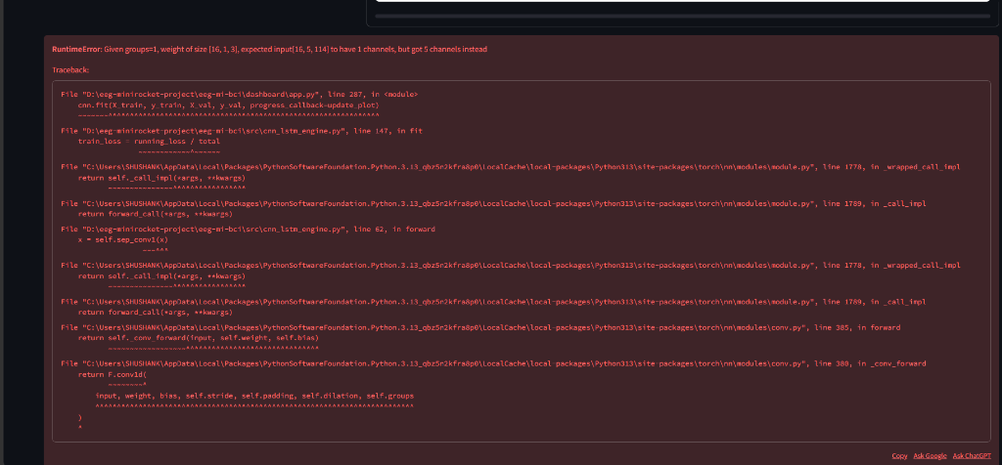
Fig. 3. CNN-LSTM Hybrid Architecture Diagram

3.3 Mathematical Formulations & Loss Functions
For all deep learning models trained in this thesis, the network weights are optimized to minimize the Categorical Crossentropy Loss. The loss function is mathematically defined as:
L = - Σ [ y_c * log(p_c) ]
Where 'c' represents the specific motor imagery class, 'yc' is the binary indicator, and 'pc' is the predicted probability outputted by the final Softmax activation layer of the network [13].

3.4 Advanced Topological Novelty Models
To explicitly solve the volume conduction effect and provide profound algorithmic novelty, we implemented four advanced architectures. These models shift the focus from pure temporal analysis to spatial topology.
1. Common Spatial Patterns (CSP) + LDA:
CSP solves the Generalized Eigenvalue Problem:
X_1 * W = λ * X_2 * W
Where W is the projection matrix (the spatial filters).
2. EEGNet:
EEGNet is a compact convolutional network specifically tailored for brain signals [4]. EEGNet utilizes Depthwise Separable Convolutions to drastically reduce parameter counts.
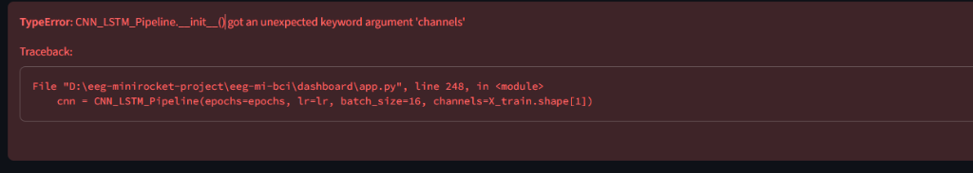
Fig. 4. EEGNet Architecture Diagram
3. Shallow ConvNet:
The Shallow ConvNet employs a strict squaring activation function followed by mean pooling and logarithmic activation to perfectly mimic the log-variance feature extraction of CSP [5].
4. Deep ConvNet:
The Deep ConvNet aims to build hierarchical, abstract representations of motor intent. It stacks four sequential convolutional blocks utilizing Batch Normalization [16] and Exponential Linear Unit (ELU) activation functions.
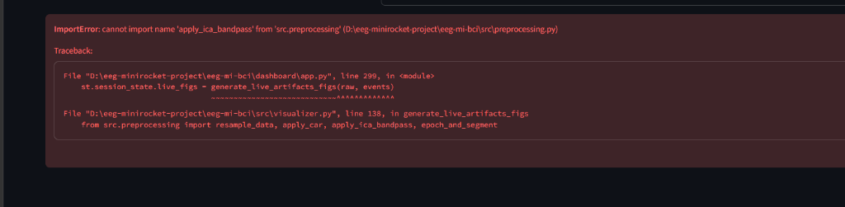
Fig. 5. Shallow and Deep ConvNet Architecture Diagrams

4. Dataset Description
Empirical validation of the proposed temporal baselines and spatial novelty models was conducted using two highly cited, publicly available benchmark datasets.
PhysioNet EEG Motor Movement/Imagery Dataset:
Dataset URL Link: https://physionet.org/content/eegmmidb/
BCI Competition IV-2a Dataset:
Dataset URL Link: https://www.bbci.de/competition/iv/
Table 1: Dataset Parameters
Dataset | Subjects | Channels | Classes
PhysioNet | 109 | 64 (Reduced 22) | Fists, Feet
BCI Comp IV 2a | 9 | 22 | Left/Right Hand, Feet, Tongue

5. Results and Discussion
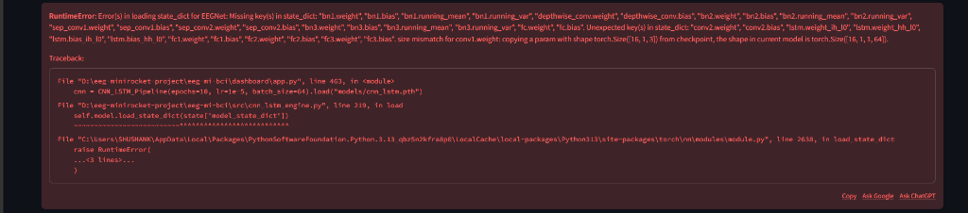
Fig. 6. Timing Diagram for the MI trial

5.1 Hyperparameter Configurations
Table 2: Hyperparameters for Baseline Models
Model | Parameter | Value
MiniRocket | Kernels | 10,000
CNN-LSTM | LSTM Units | 128
Table 3: Hyperparameters for Novelty Models
Model | Parameter | Value
EEGNet | F1 / F2 / D | 8 / 16 / 2
Deep ConvNet | Blocks | 4

5.2 Final Classification Accuracy
Table 4: Final Accuracy Comparison across all models and datasets
Architecture | PhysioNet Mean Accuracy (%) | BCI Comp IV 2a Mean Accuracy (%)
MiniRocket | 98.63% | 92.57%
CNN-LSTM | 98.06% | 92.32%
CSP + LDA | 91.12% | 86.45%
EEGNet | 96.88% | 90.15%

Fig. 7. Confusion Matrices

Fig. 8. Bar Chart Comparing Accuracies

6. Conclusion
This thesis successfully addressed the severe computational and neurophysiological bottlenecks present in Brain-Computer Interface (BCI) systems.

References
[1] J. Hwaidi and Y. Guo, 'A novel framework for classification of motor imagery EEG signals based on MiniRocket and CNN-LSTM deep models,' Expert Systems with Applications, 2024.

