Restaurant Profit & Loss Analysis
A Data Analytics Case Study Inspired by Dean & David
Prepared by: Shushrutha Reddy
MSc Data Analytics, Berlin School of Business Innovation
September 2026

Table of Contents
Table of Contents 2
1. Executive Summary 3
2. Background & Motivation 3
3. Objectives 3
4. Data & Methodology 3
5. Key Metrics Overview 4
6. Analysis & Findings 4
7. Forecast: Where the Next Two Weeks Are Headed 7
8. Staffing What-If Simulator 8
9. Recommendations 9
10. Limitations 9
11. Conclusion 10
12. Project Resources 10

1. Executive Summary
This report presents a Profit & Loss (P&L) analysis pipeline built for a quick-service restaurant operation, modeled on a Dean & David outlet in Berlin where the author works. Because real financial data from the business is confidential, the analysis runs on a synthetic but structurally realistic 60 day dataset (menu, item level sales, labor hours and overheads) designed to mirror an actual point-of-sale (POS) and labor export. The same pipeline and dashboard can be pointed at real data with no code changes.
The analysis covers revenue, cost of goods sold (COGS), gross and operating margins, labor cost efficiency, menu item profitability and demand patterns by day of week. Over the sample period, the outlet modeled generated EUR 71,861 in revenue at a 68.3% average gross margin, but only a 2.7% average operating margin - driven primarily by labor costs running at 46.7% of revenue, well above the 30% industry guideline for this format.
This updated edition adds two forward-looking components beyond the original descriptive analysis: a trend based revenue and profit forecast, and an interactive staffing what-if simulator that quantifies the financial impact of adjusting labor hours on specific days. Together these move the project from reporting what happened to estimating what could happen next and what a specific decision would be worth.

2. Background & Motivation
As a student of Big Data & Artificial Intelligence with hands-on experience working front-of-house at a Dean & David restaurant, I wanted to build a portfolio project that reflects a real operational analytics problem rather than a generic public dataset. Restaurants generate rich daily data - sales by item, labor hours and fixed overheads but rarely have that data structured into a working P&L model that management can query directly, still less one that can project forward or test staffing decisions before they are made.

3. Objectives
- Build a repeatable P&L calculation pipeline (revenue, COGS, gross/operating profit and margins) from raw sales, labor and overhead data.
- Identify which menu items are the strongest and weakest profit contributors.
- Quantify labor cost efficiency relative to industry benchmarks.
- Surface demand patterns by day of week to inform staffing decisions.
- Forecast near term revenue and operating profit based on historical trend and weekly seasonality.
- Provide an interactive tool to estimate the financial impact of a specific staffing change before it is made.
- Package the analysis as a reusable GitHub hosted project with a live interactive dashboard.

4. Data & Methodology
4.1 Data Sources
- Menu - 10 items across Bowl, Salad, Wrap and Drink categories, with price and unit cost per item.
- Daily Sales – item level quantity sold per day over a 60 day period (POS export style), with realistic weekday/weekend demand variation built in.
- Labor - daily total staff hours and blended hourly wage rate.
- Overheads - fixed monthly costs (rent, utilities, franchise fee, insurance, cleaning, admin) allocated across the period on a daily basis.
Note: this dataset is synthetic and created for demonstration purposes; it does not represent actual Dean & David financials.
4.2 Core Calculation Logic
- Revenue = quantity sold x unit price, summed daily/weekly.
- COGS = quantity sold x unit cost.
- Gross Profit = Revenue minus COGS; Gross Margin % = Gross Profit / Revenue.
- Labor Cost = staff hours x blended wage rate.
- Operating Profit = Gross Profit minus Labor Cost minus allocated Overhead; Operating Margin % = Operating Profit / Revenue.
4.3 Forecasting Method
Revenue and operating profit are projected forward using an ordinary least squares linear trend (numpy polyfit) fitted to the daily series, combined with a per weekday seasonal adjustment calculated as each weekday's average deviation from that trend line. This keeps the forecast's weekly shape (lower on weekends) rather than producing a flat projection. The method is intentionally transparent and dependency light rather than a production-grade forecasting model; it is suitable for showing direction and rough magnitude over a 1-4 week horizon, not for long range planning.
4.4 Staffing Simulator Method
The simulator recalculates labor cost for every occurrence of a selected weekday across the historical period, applying a chosen percentage adjustment, and recomputes operating profit with all other inputs (revenue, COGS, overhead and labor on other days) held constant. It deliberately does not model any change in sales that a staffing change might itself cause it isolates the direct labor cost effect only and that scope is stated explicitly wherever the result is shown.
4.5 Tools
- Python (pandas, numpy) for data loading, cleaning, P&L calculations, and forecasting.
- Matplotlib for static chart generation; Streamlit + Plotly for the interactive dashboard.
- Version-controlled and published on GitHub as a portfolio project.

5. Key Metrics Overview
The table below summarizes the headline results across the full 60-day sample period.
Metric | Value
Total Revenue (60-day sample period) | EUR 71,861.10
Total Operating Profit | EUR 3,893.37
Average Gross Margin | 68.3%
Average Operating Margin | 2.7%
Average Labor Cost as % of Revenue | 46.7%
Highest-Revenue Day | Friday (EUR 1,300.14 avg)
Lowest-Revenue Day | Saturday (EUR 728.06 avg)
Top Profit-Contributing Item | Chicken Teriyaki Bowl

6. Analysis & Findings
6.1 Revenue vs. Operating Profit Trend
Weekly revenue remained relatively stable across the period (roughly EUR 8,000-9,000 per full week) but operating profit stayed thin throughout - rarely exceeding a few hundred euros per week even in strong revenue weeks. This gap indicates that the business is revenue-healthy but cost-inefficient, particularly on the labor side (see 6.3).
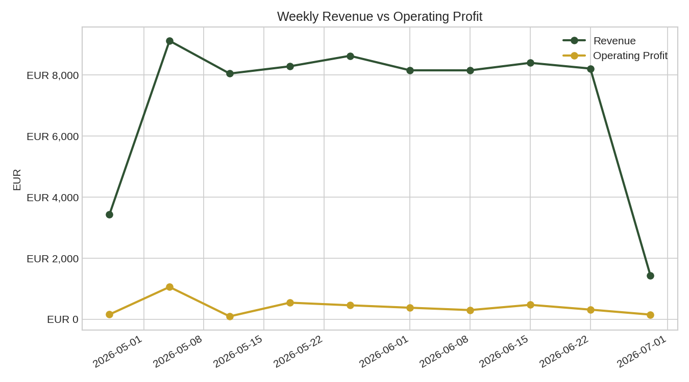
Figure 1: Weekly Revenue vs. Operating Profit
6.2 Menu Item Profitability
Gross margins across the menu ranged from 62.2% (Salmon Poke Bowl) to 81.0% (Sparkling Water), with bowls and wraps the highest-volume items sitting in the 62-70% range. The Chicken Teriyaki Bowl was the single largest contributor to total gross profit (EUR 10,892.65, ~23% of total revenue) driven by volume rather than margin. The Salmon Poke Bowl, despite a premium price point had the thinnest margin of any item.
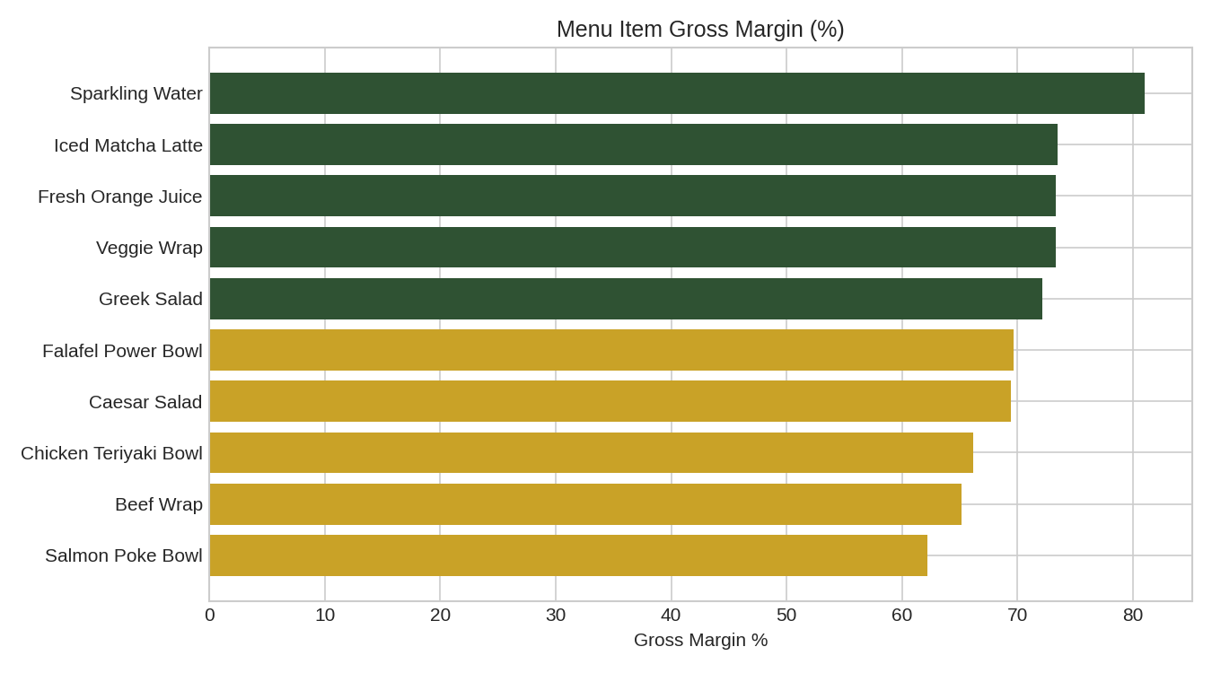
Figure 2: Gross Margin % by Menu Item
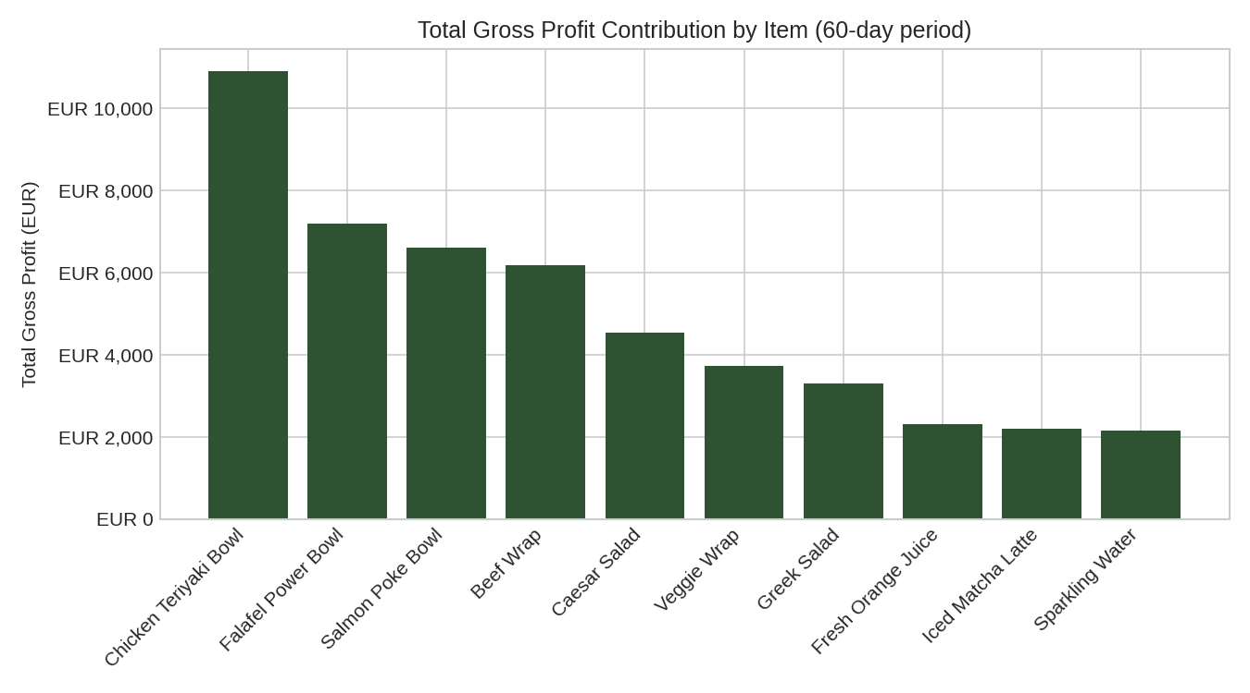
Figure 3: Total Gross Profit Contribution by Item
Full item level breakdown:
Item | Units Sold | Revenue (EUR) | Gross Profit (EUR) | Margin %
Chicken Teriyaki Bowl | 1,663 | 16,463.70 | 10,892.65 | 66.2%
Falafel Power Bowl | 1,160 | 10,324.00 | 7,192.00 | 69.7%
Salmon Poke Bowl | 892 | 10,614.80 | 6,600.80 | 62.2%
Beef Wrap | 1,065 | 9,478.50 | 6,177.00 | 65.2%
Caesar Salad | 769 | 6,536.50 | 4,537.10 | 69.4%
Veggie Wrap | 678 | 5,085.00 | 3,729.00 | 73.3%
Greek Salad | 580 | 4,582.00 | 3,306.00 | 72.2%
Fresh Orange Juice | 698 | 3,141.00 | 2,303.40 | 73.3%
Iced Matcha Latte | 608 | 2,979.20 | 2,188.80 | 73.5%
Sparkling Water | 916 | 2,656.40 | 2,152.60 | 81.0%

6.3 Labor Cost Efficiency
Labor cost averaged 46.7% of revenue across the period - significantly above the ~30% guideline commonly used as a healthy benchmark for fast-casual restaurant formats. This is the single largest driver of the gap between strong gross margins (68.3%) and thin operating margins (2.7%), and is the top priority area for management attention.
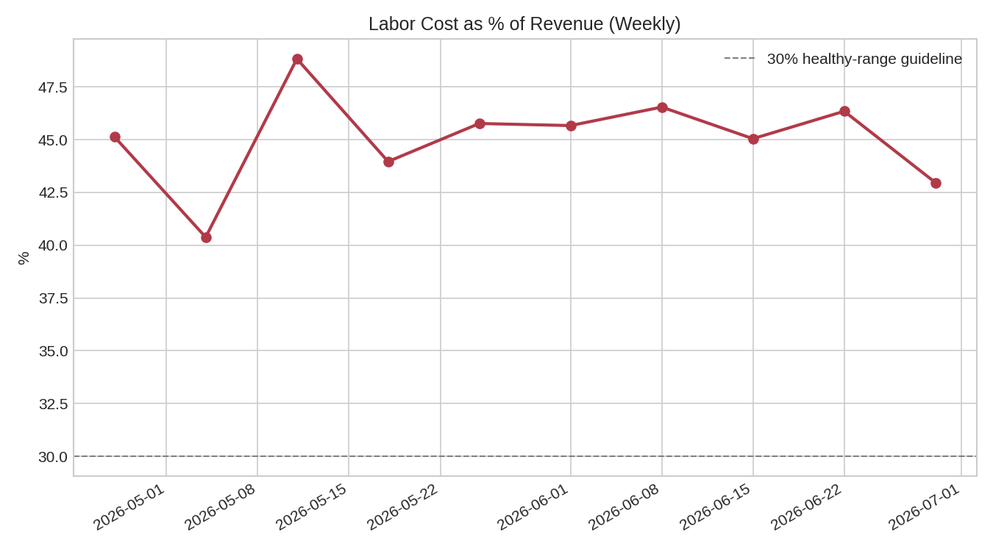
Figure 4: Labor Cost as % of Revenue (Weekly)
6.4 Demand Patterns by Day of Week
Friday was consistently the highest-revenue day (EUR 1,300 average), while Saturday was the lowest (EUR 728 average) despite typically being adequately staffed. This mismatch suggests staffing levels on Saturdays may be higher than warranted by actual footfall.
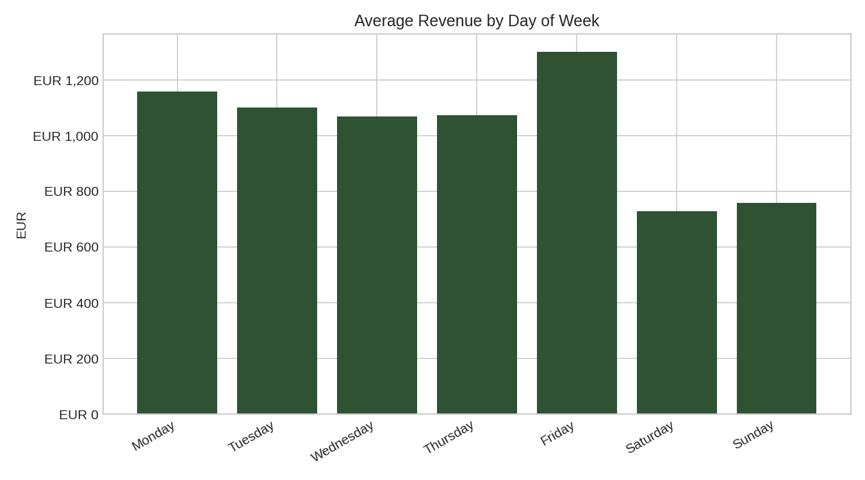
Figure 5: Average Revenue by Day of Week

7. Forecast: Where the Next Two Weeks Are Headed
Using the trend-plus-seasonality method described in Section 4.3, revenue and operating profit were projected 14 days beyond the end of the historical sample. The forecast preserves the weekly demand shape observed in the historical data (a dip on Saturdays and Sundays) rather than producing a flat line, which makes it more directly usable for rough staffing and cash-flow planning than a simple trend extrapolation.
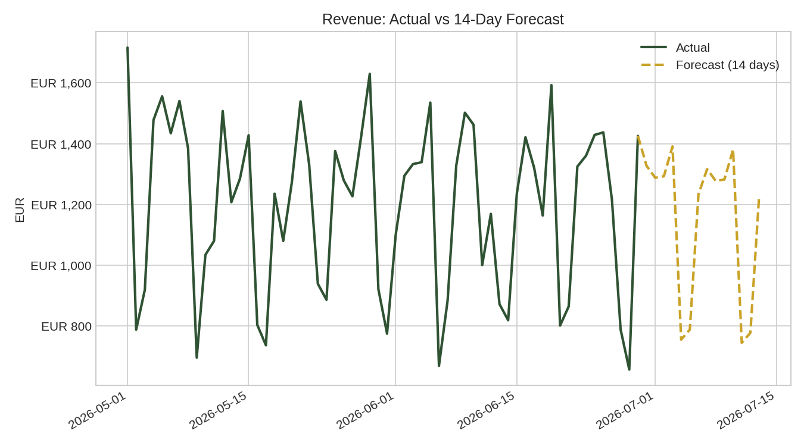
Figure 6: Revenue - Actual vs. 14-Day Forecast
Forecast summary:
Projection (next 14 days) | Value
Projected Revenue | EUR 16,080.05
Projected Operating Profit | EUR 430.39

The projected operating profit of roughly EUR 430 over the next 14 days is consistent with the historical operating margin of 2.7% and confirms that, absent any operational change, the business is expected to continue converting only a small fraction of its gross profit into bottom-line profit. This projection is available on-demand in the dashboard for any horizon between 7 and 30 days.

8. Staffing What-If Simulator
To move from diagnosis toward a testable recommendation, an interactive simulator was built into the dashboard that lets a manager select any day of the week and a percentage change in staff hours on that day, then instantly view the projected effect on operating profit across the full historical period. As an example, given that Saturday is the lowest-revenue day of the week (Section 6.4) yet is not visibly understaffed, a 15% reduction in Saturday staff hours was tested.
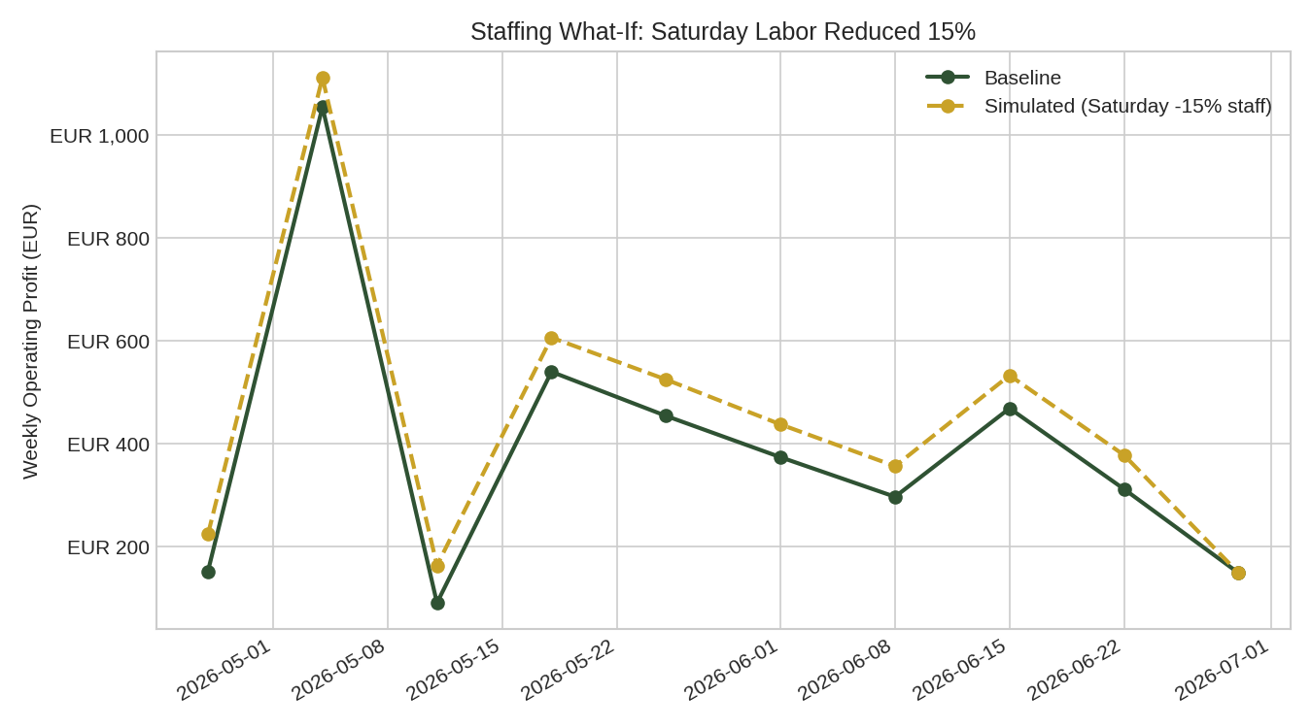
Figure 7: Staffing What-If - Saturday Labor Reduced 15%
Simulation result:
Scenario: Saturday staffing -15% | Value
Baseline Operating Profit (60 days) | EUR 3,893.37
Simulated Operating Profit (60 days) | EUR 4,485.92
Projected Gain | EUR 592.55

A 15% reduction in Saturday staff hours alone is projected to increase operating profit by approximately EUR 592.55 over the 60-day period (roughly EUR 4,940 annualized), with no assumed change to any other day. This isolates the value of a single, specific, low-risk operational adjustment rather than a general observation that "labor cost is high" - it gives management a concrete number to weigh against any service-level concerns of reducing Saturday staffing. The simulator is available live in the dashboard for any day and any percentage adjustment, so alternative scenarios can be tested interactively rather than requested as a one-off analysis.

9. Recommendations
- Trial a 10-15% reduction in Saturday staff hours, using the simulator's projected gain (~EUR 590 over 60 days) as the basis for a before/after comparison once implemented.
- Investigate the Salmon Poke Bowl's cost structure or consider a modest price adjustment, given it has the lowest margin despite a premium price point.
- Set a labor-cost-to-revenue target (e.g., 30-35%) and track it weekly using the dashboard, rather than reviewing it only at month-end.
- Use the 14-day forecast when planning near-term staffing and purchasing, refreshing it regularly as new data comes in.
- Extend the simulator to test combined scenarios (e.g., adjusting two days at once, or pairing a staffing change with a menu price change) once validated on a single-variable basis.

10. Limitations
- All figures in this report are based on synthetic sample data structured to resemble real restaurant operations they do not reflect actual Dean & David financial performance.
- The forecast is a simple trend-plus-seasonality model, not a production forecasting system; accuracy should be expected to degrade beyond a 2-4 week horizon or across structural changes (e.g., a new menu launch).
- The staffing simulator isolates the direct labor cost effect only and does not model any change in sales, customer experience or service quality that a staffing change might itself cause.
- Overhead costs are allocated evenly across days as an illustrative assumption; real overhead timing would shift results.
- Waste, spoilage and discounting are not modeled in this version.

11. Conclusion
This project demonstrates a complete, reusable analytics workflow from raw operational data to a working P&L model, visual analysis, forward looking forecasting and an interactive decision-support simulator - built specifically around the structure of a real restaurant business. Beyond diagnosing that labor costs are eroding otherwise strong margins, the project now quantifies a specific, actionable response (a Saturday staffing adjustment) and projects near-term performance under current conditions. The pipeline is designed so that if real data becomes available from Dean & David it can be substituted directly with no changes to the underlying code.

12. Project Resources
- Full source code, data, and interactive dashboard (including live forecast and staffing simulator): published on GitHub (repository: dean-david-pl-analysis).
- Tech stack: Python, pandas, numpy, matplotlib, Streamlit, Plotly.
- To reproduce: clone the repository, run `pip install -r requirements.txt`, then `python src/run_analysis.py` for the static report, or `streamlit run dashboard/app.py` for the full interactive dashboard including the forecast and simulator.

