Restaurant Profit & Loss Analysis
A Data Analytics Case Study Inspired by Dean & David
Prepared by: shushrutha Reddy
MSc Data Analytics, Berlin School of Business and Innovation
July 2026

Table of Contents

1. Executive Summary
This report presents a Profit & Loss (P&L) analysis pipeline built for a quick-service restaurant operation, modeled on a Dean & David outlet in Berlin where the author works. Because real financial data from the business is confidential, the analysis runs on a synthetic but structurally realistic 60-day dataset (menu, item level sales, labor hours and overheads) designed to mirror an actual point of sale (POS) and labor export. The same pipeline and dashboard can be pointed at real data with no code changes.
The analysis covers revenue, cost of goods sold (COGS), gross and operating margins, labor cost efficiency, menu item profitability and demand patterns by day of week. Over the sample period, the outlet modeled generated €71,861 in revenue at a 68.3% average gross margin, but only a 2.7% average operating margin driven primarily by labor costs running at 46.7% of revenue well above the 30% industry guideline for this format. This is the central finding of the analysis and the basis for the recommendations in Section 6.

2. Background & Motivation
As a student of Msc Data Analytics with hands on experience working front-of-house at a Dean & David restaurant. I wanted to build a portfolio project that reflects a real operational analytics problem rather than a generic public dataset. Restaurants generate rich daily data sales by item, labor hours and fixed overheads but rarely have that data structured into a working P&L model that management can query directly. This project builds that pipeline from raw data to actionable insight.

3. Objectives
- Build a repeatable P&L calculation pipeline (revenue, COGS, gross/operating profit and margins) from raw sales, labor and overhead data.
- Identify which menu items are the strongest and weakest profit contributors.
- Quantify labor cost efficiency relative to industry benchmarks.
- Surface demand patterns by day of week to inform staffing decisions.
- Package the analysis as a reusable GitHub hosted project with an interactive dashboard so it can be pointed at real restaurant data in future.

4. Data & Methodology
4.1 Data Sources
Four datasets were used, generated synthetically to mirror the structure of real restaurant exports:
- Menu - 10 items across Bowl, Salad, Wrap and Drink categories with price and unit cost per item.
- Daily Sales - item level quantity sold per day over a 60 day period (POS-export style) with realistic weekday/weekend demand variation built in.
- Labor - daily total staff hours and blended hourly wage rate.
- Overheads - fixed monthly costs (rent, utilities, franchise fee, insurance, cleaning, admin) allocated across the period on a daily basis.
Note: this dataset is synthetic and created for demonstration purposes it does not represent actual Dean & David financials. The data generation logic and all raw CSVs are included in the project repository for full transparency.
4.2 Calculation Logic
- Revenue = quantity sold × unit price summed daily/weekly.
- COGS = quantity sold × unit cost.
- Gross Profit = Revenue - COGS; Gross Margin % = Gross Profit ÷ Revenue.
- Labor Cost = staff hours × blended wage rate.
- Operating Profit = Gross Profit - Labor Cost - allocated Overhead; Operating Margin % = Operating Profit ÷ Revenue.
4.3 Tools
- Python (pandas) for data loading, cleaning and P&L calculations.
- Matplotlib for static chart generation.
- Streamlit + Plotly for the interactive, filterable dashboard.
- Version-controlled and published on GitHub as a portfolio project.

5. Key Metrics Overview
The table below summarizes the headline results across the full 60 day sample period.
Metric | Value
Total Revenue (60-day sample period) | €71,861.10
Total Operating Profit | €3,893.37
Average Gross Margin | 68.3%
Average Operating Margin | 2.7%
Average Labor Cost as % of Revenue | 46.7%
Highest-Revenue Day | Friday (€1,300.14 avg)
Lowest-Revenue Day | Saturday (€728.06 avg)
Top Profit-Contributing Item | Chicken Teriyaki Bowl

6. Analysis & Findings
6.1 Revenue vs. Operating Profit Trend
Weekly revenue remained relatively stable across the period (roughly €8,000-€9,000 per full week), but operating profit stayed thin throughout rarely exceeding a few hundred euros per week even in strong revenue weeks. This gap indicates that the business is revenue healthy but cost inefficient particularly on the labor side (see 6.3).
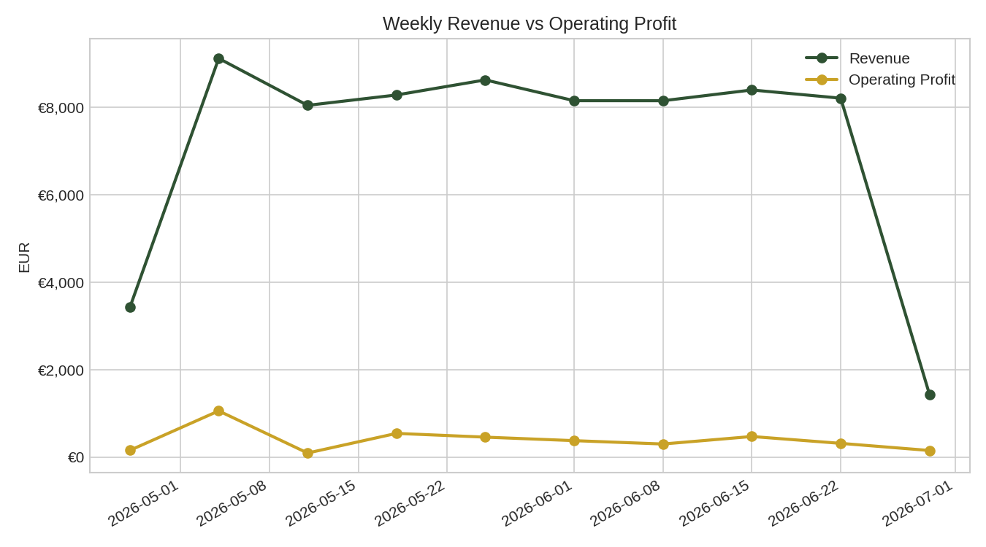
Figure 1: Weekly Revenue vs. Operating Profit
6.2 Menu Item Profitability
Gross margins across the menu ranged from 62.2% (Salmon Poke Bowl) to 81.0% (Sparkling Water), with bowls and wraps the highest-volume items sitting in the 62-70% range. The Chicken Teriyaki Bowl was the single largest contributor to total gross profit (€10,892.65, 23% of total revenue), driven by volume rather than margin. The Salmon Poke Bowl, despite a premium price point, had the thinnest margin of any item, suggesting its ingredient cost (salmon) is eating into profitability more than its pricing accounts for.
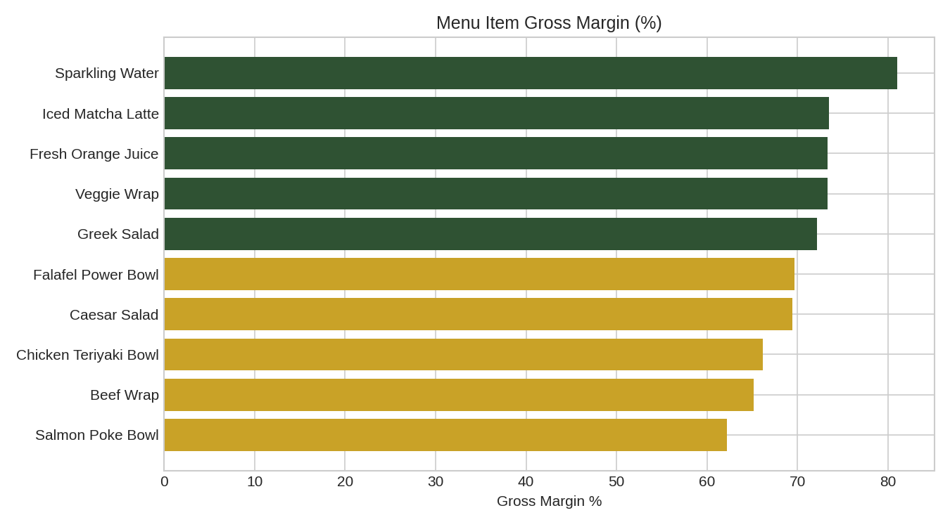
Figure 2: Gross Margin % by Menu Item
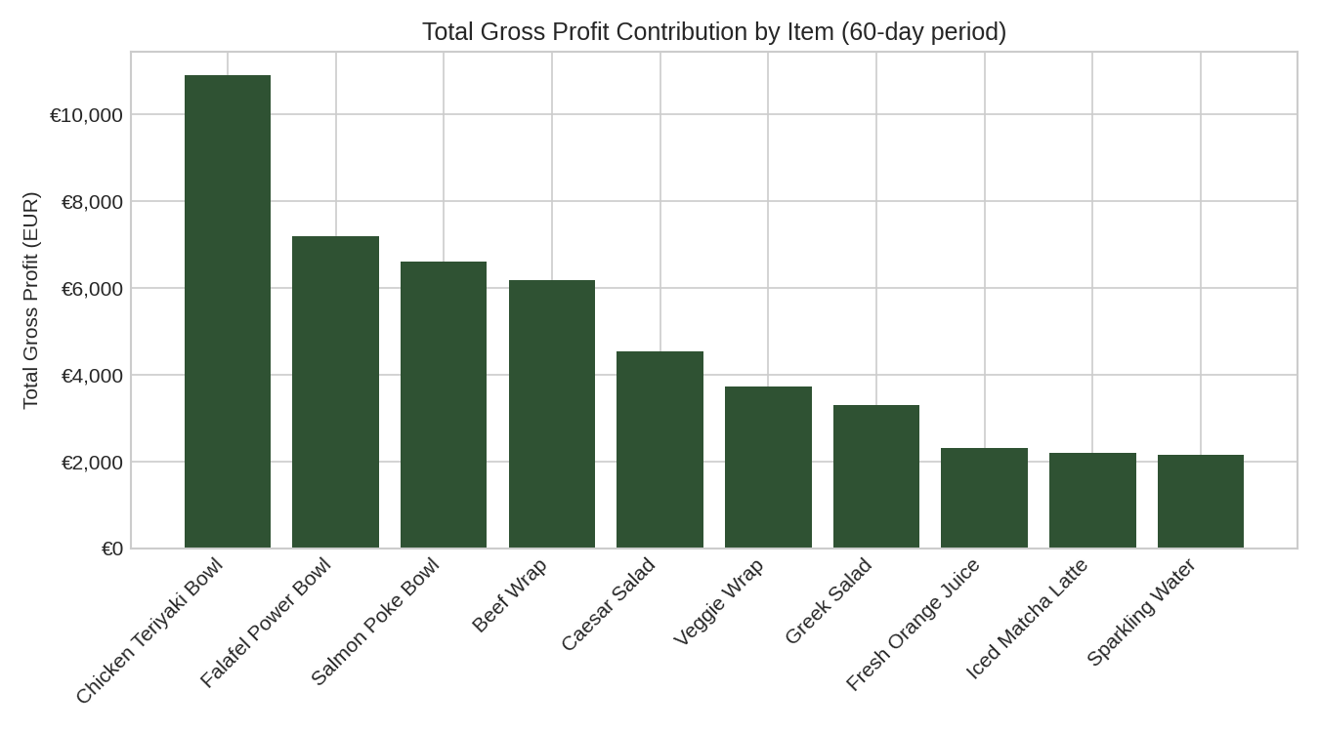
Figure 3: Total Gross Profit Contribution by Item
Full item-level breakdown:
Item | Units Sold | Revenue (€) | Gross Profit (€) | Margin %
Chicken Teriyaki Bowl | 1,663 | 16,463.70 | 10,892.65 | 66.2%
Falafel Power Bowl | 1,160 | 10,324.00 | 7,192.00 | 69.7%
Salmon Poke Bowl | 892 | 10,614.80 | 6,600.80 | 62.2%
Beef Wrap | 1,065 | 9,478.50 | 6,177.00 | 65.2%
Caesar Salad | 769 | 6,536.50 | 4,537.10 | 69.4%
Veggie Wrap | 678 | 5,085.00 | 3,729.00 | 73.3%
Greek Salad | 580 | 4,582.00 | 3,306.00 | 72.2%
Fresh Orange Juice | 698 | 3,141.00 | 2,303.40 | 73.3%
Iced Matcha Latte | 608 | 2,979.20 | 2,188.80 | 73.5%
Sparkling Water | 916 | 2,656.40 | 2,152.60 | 81.0%

6.3 Labor Cost Efficiency
Labor cost averaged 46.7% of revenue across the period significantly above the ~30% guideline commonly used as a healthy benchmark for fast casual restaurant formats. The week of 11 May 2026 was the worst point in the sample, with labor reaching 48.8% of that week's revenue. This is the single largest driver of the gap between strong gross margins (68.3%) and thin operating margins (2.7%), and is the top priority area for management attention.
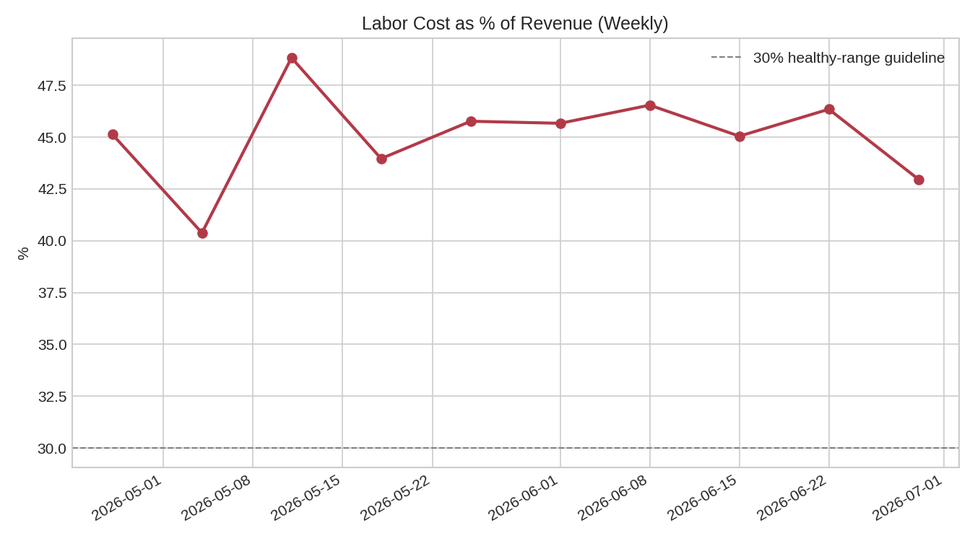
Figure 4: Labor Cost as % of Revenue (Weekly)
6.4 Demand Patterns by Day of Week
Friday was consistently the highest-revenue day (€1,300 average), while Saturday was the lowest (€728 average) despite typically being adequately staffed. This mismatch comparing this demand curve against the labor schedule suggests staffing levels on Saturdays may be higher than warranted by actual footfall, compounding the labor-cost issue identified in 6.3.
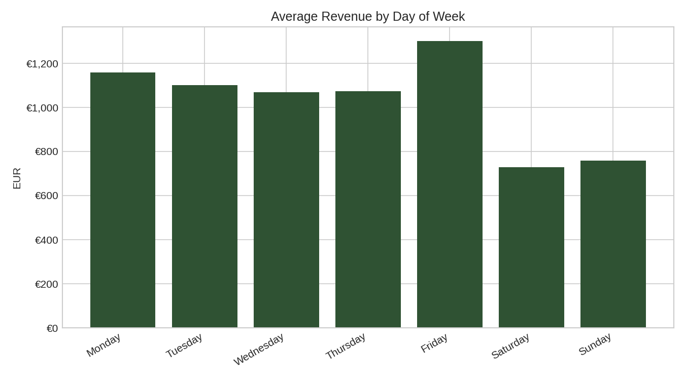
Figure 5: Average Revenue by Day of Week
7. Recommendations
- Review Saturday staffing levels against actual demand the current schedule appears misaligned with the lowest revenue day of the week.
- Investigate the Salmon Poke Bowl's cost structure or consider a modest price adjustment, given it has the lowest margin despite a premium price point.
- Set a labor cost to revenue target (e.g., 30-35%) and track it weekly using the dashboard built for this project, rather than reviewing it only at month end.
- Use the weekday demand pattern to inform shift planning shift some labor hours from Saturday toward Friday where demand is highest.
- Extend the analysis with a break even calculation (units/day needed to cover fixed and labor costs) once real data is available.
8. Limitations
- All figures in this report are based on synthetic sample data structured to resemble real restaurant operations they do not reflect actual Dean & David financial performance.
- Overhead costs are allocated evenly across days as an illustrative assumption real overhead timing (e.g., seasonal utility spikes) would shift results.
- The 60 day window means the first and last partial weeks in weekly rollups are not full 7-day periods.
- Waste, spoilage and discounting are not modeled in this version.
9. Conclusion
This project demonstrates a complete, reusable analytics workflow from raw operational data to a working P&L model, visual analysis and an interactive dashboard built specifically around the structure of a real restaurant business. The core finding, that strong gross margins are being eroded by high labor costs relative to revenue, is exactly the kind of actionable insight this type of analysis is meant to surface. The pipeline is designed so that if real data becomes available from Dean & David it can be substituted directly with no changes to the underlying code.
10. Project Resources
- Full source code, data and interactive dashboard: published on GitHub (see repository: dean-david-pl-analysis).
- Tech stack: Python, pandas, matplotlib, Streamlit, Plotly.
- To reproduce: clone the repository, run `pip install -r requirements.txt`, then `python src/run_analysis.py` for the static report or `streamlit run dashboard/app.py` for the interactive dashboard.

