**Part 3:**

What is GitHub? When was it created? Why? By who? What similar platforms exist? Why would you use such a platform?

**Answer:**

GitHub is a development platform for version control and collaboration. You can host code and work with others together on projects from anywhere by using it. It provides access control and several collaboration features such as bug tracking, feature requests, task management, and wikis for every project.

GitHub was created in April 2008 by Tom Preston-Werner. He is known for his role as founder and former CEO of GitHub, a Git repository web-based hosting service, which he co-founded in 2008 with Chris Wanstrath and PJ Hyett.

The similar platforms are: Bitbucket, GitLab, SourceForge, Gogs, and Launchpad.

I used GitHub because it is the largest online storage space of collaborative works in the world. It offers all of the distributed version control and source code management functionality of Git as well as adding its own features.

**Part 4:**

Go through the Git tutorial here: https://try.github.io. While doing the tutorial, save your work the LastnameFirstnameGitTutorial-mm-dd-yyyy.docx file.

**Answer:**

$ git init

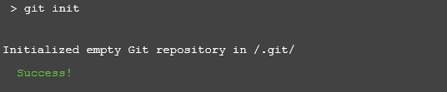

$ git status

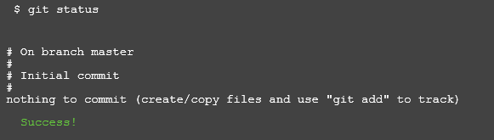

$ git add octocat.txt

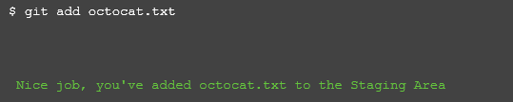

$ git status

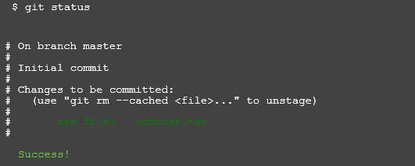

$ git commit –m “Add cute octocat story”

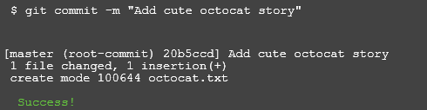

$ git add '*.txt'

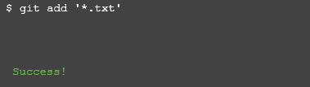

$ git commit -m 'Add all the octocat txt files'

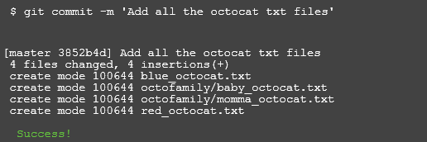

$ git log

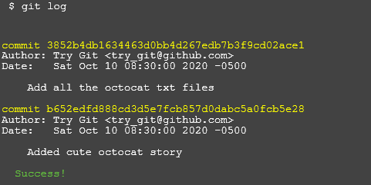

$ git remote add origin https://github.com/try-git/try_git.git

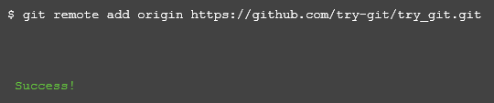

$ git push -u origin master

$ git pull origin master

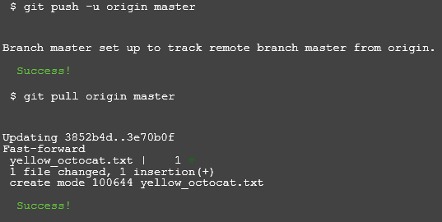

$ git diff HEAD

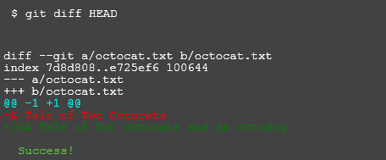

$ git add octofamily/octodog.txt

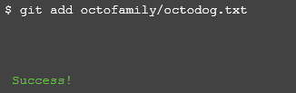

$ git diff –staged

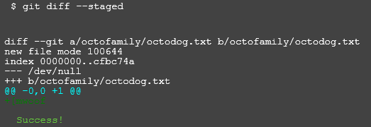

$ git reset octofamily/octodog.txt

$ git checkout -- octocat.txt

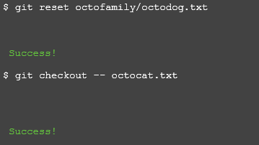

$ git branch clean_up

$ git checkout clean_up

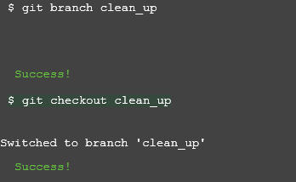

$ git rm '*.txt'

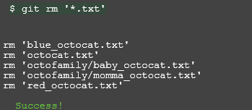

$ git commit -m "Remove all the cats"

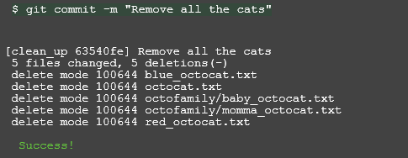

$ git checkout master

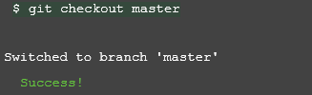

$ git merge clean_up

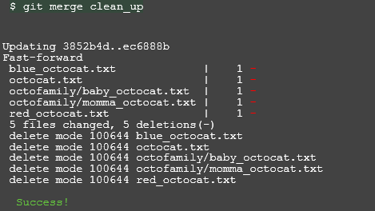

$ git branch -d clean_up

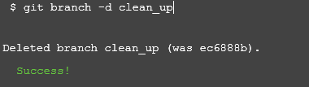

$ git push

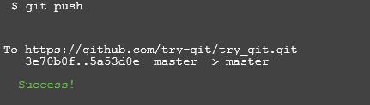

END

**Part 5:**

Define the following terms in the context of Git (2 lines maximum)

**Answer:**

•**Repository**: A repository is a place where the history of your work is stored. It can contain folders and files, images, and data sets – anything your project needs.

•**Commit**: A commit, is an individual change to a file (or set of files).

•**Push**: Pushing refers to sending your committed changes to a remote repository, such as a repository hosted on GitHub.

•**Branch**: Branching is the way to work on different versions of a repository at one time.

•**Fork**: A fork is a personal copy of another user's repository that lives on your account.

•**Merge**: Merging takes the changes from one branch (in the same repository or from a fork), and applies them into another.

•**Clone**: A clone is a copy of a repository that lives on your computer instead of on a website's server somewhere, or the act of making that copy.

•**Pull**: Pull refers to when you are fetching in changes and merging them.

•**Pull request**: Pull requests are proposed changes to a repository submitted by a user and accepted or rejected by a repository's collaborators.

**Part 7:**

List the commands and strategy you use to do this part of the exercise in the LastnameFirstnameGitTutorial-mm-dd-yyyy.docx file and push it to: <https://github.com/yourpseudo/CSXXX20XX>.

**Answer:**

Step1: Log in the website: https://github.com/paceuniversity/courses and click the README.md file

Step2: Click the pencil icon to edit the README.md file by adding name, date and time.

Step3: Click create pull request and give your pull request a title and a comment.