3) Screenshots of the relevance packets from Wireshark+ from VScode terminal

3.1)
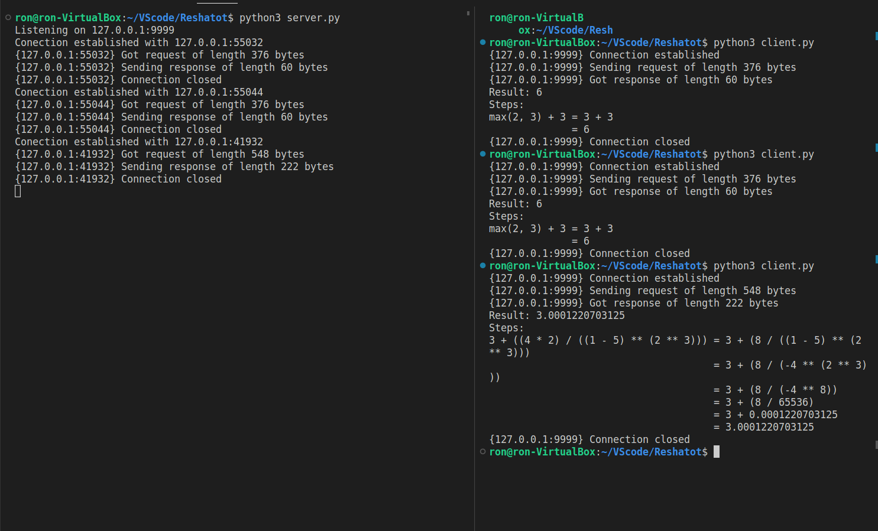
here we can see the VScode terminal where we asked the server twice the same request and then different one.
We got two terminals, one for the server (left) and one for the client (right).
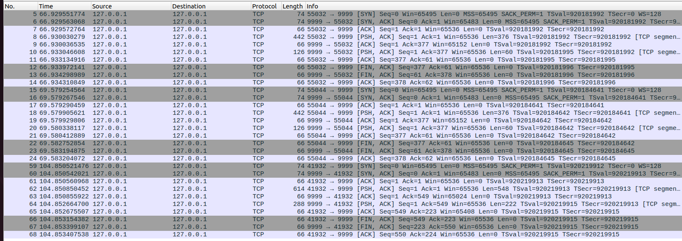
3.1) Here we can see Screenshot from the Wireshark
every "SYN" represent the connection attemped to be
and "FIN" when the connection ends. We have here 3 SYN for every request sent by the clieant and 3 FIN when the connections end
the lines that marked grey.

3.2)

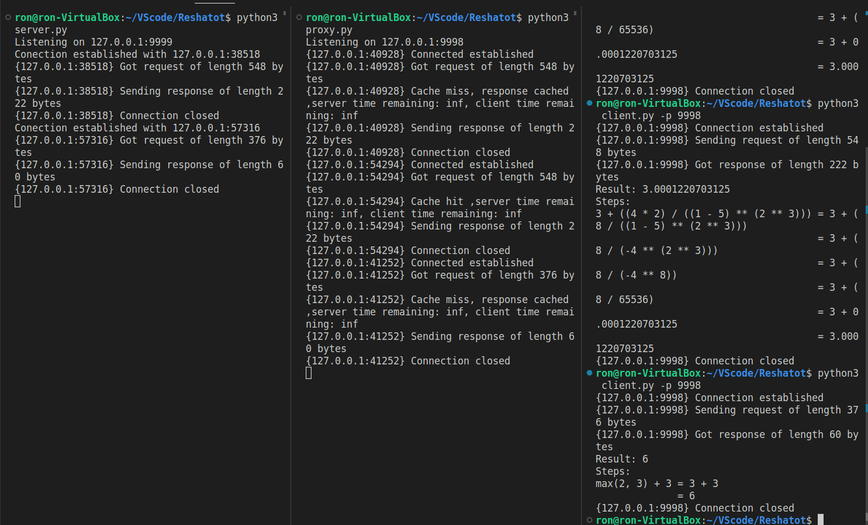
Here we can see the VScode terminals Screenshot -
left – server, midian- proxy, right- client.
We sent the same request twice then a diffrenet one,
a)first the answer hasn’t been in the proxy, that is why we got our first miss.
The proxy sends the request to the server gets the answer and keeps it in his cache.
b)Then we sent the seconed request, same as the first one, now the proxy has it in his cache so he doesn’t need to ask the server for the answer and just give it to the client, that is why we got "hit" by the proxy.
c) Here we sent different request to the proxy, the proxy has not have the answer so we enter the same proccess as the first request we sent (a)

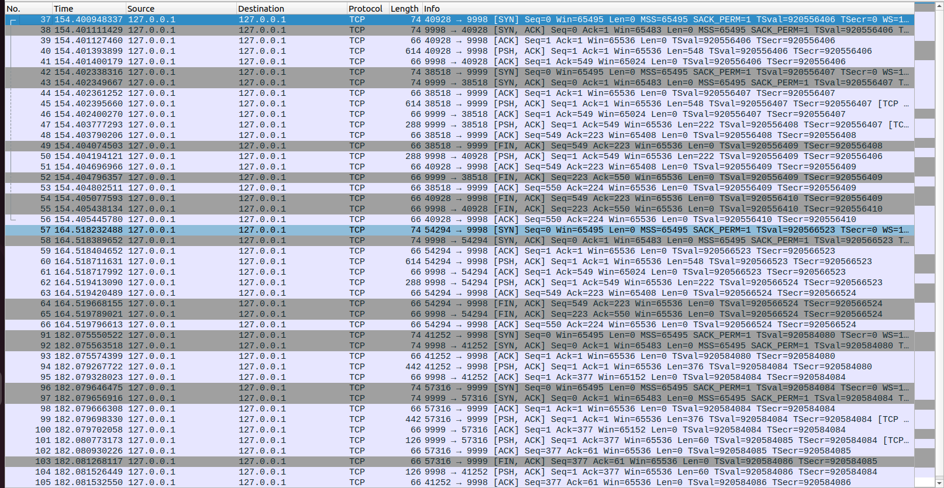
That is the Wireshark screenshots for 3.2:
in lines 37-56 we can see the connection made between the client to the proxy then the proxy to the server.
Port 9998 is for the proxy and port 9999 for the server.
Line 57-66 we don’t have a reminder for port 9999, the server, because the proxy already has the answer for the request from the client.
Line 91+ we have the third request, this time a different one so the proxy dont have the answer to it that is why the server port 9999 gets involved, sending the answer to the proxy and the proxy back to the client.

3.3)

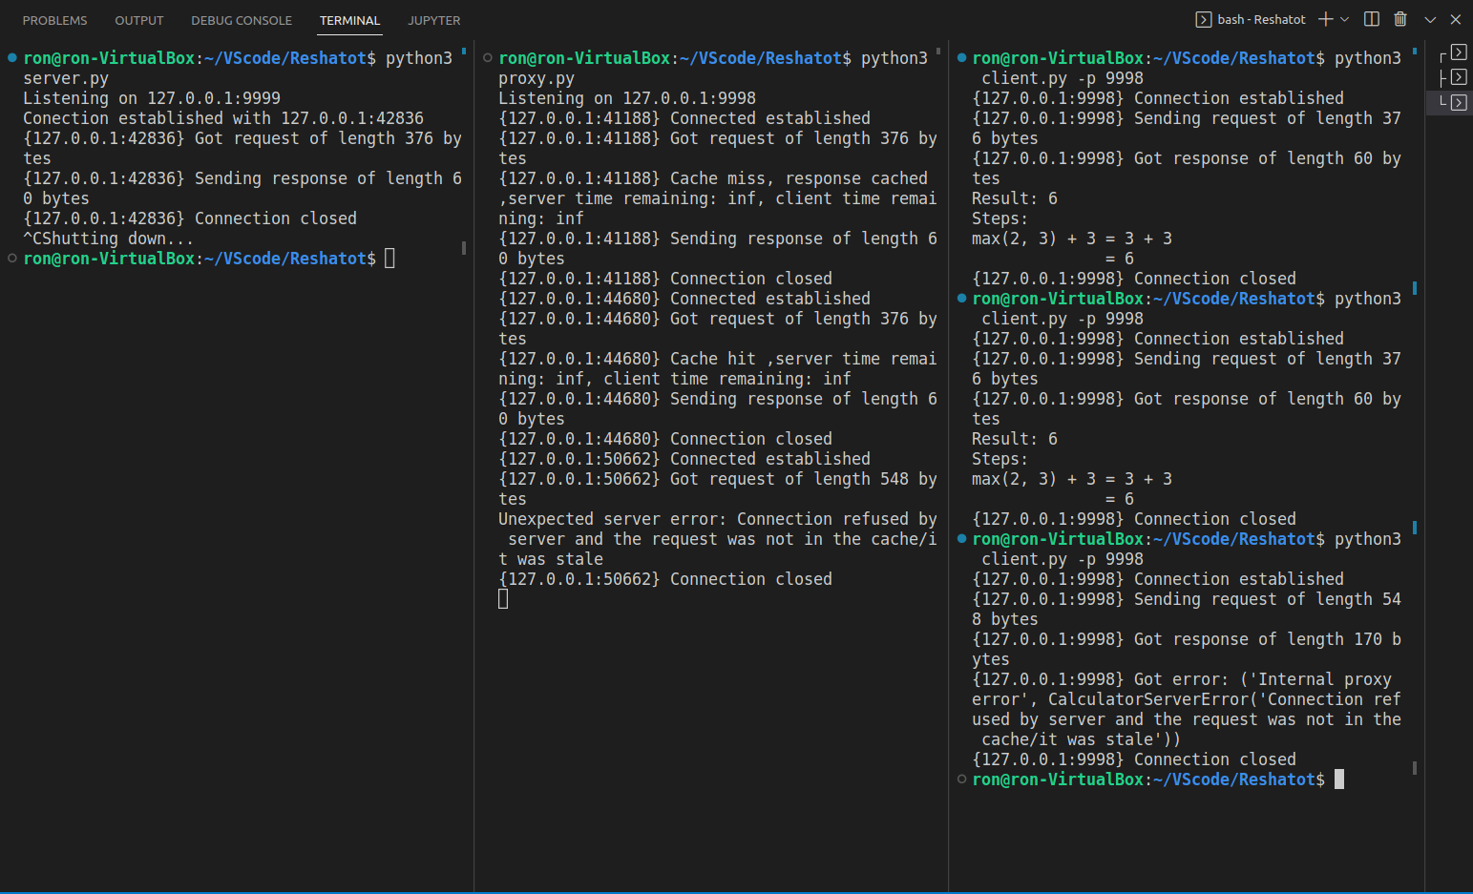
Here we have again 3 terminal server,proxy and client
this time we sent request then close the server then we sent the same request and another different one.
As we can see first we had a proxy cache miss -> the proxy connected to server for the answer -> proxy now has the answer in his cache and deliver it to the client.
The close server is not intterapting the seconed request (that is the same as the first) because the proxy has it in his cache but the third different request make a problem because the proxy doesn’t have it and tries to connect to the server for the answer but he get "error" because the server is close.

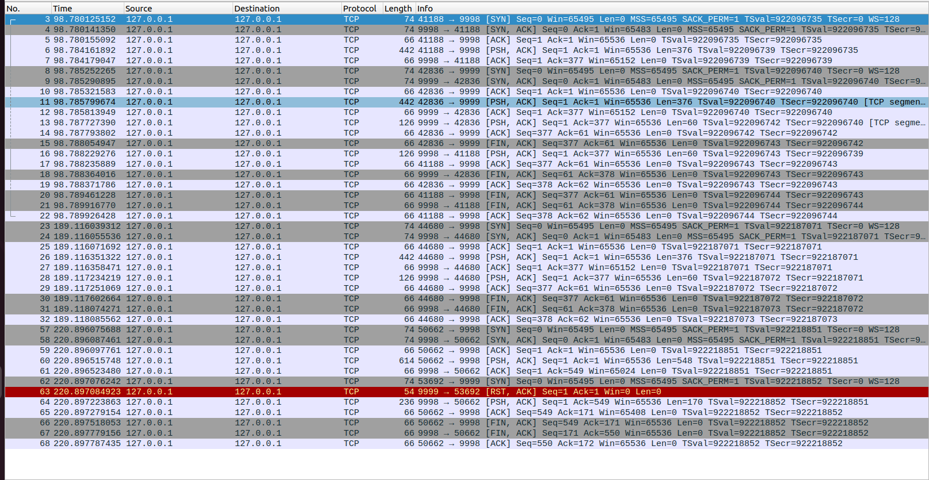
We can see in the red line the error when the proxy tries to connect to the server but gets denied end sending the error to the client.

