**Case Study 1**

Task 1:

import xlrd

import xlwt

import datetime

def combine_sheets(excel_path,sv_path):

1)

# read excel

workbook = xlrd.open_workbook(excel_path) //new excel

new_workbook = xlwt.Workbook()

new_sheet = new_workbook.add_sheet(u'Combine', cell_overwrite_ok=True)

style = xlwt.XFStyle()// convert integer to date

# count quarters

quarter_count = {'quarter1':0,'quarter2':0,'quarter3':0,'quarter4':0}

# num of sheets

sheet_names = workbook.sheet_names()

start_row = 0

for sheet_name in sheet_names:

sheet = workbook.sheet_by_name(sheet_name)

# num of rows

n_rows = sheet.nrows

for j in range(n_rows):

row = sheet.row_values(j)

# add one more col to header

if sheet_name == 'Compliants_Details':

if j==0:

row.append('Quarter')

else:

quarter = season_filter(row[2])

quarter_count[quarter]+=1

row.append(quarter)

print(row)

#columns K

for k in range(len(row)):

if sheet_name == 'Compliants_Details' and (k==2 or k==11):

style.num_format_str = 'YY/M/D'

new_sheet.write(start_row+j, k, row[k],style)

else:

new_sheet.write(start_row + j, k, row[k])

start_row+=n_rows+3

# add a new table counter_count

for n,quarter in enumerate(quarter_count.keys()):

new_sheet.write(start_row + n, 0, quarter)

new_sheet.write(start_row+n,1,quarter_count[quarter])

new_workbook.save(sv_path)

# "Quarter"

# nov'17 to jan'18 - quarter1;

# feb'18 to apr'18 - quarter2;

# may'18 to july'18 - quarter3;

# aug'18 to oct'18 - quarter4

def int2date(dates):

delta=datetime.timedelta(days=dates)

today=datetime.datetime.strptime('1899-12-30','%Y-%m-%d')+delta

return today.date()

def season_filter(num):

date = int2date(num)

year = date.year

# determine time for the season

if date < datetime.date(year,1,18):

return 'quarter1'

elif date > datetime.date(year,11,17):

return 'quarter1'

elif datetime.date(year,2,18) < date < datetime.date(year,4,18):

return 'quarter2'

elif datetime.date(year, 5, 17) < date < datetime.date(year, 7, 18):

return 'quarter3'

else:

return 'quarter4'

excel_path = '/Users/welcomemymaster/Desktop/tmp/Dataset 1.xlsx'

sv_path = '/Users/ welcomemymaster /Desktop/tmp/combine.xls'

combine_sheets(excel_path,sv_path)

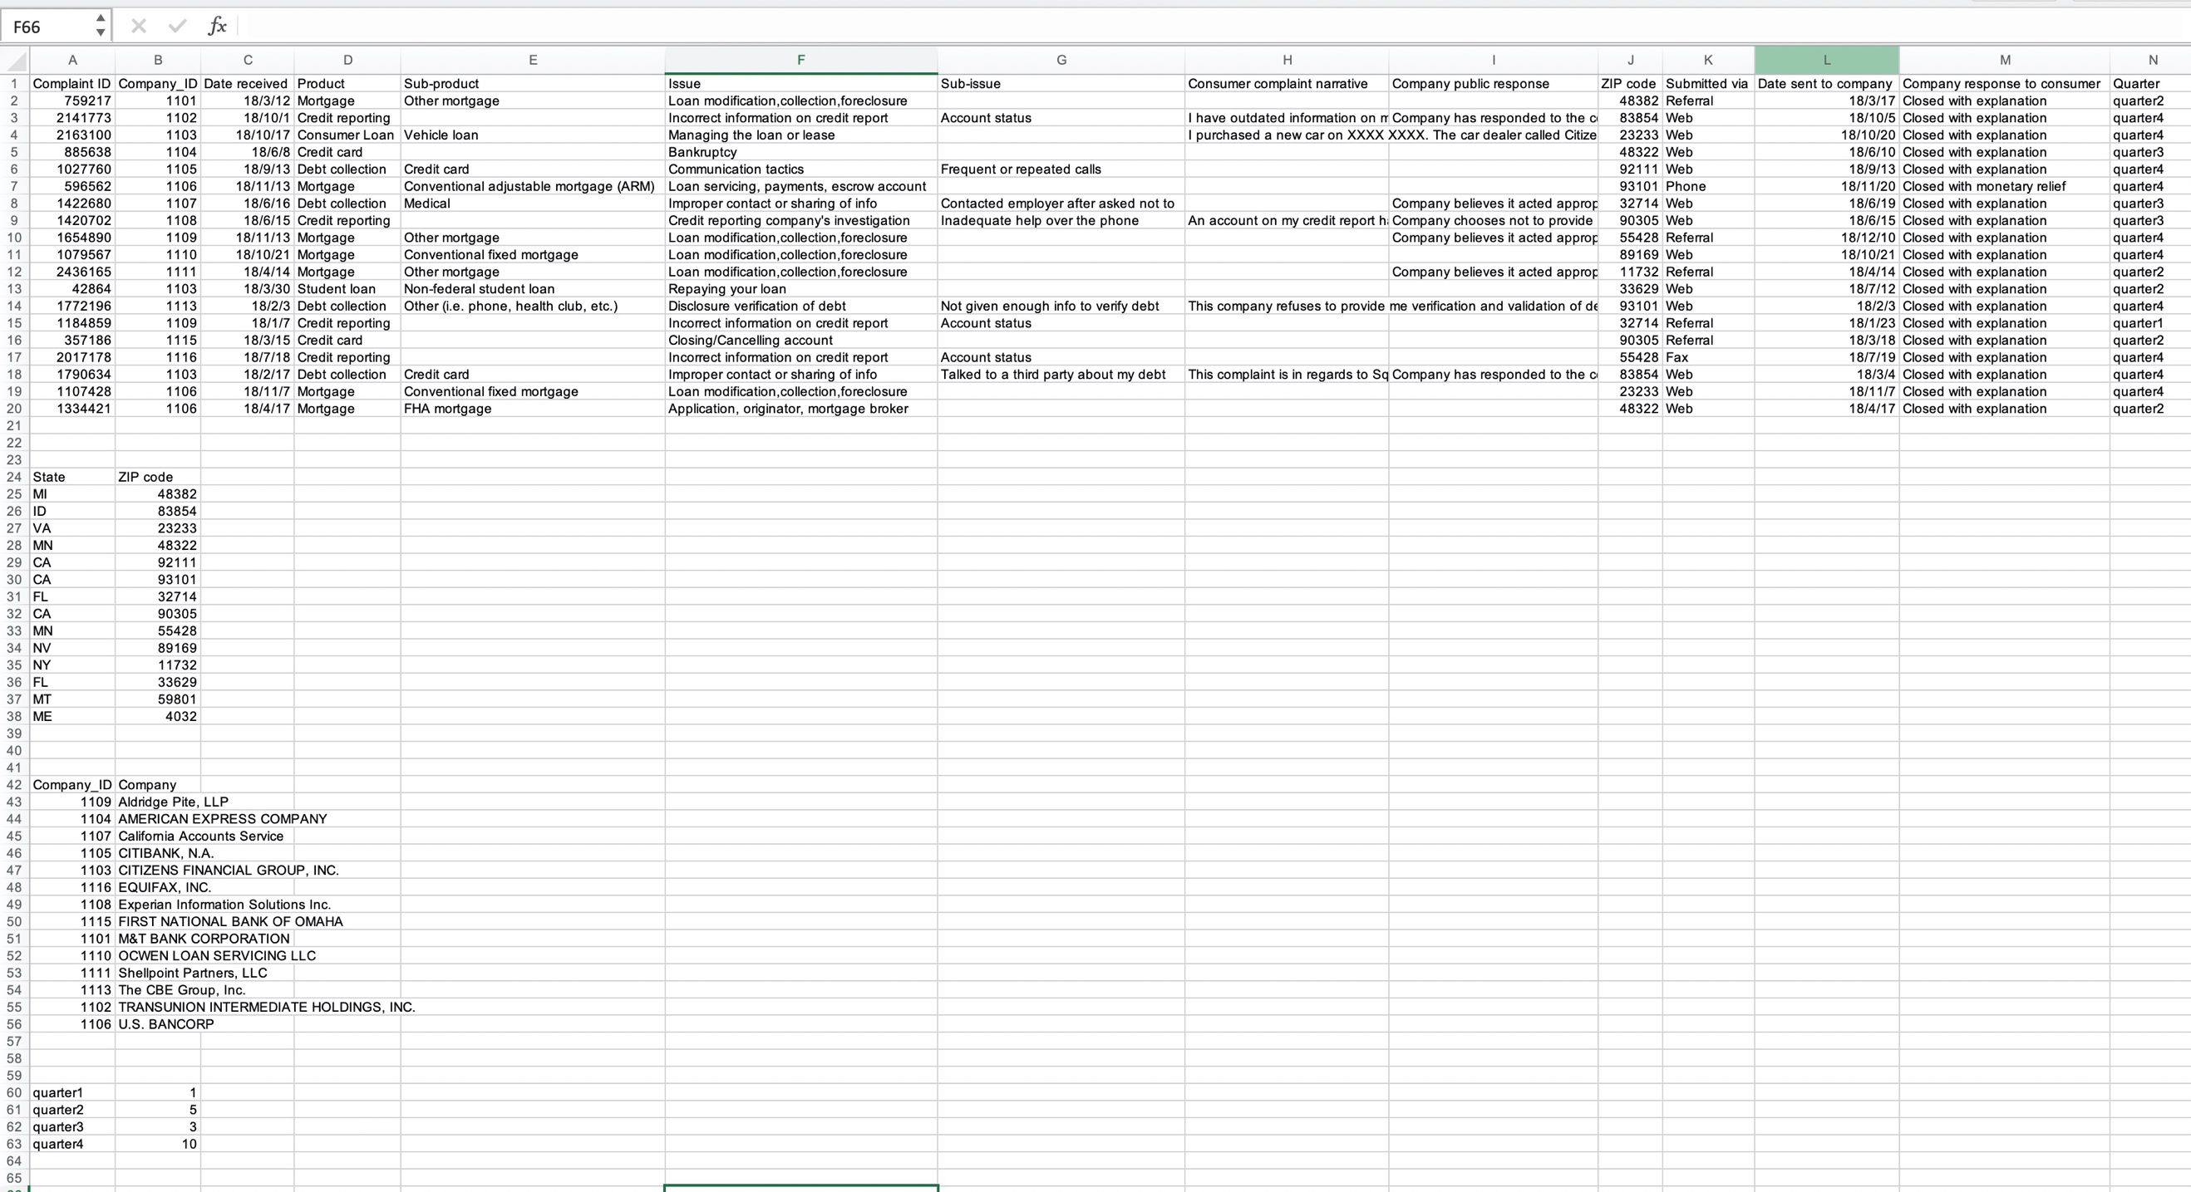

Task 2:

1)

CREATE Tab_4 AS (

SELECT *

FROM Compliants_Details

LEFT JOIN Locations_Details

ON Compliants_Details.ZIP code = Locations_Details. ZIP code

LEFT JOIN Company_Details

ON Compliants_Details .Company_ID = Company_Details. Company_ID);

2)

SELECT

Date received AS DATE_RECEIVED,

SUM(Complaint ID) AS COMPLAINTS_NO

FROM

Tab_4

WHERE year(DATE_RECEIVED) = 2018

GROUP BY

month(DATE_RECEIVED);

Task3: