Specification for National Climate Monitoring Products
Version: 0.6
Authors: John Kennedy, Lucie Vincent, Ladislaus Chang’a, Jessica Blunden, Karl Braganza, Ayako Takeuchi, Andrea Malheiros Ramos, Peer Hechler, Fatima Driouech
Date: 21 September 2015
Change history:
Version 0.1: initiation of skeleton guidance document
Version 0.2: original documents split into five separate documents one for each of the first five NCMPs. March 2015
Version 0.3: NCMPs consolidated in single document with common elements extracted for clarity and to avoid duplication 7 September 2015
Version 0.4: additional text
Version 0.5: incorporating comments from day 1 of meeting
Version 0.6: incorporating improved definitions of NCMPs and additional comments on structure and content from the face to face meeting.

Contents
One page summary 4
1 Introduction and context 5
1.1 NCMP 1: Mean Temperature 5
1.2 NCMP 2: percentage rainfall. 5
1.3 NCMP 3: standardized precipitation index 6
1.4 NCMP 4: warm days 6
1.5 NCMP 5: cold nights 6
1.6 NCMP 6: extremes of temperature and precipitation 6
1.7 Choice of base period 7
1.8 Limitations and strengths of NCMPs 7
1.9 Uncertainty of NCMPs 8
1.10 Homogenisation 8
2 Generating the products 9
2.1 Quality control and homogenisation 9
2.2 Generate the indices 10
2.2.1 Monthly mean temperature anomaly 10
2.2.2 Monthly percentage rainfall 10
2.2.3 Standardised Precipitation Index 10
2.2.4 Warm days 11
2.2.5 Cold nights 11
2.3 Calculating a variogram 12
2.3.1 Method for calculating the variogram 13
2.3.2 Suitable functional forms for the variogram 14
2.4 Interpolating the data 14
2.4.1 Method for interpolating the data 14
2.4.2 Ordinary Kriging Method 15
2.5 Averaging the index 15
2.6 Output of the NCMP 16
2.7 NCMP 6: extremes of temperature and precipitation 16
2.8 Monthly and annual updates 16
2.8.1 Monthly updates 16
2.8.2 Annual updates 16
2.8.3 Irregular updates 16
3 Dissemination 16
3.1 Data to be transmitted 17
3.1.1 Auxiliary data 17
3.2 Dissemination via focal points 17
3.3 Dissemination via BUFR message 18
3.4 Dissemination via the web 18
Appendix A: Ordinary Kriging 19

One page summary
National climate monitoring products are a simple summary of the weather and climate conditions in a particular country. They are routinely used in some countries to monitor the changing climate with interest from policymakers, scientists and the general public. NCMPs are also routinely used in reports that summarise global climate such as those produced annually by the WMO and thus attract global interest from a wide variety of people.
The six NCMPs defined in this guidance will provide a consistent basic set of NCMPs which can be used to generate regional and global syntheses as well as helping to track the change and variability in the climate of each country that produces them.
The first two NCMPs measure anomalies of mean temperature and precipitation. These give an idea of the change in average temperature and rainfall. The next three are SPI, which can describe drought and other extremes of precipitation in a standard way, and the numbers of very warm days and very cold nights, which can capture moderate extremes of temperature. Each of these five NCMPs is presented as an average across the whole country. The sixth NCMP is intended to alert people to extremes of temperature and precipitation, indicating when records of temperature or precipitation have been broken at individual stations.
The detailed guidance describes precisely how each of these is defined and provides a method for calculating them as well as some background information needed to understand what each NCMP represents and what it does not.

1 Introduction and context
Due to the impact of current climate conditions on society and ecosystems, a variety of climate monitoring products have been created by countries around the world at different spatial and temporal scales. National Climate Monitoring Products (NCMPs) are specifically those products that summarise climate conditions at a national scale.
NCMPs are useful within a country, raising awareness and understanding of the effects of climate variability and change, as well as the importance of national monitoring networks and services. At an international level, they aid the synthesis of national information to provide a broad, global view of climate variability and change. Such summaries are routinely published in high-profile publications like the WMO Annual Statement on the Status of Global Climate and the Bulletin of the American Meteorological Society’s Annual State of the Climate reports.
Currently, a wide variety of climate monitoring products are produced around the world and there are many inconsistencies between the methods used by different countries. Inconsistencies make comparisons between these products difficult or impossible, and limit their usefulness.
The aim of this document, which is the result of the work of the Task Team and expert Team on NCMPs, is to describe, motivate and define a short list of standard NCMPs that can be produced consistently and easily by most countries. By having a clearly defined short list, it should be possible for countries to focus their efforts on a small number of products which have wide applicability and interest.
The following sub-sections describe the individual NCMPs that the group has developed and some of the background to that decision.

1.1 NCMP 1: Mean Temperature
NCMP 1 is mean temperature. This is a simple measure of the country-average temperature anomaly for the month, which can be easily converted to give an average temperature anomaly for the year, or any other period. Mean temperature is a standard metric used to monitor climate change and is widely used in monitoring reports. It is a measure of overall warmth or cold, but does not distinguish between high maximum temperatures and high minimum temperatures which can have different impacts. The variability of mean temperature anomalies will vary from place to place and, in some places, from season to season.

1.2 NCMP 2: percentage rainfall.
NCMP 2 is percentage of normal rainfall. This is a measure of the country-average of station rainfall anomalies expressed as a percentage of the base-period average for the month. Precipitation percentage is a standard metric used to monitor climate change. In areas where average rainfall is low, large percentages can be recorded at individual stations which are not representative of wider areas. Although the technique use to interpolate the data partly accounts for this, in countries with limited measuring networks, there could be problems. These are partly offset by also including the average anomaly (in mm) within the NCMP report.

1.3 NCMP 3: standardized precipitation index
NCMP 3 is standardized precipitation index. This is a measure of the country-average standardized rainfall anomaly. SPI is a standard metric used to monitor rainfall and drought. Because SPI is adapted to the climatic conditions at a particular station, it is a way of comparing stations from different climatic zones within a country and between countries where the mean and variability of rainfall might differ substantially. For example, an SPI of 2 or higher indicates the kind of rainfall that occurs around 5% of the time.

1.4 NCMP 4: warm days
NCMP 4 is the warm-days index. This is a measure of the country-average number of days that exceeded the 90th percentile of the base period distribution for maximum temperatures. The number of warm days is one of the standard ETCCDI indices and has been widely used. It gives a measure of warm spells and heat waves that is relevant to the climatic conditions at each station and is a way of comparing stations from different climatic zones within a country.
This NCMP is intended to capture some information about moderate extreme events, over wide areas. It is more stable than other more extreme extreme indices, such as the highest temperature recorded in a month (Txx) and unlike the Warm Spell Duration Index (WSDI) it is not affected by ambiguity concerning which month a prolonged event should be attributed to.

1.5 NCMP 5: cold nights
NCMP 5 is the cold-nights index. This is a measure of the country-average number of days that fell below the 10th percentile of the base period distribution. Cold nights is one of the standard ETCCDI indices and has been widely used. It gives a measure of cold spells and cold waves that is relevant to the climatic conditions at each station and is a way of comparing stations from different climatic zones within a country.
As with NCMP4, This NCMP is intended to capture some information about moderate extreme events, over wide areas. It is more stable than other more extreme extreme indices, such as the lowest temperature recorded in a month (Tnn) and unlike the Cold Spell Duration Index (CSDI) it is not affected by ambiguity concerning which month a prolonged event should be attributed to.

1.6 NCMP 6: extremes of temperature and precipitation
This product gives a simple count of the number of stations which reported record daily maximum temperature, minimum temperature and precipitation. The aim is to flag extreme events.

1.7 Choice of base period
The base period for calculating the normals used to define anomalies, calculate percentiles and standardise the data is an important consideration for the NCMPs. The WMO guidelines suggest a dual normal approach with 1961-1990 used as a fixed period for climate change studies and a rolling 30-year period, updated every ten years for climate monitoring. The current monitoring normal is 1981-2010.
For NCMPs there is a difficult choice to be made. Using 1961-1990 could maximise the use of long station records, but could reduce the number of stations available for monthly updates as these might have closed since 1990. On the other hand, a more modern period like 1981-2010 would maximise the number of currently operating stations at the possible expense of long station records. The trade off between length of record and the accuracy of the monthly updates of NCMPs (which is related to the number of stations available in the calculation) is not an easy one.
On balance, the 1981-2010 period seems more appropriate. NCMPs are monitoring products and using a modern baseline will improve the accuracy of the current estimates. The context of a long series is incredibly useful, but a context is worthless without something to put in it. By emphasising the importance of long series, countries might be encouraged to digitise a greater number of historical records. 1981-2010 is also favoured in many climate service applications, which might encourage the broader take up and use of NCMPs.

1.8 Limitations and strengths of NCMPs
By providing country level information, NCMPs have some obvious weaknesses, limitations and strengths. The most obvious is that a country is not an obvious climatic unit. Climates can vary within a country sometimes to a very great extent. Thus, some local information will be lost in calculating NCMPs. Balanced against this is the fact that NCMPs by averaging out local variations in temperature and precipitation will make other, more subtle, chances evident. Long, historical records, which provide context for current conditions, are important for understanding these changes .
While a country is not a coherent climatic unit, it is a coherent psychological one. People from across society are used to thinking at this level for many other things: GDP, crop production, population changes, and other indicators are routinely calculated and discussed at this level.
Care must be taken when comparing an NCMP to output from a climate model. It is necessary to consider whether the thing measured is exactly comparable to the thing modelled. Differences can arise when the order of aggregation is rearranged and these differences can be marked if the indices are calculated before the gridding, rather than after.
The choice of some of the NCMPs was guided by a desire to build on existing effective initiatives for standardising climate data analysis. The Expert Team on Climate Change Detection and Indices (ETCCDI) has compiled a list of standard measures of climate extremes along with software to produce them. They have organised and run successful workshops across the world, training a wide range of scientists and other technical workers to produce the indices. The ET-NCMP seeks to use the existing software infrastructure and knowledge in developing the NCMPs with an eye to facilitating their production and also as a possible route to regular updates of the ETCCDI indices.

1.9 Uncertainty of NCMPs
Uncertainty has not been explicitly addressed in what follows. All indices are however subject to errors that arises from many sources, including undetected errors in the data, measurement limitations (for example, where data are rounded to the nearest whole degree), unidentified station moves or instrumentation changes, software errors, limitations of the interpolation techniques, poorly specified statistical models, ambiguities in the definitions, poor station siting, etc.
Various strategies are possible for assessing uncertainty in NCMPs some of which are described briefly here. Sensitivity to the choice of interpolation method can be tested by using other methods. Uncertainty in the interpolation can also be assessed by separating the stations into two groups, one used for the interpolation, the other to test that the interpolation was effective. The uncertainty of the country-average NCMP can be assessed using “jack knifing” whereby the NCMP is calculated multiple times on different subsamples of the data. The resulting spread of estimates gives an estimate of the uncertainty.
A thorough uncertainty analysis is beyond the scope of this initial guidance, but should be considered in the future.

1.10 Homogenisation
A key difficulty in accurately assessing long term trends is that stations move and instrumentation changes. These changes can affect the estimated long-term trends and the process of reducing their effect is known as homogenisation. Homogenisation is a complex and difficult task and outside of the remit of the ET-NCMP, but consideration of homogenisation is captured in the NCMP using quality flags which indicate whether the stations used have been homogenised.

2 Generating the products
The basic procedure, which is common to the first five NCMPs, is to calculate a set of monthly indices for each station and then interpolate the station values for each month using Ordinary Kriging to get a spatially-complete analysis. The spatially-complete analysis is then averaged across the area covered by the country to calculate the NCMP for that month. In this way, a time series is built up month by month that can be used to monitor the climate and put it in its historical context.
The basic method for the first five NCMPs is
- Quality control the daily temperature and precipitation data (See 2.1 Quality control)
- Generate the indices (See 2.2 Generate the indices)
- Calculate the variogram for each index (See 2.3 Calculating a variogram)
- Interpolate the data for each index (See 2.4 Interpolating the data)
- Average each index across the country (See 2.5 Averaging the index)
- Output the NCMP (See 2.6 Output of the NCMP)
The sixth NCMP is somewhat different and is described in Section 2.7 NCMP 6: extremes of temperature and precipitation.

2.1 Quality control and homogenisation
The aim of quality control is to ensure that stations have sufficient data to calculate the necessary indices and that the data are not contaminated with values that are badly in error. A secondary aim is to identify whether the data have been homogenised and to flag the NCMP accordingly. The basic method is as follows:
- Set the data quality and homogenisation flags to zero for each station.
- Fix the base period (1981-2010)
- Station selection. For each station reject station if:
  - The station has no data in the climatology period
  - the site does not meet WMO standards for station environment.
- Quality control the data: EITHER
  - Do nothing and leave the data quality flag at zero OR
  - If quality checks are performed and bad data set to missing, set the data quality flag to one OR
  - If quality control is performed and bad data are either set to missing, or fixed, set the data quality flag to two.
- Homogenization, for daily data: EITHER
  - Do nothing and leave the homogenisation flag at zero OR
  - reject inhomogeneous sections of station data if necessary and set the homogenisation flag to one OR
  - homogenize the station data and set the homogenisation flag to two. (Reference WMO technical publication 1186)
- Check if stations with rejected data still have data in the climatology period.

2.2 Generate the indices
The indices will form the basis for the next stages. There are five different indices that need to be calculated, which are briefly described in the next subsections. Each of the indices needs to be calculated separately for each station. The calculation of the final three indices (warm days, cold nights and SPI) can be performed using modules from the CLIMDEX and CLIMPACT software packages.

2.2.1 Monthly mean temperature anomaly
The daily mean temperature is defined as the average of the maximum and minimum temperatures for the day. The monthly mean temperature is the average of the daily mean temperatures for that month. A monthly average is calculated if there are fewer than 10% of missing values. A climatological average is calculated for each month. For January, take the average of all monthly mean temperatures for Januarys in the climatology period, 1981-2010. A climatological average is calculated if there are fewer than 10% missing values. The monthly mean temperature anomaly is the difference between the month mean temperature and the climatological average for that month.

2.2.2 Monthly percentage rainfall
The monthly total rainfall for a station is the sum of the daily precipitation totals for that station. The monthly total is calculated if there are fewer than 10% of missing values. A climatological average is calculated for each station for each month. For January, take the average of all monthly total rainfalls for Januarys in the climatology period, 1981-2010. A climatological average is calculated if there are fewer than 10% missing values. If a station has a climatological average precipitation of zero, flag that station. Two distinct anomalies are calculated from the monthly data. (1) The monthly percentage rainfall is the monthly total rainfall divided by the climatological average and multiplied by 100. (2) The monthly precipitation anomaly is the difference between the monthly total rainfall and the climatological average.

2.2.3 Standardised Precipitation Index
The monthly total rainfall is the sum of the daily precipitation totals. 1-month SPI is to be calculated using the method used by the ET-SCI, which is implemented in the following R CRAN package: (https://cran.r-project.org/web/packages/SPEI/index.html).
For each station calculate the monthly precipitation totals then fit a gamma distribution to the monthly precipitation totals for the base period, 1981-2010. This should be done separately for each calendar month. No missing monthly totals are allowed. The fitted distributions can then be used to standardize the monthly precipitation totals.

2.2.4 Warm days
For each station calculate the number of warm days for each month using the ETCCDI method which is described briefly below.

The percentiles of the climatology period are estimated for a five day period centred on each day using the quantile function in R, set to type=8 (https://stat.ethz.ch/R-manual/R-devel/library/stats/html/quantile.html). A maximum of 10% missing days are allowed for this calculation.

Computation of the index outside of the base period involves comparing the temperature data for each day with the corresponding percentiles for a 5 day running window surrounding that day. The resulting monthly series is then the monthly number of days that meet the criteria

Computation of the index inside the base period is more complicated. It involves comparison of the daily temperature data with the corresponding day of temperature data in each of (n - 1) sets of data. The sets consist of the data for the base period with the current year replaced with each of the other years. The results of these comparisons are then averaged giving a number between 0 and 1 for each day. Finally, the resulting daily series is aggregated to a monthly series by summing the daily values.

2.2.5 Cold nights
For each station calculate the number of cold nights for each month using the ETCCDI method.

The percentiles of the climatology period are estimated for a five day period centred on each day using the quantile function in R, set to type=8 (https://stat.ethz.ch/R-manual/R-devel/library/stats/html/quantile.html). A maximum of 10% missing days are allowed for this calculation.

Computation of the index outside of the base period involves comparing the temperature data for each day with the corresponding percentiles for a 5 day running window surrounding that day. The resulting monthly series is then the monthly number of days that meet the criteria

Computation of the number values inside the base period is more complicated. It involves comparison of the daily temperature data with the corresponding day of temperature data in each of (n - 1) sets of data. The sets consist of the data for the base period with the current year replaced with each of the other years. The results of these comparisons are then averaged giving a number between 0 and 1 for each day. Finally, the resulting daily series is aggregated to a monthly series by summing the daily values.

2.3 Calculating a variogram
A variogram describes how much you expect the index (mean temperature anomaly, for example) to change as you move away from a point. It is found by plotting half the squared difference in the index at all pairs of stations as a function of the distance between them. This is called the empirical variogram. It is always positive and is typically small for small separations and larger for large separations, obeying Toblers first law of geography.
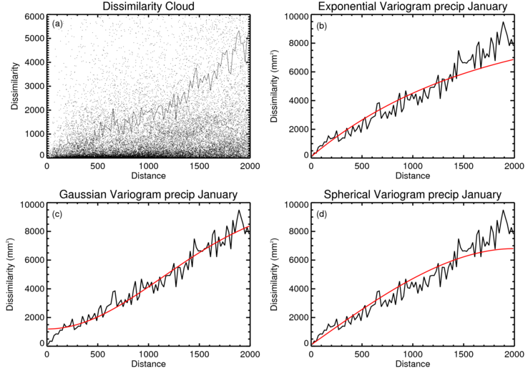
Figure 1: (top left) plot of the dissimilarity (dots) for all pairs of station data for January precipitation for Australia for the period 1961-1990 and the binned empirical variogram (solid line). (other panels) the black line is the empirical variogram and the red lines show three different functional variograms fit to the data.
In order to do the interpolation, we need a function which can be used to give an estimate of what the variogram would be for any separation. This is found by fitting a particular functional variogram model to the empirical variogram.
A separate variogram model will have to be calculated for each index and for each calendar month. A reliable variogram model can only be calculated if there are a more than around 10 stations. Countries with fewer than 10 stations will either have to use a pre-calculated variogram, or use shared data from neighbouring countries.
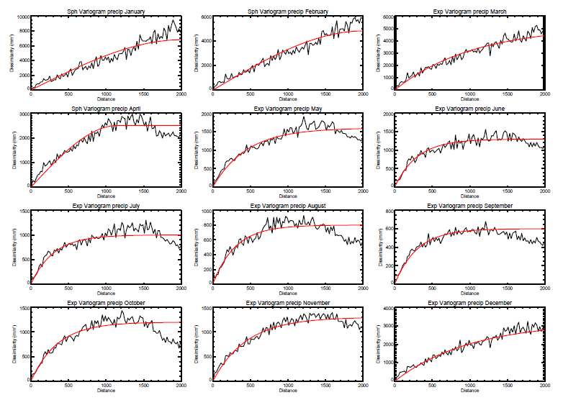
Figure 2: sample variograms for Australian precipitation for each month from January (top left) to December (bottom right). The black line is the empirical variogram. The red line is the functional variogram The average difference is small for small separations and increases as the separation of the stations increases.

2.3.1 Method for calculating the variogram
- Read in the index for all 30 Januarys and for all n stations in the base period (1981-2010).
- For each January and each pair of stations, calculate the squared difference in the index reported at each station and the distance between the stations. There should be at most 30*(n²-n) difference/distance pairs.
- Choose a maximum separation for the empirical variogram. Typically, the smaller of the maximum separation of the stations that are being used to calculate the variogram, or around 2000km for precipitation and 3000 km for temperature are good first guesses.
- Sort the difference/distance pairs into bins of equal distance (20km is a reasonable first guess) from zero to the maximum distance. For example, the first “bin” would be from 0-20 km, the second from 20-40 km and so on up to 1980-2000 km.
- In each bin calculate the trimmed mean (Wilcox 2001) of all the squared differences together and divide by two.
- Plot the empirical variogram. At this point, it might be necessary to adjust the maximum distances and bin size and repeat (c) and (d) until the variogram looks “sensible”. Sensible means that it rises steadily to a maximum value and is then more or less constant for larger separations.
- Find a function and parameters that best fits the data (Some suggested functional forms are given in 2.3.2 Suitable functional forms for the variogram). The fit can be done by eye, but it is better to do it by minimizing the summed absolute differences or summed squared differences between the functional form (evaluated at the centre of each bin) and the empirical variogram.
- Repeat (a)-(g) for February, March etc.
- At the end you should have a preferred functional form and parameters for each calendar month that can be used in the interpolation.

2.3.2 Suitable functional forms for the variogram
In each case, h is the distance between two stations. There are three parameters, s,n and r: s is the value of the sill which is the value of the variogram at very large distances; n is the nugget which is the value of the variogram at zero separation; and r is the characteristic length scale of the variogram which defines how quickly the variograms value changes from the nugget to the sill. V is the value of the variogram.
Exponential
V(h) = (s-n)(1 – exp(-h/r)) + n
Spherical
V(h) = (s-n)( 3h/2r – h³/2r³) + n, for h<r
V(h) = s, for h>r
Gaussian
V(h) = (s-n)(1 – exp(-h²/r²a)) + n
Other forms
There are other possible forms for the variogram. Typically, the function needs (1) to increase monotonically with increasing distance, (2) to be constant at very large distances, (3) be positive at all separations.

2.4 Interpolating the data
In order to get an estimate of the average of an index (mean temperature anomaly, for example) across a country, we need to estimate what the index was in the gaps between stations. The method we will use to do this is called Ordinary Kriging. It is a method widely used in geostatistics. The method naturally accounts for the uneven distribution of stations and provides a reasonable, though not perfect, estimate of what the index would be at intermediate locations. Here we will use Ordinary Kriging to estimate the value of the index at points on a regular grid, which covers the country. For a more mathematical description see Appendix A: Ordinary Kriging.
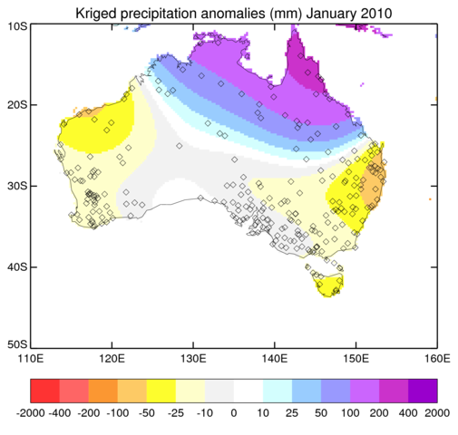
Figure 3: map showing the station locations (black lozenges) for stations in the ACORN data set for January 2010. The coloured areas shown the interpolated precipitation anomalies (mm) calculated using ordinary Kriging. The contours are not smooth as they are represented on a regular latitude-longitude grid with a resolution of approximately 0.1°.

2.4.1 Method for interpolating the data
- Define a regular latitude-longitude grid across the country ensuring that there are sufficient grid cells to resolve the major outline of the country. In order to resolve variability within the country, ensure that there are at least 100 grid boxes in total.
- Read in data for all stations for one month (e.g. March 1999)
- Read in the variogram for that month.
- Use Ordinary Kriging (see 2.4.2 Ordinary Kriging Method) together with the station data and the variogram to estimate the values at each of the grid-cell centres
- Output the interpolated data.

2.4.2 Ordinary Kriging Method
- Arrange the data from the n stations into a vector, y, with (n+1,1) elements. The first n elements are the station data values and the final element is set to 1.
- Create a matrix, C, with (n+1,n+1) elements the i^{th},j^{th} elements of the matrix is equal to V(h) where h is the distance between the i^{th} and j^{th} station and V is the value of the variogram model for that separation. The (n+1)th row and (n+1)th column are set to contains 1s and the (n+1),(n+1) element is set to zero.
- For each gridcell calculate a matrix D with (n+1,1) elements. The i^{th} element of the vector is equal to V(h) where h is the distance between the gridcell centre and the i^{th} station and V is equal to the value of the variogram model for that separation. The (n+1)th element is set to 1.
- Calculate y^{T}C⁻¹D, which gives the interpolated value for the gridcell.
- Repeat (c) and (d) for each grid cell. Note that y^{T}C⁻¹ need only be calculated once and reused in the calculation of each gridcell value.
An alternative method is to compute all the grid cell averages in one go by calculating a larger D with (n+1,m) elements where m is the number of grid cells. Whether this is feasible will depend on the available computing resources and on the number of stations in the network.
The calculation of C and the repeated calculations in steps (c) to (d) can be computationally expensive and thus can take rather a long time. Often the slowest step will be the calculation of the inverse of C. The time take is related to the third power of the number of stations. In countries with many stations, but limited computing resources, it might be necessary to limit the number of stations used in steps (c)-(e), choosing only a fixed and manageable number of stations.

2.5 Averaging the index
- Read in the interpolated data for one month (e.g. March 1999)
- Overlay country boundaries and mask out grid cells outside the boundaries.
- Calculate the area of each grid cell. Where a grid cell falls wholly within the country’s borders the area is set equal to the area of the grid cell. Where a grid cell is divided by the borders of the country, calculate the area of the grid cell that falls within the country’s boundary.
- Calculate an average from all grid cells weighted by the area of the grid cell within the country including both complete and incomplete grid cells. This is the NCMP for the month

2.6 Output of the NCMP
- Write out NCMP for this month in standard format (Year, Month, Country, NCMP indicator, NCMP value, Number of stations contributing, lowest quality flag, normal period).
- Combine individual NCMPs into standard format and transmit combined NCMP in agreed format via agreed protocol (See Section 3 Dissemination).

2.7 NCMP 6: extremes of temperature and precipitation
The sixth NCMP is somewhat different to the other five. Its purpose is to flag extremes of temperature and precipitation. Using the daily station data of temperature and precipitation, count how many stations in each month report record high or low maximum temperatures for that month, record high or low minimum temperatures for that month, or record high or low precipitation totals for that month. A record has to exceed the previous maximum. If it merely matches the previous record, then it should not be reported.

2.8 Monthly and annual updates
The methods described so far, are intended to create the initial NCMP. However, the aim is to update these each month.

2.8.1 Monthly updates
When performing monthly updates, it is necessary to quality control and process only a limited number of months. Usually this will be a single month, but in cases where processing of the data (such as quality control) takes longer, it might be necessary to reprocess several months. It is not usually necessary to recalculate the variogram for regular updates.

2.8.2 Annual updates
When performing annual updates, it is necessary to check whether the climatology period has changed. At the time of writing this should be 1981-2010, but when this period is updated to 1991-2020, then the NCMPs will need to be recalculated from the beginning.

2.8.3 Irregular updates
Updates might be desirable at times other than those described above. Homogeneity should be rechecked periodically. Recalculation of the NCMPs is also recommended when large changes (revisions, additions or deletions) are made to the station data or if there are improvements to the way that homogenisation, or quality control are done. Finally, there might be occasional updates to this guidance or software derived from it, which would necessitate a recalculation of the NCMPs.

3 Dissemination
The exact details of dissemination have not yet been determined as these depend on this specification. Here are documented the three recommended dissemination routes along with the information that will be regularly transmitted via each one.

3.1 Data to be transmitted
The format for each NCMP will have to contain the following information for all months in the record:
- Year
- Month
- Country
- NCMP indicator [1, 2, 3, 4, 5 or 6]
- NCMP value with units either given or implied by the format.
- For NCMP2, the value of the interpolated precipitation anomaly.
- For NCMP6, the counts of stations exceeding monthly records.
- the number of stations used that month to calculate the NCMP.
- lowest homogenization flag for the stations used to calculate the NCMP [0,1,2] or alternatively the number of stations with each homogenization flag.
- lowest quality flag for the stations used to calculate the NCMP [0,1,2] or alternatively the number of stations with each quality flag.
- normal period.
- version of the software used to calculate the NCMP

3.1.1 Auxiliary data
In addition to the main data, the method described above will produce many intermediate products that would be useful for the focal point and other users of NCMPs. It might help to think of the implementation of the above method as giving a set of general purpose tools, which are used to create the NCMPs but which could have wider applicability.
Up-to-date sets of station indices would be one simple output that would be of interest to the ETCCDI and ETSCI. Spatial maps of the indices are generated at the interpolation step. These could be saved out in a consistent format, such as netcdf, or output as images in a standard format (png, eps, pdf). The locations of the stations is also of interest. In conjunction with maps of the indices, it will give an idea of any spatial bias, outliers, as well as the extent of unusual events. The implementation in code ought to allow outputs of this kind.

3.2 Dissemination via focal points
The focal point within each country should ensure that the NCMPs are calculated once for all months in the historical record for which there are sufficient data and then on a monthly basis. The focal point should also ensure that they are sent to the appropriate regional centre (RCC) whose mandate is to gather climate products. The focal point should also be prepared to send the NCMPs in response to specific requests, either via email or by directing the person making the request to a web site where the NCMPs can be found. The RCC are the natural regional focus for gathering NCMPs, but a single global archive should also be designated. Ideally, this would be a world data centre.

3.3 Dissemination via BUFR message
The focal point within each country will also be responsible for ensuring that the NCMPs are transmitted via an appropriate BUFR message by a predefined day of the month.
Transmission should be monthly and we can ask IPET DRMM what technical solutions there are for disseminating, NCMPs, maps and other auxiliary data.
The products should be archived at a central location (see previous subsection).

3.4 Dissemination via the web
It is recommended that the NCMPs are also disseminated via the NMHS website on a dedicated web page or, perhaps, at RCC level. This will allow for the widest dissemination of the NCMPs to a range of stakeholders including fellow scientists, journalists, policy makers as well as interested members of the public. To aid sharing, aggregation and comparison between countries, the standard formats should be used.

Appendix A: Ordinary Kriging
We have a set of station data at locations, x_{i}, at which we have measured a particular geophysical variable Z(x_{i}). We want to estimate the value of the variable at a point x₀, Z(X₀) as a linear weighted sum of the station data.
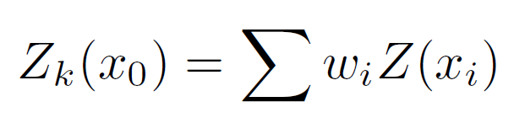
Ordinary Kriging provides the values of the weights, w_{i}. The weights are calculated based on the variogram γ(x_{i}-x_{j}). The weights can be found by solving the following linear algebra
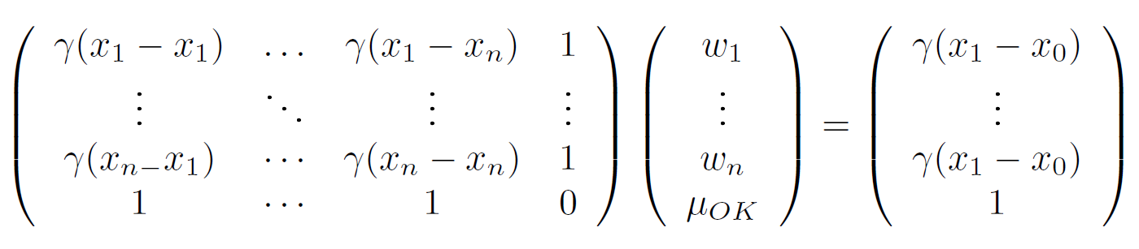
Or, more succinctly,
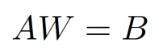
Here, W, is the vector of weights that we wish to determine. A encodes the relationships between all the stations for which we have data. B encodes the relationships between the point we are trying to estimate and all the stations for which we have data. The equation can be rearranged very simply to give.
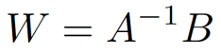
Which gives the values of W as a vector which can then be combined with the data Z(x_{i}).

Note that describing methods for homogenisation was deemed outside the scope of the ET-NCMP remit. There are WMO initiatives to do this already.
Tobler’s first law of Geography “Everything is related to everything else, but near things are more related than distant things.”

