Case study v4 lineage (canonical)
[Full author names and affiliations required]
Draft built from repository evidence

Title Page
Authors and affiliations: [AUTHOR INPUT REQUIRED]Corresponding author: [NAME, EMAIL, AND ORCID REQUIRED]

Key Points
- A train-only covariance heuristic labels dam-proximal stations as memory-dominated in two case-study networks.
- Held-out Chattahoochee type labels were frozen; fixed-model long-gap scores are a labelled post-hoc sensitivity.
- The national index is not a standalone dam classifier; the frozen pooled AUC is a defective diagnostic.

Plain Language Summary
Reservoir releases can make downstream water temperatures less seasonal and more persistent. We tested whether those changes can help decide which observations reconstruct an outage in a temperature record. We temporarily hid known daily values at three Jinsha River stations and five Chattahoochee River stations, then compared information from other stations with information at the edges of each gap. In both rivers, the station closest below a major dam depended more on its own boundaries, while farther stations depended more on simultaneous network observations. That pattern is a case-study screen, not proof that a dam caused the pattern or that the same rule works everywhere. The Jinsha files have no per-value quality codes, overlapping gaps are not independent samples, and the Chattahoochee model scores were chosen after the held-out run was already seen. Across 335 United States gauges, the same indicator weakened with distance below major dams but did not classify dams nationwide; a previously reported national score is not a valid classifier. The indicator can help inspect monitoring vulnerability in a documented network after local testing. It does not identify a safe gap length to reconstruct.
Canonical copy: paper/case_study_v1/manuscript.md
Design: design_freeze_v4 · See paper/study_manifest.json

A Case-Study Covariance Heuristic for Stream-Temperature Recoverability in Two Regulated River Networks

Abstract
Monitoring outages can remove weeks to months of stream-temperature records, yet the recoverability of a gap depends on which temporal and network information remains. We evaluated a train-only covariance heuristic across three Upper Jinsha River stations and five stations along the Upper–Middle Chattahoochee River using controlled 30–180-day gaps and a fixed roster of conventional recovery models. The heuristic separated sites whose recovery relied primarily on local boundary memory from sites benefiting from synchronous donor stations and reproduced the shape of internal best-model skill curves. It did not, however, provide transferable magnitude calibration: at the dam-proximal Chattahoochee site, the predicted 180-day skill was 0.414 whereas the post-hoc fixed-model skill was $−0.300$. An independently frozen 335-site United States panel also failed to support the heuristic as a standalone indicator of upstream major dams. These results identify covariance diagnostics as a useful local audit of monitoring redundancy, but not as a general reservoir classifier or a validated rule for gap filling.

1. Introduction
A monitoring network contains information even when none of its sensors has failed. Its arrangement determines whether an outage can be reconstructed from seasonality, synchronous river stations, atmospheric forcing, hydraulics, or observations at the edges of a gap. We call this property recoverability: performance on a predeclared missing target under a stated outage geometry and information condition, relative to a named baseline. Controlled masking supplies known truth and can therefore measure information available for reconstruction without claiming to reproduce the frequency of field failures.
Continuous gaps can bias annual thermal statistics (Johnson et al. 2021), and existing reconstructions use air temperature, discharge, seasonal structure, and spatially paired sensors (Li et al. 2017; Bal and Eyto 2023). Yet a good reconstruction does not by itself explain why one reach depends on synchronous network observations while another depends on its own boundaries.
Reservoir operation provides a physical reason for that distinction. Release depth, discharge, and storage state alter downstream seasonal amplitude and timing (Michie et al. 2020; Michel et al. 2023), process-based regulated-river models now require high-frequency in situ temperature and explicit heat-flux terms (Dorthe et al. 2025), and longitudinal observations show that thermal effects can attenuate or lag downstream (Zhao et al. 2020; Liu et al. 2025; Yang et al. 2025). Regional stream-air indicators can already identify dam-like thermal signatures without a dam map (Seyedhashemi et al. 2021). Our novelty is therefore not dam detection, a new heat budget, or a state-of-the-art imputer. We ask whether a train-only covariance heuristic can screen which information sources remain useful when observations are removed, and where that screen fails.
We address three questions. First, do dam-proximal stations in two detailed networks show a repeatable memory-dominated covariance type? Second, does a train-only covariance heuristic anticipate held-out long-gap recoverability without selecting a model on the scored event? Third, is the same fingerprint geographically portable, or does its interpretation require river and ecoregion context? The directional hypothesis is that compressed seasonal range and extended anomaly memory accompany greater boundary-memory dependence and weaker long-gap donor replacement near regulated releases.
We froze the heuristic at three Jinsha stations, evaluated structured 2018–2020 outages, and added explicitly post-hoc stationarity controls without altering that prediction. We then evaluated a five-site 2023–2025 Chattahoochee panel beginning below Buford Dam, using a fixed model chosen only from 2021–2022 validation placements. Finally, an independently frozen United States panel tested the geographic boundary. The design is an observational case-study screen across two detailed networks plus a national diagnostic, not a causal reservoir experiment, a topology-matched confirmation, or a claim that one imputation model is generally best.

2. Methods

2.1 Study networks and regulation setting
The Jinsha stations, ordered downstream, were Batang (B1), Shigu (S2), and Panzhihua (P3), separated by 463 and 558 river km (Figure 1). Daily temperature ($T$), discharge ($F$), and level ($L$) covered 1 January 2006 through 31 December 2020. Station-matched meteorology comprised air temperature, precipitation, wind, relative humidity, and NASA POWER all-sky shortwave radiation. The hydrological records are attributed to the Annual Hydrological Report of the People’s Republic of China, Volume VI (Wei et al. 2026; Wang et al. 2024). The map uses documented station coordinates, the official 27-km Guanyinyan–P3 distance for interpretation, and a separate cartographic dam coordinate (Malcolm Dunstan and Associates 2026).
Guanyinyan is the last project in the planned middle-Jinsha cascade, has weekly regulation, and lies 27 km upstream of Panzhihua according to the national impoundment-stage environmental approval (Ministry of Environmental Protection of the People’s Republic of China 2014). Its first unit began generation on 20 December 2014, three more units followed in 2015, and all five were operating in 2016 (China Datang Corporation 2026; National Energy Administration of China 2016). We use those dates only to interpret an independently observed thermal transition; this observational design does not isolate the dam from every concurrent basin change.
The external panel comprised USGS sites 02334430, 02335000, 02335450, 02336000, and 02337170 on one Upper-to-Middle Chattahoochee mainstem network. Site 02334430 is 366 m below Buford Dam (U.S. Geological Survey 1973). Buford hydropower releases originate near the reservoir bottom and are cold relative to surface water during stratification (U.S. Army Corps of Engineers, Mobile District 2017). External fitting, validation, and confirmatory periods were 2012–2020, 2021–2022, and 2023–2025.

2.2 Records, temporal separation, and controlled outages
Jinsha fitting, model-selection, and development-evaluation periods were 2006–2015, 2016–2017, and 2018–2020. The stored test label is a legacy alias of development_test; it is not an unseen confirmatory split. All scalers, climatologies, feature medians, and fitted models used the fitting period only.
The Jinsha $T$, $F$, and $L$ series contain no natural missing day in the 5,479-day study axis. Per-value provider quality flags were unavailable. Provenance reconciliation identified an 8.48-m B1 level datum step in 2019 and a 2013–2019 ordering discrepancy between supplied S2 hydrology and an external monthly archive. Values were not silently corrected: the primary version retains them with known-issue flags, and frozen versions exclude S2 hydrology, exclude B1 level, or apply a declared hypothetical B1 level shift. These sensitivities affect some covariate-dependent models but do not change the observation-only temperature type.
Artificial masks are controlled interventions used to measure network information; they do not estimate field-failure frequency. Masks hide only finite eligible values, are removed from every model input path, and span point gaps, contiguous blocks, compound $T+F+L$ outages, and matched network failures. The primary dense design has 15 block lengths from 1 to 365 days, three stations, and 20 frozen anchors (900 scenarios). The network design crosses four target-gap lengths with all eight failure subsets of B1, S2, and P3 (1,920 scenarios). These geometries are stress tests, not a fitted fault model.

2.3 Hydrothermal state and regulation fingerprint
We summarized annual minimum, maximum, mean, and amplitude directly in degrees C. Temperature anomalies subtract a fitting-period circular day-of-year median with a plus or minus seven-day window. For pre- and post-impoundment periods we report anomaly mean, standard deviation, lag-30 and lag-90 autocorrelation, skewness, and excess kurtosis.
We also estimated one post-hoc change in the complete 3,652-day P3 fitting-period anomaly series, requiring at least 365 days on each side. Pettitt’s rank statistic was the primary estimator. Because lag-1 autocorrelation was 0.973, its iid asymptotic and day-permutation p values are reference calculations only; inference uses 9,999 permutations of intact calendar-year blocks. A segmentwise circular moving-block residual bootstrap with 5,000 draws and 365-day blocks supplies a date interval. Single least-squares binary segmentation under the same permutation and bootstrap settings is a method sensitivity. Annual minimum and amplitude Pettitt tests are reported separately, recognizing that the fitting period contains only one fully post-commissioning year.
For comparison across all eight stations, the data-derived memory–range index is
$$I_{s}=\frac{{acf}_{30}(T_{s}^{′})}{max(T_{s})−min(T_{s})},$$
where the range and anomaly autocorrelation are computed only in the network’s fitting period. This is a descriptive regulation fingerprint, not a universal classifier. We compare its within-network rank with the independently frozen donor/memory type and with distance or position relative to the regulating dam.

2.4 Frozen covariance heuristic
Exact calendar-day medians fitted within the declared calibration period were subtracted from target and donor temperatures. Simultaneous donor anomalies give $R_{donor}^{2}$. Target anomaly memory at the mean distance from a uniformly distributed point inside a two-sided block to its nearest boundary is evaluated at $d/4$. The frozen heuristic is
$$R_{avail}^{2}(d)=R_{donor}^{2}+(1−R_{donor}^{2})ρ^{2}(d/4),$$
$$\hat{skill}(d)=1−\sqrt{1−R_{avail}^{2}(d)}.$$
The $d/4$ distance follows from averaging the nearest-boundary distance over a continuous block. The additive expression assumes that memory explains a fraction of variance remaining after donor information; donor and boundary signals are not empirically orthogonalized. The MAE conversion additionally assumes a common location–scale residual shape. Consequently, these equations define a screening heuristic, not a theorem, physical heat budget, or information ceiling. At 30 days, a station is donor-dominated when the donor component is at least the memory component, and memory-dominated otherwise. We also evaluate this label at 14, 60, and 90 days. The original 2006–2015 prediction was written before dense aggregation and was never altered.
To test omitted-variable sensitivity, we expanded the linear anomaly regression with same-site air temperature, $F$, and $L$, and donor-site air temperature and $F$. To test state dependence, we recalculated the heuristic for 2016–2017 (a leakage-free but short post-hoc bridge; those years remain the frozen model-selection split) and for 2016–2020 (a post-hoc state-matched diagnostic that overlaps evaluation and is not predictive evidence).

2.5 Recovery models and evidence roster
The common baseline was a training-only circular plus or minus seven-day median climatology. The formal roster contained linear and PCHIP interpolation, a local-linear-trend Kalman smoother, air-only and air-plus-hydraulics ridge regressions, donor regression, random forest, and XGBoost. Offline recovery may use both boundaries of a historical gap.
Official BRITS, SAITS, and CSDI implementations and a multisource quantile model were evaluated during validation. Under the frozen stability rule, required seeds selecting before epoch 50 or hitting the 400-epoch cap could not enter the formal roster. None of the deep candidates entered; their architecture, training diagnostics, validation-only rankings, and information-group ablations are reported only in Supporting Information. No conclusion about the capability of deep imputation follows from excluded unstable runs.

2.6 Skill, absolute error, stationarity controls, and inference
For event $e$, skill relative to a named baseline is
$${skill}_{e}=1−\frac{{MAE}_{e,model}}{{MAE}_{e,baseline}}.$$
Every main curve and table also reports model MAE and baseline MAE in degrees C. The climatology denominator was withheld at or below 0.05 degrees C. The statistical frontier is the first gap at which the non-increasing 95% lower confidence curve ceases to exceed zero. It is not an ecological or operational safety threshold.
The two frontier denominators–climatology and the validation-selected best simple baseline–pass through one anchor/year, overlap-aware bootstrap implementation. All 27 climatology frontier cells are identical between the summary and dual-denominator tables.
Training seeds were averaged before inference. Frontier curves use 2,000 joint cross-gap resamples stratified by station and anchor year, with connected overlap components retained as blocks. The only admissible hypothesis unit is an overlap component or site-year cluster. Each Jinsha station has one overlap component and three evaluation years, which is below the predeclared floor of five independent clusters. Wilcoxon p-values, Benjamini–Hochberg decisions, and statistical-frontier confidence intervals are therefore withheld. Climatology self-comparisons remain reference_not_tested. Descriptive skill and MAE curves are retained. The earlier ${10}^{−6}$ p-values treated 19–20 overlapping anchors as independent samples and are not used.
Two post-hoc robustness scores address the P3 transition. First, fixed model predictions are re-scored against a 2016–2020 state-matched climatology while the heuristic is recalibrated to the same state. Because this climatology includes evaluation years, the result diagnoses denominator contamination and is not a new test. Second, truth and prediction anomalies are separately demeaned within calendar year before MAE is computed; this removes constant and slower annual offsets while retaining within-year shape.

2.7 Donor falsification and cross-fitted node importance
Donor information was tested against lagged, implausible-lead, station-identity-permuted, and seasonal-residual-permuted contrasts. Persistence of gain under physically implausible contrasts falsifies a downstream-transport interpretation and restricts the claim to shared predictive information.
Node importance avoids selecting a model on the event being scored. For every target, gap length, and failure set, we leave out one evaluation year, choose the lowest-mean-MAE roster model using the other two years, and score that fixed choice on all anchors in the held-out year. Climatology is an ordinary candidate, not an event-wise cap. Full- and failed-network errors are paired on the same target gap,
$$Δ_{j}=MAE({\hat{m}}_{−y,j}∣j \text{failed},y)−MAE({\hat{m}}_{−y,0}∣\text{full network},y),$$
where ${\hat{m}}_{−y,j}$ is selected without year $y$. We aggregate four gap lengths. Because only three evaluation years are available, bootstrap confidence intervals are withheld. Because selection folds are drawn from development evaluation after the original analysis, this is an explicitly post-hoc, non-oracle sensitivity rather than independent confirmation. The former event-wise best envelope is retained only in Supporting Information.

2.8 Temporally held-out external evaluation
Before opening 2023–2025 performance, the external sites, periods, variables, nine-model roster, mask seed, 60 scenarios, and complete train-only predicted curves were fixed. The heuristic classified 02334430 as memory-dominated and the other four sites as donor-dominated. The run created a once-lock before model scoring and completed all 540 model–scenario units. The originally frozen best-roster envelope is retained as a descriptive estimand because it selects the maximum observed performance within a confirmatory cell.
Because that run used one mask placement per cell, a post-freeze diagnostic used only the 2021–2022 validation period. The same five sites, 30/90/180-day full-information blocks, nine-model roster, and 20 placements produced 2,700 cells; inputs were physically truncated before 2023, and confirmatory outputs were not read. For the non-oracle primary presentation, one fixed model per site is chosen by mean skill across all 60 validation site–gap–placement cells and then scored unchanged in 2023–2025. This selection rule was formulated after the confirmatory envelope had been observed, so it is labelled a post-hoc fixed-model sensitivity, not preregistration. Validation-period sample SD describes placement variation and is not a confirmatory confidence interval.

2.9 Independently frozen national regulation panel
After the two case-study analyses, but before reading any national temperature-panel outcome, we froze an independent USGS/GAGES-II test (regulation_panel_freeze_v1). Its runtime path guard and static source audit prohibit the Chattahoochee data, results, and once-lock. USGS primary daily-mean water-temperature metadata and approved values for 2000–2019 were joined by exact station number to routed GAGES-II watershed attributes (U.S. Geological Survey 2026; Falcone 2011). Eligible stream sites required one unspliced primary series and at least 10 calendar years with at least 300 approved days. The binary label was at least one upstream GAGES-II major dam in the 2009 snapshot; Euclidean nearest NID points were explicitly prohibited as upstream labels (U.S. Army Corps of Engineers 2026).
The primary predictor was the pre-existing memory–range index. The frozen primary analysis was unadjusted logistic regression with HC1 uncertainty plus leave-one-aggregated-ecoregion-out ROC AUC and 2,000 ecoregion-cluster bootstrap draws. Pooled leave-one-ecoregion-out AUC is the frozen primary generalization metric and is now labelled a preregistered defective diagnostic; an AUC near 0.5 does not reopen the freeze. The valid post-hoc discrimination summary is the mean of defined within-fold AUCs. A drainage-area/ecoregion-adjusted coefficient and a regulated-site profile in 0–5, 5–20, 20–50, 50–100, and greater than 100 km nearest-major-dam bins were sensitivities; no threshold was selected.
A post-hoc diagnosis computed AUC inside each held-out ecoregion because pooled out-of-fold AUC under leave-one-group-out can attribute intercept and base-rate mismatch to discrimination. Single-predictor logistic intercepts are calibrated on complementary folds whose dam rate is near 60%, then scored on held-out ecoregions whose dam rates range from 0 to 0.95. This diagnosis does not replace or reopen the freeze.
The modern USGS daily API returned HTTP 429 after 26 of 56 atomic batches and no API key was available. Before any panel metric, a transport amendment froze the official legacy /dv service as a fallback only for stations having exactly one frozen primary series; 22 multiple-series stations were excluded rather than spliced. Across 1,662,961 station-dates available from both transports, approved values agreed exactly. Results are labelled transport_limited_maximum_legal_panel; they do not claim a complete modern-API roster.

2.10 Preregistered versus post-hoc analyses
The table below classifies the analyses that appear in the main text. Frozen items were written before the outcomes they constrain. Post-hoc items are labelled as such wherever they support a claim. The external validation-selected fixed-model rule is post-hoc; it is not preregistered confirmation.
Analysis | Classification
Jinsha 2006–2015 covariance heuristic and donor/memory type | Frozen; written before dense aggregation
Formal nine-model roster after stability exclusion | Frozen
External sites, periods, masks, and train-only predicted curves | Frozen before 2023–2025 outcomes
Evaluate-once confirmatory lock | Frozen
National panel freeze v1 and transport amendment | Frozen before any panel metric
Unadjusted logistic regression and pooled leave-one-ecoregion-out AUC | Frozen primary national analysis
Drainage-area/ecoregion-adjusted logistic and regulated-site distance profile | Predeclared national sensitivities
Donor-falsification contrasts | Frozen
2016–2017 as the model-selection / validation split | Frozen
2016–2017 heuristic recalculation | Post-hoc; leakage-free bridge
2016–2020 state-matched heuristic and climatology | Post-hoc
Annual demeaning | Post-hoc
Expanded covariate budget | Post-hoc
P3 Pettitt and least-squares change-date | Post-hoc
Cross-fitted node importance | Post-hoc
External validation-selected fixed-model rule | Post-hoc; not preregistered confirmation
External 20-seed placement SD | Post-hoc
Within-fold leave-one-ecoregion-out AUC diagnosis | Post-hoc; this revision; does not reopen the freeze

3. Results

3.1 A regulation-consistent thermal transition at P3
P3 annual endpoints shifted in 2015 (Figure 2; Table 2). In 2006–2014, its annual minimum was 8.7–10.3 degrees C and annual amplitude was 11.7–14.1 degrees C. In 2015–2020, minima were 11.5–12.5 degrees C and amplitudes were 9.6–10.7 degrees C. Relative to the 2006–2015 climatology, anomaly SD increased from 0.91 degrees C before impoundment to 1.96 degrees C afterward, and acf30 increased from 0.39 to 0.76. B1 and S2 showed no comparable endpoint shift: their pre/post anomaly SD values were 0.94/0.91 and 0.78/0.81 degrees C, and acf30 remained near 0.14/0.07 and 0.14/0.11. If the P3 transition were a basin-wide climate shift, B1 and S2 would have shown comparable increases in anomaly SD and acf30; they did not.
The formal daily change date was method-sensitive. Pettitt estimated 26 May 2013 (95% 365-day moving-block residual-bootstrap interval, 14 May 2011 to 22 October 2013). The dependence-aware calendar-year permutation p value was 0.0088, but the interval did not contain 20 December 2014. Least-squares single segmentation instead estimated 18 October 2014 (interval, 16 April 2014 to 1 January 2015; year-block $p=0.0117$), and that interval did contain first-unit operation. In 2015, annual minimum was 2.8 degrees C above and amplitude 2.4 degrees C below their 2006–2014 medians, but annual Pettitt tests were not significant ($p=0.2208$ and $0.8607$) with only one post-commissioning fitting year. We therefore infer a statistically detectable but method-sensitive state change and temporal consistency in one sensitivity, not precise localization of commissioning or causal attribution by change-point analysis alone.
The covariance calculation classified B1 and S2 as donor-dominated and P3 as memory-dominated without dam information. The labels were unchanged at 14, 30, 60, and 90 days. P3 ranked first within the Jinsha network on the memory–range index. The same diagnostic selected Chattahoochee site 02334430, immediately below Buford Dam, as the only memory-dominated site at all four horizons. Downstream, observed temperature range increased from 9.9 to 14.8, 18.0, 23.7, and 24.0 degrees C, whereas acf30 declined from 0.762 to 0.397, 0.377, 0.304, and 0.281. That pattern is consistent with, but does not by itself identify, thermal re-equilibration below a regulated release (Zhao et al. 2020; Seyedhashemi et al. 2021).

3.2 The heuristic predicts shape but not a universal ceiling
The frozen donor $R^{2}$ was 0.464 at B1, 0.470 at S2, and 0.106 at P3. Best-envelope correlations with the predicted curve were 0.72, 0.94, and 0.95; mean absolute skill errors were 0.077, 0.085, and 0.122 (Figure 3). The best model exceeded the point heuristic in 20 of 45 cells. A historical count of nine lower confidence bounds exceeding the heuristic, all at P3, is retained only as an audit of the old interval construction; those bounds are withheld because each station has fewer than five independent clusters. These results support qualitative shape screening at B1/S2 but reject the original interpretation as a universal ceiling.
The expanded covariate regression raised $R^{2}$ only from 0.464 to 0.537 at B1, 0.470 to 0.532 at S2, and 0.106 to 0.148 at P3. The corresponding P3 long-gap skill approximation rose only from 0.055 to 0.077, excluding omission of measured air temperature and hydraulics as a sufficient explanation.
State control strongly changed the P3 conclusion. Re-scoring against a 2016–2020 climatology left the historical lower-bound audit count at one instead of nine; those bounds remain withheld. At 365 days, XGBoost changed from skill 0.209 against the old climatology to -0.588 against the state-matched climatology, while the recalibrated heuristic was 0.069. Annual demeaning was less decisive: P3 XGBoost retained skill 0.164 at 365 days. Thus the sustained offset explains much of the apparent long-gap advantage, but within-year structure also remains recoverable.

3.3 Relative skill represents tenths of a degree
Training climatology explained 97.0% of B1 temperature variance, 97.2% at S2, and 91.6% at P3. Across the dense design, climatology MAE ranged from 0.681 to 0.771 degrees C at B1, 0.648 to 0.704 degrees C at S2, and 1.218 to 1.347 degrees C at P3 (Figure 4; Table 4). A skill of 0.25 therefore usually represents an improvement of roughly 0.17–0.34 degrees C, not a multi-degree change.
Using the single corrected frontier path, descriptive right-censoring at 365 days occurred for random forest and XGBoost at B1 and S2 and for XGBoost at P3. Interpolation/Kalman point-frontier crossings occurred at 7.0–8.8 days at B1, 21.2–22.7 days at S2, and 93.1–160.0 days at P3. These are descriptive curve summaries, not confirmatory statistical frontiers. No p-value or confidence interval is reported for the 24 model-versus-climatology contrasts because each station supplies fewer than five independent clusters. Mean skills remain useful as ordered descriptions: random forest and XGBoost were positive at B1; donor regression, random forest, and XGBoost were positive at S2; and Kalman and XGBoost were positive at P3. They do not support a significance ranking.

3.4 Donor value reflects shared forcing; cross-fitted costs are modest
Observed same-day donor information exceeded the station-identity permutation by 0.057 skill across 60 paired units. Gain persisted under identity permutation and implausible lags, triggering the preregistered falsified_network_propagation decision. Synchronous stations therefore carry shared climatic or regulation information, but the experiment does not identify downstream heat transport. The paired-unit p-value is not treated as independent-sample confirmation.
The cross-fitted estimator changed both magnitude and interpretation (Figure 5; Table 5). Averaged over four gap lengths, losing S2 increased B1 MAE by 0.105 degrees C. B1 and P3 losses changed B1 MAE by -0.023 and -0.013 degrees C. For P3 recovery, B1 and S2 losses increased MAE by 0.058 and 0.054 degrees C. These 80 nested gap/anchor events occupy only three evaluation years, so bootstrap intervals are withheld. The values are post-hoc policy sensitivities, not causal station values, confirmatory intervals, or a protection ranking.

3.5 Held-out long-gap scores follow the type order in one post-hoc evaluation, but magnitude does not
Mean performance over the 2021–2022 validation placements selected XGBoost at all five sites before that rule was scored in 2023–2025 (Figure 6). The rule was written after the confirmatory envelope had been seen, so the scores are a labelled post-hoc sensitivity. At site 02334430 below Buford Dam, XGBoost skill was -0.209, -0.380, and -0.300 at 30, 90, and 180 days. The four donor-dominated sites retained 180-day skill of 0.726, 0.555, 0.746, and 0.724. The memory-site type label is also close to the 90-day threshold (margin $−0.031$). These numbers do not enter the abstract or conclusions as confirmatory evidence.
The 20-placement validation diagnostic showed substantial variation. For the selected XGBoost policy, 180-day skill SD was 0.175 at 02334430 and 0.180, 0.121, 0.058, and 0.043 at the donor sites. These are validation-period noise scales, not uncertainty intervals for the single 2023–2025 placement. The originally frozen best-roster envelope gave 02334430 skill 0.141 at 180 days, illustrating how within-cell outcome selection can make the same site appear more recoverable; that envelope is now descriptive only.
The heuristic predicted 0.414 skill at 180 days for 02334430 but the selected fixed model achieved -0.300. Exact magnitudes therefore did not transfer. The external result is a post-hoc type-order sensitivity in one temporal/network evaluation, not a universal frontier or a causal regulation effect.

3.6 National panel supports a distance gradient, not a standalone classifier
The frozen national flow discovered 5,707 temperature series, found 1,361 exact GAGES-II station overlaps and 1,344 stream sites, and retained 335 eligible stations (209 with and 126 without an upstream major dam). The primary unadjusted association was positive but uncertain: odds ratio 1.23 per index SD (95% CI 0.93–1.61; $p=0.144$). The frozen primary pooled leave-one-ecoregion-out AUC was 0.407 (ecoregion-cluster bootstrap interval 0.222–0.515). That number remains the frozen primary, but it is a defective discrimination metric: it scores fold intercept and base-rate mismatch as (anti)discrimination. Figure 7 therefore reports the fold-comparable diagnosis, not the defective ROC, as the visual headline. The index alone did not generalize as a national major-dam classifier.
A post-hoc diagnosis then computed AUC inside each held-out ecoregion (Text S15; Table S8). Fold dam rates ranged from 0 (Alaska) to 0.95 (WestPlains). In this post-hoc diagnosis, the correlation between fold base rate and fold out-of-fold probability median was $−0.671$: the Alaska fold, with no regulated sites, had the highest median predicted probability (0.722), whereas WestPlains had the lowest (0.559) despite a 0.95 dam rate. Post-hoc mean and median within-fold AUC were 0.526 and 0.513. Four eastern and central folds had AUC 0.614–0.755 (NorthEast 0.755, $n=33$, base rate 0.727; EastHghlnds 0.742; CntlPlains 0.667; MxWdShld 0.614). The Southeast Plains reversed the case-study direction (AUC 0.132; $n=63$; base rate 0.508). That reversal is consistent with a mechanism sketch in which natural low-amplitude, long-memory regimes–groundwater influence, sluggish flow, and a warm climate–can reproduce the regulated signature; it is not a causal attribution. The same geography is consistent with within-climate comparisons such as Jinsha and Chattahoochee holding while a national classifier fails. The post-hoc mean of 0.526 is still no national skill and does not replace the frozen primary.
The frozen sensitivities retain a localized descriptive signal. After drainage-area and ecoregion adjustment, the uncorrected index odds ratio was 2.52, but complete separation in a single-class Alaska ecoregion makes that coefficient and the exploding ecoregion odds ratios unreportable; they are suppressed in Table S7. A Firth unadjusted fit remains consistent with the primary null. Among regulated watersheds, median memory–range index declined from 0.0110 for 83 stations within 5 km of a major dam to 0.00690 at 5–20 km, 0.00611 at 20–50 km, and 0.00463 at 50–100 km; median acf30 declined from 0.262 to 0.135. The greater-than-100-km bin had one station and was not interpreted. A 62-station common-period coverage subset is reported only as a sensitivity. Case-study direction and the regulated-site distance profile agree descriptively, while valid cross-ecoregion binary discrimination does not.

4. Discussion

4.1 Case-study covariance structure is not an identified reservoir mechanism
The two networks show the same association: the dam-proximal station combines compressed seasonal range, extended persistence, and a memory-dominated label. Downstream of Buford, range increases and acf30 declines. This direction agrees with observations that release depth, discharge, and storage change downstream thermal amplitude (Michie et al. 2020; Michel et al. 2023), that dam effects attenuate or lag longitudinally (Zhao et al. 2020; Liu et al. 2025; Yang et al. 2025), and that regional stream-air indicators can recover dam-like thermal signatures (Seyedhashemi et al. 2021). It does not identify a reservoir mechanism. In both networks the memory-dominated site is also a network endpoint, and donor geometry is one-sided. Recent regulated-river studies with logger-grade, high-frequency observations and process heat fluxes (Dorthe et al. 2025) remain a stronger design for thermal mechanism. Our additional result is only that a train-only covariance heuristic can label those two sites before model fitting. The observational design does not show that regulation alone caused either covariance pattern.
The donor falsification result sharpens this interpretation. Donor value that survives impossible lags or station relabelling is evidence of common forcing, not advected heat. In a regulated network that shared source may include release schedules and basin-scale weather as well as ordinary seasonality. The Jinsha sites are hundreds of river kilometres apart, so “donor” denotes synchronous predictive information rather than a neighbouring sensor or a travel-time mechanism. Recoverability is an observational probe of network information, not a causal pathway identifier.
The national panel bounds the generality of the screen. The monotone 0–100-km profile is consistent with, but does not identify, downstream thermal re-equilibration. The frozen primary pooled leave-one-ecoregion-out AUC of 0.407 is a metric defect: pooling fold-calibrated probabilities across ecoregions whose dam rates range from 0 to 0.95 scores intercept mismatch as (anti)discrimination. A post-hoc within-fold diagnosis still finds no national skill (mean AUC 0.526). The informative result of that diagnosis is region-dependent direction, including a reversal in the Southeast Plains. Climate, channel scale, groundwater and sluggish-flow regimes, release depth, dam operation, and network placement can produce overlapping covariance signatures. Adjusted coefficients that rely on complete separation are not reported.

4.2 What remains of the covariance heuristic
The original ceiling language was too strong. The historical lower-bound exceedances occurred where calibration and evaluation crossed a thermal transition, and they are not used as inference. Once the denominator and heuristic were matched to the later state, almost all of that audit count disappeared, yet annual demeaning left positive long-gap skill beyond the original prediction. The additive donor-plus-memory form is not an orthogonal variance decomposition, and its MAE conversion requires empirical calibration. It is useful as a qualitative screening curve and stable type label, not as an information-theoretic bound.

4.3 Monitoring-network consequences
The cross-fitted analysis and the case-study error scale give only a limited planning sketch. In degrees C rather than skill:
- Losing S2 raises B1 reconstruction MAE by 0.105 degrees C as a descriptive three-year mean; no confidence interval is reported.
- At the two memory-labelled reaches, boundary observations matter more than a distant donor in these networks, but that is not a general protection rule.
- Typical model gains are tenths of a degree against climatology MAE of about 0.65–1.35 degrees C; no ecological safety threshold was declared.
- Thermal state changes can invert long-gap skill interpretations (P3 365-day XGBoost 0.209 to $−0.588$ under state-matched climatology).
These values depend on the three-station roster and post-hoc cross-fitting population. They do not justify station removal, sensor-protection policy, or a safe-fill length.

4.4 Scope and limitations
The Jinsha analysis has three widely separated stations on one river and no natural missing hydrological day. Controlled masks estimate recoverable information under specified outages, not field-failure probability. The 2015 annual endpoint shift is physically consistent with Guanyinyan operation, but the primary daily Pettitt interval predates commissioning and causal attribution remains observational. Provider quality flags were unavailable, the B1 level datum changes, and S2 hydrology has a provenance discrepancy; frozen sensitivities and public aggregates expose rather than resolve those limitations. The external panel has five sites on one mainstem and one scored placement per cell, not five independent basins. The national panel uses 2009 routed dam attributes rather than time-varying release depth or operation. No reservoir operations or release-depth series were obtained, and we do not invert temperature for operations. The Buford operations literature already cited is engineering context, not this study’s data.
The external train-only curves and donor/memory labels were frozen before 2023–2025 performance was opened, but no numeric effect threshold was frozen. The fixed-model selection rule was formulated afterward using only truncated 2021–2022 validation data. We therefore call it a held-out post-hoc sensitivity, not a preregistered confirmation. The validation-period SD supplies a placement scale rather than a confidence interval. Jinsha state controls, cross-fitted node importance, and the within-fold leave-one-ecoregion-out AUC diagnosis are also post-hoc. Deep models were excluded by stability rules, so no conclusion about their general capability follows.

5. Conclusions
Across two regulated river networks, fitting-period covariance structure distinguished sites relying primarily on local thermal memory from sites benefiting from synchronous network observations. This distinction was useful as a local diagnostic but did not transfer as a calibrated recovery rule, and an independently frozen national panel did not support the index as a standalone dam classifier. The evidence therefore supports using covariance diagnostics to audit monitoring redundancy within a calibrated network, not to infer reservoir causation, remove sensors, or certify long-gap reconstruction.

Acknowledgments
AUTHOR INPUT REQUIRED: Insert all funding bodies, grant identifiers, in-kind support, and acknowledged contributors before submission.

Conflict of Interest
AUTHOR APPROVAL REQUIRED: Replace this line with the final declaration approved by every author.

Author Contributions
AUTHOR INPUT REQUIRED: Insert the approved CRediT contribution statement.

6. Open Research
The analysed Jinsha daily hydrological records were supplied to the project and are attributed to the Chinese Hydrological Yearbook. Permission to redistribute the exact $T$, $F$, and $L$ files was not established. CMA humidity and sunshine and the WMO/CMA meteorological series are likewise restricted under the rights matrix. Subject to written editor approval of this restricted third-party-data exception, the exact analysis inputs will be provided through the journal’s confidential peer-review workflow; they are not “available upon request.” The paper will not be submitted without that approval. Public aggregate tables and figures do not redistribute daily records.
USGS and NASA POWER inputs for the Chattahoochee evaluation are public-source observations archived with provenance. Original code is MIT-licensed. The public repository history was rewritten to code-only scope after a verified private bundle and commit map were created; the rights audit reports zero restricted tracked paths. An immutable archival DOI is still required before submission. The CITATION.cff DOI remains unset until a real archive record is minted; no DOI is invented in this manuscript.
The reproducible revision entry point is scripts/34_run_major_revision.py. Formal internal outputs are accepted only when results/analysis/analysis_manifest.json is complete; external evidence is accepted only with the complete once-lock and completion_manifest.json. The frozen prediction remains results/predictions/recoverability_prediction_v1.json.

Tables

Table 1
network | station_id | station_name | recoverability_type | donor_component | memory_component | type_margin | near_classification_threshold | acf30 | training_observed_range_degC | memory_range_index_per_degC | dam_distance_km | regulation_context
Upper Jinsha | B1 | Batang | donor_dominated | 0.464 | 0.058 | 0.406 | False | 0.131 | 20.5 | 0.006 | undefined | upstream of Guanyinyan
Upper Jinsha | S2 | Shigu | donor_dominated | 0.47 | 0.079 | 0.391 | False | 0.141 | 16.5 | 0.009 | undefined | upstream of Guanyinyan
Upper Jinsha | P3 | Panzhihua | memory_dominated | 0.106 | 0.553 | -0.447 | False | 0.59 | 14.5 | 0.041 | 27.0 | 27 km downstream of Guanyinyan
Upper–Middle Chattahoochee | 02334430 | CHATTAHOOCHEE RIVER AT BUFORD DAM, NEAR BUFORD, GA | memory_dominated | 0.367 | 0.507 | -0.14 | False | 0.762 | 9.9 | 0.077 | 0.366 | 0.366 km below Buford Dam
Upper–Middle Chattahoochee | 02335000 | CHATTAHOOCHEE RIVER NEAR NORCROSS, GA | donor_dominated | 0.853 | 0.043 | 0.81 | False | 0.397 | 14.8 | 0.027 | 21.432 | downstream re-equilibration reach
Upper–Middle Chattahoochee | 02335450 | CHATTAHOOCHEE RIVER ABOVE ROSWELL, GA | donor_dominated | 0.913 | 0.027 | 0.886 | False | 0.377 | 18 | 0.021 | 29.325 | downstream re-equilibration reach
Upper–Middle Chattahoochee | 02336000 | CHATTAHOOCHEE RIVER AT ATLANTA, GA | donor_dominated | 0.925 | 0.019 | 0.905 | False | 0.304 | 23.7 | 0.013 | 48.279 | downstream re-equilibration reach
Upper–Middle Chattahoochee | 02337170 | CHATTAHOOCHEE RIVER NEAR FAIRBURN, GA | donor_dominated | 0.868 | 0.031 | 0.837 | False | 0.281 | 24 | 0.012 | 78.521 | downstream re-equilibration reach
Table 1. Eight-station regulation fingerprint.. Network, station, recoverability type, donor and memory components, signed type margin, near-threshold flag, lag-30 memory, observed range, memory–range index, and dam context.

Table 2
station_id | year | annual_minimum_degC | annual_maximum_degC | annual_mean_degC | annual_amplitude_degC | n_days
B1 | 2006 | 1 | 20.6 | 10.254 | 19.6 | 365
B1 | 2007 | 1.6 | 18 | 9.761 | 16.4 | 365
B1 | 2008 | 0.6 | 18.1 | 9.028 | 17.5 | 366
B1 | 2009 | 0.1 | 18.5 | 9.482 | 18.4 | 365
B1 | 2010 | 0.4 | 18.6 | 9.369 | 18.2 | 365
B1 | 2011 | 1 | 17.7 | 9.18 | 16.7 | 365
B1 | 2012 | 1.1 | 18.2 | 9.398 | 17.1 | 366
B1 | 2013 | 0.2 | 18.2 | 9.625 | 18 | 365
B1 | 2014 | 1.4 | 18 | 9.282 | 16.6 | 365
B1 | 2015 | 1 | 18.4 | 9.633 | 17.4 | 365
B1 | 2016 | 1.1 | 18.6 | 9.956 | 17.5 | 366
B1 | 2017 | 1.8 | 18.5 | 9.858 | 16.7 | 365
B1 | 2018 | 1.6 | 17.7 | 9.895 | 16.1 | 365
B1 | 2019 | 1.6 | 18.6 | 9.792 | 17 | 365
B1 | 2020 | 1.5 | 18.1 | 9.759 | 16.6 | 366
S2 | 2006 | 5.2 | 20.5 | 12.706 | 15.3 | 365
S2 | 2007 | 5.4 | 19.5 | 12.613 | 14.1 | 365
S2 | 2008 | 6 | 18.5 | 12.064 | 12.5 | 366
S2 | 2009 | 4.8 | 20.3 | 12.677 | 15.5 | 365
S2 | 2010 | 4.6 | 19.9 | 12.378 | 15.3 | 365
S2 | 2011 | 4.8 | 19.3 | 12.294 | 14.5 | 365
S2 | 2012 | 4.8 | 19.7 | 12.133 | 14.9 | 366
S2 | 2013 | 4.8 | 19.7 | 12.253 | 14.9 | 365
S2 | 2014 | 4.6 | 19.3 | 12.304 | 14.7 | 365
S2 | 2015 | 4 | 19.6 | 12.65 | 15.6 | 365
S2 | 2016 | 4.2 | 19.3 | 12.539 | 15.1 | 366
S2 | 2017 | 5 | 19 | 12.486 | 14 | 365
S2 | 2018 | 4.5 | 19.1 | 12.422 | 14.6 | 365
S2 | 2019 | 4 | 19.5 | 12.293 | 15.5 | 365
S2 | 2020 | 5 | 18.9 | 12.417 | 13.9 | 366
P3 | 2006 | 9.5 | 23 | 16.494 | 13.5 | 365
P3 | 2007 | 9.7 | 22.6 | 16.264 | 12.9 | 365
P3 | 2008 | 9.9 | 21.6 | 15.81 | 11.7 | 366
P3 | 2009 | 9.1 | 22.2 | 16.219 | 13.1 | 365
P3 | 2010 | 8.7 | 22.8 | 16.135 | 14.1 | 365
P3 | 2011 | 9.3 | 21.6 | 16.173 | 12.3 | 365
P3 | 2012 | 10.3 | 22 | 16.048 | 11.7 | 366
P3 | 2013 | 9.7 | 22.9 | 16.696 | 13.2 | 365
P3 | 2014 | 9.6 | 23.2 | 16.946 | 13.6 | 365
P3 | 2015 | 12.4 | 23.1 | 17.832 | 10.7 | 365
P3 | 2016 | 12 | 22.3 | 17.508 | 10.3 | 366
P3 | 2017 | 12.5 | 22.3 | 17.438 | 9.8 | 365
P3 | 2018 | 11.8 | 22.4 | 16.81 | 10.6 | 365
P3 | 2019 | 11.5 | 21.8 | 16.642 | 10.3 | 365
P3 | 2020 | 12.5 | 22.1 | 17.689 | 9.6 | 366
Table 2. Annual Upper Jinsha thermal statistics.. Minimum, maximum, mean, and amplitude in degrees C for every station and year, 2006–2020.

Table 3
analysis | station_id | correlation | mean_absolute_skill_error | best_exceeds_budget_count | best_lower_ci_exceeds_budget_count | comparison_cells
bridge_2016_2017_climatology | B1 | 0.695 | 0.068 | 4 | 0 | 15
bridge_2016_2017_climatology | P3 | 0.824 | 0.263 | 11 | 10 | 15
bridge_2016_2017_climatology | S2 | 0.885 | 0.06 | 4 | 0 | 15
original_training_climatology | B1 | 0.722 | 0.077 | 4 | 0 | 15
original_training_climatology | P3 | 0.953 | 0.122 | 15 | 9 | 15
original_training_climatology | S2 | 0.94 | 0.085 | 1 | 0 | 15
state_matched_2016_2020_climatology | B1 | 0.571 | 0.18 | 0 | 0 | 15
state_matched_2016_2020_climatology | P3 | 0.979 | 0.236 | 4 | 1 | 15
state_matched_2016_2020_climatology | S2 | 0.93 | 0.177 | 0 | 0 | 15
Table 3. Frozen and stationarity-controlled covariance-heuristic evaluation.. Prediction correlation, mean absolute skill error, and point exceedance count by station. The best_lower_ci_exceeds_budget_count column is a historical audit of the old interval construction and is not an inferential claim; those bounds are withheld because each station has fewer than five independent clusters. The 2016–2017 and 2016–2020 rows are post-freeze diagnostics.

Table 4
station_id | gap_length | validation_selected_model | validation_mean_MAE | mean_skill | mean_MAE_degC | mean_climatology_MAE_degC | n_anchors | n_independent_clusters | hypothesis_status
B1 | 30 | xgboost | 0.446 | 0.194 | 0.517 | 0.757 | 20 | 1 | withheld_insufficient_independent_clusters
B1 | 90 | xgboost | 0.446 | 0.198 | 0.502 | 0.699 | 20 | 1 | withheld_insufficient_independent_clusters
B1 | 180 | xgboost | 0.446 | 0.225 | 0.518 | 0.718 | 20 | 1 | withheld_insufficient_independent_clusters
P3 | 30 | kalman | 0.458 | 0.58 | 0.364 | 1.306 | 20 | 1 | withheld_insufficient_independent_clusters
P3 | 90 | kalman | 0.458 | 0.479 | 0.48 | 1.296 | 20 | 1 | withheld_insufficient_independent_clusters
P3 | 180 | kalman | 0.458 | -0.045 | 1.119 | 1.218 | 20 | 1 | withheld_insufficient_independent_clusters
S2 | 30 | donor_regression | 0.357 | 0.183 | 0.539 | 0.674 | 20 | 1 | withheld_insufficient_independent_clusters
S2 | 90 | donor_regression | 0.357 | 0.173 | 0.552 | 0.674 | 20 | 1 | withheld_insufficient_independent_clusters
S2 | 180 | donor_regression | 0.357 | 0.183 | 0.539 | 0.651 | 20 | 1 | withheld_insufficient_independent_clusters
Table 4. Descriptive recoverability in relative and absolute units.. One block-recovery model per station is selected on 2016–2017 validation data and reported at 30, 90, and 180 days in 2018–2020. Columns give validation MAE, mean skill, model and climatology MAE, raw anchor counts, and independent-cluster status. Skill confidence intervals and statistical frontiers are withheld.

Table 5
experiment | mask_type | layout | outage_mode | overlap_ratio | pattern | window_length | training_protocol | fit_split | tuning_split | evaluation_split | validation_scope | target_station_id | station_id | target | model | failed_station_id | full_network_value | failed_value | impact | impact_ci_lower | impact_ci_upper | value_metric | impact_definition | selection_population | evidence_role | formal_evidence | eventwise_oracle_selection | full_network_selected_model_counts | failed_selected_model_counts | n_gap_lengths | n_anchor_years | n_events | reason | n_independent_clusters | minimum_independent_clusters | inference_status | inference_claim_allowed | inference_reason
SCI_NET | matched_network | matched_target_gap | hydro-only | undefined | T | 368 | seen_length | train | validation | development_test | development_evaluation | B1 | B1 | T | cross_fitted_policy | B1 | 0.52 | 0.497 | -0.023 | undefined | undefined | MAE | leave_one_anchor_year_out_cross_fitted_failed_minus_full | development_evaluation_cross_fit | post_hoc_non_oracle_sensitivity | False | False | {“donor_regression”:30,“pchip”:10,“random_forest”:32,“xgboost”:8} | {“pchip”:10,“random_forest”:46,“xgboost”:24} | 4 | 3 | 80 | undefined | 3 | 5 | withheld_insufficient_independent_clusters | False | year/overlap clusters below the predeclared floor; point estimates remain descriptive only
SCI_NET | matched_network | matched_target_gap | hydro-only | undefined | T | 368 | seen_length | train | validation | development_test | development_evaluation | B1 | B1 | T | cross_fitted_policy | P3 | 0.52 | 0.507 | -0.013 | undefined | undefined | MAE | leave_one_anchor_year_out_cross_fitted_failed_minus_full | development_evaluation_cross_fit | post_hoc_non_oracle_sensitivity | False | False | {“donor_regression”:30,“pchip”:10,“random_forest”:32,“xgboost”:8} | {“donor_regression”:70,“pchip”:10} | 4 | 3 | 80 | undefined | 3 | 5 | withheld_insufficient_independent_clusters | False | year/overlap clusters below the predeclared floor; point estimates remain descriptive only
SCI_NET | matched_network | matched_target_gap | hydro-only | undefined | T | 368 | seen_length | train | validation | development_test | development_evaluation | B1 | B1 | T | cross_fitted_policy | S2 | 0.52 | 0.625 | 0.105 | undefined | undefined | MAE | leave_one_anchor_year_out_cross_fitted_failed_minus_full | development_evaluation_cross_fit | post_hoc_non_oracle_sensitivity | False | False | {“donor_regression”:30,“pchip”:10,“random_forest”:32,“xgboost”:8} | {“air_only”:38,“climatology”:10,“kalman”:10,“linear”:12,“pchip”:10} | 4 | 3 | 80 | undefined | 3 | 5 | withheld_insufficient_independent_clusters | False | year/overlap clusters below the predeclared floor; point estimates remain descriptive only
SCI_NET | matched_network | matched_target_gap | hydro-only | undefined | T | 368 | seen_length | train | validation | development_test | development_evaluation | P3 | P3 | T | cross_fitted_policy | B1 | 0.489 | 0.547 | 0.058 | undefined | undefined | MAE | leave_one_anchor_year_out_cross_fitted_failed_minus_full | development_evaluation_cross_fit | post_hoc_non_oracle_sensitivity | False | False | {“kalman”:54,“linear”:6,“xgboost”:20} | {“donor_regression”:12,“kalman”:62,“linear”:6} | 4 | 3 | 80 | undefined | 3 | 5 | withheld_insufficient_independent_clusters | False | year/overlap clusters below the predeclared floor; point estimates remain descriptive only
SCI_NET | matched_network | matched_target_gap | hydro-only | undefined | T | 368 | seen_length | train | validation | development_test | development_evaluation | P3 | P3 | T | cross_fitted_policy | P3 | 0.489 | 0.5 | 0.011 | undefined | undefined | MAE | leave_one_anchor_year_out_cross_fitted_failed_minus_full | development_evaluation_cross_fit | post_hoc_non_oracle_sensitivity | False | False | {“kalman”:54,“linear”:6,“xgboost”:20} | {“kalman”:54,“linear”:6,“xgboost”:20} | 4 | 3 | 80 | undefined | 3 | 5 | withheld_insufficient_independent_clusters | False | year/overlap clusters below the predeclared floor; point estimates remain descriptive only
SCI_NET | matched_network | matched_target_gap | hydro-only | undefined | T | 368 | seen_length | train | validation | development_test | development_evaluation | P3 | P3 | T | cross_fitted_policy | S2 | 0.489 | 0.543 | 0.054 | undefined | undefined | MAE | leave_one_anchor_year_out_cross_fitted_failed_minus_full | development_evaluation_cross_fit | post_hoc_non_oracle_sensitivity | False | False | {“kalman”:54,“linear”:6,“xgboost”:20} | {“air_only”:12,“kalman”:62,“linear”:6} | 4 | 3 | 80 | undefined | 3 | 5 | withheld_insufficient_independent_clusters | False | year/overlap clusters below the predeclared floor; point estimates remain descriptive only
SCI_NET | matched_network | matched_target_gap | hydro-only | undefined | T | 368 | seen_length | train | validation | development_test | development_evaluation | S2 | S2 | T | cross_fitted_policy | B1 | 0.487 | 0.51 | 0.023 | undefined | undefined | MAE | leave_one_anchor_year_out_cross_fitted_failed_minus_full | development_evaluation_cross_fit | post_hoc_non_oracle_sensitivity | False | False | {“donor_regression”:10,“kalman”:4,“pchip”:20,“xgboost”:46} | {“air_hydro”:29,“climatology”:11,“kalman”:20,“pchip”:20} | 4 | 3 | 80 | undefined | 3 | 5 | withheld_insufficient_independent_clusters | False | year/overlap clusters below the predeclared floor; point estimates remain descriptive only
SCI_NET | matched_network | matched_target_gap | hydro-only | undefined | T | 368 | seen_length | train | validation | development_test | development_evaluation | S2 | S2 | T | cross_fitted_policy | P3 | 0.487 | 0.482 | -0.005 | undefined | undefined | MAE | leave_one_anchor_year_out_cross_fitted_failed_minus_full | development_evaluation_cross_fit | post_hoc_non_oracle_sensitivity | False | False | {“donor_regression”:10,“kalman”:4,“pchip”:20,“xgboost”:46} | {“kalman”:20,“pchip”:20,“random_forest”:8,“xgboost”:32} | 4 | 3 | 80 | undefined | 3 | 5 | withheld_insufficient_independent_clusters | False | year/overlap clusters below the predeclared floor; point estimates remain descriptive only
SCI_NET | matched_network | matched_target_gap | hydro-only | undefined | T | 368 | seen_length | train | validation | development_test | development_evaluation | S2 | S2 | T | cross_fitted_policy | S2 | 0.487 | 0.494 | 0.007 | undefined | undefined | MAE | leave_one_anchor_year_out_cross_fitted_failed_minus_full | development_evaluation_cross_fit | post_hoc_non_oracle_sensitivity | False | False | {“donor_regression”:10,“kalman”:4,“pchip”:20,“xgboost”:46} | {“donor_regression”:15,“kalman”:15,“pchip”:20,“random_forest”:30} | 4 | 3 | 80 | undefined | 3 | 5 | withheld_insufficient_independent_clusters | False | year/overlap clusters below the predeclared floor; point estimates remain descriptive only
Table 5. Leave-one-year-out cross-fitted node importance.. Full- and failed-network cross-fitted MAE, failed-minus-full difference, selected-model counts, four gap lengths, and matched event count by target and failed station. Confidence intervals are withheld because only three evaluation years are available.

Figures

Figure 1
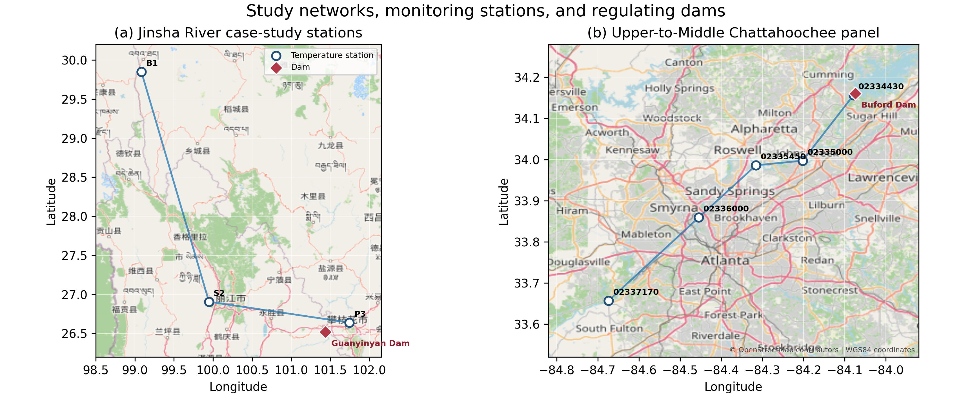 Figure 1. Study networks, monitoring stations, and regulating dams.. (a) Jinsha River case-study stations and Guanyinyan Dam. B1, S2, and P3 are separated by 463 and 558 river km; straight connecting segments indicate station order rather than the detailed river centerline. (b) Upper-to-Middle Chattahoochee sites from immediately below Buford Dam through the Atlanta reach. Station coordinates are documented inventory locations. The Guanyinyan symbol uses a cartographic RCC-dam coordinate; the scientific distance context is the official 27 river km to P3. Basemap © OpenStreetMap contributors.

Figure 2
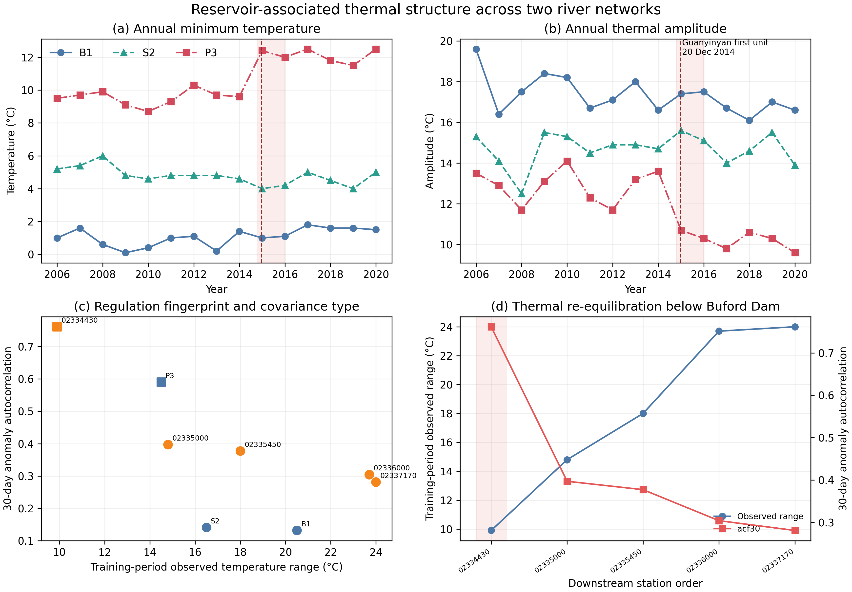 Figure 2. Reservoir-associated thermal structure across two networks.. (a) Annual minimum stream temperature and (b) annual amplitude at B1, S2, and P3; the dashed line marks first-unit generation at Guanyinyan on 20 December 2014 and shading covers commissioning. The line is engineering context, not an estimated change date; formal method-sensitive results are in Figure S1. (c) Fitting-period temperature range versus lag-30 anomaly autocorrelation. Squares are memory-dominated and circles donor-dominated. (d) Chattahoochee downstream profile. Range increases and memory decreases away from Buford Dam. These are observational associations, not a causal heat-budget attribution.

Figure 3
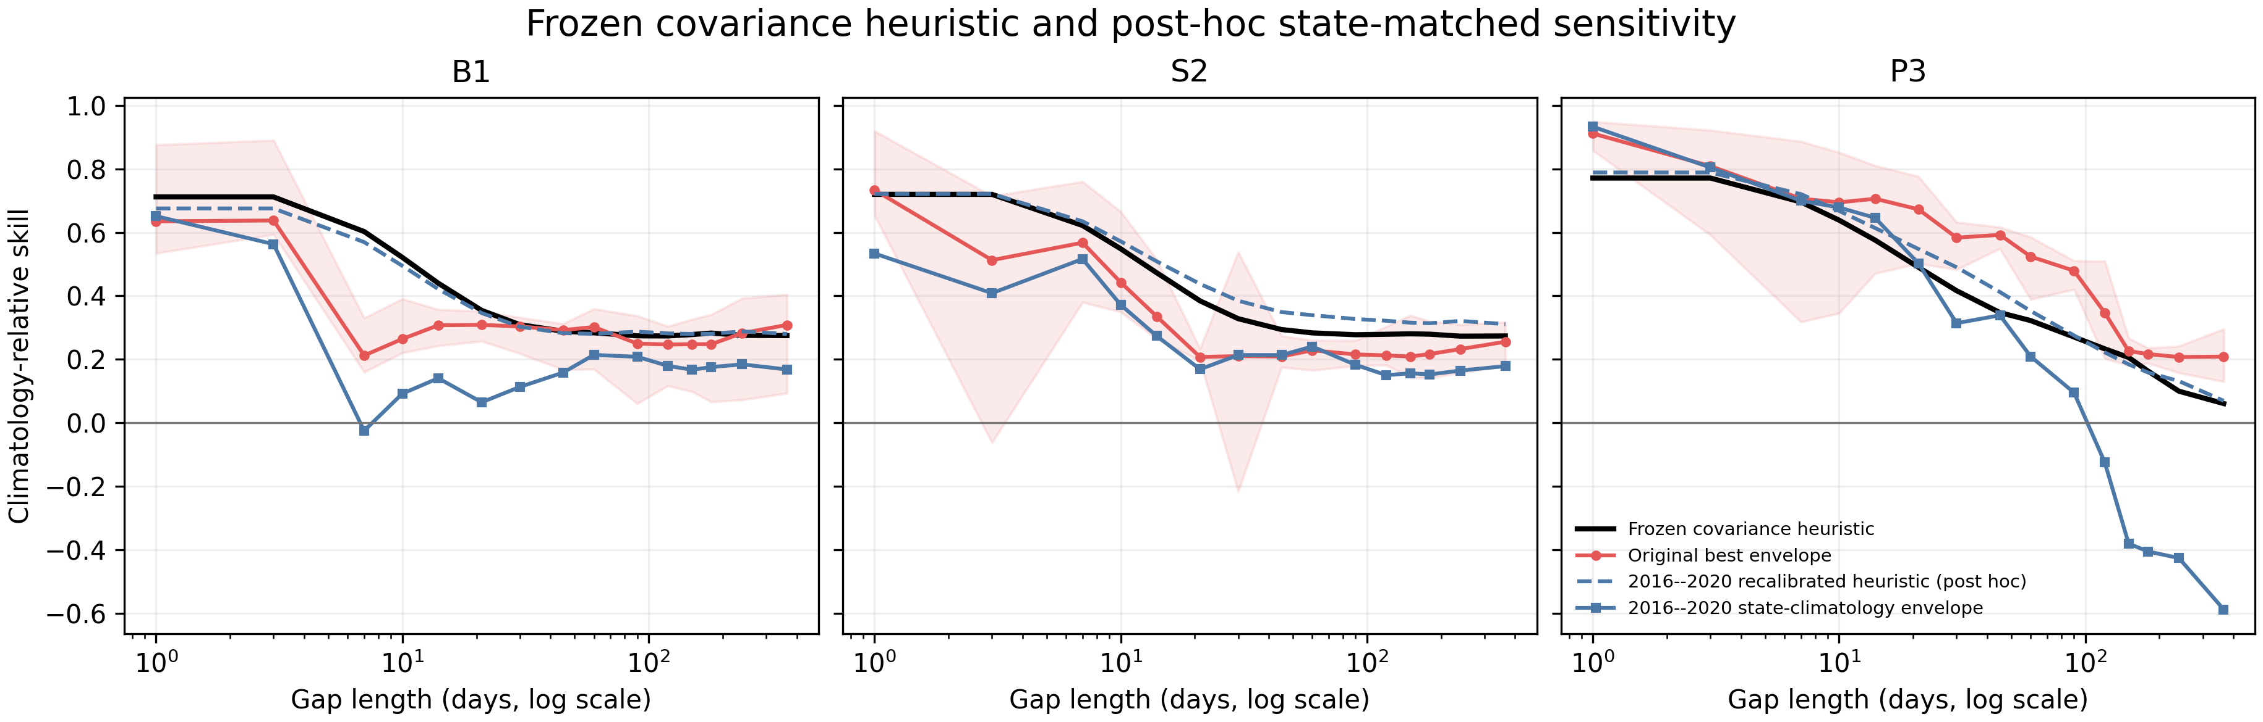 Figure 3. Frozen covariance heuristic and post-hoc thermal-state control.. Best-roster-envelope climatology-relative skill and the train-only heuristic at B1, S2, and P3. Red/black use the original 2006–2015 calibration and denominator; blue re-scores fixed predictions and recalibrates the heuristic to 2016–2020. The blue analysis overlaps evaluated years and diagnoses nonstationarity; it is not predictive evidence. Shading is a descriptive envelope band from the historical anchor/year resampling path. It is not a valid 95% inferential interval: each station has fewer than five independent clusters, so confidence intervals are withheld.

Figure 4
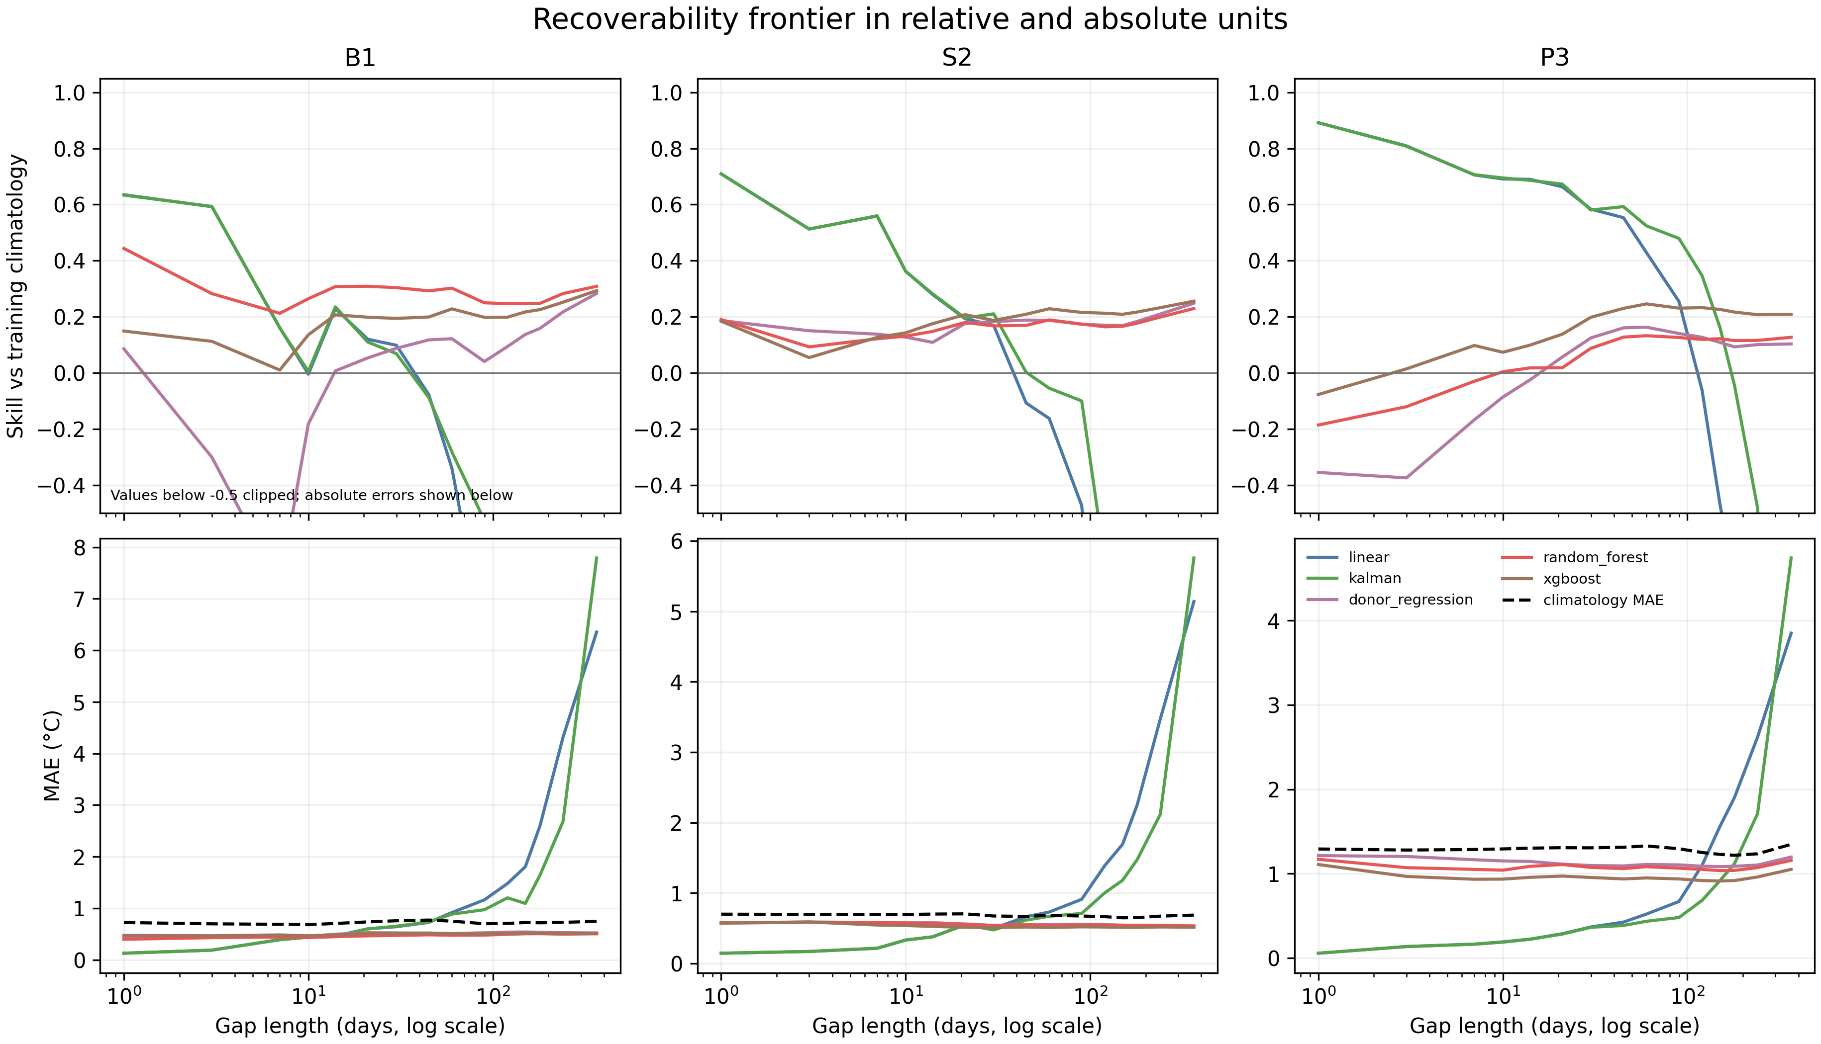 Figure 4. Recoverability in relative and absolute units.. Top: climatology-relative skill for five representative stable methods. Values below -0.5 are clipped for readability. Bottom: the same methods’ MAE in degrees C, with paired training-climatology MAE shown as a black dashed line. All methods use common artificial cells. These are descriptive skill and error curves. Statistical recoverability frontiers and their confidence intervals are withheld.

Figure 5
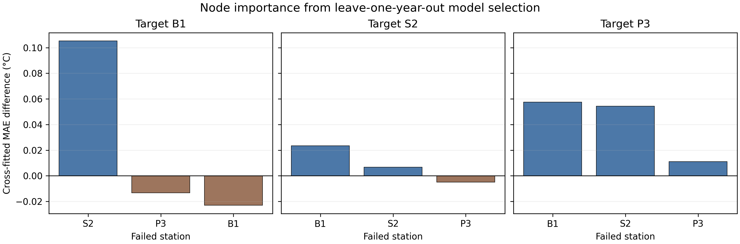 Figure 5. Cross-fitted node importance.. Mean failed-minus-full MAE after each singleton station failure, faceted by target and averaged over 10-, 30-, 90-, and 180-day gaps. For every target, gap, and failure set, the model is selected using the other two evaluation years and scored on the held-out year. Confidence intervals are withheld because only three evaluation years are available. The analysis is a post-hoc non-oracle sensitivity, not independent confirmation or a causal station value.

Figure 6
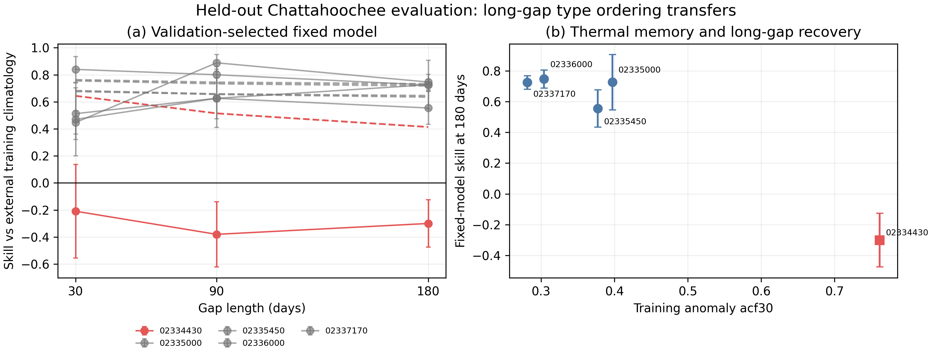 Figure 6. Held-out Chattahoochee post-hoc fixed-model sensitivity.. Mean 2021–2022 validation performance across all gaps and placements selected XGBoost at every site after the confirmatory envelope had been observed. (a) Solid curves score that fixed model on the single 2023–2025 placement; dashed curves are frozen train-only heuristic predictions. Error bars are plus or minus one XGBoost placement SD from 20 validation masks and are not confidence intervals for the held-out point. (b) Fitting-period anomaly memory versus fixed-model 180-day skill. Red identifies memory-dominated site 02334430 below Buford Dam. These scores are not preregistered confirmation.

Figure 7
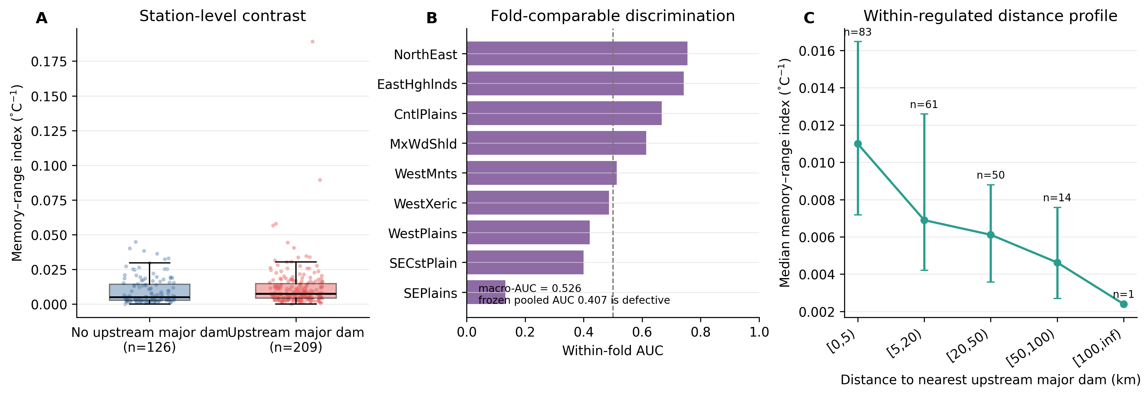 Figure 7. National regulation-panel boundary, not a valid classifier.. (a) Memory–range index by 2009 GAGES-II upstream-major-dam label for 335 eligible stations. (b) Post-hoc within-fold AUC by held-out ecoregion; the valid fold-comparable level is the macro-AUC of 0.526. The frozen pooled leave-one-ecoregion-out AUC of 0.407 is retained only as a preregistered defective diagnostic and is not shown as the headline ROC. (c) Within regulated watersheds, median index declines across 0–5, 5–20, 20–50, and 50–100 km nearest-major-dam bins; whiskers show the interquartile range. The greater-than-100-km bin contains one station and is not interpreted.
Bal, Guillaume, and Elvira de Eyto. 2023. “Simple Bayesian Reconstruction and Forecasting of Stream Water Temperature for Ecologists—a Tool Using Air Temperature, Optionally Flow, in a Time Series Decomposition Approach.” PLOS ONE 18 (9): e0291239. https://doi.org/10.1371/journal.pone.0291239.
China Datang Corporation. 2026. Twenty Years of Guanyinyan Hydropower Development. Corporate project history. https://www.china-cdt.com/dtwz/xwzx/sdbd/2026/6/I1516080066600108032.html.
Dorthe, David, Michael Pfister, and Stuart N. Lane. 2025. “Model Inputs and Data Requirements for Process-Based Stream Temperature Modeling in Regulated Peri-Alpine Rivers.” Water Resources Research 61: e2024WR038860. https://doi.org/10.1029/2024WR038860.
Falcone, James A. 2011. GAGES-II: Geospatial Attributes of Gages for Evaluating Streamflow. U.S. Geological Survey data release. https://doi.org/10.5066/P96CPHOT.
Johnson, Zachary C., Brittany G. Johnson, Martin A. Briggs, Craig D. Snyder, Nathaniel P. Hitt, and Warren D. Devine. 2021. “Heed the Data Gap: Guidelines for Using Incomplete Datasets in Annual Stream Temperature Analyses.” Ecological Indicators 122: 107229. https://doi.org/10.1016/j.ecolind.2020.107229.
Li, Han, Xinwei Deng, and Eric Smith. 2017. “Missing Data Imputation for Paired Stream and Air Temperature Sensor Data.” Environmetrics 28 (1): e2426. https://doi.org/10.1002/env.2426.
Liu, Zhicheng, Di Zhang, Junqiang Lin, et al. 2025. “Spatiotemporal Evolution of Thermal Structure and Released-Water Temperature Lag in Wudongde Reservoir.” Water Resources and Hydropower Engineering 56 (4): 145–57. https://doi.org/10.13928/j.cnki.wrahe.2025.04.012.
Malcolm Dunstan and Associates. 2026. Guanyinyan Dam: RCC Dam Database Record RCCDAM0643. Cartographic dam record. https://rccdams.co.uk/dams/guanyinyan/.
Michel, Cyril J., Miles E. Daniels, and Eric M. Danner. 2023. “Discharge-Mediated Temperature Management in a Large, Regulated River, with Implications for Management of Endangered Fish.” Water Resources Research 59: e2023WR035077. https://doi.org/10.1029/2023WR035077.
Michie, Laura E., James N. Hitchcock, Jason D. Thiem, Craig A. Boys, and Simon M. Mitrovic. 2020. “The Effect of Varied Dam Release Mechanisms and Storage Volume on Downstream River Thermal Regimes.” Limnologica 81: 125760. https://doi.org/10.1016/j.limno.2020.125760.
Ministry of Environmental Protection of the People’s Republic of China. 2014. Reply on Environmental-Protection Acceptance for the Impoundment Stage of the Guanyinyan Hydropower Project on the Middle Jinsha River. Official approval, Huan Yan Han [2014] No. 84. https://www.mee.gov.cn/gkml/sthjbgw/spwj1/201412/t20141210_292787.htm.
National Energy Administration of China. 2016. China Electric Power Industry Annual Development Report 2016. Industry development report. https://gzb.nea.gov.cn/dtyw/hyxx/202310/t20231023_192141.html.
Seyedhashemi, Hanieh, Florentina Moatar, Jean-Philippe Vidal, et al. 2021. “Thermal Signatures Identify the Influence of Dams and Ponds on Stream Temperature at the Regional Scale.” Science of The Total Environment 766: 142667. https://doi.org/10.1016/j.scitotenv.2020.142667.
U.S. Army Corps of Engineers. 2026. National Inventory of Dams Public Web-GIS Services. Official public feature and mapping services. https://nid.sec.usace.army.mil/nid/.
U.S. Army Corps of Engineers, Mobile District. 2017. Apalachicola–Chattahoochee–Flint River Basin Water Control Manual, Appendix b: Buford Dam and Lake Sidney Lanier. U.S. Army Corps of Engineers. https://water.usace.army.mil/cda/documents/wc/2050/ACF%20Buford_Final_Mar%202017.pdf.
U.S. Geological Survey. 1973. Water Resources Data for Georgia, 1973: Station 02334430, Chattahoochee River at Buford Dam, Near Buford, Georgia. U.S. Geological Survey. https://pubs.usgs.gov/wdr/1973/ga-73-1/report.pdf.
U.S. Geological Survey. 2026. USGS Water Data APIs: Daily Values, Time-Series Metadata, and Monitoring Locations. Official OGC API documentation. https://api.waterdata.usgs.gov/docs/ogcapi.
Wang, Zhangpeng, Jun Ma, Shengde Yu, et al. 2024. “Analysis of Water Temperature Variations in the Yangtze River’s Upper and Middle Reaches in the Context of Cascade Hydropower Development.” Water 16 (12): 1669. https://doi.org/10.3390/w16121669.
Wei, Mengru, Tao Feng, Qiuwen Chen, et al. 2026. “Flow Composition Mediates the Sensitivity to Air Temperature of Streams in a Qinghai-Tibetan Watershed.” Communications Earth & Environment 7 (1): 327. https://doi.org/10.1038/s43247-026-03340-2.
Yang, Yu, Dingguo Jiang, Lili Liang, et al. 2025. “Simulation of Water Temperature and Analysis of Stratified Water Intake Effect of Stoplog Gates at Xiluodu Reservoir.” Water Resources and Hydropower Engineering 56 (9): 143–55. https://doi.org/10.13928/j.cnki.wrahe.2025.09.011.
Zhao, Jiayang, Hui Li, Xiaobin Cai, et al. 2020. “Long-Term (2002–2017) Impacts of Danjiangkou Dam on Thermal Regimes of Downstream Han River (China) Using Landsat Thermal Infrared Imagery.” Journal of Hydrology 589: 125135. https://doi.org/10.1016/j.jhydrol.2020.125135.

