Let’s take a look at the following context diagram of payroll system.

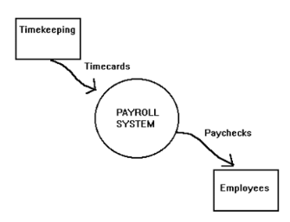

**1. Design level-1 DFD based on following scenario.**

|  |
| --- |
| Payroll system is divided into two processes, verify payroll data and calculate pay. To verify payroll data, it takes timecards from Timekeeping and current status from employee datastore and generate valid payroll data. Along with valid payroll data, calculate pay process receives exemption data from withholding datastore and generate Net pay and deduction which is saved into employee datastore, posting information which is saved into payroll journal datastore and send paychecks to Employees. |

**2. Design level-2 DFD based on following scenario.**

|  |
| --- |
| *Calculate pay process* is decomposed in two processes, compute net pay and prepare payroll. Compute net pay process take valid payroll data and exemption data from withholding datastore and generate Net pay and deduction which is saved to employee datastore and also sends to prepare payroll process. Finally prepare payroll process saves posting information to payroll journal datastore and send paychecks to Employees. |