Author Name: Shutirtha Roy ID: 105008711

Project URL: https://mercury.swin.edu.au/cos80021/s105008711/Project1/src/pages/home/shiponline.php

Code Instructions:

In the public folder, only statics files are kept like css. In the src folder, all codes files are kept. Here, the database is connected through the src/configuration/connection/connect.php folder. The main pages are kept in the src/pages/ folder which includes the other files to make it over. The files are arranged separately so that the project is scalable and so that the code is clean. For example, src/pages/account/register.php calls src/service/account_service.php to access the function which contains all the login. The account_service.php file calls src/helpers/account_validation.php for validation and src/repository/account_repository.php to access the database related queries. All the constants are stored in the src/configuration/constants folder.

Web Application Instructions:

At first browse the web application with the help of URL. Then you will see this page.

Users have the option to Login, Register and see the admin page. When the user clicks on Get Started, it will take to the Login Page. When the user clicks on Register (register.php), this page is shown.

Over here the user is trying to Register into the system. When the customer registers, pre-request-shipment.php page is open which shows the Dashboard and the confirmation page with the unique customer ID.

Over here the user is logged in and when the user clicks on Request Shipments or Start Your Shipment it will open the request.php page. Before going to request.php page, let’s look at the login.php page by clicking on Logout (logout.php) and then by clicking on Login.

After that it is redirected to the request page.

After writing all the inputs, a message is shown below the request page and an email is sent.

The customer will receive an email.

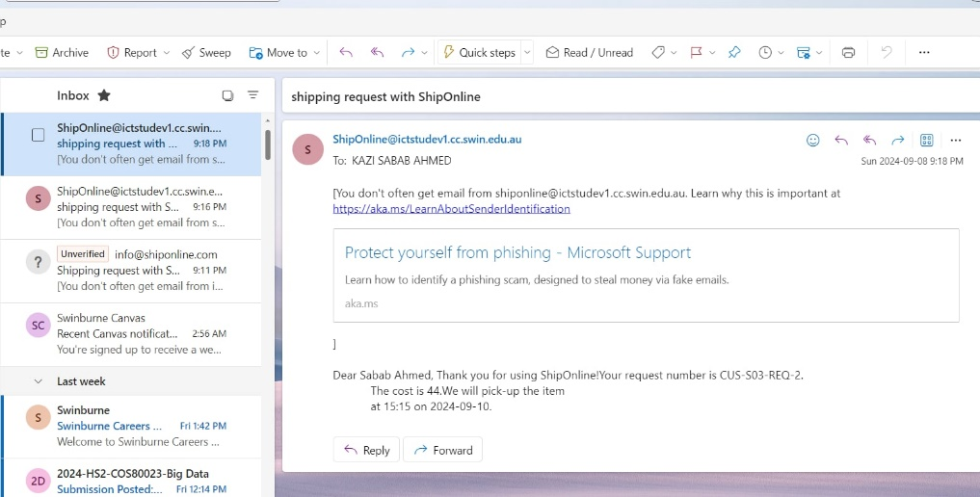

The admin page (admin.php) can be accessed only by logging out (logout.php). When the admin.php page is clicked, this page opens.

When request date is selected with the retrieval date then this data is shown which shows the table correctly.

When pick up date is selected with the retrieval date then this data is shown which shows the table sorted correctly.

List of all files:

1. Folder: public/css/

* admin.css
* home-ship-online.css
* login.css
* pre-request.shipment.css
* register.css
* request-shipment.css

1. Folder: src/configuration/

* connection/connect.php
* constants/account-service-contants.php
* constants/database-constants.php
* constants/ database-server-constants.php
* constants/ request-service-contants.php

1. Folder: src/helpers/

* account_validation.php
* request_validation.php

1. Folder: src/pages/

* account/login.php
* account/logout.php
* account/register.php
* admin/admin.php
* common/nav.php
* home/shiponline.php
* request_shipment/pre-request-shipment.php
* request_shipment/request-shipment.php

1. Folder: src/repository/

* account_repository.php
* admin_repository.php
* repository.php
* request_repository.php

1. Folder: src/service/

* account_service.php
* admin_service.php
* request_service.php