ОТЧЕТ ПО РАЗРАБОТКЕ ВЕБ-САЙТА
"Библиотечная информационная система"

Выполнил студент
3 курса К.305c11-1 группы
Шутов Евгений Николаевич

1. ДИАГРАММЫ
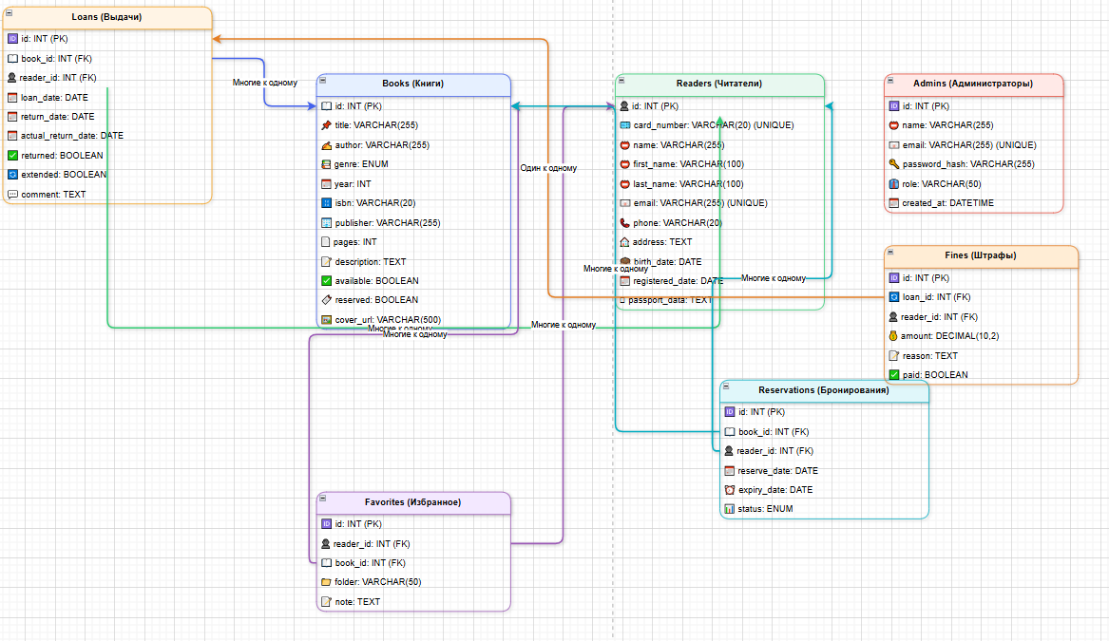
2. Ссылки
2.1. GitHub
Ссылка: https://github.com/shutov321/shutov305.git
2.2. Хостинг
Ссылка: vudysm7o.beget.tech
Админ: admin@library.ru / admin123
Читатель: user@library.ru / user123

3. СКРИНШОТЫ РЕАЛИЗАЦИИ
3.1. Скриншоты страниц сайта
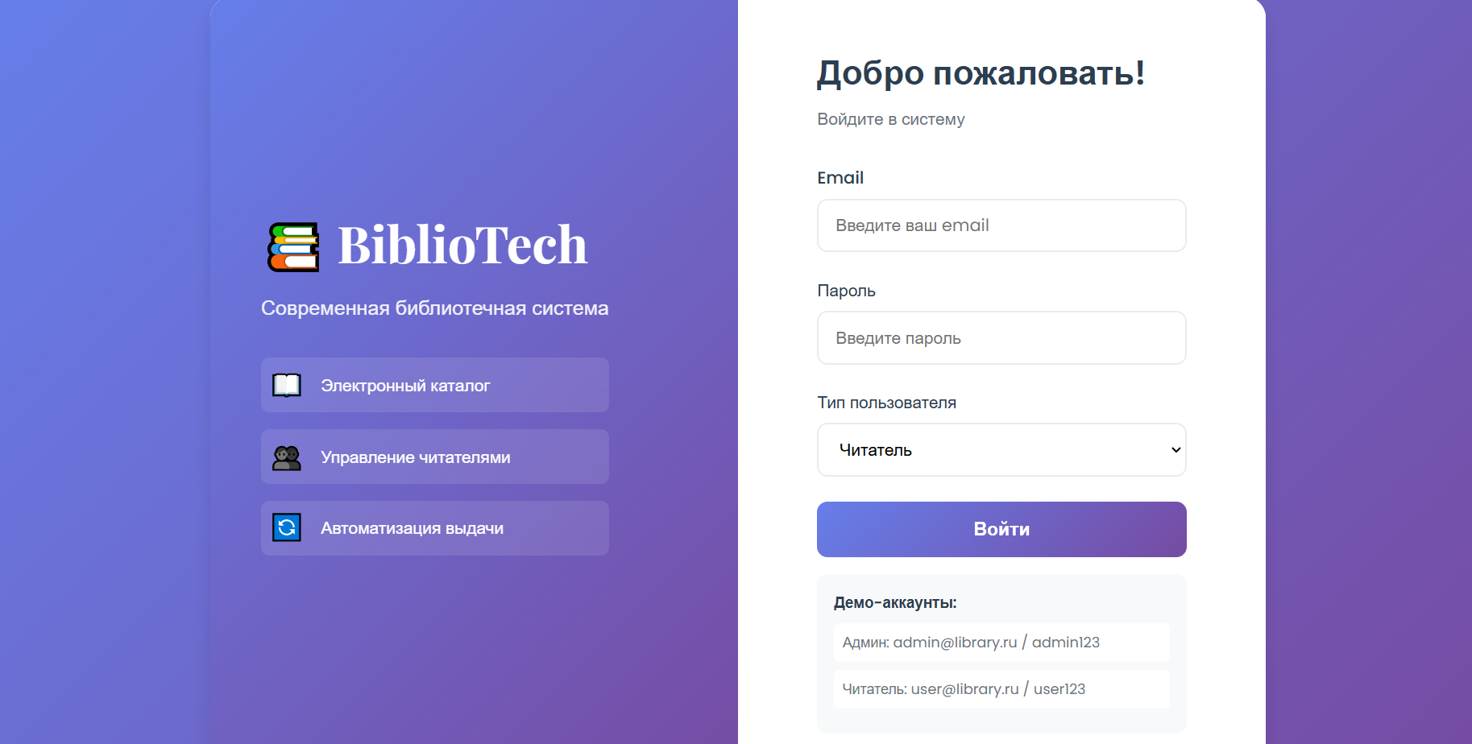
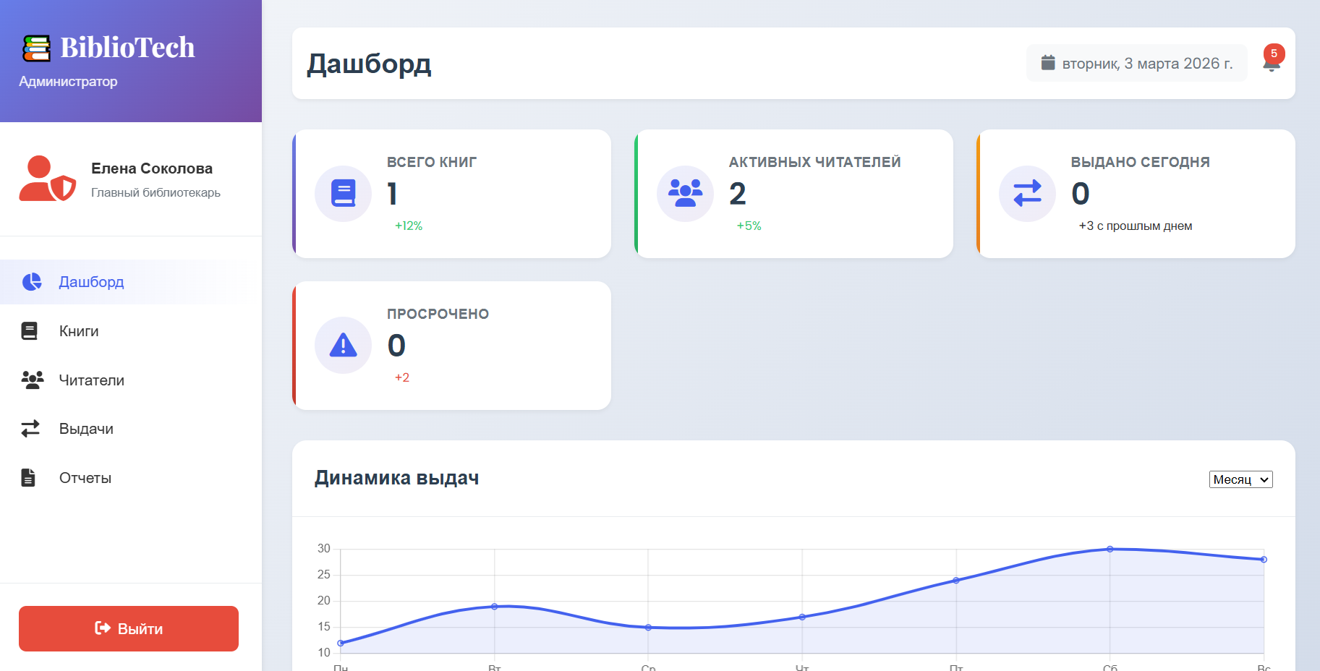
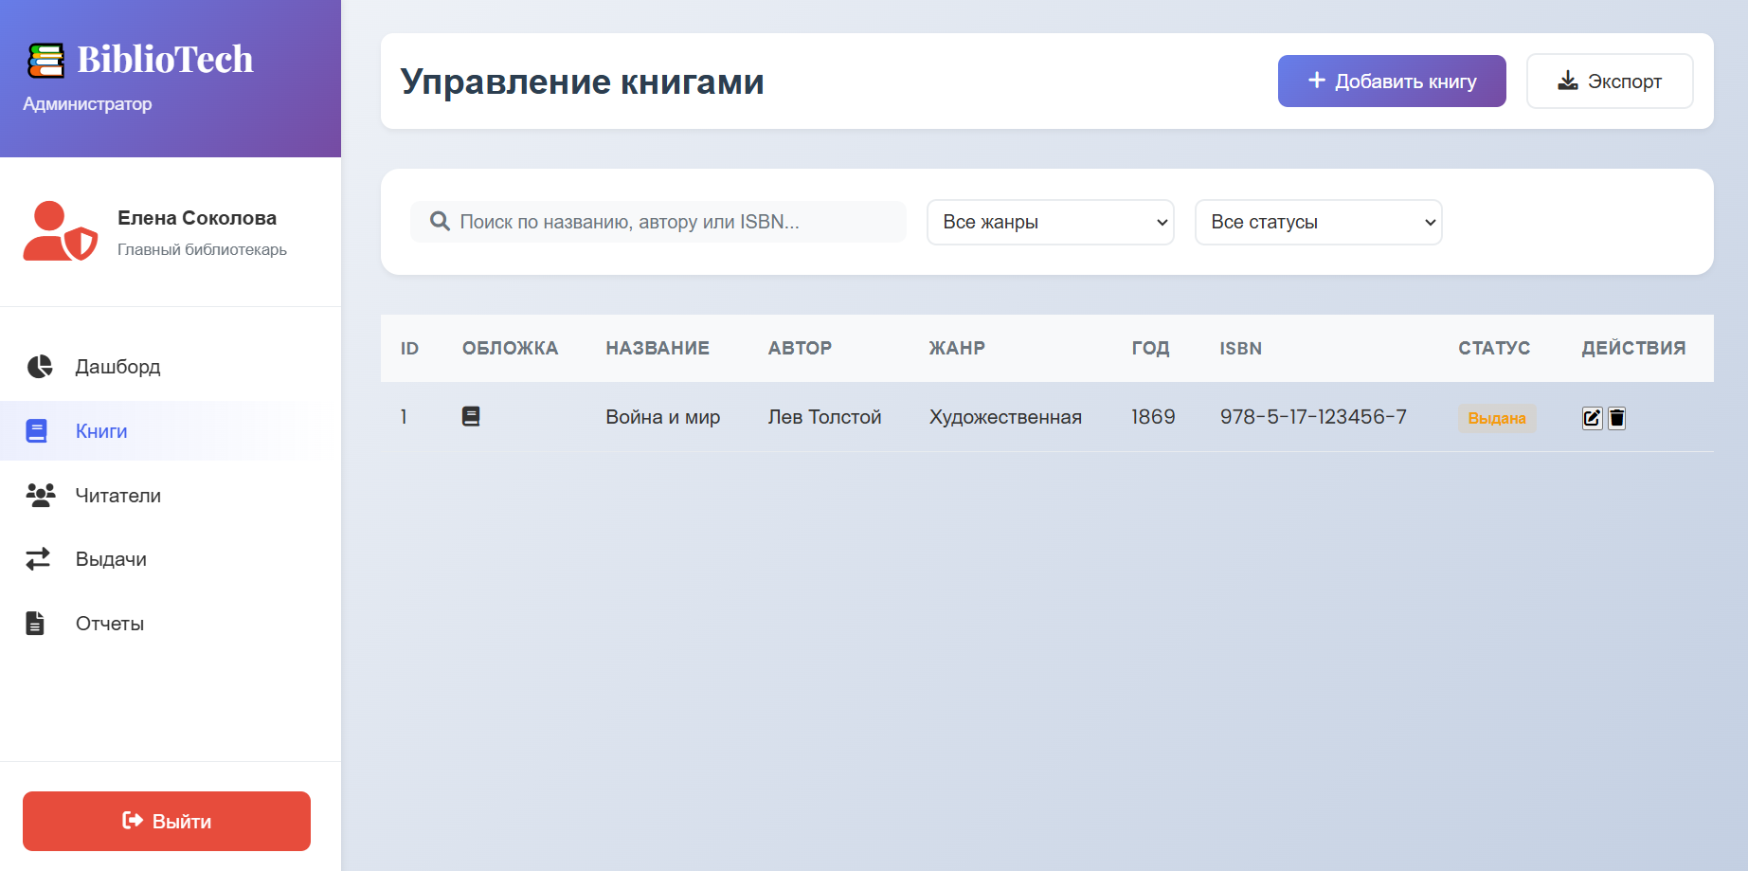
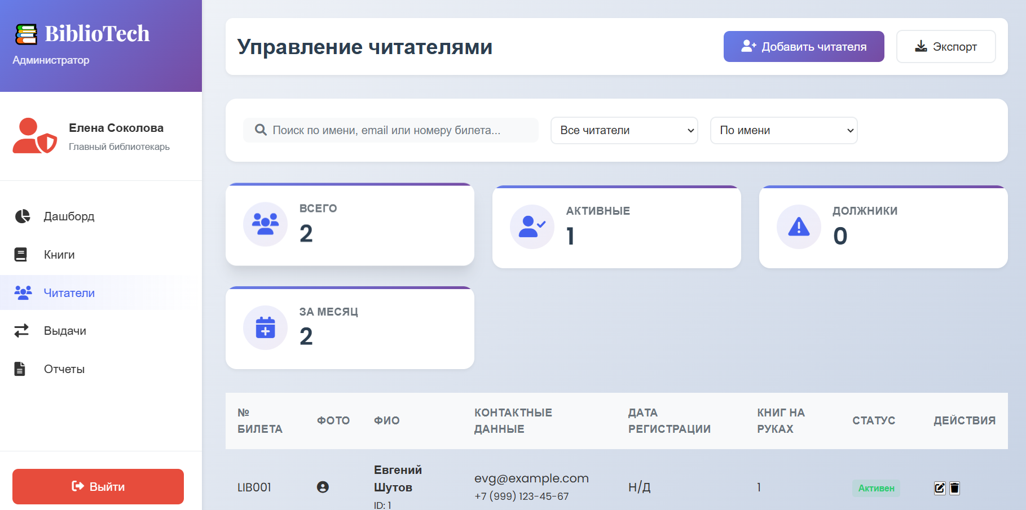
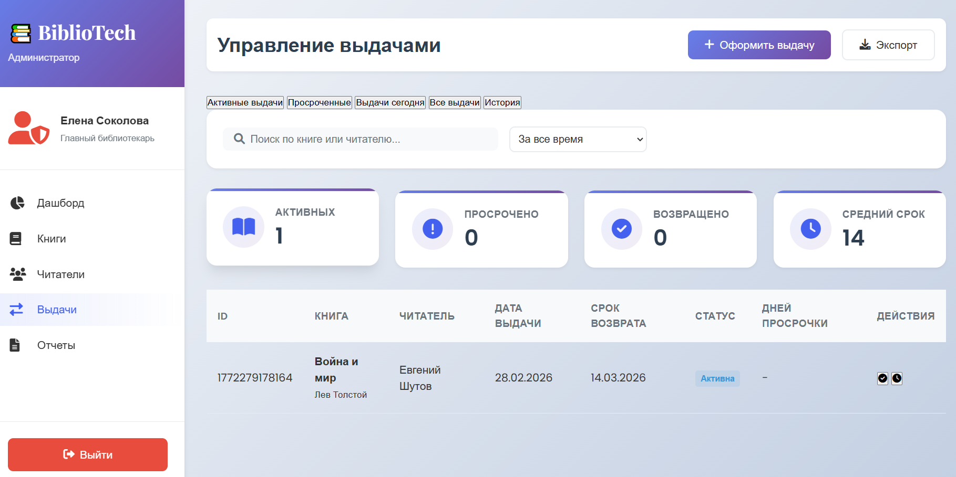

Страницы читателя:
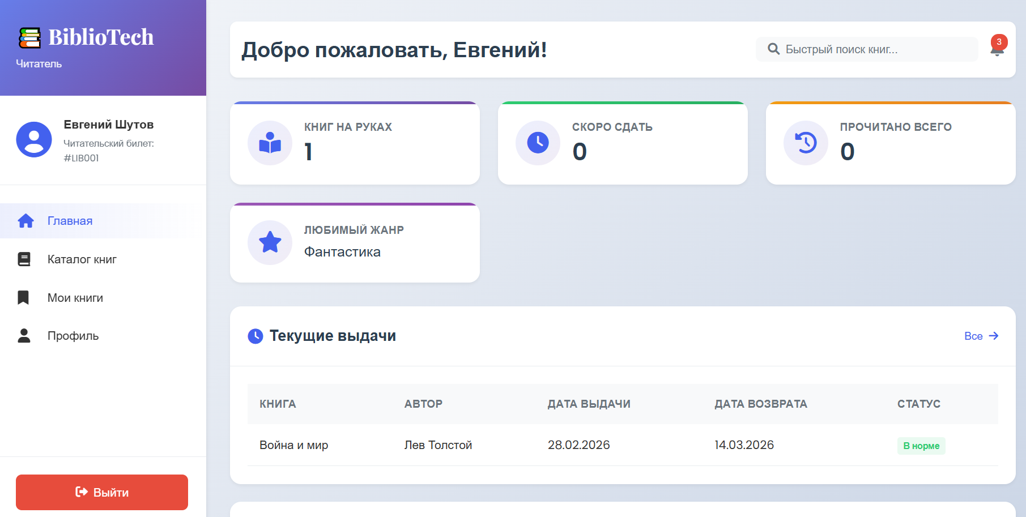
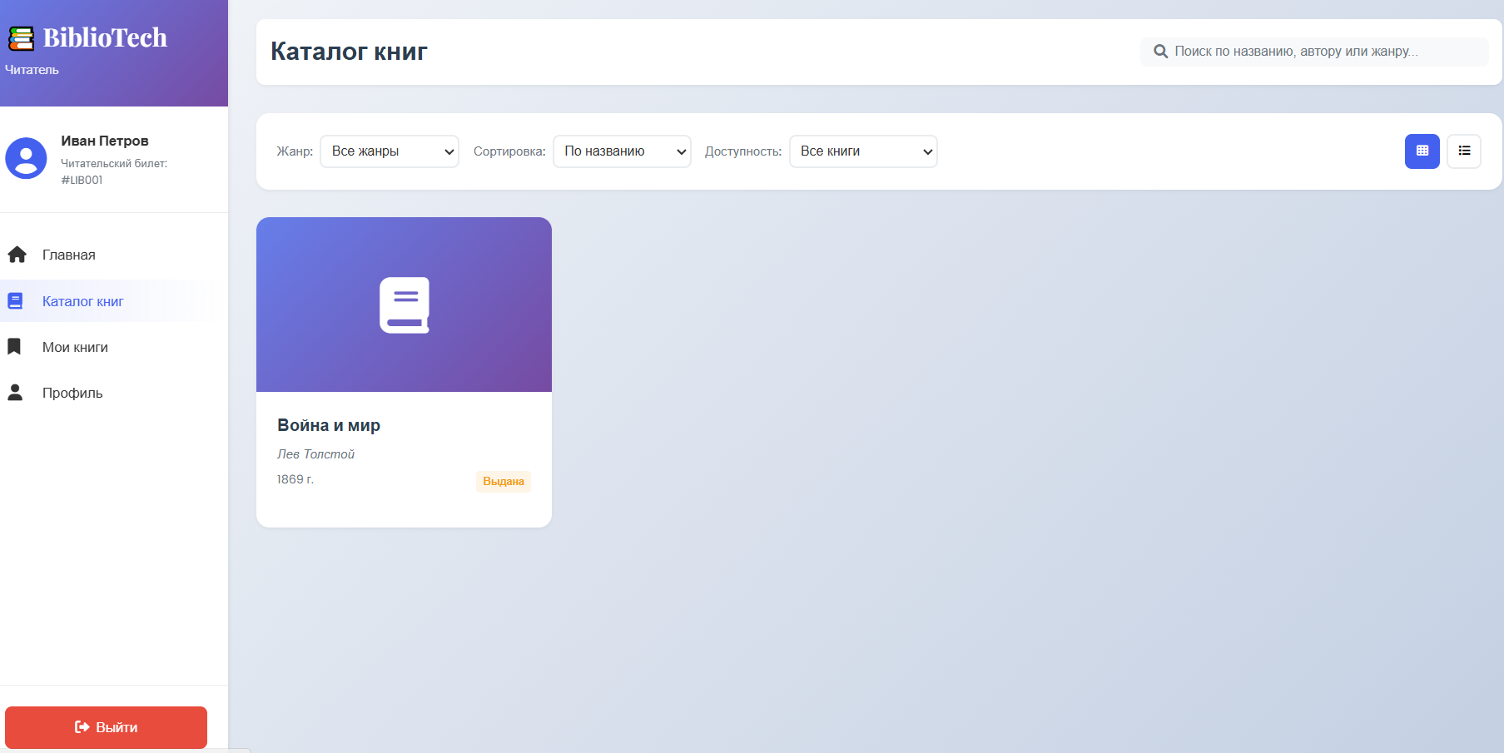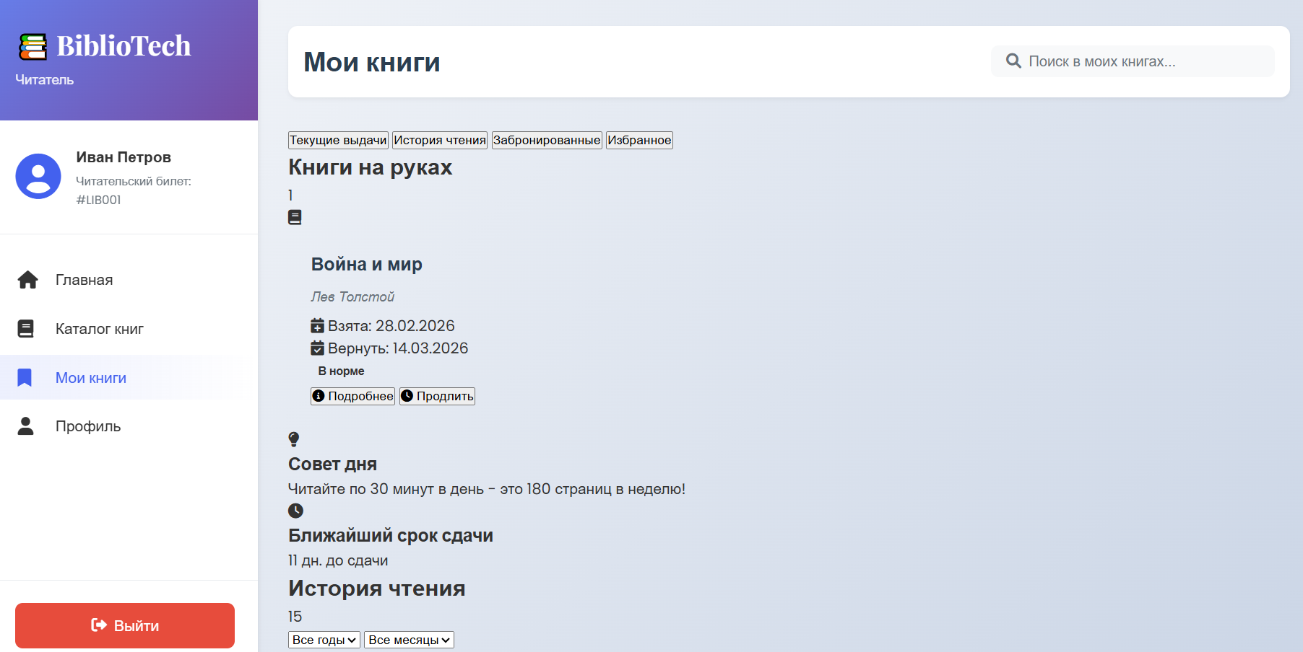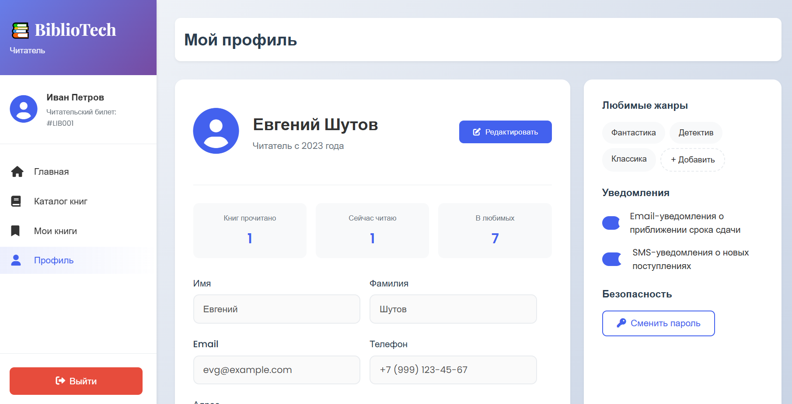
3.2. Скриншоты базы данных
Структура таблиц в phpMyAdmin: 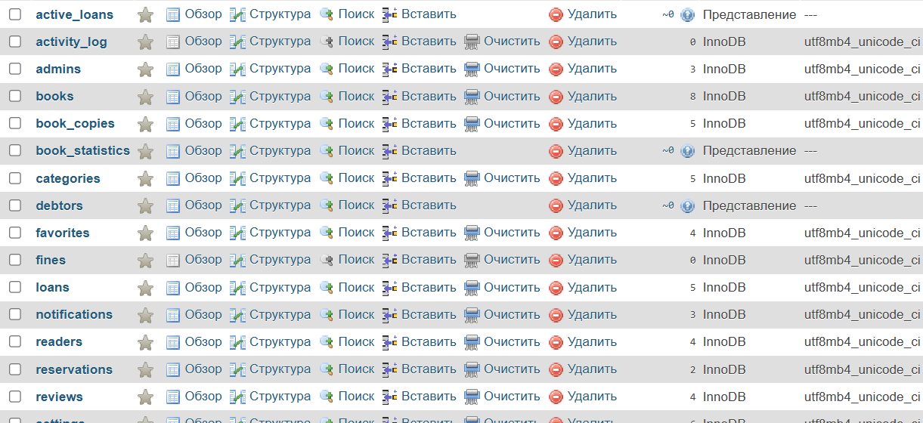
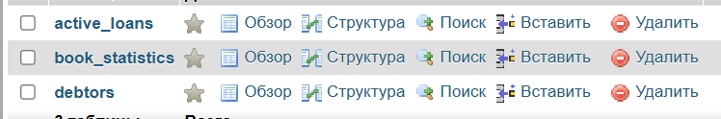

4. ФРАГМЕНТЫ ПРОГРАММНОГО КОДА
4.1. Подключение к базе данных (config/database.php)
<?php
/**
* Класс для подключения к базе данных
* Использует паттерн Singleton для единственного подключения
*/
class Database {
private static $instance = null;
private $connection;

// Параметры подключения
private $host = 'localhost';
private $dbname = 'bibliotech';
private $username = 'bibliotech_user';
private $password = 'SecurePass123!';
private $charset = 'utf8mb4';

/**
* Приватный конструктор (Singleton)
*/
private function __construct() {
try {
$dsn = "mysql:host={$this->host};dbname={$this->dbname};charset={$this->charset}";
$options = [
PDO::ATTR_ERRMODE => PDO::ERRMODE_EXCEPTION,
PDO::ATTR_DEFAULT_FETCH_MODE => PDO::FETCH_ASSOC,
PDO::ATTR_EMULATE_PREPARES => false,
PDO::MYSQL_ATTR_INIT_COMMAND => "SET NAMES utf8mb4"
];

$this->connection = new PDO($dsn, $this->username, $this->password, $options);

} catch(PDOException $e) {
error_log("Database connection failed: " . $e->getMessage());
throw new Exception("Database connection failed");
}
}

/**
* Получение экземпляра подключения
*/
public static function getInstance() {
if (self::$instance === null) {
self::$instance = new self();
}
return self::$instance->connection;
}

/**
* Защита от клонирования
*/
private function __clone() {}

/**
* Защита от десериализации
*/
public function __wakeup() {
throw new Exception("Cannot unserialize singleton");
}
}
?>
4.2. Авторизация пользователей
<?php
require_once 'config/database.php';

class Auth {
private $db;

public function __construct() {
$this->db = Database::getInstance();
session_start();
}

/**
* Авторизация пользователя
*/
public function login($email, $password, $userType) {
try {
if ($userType === 'admin') {
$query = "SELECT * FROM admins WHERE email = :email AND is_active = TRUE";
} else {
$query = "SELECT * FROM readers WHERE email = :email AND status = 'active'";
}

$stmt = $this->db->prepare($query);
$stmt->execute(['email' => $email]);
$user = $stmt->fetch();

if ($user && password_verify($password, $user['password_hash'])) {
$_SESSION['user_id'] = $user['id'];
$_SESSION['user_type'] = $userType;
$_SESSION['user_name'] = $user['name'];

// Логирование входа
$this->logActivity($user['id'], $userType, 'login');

return [
'success' => true,
'user' => [
'id' => $user['id'],
'name' => $user['name'],
'email' => $user['email'],
'type' => $userType
]
];
}

return ['success' => false, 'message' => 'Неверный email или пароль'];

} catch(PDOException $e) {
error_log("Login error: " . $e->getMessage());
return ['success' => false, 'message' => 'Ошибка сервера'];
}
}

/**
* Регистрация нового читателя
*/
public function register($data) {
try {
// Проверка уникальности email
$check = $this->db->prepare("SELECT id FROM readers WHERE email = ?");
$check->execute([$data['email']]);

if ($check->fetch()) {
return ['success' => false, 'message' => 'Email уже зарегистрирован'];
}

// Хеширование пароля
$passwordHash = password_hash($data['password'], PASSWORD_DEFAULT);

// Генерация номера билета
$cardNumber = $this->generateCardNumber();

$query = "INSERT INTO readers (
card_number, name, first_name, last_name,
email, phone, address, birth_date, password_hash,
registered_date
) VALUES (
:card_number, :name, :first_name, :last_name,
:email, :phone, :address, :birth_date, :password_hash,
CURDATE()
)";

$stmt = $this->db->prepare($query);
$stmt->execute([
'card_number' => $cardNumber,
'name' => $data['first_name'] . ' ' . $data['last_name'],
'first_name' => $data['first_name'],
'last_name' => $data['last_name'],
'email' => $data['email'],
'phone' => $data['phone'],
'address' => $data['address'],
'birth_date' => $data['birth_date'],
'password_hash' => $passwordHash
]);

$readerId = $this->db->lastInsertId();

return [
'success' => true,
'message' => 'Регистрация успешна',
'card_number' => $cardNumber
];

} catch(PDOException $e) {
error_log("Registration error: " . $e->getMessage());
return ['success' => false, 'message' => 'Ошибка регистрации'];
}
}

/**
* Выход из системы
*/
public function logout() {
if (isset($_SESSION['user_id'])) {
$this->logActivity($_SESSION['user_id'], $_SESSION['user_type'], 'logout');
}

session_destroy();
return ['success' => true];
}

/**
* Проверка авторизации
*/
public function checkAuth() {
return isset($_SESSION['user_id']);
}

/**
* Генерация номера читательского билета
*/
private function generateCardNumber() {
$prefix = 'LIB';
$year = date('Y');

$query = "SELECT COUNT(*) as count FROM readers WHERE YEAR(registered_date) = YEAR(CURDATE())";
$result = $this->db->query($query)->fetch();
$number = str_pad($result['count'] + 1, 4, '0', STR_PAD_LEFT);

return $prefix . $year . $number;
}

/**
* Логирование действий
*/
private function logActivity($userId, $userType, $action, $details = []) {
try {
$query = "INSERT INTO activity_log (
user_id, user_type, action, details,
ip_address, user_agent, created_at
) VALUES (
:user_id, :user_type, :action, :details,
:ip_address, :user_agent, NOW()
)";

$stmt = $this->db->prepare($query);
$stmt->execute([
'user_id' => $userId,
'user_type' => $userType,
'action' => $action,
'details' => json_encode($details),
'ip_address' => $_SERVER['REMOTE_ADDR'] ?? null,
'user_agent' => $_SERVER['HTTP_USER_AGENT'] ?? null
]);

} catch(Exception $e) {
error_log("Activity log error: " . $e->getMessage());
}
}
}

// Обработка AJAX запросов
if ($_SERVER['REQUEST_METHOD'] === 'POST') {
$auth = new Auth();
$data = json_decode(file_get_contents('php://input'), true);

switch($data['action']) {
case 'login':
echo json_encode($auth->login($data['email'], $data['password'], $data['userType']));
break;

case 'register':
echo json_encode($auth->register($data));
break;

case 'logout':
echo json_encode($auth->logout());
break;

case 'check':
echo json_encode(['authenticated' => $auth->checkAuth()]);
break;
}
}
?>

4.3. Управление книгами (models/Application.php)
<?php
require_once 'config/database.php';
require_once 'auth.php';

class Books {
private $db;
private $auth;

public function __construct() {
$this->db = Database::getInstance();
$this->auth = new Auth();
}

/**
* Получение списка книг с фильтрацией
*/
public function getBooks($params = []) {
try {
$search = $params['search'] ?? '';
$genre = $params['genre'] ?? 'all';
$available = $params['available'] ?? false;
$sort = $params['sort'] ?? 'title';
$page = $params['page'] ?? 1;
$limit = $params['limit'] ?? 12;
$offset = ($page - 1) * $limit;

// Использование хранимой процедуры
$query = "CALL search_books(:search, :genre, :available)";
$stmt = $this->db->prepare($query);
$stmt->execute([
'search' => $search,
'genre' => $genre,
'available' => $available
]);

$books = $stmt->fetchAll();

// Сортировка
if ($sort === 'title') {
usort($books, fn($a, $b) => strcmp($a['title'], $b['title']));
} elseif ($sort === 'author') {
usort($books, fn($a, $b) => strcmp($a['author'], $b['author']));
} elseif ($sort === 'year_desc') {
usort($books, fn($a, $b) => $b['year'] - $a['year']);
}

// Пагинация
$total = count($books);
$books = array_slice($books, $offset, $limit);

return [
'success' => true,
'data' => $books,
'pagination' => [
'total' => $total,
'page' => $page,
'limit' => $limit,
'pages' => ceil($total / $limit)
]
];

} catch(PDOException $e) {
error_log("Get books error: " . $e->getMessage());
return ['success' => false, 'message' => 'Ошибка получения данных'];
}
}

/**
* Добавление новой книги (только для админов)
*/
public function addBook($data) {
try {
// Проверка прав доступа
if (!$this->checkAdminAccess()) {
return ['success' => false, 'message' => 'Доступ запрещен'];
}

// Валидация данных
$this->validateBookData($data);

$query = "INSERT INTO books (
title, author, genre, year, isbn,
publisher, pages, description, cover_url
) VALUES (
:title, :author, :genre, :year, :isbn,
:publisher, :pages, :description, :cover_url
)";

$stmt = $this->db->prepare($query);
$stmt->execute([
'title' => $data['title'],
'author' => $data['author'],
'genre' => $data['genre'],
'year' => $data['year'],
'isbn' => $data['isbn'],
'publisher' => $data['publisher'] ?? null,
'pages' => $data['pages'] ?? null,
'description' => $data['description'] ?? null,
'cover_url' => $data['cover_url'] ?? null
]);

$bookId = $this->db->lastInsertId();

// Логирование действия
$this->logAction('add_book', ['book_id' => $bookId]);

return [
'success' => true,
'message' => 'Книга успешно добавлена',
'book_id' => $bookId
];

} catch(Exception $e) {
error_log("Add book error: " . $e->getMessage());
return ['success' => false, 'message' => $e->getMessage()];
}
}

/**
* Редактирование книги
*/
public function updateBook($id, $data) {
try {
if (!$this->checkAdminAccess()) {
return ['success' => false, 'message' => 'Доступ запрещен'];
}

$this->validateBookData($data, true);

$fields = [];
$params = ['id' => $id];

$updatable = ['title', 'author', 'genre', 'year', 'isbn',
'publisher', 'pages', 'description', 'cover_url'];

foreach ($updatable as $field) {
if (isset($data[$field])) {
$fields[] = "$field = :$field";
$params[$field] = $data[$field];
}
}

if (empty($fields)) {
return ['success' => false, 'message' => 'Нет данных для обновления'];
}

$query = "UPDATE books SET " . implode(', ', $fields) . " WHERE id = :id";
$stmt = $this->db->prepare($query);
$stmt->execute($params);

$this->logAction('update_book', ['book_id' => $id]);

return ['success' => true, 'message' => 'Книга обновлена'];

} catch(Exception $e) {
error_log("Update book error: " . $e->getMessage());
return ['success' => false, 'message' => $e->getMessage()];
}
}

/**
* Удаление книги
*/
public function deleteBook($id) {
try {
if (!$this->checkAdminAccess()) {
return ['success' => false, 'message' => 'Доступ запрещен'];
}

// Проверка наличия активных выдач
$check = $this->db->prepare(
"SELECT id FROM loans WHERE book_id = ? AND returned = FALSE"
);
$check->execute([$id]);

if ($check->fetch()) {
return ['success' => false, 'message' => 'Нельзя удалить книгу с активными выдачами'];
}

$query = "DELETE FROM books WHERE id = ?";
$stmt = $this->db->prepare($query);
$stmt->execute([$id]);

$this->logAction('delete_book', ['book_id' => $id]);

return ['success' => true, 'message' => 'Книга удалена'];

} catch(PDOException $e) {
error_log("Delete book error: " . $e->getMessage());
return ['success' => false, 'message' => 'Ошибка удаления'];
}
}

/**
* Валидация данных книги
*/
private function validateBookData($data, $isUpdate = false) {
$errors = [];

if (!$isUpdate || isset($data['title'])) {
if (empty($data['title'])) {
$errors[] = 'Название книги обязательно';
}
}

if (!$isUpdate || isset($data['author'])) {
if (empty($data['author'])) {
$errors[] = 'Автор обязателен';
}
}

if (!$isUpdate || isset($data['isbn'])) {
if (!empty($data['isbn']) && !preg_match('/^\d{13}$/', preg_replace('/[^0-9]/', '', $data['isbn']))) {
$errors[] = 'Неверный формат ISBN';
}
}

if (!$isUpdate || isset($data['year'])) {
if (!empty($data['year']) && ($data['year'] < 1000 || $data['year'] > date('Y'))) {
$errors[] = 'Некорректный год издания';
}
}

if (!empty($errors)) {
throw new Exception(implode(', ', $errors));
}
}

/**
* Проверка прав администратора
*/
private function checkAdminAccess() {
return isset($_SESSION['user_type']) && $_SESSION['user_type'] === 'admin';
}

/**
* Логирование действий
*/
private function logAction($action, $details = []) {
$query = "INSERT INTO activity_log (user_id, user_type, action, details)
VALUES (:user_id, :user_type, :action, :details)";

$stmt = $this->db->prepare($query);
$stmt->execute([
'user_id' => $_SESSION['user_id'] ?? null,
'user_type' => $_SESSION['user_type'] ?? 'system',
'action' => $action,
'details' => json_encode($details)
]);
}
}

// REST API endpoint
header('Content-Type: application/json');

$books = new Books();

switch($_SERVER['REQUEST_METHOD']) {
case 'GET':
echo json_encode($books->getBooks($_GET));
break;

case 'POST':
$data = json_decode(file_get_contents('php://input'), true);
echo json_encode($books->addBook($data));
break;

case 'PUT':
$data = json_decode(file_get_contents('php://input'), true);
$id = $_GET['id'] ?? null;
if ($id) {
echo json_encode($books->updateBook($id, $data));
}
break;

case 'DELETE':
$id = $_GET['id'] ?? null;
if ($id) {
echo json_encode($books->deleteBook($id));
}
break;
}
?>

