CURRICULUM VITAE

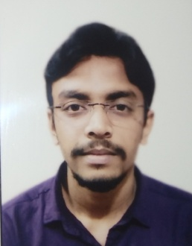

**Shuvam Das**

Raghunathpur,Daspara,Monshatola, Dankuni, Hooghly, West Bengal.

PIN : 712247

mail:dasshubham453@gmail.com

Mobile No: +917003799673(M)

Skype ID :.cid.1d34b4fa02e74e2e

# Objective:-

To obtain a challenging position in a dynamic organization and be an integral part of growth oriented company. To utilize and grow my skills and experience in the organization.

* Positive attitude and eagerness to learn.
* To make company more profitable.

# Working experience: -

## Jr. Graphics Designer in PixelSolutionz Pvt. Ltd. 25th January 2021 to 28th February 2021.

## Web Designer in Atone Mark Pvt. Ltd. 9th March 2021 to 31th May 2021

# Technical Qualification:-

|  |  |  |  |  |  |  |  |  |  |  |
| --- | --- | --- | --- | --- | --- | --- | --- | --- | --- | --- |
| Institution | Discipline / Stream | Council | 3 Year Diploma Semester wise break – up % Marks | | | | | | | Year of passing out |
| Technique Polytechnic Institute,  Hooghly, West Bengal | **Diploma** in Computer Science & Technology | West Bengal State Council of Technical and Vocational Education and Skill Development | 1st  Sem | 2nd  Sem | 3rd  Sem | 4th  Sem | 5th  Sem | 6th  Sem | Average % upto ____ Semester | 2020 |
| 65.4 | 75.2 | 65.8 | 63.7 | 61.6 | 90 | 70.3% |

Educational Qualification:-

|  |  |  |  |  |  |
| --- | --- | --- | --- | --- | --- |
| Exam | Institution Name | Board | Subjects taken | % of Marks | Year of Passing |
| 10th Standard | Raghunathpur Nafar Academy | WBBSE | Bengali,English,Maths,Phy.Sc,  Life.Sc, History, Geography, | 50. 4% | 2015 |
| 12th Standard | Bally Jora-Aswattha Tala Vidyalaya | WBCHSE | Bengali, English,Accountancy,  Business Studies, Commercial Law, Costing & Taxation, | 55% | 2017 |

## Technical Skill:-

* Skills : HTML(5)

: CSS(3)

: Photoshop

: Bootstrap(4)

: JavaScript

: JAVA

: C++

: C Programming

* Training : Font End Development from Topstack 80 hrs Training.

## Project:-

* **Resort Booking :** It is a resort booking website. And some many facilities of the resort and there details information. Many room options are available in the website. It's a totally front end development( HTML, CSS, Bootstrap framework, JavaScript ) based.

## Personal Details:-

Name : Shuvam Das

Father’s Name : Sri Gautam Das

Sex : Male

Date of Birth : 24th August 1999

Nationality : Indian

Marital Status : Single

## Languages Known:-

English : Read, Write, Speak well. Hindi : Speak well.

Bengali : Read, Write, Speak well.

Declaration:-

I, Shuvam Das, hereby declare that the above furnished information is authentic to the best of my knowledge.

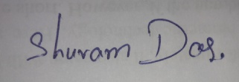

Place: Raghunathpur ___________________

Date: Shuvam Das