Customer Behavior Analysis for Retail Optimization

1. Executive Summary
This project analyzes customer shopping behavior using a synthetic retail dataset of ~3900 records. The objective was to uncover patterns in purchasing behavior, customer segmentation, and revenue drivers to support data-driven business decisions.
Using Python (data cleaning & feature engineering), PostgreSQL (analysis), and Power BI (visualization), the study identified key insights around customer segments, product performance, subscription impact, and discount effectiveness.
Key findings indicate that:
- Male customers contribute significantly higher revenue than female customers
- Loyal customers dominate the customer base and revenue contribution
- Discount strategies are widely used but may not be optimized for profitability
- Subscription status does not significantly increase average spending
- Product performance varies significantly across categories

These insights provide actionable opportunities to optimize marketing, pricing strategies, and customer retention.

2. Business Problem
Retail businesses often struggle to:
- Identify high-value customers
- Optimize discount strategies
- Improve customer retention
- Understand purchasing patterns across segments

This project aims to answer:
“How can customer behavior insights be leveraged to improve revenue and customer engagement?”

3. Dataset Overview
Type: Synthetic retail dataset
Size: 3900 records
Granularity: Customer-level transactions
Key Features:
Demographics: Age, Gender
Purchase behavior: Item, Category, Purchase Amount
Engagement: Subscription Status, Previous Purchases
Transaction details: Shipping Type, Discounts, Payment Method
Derived features:
age_group
purchase_frequency_days

4. Data Preparation (Python)
Key steps performed:
- Handled missing values: Imputed 37 missing review_rating values using median by category
- Standardized column names for consistency
- Feature engineering:
  - Age segmentation (age_group)
  - Purchase frequency normalization (purchase_frequency_days)
- Removed redundant column (promo_code_used)
- Loaded cleaned data into PostgreSQL for analysis
This ensured data consistency, usability, and analytical readiness

5. Data Analysis (PostgreSQL)
Revenue & Demographics
Male Revenue: 157,890
Female Revenue: 75,191
- Male customers contribute ~2x more revenue

Customer Segmentation
Loyal: 3116 (majority)
Returning: 701
New: 83
- Business is heavily dependent on loyal customers

Subscription Impact
Metric | Subscribed | Non-Subscribed
Avg Spend | 59.49 | 59.87
Total Revenue | 62,645 | 170,436

- Subscription does not significantly increase spending

Discount Analysis
839 transactions where discounted purchases exceed average spend
Top discounted products:
Hat (50%)
Sneakers (49%)
- Discounts are widely used but not clearly revenue-optimized

Product Insights
Top-rated products:
- Gloves (3.86)
- Sandals (3.84)
- Boots (3.82)
Top purchased products vary by category:
- Clothing: Blouse, Pants, Shirt
- Accessories: Jewelry, Sunglasses
- Footwear: Sandals
Shipping Behavior
- Express Avg Purchase: 60.48
- Standard Avg Purchase: 58.46

- Customers choosing express shipping tend to spend slightly more

Age Group Contribution
Young Adults: 62,143 (highest)
Middle-aged: 59,197
Adults: 55,978
Seniors: 55,763

- Younger segments contribute slightly more revenue

6. Dashboard (Power BI)
The dashboard includes:
- KPI Cards:
  - Total Customers
  - Average Purchase Amount
  - Average Review Rating
- Visuals:
  - Revenue by Category
  - Sales by Category
  - Revenue & Sales by Age Group
- Subscription Distribution
- Filters:
  - Gender
  - Subscription Status
  - Category
  - Shipping Type
Enables interactive exploration of customer behavior
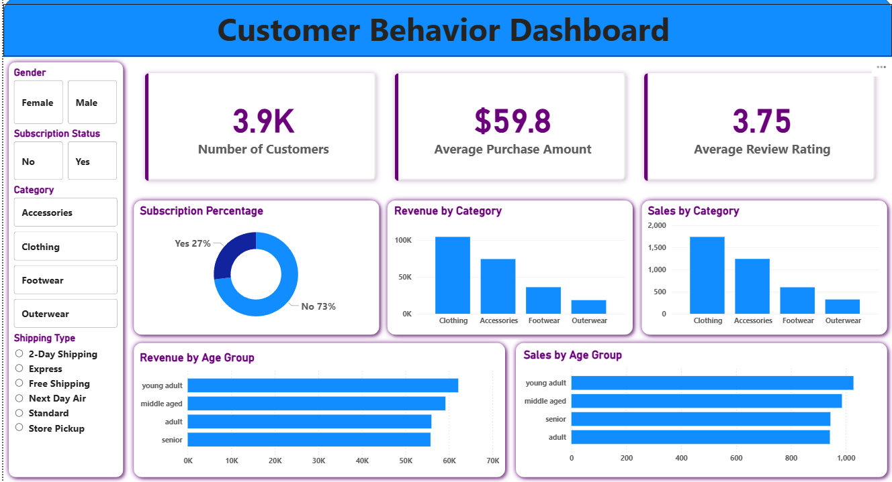
Fig 1. Customer Behavior Dashboard

7. Key Insights
Insight 1: Revenue concentration risk
Heavy reliance on loyal customers (80%+)
Risk: Revenue drops if retention declines
Insight 2: Subscription model is weak
No significant increase in spending
Indicates low perceived value of subscription
Insight 3: Discounts may be misused
High discount usage but unclear ROI
Potential margin loss
Insight 4: High-value customers prefer express shipping
Opportunity for premium targeting
Insight 5: Young adults drive revenue
Ideal target for marketing campaigns

8. Business Recommendations
1. Strengthen Customer Retention Strategy
- Introduce loyalty rewards for repeat buyers
- Personalized offers for returning customers
2. Redesign Subscription Model
- Add exclusive benefits:
  - Free express shipping
  - Early product access
- Increase perceived value
3. Optimize Discount Strategy
- Target discounts:
  - Low-performing products
- Avoid blanket discounting
4. Target High-Value Segments
- Focus on:
  - Loyal customers
  - Young adults
- Use personalized marketing
5. Upsell Express Shipping
- Bundle with premium offers
- Offer free upgrades for high spenders

9. Limitations
- Synthetic dataset (may not reflect real-world complexity)
- No time-based trends (no date column)
- Limited behavioral depth (no session/user journey data)

10. Future Improvements
- Add time-series analysis
- Build customer lifetime value (CLV) model
- Apply clustering (K-means) for segmentation
- A/B testing for discounts

