The Geography of Commercialization: Where Portfolio Hosts Dominate Sydney

Introduction
When discussing the impact of short-term rentals on Sydney's housing market, a common mistake is treating the entire city as a single, uniform ecosystem. In reality, Airbnb commercialization is intensely localized. This report investigates the spatial distribution of "portfolio hosts" (hosts managing multiple properties) to reveal exactly where the market has shifted from traditional home-sharing to decentralized hotel networks. By isolating the geographical concentration of these commercial operators, we provide housing planners and councils with the targeted insights needed for effective, localized regulation.

1. The Concentration of Commercialization by LGA
To understand the geographic spread of professional hosting, we first look at the percentage of listings in each Local Government Area (LGA) controlled by multi-listing hosts.
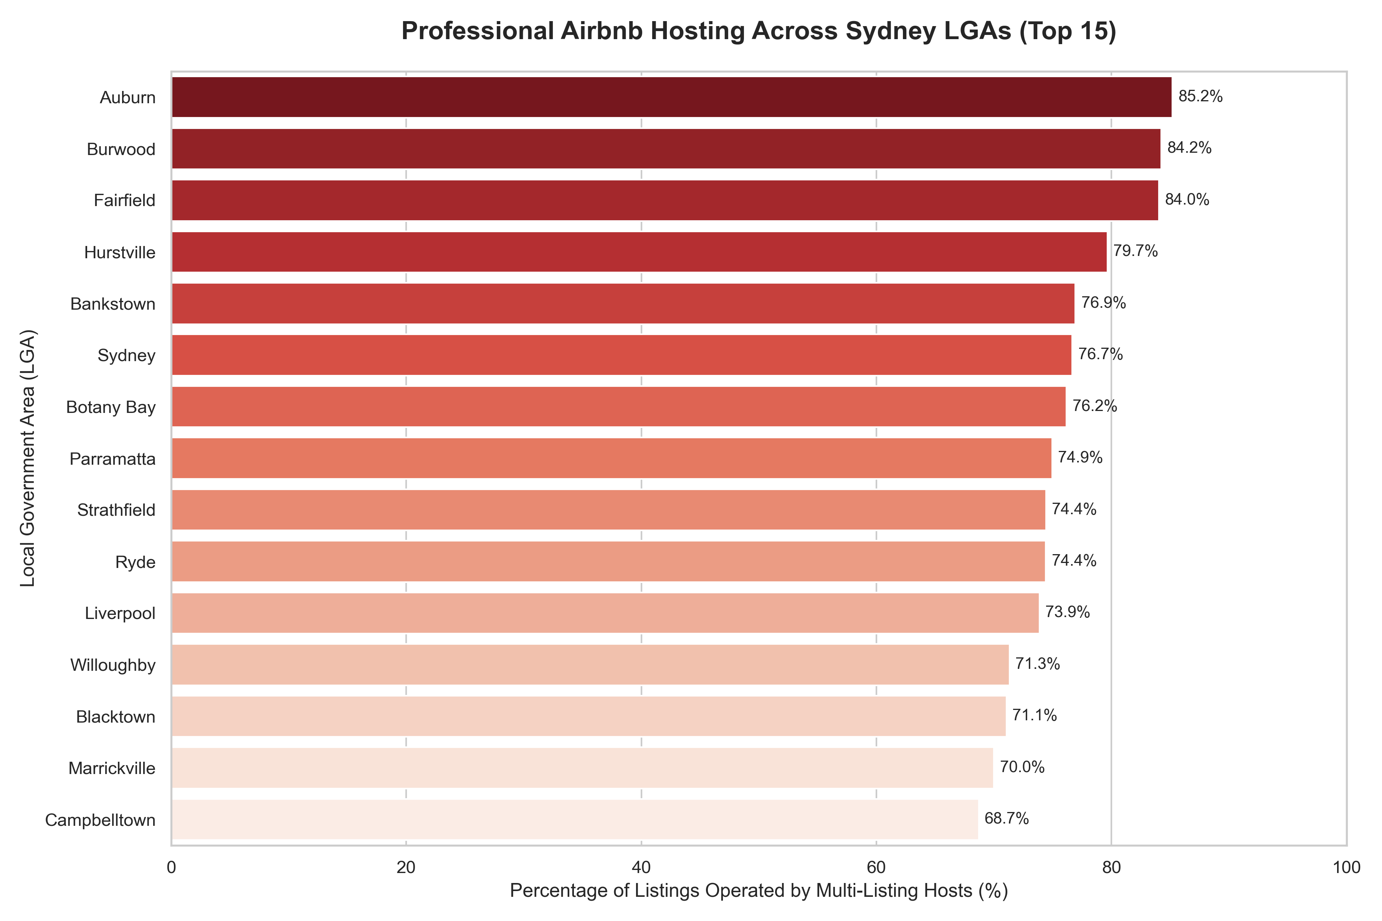
As the chart reveals, commercialization is highly concentrated. In areas like Auburn, the City of Sydney, and Botany Bay, an overwhelming majority of listings (over 75%) belong to portfolio operators. This fundamentally challenges the traditional "home-sharing" image in these districts, proving that the market here is driven by professional businesses rather than casual residents.

2. Market Composition in High-Volume Areas
While percentage rankings are revealing, it is crucial to look at market composition within Sydney's largest short-term rental hubs.
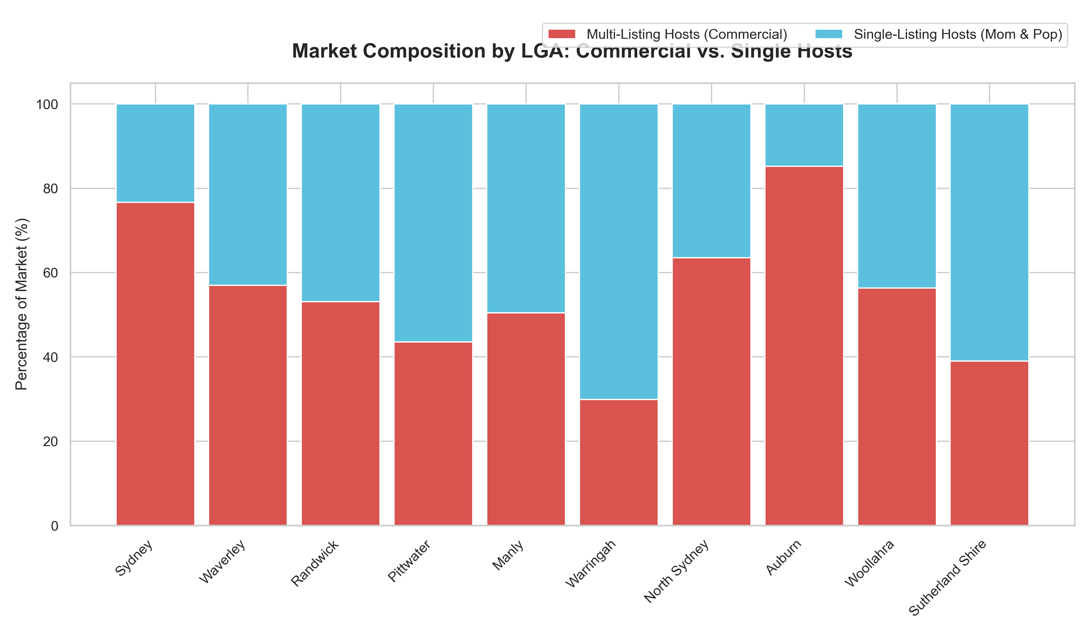
By breaking down the absolute market composition in the top 10 largest LGAs, the stark contrast between the "sharing economy" myth and commercial reality becomes visually undeniable. The sheer volume of Red (Commercial Hosts) dominating areas like Sydney and Waverley demonstrates that the largest rental markets are heavily corporatized, squeezing out the space for single-listing "Mom & Pop" hosts (Blue).

3. The Intersection of Size and Commercialization
A critical question for policymakers is whether commercialization only happens in niche, low-volume areas, or if it impacts the largest housing markets.
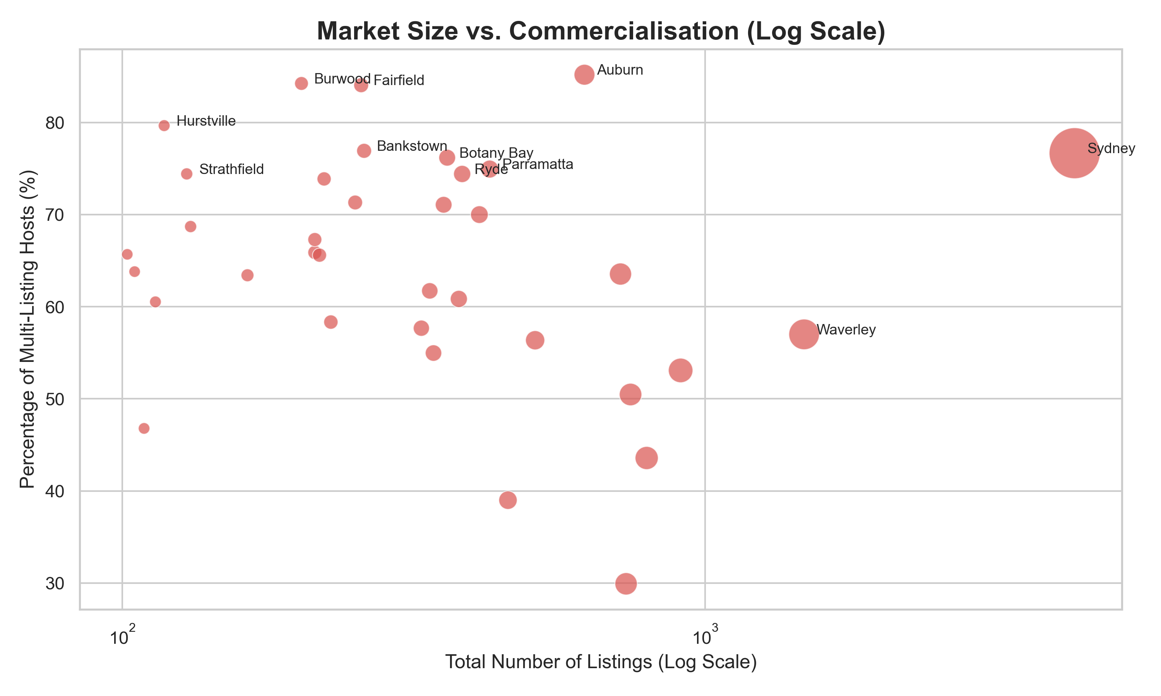
This scatter plot proves that the problem scales aggressively with market size. The LGAs positioned in the top right—such as the City of Sydney—suffer from both exceptionally high absolute volumes of listings and extremely high rates of commercialization. These are the "crisis zones" where the drain on residential housing stock is most severe.

4. Mapping the Commercial Footprint
Finally, taking these metrics out of bar charts and placing them onto a physical map of Sydney reveals the literal footprint of the commercial short-term rental market.
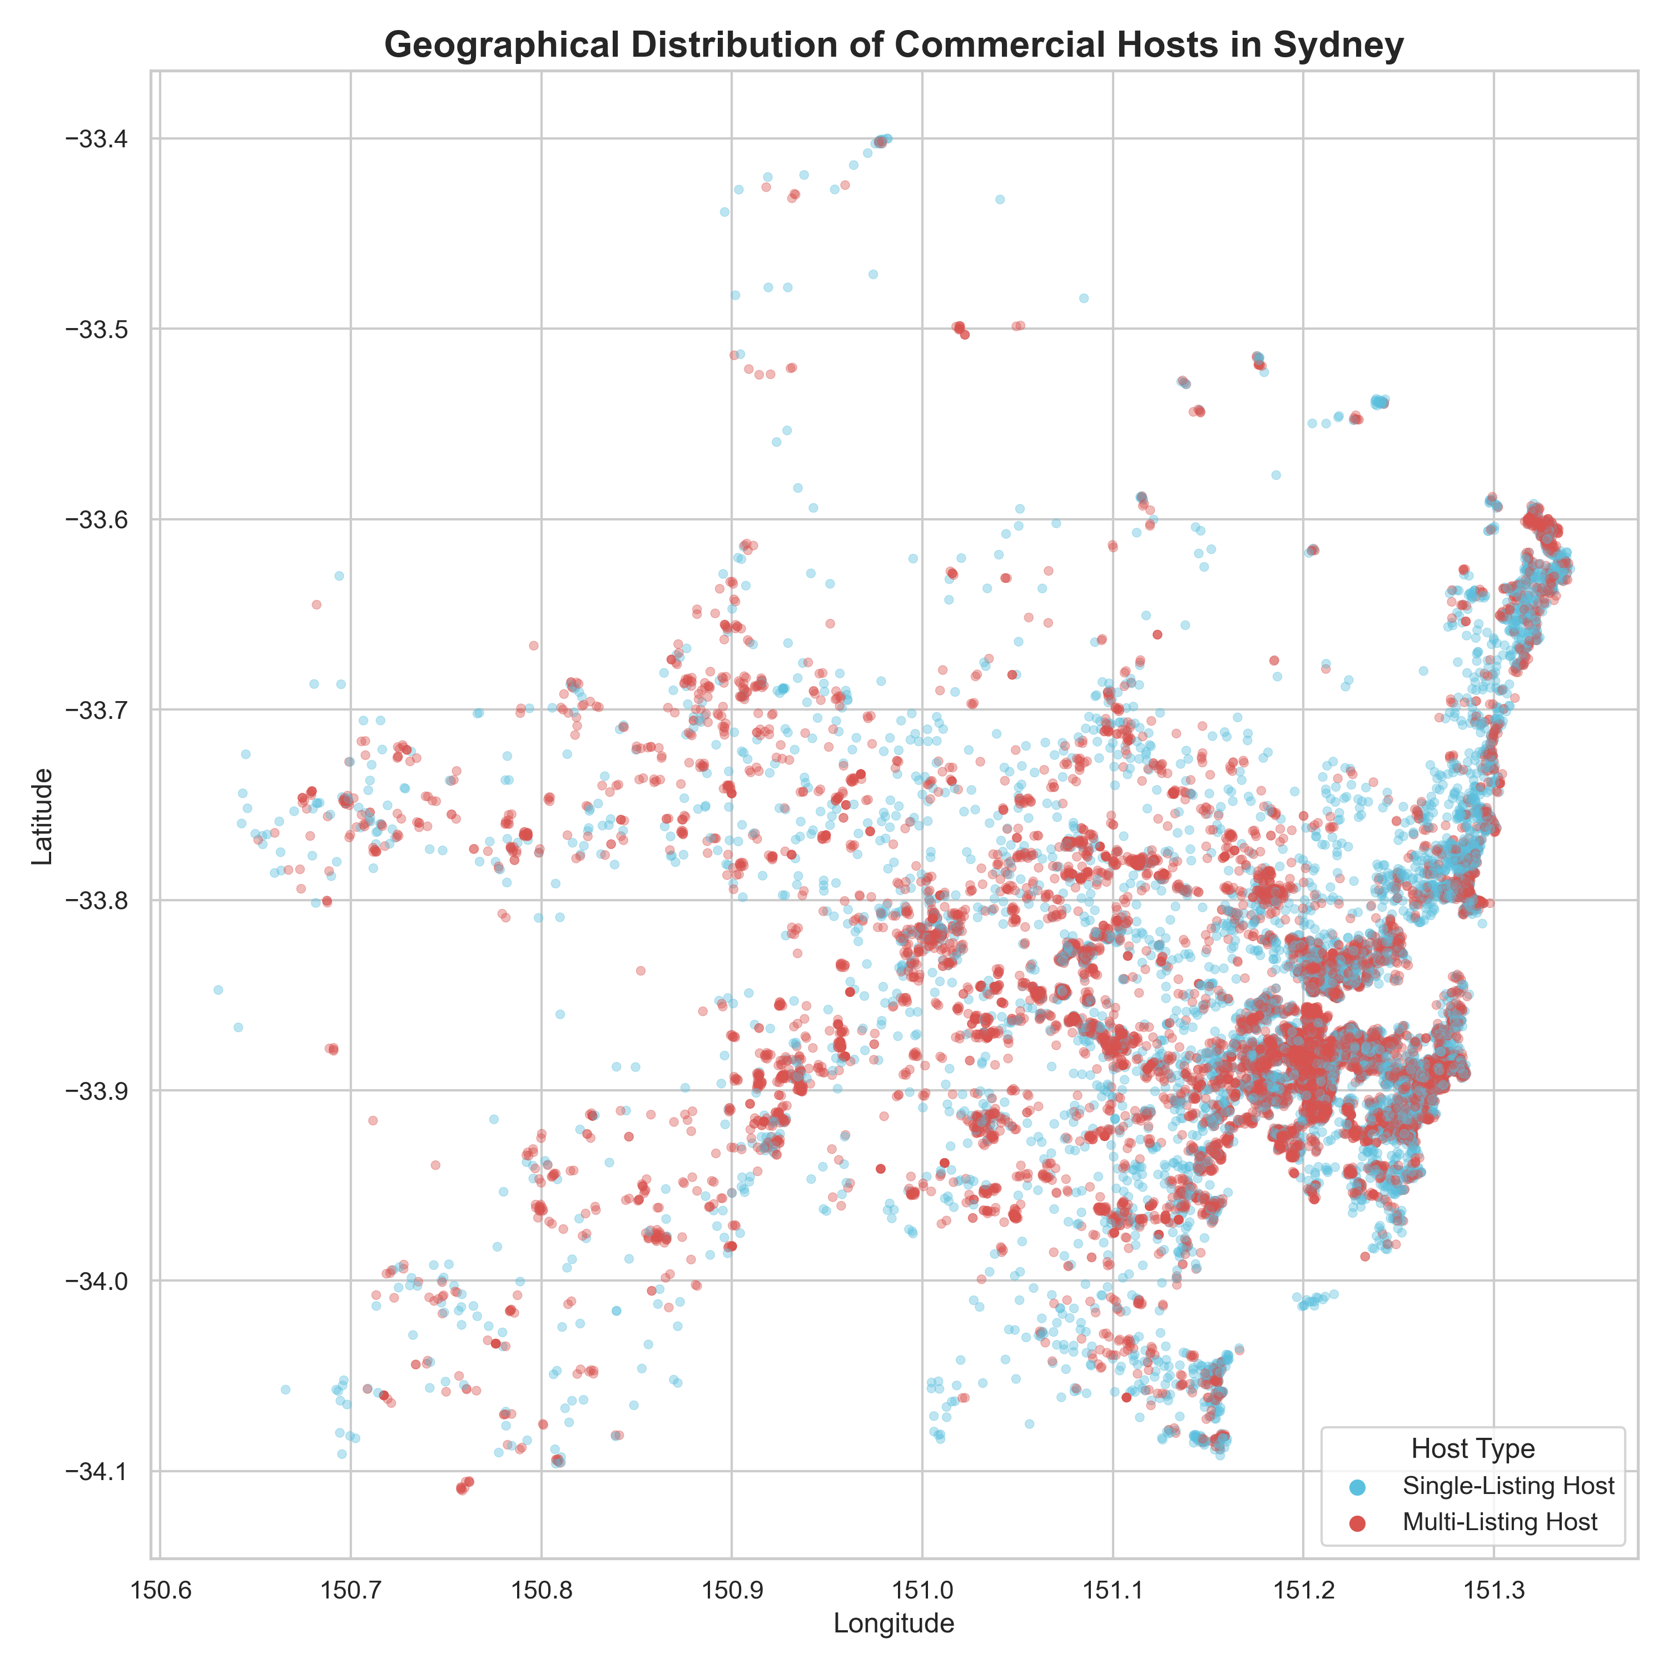
By plotting every single Airbnb in Sydney using latitude and longitude, we can physically see the intense cluster of commercial operators (Red). The data shows a dense hollowing out of specific coastal suburbs and CBD neighborhoods, visualizing exactly which streets and communities are most affected by portfolio operators.

Value Proposition & Policy Implications
A uniform, city-wide policy overlooks the stark differences between local markets. The impacts of short-term rentals on housing supply and neighborhood character are highly geographically concentrated. Therefore, monitoring, regulation, and zoning efforts should not be applied blindly across all of Sydney. Instead, housing planners and councils can use this spatial data to focus their regulatory resources—such as targeted caps, localized licensing fees, or zoning restrictions—specifically on the LGAs and coastal strips where portfolio hosting creates the greatest market impact.

Appendix: Data & Code Methodology

Data Used
The visualizations were generated using the cleaned Sydney Airbnb dataset (listings_clean.csv). The specific variables utilized for this geographic commercialization analysis were:
- • lga (Local Government Area): Used to group listings by geographic boundaries.
- • latitude & longitude: Used for the geospatial scatter map to pinpoint precise listing locations.
- • is_multi_listing_host: A boolean variable indicating if the host manages more than one property, serving as the primary metric for commercialization.
- • calculated_host_listings_count: Used to determine the volume of properties managed by individual hosts.

Python Code
The following Python code utilizes pandas for data manipulation and seaborn/matplotlib for visualization generation:
import pandas as pd
import matplotlib.pyplot as plt
import seaborn as sns
import numpy as np
# Set standard style
sns.set_theme(style='whitegrid')
# Load data
df = pd.read_csv('listings_clean.csv', low_memory=False)
# Precompute LGA statistics
lga_stats = df.groupby('lga').agg(
total_listings=('id', 'count'),
multi_host_listings=('is_multi_listing_host', 'sum')
).reset_index()
# Filter to LGAs with at least 100 listings to avoid statistical noise
lga_stats = lga_stats[lga_stats['total_listings'] >= 100].copy()
# Calculate proportions
lga_stats['pct_multi_host'] = (lga_stats['multi_host_listings'] / lga_stats['total_listings']) * 100
lga_stats['single_host_listings'] = lga_stats['total_listings'] - lga_stats['multi_host_listings']
lga_stats['pct_single_host'] = 100 - lga_stats['pct_multi_host']
# --- GRAPH 1: Horizontal Bar Chart (LGA Ranking) ---
lga_stats_sorted = lga_stats.sort_values('pct_multi_host', ascending=False)
plt.figure(figsize=(12, 8))
sns.barplot(x='pct_multi_host', y='lga', data=lga_stats_sorted.head(15), palette='Reds_r')
plt.title('Professional Airbnb Hosting Across Sydney LGAs', fontsize=16, fontweight='bold')
plt.xlabel('Percentage of Listings Operated by Multi-Listing Hosts (%)')
plt.ylabel('Local Government Area (LGA)')
plt.tight_layout()
plt.savefig('graph_04_lga_commercialisation.png')
# --- GRAPH 2: Stacked Bar Chart (Market Composition) ---
top_volume_lgas = lga_stats.sort_values('total_listings', ascending=False).head(10)
plt.figure(figsize=(12, 7))
names = top_volume_lgas['lga']
plt.bar(names, top_volume_lgas['pct_multi_host'], color='#d9534f', label='Multi-Listing Hosts (Commercial)')
plt.bar(names, top_volume_lgas['pct_single_host'], bottom=top_volume_lgas['pct_multi_host'], color='#5bc0de', label='Single-Listing Hosts (Mom & Pop)')
plt.xticks(rotation=45, ha='right')
plt.ylabel('Percentage of Market (%)')
plt.title('Market Composition by LGA: Commercial vs. Single Hosts', fontsize=16, fontweight='bold')
plt.legend()
plt.tight_layout()
plt.savefig('graph_04b_stacked_composition.png')
# --- GRAPH 3: Scatter Plot (Volume vs Concentration) ---
plt.figure(figsize=(10, 6))
sns.scatterplot(data=lga_stats, x='total_listings', y='pct_multi_host', size='total_listings', sizes=(50, 1000), alpha=0.7, color='#d9534f', legend=False)
plt.xscale('log')
plt.title('Market Size vs. Commercialisation (Log Scale)', fontsize=16, fontweight='bold')
plt.xlabel('Total Number of Listings (Log Scale)')
plt.ylabel('Percentage of Multi-Listing Hosts (%)')
plt.tight_layout()
plt.savefig('graph_04c_volume_vs_concentration.png')
# --- GRAPH 4: Geospatial Map ---
plt.figure(figsize=(10, 10))
sydney_map = df[(df['longitude'] > 150.5) & (df['longitude'] < 151.4) & (df['latitude'] > -34.2) & (df['latitude'] < -33.4)]
sns.scatterplot(x='longitude', y='latitude', hue='is_multi_listing_host', data=sydney_map, palette={True: '#d9534f', False: '#5bc0de'}, s=15, alpha=0.4)
plt.title('Geographical Distribution of Commercial Hosts in Sydney', fontsize=16, fontweight='bold')
plt.tight_layout()
plt.savefig('graph_04d_geospatial_map.png')

