# Submitted by:

**SUBHECHHA SHRESTHA 1001393553**

**PROJECT 2**

**PHASE 1**

**DATABASE AND FILE STRUCTURES**

# HONOR CODE

I pledge, on my honor, to uphold UT Arlington's tradition of academic integrity, a tradition that values hard work and honest effort in the pursuit of academic excellence.

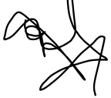I promise that I will submit only work that I personally create or that I contribute to group collaborations, and I will appropriately reference any work from other sources. I will follow the highest standards of integrity and uphold the spirit of the Honor Code.

**Proof of CREATE TABLE**

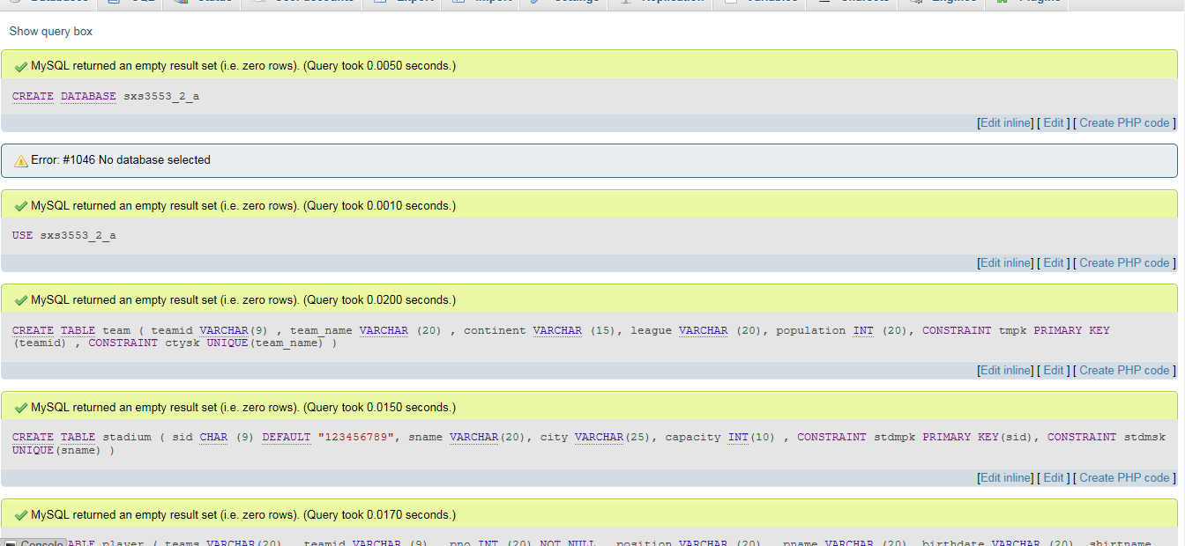

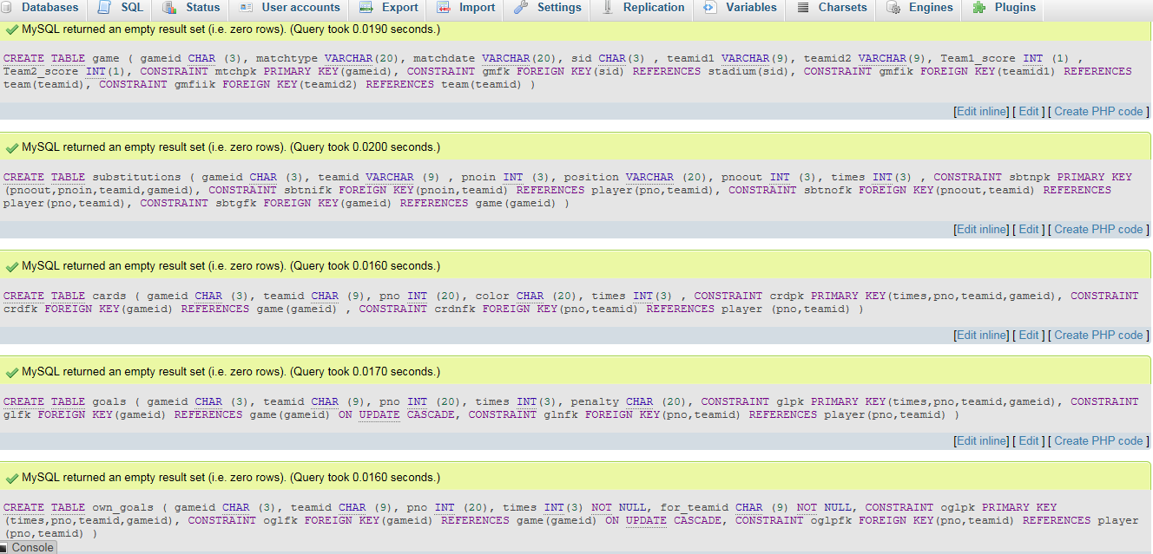

**A script to generate all the tables, load the data, show all the tables, show columns of all tables.**

**Running Instructions:**

**While loading data in table in mysql, please do not enable foreign key check as it did not work for teamid1 and teamid2 for table Game while referencing teamid in team table as teamid was being referenced by both teamid1 and teamid2.**

CREATE DATABASE sxs3553_2_a;

USE sxs3553_2_a;

CREATE TABLE team

(

teamid VARCHAR(9) ,

team_name VARCHAR (20) ,

continent VARCHAR (15),

league VARCHAR (20),

population INT (20),

CONSTRAINT tmpk PRIMARY KEY(teamid) ,

CONSTRAINT ctysk UNIQUE(team_name)

);

CREATE TABLE stadium

(

sid CHAR (9) DEFAULT "123456789",

sname VARCHAR(20),

city VARCHAR(25),

capacity INT(10) ,

CONSTRAINT stdmpk PRIMARY KEY(sid),

CONSTRAINT stdmsk UNIQUE(sname)

);

CREATE TABLE player

(

team_name VARCHAR(20) ,

teamid VARCHAR (9) ,

pno INT (20) NOT NULL ,

position VARCHAR (20) ,

pname VARCHAR (20),

birthdate VARCHAR (20),

shirtname VARCHAR (20),

club VARCHAR (15),

height INT (5),

weight INT (5),

CONSTRAINT plyrpk PRIMARY KEY(pno,teamid),

CONSTRAINT plyrfk FOREIGN KEY(teamid) REFERENCES team(teamid)

);

CREATE TABLE game

(

gameid CHAR (3),

matchtype VARCHAR(20),

matchdate VARCHAR(20),

sid CHAR(3) ,

teamid1 VARCHAR(9),

teamid2 VARCHAR(9),

Team1_score INT (1) ,

Team2_score INT(1),

CONSTRAINT mtchpk PRIMARY KEY(gameid),

CONSTRAINT gmfk FOREIGN KEY(sid) REFERENCES stadium(sid),

CONSTRAINT gmfik FOREIGN KEY(teamid1) REFERENCES team(teamid),

CONSTRAINT gmfiik FOREIGN KEY(teamid2) REFERENCES team(teamid)

);

CREATE TABLE substitutions

(

gameid CHAR (3),

teamid VARCHAR (9) ,

pnoin INT (3),

position VARCHAR (20),

pnoout INT (3),

times INT(3) ,

CONSTRAINT sbtnpk PRIMARY KEY(pnoout,pnoin,teamid,gameid),

CONSTRAINT sbtnifk FOREIGN KEY(pnoin,teamid) REFERENCES player(pno,teamid),

CONSTRAINT sbtnofk FOREIGN KEY(pnoout,teamid) REFERENCES player(pno,teamid),

CONSTRAINT sbtgfk FOREIGN KEY(gameid) REFERENCES game(gameid)

);

CREATE TABLE cards

(

gameid CHAR (3),

teamid CHAR (9),

pno INT (20),

color CHAR (20),

times INT(3) ,

CONSTRAINT crdpk PRIMARY KEY(times,pno,teamid,gameid),

CONSTRAINT crdfk FOREIGN KEY(gameid) REFERENCES game(gameid) ,

CONSTRAINT crdnfk FOREIGN KEY(pno,teamid) REFERENCES player (pno,teamid)

);

CREATE TABLE goals

(

gameid CHAR (3),

teamid CHAR (9),

pno INT (20),

times INT(3),

penalty CHAR (20),

CONSTRAINT glpk PRIMARY KEY(times,pno,teamid,gameid),

CONSTRAINT glfk FOREIGN KEY(gameid) REFERENCES game(gameid) ON UPDATE CASCADE,

CONSTRAINT glnfk FOREIGN KEY(pno,teamid) REFERENCES player(pno,teamid)

);

CREATE TABLE own_goals

(

gameid CHAR (3),

teamid CHAR (9),

pno INT (20),

times INT(3) NOT NULL,

for_teamid CHAR (9) NOT NULL,

CONSTRAINT oglpk PRIMARY KEY(times,pno,teamid,gameid),

CONSTRAINT oglfk FOREIGN KEY(gameid) REFERENCES game(gameid) ON UPDATE CASCADE,

CONSTRAINT oglpfk FOREIGN KEY(pno,teamid) REFERENCES player(pno,teamid)

);

**LOAD THE DATA**

LOAD DATA INFILE 'C:/xampp/mysql/data/worldcup/world-cup-teams-text.txt' INTO TABLE team

FIELDS TERMINATED BY ',';

LOAD DATA INFILE 'C:/xampp/mysql/data/worldcup/world-cup-stadiums-text.txt' INTO TABLE stadium

FIELDS TERMINATED BY ',';

LOAD DATA INFILE 'C:/xampp/mysql/data/worldcup/world-cup-rosters-text.txt' INTO TABLE player

FIELDS TERMINATED BY ',';

LOAD DATA INFILE 'C:/xampp/mysql/data/worldcup/world-cup-matches-text.txt' INTO TABLE game

FIELDS TERMINATED BY ',';

LOAD DATA INFILE 'C:/xampp/mysql/data/worldcup/world-cup-substitutes-text.txt' INTO TABLE substitutions

FIELDS TERMINATED BY ',';

LOAD DATA INFILE 'C:/xampp/mysql/data/worldcup/world-cup-goals-text.txt' INTO TABLE goals

FIELDS TERMINATED BY ',';

LOAD DATA INFILE 'C:/xampp/mysql/data/worldcup/world-cup-own-goals-text.txt' INTO TABLE own_goals

FIELDS TERMINATED BY ',';

LOAD DATA INFILE 'C:/xampp/mysql/data/worldcup/world-cup-cards-text.txt' INTO TABLE cards

FIELDS TERMINATED BY ',';

**Proof of LOAD**

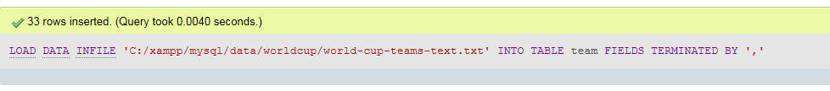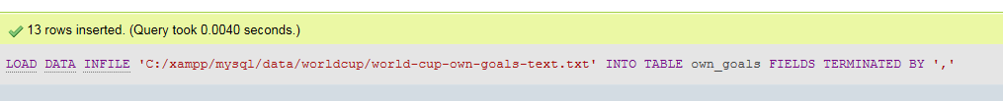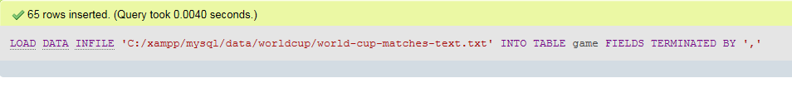

USE sxs3553_2_a;

SHOW TABLES;

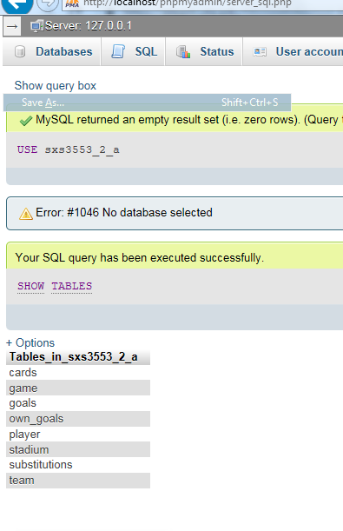

**COLUMN NAMES**

SELECT column_name

FROM information_schema.columns

WHERE table_schema = 'sxs3553_2_a'

ORDER BY table_name,ordinal_position

**WITH PROOF OF EXECUTION**

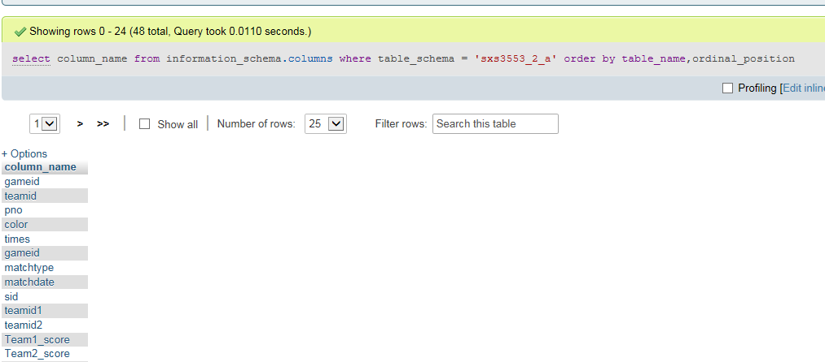

**With all the column names**

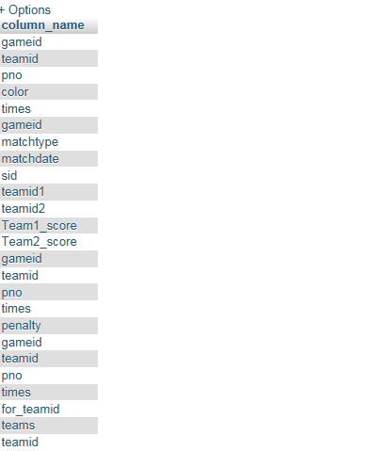

**Query Text Along with Screenshots**

Q1.

SELECT T.team_name,pname,height

FROM team AS T,player AS P

WHERE P.teamid = T.teamid AND continent = 'Africa' and height > 190

ORDER BY T.team_name , P.height

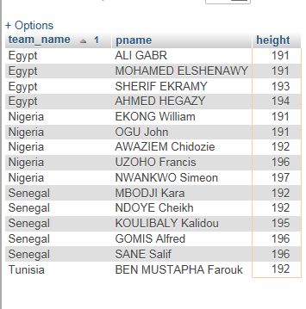

Q2.

SELECT team1.team_name AS team1_name,Team1_score,team2.team_name AS team2_name,Team2_score

FROM game AS G , team AS team1, team AS team2

WHERE (team1.teamid = G.teamid1 AND team2.teamid = G.teamid2 ) AND (Team1_score>0 AND Team2_score>0) AND(matchtype = 'A' OR matchtype = 'B')

ORDER BY matchtype

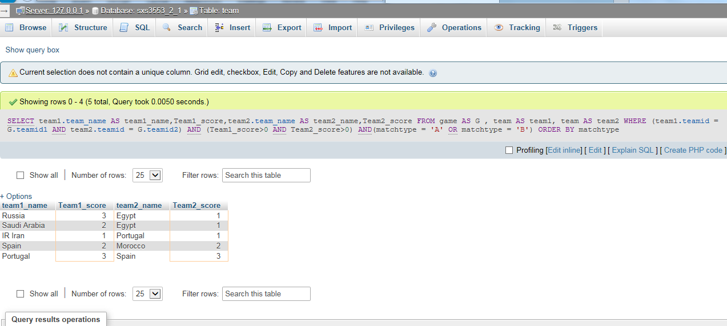

Q3.

SELECT T.team_name,pname,height,weight

FROM cards AS C,team AS T,player AS P

WHERE (C.pno,C.teamid)=(P.pno,P.teamid) AND P.teamid=T.teamid AND C.color= 'Red'

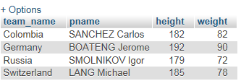

Q4.

SELECT pname,COUNT(*) AS cnum , T.team_name

FROM player AS P INNER JOIN Cards AS C ON (C.pno,C.teamid) = (P.pno,P.teamid) JOIN team AS T ON T.teamid = P.teamid AND C.color = 'Yellow'

GROUP BY C.pno,C.teamid

ORDER BY cnum DESC

LIMIT 1

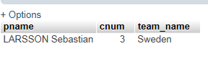

Q5.

SELECT p.team_name,COUNT(*)

FROM `own_goals` AS o ,`player` AS p

WHERE (o.pno,o.teamid) = (p.pno,p.teamid)

GROUP BY o.teamid

HAVING COUNT(*) > 1

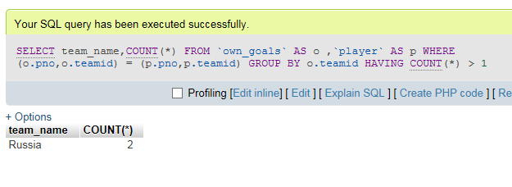

Q6.

CREATE VIEW GAME_INFO(matchtype,matchdate,sname,city,team1_name,Team1_score,team2_name,Team2_score)

AS SELECT matchtype,matchdate,sname,city,team1.team_name AS team1_name,Team1_score,team2.team_name AS team2_name,Team2_score

FROM team AS team1,team AS team2,game AS G,stadium AS S

WHERE S.sid = G.sid AND team1.teamid = G.teamid1 AND team2.teamid = G.teamid2

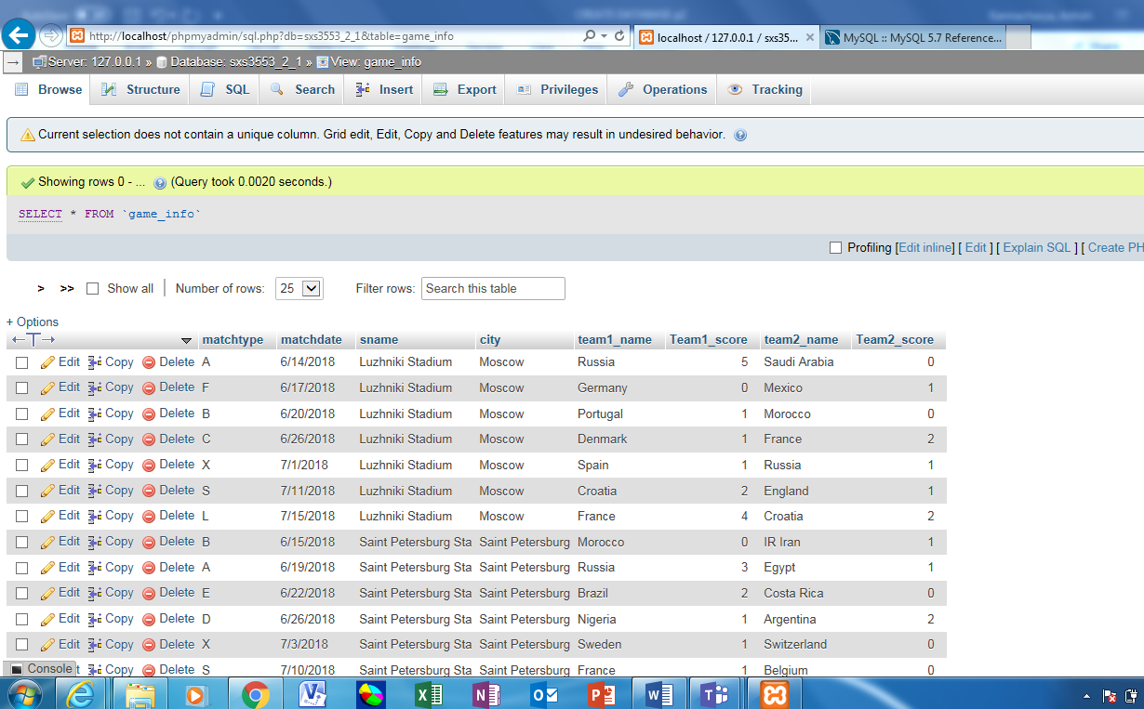

Q7 i.

SELECT *

FROM `game_info`

WHERE team1_name = 'France' OR team2_name = 'France'

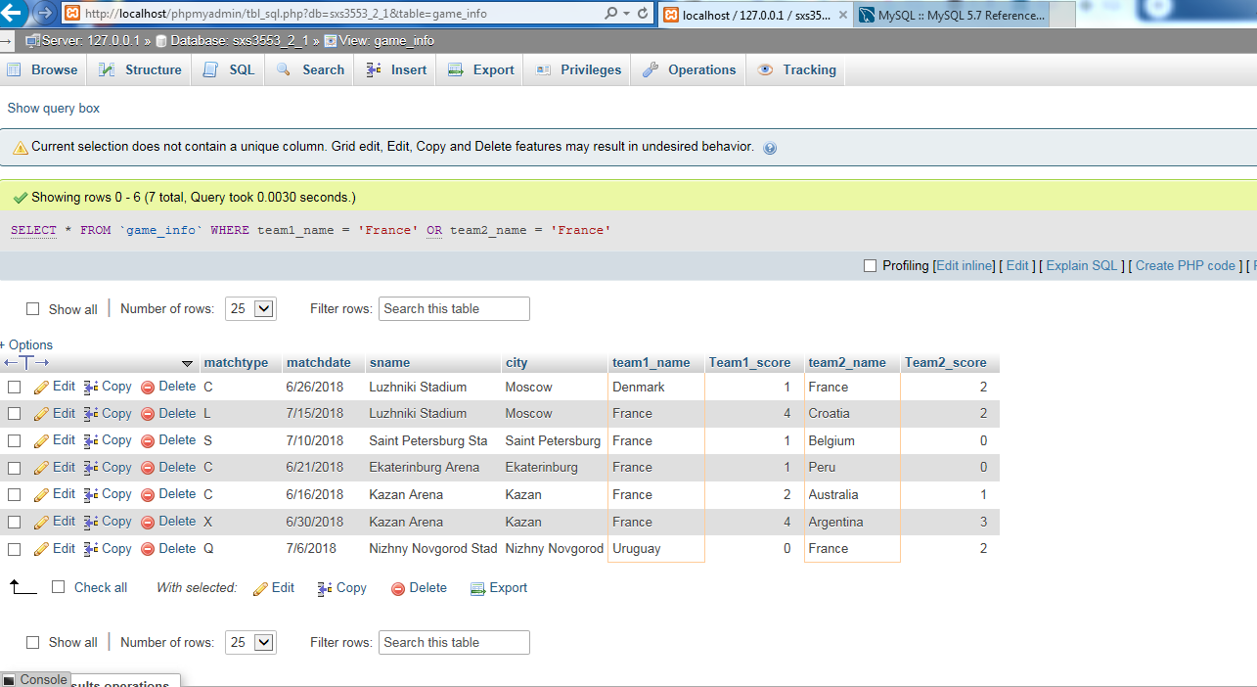

7.ii

SELECT *

FROM `game_info`

WHERE matchtype = 'A' OR matchtype = 'X'

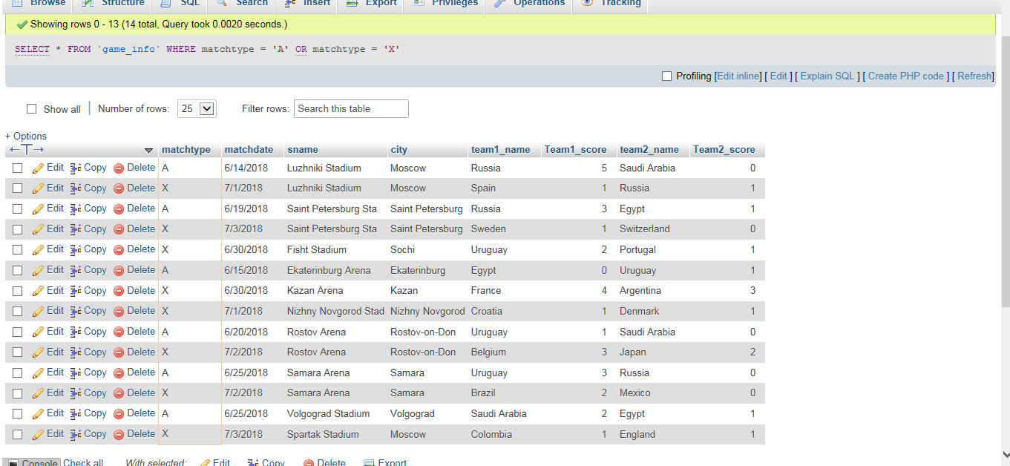

7.iii

SELECT *

FROM `game_info`

WHERE Team1_score > 2

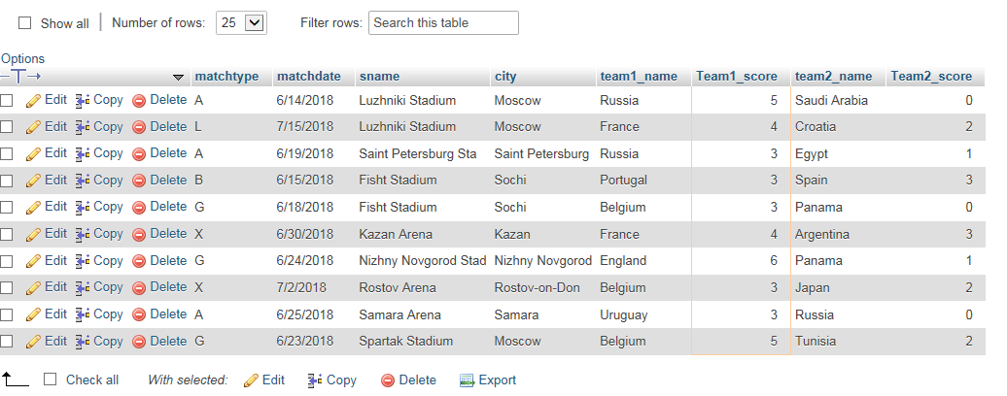

7.iv

SELECT *

FROM `game_info`

WHERE sname LIKE '%Kazan%'

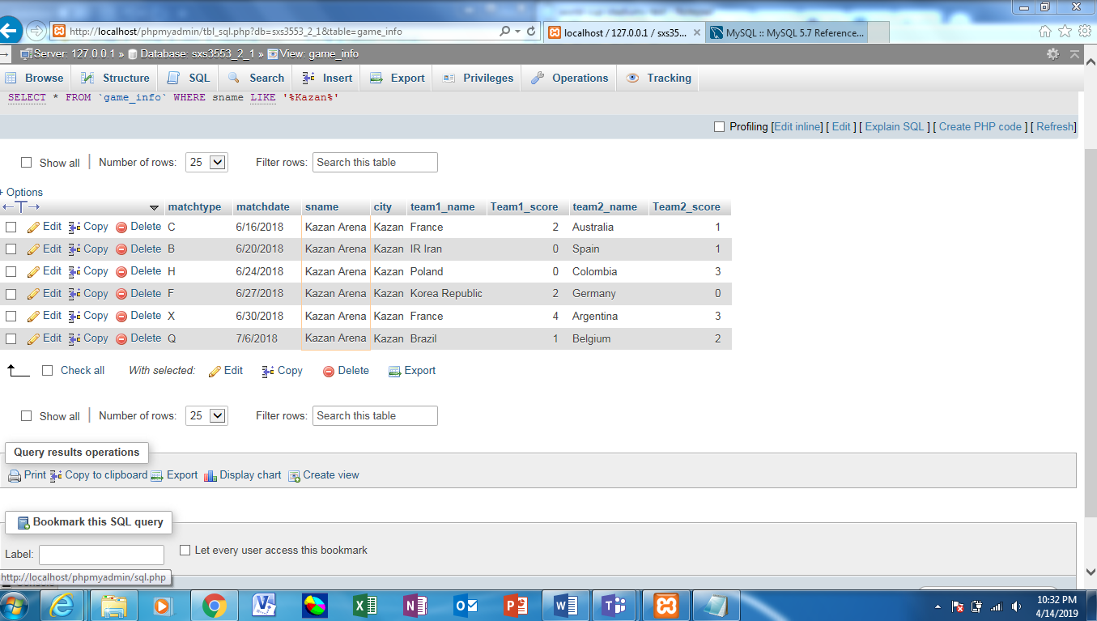

8.i

SELECT pname,p.team_name

FROM player as p,game as g,cards as c

WHERE c.gameid = g.gameid AND (c.pno,c.teamid) = (p.pno,p.teamid) AND color = 'Yellow' AND matchtype = 'A'

ORDER BY team_name

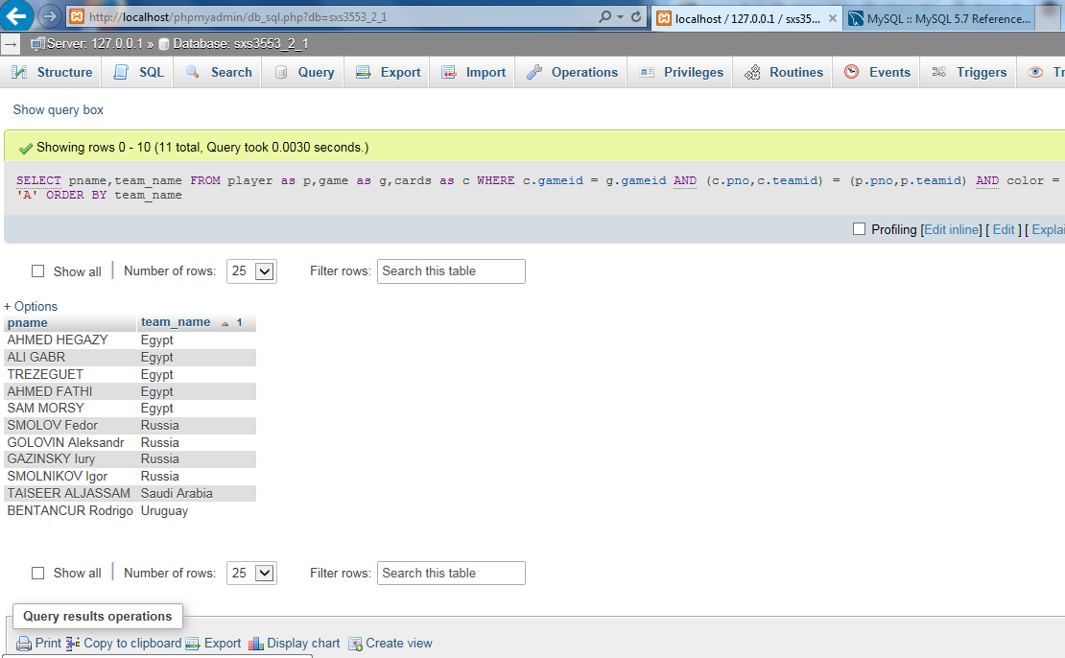

8.ii

(SELECT t.team_name

FROM `team` AS t,game AS g,stadium AS s

WHERE t.teamid = g.teamid1 AND g.sid = s.sid AND city = 'Sochi'

GROUP BY gameid

HAVING COUNT(*) > 0)

UNION

(SELECT t.team_name

FROM `team` AS t,game AS g,stadium AS s

WHERE t.teamid = g.teamid2 AND g.sid = s.sid AND city = 'Sochi'

GROUP BY gameid

HAVING COUNT(*) > 0

)

ORDER BY team_name

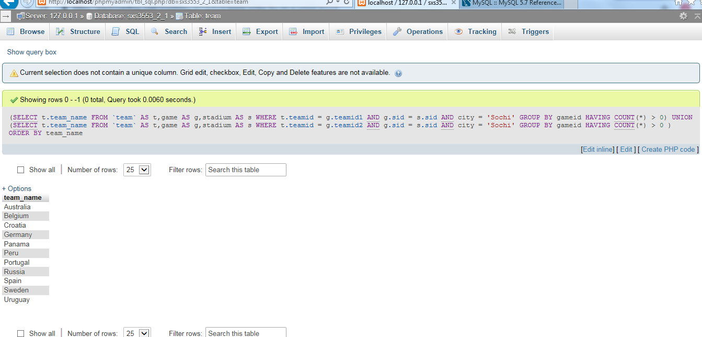

8.iii

SELECT pnoin,pnoout,times,p.team_name

FROM `substitutions`AS s,player as p

WHERE (s.pnoout,s.teamid) = (p.pno,p.teamid) AND times < 31

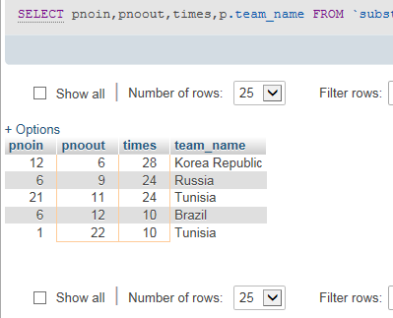

**THE END**