1. Write a program to copy and paste a file to other location

package JAVA8;
import java.io.*;
import java.nio.file.Files;
import java.nio.file.StandardCopyOption;
import static java.nio.file.StandardCopyOption.REPLACE_EXISTING;
/**
* Created by hackerfreak on 25/6/17.
*/
public class Ques1 {
public static void main(String[] args) {
int readChar = 0;
File source = new File("/media/hackerfreak/New Volume/UbuntuWorkSpace/ttn boot camp/ques3.html");
File destination = new File("/media/hackerfreak/New Volume/UbuntuWorkSpace/DBs/copy_ques3.html");
FileOutputStream fileOutputStream = null;
FileInputStream fileInputStream = null;
try {
fileOutputStream = new FileOutputStream(destination);
fileInputStream = new FileInputStream(source);
while ((readChar = fileInputStream.read()) != -1) {
fileOutputStream.write((char) readChar);
}
} catch (FileNotFoundException e) {
e.printStackTrace();
} catch (IOException e) {
e.printStackTrace();
} finally {
try {
fileOutputStream.close();
} catch (IOException e) {
e.printStackTrace();
}
try {
fileInputStream.close();
} catch (IOException e) {
e.printStackTrace();
}
}
}
}

2. Write a program to serialize a class Employee with property name and then deserialize it

package JAVA8;
import java.io.*;
import java.util.Scanner;
/**
* Created by hackerfreak on 26/6/17.
*/
class Employee implements Serializable{
String EmployID;
String EmployeeName;
public String getEmployID() {
return EmployID;
}
public Employee setEmployID(String employID) {
EmployID = employID;
return this;
}
public String getEmployeeName() {
return EmployeeName;
}
public Employee setEmployeeName(String employeeName) {
EmployeeName = employeeName;
return this;
}
}
public class Ques2 {
public static void main(String[] args) {
Employee employee=new Employee();
employee.setEmployeeName("ramesh").setEmployID("007");
try {
ObjectOutputStream oos=new ObjectOutputStream
(new FileOutputStream("/media/hackerfreak/New Volume/UbuntuWorkSpace/ttn boot camp/JAVA CORE/ObjSerial.txt"));
oos.writeObject(employee);
} catch (IOException e) {
e.printStackTrace();
}
Scanner s=new Scanner(System.in);
System.out.println("press 1 to deserialize");
int x=s.nextInt();
if(x==1)
{
try {
ObjectInputStream oio=new ObjectInputStream(new FileInputStream("/media/hackerfreak/New Volume/UbuntuWorkSpace/ttn boot camp/JAVA CORE/ObjSerial.txt"));
try {
Employee DEmp=(Employee) oio.readObject();
System.out.println("Deserialized Object is "+DEmp.getEmployID()+"\n"+DEmp.getEmployeeName());
} catch (ClassNotFoundException e) {
e.printStackTrace();
}
} catch (IOException e) {
e.printStackTrace();
}
}
}
}
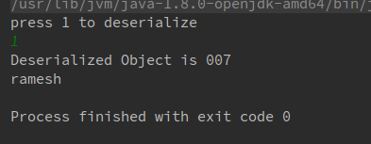

3. Write a program to read all field and method names of a class using reflection

package JAVA8;
import java.lang.Class;
import java.lang.reflect.Field;
import java.lang.reflect.Method;
/**
* Created by hackerfreak on 27/6/17.
*/
class ReflectionClass{
private int member1;
int member2;
private void display(){
System.out.println("I am a private method");
}
void show(){
System.out.println("I am default Method");
}
}
public class Ques3 {
public static void main(String[] args) {
Class c;
ReflectionClass rf=new ReflectionClass();
c=rf.getClass();
System.out.println(c.getName());
Field f[]=c.getDeclaredFields();
Method m[]=c.getDeclaredMethods();
for (Field a:f) {
System.out.println(a);
}
for (Method x:m
) {
System.out.println(x);
}
System.out.println();
}
}
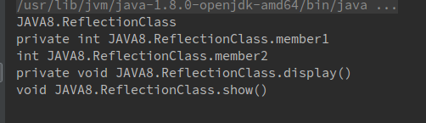
4. Write a program to print a table of any number using lambda expression

package JAVA8;
import java.util.Scanner;
/**
* Created by hackerfreak on 27/6/17.
*/
@FunctionalInterface
interface Lambda{
public void ComputeTable(int y);
}
public class Ques4 {
public static void main(String[] args) {
Scanner s=new Scanner(System.in);
System.out.println("enter any number");
int x=s.nextInt();
Lambda lambda = (int y) -> {
y=2;
for (int i=1;i<=10;i++)
System.out.println(y+" x "+i+" = "+(y*i));
};
lambda.ComputeTable(x);
}
}
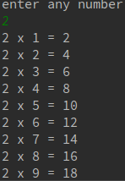

5. Write a program having interface with default and static methods and call them also in your main method

package JAVA8;
import javax.jws.soap.SOAPBinding;
/**
* Created by hackerfreak on 27/6/17.
*/
interface MyInterface{
default void show(){
System.out.println("show is called");
}
static int returnVal(String x){
return x.length();
}
}
public class Ques5 implements MyInterface {
public static void main(String[] args) {
System.out.println(MyInterface.returnVal("Shubham Verma"));
MyInterface myInterface=new MyInterface() {
@Override
public void show() {
MyInterface.super.show();
}
};
myInterface.show();
}
}
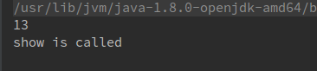

6. Create a class Employee with name and age. Then write a program to print all those employees whose name start with n and age is greater then 24.

package JAVA8;
import java.util.ArrayList;
import java.util.Random;
import java.util.Scanner;
import java.util.function.Predicate;
import java.util.regex.Pattern;
/**
* Created by hackerfreak on 27/6/17.
*/
class EmployeeNew{
String name;
int age;
}
public class Ques6 {
public static void evaluate(ArrayList<EmployeeNew> list, Predicate<EmployeeNew> p)
{
for(EmployeeNew employee:list){
if(p.test(employee))
{
System.out.println("Name:"+employee.name);
System.out.println("Name:"+employee.age);
}
}
}
public static void main(String[] args) {
Random r=new Random();
ArrayList<EmployeeNew> list=new ArrayList<>();
for(int i=0;i<5;i++)
{
EmployeeNew emp=new EmployeeNew();
emp.age=r.nextInt(15)+20;
emp.name="";
list.add(emp);
}
Scanner s=new Scanner(System.in);
for (EmployeeNew e:list
) {
System.out.println("enter the name");
String s1=s.nextLine();
e.name=e.name+s1;
}
evaluate(list,(employee)->{
String name=employee.name;
if(name.startsWith("n"))
{
if(employee.age>24)
{
System.out.println("returning true");
return true;
}
else
return false;
}
else
return false;
});
}
}
