Problem Statement: There can be multiple customers, who can place multiple orders on the site. Now a sales person can handle these orders will distribute into multiple sales persons (One order will be assign to one salesperson only). So a sales person can have multiple orders of multile customers
- Create Database
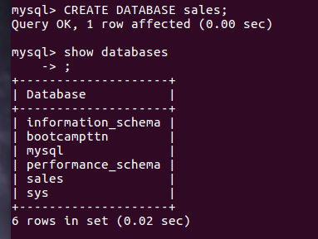

- Design Schema
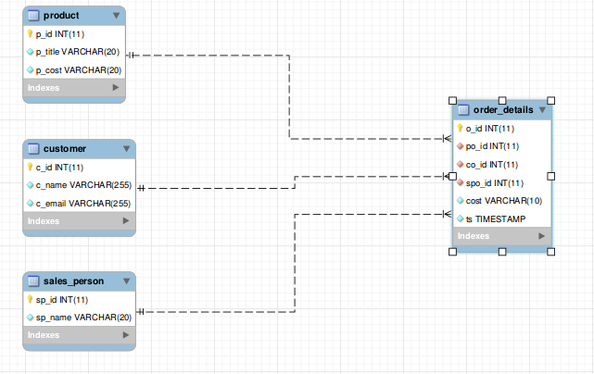
- Create tables
table customer
table product
table sales_person
table order_details
- Insert sample data
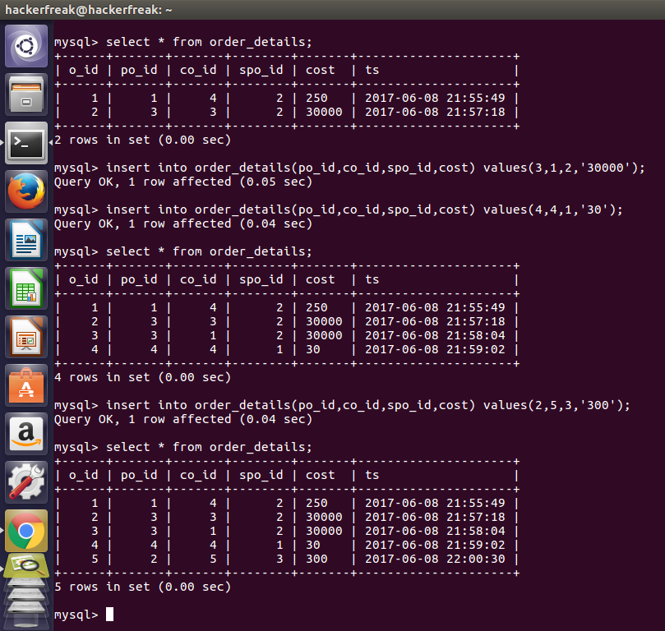

- Find the sales person have multiple orders.
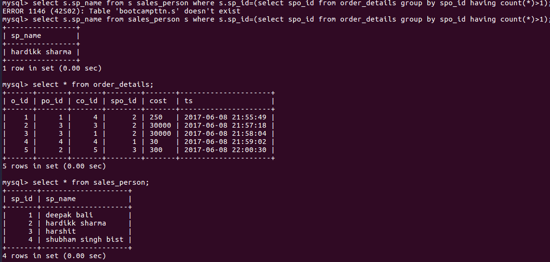
- Find the all sales person details along with order details
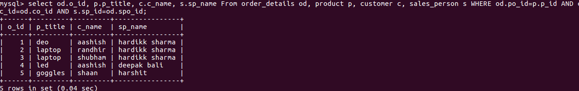
- Create index
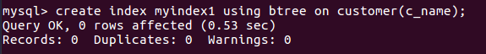
- How to show index on a table
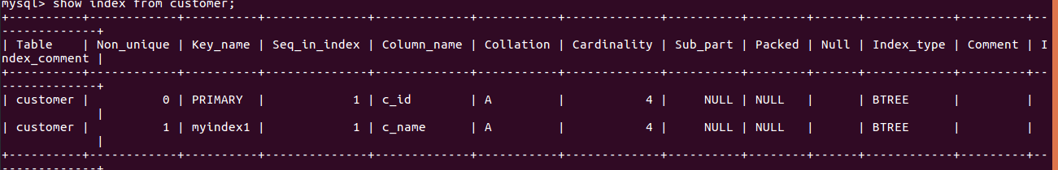
- Find the largest order amount for each salesperson and the associated order number, along with the customer to whom that order belongs to
