- Increase maximum copy history to 50
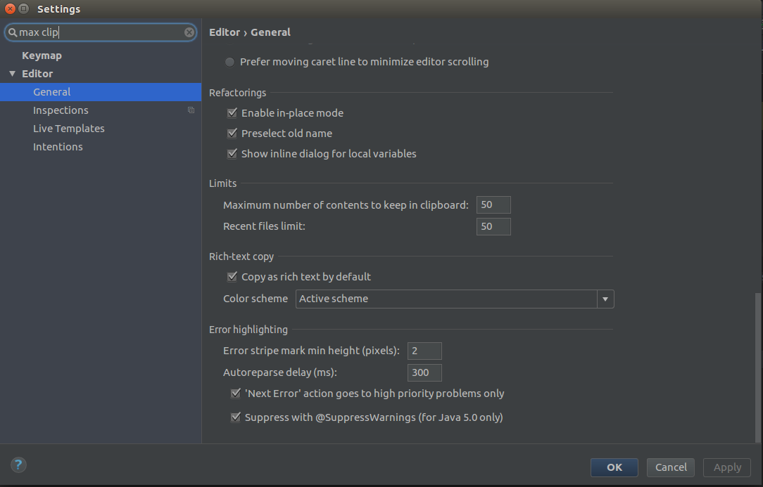

- Enable show line number, method separator, right margin
SHOW LINE NUMBERS
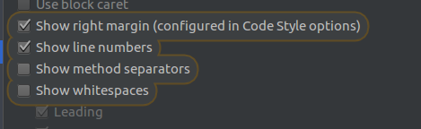

METHOD SEPRATOR


RIGHT MARGIN

- Indentaion of 4,4,8
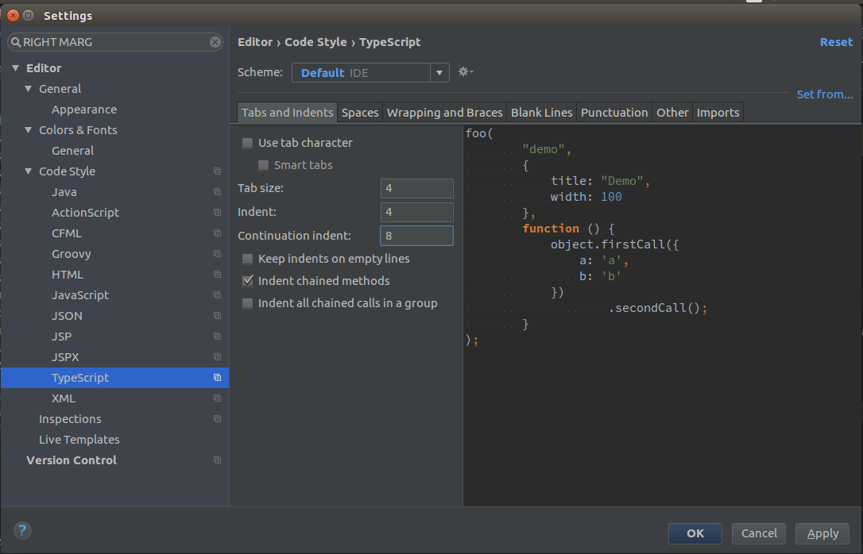

- Create Live Templates
  - prt for println
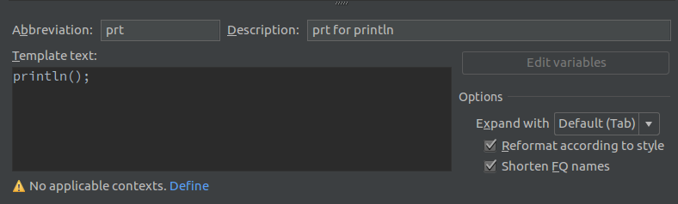
  - swt for setup: when: then:
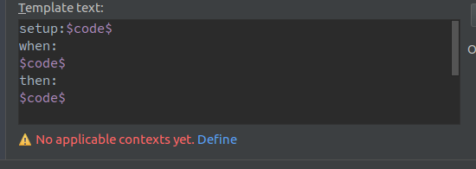
  - surround with try catch
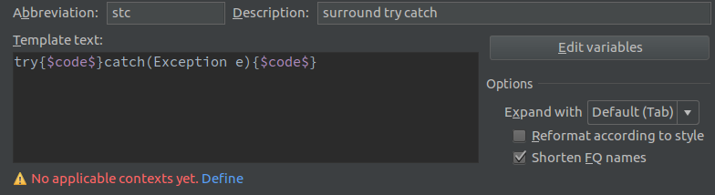
  - surround with if

