- Console "Hello Word" in document.ready function
<!DOCTYPE html>
<html>
<head>
<title></title>
</head>
<body>
<script src="../jquery-3.2.1.js"></script>
<script>
jQuery(document).ready(function(){
console.log("hello world");
});
</script>
</body>
</html>
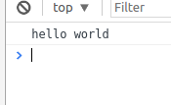

- Select a ID name "#test" and add class "load" when DOM is loaded
<!DOCTYPE html>
<html>
<head>
<style>
.load{
color: red;
font-family: monospace;
}
</style>
<title></title>
</head>
<body>
<p id="test">test selected and class loaded</p>
<script src="../jquery-3.2.1.js"></script>
<script >
jQuery(document).ready(function(){
jQuery("#test").toggleClass("load");
});
</script>
</body>
</html>

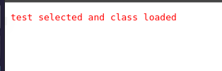
- Change the color of element which class name end with "-new"
<!DOCTYPE html>
<html>
<head>
<style type="text/css">
.first-new{
color: red;
}
.second-new{
color: green;
}
.third{
color: blue
}
.fourth{
color: yellow;
}
</style>
<title></title>
</head>
<body>
<script src="../jquery-3.2.1.js"></script>
<script>
jQuery(document).ready(function(){
jQuery("p[class$='-new']").click(function(){
jQuery(this).css("color","orange");
});
});
</script>
<p class="first-new">my class is first-new</p>
<p class="second-new">my class is second-new</p>
<p class="third">my class is third</p>
<p class="fourth">my class is fourth</p>
</body>
</html>
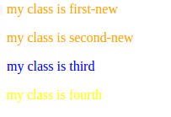

- Disable submit button using jquery attr method
<!DOCTYPE html>
<html>
<head>
<title></title>
</head>
<body>
<script src="../jquery-3.2.1.js"></script>
<script>
jQuery(document).ready(function(){
jQuery("[type=submit]").attr("disabled",true);
});
</script>
<form method="get">
<label>Enter your name</label>
<input type="text" >
<input type="submit" name="">
</form>
</body>
</html>
- Change the font size of ".target" which has parent element with id name "#main"
<!DOCTYPE html>
<html>
<head>
<title></title>
<style type="text/css">
#main{
color:blue;
}
.target{
color: red;
}
</style>
</head>
<body>
<script src="../jquery-3.2.1.js"></script>
<script>
jQuery(document).ready(function(){
jQuery("div#main > div.target").click(function(){
jQuery(this).css("font-size","larger");
});
});
</script>
<div id="main">
<h1>hello</h1>
<div class="target">
how are you
</div>
</div>
</body>
</html>

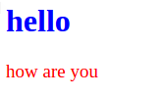
- After page load change the HTML of div element with "p" element
<!DOCTYPE html>
<html>
<head>
<title></title>
<style type="text/css">
div{
color: blue;
}
#para{

font-size: 15px;
}
.mypara{
color: green;
}
</style>
</head>
<body>
<script src="../jquery-3.2.1.js"></script>
<script>
var el = jQuery('<P id="para" class="mypara">HELLO THERE I AM A PARAGRAPH, PARAGRAPH HAS GREEN COLOR</P>');
jQuery(document).ready(function(){
jQuery("div").html(el);
});
</script>
<DIV>
HELLO THERE I AM A DIV, DIV HAS BLUE COLOR
</DIV>

</body>
</html>

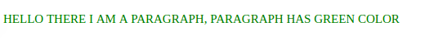
- Bind a click function to an "click" element and append next "click" next to it.
<!DOCTYPE html>
<html>
<head>
<title></title>
</head>
<body>
<script src="../jquery-3.2.1.js"></script>
<script>
var nBut=jQuery('<button id="b2">Now! click me too</button>');
jQuery(document).ready(function(){
jQuery("#b1").click(function(){
jQuery(this).after(nBut);
});
});
</script>
<button id="b1">click me</button>
</body>
</html>
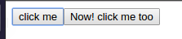

- Click event not working on element which added dynamicly or via script, make it work using .on method
<!DOCTYPE html>
<html>
<head>
<title></title>
</head>
<body>
<script src="../jquery-3.2.1.js"></script>
<script>
var nBut=jQuery('<button id="b2">Now! click me too</button>');
var x=jQuery('<span> heya</span>')
jQuery(document).ready(function(){
jQuery("#b1").click(function(){
jQuery(this).after(nBut);
});
});
jQuery(document).on("click","#b2",function(){
jQuery(this).after(x);
});
</script>
<button id="b1">click me</button>
</body>
</html>

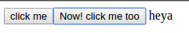

- Get dropdown selected value on onchanage event and append in div container
<!DOCTYPE html>
<html>
<head>
<title></title>
</head>
<body>
<script src="../jquery-3.2.1.js"></script>
<script>
jQuery(document).ready(function(){
jQuery("#sel").on("change",function(){
var x=jQuery('#sel :selected').text();
jQuery("#my_div").append(" "+x);
});
});

</script>
<select id="sel">
<option>delhi</option>
<option>mumbai</option>
<option>chennai</option>
<option>punjab</option>
</select>
<br/>
<br/>
<div id="my_div">this is a drop down lis above and selected value is</div>
</body>
</html>

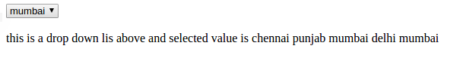
- Create a dropdown menu using hover method in jquery
<html>
<head>
<script src="../jquery-3.2.1.js"></script>
<style>
span{
display:inline-block;
border:1px solid black;
padding:5px 10px 5px;
margin:10px 10px 0px;
}
ul{display:none;
list-style:none;
margin-top:0px;}
</style>
</head>
<body>
<div>
<span>Dropdown &#9660;</span>
<ul id="list">
<li>value 1</li>
<li>value 2</li>
<li>value 3</li>
</ul>
</div>
<script>
$(function(){
$("span").hover(function(){
$("#list").show();
},
function(){
$("#list").hide();
}
);
});
</script>
</body>
</html>
- On clicking on "google" tag. It is taking us to google home page. Stop it from happening.
<!DOCTYPE html>
<html>
<head>
<title></title>
</head>
<body>
<script src="../jquery-3.2.1.js"></script>
<script >
jQuery(document).ready(function(){
jQuery("a").on("click", function(e){
e.preventDefault();
});
});
</script>
<a href="http://www.google.com">Google</a>
</body>

</html>
- We have bind a click funtion to parent div but we want stop it from performing when user clicks on its child li
<!DOCTYPE html>
<html>
<head>
<style type="text/css">
</style>
<title></title>
</head>
<body>
<script src="../jquery-3.2.1.js"></script>
<script >
jQuery(document).ready(function(){
jQuery("#dp").on("click", function(){
jQuery(this).css("color", "red");
});
jQuery("#d2").on("click",function(e){
jQuery(e.stopPropagation());
})
});

</script>
<div id=dp>i am parent
<div id=d2>i am 2nd
<div id=d3>i am 3rd
<div id=d4>
i am 4th
</div>
</div>
</div>
</div>
</body>
</html>

- Get the max height of elements using jquery each method
<!DOCTYPE html>
<html>
<head>
<title></title>
</head>
<body>
<script src="../jquery-3.2.1.js"></script>
<script >

jQuery(document).ready(function(){
jQuery("div").on("click",function(){
alert(jQuery(this).height());
});
jQuery("p").on("click",function(){
alert(jQuery(this).height());
});
});
</script>
<div>
hi<br/>
how<br>
are<br>
you
</div>
<p>
i am a para<br>
continued after <\br> tag<br>
</p>
</body>
</html>

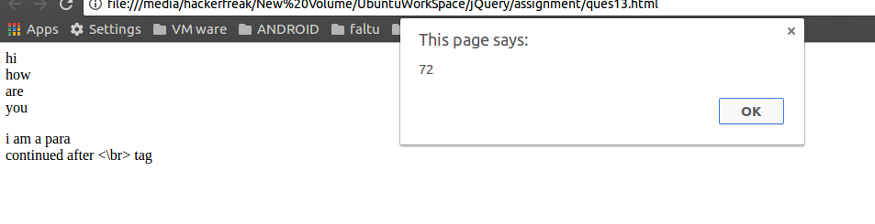

- Chagne color of every cell which has numberl larger than 10.
<!DOCTYPE html>
<html>
<head>
<style type="text/css">
table{
border-color: black;
border:2px solid;
width:100%;
}
td,tr{
border:2px solid;
text-align: center;
}
.col{
color: red;
}
</style>
<title></title>
</head>
<body>
<script src="../jquery-3.2.1.js"></script>
<script >

jQuery(document).ready(function(){
jQuery("td").each(function(){
if(jQuery(this).text()>10)
{
jQuery(this).addClass("col");
}
});
jQuery("td").mouseover(function(){
if(jQuery(this).text()>10)
{
jQuery(this).toggleClass("col");
}
});
});
</script>
<table>
<tr>
<td>
1
</td>
<td>
25
</td>
</tr>
<tr>
<td>
20
</td>
<td>
5
</td>
</tr>
<tr>
<td>
7
</td>
<td>
60
</td>
</tr>
</table>
</body>
</html>
- Retrive the data from server using ajax get call
<!DOCTYPE html>
<html>
<head>
<title></title>
</head>
<body>
<script src="../jquery-3.2.1.js"></script>
<script >

jQuery(document).ready(function(){
jQuery("div").on("click",function(){
jQuery.get("https://code.jquery.com/jquery-3.2.1.min.js",function(data,status){
alert(data+" "+status);
});
});

});
</script>
<div>
click me
</div>
</body>
</html>
- Add cross button on row and bind click function which make a delete request to server, after success event remove the row from dom

