- Prompt for amount, interest rate and no. of years and calculate simple interest.
<!DOCTYPE html>
<html>
<head>
<title></title>
</head>
<body>
<input type="button" value="click to get SI" onclick="calCi();">
<script type="text/javascript">
function calCi()
{
var principal = prompt("Please enter principal");
var rate = prompt("Please enter rate of interest");
var time = prompt("Please enter your time");
var si=((principal*rate*time)/100);
alert(si);
}
</script>
</body></html>
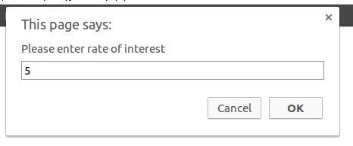
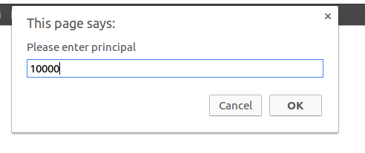

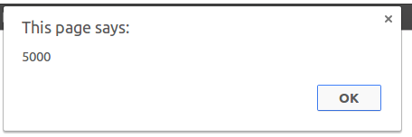
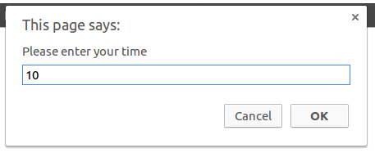

- is palindrome string
<!DOCTYPE html>
<html>
<head>
<title></title>
</head>
<body>
<input type="text" name="palindriome" id="pd">
<input type="button" value="Click to check" onclick="ckPald();">
<script type="text/javascript">
function ckPald(){
var x=true;
var p=document.getElementById("pd").value;
var len = Math.floor(p.length / 2);
for (var i = 0; i < len; i++){
if (p[i] !== p[p.length - i - 1])
{
x= false;
break;
}

}
if(x==true){
alert("string is palindriome");
}
else{
alert("string is not palindriome");
}
}

</script>
</body>
</html>

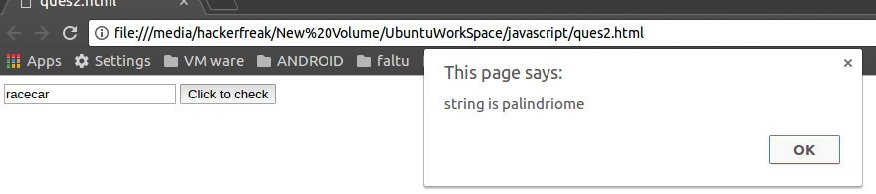
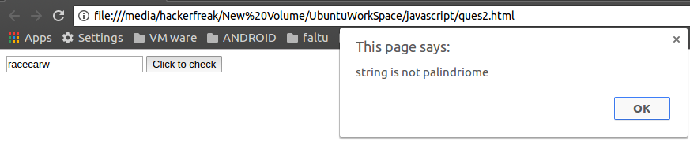
- Area of circle
<!DOCTYPE html>
<html>
<head>
<title></title>
</head>
<body>
<input type="text" name="radius" placeholder="Enter the radius" id="r">
<input type="button" value="Click to cal area" onclick="calAr();">
<script type="text/javascript">
function calAr(){
var p=document.getElementById("r").value;
alert("Area of circle with "+p+" units is "+3.14*p*p+" sq.units");
}

</script>
</body>
</html>

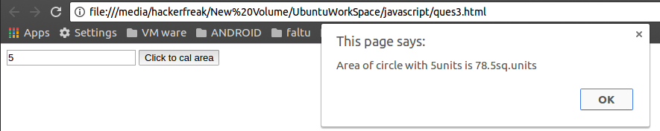
- Copy information of one object to another and log it to console.
<!DOCTYPE html>
<html>
<head>
<title>

</title>
</head>
<body>
<button onclick="person.cpy(person)">click me</button>
<script type="text/javascript">
var person = {
firstName: "John",
lastName : "Doe",
id : 5566,
cpy : function() {
x={};
x.firstName=this.firstName;
x.lastName=this.lastName;
x.id=this.id;
console.log(x.firstName+" "+x.lastName+" "+x.id);
}
};
//alternative code
var newp=new Object(person);
console.log(newp.firstName+" "+newp.lastName+" "+newp.id);

</script>
</body>
</html>

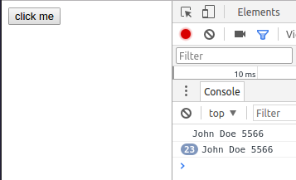
- create a list of objects of Employee with info as follow :
  - Name, age, salary ,DOB
  - filter all employees with salary greater than 5000
  - group employee on the basis of their age
  - fetch employees with salary less than 1000 and age greater than 20. Then give them an increment 5 times their salary
<!DOCTYPE html>
<html>
<head>
<title></title>
</head>
<body>

<script type="text/javascript">

person=[{Name: "John",age: 20,salary: 200,DOB:"12 may 1990"},
{Name: "ram",age: 52,salary: 350,DOB:"05 aug 1961"},
{Name: "Johnny",age: 56,salary: 400,DOB:"06 nov1957"},
{Name: "suresh",age: 16,salary: 400,DOB:"06 nov1957"},
{Name: "rakesh",age: 56,salary: 6000,DOB:"06 nov1957"},
{Name: "militia",age: 56,salary: 5500,DOB:"06 nov1957"}];

for(var i=0;i<person.length;i++)
{
document.write("<ol>");
document.write("<li>"+person[i].Name+"</li>"+"<li>"+person[i].age+"</li>"+"<li>"+person[i].salary+"</li>"+"<li>"+person[i].DOB+"</li>");

document.write("</ol>");
document.write("<br>");

}
function part2(){
for(var i=0;i<person.length;i++)
{
document.write("<ol>");
if(person[i].salary>5000){
document.write("<li>"+person[i].Name+"</li>"+"<li>"+person[i].age+"</li>"+"<li>"+person[i].salary+"</li>"+"<li>"+person[i].DOB+"</li>");
}
document.write("</ol>");

}
document.write('<button onclick="part3();">click for part 3</button>');
}
function part3()
{

}
function part4()
{
emp=[];
var count=0;
for(var i=0;i<person.length;i++)
{

if(person[i].salary<1000&&person[i].age>20){
emp[count]=person[i];
person[i].salary+=1000;
count++;
}
}
for(var i=0;i<emp.length;i++){
document.write("<ol>");
document.write("<li>"+emp[i].Name+"</li>"+"<li>"+emp[i].age+"</li>"+"<li>"+emp[i].salary+"</li>"+"<li>"+emp[i].DOB+"</li>");
document.write("</ol>");
}
}
</script>
<button onclick="part2();">click for part 2</button>
<!--<button onclick="part3();">click for prt 2</button>
<button onclick="part4();">click for part 2</button>-->
</body>
</body>
</html>

