|  |
| --- |
| Close-up image showing the leaf-sides of two oversized books side-by-side on a bookshelf, with additional books in soft focus background |
| Smart Health |
| |  |  |  | | --- | --- | --- | | shuvo | 10/29/17 | Software Project Lab-3 | |

Software Requirement Specification, Analysis, Design and Test Plan

Smart Health Project

Software project lab-3

Supervisor

Nadia Nahar

Lecturer

Institute of Information Technology

University of Dhaka

Submitted by

Shubho Chandro Roy

BSSE-0619

Date: 29-10-2017

Table of Contents

Chapter 1 5

Introduction 5

1.1 Purpose 5

1.2 Intended Audience 5

Chapter 2 6

Inception 6

2.1 Introduction 6

2.1.1 Identifying Stakeholders 6

2.1.2 Asking the First Questions 7

2.1.3 Recognizing Multiple Viewpoints 7

2.1.4 Working towards Collaboration: 7

2.1.5 Conclusion 7

Chapter 3 8

Elicitation 8

3.1 Introduction 8

3.2 Eliciting Requirements 8

3.3 Collaborative Requirements Gathering 8

3.4 Quality Function Deployment 8

3.4.1 Normal Requirements 8

3.4.2 Expected Requirements 9

3.4.3 Exciting Requirements 9

3.5 Usage Scenario 9

Chapter 4 10

Scenario-Based Model 10

4.1 Introduction 10

4.2 Use Case Scenario 10

4.3 Use Case Diagram 10

4.3.1 System Description 10

4.3.2 Use Case Diagram for Smart Health level-1 Description 11

4.3.2.1 Use Case for Authentication 12

4.3.2.2 Use Case for Registration 13

4.3.2.2 Use Case for Login 17

4.3.3 Use Case for Update Profile 18

4.3.4 Use Case for Find Doctor 21

4.3.5 Use Case for Messaging 23

4.3.6 Use Case for Video Calling 26

4.3.7 Use Case for Recommendation 29

Chapter 5 37

Data Model 37

5.1 Data Modeling Concept 37

5.2 Data Objects 37

5.3 Entity Relationship Diagram 39

Chapter 6 40

Class Based Model 40

6.1 Introduction 40

6.2 General Classification 40

6.3 Selection Criteria 40

6.4 Attributes Section 41

6.5 Method Selection 42

6.6 Class Responsibility 42

6.6 Class Responsibility Collaboration (CRC) 43

Chapter 7 44

Flow-Oriented Model 44

7.1 Introduction 44

7.2 Data Flow Diagram (DFD) 44

Chapter 8 45

Behavioral Model 45

8.1 Introduction 45

8.2 Identifying Events with the Use Case 45

8.3 State Transition 45

8.4 Sequence Diagram 47

Chapter 9 48

Software Design Architecture 48

9.1 Architectural Design for OOP 48

9.1.1 Representing the system in context 48

9.1.2 Define Archetypes 48

9.1.3 Refining architecture into components 48

9.1.4 Describing Instantiation of the system 49

9.1.5 Mapping Requirements into Software Architecture 49

# **Chapter 1**

# Introduction

## 1.1 Purpose

This document is the Software Requirements Specification (SRS) for Smart Health project. It contains detailed functional, non-functional, and support requirements and  
establishes a requirements baseline for development of the system. The requirements  
contained in the SRS are independent, uniquely numbered, and organized by topic. The SRS  
serves as the official means of communicating user requirements to the developer and provides  
a common reference point for both the developer team and stakeholder community.

1.2 Intended Audience

This SRS is intended for several audiences including the customer, as well as the project managers, designers, development and testers.

* The User will use this SRS to verify that the developer team has created a system  
  that is acceptable to the user.
* I will use this SRS as a basis for developing the system’s functionality. I will link the  
  requirements defined in this SRS to ensure that I have created software that will fulfill all  
  of the user’s documented requirements.
* The testers will use this SRS to derive test plans and test cases for each documented  
  requirement. When portions of the software are being completed, the testers will run  
  their tests on the software to ensure that the software fulfills the requirements  
  documented on the SRS. The testers will again run their tests on the entire system when  
  it is completed and more use of that all requirements documented in the SRS have been  
  fulfilled.

# Chapter 2

# Inception

## 2.1 Introduction

Inception is the beginning phase of requirements engineering. It defines how does a software  
project get started and how is the scope and nature of the problem to be solved. The goal of the  
inception phase is to identify concurrence needs and conflict requirements among the  
stakeholders of a software project. To establish the groundwork I have worked with the Factors  
related to the inception phases:

* Identifying Stakeholders
* Asking the First Questions
* Recognizing Multiple Viewpoints
* Working Towards Collaboration

### 2.1.1 Identifying Stakeholders

Stakeholder refers to any person or group who will be affected by the system directly or  
indirectly. Stakeholders include end-users who interact with the system and everyone else in an  
organization that may be affected by its installation. To identify the stakeholders, I find some  
question:

* Who is paying for the project?
* Who will be using the project outcomes?
* Who gets to make the decisions about the project (if this is different from the money  
  source)?
* Who has resources I need to get the project done?
* Whose work will my project affect? (During the project and also once the project is  
  completed)

**Stakeholder**

1. Doctor: Doctor can login into the system via email id and password. He/she can provide service to the patient according the patients’ problem.
2. Patient: Patient can login into the system via email id and password. He/she can find doctor, contact with them through messaging and if necessary
3. Supervisor: He/she plays a vital role for this project. Every steps and features of this project has been verified by his/her.
4. Developer: A group of developer or a single person may develop this system.
5. Tester: A group of tester or a single person may test this project.

### 2.1.2 Asking the First Questions

I set my first set of context-free questions focusing on the users and other stakeholders, overall  
project goals and benefits. The questions are mentioned above. This questions helped me to  
identify all stakeholders’ measurable benefit of the successful implementation and possible  
alternatives to custom software development. Next set of question helped us to gain a better  
understanding of problem and allows the customer to voice his or her perception about the  
solution. The final set of question focused on the effectiveness of the communication activity  
itself.

### 2.1.3 Recognizing Multiple Viewpoints

I collect this viewpoint by discussing with the supervisor, doctors, patients, medical center and Teachers of Institute of Information Technology, University of Dhaka. Further I also collect some viewpoints from some non-registered people as guest.

1. Doctors: Create own profile and give services to patients.
2. Patients:

* Contact with doctors via messaging.
* Contact with doctors via video calling.
* Get recommended hospital name nearby his/her location according to his/her disease.

### 2.1.4 Working towards Collaboration:

Every stakeholder has their own requirements. I have followed following steps to merge these  
requirements:

* Identify the common and conflicting requirements
* Categorize the requirements
* Take priority points for each requirement from stakeholders and on the basis of this  
  voting prioritize the requirements
* Make final decision about the requirements

### 2.1.5 Conclusion

Inception phase helped me to establish basic understanding about Smart Health project for doctor and patient and identify the people who want to give and take treatment via online, define the nature of the Smart Health project and establish a preliminary communication with our stakeholders.

# Chapter 3

# **Elicitation**

3.1 Introduction

Elicitation is a task that helps the traveler to define what is required. To complete the elicitation  
step I face many problems like problems of scope, problems of volatility and problems of  
understanding. However, this is not an easy task. To help overcome these problems, I have  
worked with the Eliciting requirements activity in an organized and systematic manner.

3.2 Eliciting Requirements

Unlike inception where Q&A (Question and Answer) approach is used, elicitation makes use of  
a requirements elicitation format that combines the elements of problem solving, elaboration,   
negotiation, and specification. It requires the cooperation of a group of end-users and  
developers to elicit requirements. To elicit requirements, I completed following four works.

* Collaborative Requirements Gathering
* Quality Function Deployment
* Usage Scenarios
* Elicitation work products

## 3.3 Collaborative Requirements Gathering

Many different approaches to collaborative requirements gathering have been proposed. Each  
makes use of a slightly different scenario.

## 3.4 Quality Function Deployment

Quality Function Deployment (QFD) is a technique that translates the needs of the customer  
into technical requirements for software .It concentrates on maximizing customer satisfaction  
from the Software engineering process .With respect to my project the following requirements  
are identified by a QFD.

### 3.4.1 Normal Requirements

Normal requirements consist of objectives and goals that are stated during the meeting with the  
customers. Normal requirements of my project are:

* Accessible via the Internet.
* Allow interface to check for valid access and decision for valid system administrator and  
  user.
* Doctor create his/her own profile for that patient can easily find his/her expected doctor.
* Patient sends message to the doctors
* Patient can direct communicate with doctors via video calling.

### 3.4.2 Expected Requirements

* Restrict access to functionality of the system based upon roles.
* Allow valid system administrator to login and logout to the system.

### 3.4.3 Exciting Requirements

* Get recommended medical center nearby patients’ location and disease and other information.

## 3.5 Usage Scenario

Smart Health is an online platform for patient where they can easily find their expected doctor and contact with them through messenger or video calling. At first, every user must be registered into the system. For registration, they submit their first and last name, username, email id, password and select user role. Based on the user role some additional fields are appeared. Such as, for doctor, designation, college/university name, hospital name, speciality and for patient, age, height, weight, blood pressure, blood group and address. According the user role, user get a profile which they can update.

After login, patient can get more option such as messaging, video calling and recommendation. According to patients’ problem, they can find their expected doctor and contact with doctor through messaging and video calling. If the doctor is unable to understand patients’ problem in messaging session, they make video call for direct communication. Patients also able to get recommended hospital name nearby their location and according their given information which they give in authentication session.

# Chapter 4

# Scenario-Based Model

4.1 Introduction

In this model the system is described from the user’s point of view. As this is the first model, it serves as input for creation of other modeling elements. Basically scenario based modelling evolves basic use case, use case diagrams (activity and Swim lane diagram).

4.2 Use Case Scenario

In software and systems engineering, a usecase is a list of actions or event steps typically defining the interactions between a role (known in the Unified Modeling Language as an actor) and a system to achieve a goal. The actor can be a human or other external system. The first step in writing a use case is to define that set of “actors” that will be involved in the story. Actors are the different people that use the system or product within the context of the function and behavior that is to be described. Actors represent the roles that people play as the system operators. Every user has one or more goals when using system.

**Primary Actor**: Primary actors interact directly to achieve required system function and derive  
the intended benefit from the system. They work directly and frequently with the software. Here doctors and patients are primary actor.

**Secondary Actor:** Secondary actors support the system so that primary actors can do their work.  
They either produce or consume information.

## 4.3 Use Case Diagram

Use case diagrams give the non-technical view of overall system.

### 4.3.1 System Description

After analyzing the user scenario, I found two actors who will directly communicate through the system as a system operator. I shall elaborate use case scenario to use case diagram, description, activity diagram & swim lane diagram. Here is the use case diagram of level-0 for Smart Health in Figure-1:

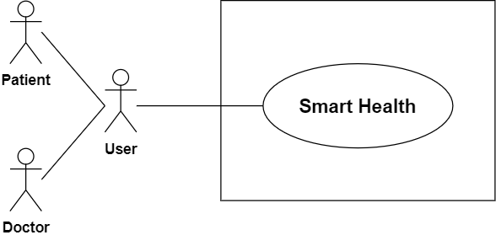

Figure 1: Use case diagram for level-0

### 4.3.2 Use Case Diagram for Smart Health level-1 Description

Primary actor : User

Secondary actor : System

Goal in context : To operate the application

Scenario : The actors of this system have to play different actions and system will reply according to these actions-

Action 1 : Enter Registration form.

Reply 1 : Please fill up the required filled.

Action 2 : Enter the information.

Reply 2 : Registration successful.

Action 3 : Enters username and password.

Reply 3 : Successfully login and shows more option for interact with system.

Action 4 : Click on profile.

Reply 4 : Shows user profile.

Action 5 : Enter information for update user profile

Reply 5 : User profile updated.

Action 6 : Click on Find Doctor

Reply 6 : Shows active doctor list

Action 7 : Click on message

Reply 7 : Shows chat box for messaging

Action 8 : Click on video call

Reply 8 : Video calling window appear for video conference

Action 9 : Click on recommendation

Reply 9 : Recommendation page appeared

Action 10 : Enter disease name for recommendation and search

Reply 10 : Recommended hospital name

Exception : No Exceptions (if system works correctly by fulfilling requirements)   
Exceptions (if) : User is not authenticated.  
 : System error

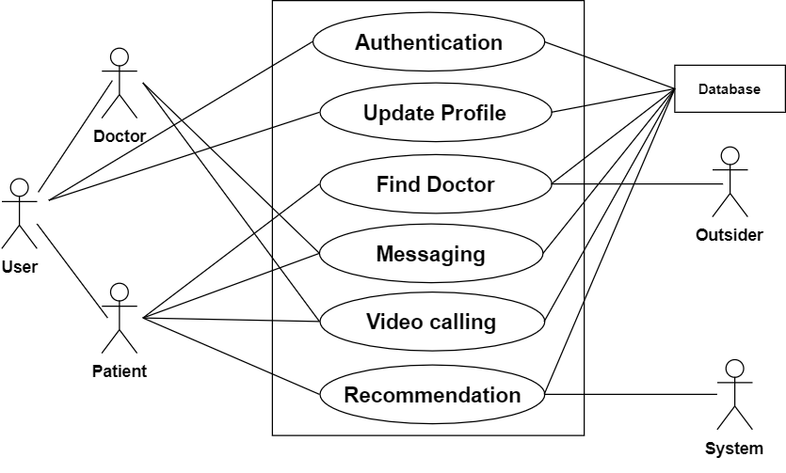

Figure 2: Use case diagram for level-1

#### 4.3.2.1 Use Case for Authentication

I define authentication system into four subsystem. The use case for authentication is given below:-

Action 1 : Enter required information

Reply 1 : Successfully registered.

Action 2 : Enters Email id and password.

Reply 2 : Successfully logged in.

Action 3 : Enter information for update profile.

Reply 3 : Profile is updated.

Action 5 : Click on log out

Reply 4 : Logged out.

Exception: No Exceptions

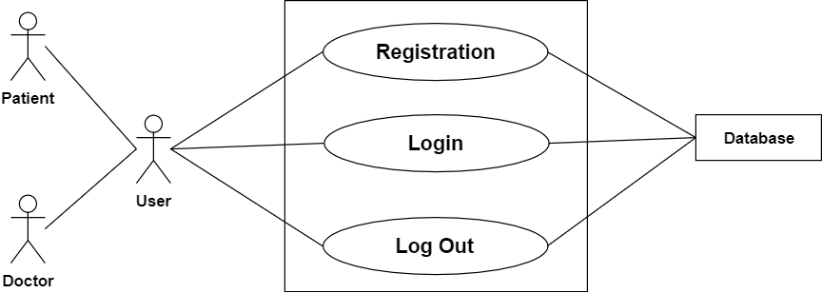

Figure 3: Use case for authentication level-1.1

#### 4.3.2.2 Use Case for Registration

Use case: Registration

**Primary Actor** : User (Doctor, Patient)

**Secondary Actor** : System

**Goal in Context** : To enter the system for User.

**Priority** : Essential, must be implemented.

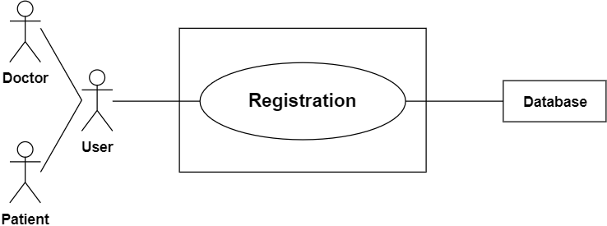

Figure 4: Use case for registration level-1.1.1

Activity diagram of Registration In is given below in figure in Figure-5

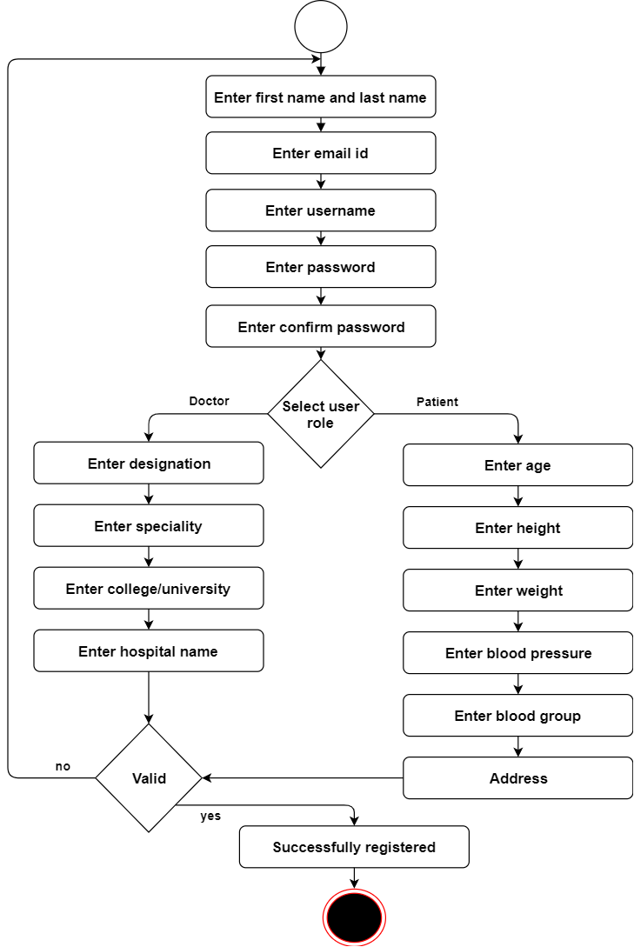

Figure 5: Activity diagram for registration

**Activity Diagram (Registration):** Doctor and patient must be completed registration activity for getting more option to perform. Without registration, a patient is not able to contact with doctor and cannot use the recommendation activity. If a doctor do not want to registered, he/she are not allowed to provide any online activity. So for registration, user must enter first name, last name, email id, username, password, confirm password and additional fields.

Swim Lane diagram of registration is given below in Figure-6

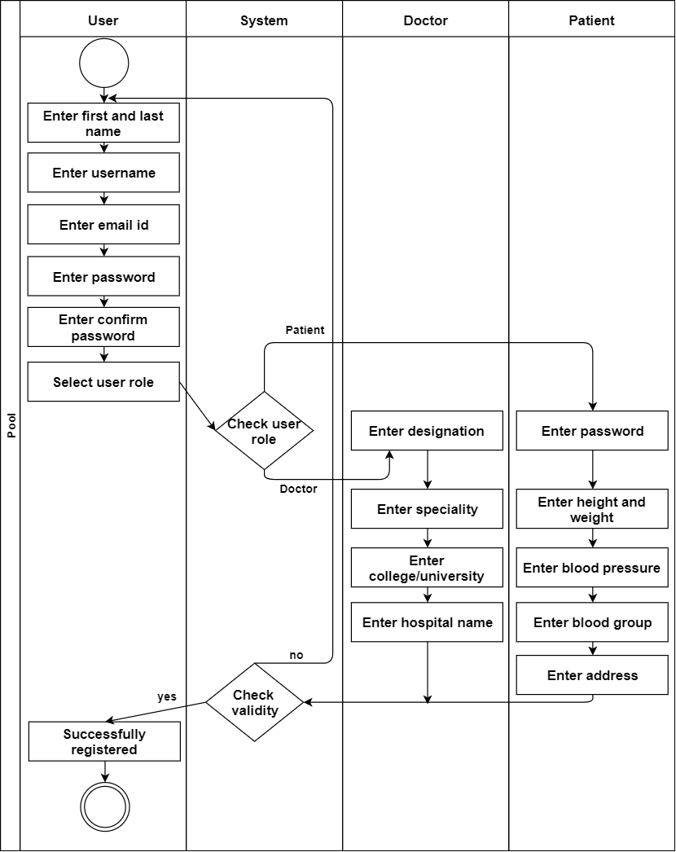

Figure 6: Swim lane diagram for registration

#### 4.3.2.2 Use Case for Login

Use case: Login

**Primary Actor** : User (Doctor, patient)

**Secondary Actor** : System

**Goal in Context** : To entry the system.

**Priority** : Essential, must be implemented.

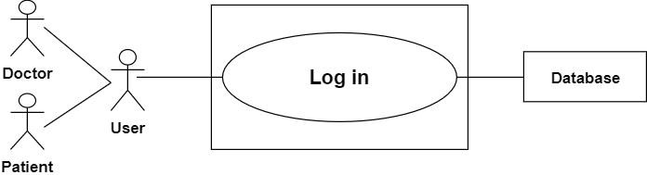

Figure 7: Use case for login level-1.1.2

Activity diagram of Log in is given below in figure in Figure-8

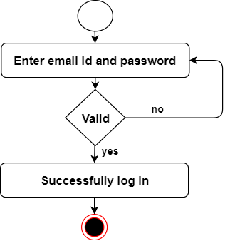

Figure 8: Activity diagram for login

**Activity Diagram (Log in):** For completing Log in activity, user need to provide  
valid email id and password

Swim lane diagram for login is given below in figure-9

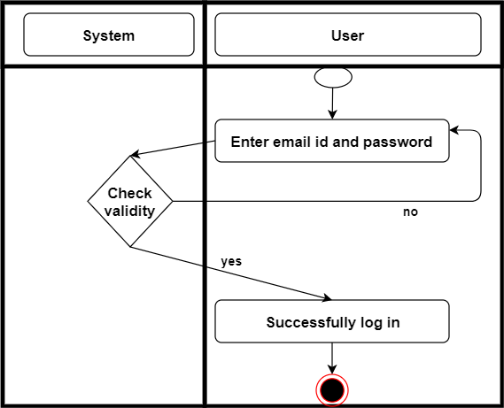

Figure 9: Swim lane diagram for login

### 4.3.3 Use Case for Update Profile

Use case: Update profile

**Primary Actor** : User (Doctor, Patient)

**Secondary Actor** : System

**Goal in Context** : To entry the system.

**Priority** : Essential, must be implemented.

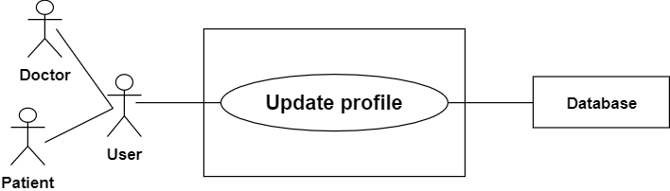

Figure 10: Use case for update profile level-1.1.3

Activity diagram of update profile is given below in figure-11

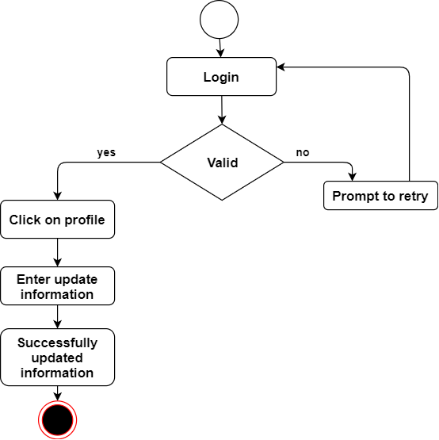

Figure 11: Activity diagram for update profile

**Activity diagram (Update profile):** User can update their profile. For updating their profile they  
must be logged into the system. After login they can update their profile information like  
password change, name change or anything they want to update.

Swim lame for update profile is given in figure 12

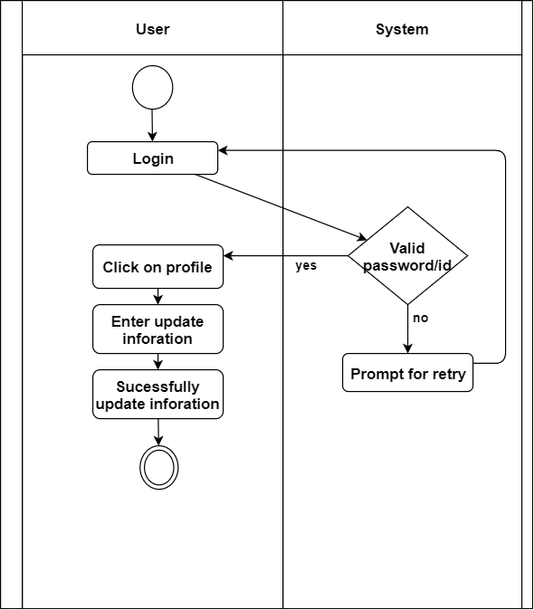

Figure 12: Swim lane diagram for update profile

### 4.3.4 Use Case for Find Doctor

Use case: Find Doctor

**Primary Actor** : Patient

**Secondary Actor** : System

**Goal in Context** : To find doctor list.

**Priority** : Essential, must be implemented.

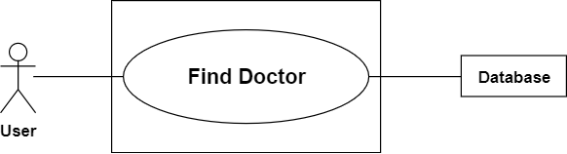

Figure 13: Use case for find doctor

Activity diagram for find doctor is given below in figure-14

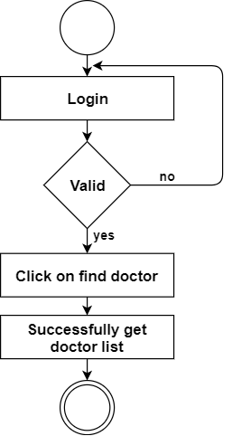

Figure 14: Activity diagram for find doctor

**Activity diagram (Find Doctor):** Patient firstly login into the system and then click on find doctor for getting doctor list.

Swim lane diagram for find doctor is given in figure-15

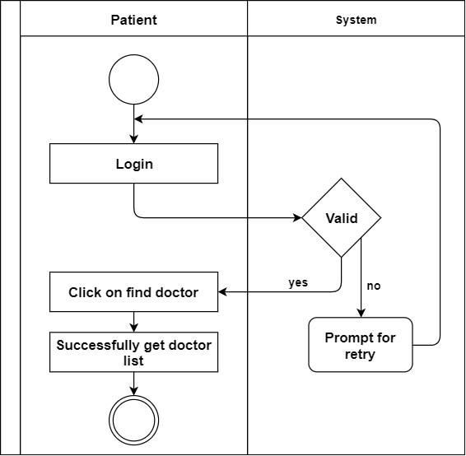

Figure 15: Swim lane diagram for find doctor

### 4.3.5 Use Case for Messaging

Use case: Messaging

**Primary Actor** : Patient, Doctor

**Secondary Actor** : System

**Goal in Context** : For communication between doctor and patient.

**Priority** : Essential, must be implemented.

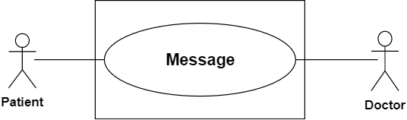

Figure 16: Use case for message

Activity diagram for message is given in figure-17

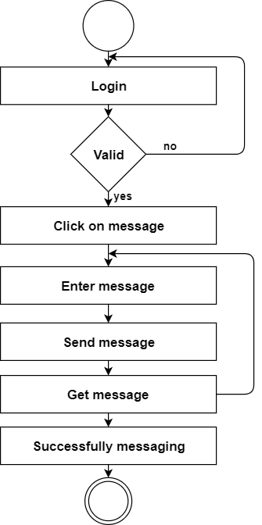

Figure 17: Activity diagram for message

**Activity diagram (Messaging):** Primarily patient can communicate with a doctor via messaging system.

Swim lane diagram for Messaging is in figure-18

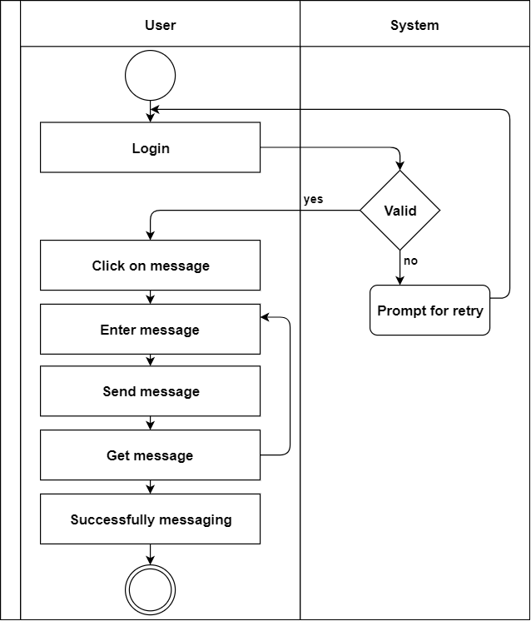

Figure 18: Swim lane diagram for messaging

### 4.3.6 Use Case for Video Calling

Use case: Video calling

**Primary Actor** : Patient, Doctor

**Secondary Actor** : System

**Goal in Context** : For communication between doctor and patient.

**Priority** : Essential, must be implemented.

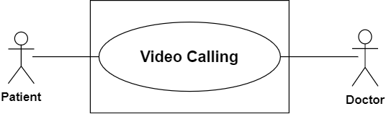

Figure 19: Use case for video calling

Activity diagram for video calling is given in figure-20

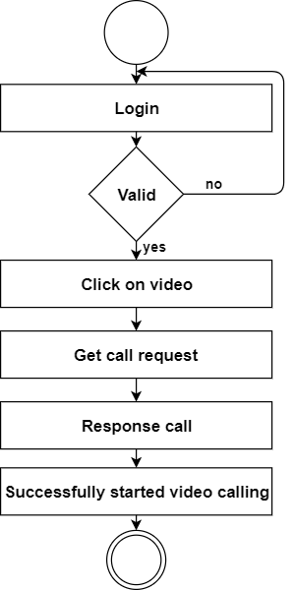

Figure 20: Activity diagram for video calling

**Activity diagram (Video calling):** Primarily patient can communicate with a doctor via video calling. Here doctor see the patient and suggest proper medicine. For video calling, patient enter his/her username.

Swim lane diagram for video calling is given in figure-21

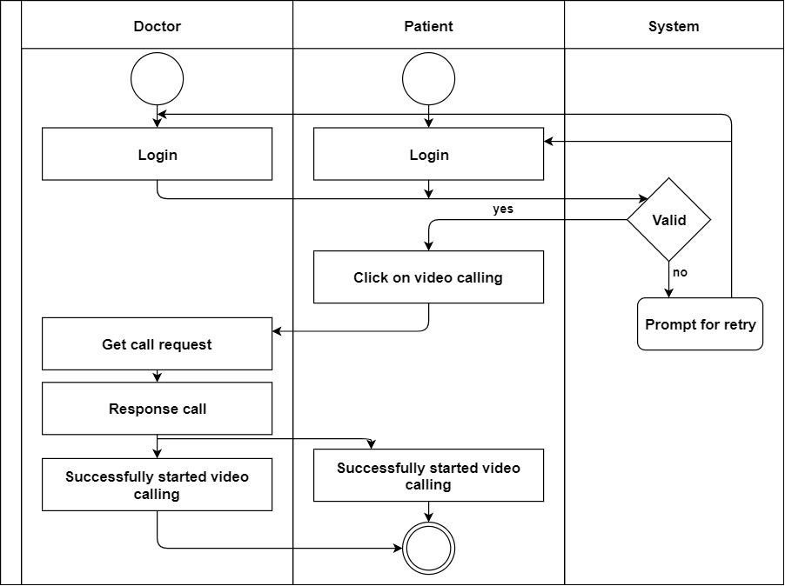

Figure 21: Swim lane diagram for video calling

### 4.3.7 Use Case for Recommendation

Use case: Recommendation

**Primary Actor** : Patient

**Secondary Actor** : System

**Goal in Context** : For recommendation

**Priority** : Essential, must be implemented.

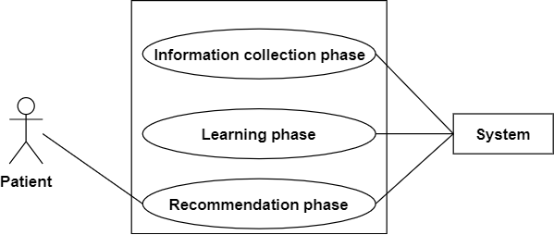

Figure 22: Use case for recommendation

Activity diagram of information collection phase for patient is in figure-23

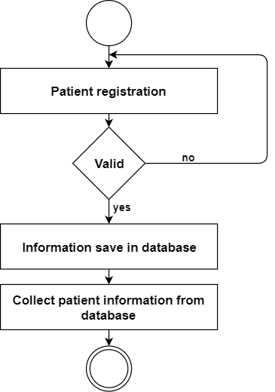

Figure 23: Activity diagram of information collection phase for patient

**Activity diagram (Information collection phase):** Information collect from patient registration.

Activity diagram of information collection phase for hospital is in figure-24

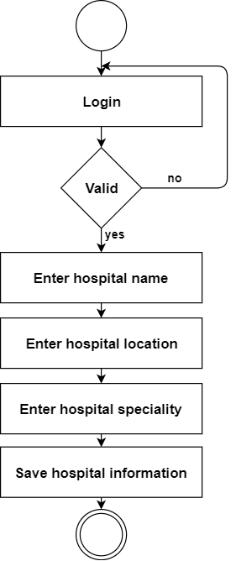

Figure 24: Activity diagram of information collection phase for hospital

**Activity diagram (Information collection phase for hospital):** Admin can enter hospital information after login into the system.

Swim lane diagram of information collection phase for patient is given below

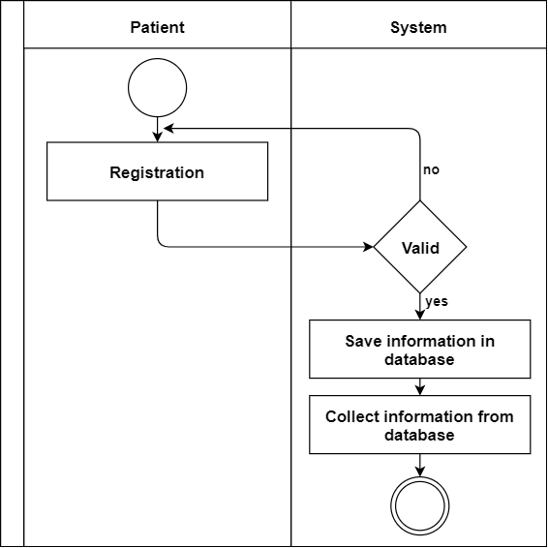

Figure 25: Information collection (patient) swim lane diagram

Swim lane diagram of information collection phase for hospital is given below

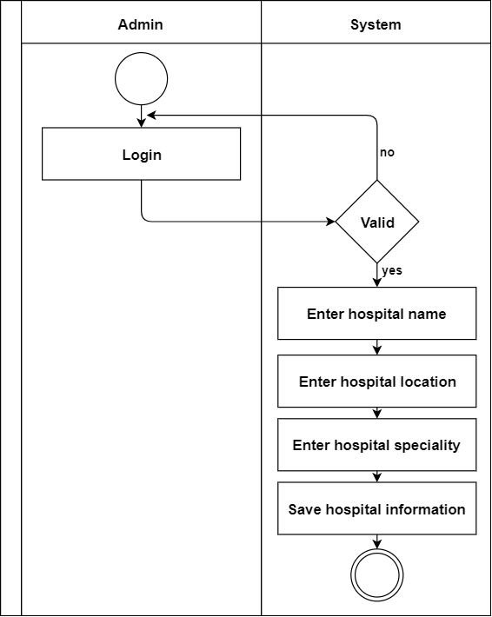

Figure 26: Information collection (hospital) swim lane diagram

Activity diagram for learning phase

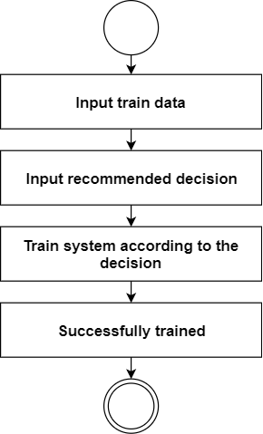

Figure 27: Activity diagram for learning phase

Activity diagram for recommendation phase

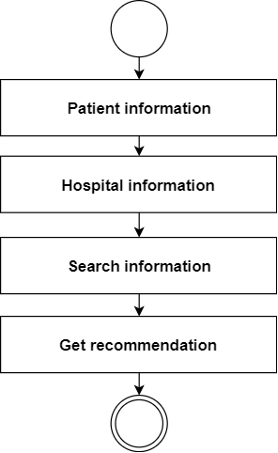

Figure 28: Activity diagram for recommendation phase

Swim lane diagram for recommendation

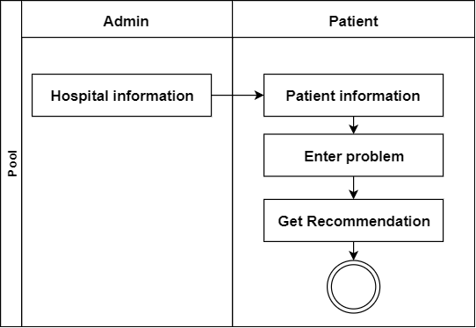

Figure 29: Swim lane diagram for recommendation

# Chapter 5

# Data Model

In this chapter I will discuss about the data models of Smart Health system.

## 5.1 Data Modeling Concept

If software requirements include the need to create, extend, or interface with a database or if complex data structures must be constructed and manipulated, a software team may choose to create a data model as part of overall requirements modeling.

## 5.2 Data Objects

A data object is representation of composite information that must be understood by software. Here, composite information means that has a number of different properties or attributes. A data object can be an external entity, a thing, an occurrence, a role, an organizational unit, a place or a structure.

**Identify Data Objects**

Nouns having attributes are selected as data object. Those who doesn’t have any attributes have covered under the data objects.

**Data Object:** User

Attributes:

* User id
* Password
* First Name
* Last Name
* Email id
* User role
* Picture
* Gender

**Data Object:** Role

Attributes

* Role id
* Role name

**Data Object:** Doctor

Attributes

* College/University
* Designation
* Speciality
* Hospital id
* Role id
* User id

**Data Object:** Patient

Attributes

* Age
* Height
* Weight
* Blood pressure
* Blood group
* Location
* Name of disease
* User id
* Role id

**Data Object:** Messaging

Attributes

* Patient id
* Doctor id
* Connection id

**Data Object:** Video calling

Attributes

* Patient id
* Doctor id
* Connection id

**Data Object:** Hospital

Attributes

* Hospital id
* Hospital name
* Location
* Speciality
* Description
* Doctor id

## 5.3 Entity Relationship Diagram

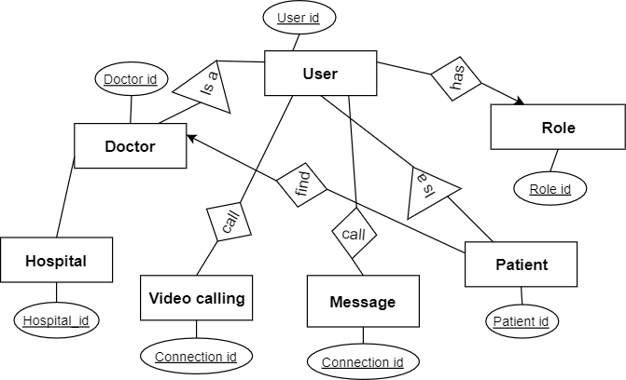

Figure 30: Entity diagram

# Chapter 6

# Class Based Model

## 6.1 Introduction

Class-based modeling is the operations that will be applied to the objects, relationships between the objects and the collaborations that occur between the classes that are defined.

## **6.2 General Classification**

To identify potential classes, I have first find out all the nouns which are in solution space. Then  
analyses the nouns to find out if they are in following zero or more criteria:

* External entity
* Thing
* Occurrence
* Role
* Organizational unit
* Place
* Structure

|  |  |
| --- | --- |
| G.C | Noun |
| External entity | First name, last name, username, password, gender, email id, designation, college/university name, specialty, age, height, weight, blood pressure, blood group, address |
| Thing | Recommendation system |
| Occurrence | Authentication, messaging, video calling, recommendation |
| Role | Doctor, patient |
| Organizational unit | Doctor, patient |
| place | - |
| Structure | - |

## 6.3 Selection Criteria

There have six characteristics that are given below:

* Retained information
* Needed Services
* Multiple Attributes
* Common Attributes
* Common operations
* Essential Requirements

**Table 3: Potential Class Identification**

|  |  |  |  |
| --- | --- | --- | --- |
| Noun | Problem/Solution space | Selection criteria | General criteria |
| Authentication | s | Accepted | 1,2,3,4,5 |
| Doctor | s | Accepted | 1,2,3,4,5,6 |
| Messaging | s | Accepted | 1,2,3,4,5,6 |
| Video calling | s | Accepted | 1,2,3,4,5,6 |
| Patient | s | Accepted | 1,2,3,4,5,6 |
| Recommendation | s | Accepted | 1,2,3,4,5,6 |
| User | s | Accepted | 1,2,3,4,5,6 |
| Role | s | Accepted | 1,2,3,4,5,6 |

## 6.4 Attributes Section

Here I find attributes for selected classes.

**Table 4: Selected Classes and their attributes:**

|  |  |
| --- | --- |
| **Selected class** | **Attributes** |
| Authentication | User id, first name, last name, email id, password, gender, role id, designation, college/university name, specialty, age, height, weight, blood pressure, blood group, address, hospital name |
| User | User id, first name, last name, email id, password, gender, role id |
| Doctor | designation, college/university name, hospital name, specialty |
| Patient | age, height, weight, blood pressure, blood group, address |
| User role | Role id, role name |
| Messaging | Message id, connection id, user id |
| Video calling | Connection id, user id |
| Hospital | Hospital id, name, location, specialty, description |

## 6.5 Method Selection

**Table 4: Selected method**

|  |  |
| --- | --- |
| **Selected class** | **Method** |
| Authentication | Signup(), Login(), Logout(), Update_Profile() |
| User | Get(), Set() |
| Doctor | Get(), Set(), GetMessage(), GetVideoCall() |
| Patient | GetDoctorList(), GetRecommendation(), SendMessage(), SendVideoCall(0 |
| User role | Get(), Set(), SendRole() |
| Messaging | GetUserId(), SetConnection() |
| Video calling | GetUserId(), SetConnection() |
| Hospital | SendHospitalList() |

## 6.6 Class Responsibility

Class responsibility is shown below

Table: Class responsibility

|  |  |
| --- | --- |
| **Class** | **Responsibility** |
| User | Entering the system |
| Doctor | Creating profile |
| Patient | Messaging and video calling with doctor, take recommended information |
| Message | Make a bridge between patient and doctor via message chatting |
| Video conference | Make a bridge between patient and doctor via video calling |
| Hospital | Sending hospital list for recommendation |
| Database | Storing and retrieving information |

## 6.6 Class Responsibility Collaboration (CRC)

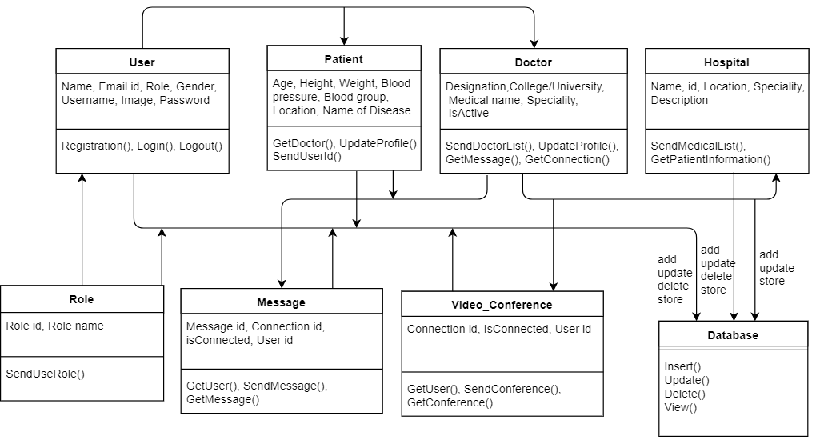

Figure 31: Class diagram

# Chapter 7

# Flow-Oriented Model

## 7.1 Introduction

Although data flow-oriented modeling is perceived as an outdated technique by some software

Engineers, it continues to be one of the most widely used requirements analysis notations in use

Today.

## 7.2 Data Flow Diagram (DFD)

The Data Flow Diagram (DFD) takes an input-process-output view of a system. Data objects flow into the software, are transformed by processing elements and resultant data objects flow out of the software. Data objects are represented by labeled arrows and transformations are represented by circles.

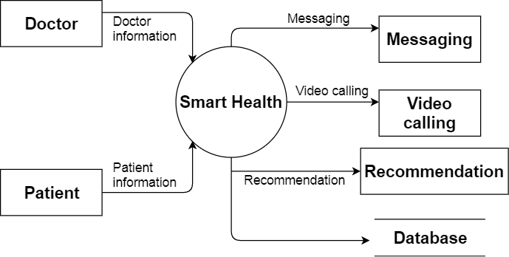

Figure 32: Data flow diagram level-1

# Chapter 8

# Behavioral Model

## 8.1 Introduction

The behavioral model indicates how software will respond to external events or stimuli. To create the model, some steps should be followed. These steps are given below:

* Evaluate all use cases to fully understand the sequence of interaction within the system.
* Identify events that drive the interaction sequence and understand how these events relate to specific objects.
* Create a sequence for each use case.
* Build a state diagram for the system.
* Review the behavioral model to verify accuracy and consistency.

## 8.2 Identifying Events with the Use Case

Use case for Smart Health authentication.

User uses the keypad to key in a six digit password. The password is compared with the valid password stored in the system. If the password is incorrect, it shows an error message and user may try again for additional input. If the password is correct, user can access more options.

## 8.3 State Transition

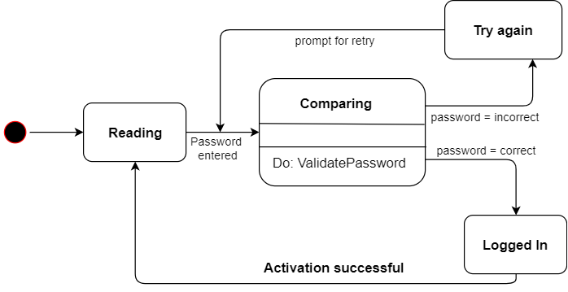

Figure 33: State transition

Messaging and video calling

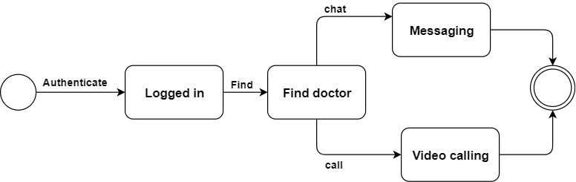

Figure 34: State transition for messaging and video calling

Recommendation

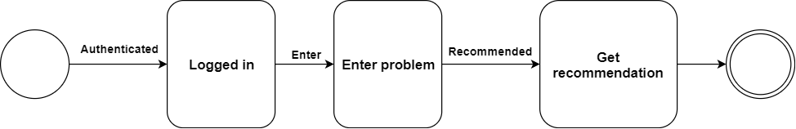

Figure 35: State transition for recommendation

## 8.4 Sequence Diagram

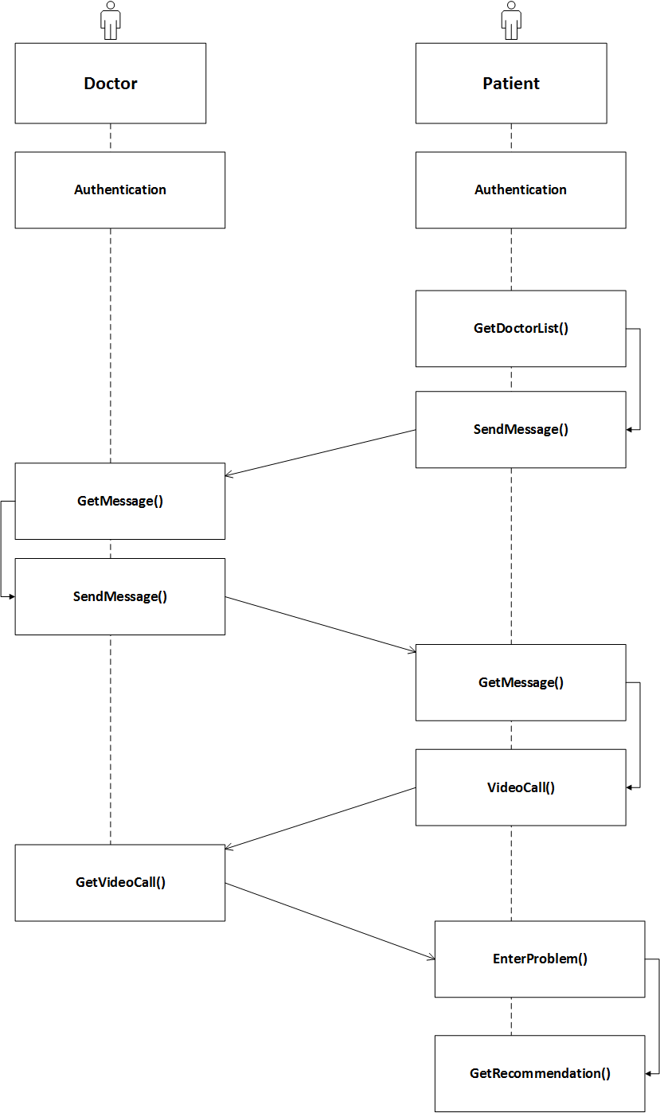

Figure 36: Sequence diagram

# Chapter 9

# Software Design Architecture

## 9.1 Architectural Design for OOP

### 9.1.1 Representing the system in context

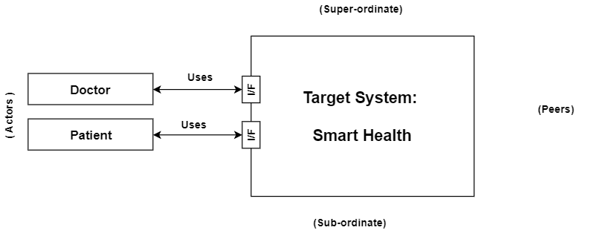

Figure 9.1.1: Representing the system in context

### 9.1.2 Define Archetypes

1. Authentication
2. Find doctor
3. Messaging
4. Video calling
5. Recommendation

### 9.1.3 Refining architecture into components

Components

1. Doctor details, Patient details
2. Doctors’ details
3. Message details
4. Video conferencing
5. Patient details, Recommended hospital

Classes:

1. Doctor, Patient, DAL
2. DAL, Doctor
3. Patient, Doctor, Message, DAL
4. Patient, Doctor, Video conference, DAL
5. Hospital, Patient, DAL

### 9.1.4 Describing Instantiation of the system

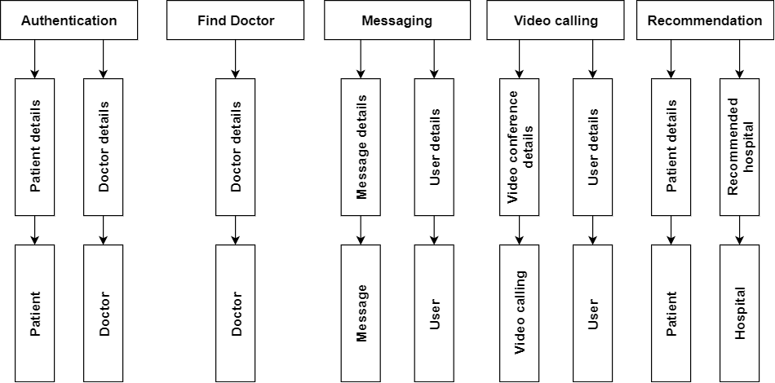

Figure 9.1.4: Refining archetype into component & classes

### 9.1.5 Mapping Requirements into Software Architecture

As this system built in OOP concept so mapping requirement into software architecture is not needed here.