**“Office Management System”**





International University of Business Agriculture and Technology

**CSC 470–: Software Engineering Lab**

**Title of the Project: Office Management system**

**Name of the team: Overflow Archives**

**Submitted To**

Camelia Sinthia

Assistant Professor, Department of CSE

IUBAT

**Section: I**

**Team Members:**

|  |  |
| --- | --- |
| ID | Name |
| 18103107 | Mohammad Ali |
| 18103275 | A.K.M Miftahur Rahman Sarker |
| 18103336 | Sifat Nowshin |

**Chapter 1**

**Introduction**

**Introduction**

The Office Management System manages the internal activities of a company. In this system new employee can register, employee can chat, give task, assign task, group chat and many more. All kinds of internal communication in an office or any kinds of organization can be done through this single software. In our project we were working in **“Office Management System”.** This management system will help in maintaining the available people to meet the requirements.

**Aim**

Our main aim is to make all internal works of a business company easy for all the employees. The admin will manage all his employee’s work. He will assign work to the employees. He can do anything. The users also have facility in this system. For the users it will be easier to get work, chat with other employees and edit their profile.

**Objectives**

* This system will solve all kinds of internal official task and build a good communication between office and employees.
* By these System, a user can see daily official notice, tasks, and events.
* By this system, a user has to sign up first then he/she can login into the system. But after sign up, if admin approve this user then the user can login into the system.
* A user can see real time notice update with notice types and priority, and also can set reminder for any specific event to the event calendar. User can see the details of any news, and save notice files, see the priority of notice and keep remainder his/her for any specific notice.
* An event calendar gives a user real time update for any upcoming events with full details of that event. Also, user can see list of full events.
* This system gives a user real time clock feature with weather and location updates.
* By this system a user can chat to other authorize members of that office. This chat will be real time chat and user can send photos, files to other members through this real time chat feature.
* By this system users can assign task to other members like task name, task description, attach files, task priority, start and deadline of tasks and many more.
* By this system user can see their all task details with assign tasks, incomplete task, complete tasks, approve and unapproved for any specific task.
* By this system user can see their task completion chart and data like how many tasks he/she has completed, uncompleted, deadline crossed and his/her work status. Also, this data will show with charts.
* By this system a user has full functionality to change his/her profile like profile name, password, and update his/her bio and upload profile picture.
* This system gives a user beautiful interactive UI features with full functionality and also dark/light mode feature.
* In the admin panel, admin of this system at first have to be login first to enter the admin panel.
* In admin panel, admin can see total user, total events, total tasks, total notice, current/previous month tasks, notice types and priorities through some beautiful real time updated charts.
* Admin can change his/her profile name, password, profile picture.
* Admin can create post, edit post, delete post and all of this change will be real time.
* Admin can register any member, approve any member, edit /delete any member.

**Admin module**

• Add notice

• Update Database

• Add record

• Delete record

• Search database

• Manage Employee

**User module**

• Sign up/log in

• Chat

• Group chat

• Create profile

• Edit profile

• Assign task

• Filling notice post

**System benefit**

1. It will give a user beautiful interactive UI features with full functionality and also dark/light mode feature.
2. It will solve all kinds of internal official.
3. Admin can change his/her profile name, password, profile picture.
4. This system gives a user real time clock feature with weather and location updates.
5. By this system user can see their all task details with assign tasks, incomplete task, complete tasks, approve and unapproved for any specific task.

# **We choose Incremental Model**

Incremental Model is a process of software development where requirements divided into multiple standalone modules of the software development cycle. In this model, each module goes through the requirements, design, implementation and testing phases. Every subsequent release of the module adds function to the previous release. The process continues until the complete system achieved.

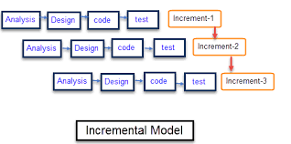

Figure: Incremental Model

## The various phases of incremental model are as follows:

**1. Requirement analysis:** In the first phase of the incremental model, the product analysis expertise identifies the requirements. And the system functional requirements are understood by the requirement analysis team. To develop the software under the incremental model, this phase performs a crucial role.

**2. Design & Development:** In this phase of the Incremental model of SDLC, the design of the system functionality and the development method are finished with success. When software develops new practicality, the incremental model uses style and development phase.

**3. Testing:** In the incremental model, the testing phase checks the performance of each existing function as well as additional functionality. In the testing phase, the various methods are used to test the behavior of each task.

**4. Implementation:** Implementation phase enables the coding phase of the development system. It involves the final coding that design in the designing and development phase and tests the functionality in the testing phase. After completion of this phase, the number of the product working is enhanced and upgraded up to the final system product.

## Advantage of Incremental Model

* Errors are easy to be recognized.
* Easier to test and debug
* More flexible.
* Simple to manage risk because it handled during its iteration.
* The Client gets important functionality early.

**User requirements**

The company wants a unique software that can give access to admin and employee.

The requirements are:

Chat: Any member of the office can talk with other members using this function.

Group chat: Any employee can create group with other employee to group chat.

Event: The system will allow to show events to employees.

Notification: The system will notify every employee of any update or event.

Reminder: Any member can add reminder to the system.

Calendar: The system will show a calendar.

File sharing: Employee can share files with each other

**System Description**

To develop Business Communication Tool, I use some module (part of the software required by the most of the recruiting agencies) are listed below:

Authentication: An employee must have an account to log in. This function will check whether the user has an account or not. If a user has no account, he/she must have to create an account.

Register: A new user will register using his/her email id and a unique password.

Log in: An existing user will log in using her password and id.

Chat: Any member of the office can talk with other members using this function.

Add reminder: Any employee can add reminder according to date and time and he/she will also get notified.

Assign task: An employee can assign a task to another employee.

Theme changing: This function will change the color or theme according to day and night.

Show official newsfeed: The system will show new notice, announcement in the newsfeed.

Add notice: Employee can add notice which will be visible to everyone.

Edit profile: Employee can edit his/her name, designation and his/her bio.

Update Database: Only Admin has the power to update the database. By this admin change the database of the office.

Delete/update record: Only Admin has the power to delete or update the record. By this admin change the record or delete the record.

**Functional Requirement**

A Functional Requirement (FR) is a description of the service that the software must offer. It describes a software system or its component. A function is nothing but inputs to the software system, its behavior, and outputs. It can be a calculation, data manipulation, business process, user interaction, or any other specific functionality which defines what function a system is likely to perform. Functional Requirements are also called Functional Specification.

In software engineering and systems engineering, a Functional Requirement can range from the high-level abstract statement of the sender's necessity to detailed mathematical functional requirement specifications. Functional software requirements help you to capture the intended

**Functional Requirements includes the following things:**

* Details of operations conducted in every screen
* User able to enter his/her own data
* User interface to change weather
* The notice board will change in every 24 hours.
* The application must verify the user whether it is valid or not.
* Live chat with any of the employee.
* It should have descriptions of system reports or other outputs
* Complete information about the workflows performed by the system
* It has clearly defined who will be allowed to create/modify/delete the data in the system
* The system will fulfill applicable regulatory and compliance needs captured in the functional document

**Nonfunctional Requirements**

Nonfunctional Requirements (NFRs) define system attributes such as security, reliability, performance, maintainability, scalability, and usability. They serve as constraints or restrictions on the design of the system across the different backlogs. Also known as system qualities, nonfunctional requirements are just as critical as functional Epics, Capabilities, Features, and Stories. They ensure the usability and effectiveness of the entire system. Failing to meet any one of them can result in systems that fail to satisfy internal business, user, or market needs, or that do not fulfill mandatory requirements imposed by regulatory or standards agencies. In some cases, non-compliance can cause significant legal issues (privacy, security, safety, to name a few).

**Feasibility Study**

Feasibility study is made to see if the project on completion will serve the purpose of the organization for the amount of work effort and the time that spend on it. Feasibility study lets the developer foresee the future of the project and the usefulness. A feasibility study of a system proposal is according to its workability, which is the impact on the organization, ability to meet their user needs and effective use of resources. Thus, when a new application is proposed it normally goes through a feasibility Study before it is approved for development.

The document provides the feasibility of the project that is being designed and lists various areas that were considered very carefully during the feasibility study of this project such as Technical Economic and Operational feasibilities. The following are its features:

**• Technical Feasibility**

The system must be evaluated from the technical point of view first. The assessment of this feasibility must be based on an outline design of the system requirement in the terms of input, output, programs and procedures. Having identified an outline system, the investigation must go on to suggest the type of equipment, required method developing the system, of running the system once it has been designed.

Technical issues raised during the investigation are:

Does the existing technology sufficient for the suggested one?

Can the system expand if developed?

The project should be developed such that the necessary functions and performance are achieved within the constraints the project is developed within least technology. Through the technology may become obsolete after some period of time, due to the fact that never version of same software supports older versions, the system may still be used. So, there are minimal constraints invoked with this project. The system has been developed using Java the project is technically feasible for development.

**• Economic Feasibility**

The developing system must be justified by cost and benefit. Criteria to ensure that effort is concentrated on project, which will give best, return at the earliest. One of the factors, which affect the development of a new system, is the cost it would require.

The following are some of the important financial questions asked during preliminary investigation:

* The costs conduct a full system investigation.
* The cost of the hardware and software.
* The benefits in the form of reduced costs or fewer costly errors.

Since the system is developed as part of project work there is no manual cost to spend for the proposed system. Also, all the resources are already available, it gives an indication of the system is economically possible for development.

**• Operational Feasibility**

This includes the following questions:

> Is there sufficient support for the users?

> Will the proposed system cause harm?

The project would be benefited because it satisfies the objectives when developed and installed. All behavioral aspects are considered carefully and conclude that the project is behaviorally feasible.

**Use Case Diagram**

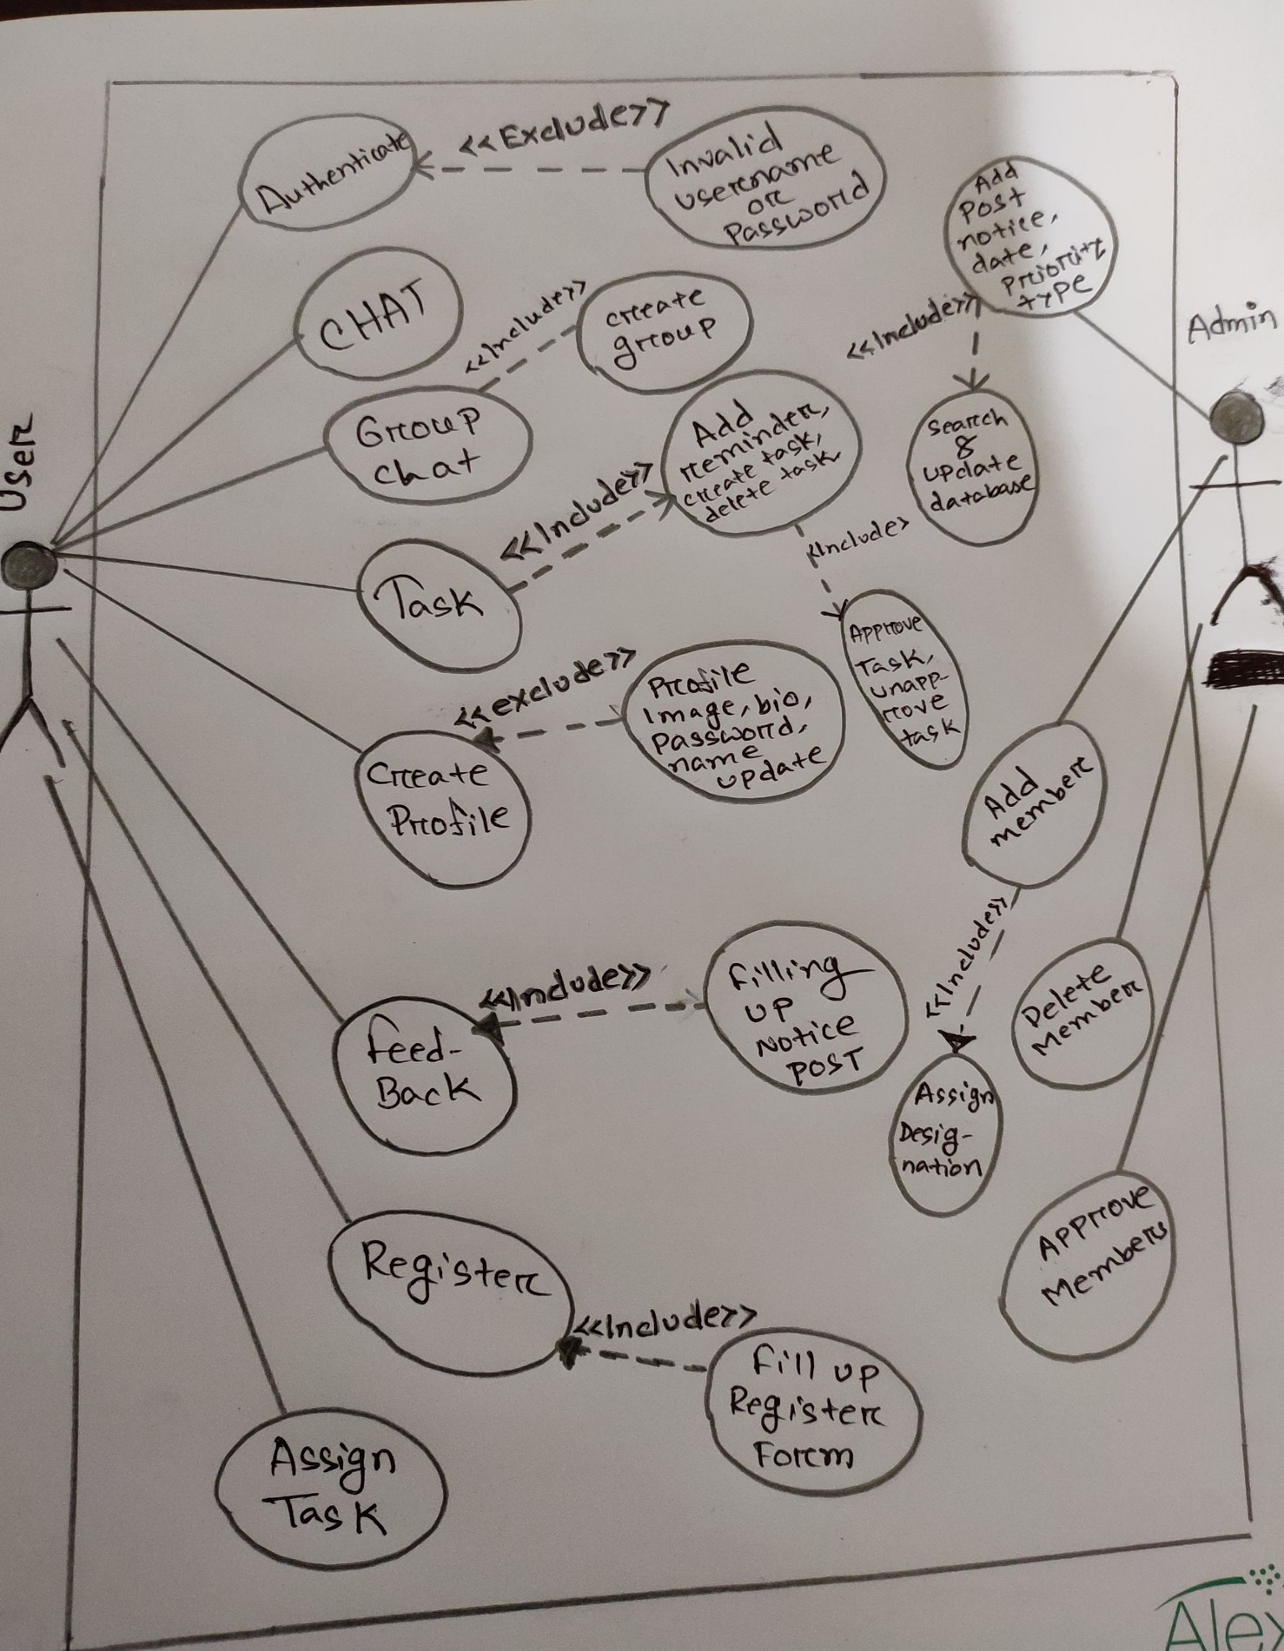

**Use case Text**

Use case name: Business Communication Tool

Actors: User, Admin

Authentication: An employee must have an account to log in. This function will check whether the user has an account or not. If a user has no account, he/she must have to create an account.

Register: A new user will register using his/her email id and a unique password.

Log in: An existing user will log in using her password and id.

Chat: Any member of the office can talk with other members using this function.

Add reminder: Any employee can add reminder according to date and time and he/she will also get notified.

Assign task: An employee can assign a task to another employee.

Theme changing: This function will change the color or theme according to day and night.

Show official newsfeed: The system will show new notice, announcement in the newsfeed.

Add notice: Employee can add notice which will be visible to everyone.

Create/Edit profile: Employee can edit his/her name, designation and his/her bio.

Update Database: Only Admin has the power to update the database. By this admin change the database of the office.

Delete/update record: Only Admin has the power to delete or update the record. By this admin change the record or delete the record.

Add notice: Admin can add notice to the system.

Feedback: An employee can give feedback.

**Swimlane Diagram**

A swimlane diagram is a type of flowchart that delineates who does what in a process. Using the metaphor of lanes in a pool, a swimlane diagram provides clarity and accountability by placing process steps within the horizontal or vertical “swimlanes” of a particular employee, work group or department.

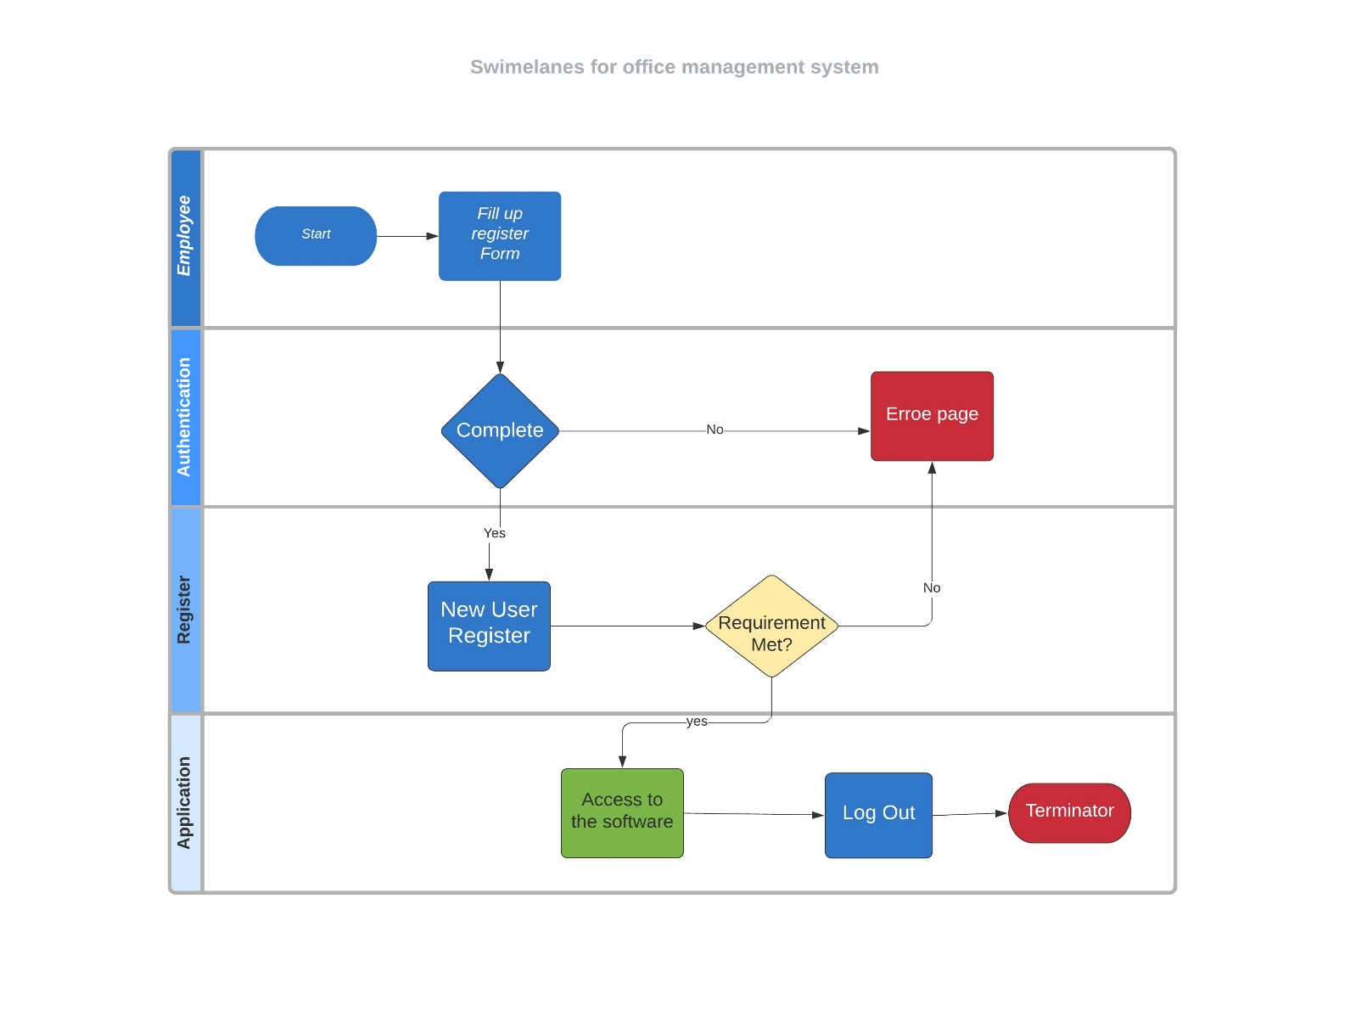

**Class Diagram**

The class diagram is the main building block of object-oriented modeling. It is used for general conceptual modeling of the structure of the application, and for detailed modeling translating the models into programming code. Class diagrams can also be used for data modeling.

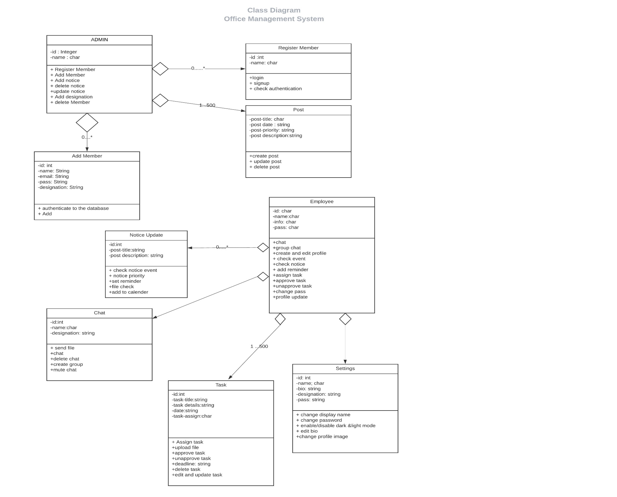

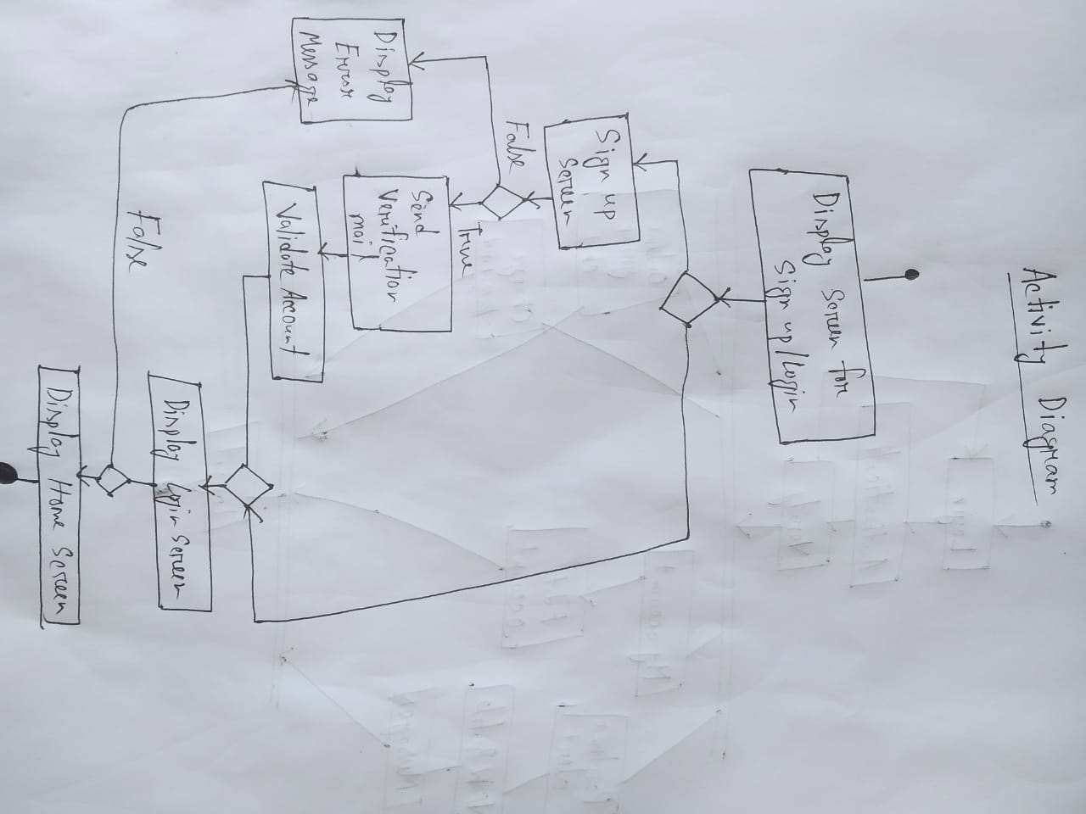**Activity Diagram**

