

**Software Requirements Specification**

**For**

**Online digital Wallet (collection professional peoples Information’s)**

**PREPARED BY**

**Shobo Mozumder**

**ID: 171-35-2015**

**Section: A**

**Batch: 22nd**

**Department of Software Engineering**

**SUBMITTED TO**

**Khalid Been Md. Badruzzaman Biplob**

**Lecturer  
Department of Software Engineering  
Daffodil International University**

# **Declaration**

In this project one kind of Social media platforms like Facebook, Instagram and Twitter have become critical pieces of social infrastructure. More and more sociopolitical conversations and activism are shifting there sometimes with unintended and surprising consequences. Such wrongdoers are a numerical minority on any platform, but they have a disproportionate effect in poisoning both private exchanges and public discourse. They undermine personal, societal, and democratic uses of social media.

# **Project in Brief**

**Project Title:** **Wallet (collection professional peoples Information’s)**

**Tools Used:**

Hard Disk:

Ram: 4 GB

Processor: Core i3

Software:

* ASP.NET Core
* .Net Framework.
* Database (MySQL).
* GitHub

**Operating System:** Windows 10 Pro Edition

# **Abstract**

The explosion of this project is changing the way we communicate, thus affecting the processes involved with information services supporting project management. In this paper, we document the emerging practice of companies using social media to support project management, review relevant literature, identify several examples of this practice, delineate dimensions along which these systems vary and lay the groundwork for the development of a model and future research into this area. Practitioners and researchers can build on this work to help organizations realize more value by using social media to support project management.

**Table of Content**

**Contents**

**Declaration** ii

**Project in Brief** ii

**Abstract** iii

**1.Introduction** 6

**1.1** **About the System** 6

**1.2** **Purpose** 6

**1.3** **Scope** 6

**1.4 Why the System is necessary** 6

**1.5 Proposed Solution** 7

**2. System Analysis** 7

**2.1 Use Case Model** 7

**2.1.1 Use Case Model of User And Admin:** 8

**2.2 Actor Goal List** 8

**2.3 Use Case Description:** 8

**2.4 Activity Diagram** 2

**2.4.1 Activity Diagram of User** 4

**2.4.3 Activity Diagram of Admin:** 42

**3. System Design** 53

**3.1 Sequence Diagrams** 5

**3.1.1 Sequence Diagrams of Registration** 5

**3.1.2 Sequence Diagrams of Login** 6

**3.1.3 Sequence Diagrams of Client** 6

**3.1.4 Sequence Diagrams of Senior Advocate** 7

**3.1.5 Sequence Diagrams of Junior Advocate** 7

**3.2 Class Diagram** **Error! Bookmark not defined.**

**3.4 Entity Relationship Diagram** 8

**4. Implementation** 9

**4.1 Tools & Technologies** 9

**4.2 Project Link** 9

**5. Conclusion** **Error! Bookmark not defined.**

**5.1 Good Features of the System** **Error! Bookmark not defined.**

**5.2 Limitations of the System** **Error! Bookmark not defined.**

**5.3 Future Enhancements** **Error! Bookmark not defined.**

**6. User manuals** 9

**6.1 Log in Screen of Advocate Case Information** 10

**7. References** **Error! Bookmark not defined.**

**Chapter 1**

# **1.Introduction**

## In daily life wallet a is very important object to keep our money and many other important papers. Most of us use wallet for keeping important papers. But those wallets are taken by pickpockets very often. And it’s quite impossible to get them back. As a result of that we have to face a lot of problem. Here comes our website. Anyone can use it without any cost or risk of piracy or any other disaster. And it is user friendly. User can find and use the information from anywhere they want. Finally, I can assure you that your information is in safe hand.

## **About the System**

This Web application intends to provide a well-established web-based Social Network system between a job seeker and a recruiter. This documents a networking system scope, functionalities, requirements and feasibility. This project aims to develop a website which provides a Communication among peoples on network, which works quite similar to Social Media Site. This website also provides the features of writing and posting a post or any event all at one place. The main idea behind it is to share the job-related details posted by placement officer via adding a post which can be read by all the student as well as faculty using the website. This web application can be handled by the admin and manage student as well as faculty.

## **Purpose**

To reduce the gap between primary user and secondary user. And make the way to get good suggestion from the expert. Where user will have more perfect another user view some of information and message this person. To reduce distraction, form other social media.

## **Scope**

User want to start a new thing like etc. But most of the time people do not know how to start and where to start from. Some time they takes wrong dissection. Who can help them and provide them to take good or better suggestions. This system bridges the gap between Counselor and Client.

## **1.4 Why the System is necessary**

* There are many web sites where visiting cards can be made
* There are many web sites that are like social media (Facebook, Link in, etc.)
* There are many web sites where information can be kept but not user friendly (Google Drive etc.)

## **1.5 Proposed Solution**

* Store Personal Information:
* CV
* Driving License
* NID etc.
* Generate Visiting Card with QR Code
* Add Other People
* Messaging
* Search People Order By
* Name
* Occupation

**Chapter 2**

# **2. System Analysis**

In this system, there are three types of users. The users are Senior Advocate (Admin), Junior Advocate and Customer.

**User:** everything. From assigning case to Jr. Advocate to accepting/rejecting cases and maintaining payment. Junior Advocate is directly connected with customers. He will handle the assigned case on him and give update to Senior Advocate by setting status.

**Admin:** Our main user is customer. They can enter the system, search, view, hire advocate, take appointment, payment by the system easily.

## **2.1 Use Case Model**

### **2.1.1 Use Case:**

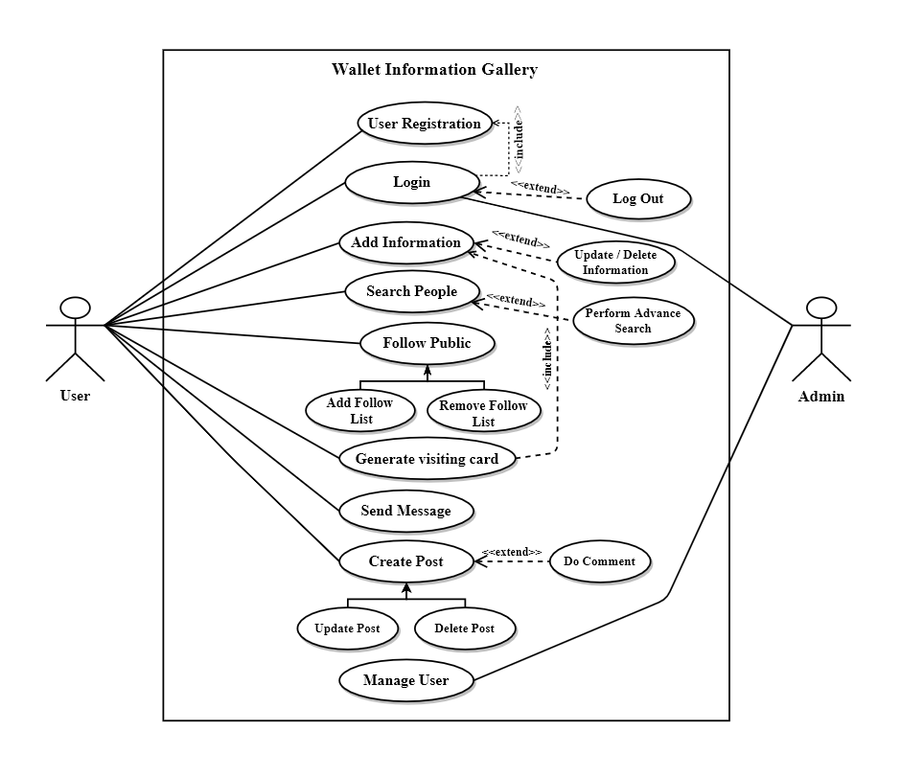

## **2.2 Actor Goal List**

In our system, there are three actors. They are Senior Advocate, Junior Advocate, Customer.

**Goal List of User:**

* Add information
* Add people
* Message
* Generate visiting card

**Goal List of Admin:**

* Collect all data from the User
* Provide updates to user
* Maintain case status

## **2.3 Use Case Description:**

|  |  |
| --- | --- |
| Use Case Id | UC-1 |
| Use Case name | Registration |
| Scenario | User can do Registration to create a new account |
| Triggering event | If any user want to create a new account and clicked Sign up button. |
| Brief description | User can create an account, Where it should be provided some basic information about user : First Name, Last Name, Email, Password and user type: Counselor, Client. |
| Actors | Counselor, Client |
| Included use case | None |
| Stakeholders | Counselor, Client |
| Pre-Condition | User must have a new email address to create a new account. |
| Basic path | 1. Click on “Sign up” link on Home page 2. Get Registration page 3. Enter the First Name 4. Enter the Last Name 5. Enter the Email 6. Enter the Password 7. Re-Enter the Password 8. Click on Create account button |

Table: use case description Registration

|  |  |
| --- | --- |
| Use Case Id | UC-2 |
| Use Case name | Login |
| Scenario | User can Log in to the system if they have account. |
| Triggering event | If any user want to Log in to the System and clicked Sign in button. Or want to use any feature that required Authentication then this page will be appear. |
| Brief description | User can click on Sign in button to log in to the system. Then Log in page will be appear. It will ask for Email and Password, click on Log in button. |
| Actors | Counselor, Client, Admin |
| Extending use case | Retrieve Password (Forgotten Account?) Registration (Don’t have account? ) |
| Included use case | None |
| Stakeholders | Counselor, Client, Admin |
| Pre-Condition | User must have an account and remember the password for Log in to the System. |
| Basic path | 1. Click on “Sign in” button 2. Get Sign in page 3. Enter the Email 4. Enter the Password 5. Click on Log in button |

Table: use case description Login

|  |  |
| --- | --- |
| Use Case Id | UC-3 |
| Use Case name | Retrieve Password |
| Scenario | If the user forgets his / her account then they can Retrieve Password or account. |
| Triggering event | If any user forgets his or her account and clicked “Forgotten  Account?” link. |
| Brief description | User may forget his / her password then they will have a option by what they will provide their email and send the code that code will be one time code that will be use to verify their account and after verified the account user can enter a new password and re-enter the same password and confirm it. That new password will be saved in to the system. |
| Actors | User, Admin |
| Stakeholders | User, Admin |
| Pre-Condition | User must have pre-registered email address remembered. |
| Basic path | 1. Click on “Forgotten Account” link on Sign in page 2. Get Forgotten Account Email page 3. Enter that code to verify the account 4. Click the button “Verify” 5. Get Forgotten Account New Password page 6. Enter the New Password 7. Re-enter same password 8. Click the button “Confirm” 9. Get the Sign in page |
| Post-Condition | New password must be matched |

Table: use case description Retrieve Password

|  |  |
| --- | --- |
| Use Case Id | UC-4 |
| Use Case name | Add Profile |
| Scenario | User can Add Profile if they have social media account or upload a cv if it is in pdf format. |
| Triggering event | If any user want to create a new account and clicked Sign up button. |
| Brief description | User must have account on LinkedIn, Facebook, Twitter, YouTube, Portfolio or upload a cv if it is in pdf format. But user can not add more link for a single option. |
| Actors | Counselor, Client |
| Extending use  case | None |
| Included use case | None |
| Stakeholders | Counselor, Client |
| Pre-Condition | User must have an account on social media or a cv in pdf format. |
| Basic path | 1. Click on “Add new profile” button on Counselor or Client Dashboard page 2. Get Add new profile modal. 3. Checked any social media (Profile type) 4. Click the button “Add Profile” 5. Get the Counselor |
| Alternative path | * 1. Enter the link |
| 3.1 If Checked CV then Choose file option will be appear |

Table: use case description Add Profile

|  |  |
| --- | --- |
| Use Case Id | UC-5 |
| Use Case name | View Profile |
| Scenario | User can View Profile of Counselor. Counselor, Admin can view client’s Profile. User can check their own profile. |
| Triggering event | If any user click on “Profile” button. |
| Brief description | User can view profile of Counselor if click on profile then profile modal will be appearing with all the links, then user can choose any of them and another tab will be appearing on browser. But Counselor and Admin only they can view Client’s Profile. And all the users can view their own profile from their dashboard. |
| Actors | User, Admin |
| Extending use case | None |
| Included use case | None |
| Stakeholders | User, Admin |
| Pre-Condition | None |
| Basic path | 1. Click on “Profile” button 2. Get the modal “Profile” 3. Click any link on that 4. Get a new tab with that clicked item. |

Table: use case description View Profile

|  |  |
| --- | --- |
| Use Case Id | UC-6 |
| Use Case name | Search available Counselling by sector |
| Scenario | User and Client can Search available Counselling by sector |
| Triggering event | If any user and Client Click on “Search Counselling” button. |
| Brief description | If any user and Client want to search available Counselling by selecting sector they can do. |
| Actors | User, Client |
| Extending use case | View Profile  Request for an Appointment |
| Included use case | None |
| Stakeholders | User, Client |
| Pre-Condition | None |
| Basic path | 1. Click on “Search ” button in Home page 2. Get the page Search Counselling 3. Select sector in this page 4. Click on “Search” button |

Table: use case description Search

## **2.4 Activity Diagram**

Activity diagrams are graphical representations of workflows of stepwise activities and actions with support for choice, iteration and concurrency.

In this System, the activity starts by crating account or doing registration of all User by logging in through the provided email and password by Admin.

### **2.4.1 Activity Diagram of User :**

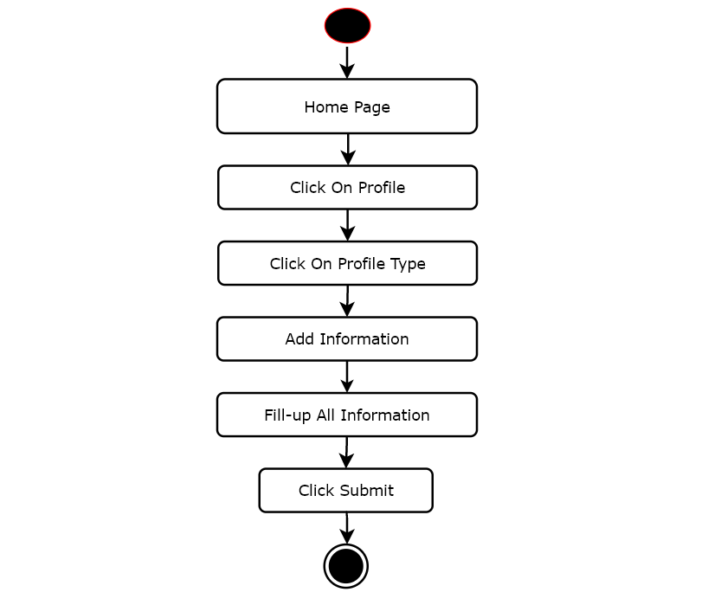

### **2.4.3 Activity Diagram of Admin :**

### 

**Chapter 3**

# **3. System Design**

Design is a process that uses the product of analysis to produce a specification for implementing a system. Design is the logical description of how a system will work.

Design emphasizes a conceptual solution that fulfills the requirements, rather than its implementation.

## **3.1 Sequence Diagrams**

### **3.1.1 Sequence Diagrams of Registration**

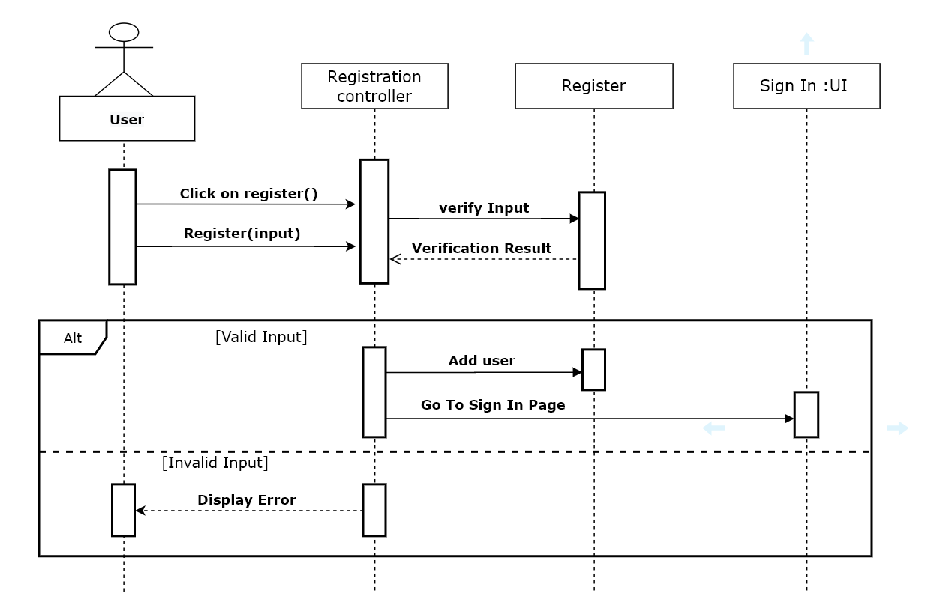

### **3.1.2 Sequence Diagrams of Login**

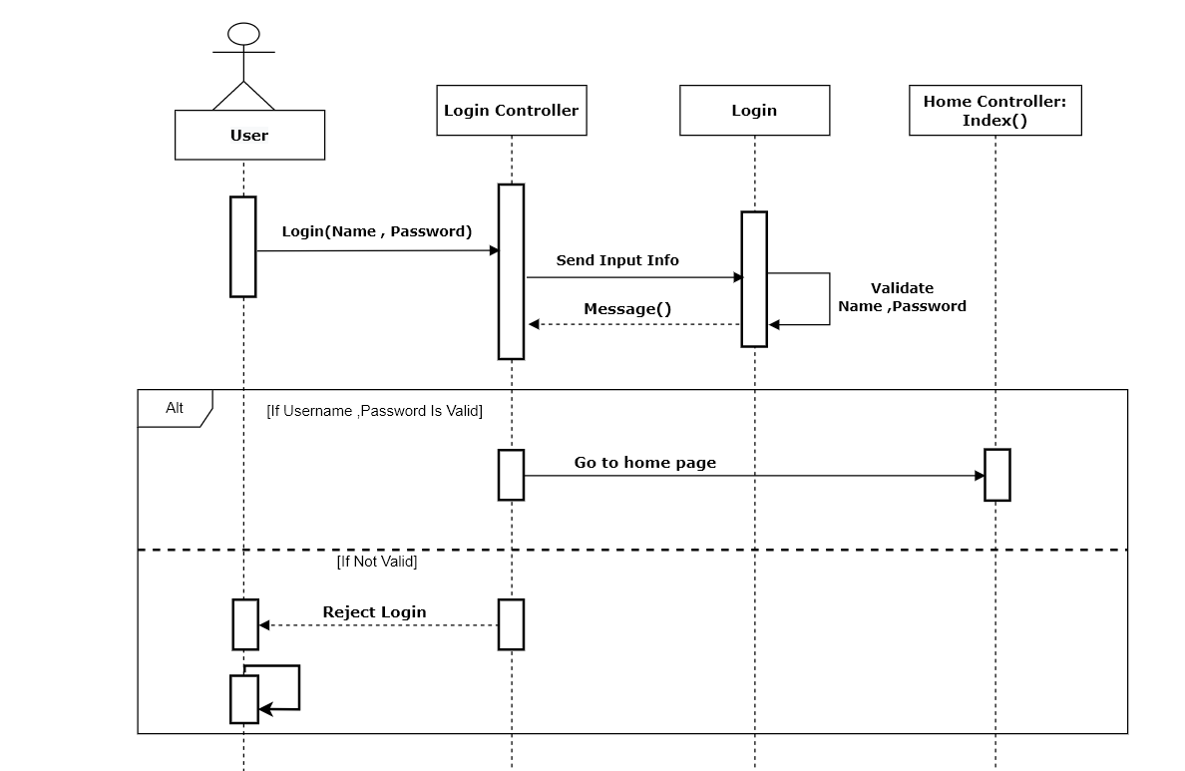

### **3.1.3 Sequence Diagrams of User:**

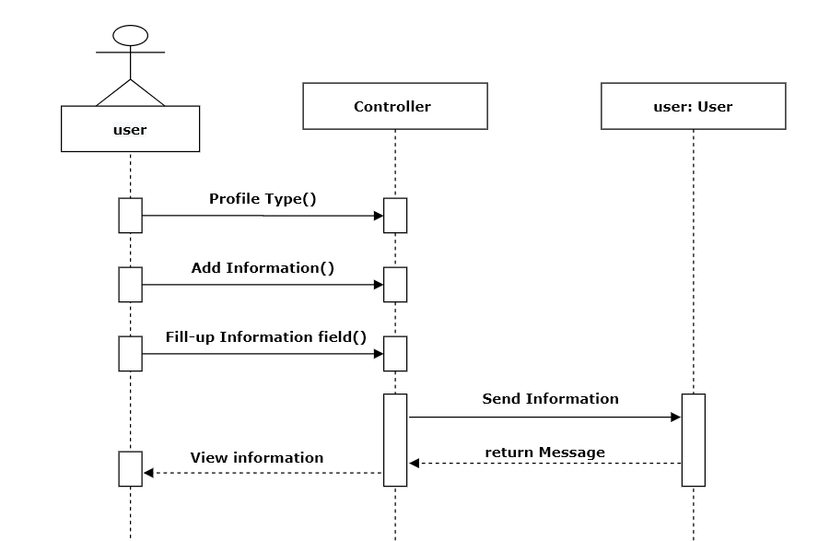

### **3.1.4 Sequence Diagrams message:**

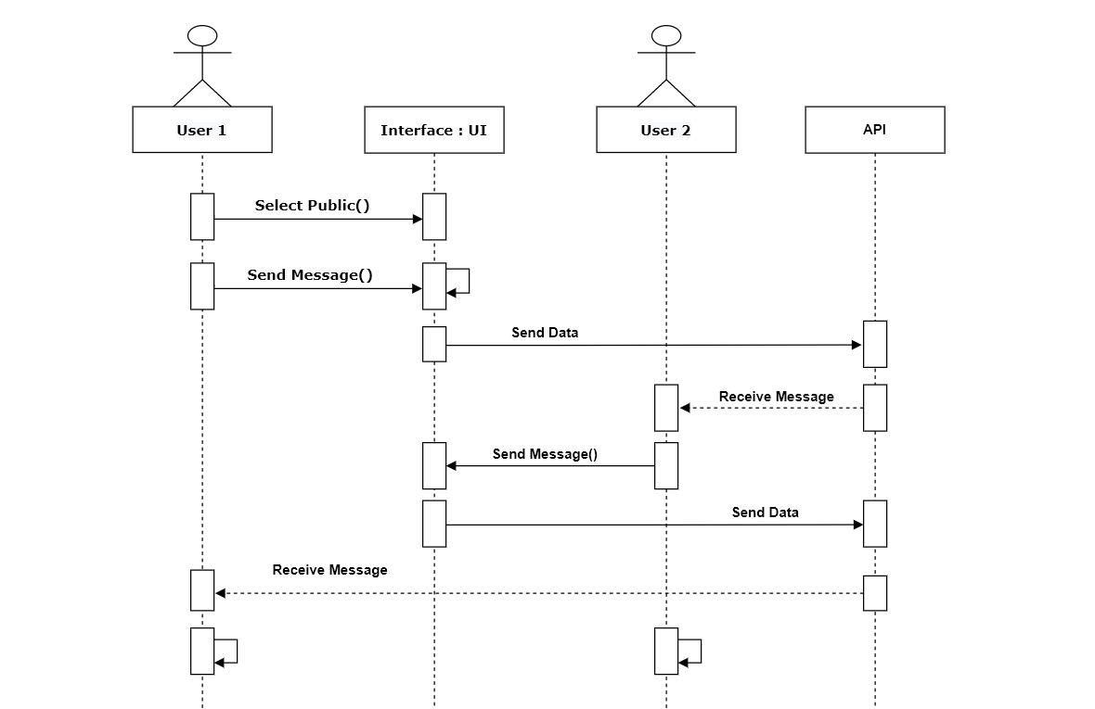

### **3.1.5 Sequence Diagrams of Admin:**

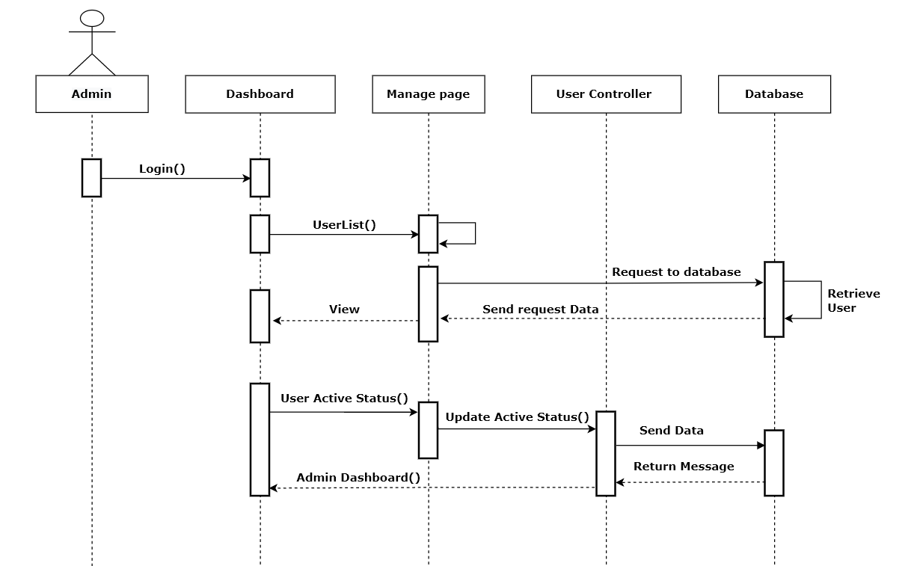

## **3.4 Entity Relationship Diagram**

Registration

_controller

search_

controller

CreateProfile_

_controller

Message_

_controller

**Chapter 4**

# **4. Implementation**

## **4.1 Tools & Technologies**

Following are the tools and technologies used in development of this project:

Software:

* ASP.NET Core
* .Net Framework.
* Database (MySQL).
* GitHub

## **Project Link**

1. GitHub Link :….

**Chapter 6**

# **6. User manuals**

A user guide or user’s guide, also commonly known as a manual, is a technical communication document intended to give assistance to people using a particular system. It is usually written by a technical writer, although user guides are written by programmers, productor project managers, or other technical staff, particularly in smaller companies. User guides are most commonly associated with electronic goods, computer hardware and software. Most user guides contain both a written guide and the associated images. In the case of computer applications, it is usual to include screenshots of the human-machine interface, and hardware manuals often include clear, simplified diagrams. The language used is matched tot he intended audience, with jargon kept to a minimum or explained thoroughly.

## **6.1 Log in Screen of User Information**

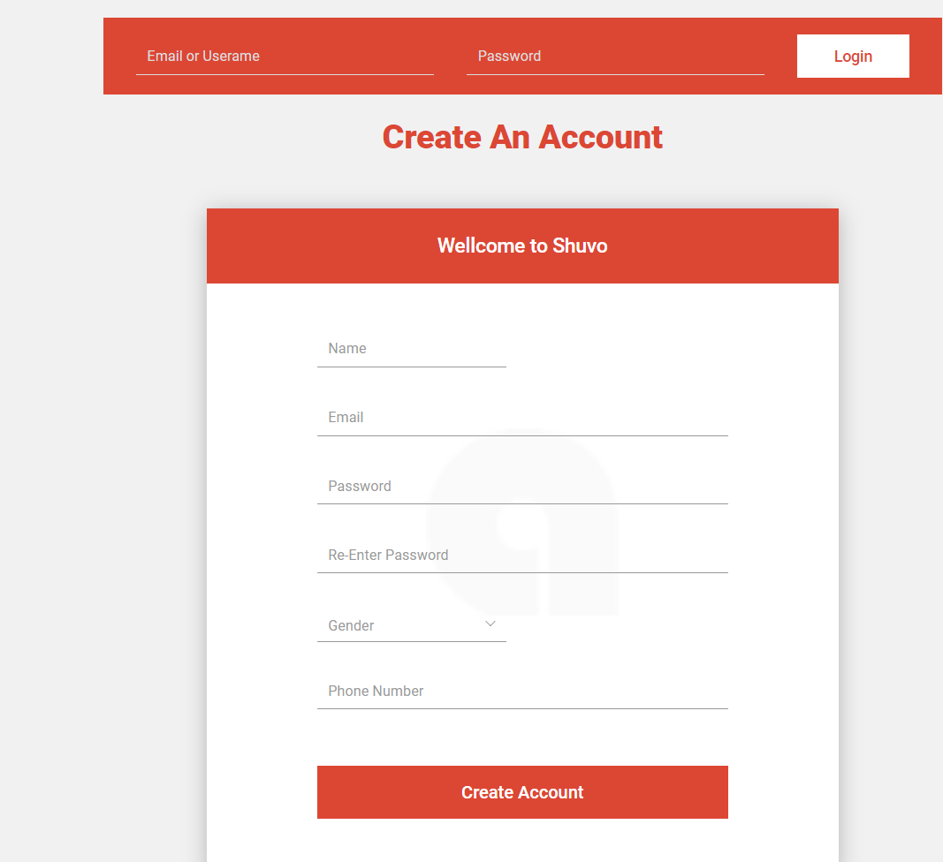

## **6.2 Profile Page Screen:**

