ClauseChain — Technical Memo
Hash-Anchored Regulatory Evidence for Digital Trade | UN Global Hackathon: AI for Digital Trade Regulatory Analysis | RDTII Pillars 6 & 7
ClauseChain is an open-source AI pipeline that discovers, extracts, and maps digital trade regulations to the UN RDTII framework. Hallucination resistance is structural, not prompted: every classification is bound to a verbatim, hash-anchored citation from an authoritative source and passes a three-gate Cite-Verify-Reject (CVR) loop. A failed gate rejects rather than softens.
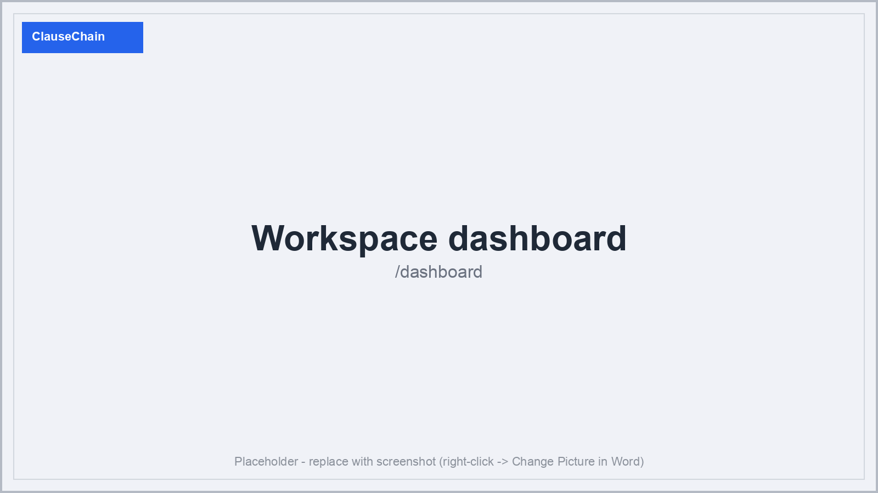
Figure 1 — Workspace dashboard: coverage, KPIs, and pipeline health.

1. System Architecture
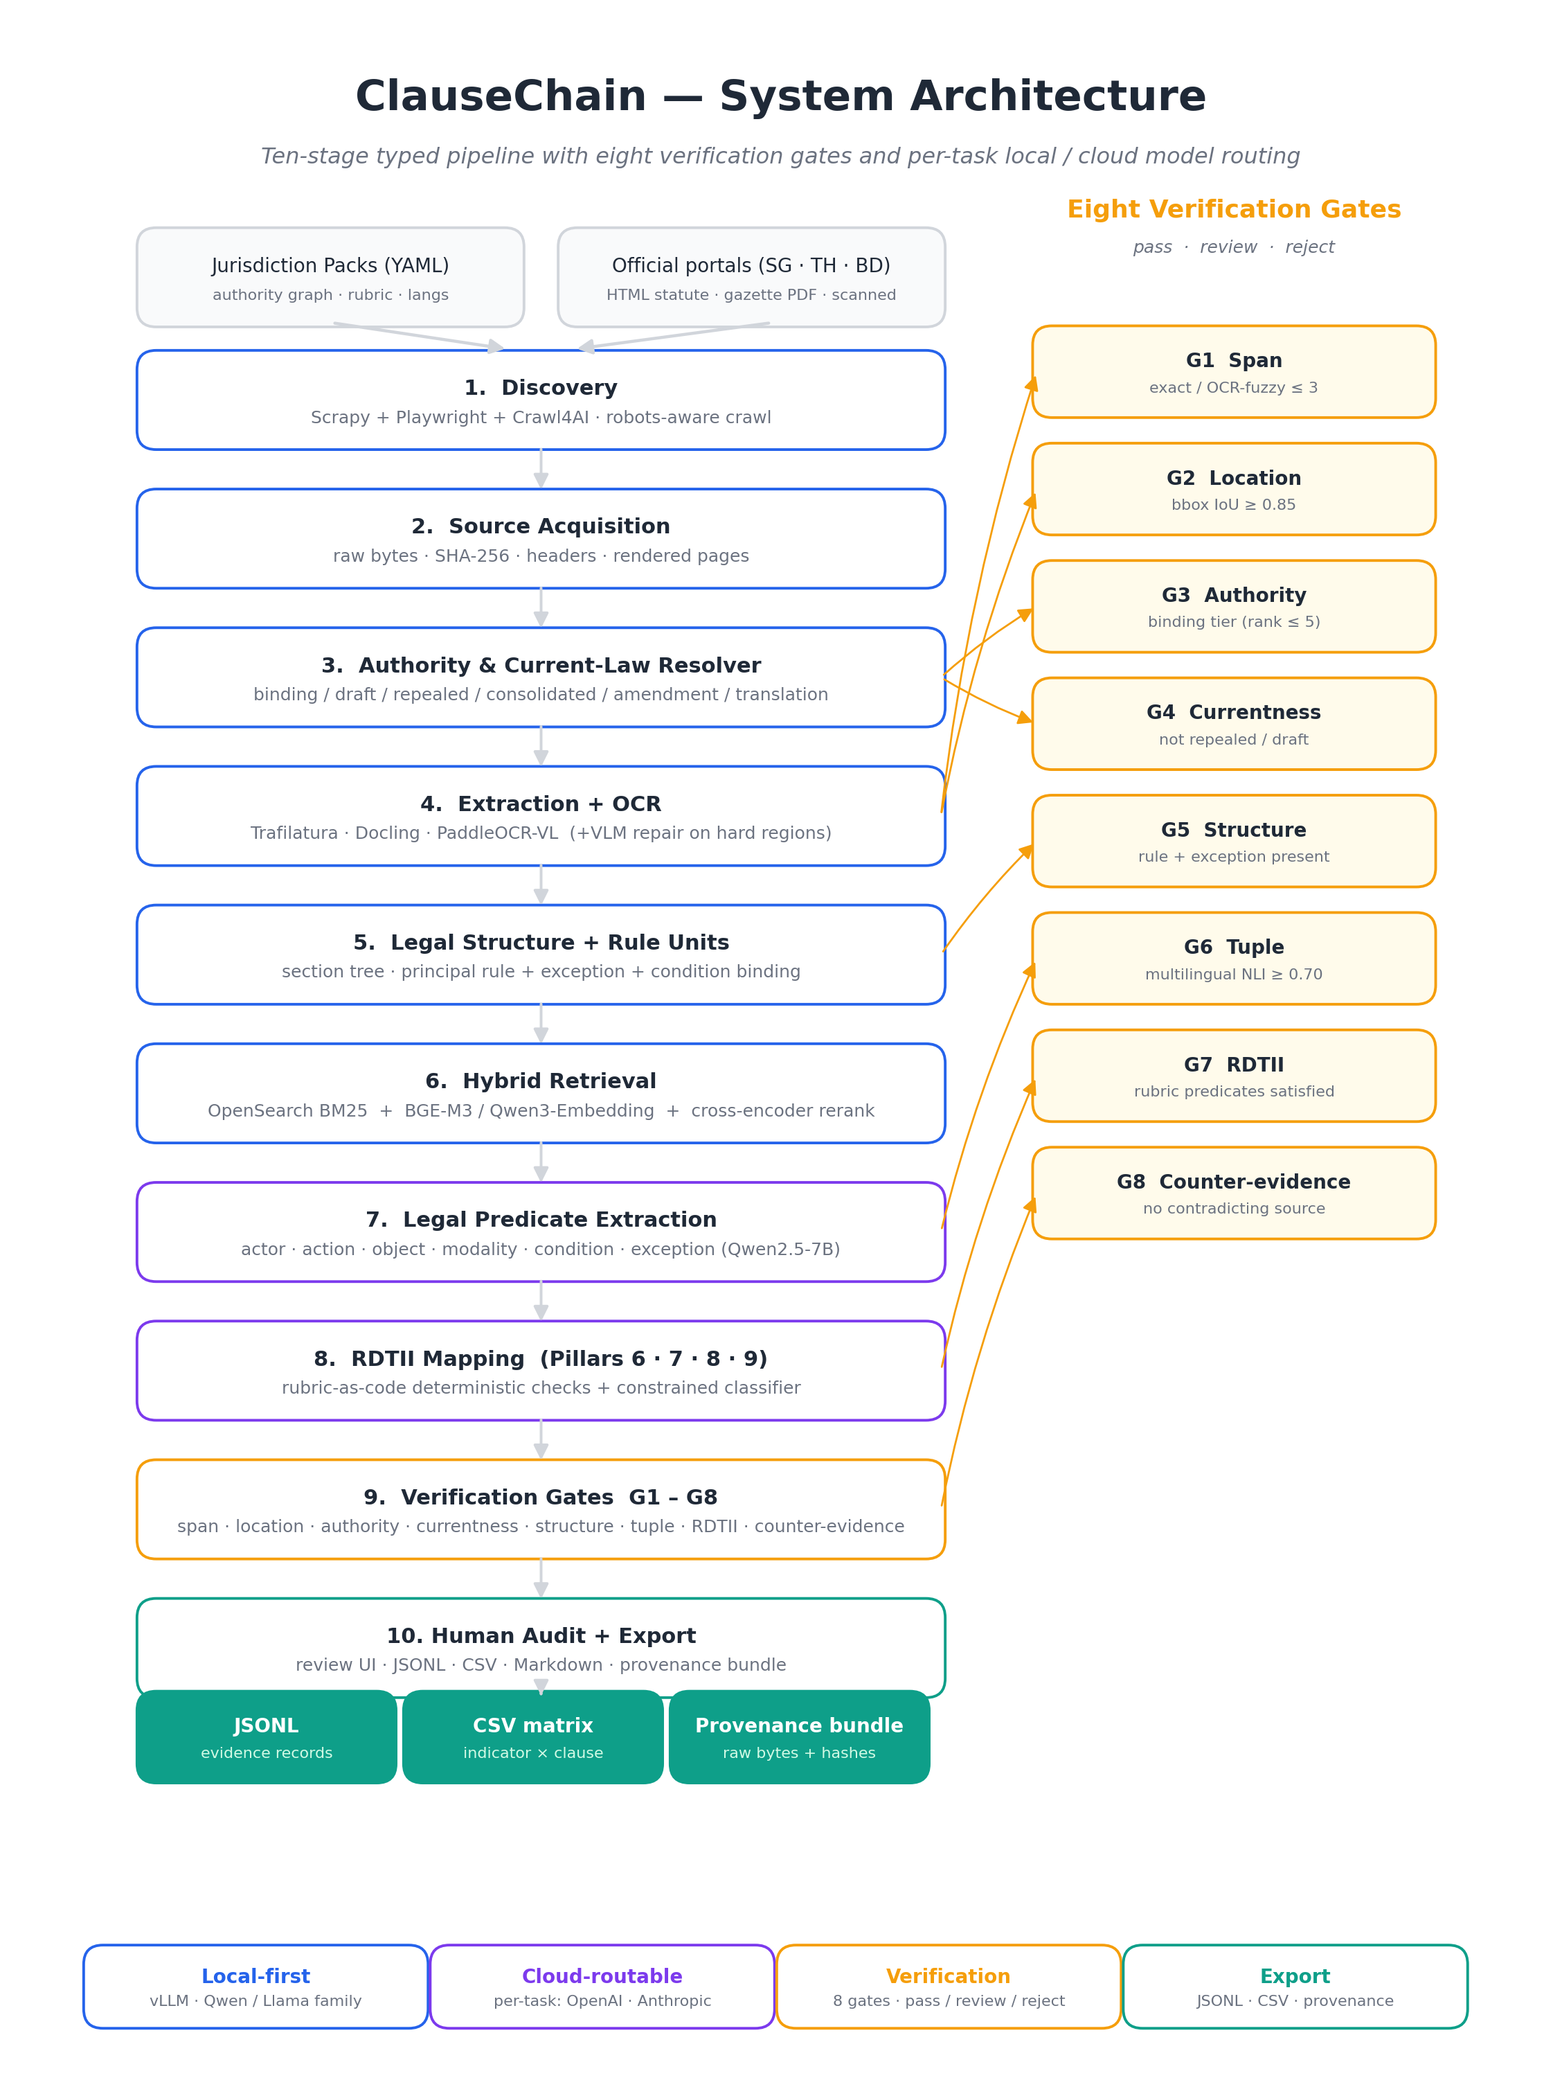
Figure 0 — System architecture: pipeline stages and CVR loop with local/cloud routing.
ClauseChain implements six stages: Collect, Extract, Classify, Explain, Cite, Export. A seed registry drives Crawl4AI across official gazettes and statute databases. A file-type router dispatches HTML to a legal-structure parser, native PDFs to Docling, and scanned PDFs to dual-engine OCR (Qwen2-VL + Tesseract, consensus), emitting canonical JSON with character offsets and bounding boxes. Clauses embed into Qdrant via BGE-M3; Llama 3.1 fills a constrained JSON schema — no free prose, no paraphrase.
Stage | Output
Discovery | crawled documents, source confidence-scored
Extraction | canonical JSON with hierarchy, char offsets, bbox, SHA-256
Indexing | BGE-M3 embeddings → Qdrant hybrid index
Mapping | constrained schema: pillar, verbatim_span, rule, exceptions, confidence
CVR Verification | three-gate pass/reject with gate scores logged
Export | JSONL / CSV / provenance bundle for independent re-verification

The nine-page interface — dashboard, jurisdiction detail, audit view, RDTII matrix, pipeline ledger, crawl console, harvest triage, extraction workspace, mapping run — is a working Next.js / React prototype.
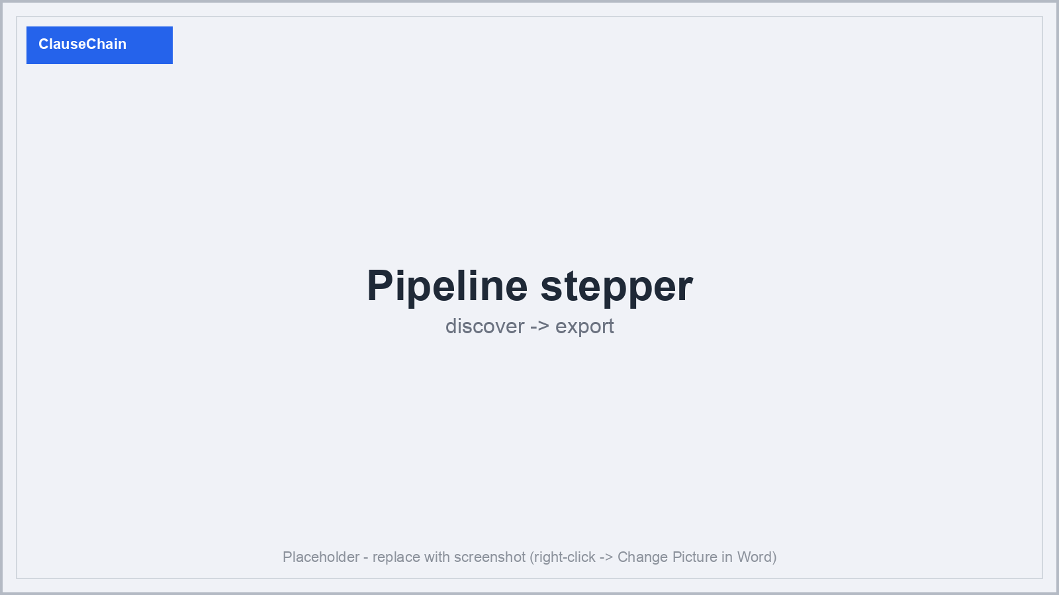
Figure 2 — Nine-stage pipeline stepper (Discover → Export) shown across all pipeline pages.

2. Tools, Models, and Methods
ClauseChain defaults to self-hosted open-weight models on a single 24 GB GPU, with optional per-task cloud routing to OpenAI or Anthropic, capped by a per-run token budget.
Task | Local default | Cloud (optional)
Crawling | Crawl4AI | n/a
HTML parsing | markdown + legal-structure parser | n/a
PDF extraction | Docling | n/a
OCR (scanned PDF) | Qwen2-VL 7B + Tesseract (consensus) | n/a
Embeddings | BGE-M3 | text-embedding-3-large
LLM classification | Llama 3.1 8B | gpt-4.1 / claude-sonnet-4-6
NLI verification | DeBERTa-v3 (MNLI/FEVER) | gpt-4o / claude-sonnet-4-6
Output structuring | Outlines / Pydantic | n/a

Serving: vLLM · FastAPI · Qdrant · Postgres · MinIO · Docker Compose. Orchestration: Prefect 2.
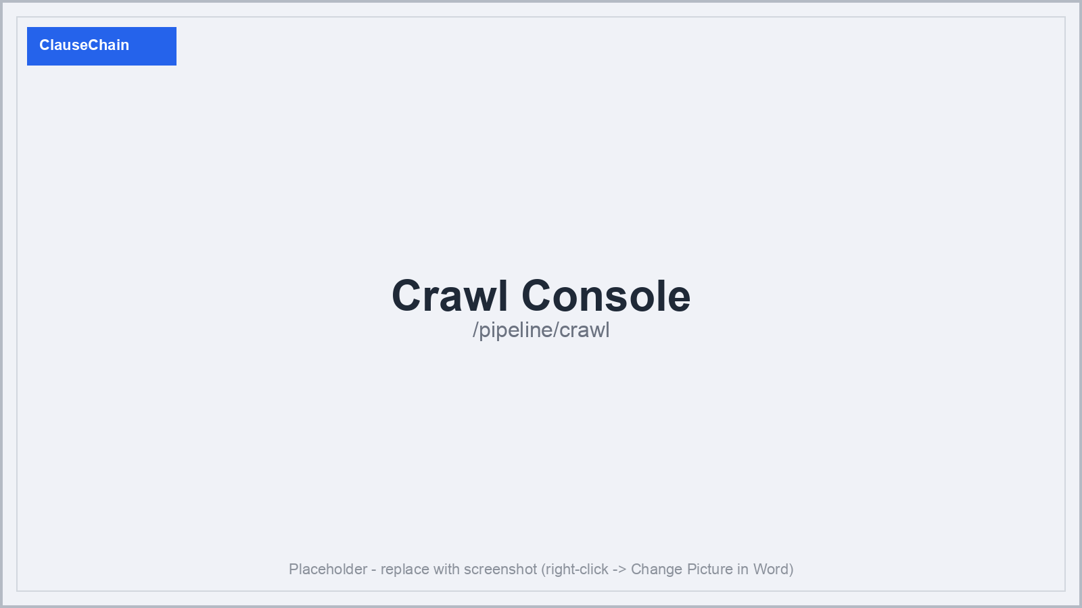
Figure 3 — Crawl Console: candidate documents with type tags and discovery confidence.
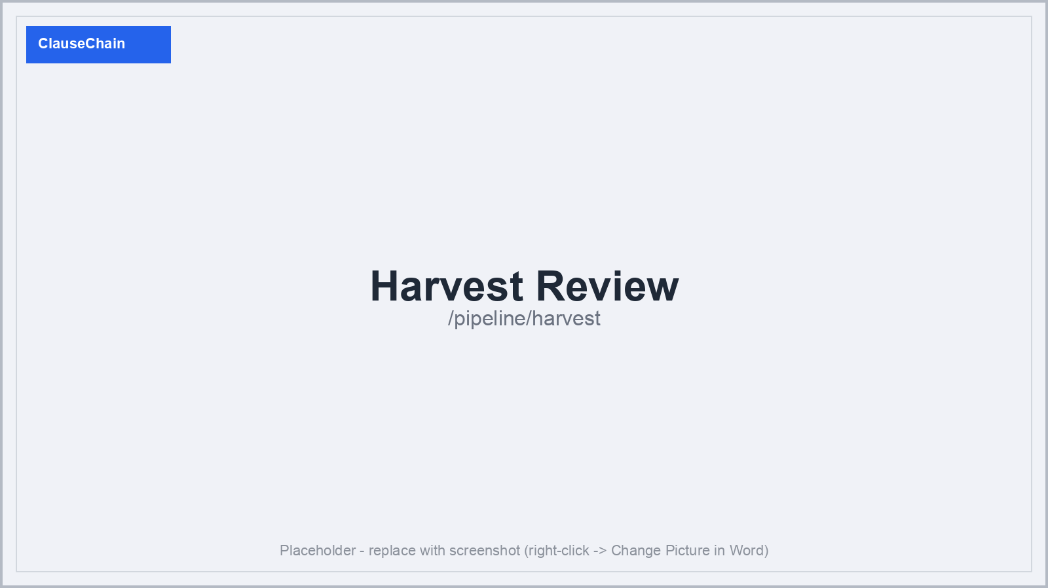
Figure 4 — Harvest Review: human keep/discard triage before extraction begins.
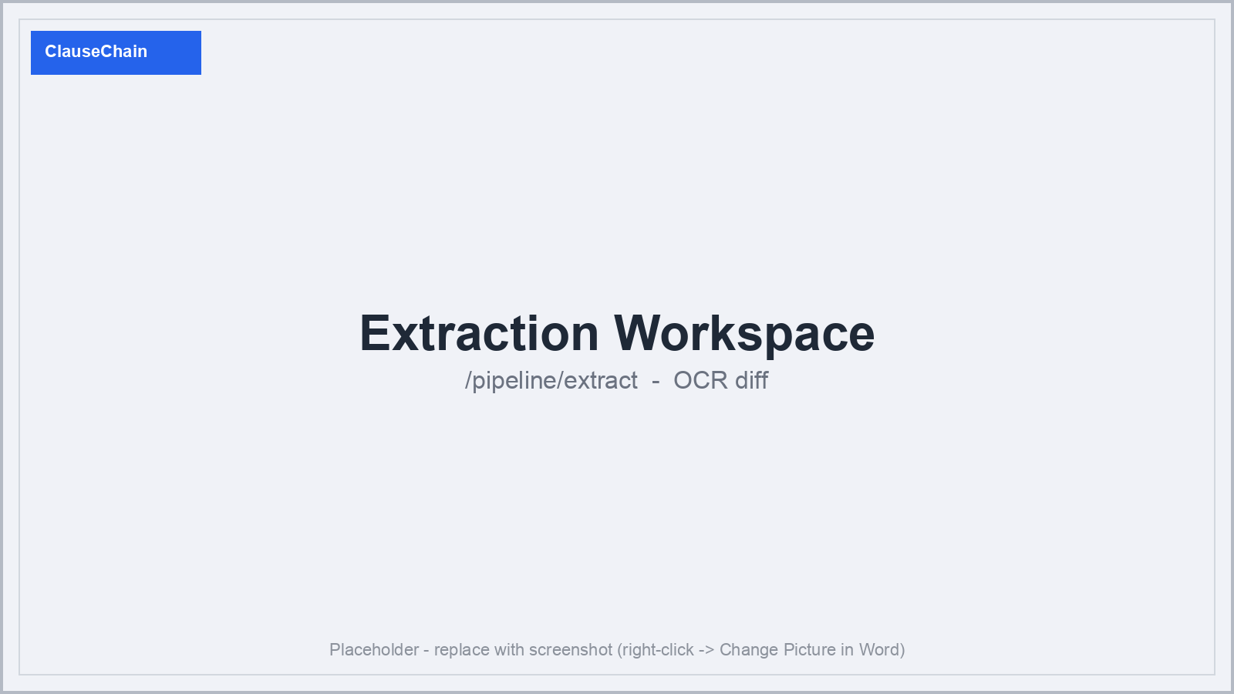
Figure 5 — Extraction Workspace: dual-engine OCR diff (Qwen2-VL vs. Tesseract) on a scanned Bengali page.
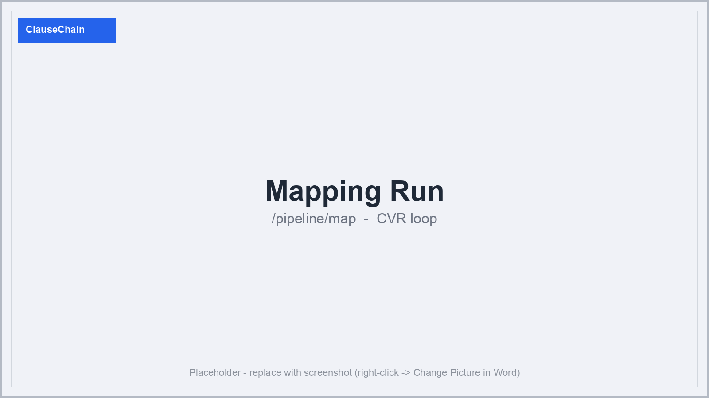
Figure 6 — Mapping Run: autonomy selector (L0–L3) and CVR gates streaming in real time.

3. Accuracy, Transparency, and Cost-Efficiency

Accuracy — CVR Loop
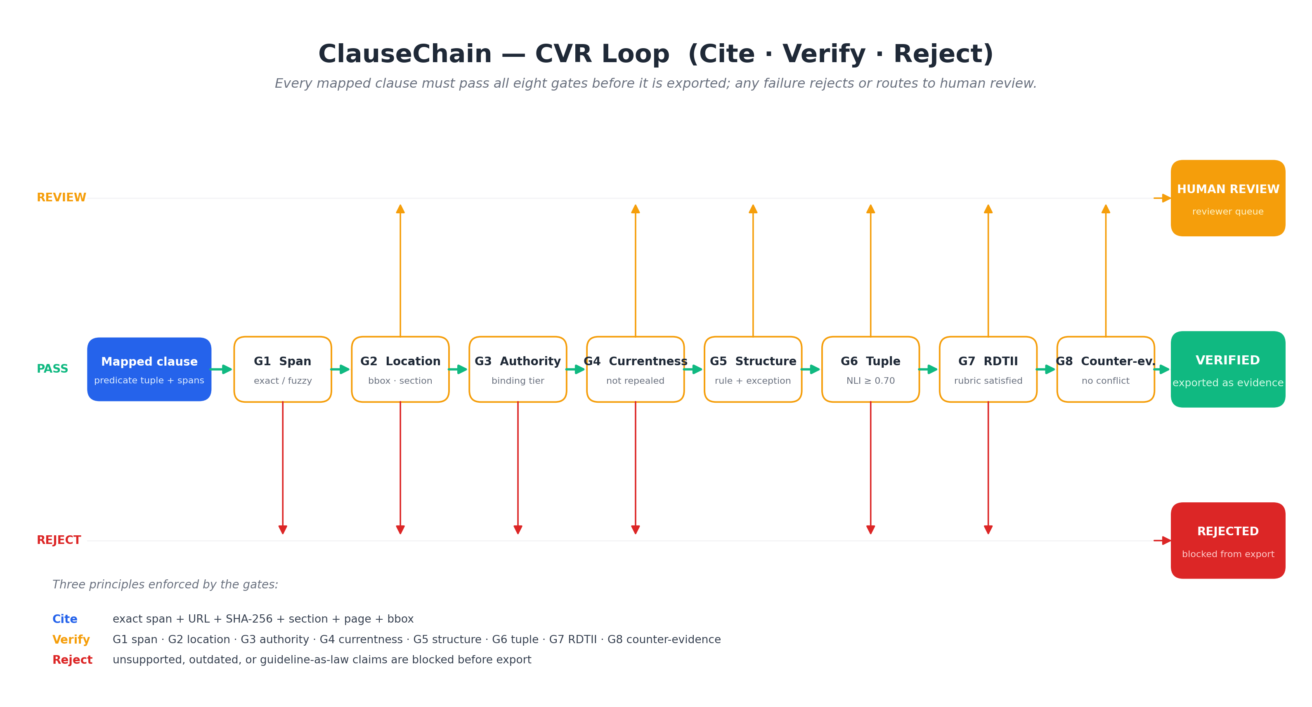
Figure 9 — CVR loop: every claim passes G1 Span, G2 Entailment, and G3 Structure before export.
Every claim passes three sequential gates. G1 Span Match: verbatim span present character-for-character in source (length-proportional fuzzy tolerance in OCR regions only; edit distance logged). G2 NLI Entailment: DeBERTa-v3 confirms the span entails the classification above a gold-set-calibrated threshold. G3 Structural Plausibility: cited section exists, rubric operative predicates present, clause role is operative not definitional. Any gate failure rejects or routes to human review. Autonomy (L0–L3) controls human gating; CVR gates always run.
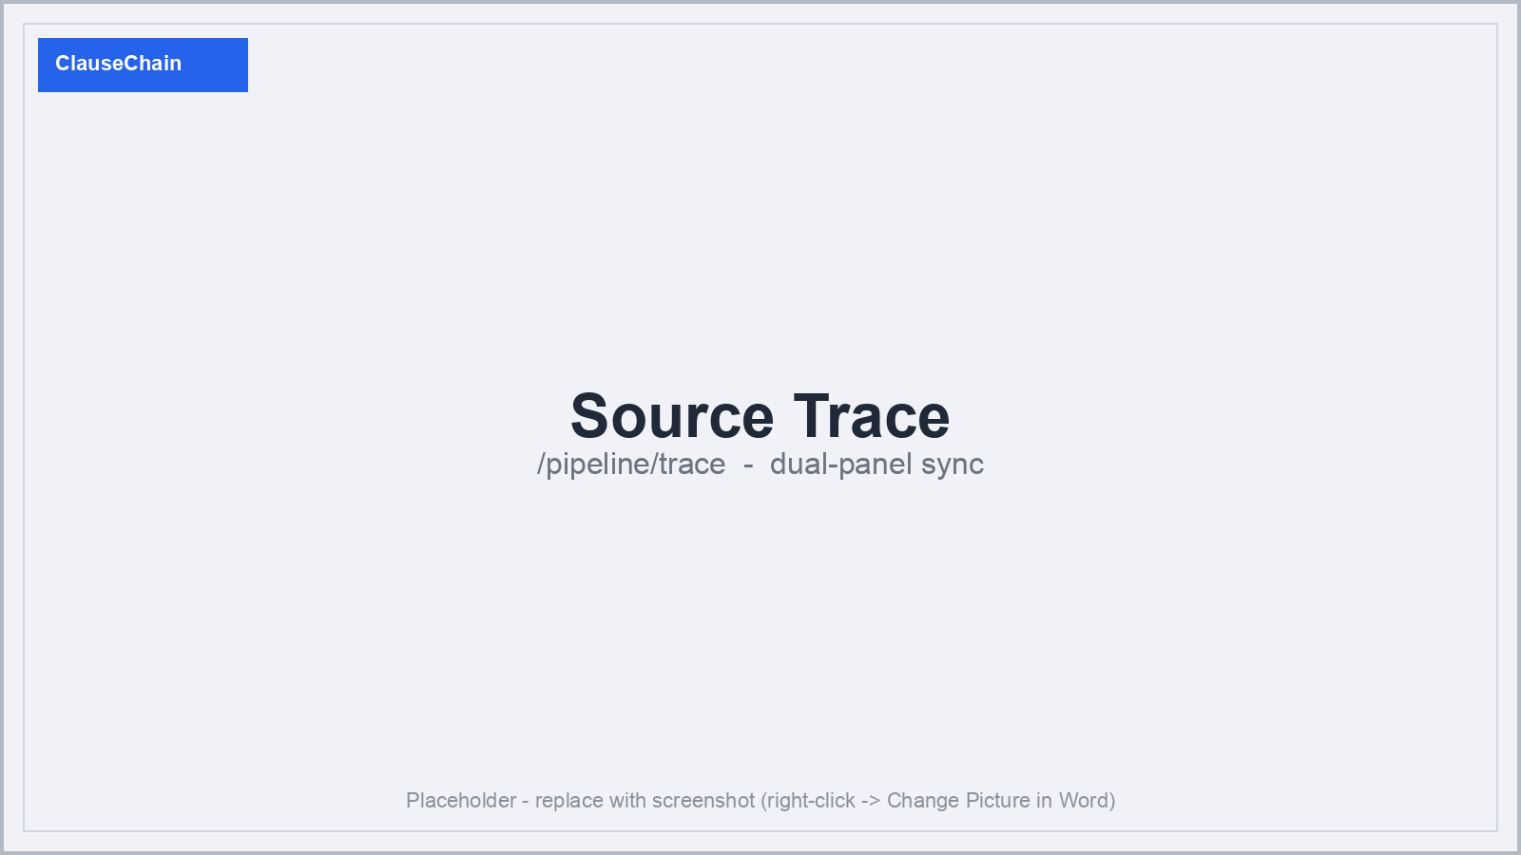
Figure 7 — Source Trace: dual-panel sync between extracted clauses and original source, with per-gate results.
A hand-labeled gold set (~20 clauses per jurisdiction, BD / TH / SG) benchmarks classification F1 (target ≥ 0.75) and citation accuracy (target ≥ 0.95). The same set runs against a naive frontier-model baseline to quantify the value of verification. CVR rejection rate and inter-annotator agreement (Cohen's κ) are also reported.

Transparency — Provenance Bundle
Every record carries: source URL, SHA-256, retrieval timestamp, section, page, char offsets, bbox, verbatim quote, and model identity. Any third party can re-verify any claim by fetching the source, recomputing the hash, and re-running NLI locally from the provenance bundle.
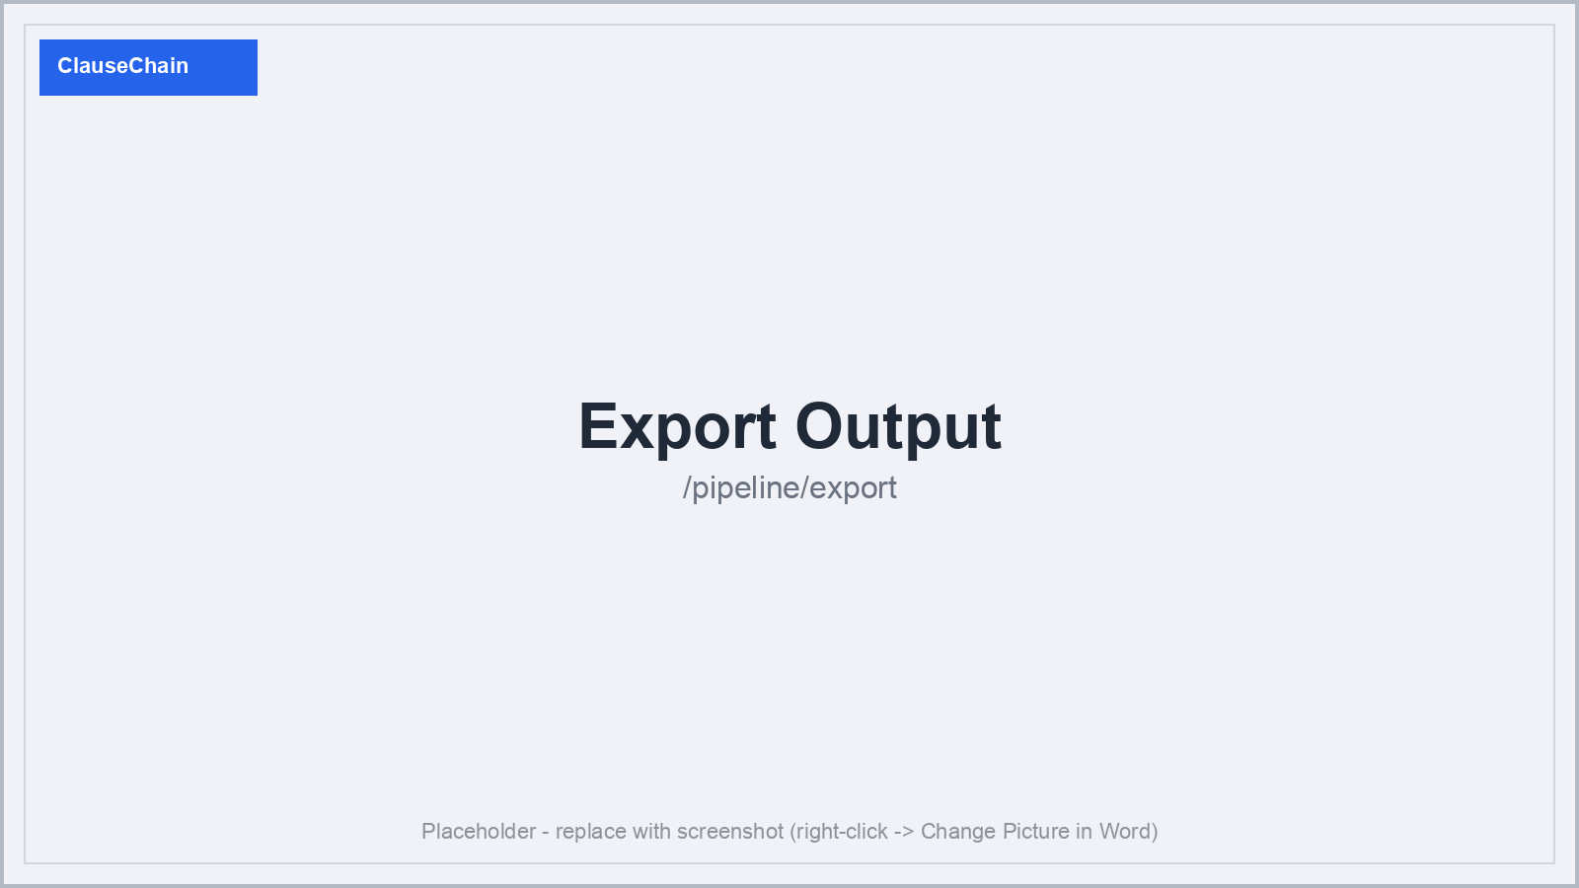
Figure 8 — Export Output: JSONL / CSV records with discovery tags, CVR gate results, and verbatim citations.

Cost-Efficiency
Self-hosted default incurs zero per-token cost. VLM repair runs only on low-confidence OCR regions. Cloud escalation is opt-in, per-task, and budget-capped; on cap the pipeline falls back to local and logs the event. Per-run cost is reported by task and provider.

