|  |  |  |  |  |  |  |  |  |  |  |
| --- | --- | --- | --- | --- | --- | --- | --- | --- | --- | --- |
|  |  | | Daffodil International University | | | | |  |  | |
|  |  | | |  | | |  | |  | |
|  | | | | | | | | | | |
| http://4.bp.blogspot.com/-SotLIkzmscA/UqQLE9BjdPI/AAAAAAAAARc/-SF46qFfVE0/s1600/daffodil-international-university-logo.png | | | | | | | | | | |
|  | | | | | | | | | | |
| **Online Exam System.** | | | | | | | | | | |
|  | | NAME | | | **:** | Shubha Sarker | | | |  |
| ID | | | **:** | 141-35-629 | | | |
| DEPARTMENT | | | **:** | Software Engineering | | | |
| Faculty of Science and Information Technology | | | | | | | |
|  | | |  |  | | | |
| December 2017 | | | | | | | | | | |

Table of Contents

Chapter 1 1

1. Introduction 2

1.1 About the System2

1.2 Purpose2

1.3 Scope2

1.4 Vision2

1.5 Why this system is necessary?2

1.6 Proposed Solution2

Chapter 2 3

2. System Analysis 4

2.1 Use Case Model5

2.2 Actor Goal List5

2.2.1 Assumptions5

2.3 Use Case Model5

2.4 Use Case Description (Brief)5

2.4.1 Register Accounts (Example)5

2.5 Use Case Description (Detailed)6

2.5.1 Register Account (Example)6

2.6 System Sequence Diagrams6

2.6.1 Register Account6

2.7 Domain/Conceptual Model7

2.8 Activity diagram8

Chapter 3 9

3. System Design 10

3.1 Sequence Diagrams10

3.1.1 Register Account10

3.2 Class Diagram11

3.3 Entity Relationship Diagram13

Chapter 4 15

4. Implementation 15

4.1 Tools &Technologies16

4.2 Project Link16

Chapter 5 17

5. System Testing 19

5.1 Why Software Testing is Essential?19

5.1.1 Black box testing19

5.1.2 White box testing19

5.2 Test Cases19

5.2.1 Test case: Sign up 19

Chapter 6 20

6. Conclusion 21

6.1 Good Features of the System21

6.2 Limitations of the System21

6.3 Future Enhancements21

Appendices 22

7. User Manual 23

7.1 Log in Screen of Federal Shariat Court Case Flow Automation System.23

8. References 24

Chapter 1

Introduction

# 1.Introduction

* 1. About the System:

Online Exams is being launched because a need for a destination that is beneficial for both institutes and students. With this site, institutes can register and host online exams. Students can give exams and view their results. Student can create his account in this site . This site is an attempt to remove the existing flaws in the manual system of conducting exams.

## 1.2 Purpose :

## 1.Student Exam System planning phase.

## 2. Requirement selection phase.

## 3. Student Exam System Design phase.

## 4. Developing with Database phase.

## 5. Testing phase.

## 1.3 Scope :

* On-line Exam system is designed for Educational Institutes (like schools, universities, training centers).

## The system handles all the operations, and generates reports as soon as the test is finish, that includes name, mark, time spent to solve the exam

* Allow students to see or display his answers after the exam is finish.
* The type of questions is only multiple choice or true and false.

## 1.4 Vision:

## 1.5 Why this system is necessary?

Online Exams System fulfills the requirements of the institutes to conduct the exams online. They do not have to go to any software developer to make a separate site for being able to conduct exams online. They just have to register on the site and enter the exam details and the lists of the students which can appear in the exam. Students can give exam without the need of going to any physical destination. They can view the result at the same time. Thus the purpose of the site is to provide a system that saves the efforts and time of both the institutes and the students

## 1. 6 Proposed Solution

This Web Application provides facility to conduct online examination world wide.

It saves time as it allows number of students to give the exam at a time and no need to wait for the result. It is automatically generated by the server.

Administrator has a privilege to create, modify and delete the test papers and its particular questions.

User can create his account in this site

User can register, login and give the test with his specific id, and can see the results as well.

## 1.5 Budget (Time & cost):

|  |  |  |  |
| --- | --- | --- | --- |
| Activities | Time | Cost | |
| Requirement Analysis and selection. | 6 day | 3000Tk. | |
| Designing. | 7 day | 5500Tk. | |
| Developing. | 15day | 7000Tk. | |
| Testing. | 3 day | | 5000Tk. |

Chapter 2

**System Analysis**

# 2. System Analysis

# 2.1 Use Case Model

Online Exam System

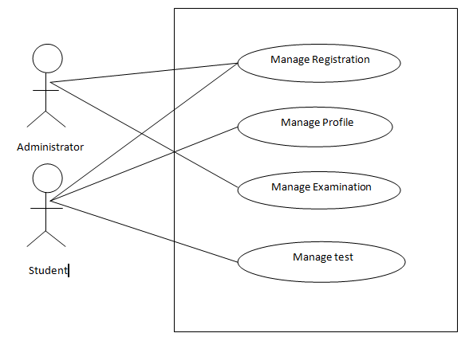

Fig 2.1 : Use Case Diagram

## 

## 2.2 Actor Goal List

## 2.2.1. Administrator

## Administrator can access all information in this system.

## Administrator can make question pattern and update any questions

## Administrator can add any subject delete any questions and subjects.

## Administrator can any students profile disable and enable .

## 2.2.2. Student

## Student can manage their exam question which exam they will give.

## Student can create their personal profile in this system.

## Student can view their exam mark and if they want to again exam then they can .

## 2.3 Use Case Description (Brief)

## 2.3.1 Manage Registration

**Admin of System has necessary data required for Reports generation. Admin can also register account and can assign roles to accounts registered. When admin and student have finished their registration then admin access all section and students can manage their exam and manage their profile in this system.**

## 2.3.2 Manage profile

## Students have finished their registration then they can able to create their personal individual profile in this system. When Students create their account then they will be able to modify their account section and after all exam details information and mark see their profile.

## 2.3.3 Manage Examination

## Admin do manage all exam information and all questions. Admin community can modify question pattern and they can delete, update, add any questions and any subjects.

## 2.3.4 manage test

## When students have finished their registration then they will be able to manage their exam .Students first select their course which subject exam they will do then start their exam.

## 2.4 Use Case Description (Detailed)

## 2.4.1 Manage Registration

|  |  |
| --- | --- |
| Use Case ID | 1 |
| Name | Manage Registration |
| Primary Actor | Admin |
| Secondary Actor | Students |
|  |
| Goal | User can access system. As like create profile, start exam , also user can view result and can Rexam. |
| Precondition | Must be registered in specific institution as a student or employee |
| Post Condition | After complete registration he can start exam and create profile |
| Main Success Scenario | 1. Administrator and student must be registered  2. Administrator can create exam question delete and update question, also he can block or delete any student.  3. Student can give exam, create profile, view result  4. Student can search exam category . |
| Scenario Extensions | 1. When admin tries to enter data for an already register user the system will generate an error message.  2. System will not register an account unless an admin register the account  3. If Administrator don’t create exam question students can’t give exam |

2.4.2 Manage profile

|  |  |
| --- | --- |
| Use Case ID | 1 |
| Name | Manage profile |
| Primary Actor | Student |
| Secondary Actor |
| Goal | Student can create profile in this system . Student if want before all information he can . Student can update his profile , upload his profile picture . |
| Precondition | Must be registered and maintain and flow all rules then he can manage his profile |
| Post Condition | When student registered then he create his profile in this system.  Student can update and upload any information and picture in his profile. |
| Main Success Scenario | 1.When a student manage his profile in this system then he get before and after all information in his profile.  2. Student can see before all exam mark |
| Scenario Extensions | 1. when a student do not manage and create profile in this system then he will do logout in this system then not save his exam mark and details.  2. When student do not manage profile then he can not update information and upload his picture . |

## 2.4.3 Manage Examination

|  |  |
| --- | --- |
| Use Case ID | 1 |
| Name | Manage Examination |
| Primary Actor | Admin |
| Secondary Actor |
| Goal | Manage all exam question . Add , update , delete any question any subject and can delete any student profile . |
| Precondition | Must be registered because he is a admin. |
| Post Condition | Manage all exam question . Add , update , delete any question any subject and can delete any student profile . |
| Main Success Scenario | 1. Access all system .  2. All subject and all question can Add, delete, update.  3. Any students profile can disable or enable and delete |
| Scenario Extensions | 1. When didn’t registered than can not access in this system.  2. When don’t make any subject any question than student can not give any exam. |

## 2.4.4 manage test

|  |  |
| --- | --- |
| Use Case ID | 1 |
| Name | manage test |
| Primary Actor | Students |
| Secondary Actor |
| Goal | Student when manage test than can give any exam. Firstly student do select his course then he give his exam . |
| Precondition | Must be Registered and maintain all before rules |
| Post Condition | Student when manage test than can give any exam and view exam mark |
| Main Success Scenario | 1. When a student manage his test then he can justify his knowledge.  2. When student manage and start test and when have finished his test then he can see his mark.  3. When have finished test then can again start another subject test. |
| Scenario Extensions | 1. When student do not manage test then he do not give any test.  2. when a student do not manage test then he can not justify his knowledge .  3. When he do not manage any test then he can not view exam mark . |

## 

## 2.5 System Sequence Diagrams

## 2.6.1 Manage Registration

**2.6.1.1 Success scenario**

**2.6.1.1.1 Success scenario (Admin)**

System

System Administrator

**Admin registration**

**Admin registration (name ,Email, password )**

**Result**

**Successfully complete registration**

**Done**

**2.5.1.1.2 Success scenario (Students)**

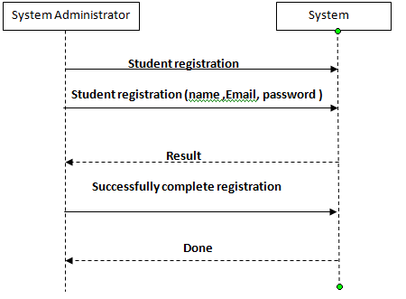

**2.5.1.2 Failure Scenario**

**2.5.1.2.1 Failure Scenario(Admin)**

System

System Administrator

**Admin registration (name ,Email, password)**

**Password too short**

**Admin registration (name ,Email, password)**

**At least one special character**

**Admin registration (name ,Email, password)**

**Done**

**2.5.1.2.2 Failure Scenario(Students)**

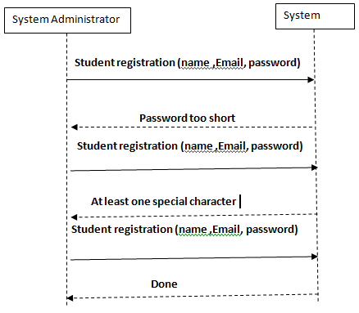

**2.5.2** Manage profile

**2.6.2.1 Success scenario**

System

Student

**Student createProfile(name, profile_pic,**

**view_result )**

**done**

**2.5.2.2 Failure Scenario**

System

Student

**Student createProfile(name, profile_pic,**

**view_result)**

**Messing id, parameter**

**Correct id, paremeter**

**Done**

**2.5.3** Manage Examination

**2.6.3.1 Success scenario**

System

Admin

**Admin manage_Ques( add_ques, add_sub, add_info)**

**Done**

**2.5.3.2 Failure Scenario**

System

Admin

**Admin manage_Ques( add_ques, add_sub, add_info)**

**Attribute is messing (add_ques, add_sub, add_info)**

**Correct attribute (add_ques, add_sub, add_info)**

**Done**

**2.5.4** manage test

**2.5.4.1 Success scenario**

System

Student

**Student manage_test( select_ Subject, Select_Q)**

**Done**

**2.5.4.2 Failure Scenario**

System

Student

**Student manage_test( select_ Subject, Select_Q)**

**Mistake select question**

**Again correct select question**

**Done**

## 

## 2.6 Domain/Conceptual Model

## C:\Users\shuvo\Desktop\Captureccccccccccccccc.PNG

## 

## 2.7 Activity diagram

Activity diagrams are graphical representations of workflows of stepwise activities and actions with support for choice, iteration and concurrency.

In the system workflows starts from the stage when an applications enters the area of Federal Shariat Court i.e. uploaded in the system to last activity that is a judgment comes or the case is dismissed .This whole process is shown in the below diagram.

## 2.7.1 Administrator

## C:\Users\shuvo\Desktop\aaaaaaaaaaaaaaa.PNG

## Figure (3.7.1): the activity diagram ( a )for administrator

## 2.7.2 Student

## 

## C:\Users\shuvo\Desktop\bbbbbbbbbbbb.PNG

## (b)

## Figure (3.7.2): the activity diagram ( b ) for student

Chapter 3

**System Design**

# 

# 3. System Design

Design is a process that uses the product of analysis to produce a specification for implementing a system. Design is the logical description of how a system will work.

Design emphasizes a conceptual solution that fulfills the requirements, rather than its implementation. For example, a description of a database schema and software objects. Design ideas often exclude low-level or "obvious" details obvious to the intended consumers. Ultimately, designs can be implemented, and the implementation (such as code) expresses the true and complete realized design. The term is best qualified, as in object-oriented design or database design.

## 

## 3.1 Sequence Diagrams

The UML includes interaction diagrams to illustrate how objects interact via messages. They are used for dynamic object modeling. The term interaction diagram is a generalization of two more specialized UML diagram types:

### 3. 1.1 Administrator

## C:\Users\shuvo\Desktop\ssssssss.PNG

Figure (3.1. 1): the insert operation done by administrator. The update operation is similar to this sequence diagram but rather than Registration process put Update process.

### 3.1.2 Student

## 

Figure (3.3.2): present how student take an exam and give the result.

## 

## 3.2 Class Diagram

Class or structural diagrams define the basic building blocks of a model. They are used for static object modeling, describing what attributes and behavior it has rather than detailing the methods for achieving operations.

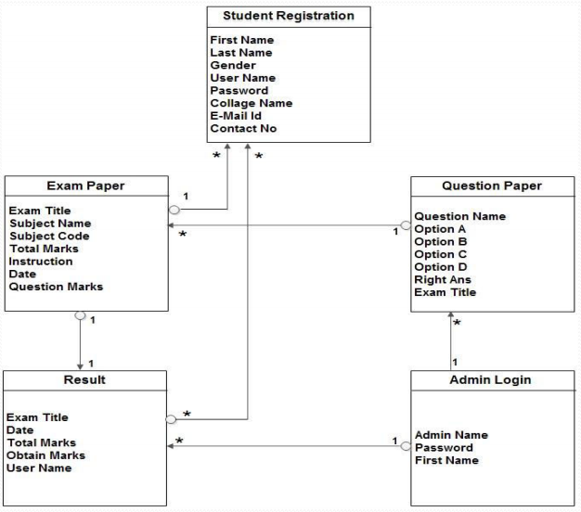

## 

## 3.3 Entity Relationship Diagram

An entity-relationship model is an abstract and conceptual representation of data. Entity-relationship modeling is a database modeling method, used to produce a type of conceptual schema or semantic data model of a system, often a relational database, and its requirements in a top-down fashion. Diagrams created by this process are called Entity-Relationship Diagrams.

E-R Diagram

## C:\Users\shuvo\Desktop\ddddddddddddddddddddd.PNG

Chapter 4

**Implementation**

# 4. Implementation

Implementation (software) perspective describes software implementations in a particular technology (such as C#). In the UP, Implementation means programming and building the system, not deploying it.

In the implementation phase, the developer builds the components either from scratch or by composition given the architecture document from the design phase and the requirement document from the analysis phase. The architecture document should give guidance. Sometimes, this guidance is found in the requirement document. The implementation phase deals with issues of quality, performance and debugging. The end deliverable of implementation phase is the product itself.

## 4.1 Tools &Technologies

Following are the tools and technologies used in development of this project:

Microsoft Visual Studio 2012

Microsoft SQL Server 2008

Telluric reports

Microsoft Visio

Microsoft Architect

HTML5, CSS, JavaScript, J-query, Twitter bootstrap

## 4.2 Project Link

They provide github repository link after uploading the project there.