Python

Python

Decision making

Python programming language assumes any non-zero and non-null values as TRUE, and if it is either zero or null, then it is assumed as FALSE value.  
Python programming language provides following types of decision-making statements

1. If Statement
2. If…. else Statement
3. elif statement
4. nested if Statement

If Statement**:** In Python, If Statement is used for decision making. It will run the body of code only when IF statement is true.

Syntax:

if expression

Statement

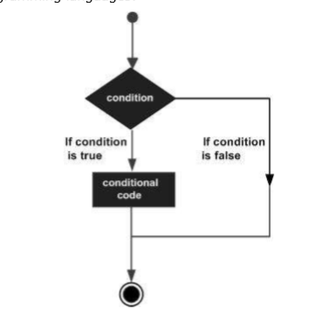Flow Chart:

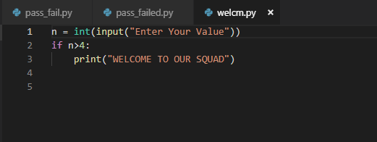Source Code of if:

Output:

If….else Statement:

The if…else statement evaluates test expression and will execute body of if only when test condition is True.

If the condition is False, body of else is executed. Indentation is used to separate the blocks.

Syntax:

if test expression:

Body of if

else:

Body of else

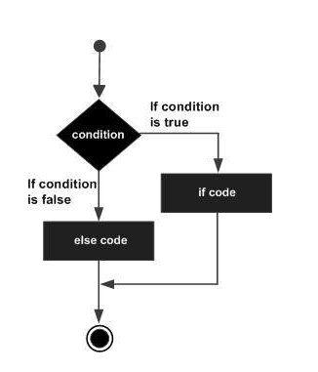Flow Chart:

Source Code of if…….else:

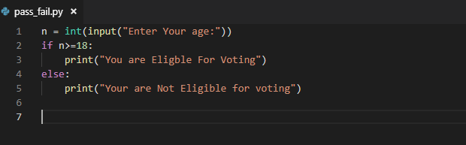

Output:

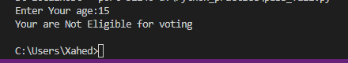

elif Statement:

The elif statement allows you to check multiple expressions for TRUE and execute a block of code as soon as one of the conditions evaluates to TRUE.

Similar to the else, the elif statement is optional. However, unlike else, for which there can be at most one statement, there can be an arbitrary number of elif statements following an if.

Syntax:

if expression1:

statement(s)

elif expression2:

statement(s)

elif expression3:

statement(s)

else:

statement(s)

Flow Chart:



Source Code:

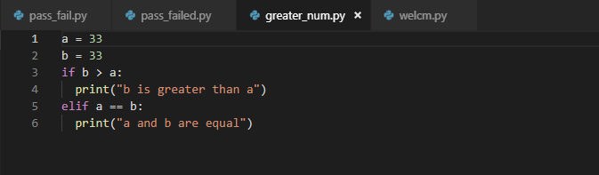

Output:



Nested if Statement:

Once you are feeling comfortable with the if, elif, and else statements, you can move on to nested conditional statements. We can use nested if statements for situations where we want to check for a secondary condition if the first condition executes as true. For this, we can have an if-else statement inside of another if-else statement. Let’s look at the syntax of a nested if statement:

Flow chart:

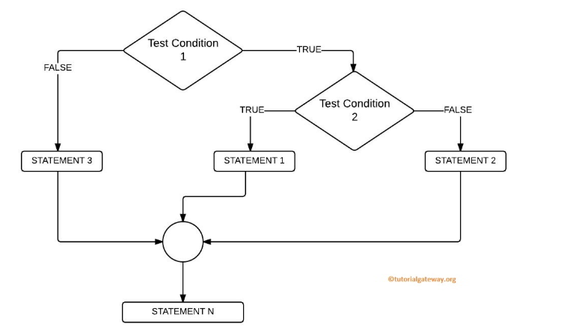

Source Code:

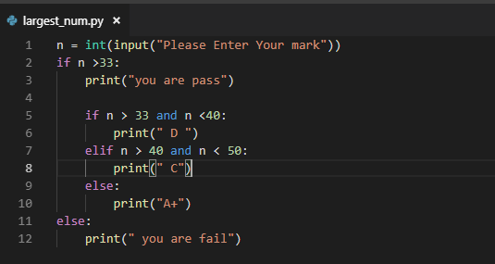

Output:

