# Portfolio

My portfolio site.The site is responsive across all devices(phones,tablets and PCs).

Desktop View

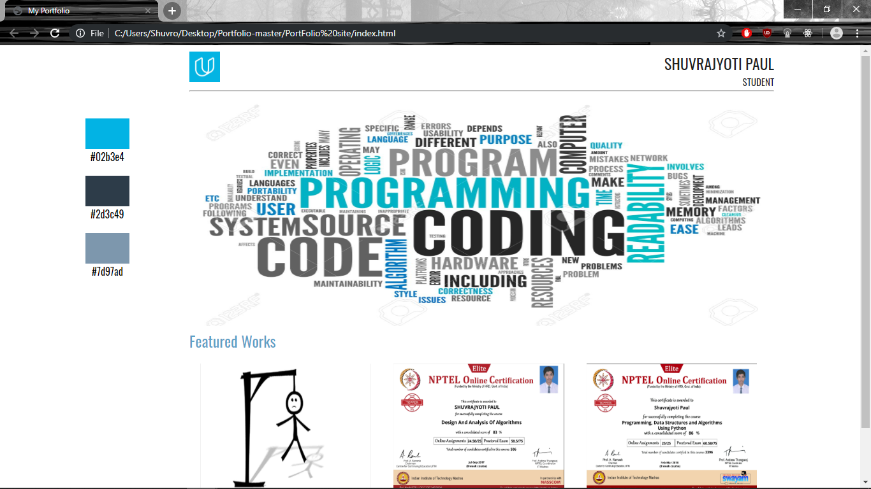

Mobile View

