Background
Many applications require a low-speed data link in rural areas for telemetry, data acquisition, or communications and control. The distances spanned may range anywhere from less than a kilometre up to 20 kilometres or more. In regions where no data infrastructure exists, it may be impractical or too costly to install landlines for these applications. Furthermore, many existing wireless data solutions would be unacceptable either due to insufficient range (802.11) or high cost (microwave, satellite, or specialized data links).

Relatively powerful VHF and UHF FM radios exist that can transmit voice-band audio signals in the range of 300 Hz – 3000 Hz over these distances [1]. Transmitter power typically varies anywhere between 1 W to 30 W and above.

By developing a low-cost data modem that can interface these radios to computers or other digital equipment, an economical wireless data link can be established for these applications. Using off-the-shelf radios provides additional flexibility, allowing the modem to be interfaced to different radios depending upon the particular application. Providing a standard asynchronous serial data interface on the modem allows for connection with embedded computers, PCs, smart sensors, or other equipment. Figure 1 illustrates a typical application of such a modem.

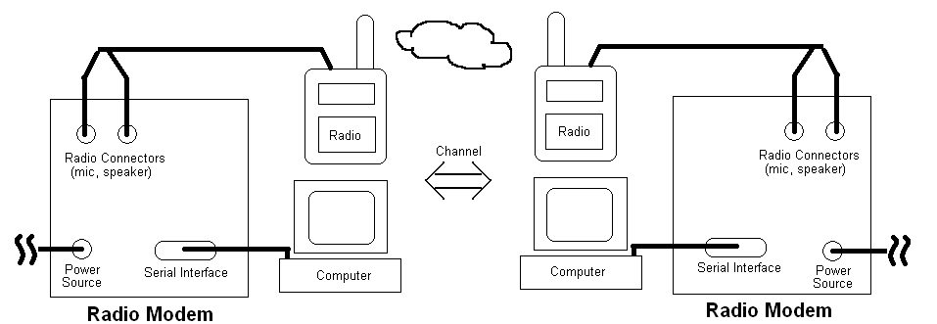
Figure 1 – System diagram of wireless data modem interfaced with radios and computers

Uses and Applications
User/Application | Background | Needs
Scientific researchers | Has experiments located in remote areas | Remote data must be collected; control information must be sent
Small weather stations | Unmanned data-logging weather stations | Weather data and measurements need to be recorded from stations
Industrial control/monitoring | Remote field processes/automation | Monitoring and control data must be exchanged with process at distance

Functional Requirements
Priority | Name | Measure | Description
MUST | Radio Interface | By design | Must work with audio interface of voice-band radios
MUST | Signal bandwidth | 300 Hz – 3000 Hz | Modem output signals must fit within audio bandwidth of radios
MUST | Serial interface | By design | Must interface with other equipment over a standard RS-232 serial interface
MUST | Transparent operation | By design | Must provide transparent operation through RS-232 and behave similarly to landline modems or null-modem connections
SHOULD | Forward error correction | By design | Should implement forward error correction to reduce error rate of received data
SHOULD | Half-duplex communication | By design | Modem should be able to operate in a half-duplex mode for two-way operation over a single radio channel
SHOULD | Audio input levels | -20 dBV – 0 dBV | Should tolerate reasonable range of nominal input signal amplitudes
SHOULD | Audio output levels | -20 dBV – 0 dBV into 600 Ω | Should be capable of producing reasonable range of output signal amplitudes

Non-functional Requirements
Priority | Factor | Requirement
MUST | Size | PCB must be less than 25 cm in either direction
MUST | Weight | Less than 3.0 kg in weight
SHOULD | Power | Should not require over 6 VDC @ 800 mA
SHOULD | Portability | Should be small and light enough to be portable

Performance Metrics
The data transfer rate and bit error rate are two metrics by which the final design will be evaluated. Below are the suggested minimum acceptable scores for this modem. These are significantly lower than the theoretical achievable limits for the given bandwidth (300 Hz – 3000 Hz) and signal-to-noise ratio [2]. Since many factors affect the final performance (modulation scheme, radio performance, etc.), these minimums are intended only as a reference at this stage. Significantly more accurate targets supported by measurements and additional research will be presented in the Block Verification deliverable.

Metric | Target Minimum | Description
Net data transfer rate | 100 bits/second | Must transfer data at minimum rate over reasonable channels (15 dB SNR per bit)
Bit error rate | 10⁻³ | Must not exceed 1 bit error per 1000 bits over reasonable channel conditions (15 dB SNR per bit)

Unit Cost
Prototype (1-10) | Mass Production (100-1000)
< $300 CDN each | < $150 CDN each

Block Diagram
Figure 2 illustrates a simplified block diagram of the modem hardware, to be realized on a PCB. A highly integrated embedded DSP (Digital Signal Processor) will be used to execute the modem software. The DSP will be connected to an RS-232 interface for data transfer and to an audio CODEC interface for voice-band audio input and output. Figure 3 illustrates an initial architecture of the software modem blocks that will be executed on the DSP.
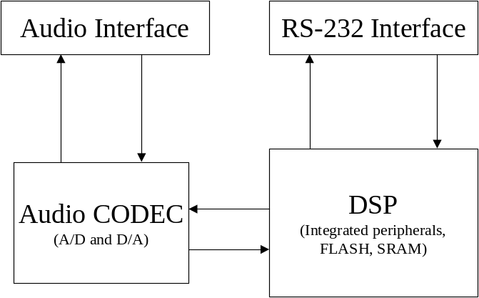
Figure 2 – Simplified hardware block diagram of modem

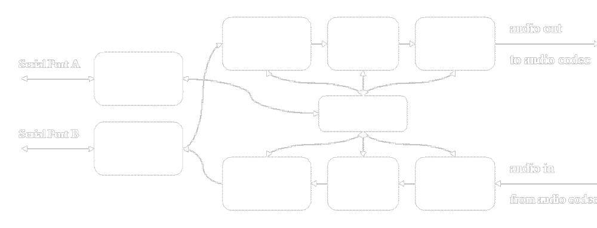
Figure 3 – Block diagram of modem software architecture

Risks
Level | Description | Response
High | Hardware implementation non-functional | Demonstrate modem in software simulation
High | Interfacing to voice radios problematic | Test interfaces early and choose appropriate radios
Medium | Modem has insufficient performance for required goals | Consult with advisor and perform sufficient up-front research
Medium | Insufficient memory and processing resources to implement required features | Choose embedded processor with plenty of processing power and memory to spare
Low | Hardware prototypes cannot be produced in time for demonstration | Begin work on hardware prototypes immediately

Plan
The milestones below represent the different phases of the project. Associated with each milestone is a well defined deliverable that should be produced by the target completion date. Each milestone is broken down into different tasks that will be partitioned among the group members (as will be detailed in the logs). Time estimates are given for each task. While each milestone has a single target completion date, work for several milestones can proceed in parallel since there is a very clean division between the hardware, firmware, and software modem aspects of the design.

Significant work will have been completed on both hardware development and firmware development by the end of the 3B academic term (as per risk analysis) in order to ensure that the first two milestones can be met successfully.

Milestone | Deliverables | Target Completion Date | Estimated Man Hours
Hardware development | Functional hardware | 9-May-05
Schematic design |  |  | 50
PCB layout |  |  | 50
PCB assembly and testing |  |  | 50
Fimware development | Functional firmware drivers | 16-May-06
Develop hardware interface drivers |  |  | 50
Develop debug layer |  |  | 20
Test drivers and debug layer |  |  | 10
Research and Simulation | Block Verification | 13-May-05
Test and characterize radios |  |  | 15
Research modem architecture |  |  | 20
Simulate modem algorithms |  |  | 50
Software modem design | Detailed Design | 3-Jun-05
Compare alternatives and choose algorithms |  |  | 10
Design modem architcture (blocks) |  |  | 25
Partition block implementation |  |  | 5
Software modem implementation | Functional Software Modem | 18-Jul-05
Block development |  |  | 100
Block-level testing (in simulation) |  |  | 25
System-level testing (in simulation) |  |  | 50
Hardware-implementation testing (in hardware) |  |  | 25
Prototype testing checklist | Same | 11-Jul-05 | 5
Prototype demonstration | Same | 25-Jul-05 | 5
Experience report | Same | 29-Jul-05 | 10
Total project man hours |  |  | 575

Budget
NEED |  |  |  |  |  | TEAM FUND
CATEGORY | ITEM | PRICE EA | QTY | UNIT | TOTAL | TOTAL
Prototype Material |  |  |  |  | $973 | $973
 | PCB | N/A | 5 | EA | $300 | $300
 | DSP | $36 | 8 | EA | $292 | $292
 | Parts for prototype boards (excluding DSPs) | $160 | 4 | sets | $640 | $640
 | 1/8" 8"x8" aluminum grounding back plane | $7 | 4 | EA | $28 | $28
 | Power adapters | $5 | 3 | EA | $14 | $14
 | Portable radios | $70 | 1 | pair | $70 | $70
Education Material |  |  |  |  | $316 | $316
 | "Wireless Digital Communications" text | $64 | 4 | EA | $256 | $256
 | Practice soldering kit | $30 | 2 | EA | $60 | $60
Services |  |  |  |  | $200 | $200
 | Poster | $200 | 1 | EA | $200 | $200
GRAND TOTAL |  |  |  |  | $1,489 | $1,489

References

[1] | An example of one such radio is the Summation Research Inc. STR-1700. It provides an analogue audio interface to a UHF/VHF FM radio with power output as high as 35 W.  http://www.summationresearch.com/pages/products/pdf/STR-1700.pdf
[2] | McDermott, Tom, Wireless Digital Communications: Design and Theory,  Tucson Amateur Packet Radio Corporation, 1998

