Background

GANG

Users

User | Background | Needs
Users in rural areas | Many users live in remote areas without existing data infrastructure (wireless or wired) | Needs access to Internet (text-based) and email.
Amateur Radio Users | Has powerful existing voice radios | Wants to send digital data (i.e. text messages) over existing radios.
Scientific Researchers | Has experiments with sensors located in remote areas | Needs a cheap alternative to collect remote data.

Insert: Block diagram from user’s perspective AARON

Functional Requirements
Priority | Name | Measure | Description
MUST | Radio Interface | By design | Modem must interface with audio interface (speaker output, microphone input) of off-the-shelf voice radios
MUST | Audio bandwidth | 2.5 kHz | Bandwidth of baseband audio modem output must not exceed 2.5 kHz
MUST | Audio signal level | TODO | Signal levels of audio interface on modem must be compatible with voice radios.
MUST | Data transfer rate | 100 bits/second minimum | Modem must transfer data at minimum rate over a good channel (high SNR)
MUST | Transparent Operation | By design | Modem must interface transparently with other equipment over an RS-232 serial interface
MUST | Forward error correction | By design | Modem must implement forward error correction to minimize error rate of received data
SHOULD | Half-duplex communication | By design | Modem should be able to operation in a half-duplex mode for two-way operation over a single radio channel
MUST | Hardware realization | By design | Modem should be realized using embedded processor and appropriate hardware interfaces

Non-functional Requirements
Priority | Factor | Requirement
MUST | Size | Less than 50 cm in any dimension
MUST | Weight | Less than 2.5 kg in weight
MUST | Power Source | Must operate from standard 120V 60Hz outlet
SHOULD | Portability | Modem should be small and light enough to be portable.
SHOULD | Interference | Should not cause harmful interference to other electronic devices.

Unit Cost
Prototype (1-10) | Mass Production (100-1000)
< $300 CDN each | < $150 CDN each

Block Diagram

Hardware: STEFAN

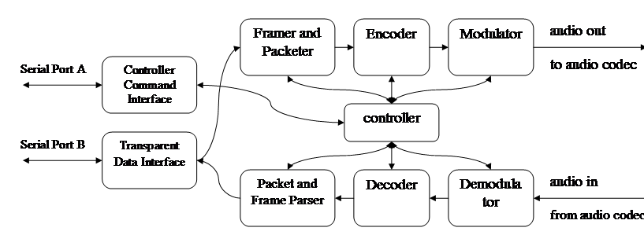

Figure #. Software Architecture Top-level Block Diagram

Risks
Level | Description | Response
High | PCB hardware implementation non-functional | Use existing evaluation boards to demonstrate modem
High | Audio interfacing to voice radios problematic | Test audio interfaces early and choose radios appropriate
Medium | Modem has insufficient performance for required goals | Consult with advisor and perform sufficient up-front research
Medium | Insufficient memory and processing resources to implement required features | Choose embedded processor with plenty of processing power and memory to spare
Low | Hardware prototypes cannot be produced in time for demonstration | Begin work on hardware prototypes immediately

Plan

How detailed does this have to be?

- Modem fully software defined for flexibility
- Hardware can be developed and tested completely independently of modem design

Project Milestones:
- PCB design and layout
- PCB testing and assembly
- Design and implementation of device drivers for embedded processor
- Software modem architecture
- Packet design
- Characterization of radios
- Modeling and simulation of algorithms in Matlab
- Modulator/Demodulator design and SW implementation
- FEC Encoding/Decoding design and SW implementation
- Framing and packet design and SW implementation
- Block-level testing on PC (simulation)
- System-level testing on PC
- System-level testing on embedded processor with radios

Budget
Aaron and Stefan

