



www.sgsolutions.ca/marconi
Transparent Wireless Modem
Block Verification

May 10th, 2005

Department of Electrical and Computer Engineering
University of Waterloo
200 University Ave. W., Waterloo, ON

Aaron Cheung
Hardware Lead
00141344

Stefan Janhunen
Algorithms Lead
00057388

Vincent G. Liu
Marketing Lead
20069140

Shu Wu
Software Lead
20069140

Table of Contents

2. DSP Software Architecture #
2.1 Overview #
2.2 Software Methodology #
2.3 Software Modem Blocks #
2.3.1 Soft-Decision Viterbi Convolutional Codec #

2. ########## #

2. Hardware Layout

Referring to the project specifications, there are four sub blocks that fall into the hardware section of the radio modem, namely the serial interface, the digital signal processor (DSP), the audio codec, and the audio interface. Each sub block serves a specific function in the wireless modem. The following sections will briefly describe the functions of each sub block, followed by an overview to evaluate whether the according specifications listed in the project specification document can be satisfied.
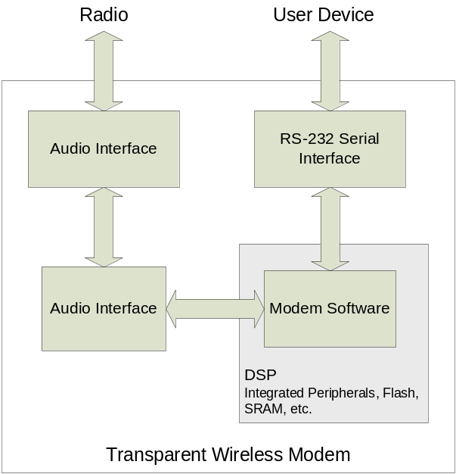

Figure 1. Hardware Blocks Abstraction

2.1 Serial Interface

The main function of the serial interface is to allow data transfer between the radio modem and the device attached, a portable computer for example. Since the radios in consideration will support half duplex data transfers, one of the two modems will be transmitting data while the other will be receiving data at any given time. On the transmission side, the serial interface on the radio modem receives information from the device and feeds the information to the DSP for processing. On the receiving end, the serial interface receives the processed data from the DSP and feeds it into the device. There are three major concerns regarding the serial interface, namely the speed of data transfer capability, number of serial ports, and choice of industry standard.

In order to ensure the final product operates as a transparent modem, the serial interface must be able to transmit and receive data above a minimum speed. Referring from the project specification document, it is required that the modem should be able to transmit or receive data greater than a rate or 100 bits per second (bps) over a reasonable channel. A preliminary investigation shows that the current technology supports serial interface with data transfer speed up to or greater than 250kbps, hence this requirement can be satisfied.

Regarding the number of serial ports, the radio modem requires only one serial port under normal operating conditions. However, during the development phase, it is much more convenient for the designer to have an additional serial port for hardware debugging. Consequently, it is desirable to have a serial interface that has two serial ports. Preliminary investigation shows that the current technologies support multi-channel serial interfaces, hence this requirement is not a concern.

As for the choice of industry standard, it is required that an appropriate serial interface standard that is widely used by the industry be selected. For the radio modem, it is assumed that the distance between the modem and the device attached to the modem is relatively short (i.e. less than 50ft). As well, as mentioned before, the data transfer rate will be in the order of 100bps, which is a fairly low data rate. Since the distance and data rate requirement is not very stringent, there exists a number of industry standards that are available for selection, namely the RS-232 standard. Hence an appropriate choice of serial interface standards exists.

2.2 Digital Signal Processor (DSP)

The DSP block is the most important block within the hardware section. Its main function is to carry out most, if not all computation required for the radio modem to function properly. On the transmission end of the transmit-receive pair, the DSP receives binary information from the serial interface, then it performs numerous operations on the raw data in preparation for transmission, and finally sent off the transformed bit stream to the audio codec. Operations that the DSP performs on the data in preparation for transmission include framing, encoding, and modulation. On the receiving side, the DSP performs these operations in a reversed order to produce data to be sent off to the serial interface, namely demodulation, decoding, and frame parsing. Of all the operations performed on both the transmitter and receiver side, the demodulation operation is the most computational power intensive. As such, it is necessary to investigate the computational speed of the DSP and its internal peripheral features.

During demodulation on the receiver’s end, the DSP block receives Pulse Code Modulated (PCM) bit stream from the audio codec and transforms the data back to the original form for the serial interface to send off to the device. Assuming the simplest modulation-demodulation scheme where a four tone Frequency Shift Keying (FSK) method is used, the DSP will need to perform convolution on the input bit stream quickly so as to identify which of the four possible tones are received. The act of convolution can be broken down into multiplication and addition operations, also known as multiply and accumulate, or MAC in short. Assuming the radio modules have a fairly narrow usable bandwidth over the audible frequencies, the separation between each of the four chosen frequencies cannot be excessively wide. As a result, narrowband filters are required in the demodulator at the receiver. With narrow band filters come tradeoffs for long trailing tails in the reference waveform in the time domain used in each of the four frequency filters, implying the need for more MAC operations. Since the radio modem must transmit or receive no less than 100bps, the DSP block must be able to perform a lot of MAC operations quickly. With a preliminary investigation on current technologies, DSPs are sufficiently powerful to suffice this requirement. For instance, the TMS320F2811 DSP from Texas Instruments is capable of performing one MAC operation per cycle at a maximum frequency of 135MHz. If the audio input from the radio modules are sampled at 8kSa/sec, and assuming no other operations are being performed at the time of demodulation, the DSP can perform at a maximum of , which is more than sufficient for an acceptable quality narrow band filter.

Besides concern on the DSP’s computational power, it is also necessary to consider the DSP’s peripherals included with the package, so as to simplify circuit integration and avoid unforeseen hardware problems in the future. For the DSP to perform computations on the data for transmission and reception, there must be sufficient FLASH memory to store the software and RAM to allow the DSP to function at its optimum speed. Investigations on the TI TMS320F2811 DSP shows that current technologies support up to or more than 36K of RAM and 256K of FLASH memory, which is more than sufficient for the purpose of this radio modem. Since there are DSP on the market that has internal memory integrated within the package, circuit design can be made much easier and simpler.

2.3 Audio Codec

The audio codec serves as a digital to analog converter (DAC) on the transmitting side and an analog to digital converter (ADC) on the receiving side of the radio modem, interfacing between the audio interface and the DSP block. On the transmit side, the audio code receives PCM bit stream from the DSP and output an analog signal to the audio interface. On the receive side, the audio codec samples the analog signal and outputs a PCM bit stream to the DSP block for processing. There are two major concerns regarding the audio codec, namely resolution and sampling speed.

Regarding resolution, investigation shows that current technology supports audio codec up to 24 bits, which represents 224 = 16.8 * 106 possible levels. Since the audio interface can be designed to amplify or attenuate input and output signals to or from the audio codec block, current technologies are capable of representing sinusoids with negligible quantization noise, thus eliminating audio codec resolution as a concern.

As for sampling rate, audio codec with the current technologies are capable of sampling at frequencies ranging from the kHz range up to the MHz range. Since the radio modules are band pass filtered for the audio frequency range, audio codec sampling rate is not a concern for the design of the radio modem.

2.4 Audio Interface

The main function of the audio interface is to amplify or attenuate signals as required depending on the choice of radio modules, so as to ensure signals can be transmitted or received clearly. On the transmitter side, operational amplifiers along with tuneable potentiometers can be used to amplify or attenuate signals from the audio codec to the radio modules as desired to ensure clear transmission. On the receiver side, op amps and potentiometers can also be used to ensure clear reception from the radio modules to the audio codec.

For proper operation of the radio modem, the audio interface should allow the audio input and output levels to be adjusted such that it falls between 0dBV and 20dBV. Since most op amps can deliver such performances, the audio interface block pertains no major concern for the project design.

2. DSP Software Architecture

2.1 Overview

The DSP software project is clearly divided into two parts, the lower-level firmware and the modem software and an optional debug component.

The firmware is responsible for performing I/O operations and controller external devices.

The debug component produces an command-line interface through the serial port, allowing the developer to configure modem options and debug the modem while its in use.

The modem software is platform independent, so it can be reused as new technology arises. Another advantage is that exactly the same code used on the DSP can be developed and simulated on the PC.

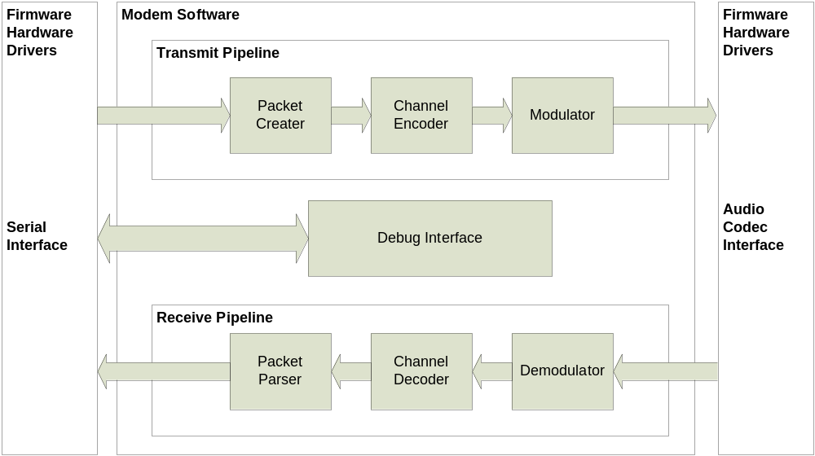
Figure 2. Software Architecture Overview

The C language is chosen to implement the project. It was chosen for its wide acceptance and ease of learning. As opposed to higher level languages such as C++ and Java, C gives us more ability to optimize our software framework and its underlying pieces.

2.2 Software Methodology

Like all engineering projects, it is a good idea to split up a complex design into smaller chunks.
For the modem software, this methodology is enforced through the use of object-oriented design. The modem is organized into what are called pipelines and controllers using a custom designed object framework.

Each controller, or modem block, performs one processing stage of the modem, such as encoding or modulation. The controllers use a defined interface that is then strung together into a pipeline.

Another important advantage of the object-oriented design is that it allows multiple modems to be instantiated. This makes it possible to test interactions between two modems in the PC simulation environment.
2.3 Software Modem Blocks

2.3.1 Soft-Decision Viterbi Convolutional Codec

The Convolutional codec is a forward error correction technique which is widely used in wireless digital communication systems where low SNR makes it highly susceptible to bit errors.

The performance of a convolutional encoder and decoder, which known parameters, when subjected to Additive White Gaussian Noise is well defined and documented. These parameters are the output rate, code length, polynomial coefficients, and length of history bits kept inside the trellis. The codec is also soft-decision, which means that uncertainty levels of received binary signals are passed to the decoder.

These parameters have to be set based on tests with real signals and adjusted for the processing power of the DSP used.

The Convolutional decoder is implemented using a Viterbi algorithm, which has a fixed runtime and relatively good performance. It is important to note that the decoding algorithm only has an affect on the processing requirements and does not error-correction performance when identical parameters are chosen.

At this stage of modem development, only the PC simulation environment is available, and so a simulated AWGN channel was created to compare the performance of the designed Convolutional codec as compared to references.

The codec parameters are configurable at run-time, which allows for easy testing. The results are shown below. The BER (Bit Error Rate) vs. SNR graph is normalized for different data rates (which some books usually omit).

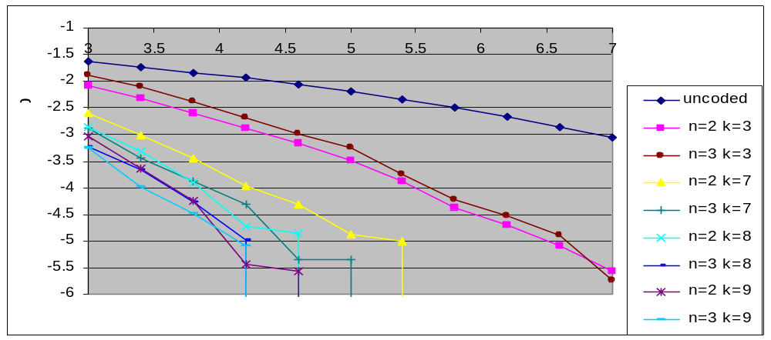

Figure #. BER vs. SNR for Soft-Decision Viterbi Convolutional Codec
The n and k parameters, in the chart above, represent the output data rate and constraint length parameters respectively.

As the convolutional data rate is increased, there is very little effect on the BER performance. This is because the chart is normalized with respect to higher data rates, which offsets any error-correction benefits.

However, the BER performance increases significantly as the constraint length is increased. Larger constraints cost nothing in terms of bandwidth, but are very expensive in terms of processing power. In fact, there is an inverse exponential relationship has constraint lengths are increased, as shown in the graph below.

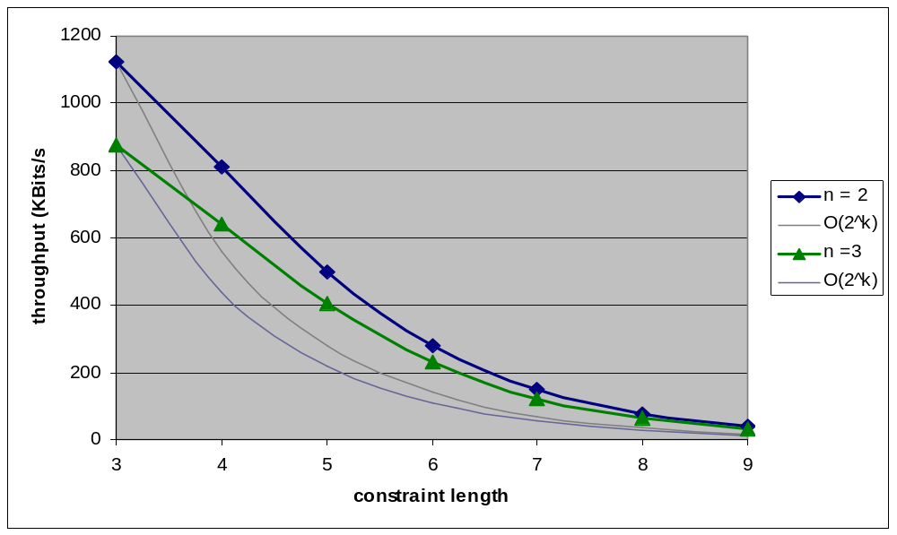

Figure 2. Codec performance vs. Constraint Length
In conclusion, the ability of the convolutional codec to improve Bit Error Rates is well proven and confirmed with simulation. The next step in the design phase is to optimize the codec parameters for the intended application and to push constraint length as high as high as the processing resources allow.

1.3.2 Packet Encapsulation

References

1. McDermott Tom, Wireless Digital Communications: Design and Theory, TAPR, 1998

Viterbi Convolutional Codec

