Modulator and Demodulator

Several aspects that affect the modulation scheme design will now be considered. Modulation schemes that have constant or relatively constant envelopes are less sensitive to fluctuations in amplitude and non-linearity in amplification. Thus in applications where these effects are factors, angle modulation of some form is generally preferred. Two forms of angle modulation will be considered here: FSK (Frequency-Shift Keying) and PSK (Phase-Shift Keying).

When encoding the transmitted data the net data rate is scaled by the rate of the data code. This can be offset by choosing a multilevel modulation scheme that compensates for the loss in data rate by increasing the number of bits transmitted per symbol. In the case of a one-half rate convolutional code, the net data rate will remain unchanged if two bits are encoded in each transmitted symbol. For the cases of FSK and PSK this entails using 4-FSK or 4-PSK (also known as QPSK).

Figure 1 illustrates the uncoded error rate curves for these two modulation schemes. Instead of using SNR (Signal-to-Noise Ratio) as the horizontal variable, a normalized metric of bit energy per noise power density (E_{b}/N_{o}) is utilized. This is the ratio of the energy contained in one transmitted bit divided by the noise power per Hertz of bandwidth. Implementations with different symbol rates (baud rates) and different receiver filter bandwidths can be conveniently compared by converting SNR figures to E_{b}/N_{o.}

The upper curve represents the error rate for non-coherent, orthogonal 4-FSK. In this modulation scheme, four tones are used to encode all four possible values of a symbol of two bits. Non-coherent receivers do not rely on phase synchronization for the demodulation of the modulated signal. The advantage of this is simplicity of implementation. The cost is reduced performance over coherent demodulation schemes. Orthogonality implies that the various tone frequencies are spaced such that they do not interfere with one another when filtered ideally.

The lower curve represents the error rate for (coherent) differentially encoded 4-PSK. In this scheme, the four possible values of a two-bit symbol are encoded into four equally spaced carrier phases (each 90° apart). Coherent demodulation is used to recover these shifts in carrier phase. Additionally, the bits are usually differentially encoded so that the exact starting phase is not required to recover the data, only the relative phase shifts.

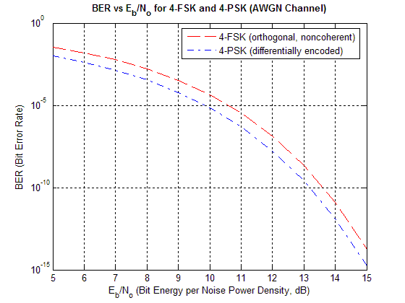
Figure 1 – Error rate curves for 4-FSK and 4-PSK
To evaluate the best-case theoretical performance of these two modulation schemes with various SNRs, it is necessary to convert SNR figures to E_{b}/N_{o}. This can be done using

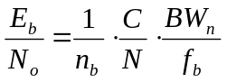,

where C is the carrier power, N is the noise power, BW_{n} is the equivalent noise bandwidth of the receiver (or the noise-measuring filter), f_{b} is the symbol rate (or baud rate), and n_{b} is the number of bits per symbol.

With our previously measured noise floor for the radios used in this project, the following results were obtained:

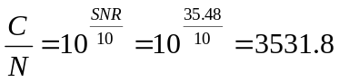 and 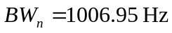.

This yields

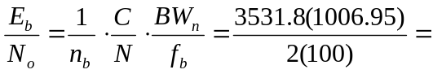17781.89 = 42.5 dB

for a symbol rate of f_{b} = 100, corresponding to the minimum data rate set in the project specification (100 bits per second) while allowing for a one-half rate code. From Figure 1, it can be seen that this best-case condition of E_{b}/N_{o} will result in an extremely low BER for both 4-FSK and 4-PSK without considering any coding improvement.
The analysis can also proceed in the reverse direction. In the project specification, the maximum acceptable BER for usability was set at 10⁻³. The E_{b}/N_{o} corresponding to this condition (neglecting any improvements due to coding) can be estimated from Figure 1 to be near E_{b}/N_{o} = 8.3 dB for the case of 4-FSK. Working backwards, it can be seen that this requires a C/N ratio of

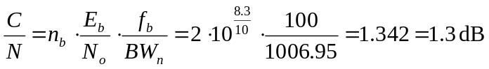.

The C/N radio for the same error rate using 4-PSK will be even lower. All of these numbers assume AWGN and an ideal demodulator. In reality, neither of these conditions will be achievable. Thus the numbers above serve only as bounds on the expected modem performance. Actual (simulated and/or measured) error rates for the implemented modem will appear in the final report.

One additional aspect that must be explored is the power spectrum produced by each modulation scheme. This is important since the voice-band radios provide a band-limited channel for transmission. Figure 2 illustrates a typical power spectrum of a modulated square wave for a single carrier frequency (PSK or on-off keying). While the spectrum theoretically extends indefinitely, it is convenient to approximate the minimum bandwidth required for transmission as the width of the central lobe, as it contains most of the signal power. Moreover, the height of the other side lobes can be reduced significantly with appropriate filtering.

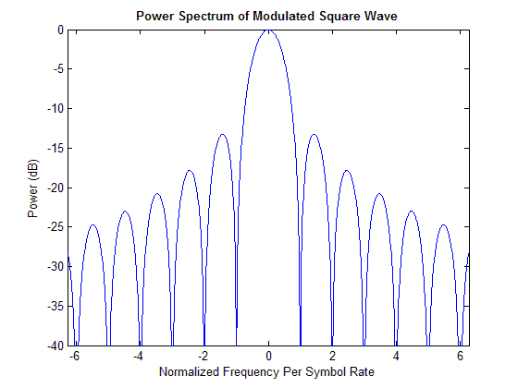
Figure 2 – Typical power spectrum of a modulated square wave
The width of the main lobe is

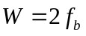,

where f_{b} is the symbol or baud rate of the baseband digital signal. This is seen in Figure 2 by the fact the main lobe extends from –1 to 1, representing a (normalized) frequency width of twice the symbol rate.

A 4-PSK modulated signal contains a single carrier with varying phase. Thus, the bandwidth required for a symbol rate of 100 symbols per second is estimated as the width of the main lobe:

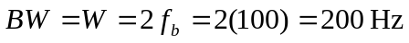.

4-FSK modulation can be thought of as four independent carriers each modulated with on-off keying such that only one is on at any time instant (at least for the case of square-wave baseband data). For orthogonality in non-coherent demodulation it is required that a given carrier be located at the spectral nulls of all other carriers. From Figure 2 it is evident that the shortest possible spacing between carriers is thus one, or f_{b}, the symbol rate. In this case, the required bandwidth of 4-FSK for a symbol rate of 100 symbols per second becomes the width of all the main lobes when spaced appropriately:

.

From the radio characterization data, it was observed that frequencies below 300 Hz and above 2000 Hz are significantly attenuated. Moreover, the response is flattest between 400-800 Hz. From the above calculations, it should be possible to work with either 4-FSK or 4-PSK within the bandwidth of the specified radios.

In summary, 4-PSK has advantages over 4-FSK in both error rate performance and required bandwidth. The downside to 4-PSK is the increased implementation complexity required by coherent demodulation to continually track the received carrier phase. 4-FSK offers good performance with the advantage of implementation simplicity for non-coherent demodulation.

