Radio Link Characterization

The voice-band radios used with the modem play a key factor in determining design decisions, particularly for the modulator and demodulator blocks. For this reason, it is necessary to have at least some metrics by which the radios can be characterized.

The Cobra MicroTalk PR-245-2 GMRS radio was chosen for use in this project due to its low cost and simple audio interface that will allow connection to the modem. This 1-watt UHF-FM radio provides a relatively clean voice-grade link spanning several kilometers. The modem will not be limited to functioning with this particular radio, but should function well with higher-performance, higher-power UHF voice-band radios.

Since the particular characteristics (such as usable audio bandwidth and noise floor) of this radio were unknown, several tests, two of which are detailed in the following discussion, were performed to provide performance characterization. It should be noted that all of these test were performed indoors with the radios 10 cm apart. Thus, they represent the best-case conditions, or an upper bound on voice-link performance. The PR-245-2 supports both FRS (Family Radio Service) and GMRS (General Mobile Radio Service) channels. The maximum allowable transmit power for GMRS channels is 1 watt as opposed to the 0.5 watt limit of FRS channels. Additionally, channel spacing is wider over GMRS channels. The tests discussed here were performed over FRS channels.

Frequency Response
A vital parameter in the design of the modulator and demodulator is the bandwidth available for transmitting data. Figure 1 illustrates the measured frequency response of the end-to-end bandpass voice link. A frequency swept tone was transmitted from one radio while the received amplitude response was measured at the output of the other radio. It should be noted that the vertical offset of the response (or the passband amplitude) is somewhat arbitrary since it depends upon the gain settings of the receiving audio equipment. What does matter is the relative variation of the response. From Figure 1 it should be noted that frequencies below 300 Hz and above 2000 Hz are significantly attenuated. Thus, as long as the modulated spectrum is constrained within the passband sufficiently the frequency response should not present an obstacle to data transmission at sufficiently low data rates.

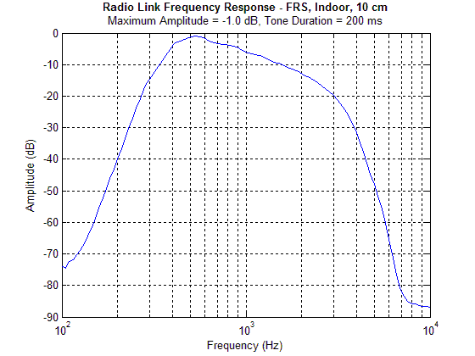
Figure 1 – Frequency response of voice-band channel

Noise Floor
Another useful metric is the noise floor of the radios at close range. Figure 2 illustrates the received power spectrum of a 1000 Hz test tone transmitted between the two radios. The amplitude of the transmitted tone was maximized while attempting to keep the power of the odd harmonics from increasing due to audio circuitry distortion in the radios.

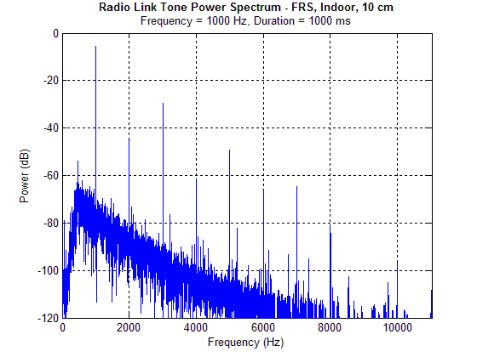
Figure 2 – Power spectrum of test tone
Several observations are now possible. This measurement represents a best-case channel condition: maximum transmitted signal power with minimum path loss. As path length is increased, the tone will eventually disappear into the noise floor. Also, interference from other sources will serve to increase the noise floor. Noise conditions over longer path lengths will not be explored here, but will be left to the bit-error-rate performance simulations and/or measurements in the final report.

The harmonic distortion introduced by the radios is also evident, particularly at the odd harmonics. Non-linear amplification and FM modulation imperfections contribute to this distortion.

The SNR (Signal-to-Noise Ratio) for the test tone under these conditions was measured by bandpass filtering the receiver output both in the presence and absence of the tone and comparing the relative measured power. The equivalent noise bandwidth (BW_{N}) of the filter and the SNR (C/N) of the tone were calculated to be:

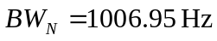

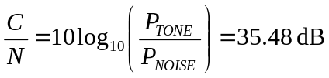

From these figures, and with knowledge of the desired baud rate, it is possible to estimate the ratio of bit energy to noise power density for a particular data rate under ideal conditions.

