Modulator and Demodulator Design
Previously, in the Block Verification stage of this project, two possible modulation schemes were proposed: 4-FSK (4-level Frequency Shift Keying) and 4-PSK (4-level Phase Shift Keying). A decision was ultimately made in favor of 4-FSK due to the simplicity of robust implementation. Since the design is non-coherent, it is not necessary to track phase and frequency variations in the received carrier(s). This simplifies the receiver design significantly but reduces error-rate performance when operating in very low SNR conditions.

To design the appropriate signal set to be used for 4-FSK modulation, it is necessary to consider once again the available bandwidth of the voice channel provided by the radios, as illustrated in Figure 1. As was discussed in the Block Verification, the outer null-to-outer null bandwidth of M-ary FSK can be calculated as:

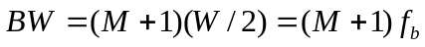

where M is the number of tones used, W is the width of the main lobe of the power spectrum for each tone, and f_{b} is the baud rate in symbols per second. According to project specifications, a net data rate of 100 bits per second is required. Since a ½ rate convolutional encoder will be used to encode the data, this necessitates a gross bit rate of 200 bits per second. 4-FSK uses four distinct symbols (signals) for transmission, corresponding to four distinct tones, allowing two bits of information to be encoded per symbol. Thus, the required baud rate is f_{b} = 100 symbols per second.

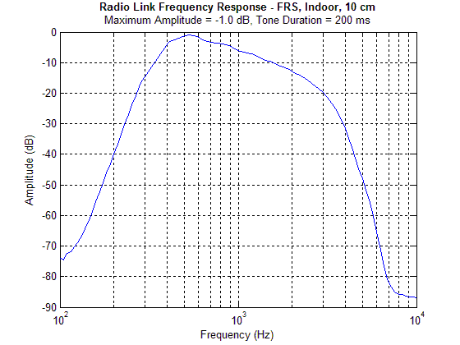
Figure 1 – Frequency response of radio voice channel
Using this, we can calculate the required bandwidth and design the required tone set:

To maintain orthogonally among the tones, it is necessary that a given tone be located in the spectral nulls of all other tones in the set. Referring to Figure 2, it is evident that the minimum distance between tones for which this is possible is equal to f_{b}, the baud rate. This ensures that for any two tones s_{i}(t) and s_{j}(t) the condition

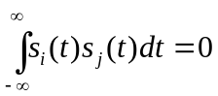 for any 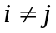

is satisfied. Essentially, this relationship states that the correlation between any two tones in the tone set is zero.

A tone set satisfying these criteria can now be chosen:

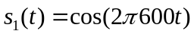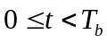
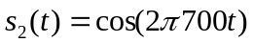
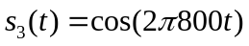
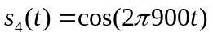

These signals correspond to tones located at 600, 700, 800, and 900 Hz, respectively. This satisfies the spacing requirement and fits well within the bandwidth defined in Figure 1.
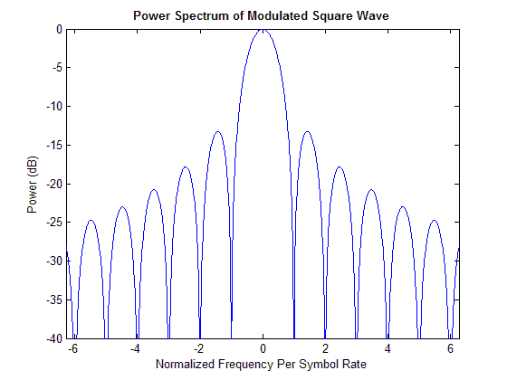
Figure 2 – Power spectrum of modulated square wave
The structure of the modulator and demodulator can now be discussed. Figure 3 illustrates the design of the 4-FSK modulator. Incoming bits are received from the output of the convolutional encoder in pairs. These bit pairs are passed through a 2-to-4 decoder to produce a one-hot output corresponding to the symbol for transmission. The output of the decoder changes at a rate equal to the symbol or baud rate (f_{b}). These decoder outputs must be up-sampled to the sampling rate of the audio interface (f_{s}) before further processing can take place. The output of each up-sampling block is a train of rectangular pulses, which have the power spectrum illustrated in Figure 2. To suppress the excess side lobe bandwidth, the rectangular pulses can be filtered with a pulse shaping filter h_{s}(t). These filtered baseband pulses are then modulated up to one of the four tone frequencies by multiplication by the appropriate tone frequency. The four modulator outputs are summed to produce an orthogonal 4-FSK output signal.

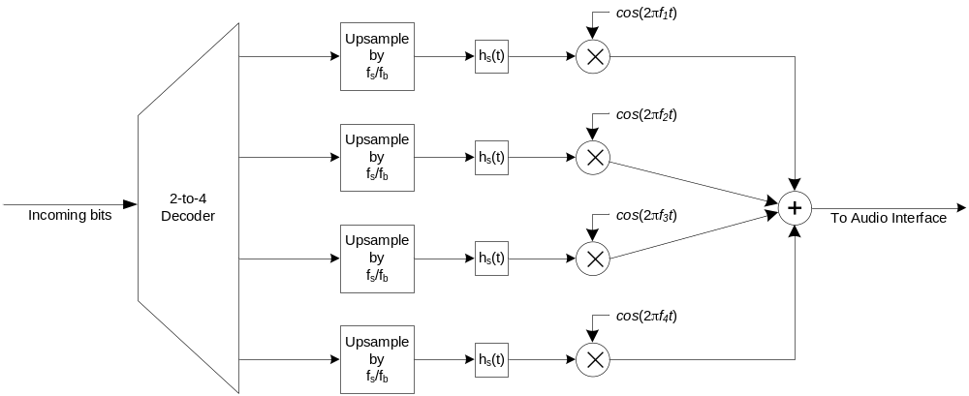
Figure 3 – Structure of 4-FSK modulator
In this form, the modulator structure is relatively easy to implement on a DSP. Most of the operations map nicely into MAC (Multiply-and-Accumulate) operations. Furthermore, reference waveforms for each tone can be stored in look-up tables for efficiency rather than being computed in real-time.

The demodulator structure is illustrated in Figure 4. Incoming samples from the audio interface are multiplied by four complex sinusoids, corresponding to the four tones. The result of this is a demodulated baseband pulse and a signal component at twice the tone frequency, which is removed with the filter h_{f}(t). Using complex sinusoids for demodulation has the advantage of producing complex-baseband representation of the received pulses, which can be viewed as a convenient way of separating magnitude and phase information in the received signal. Since the demodulator is non-coherent, only magnitude information is used to make the symbol detection decision. Thus, after filtering the received pulse with a (matched) pulse filter h_{s}(t) the magnitude information of the signal is extracted by taking the magnitude of the complex signal and discarding the phase information.

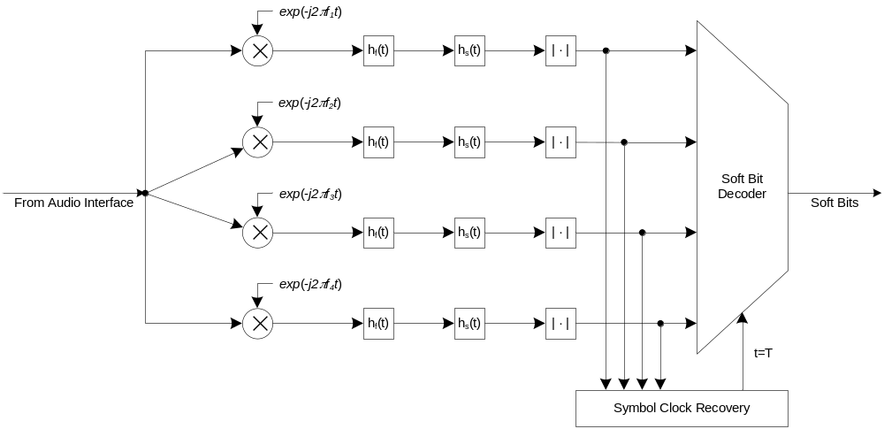
Figure 4 – Structure of 4-FSK demodulator

The magnitude output of the each matched filter detector is then fed into the soft-bit decoder. When triggered at the appropriate sampling instant, as determined by symbol clock recovery, this decoder simply chooses the tone with the greatest energy and produces the two output bits associated with the chosen symbol. Each of the output bits is weighted by the relative certainty of the decision as measured by the relative difference between the four matched filter outputs. These soft bits are then used by the Viterbi decoder to produce more accurate error metrics during decoding.

Several methods may be used to recover the symbol clock timing. Timing recovery is necessary to ensure that decoding decisions are made at the optimal point. As an example, Figure 5 illustrates a received and filtered pulse. The optimal sampling instant is at the peak of the pulse. At this point, received energy is maximized and interference from other tones is minimized, assuming the filters have been designed for minimal inter-symbol-interference. To discover this optimal sampling instant, a maximum-seeking search will be used to find the peak of the pulse shape. While this technique is computationally intensive since every possible offset across the symbol must be tested in a linear manner, it offers very fast synchronization acquisition, even on the initial symbol of a transmission.

As in the case of the modulator, most operations performed within the demodulator map nicely into MAC operations. Complex signals are represented as two separate signals, corresponding to in-phase and quadrature components, for all processing. Once again, all reference tones in both in-phase and quadrature form are stored in look-up tables for computational efficiency.

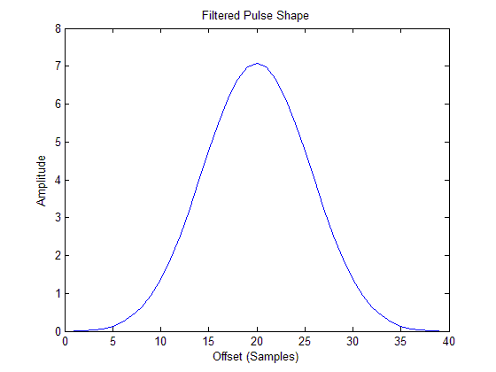
Figure 5 – Sample pulse shape after demodulation and matched filtering

