**Large prostitution ring, Bellevue brothels shut down**

Originally published January 7, 2016 at 11:13 am Updated January 9, 2016 at 11:11 am

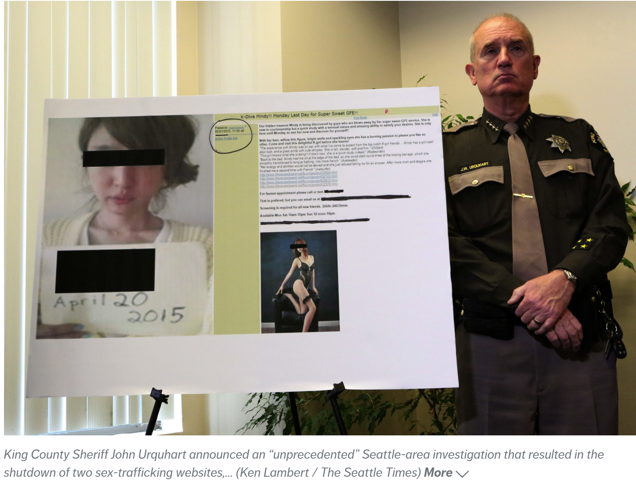

*King County Sheriff John Urquhart announced an “unprecedented” Seattle-area investigation that resulted in the shutdown of two sex-trafficking websites, the shuttering of 12 brothels and the arrest of about a dozen people, police announced Thursday. The brothels were operated out of “high-end, luxury, upscale apartment complexes” in Bellevue, according to Bellevue Police Chief Steve Mylett. Many of the women were forced to work as prostitutes, often for 12 hours a day and seven days a week, to pay off debts, he said. (Ken Lambert / The Seattle Times)*

**A Seattle-area investigation has resulted in the shutdown of two sex-trafficking websites, the shuttering of 12 brothels and the arrest of about a dozen people.**

Twelve men and one woman have been charged with promoting prostitution following a wide-ranging investigation that resulted in the shutdown of 12 brothels in Bellevue and the seizure of two sex-trafficking sites, according to police and prosecutors.

The brothels were operated out of high-end apartment complexes in Bellevue, where prostituted women from South Korea were forced to work often for 12 hours a day, seven days a week, to pay off debts, according to Bellevue Police Chief Steve Mylett.

One of the brothel owners is an alleged member of “The League,” an exclusive group of local sex buyers who were also charged with promoting prostitution after being infiltrated by undercover detectives, he said.

Prosecutor Dan Satterberg said King County is the first jurisdiction in the country to charge “an organized group of sex buyers” with promoting the prostitution of women from South Korea, who are brought to the U.S. to work as prostitutes and are shuttled between major cities.

The joint operation between Bellevue police and the King County Sheriff’s Office led to the seizure Tuesday of website TheReviewboard.net and a sister site called kgirldelights.com, with the “K” standing for Korea, officials announced at a news conference Thursday.

TheReviewboard.net, with an estimated 23,000 members, allowed men to post graphic descriptions of their sexual encounters with prostituted women and share tips to avoid police attention and suspicion from wives and girlfriends, according to charging papers.

“This website facilitated prostitution,” Sheriff John Urquhart said at a news conference.

Sigurd Zitars, 61, is the owner and operator of TheReviewboard.net, according to charging papers. Zitars and a group of 50 of his most prolific posters nationwide established themselves as an exclusive, invitation-only group that called itself “The League,” police and prosecutors say.

All but two of the people arrested Tuesday are alleged local members of The League.

Members of The League set up the kgirldelights.com site to advertise South Korean women after Zitars — who goes by the handle “Tahoe Ted” — decided to restrict the number of Asian sex workers on his site to avoid police notice, charging papers say.

Both websites worked with agencies that move women from city to city after they arrived in the U.S. and “bookers” who book appointments for the women, according to the charges.

Members of “The League,” who used anonymous handles instead of their real names, would regularly meet at local pubs or restaurants. Many times “the discussions were so graphic that patrons sitting at tables next to us would get up and leave or move to another table,” an undercover detective, who infiltrated the group, wrote in charging documents.

In many instances, police identified League members by following them to their vehicles and running their license plate numbers. Several of the meetings were also secretly recorded by police, the charges say.

“Many of the members made comments that indicated they were aware these girls were more than likely trafficked and had little choice in choosing to work as prostitutes,” say the charges.

Zitars was arrested Tuesday along with alleged League members Charles Peters, 46; Justin Yoon, 45; Stephen Jenkins, 44; Lawrence Masaki, 44; Mark Yamada, 54; Keith Emmanuel, 28; Noah Jorgenson, 27; and Donald Mueller, 58.

Except for Mueller, all of the men are being held in lieu of $75,000 bail. Richard Homchick, 49, has also been charged with second-degree promoting prostitution, but his name does not appear in the King County Jail register.

The men paid an estimated $300 per encounter with dozens, if not hundreds, of women, say the charges.

Mueller, who is also accused of running brothels out of high-end, luxury apartments in Bellevue, is being held in lieu of $150,000 bail, as is Michael Durnal, 47. Durnal was not a member of The League but signed a lease for Mueller before the pair had a falling out and Durnal allegedly started up his own brothel, say the charges.

Mueller is a longtime sex buyer who previously had made his living off illegal marijuana grows, but moved into prostitution when the drug was legalized, the charges say.

Jabong “Crystal” Kim, a Korean national and former sex worker, is the sole woman so far charged in the case, according to charging documents. She, too, is accused of running a brothel and is now being held without bail in the King County Jail, say jail and court records.

Urquhart said the arrests are just the beginning of a very complicated investigation and additional arrests and charges are possible.

Urquhart said detectives also have the names and photos of thousands of men who signed up for accounts on TheReviewboard.net, but he said it’s unlikely those men will face misdemeanor prostitution charges.

Urquhart said the investigation into TheReveiwboard.net and “The League” is “unprecedented in size and scope” in the region. Twelve South Korean women were rescued from the brothels and will be eligible for visas to remain in the U.S., he said.

Urquhart said many of the women were forced to work as prostitutes in order to pay off debt incurred by traveling to the U.S.

“These women are true victims, make no mistake about it,” said Urquhart.

The sheriff’s office, which has been investigating TheReviewboard.net for years, launched an investigation last spring after a sex-trafficking victim told authorities she had been brought to the U.S. from South Korea and coerced into prostitution to pay off a family debt, Urquhart said.

Mylett, noting some believe prostitution is a victimless crime, said [one woman killed last April](http://www.seattletimes.com/seattle-news/eastside/police-bellevue-stabbing-suspect-wakes-up-to-handcuffs/) in a Bellevue apartment worked as a prostitute, though her death is unrelated to the current investigation.

Song Wang, 30, is accused of killing a 37-year-old Bellevue woman and torching her apartment. He has been charged with first-degree murder and first-degree arson, accused of fatally stabbing Kittaporn Saosawatsri and torching her apartment.

One former Seattle-area sex worker decried the shutdown of thereviewboard.net, saying it now forces sex workers to go into the street where prospective customers cannot be screened. The website allowed sex workers to vet potential clients.

“It (the shutdown) increases the odds a sex worker needing to make rent will take an unverified client,” Savannah Sly, president of the Sex Worker Outreach Project, wrote in an email.