**Fairfax County Police bust sex trafficking ring at luxury apartment**

**By**[Evan Lambert](https://www.fox5dc.com/person/l/evan-lambert)

**Published** September 30, 2019

[Crime and Public Safety](https://www.fox5dc.com/tag/crime-publicsafety)

[FOX 5 DC](http://www.fox5dc.com/)

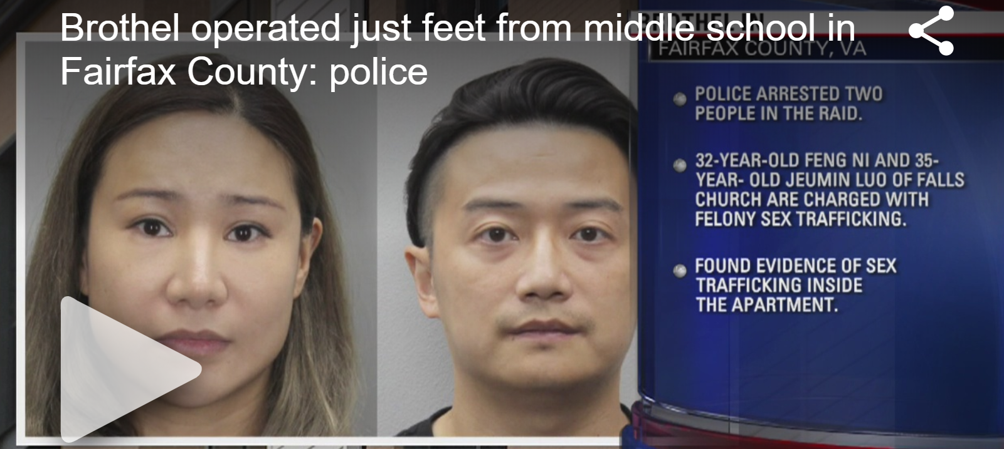

**FAIRFAX COUNTY, Va. (FOX 5 DC)** - Fairfax County Police tell FOX 5 they arrested two people in connection with a sex trafficking operation being run out of a luxury apartment at the Mosaic District shopping center near Merrifield.

Police say they found evidence of sex trafficking last Wednesday during a raid of the unit in the Avalon Mosaic luxury apartments. Sources tell FOX 5 that evidence typically includes large amounts of cash, condoms and other materials used for sex.

Officials arrested Feng Ni, 32, and Juemin Luo, 35, both of Falls Church. They are charged with felony sex trafficking.

Luo bonded out of jail, while Ni is being held without bond.

Police did not say whether they identified any sex trafficking victims.

<https://www.fox5dc.com/news/fairfax-county-police-bust-sex-trafficking-ring-at-luxury-apartment>