Springmvc默认的json工具采用的是Jackson
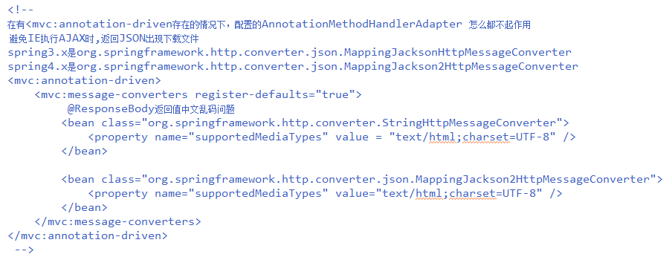
<!--
在有mvc:annotation-driven存在的情况下，配置的AnnotationMethodHandlerAdapter 怎么都不起作用。
避免IE执行AJAX时,返回JSON出现下载文件，
spring3.x是
org.springframework.http.converter.json.MappingJacksonHttpMessageConverter
spring4.x是
org.springframework.http.converter.json.MappingJackson2HttpMessageConverter
-->
<mvc:annotation-driven>
<mvc:message-converters register-defaults="true">
<bean class="org.springframework.http.converter.StringHttpMessageConverter">
<property name="supportedMediaTypes" value = "text/html;charset=UTF-8" />
</bean>
<bean class="org.springframework.http.converter.json.MappingJackson2HttpMessageConverter">
<property name="supportedMediaTypes" value="text/html;charset=UTF-8" />
</bean>
</mvc:message-converters>
</mvc:annotation-driven>

Fastjson的方式
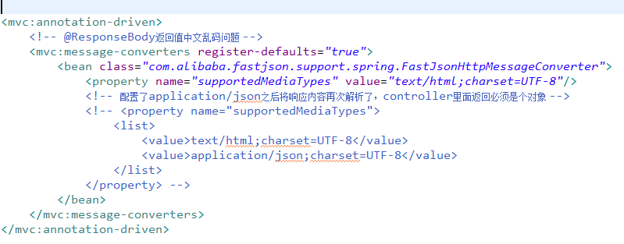
<mvc:annotation-driven>
<!-- @ResponseBody返回值中文乱码问题 -->
<mvc:message-converters register-defaults="true">
<bean class="com.alibaba.fastjson.support.spring.FastJsonHttpMessageConverter">
<property name="supportedMediaTypes" value="text/html;charset=UTF-8"/>
<!-- 配置了application/json之后将响应内容再次解析了，controller里面返回必须是个对象 -->
<!-- <property name="supportedMediaTypes">
<list>
<value>text/html;charset=UTF-8</value>
<value>application/json;charset=UTF-8</value>
</list>
</property> -->
</bean>
</mvc:message-converters>
</mvc:annotation-driven>

