# install

mvn install

# assembly 打包时将依赖jar引入

这种引入外部jar到程序，不是将jar依赖引入，而是直接将源码引入到jar里。

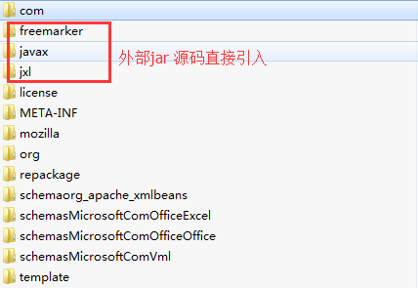

Pom.xml 添加assembly 然后执行 mvn package

|  |
| --- |
| <plugin>  <artifactId>maven-assembly-plugin</artifactId>  <configuration>  <descriptorRefs>  <descriptorRef>jar-with-dependencies</descriptorRef>  </descriptorRefs>  <!-- 可运行的类，提供main方式的运行类  <archive>  <manifest>  <mainClass>com.cetc.di.App</mainClass>  </manifest>  </archive> -->  </configuration>  <executions>  <execution>  <id>make-assembly</id>  <phase>package</phase>  <goals>  <goal>single</goal>  </goals>  </execution>  </executions>  </plugin> |